Supplemental Table 1. Parameter names, values, and sources used to build and calibrate a novel simulation model of maternal glucose and insulin dynamics in early (12-16 weeks) and late (34-36) weeks gestation under oral glucose tolerance test and hyperinsulinemic-euglycemic clamp conditions.
Variable name | Baseline value | Unit | Source
Early pregnancy oral glucose tolerance test (OGTT) model
Insulin secretion time | 1 | Minutes | Calibration at baseline equilibrium
Reference insulin secretion amount | 0.302 | uU/mL | Calibration at baseline equilibrium
Initial insulin in plasma | 3.631 | uU/mL | MAMMA data – Median plasma insulin in early pregnancy at minute 0 of OGTT
Fraction insulin lost | 0.333 | dmnlª | Tokraz, 2018 (1)  Yang, 1989 (2)
Plasma exchange time | 12 | Minutes | Yang, 1989 (2)
Plasma insulin loss time | 12 | Minutes | Assumed plasma loss time is the same as plasma exchange time
Initial insulin in interstitial fluid | 3.631 | uU/mL | Assumed same starting point as initial insulin in plasma
S, Insulin secretion function | 457.112 | uU/mL | Estimated through optimization, Weibull distribution parameter
L, Insulin secretion function | 83.716 | dmnl | Estimated through optimization, Weibull distribution parameter
K, Insulin secretion function | 1.31873 | dmnl | Estimated through optimization, Weibull distribution parameter
Insulin decay time | 20 | Minutes | Park, 2021 (3)
Insulin threshold for hepatic glucose shut off | 30 | uU/mL | Estimated through optimization, informed by Catalano, 1999 (4)
Time to sense insulin in adipose tissue | 249.147 | Minutes | Estimated through optimization, informed by Catalano, 1999 (4) and Bergman, 2021 (5)
Percent suppression | 0.9 | dmnl | Catalano, 1999 (4)
Hepatic glucose production amount | 130 | mg/dL | Catalano, 1999 (4) and Lain, 2007 (6)
Blood volume | 44.23 | dL | Sharma, 2022 (7)
Hepatic glucose production time | 5.458 | Minutes | Estimated through optimization
Initial blood glucose | 82.962 | mg/dL | MAMMA data – Mean blood glucose in early pregnancy at minute 0 of OGTT
Maternal glucose uptake time | 120 | Minutes | Calibration at baseline equilibrium
Percent of glucose to placenta and fetus | 0% | dmnl | Amount of glucose to placenta and fetus is negligible in early pregnancy
Insulin effect | 1.12 | dmnl | Rorsman, 2003 (8); Bergman, 2021 (5); Park, 2021 (3)
Insulin threshold for effect | 20.449 | uU/mL | Estimated through optimization
Oral glucose amount | 16.595 | (mg/dL)/Minutes | Estimated through optimization
Glucose intake start time | 0 | Minutes | Blood is drawn and then glucose is consumed starting at minute 0 of OGTT
Glucose intake end time | 5 | Minutes | Participants are instructed to consume entire glucose drink in 5 minutes during OGTT
Initial oral glucose load | 0 | mg/dL | No glucose is consumed yet
Oral glucose absorption time | 32.546 | Minutes | Estimated through optimization
Early pregnancy hyperinsulinemic-euglycemic clamp model – only parameters that differed from OGTT model are listed below
Time to sense insulin in adipose tissue | 1 | Minutes | Estimated through optimization, informed by Catalano, 1999 (4) and Bergman, 2021 (5)
Hepatic glucose production time | 5.860 | Minutes | Estimated through optimization
Insulin threshold for effect | 10.012 | uU/mL | Estimated through optimization
Infusion in mg | 8.764 | mg/kg | Estimated through optimization, informed by Catalano, 1999 (4)
Infusion time | 1 | Minutes | Catalano, 1999 (4)
Conversion from kg to dL | 0.1 | kg/dL | Unit conversion
Insulin infusion amount | 20 | uU/(meter*meter) | Catalano, 1999 (4)
Conversion | 0.194 | (meter*meter)/mL | Estimated through optimization, informed by Catalano, 1999 (4)
Late pregnancy oral glucose tolerance test (OGTT) model – only parameters that differed from early pregnancy OGTT model are listed below
Reference insulin secretion amount | 0.5 | uU/mL | Calibration at baseline equilibrium
Initial insulin in plasma | 5.321 | uU/mL | MAMMA data – Median plasma insulin in late pregnancy at minute 0 of OGTT
Initial insulin in interstitial fluid | 5.321 | uU/mL | Assumed same starting point as initial insulin in plasma
S, Insulin secretion function | 755.366 | uU/mL | Estimated through optimization, Weibull distribution parameter
L, Insulin secretion function | 90.840 | dmnl | Estimated through optimization, Weibull distribution parameter
K, Insulin secretion function | 1.517 | dmnl | Estimated through optimization, Weibull distribution parameter
Insulin effect | 1.20 | dmnl | Rosman, 2003 (8); Bergman, 2021 (5); Park, 2021 (3); Catalano, 1999 (4)
Blood volume | 62 | dL | Estimated 40% increase in blood volume between early and late pregnancy (9)
Hepatic glucose production amount | 170 | mg/dL | Catalano, 1999 (4)
Hepatic glucose production time | 3.719 | Minutes | Estimated through optimization
Initial blood glucose | 83.68 | mg/dL | MAMMA data – Mean blood glucose in late pregnancy at minute 0 of OGTT
Percent of glucose to placenta and fetus | 20% | dmnl | Hay, 2006 (10)
Placenta glucose uptake time | 60 | Minutes | Calibration at baseline equilibrium
Oral glucose amount | 21.827 | (mg/dL)/Minutes | Estimated through optimization
Glucose intake start time | 0 | Minutes | Blood is drawn and then glucose is consumed starting at minute 0 of OGTT
Glucose intake end time | 5 | Minutes | Participants are instructed to consume entire glucose drink in 5 minutes during OGTT
Oral glucose absorption time | 36.510 | Minutes | Estimated through optimization
Late pregnancy hyperinsulinemic-euglycemic clamp model – only parameters that differed from OGTT model are listed below
Time to sense insulin in adipose tissue | 1.090 | Minutes | Estimated through optimization, informed by Catalano, 1999 (4) and Bergman, 2021 (5)
Hepatic glucose production time | 1.974 | Minutes | Estimated through optimization
Insulin threshold for effect | 10.012 | uU/mL | Estimated through optimization
Infusion in mg | 4.140 | mg/kg | Estimated through optimization, informed by Catalano, 1999 (4)
Infusion time | 1 | Minutes | Catalano, 1999 (4)
Conversion from kg to dL | 0.1 | kg/dL | Unit conversion
Insulin infusion amount | 20 | uU/(meter*meter) | Catalano, 1999 (4)
Conversion | 0.194 | (meter*meter)/mL | Estimated through optimization, informed by Catalano, 1999 (4)
ªdmnl = dimensionless (i.e., no units)
Sources:
1. Tokarz VL, MacDonald PE, Klip A. The cell biology of systemic insulin function. J Cell Biol. 2018;217(7):2273.
2. Yang YJ, Hope ID, Ader M, Bergman RN. Insulin transport across capillaries is rate limiting for insulin action in dogs. Journal of Clinical Investigation. 1989;84(5):1620.
3. Park SY, Gautier JF, Chon S. Assessment of Insulin Secretion and Insulin Resistance in Human. Diabetes Metab J. 2021 Sep 1;45(5):641.
4. Catalano PM, Huston L, Amini SB, Kalhan SC. Longitudinal changes in glucose metabolism during pregnancy in obese women with normal glucose tolerance and gestational diabetes mellitus. Am J Obstet Gynecol. 1999 Apr 1;180(4):903–16.
5. Bergman RN. Origins and History of the Minimal Model of Glucose Regulation. Front Endocrinol. 2021 Feb 15;11:1151.
6. Lain KY, Catalano PM. Metabolic changes in pregnancy. Clin Obstet Gynecol. 2007 Dec;50(4):938–48.
7. Sharma R, Sharma S. Physiology, Blood Volume. StatPearls. 2022; Available from: https://www.ncbi.nlm.nih.gov/books/NBK526077/
8. Rorsman P, Renström E. Insulin granule dynamics in pancreatic beta cells. Diabetologia. 2003;46(8):1029–45.
9. Aguree S, Gernand AD. Plasma volume expansion across healthy pregnancy: A systematic review and meta-analysis of longitudinal studies. BMC Pregnancy Childbirth. 2019 Dec 19;19(1):1–11.
10. Hay WW. Placental-Fetal Glucose Exchange and Fetal Glucose Metabolism. Trans Am Clin Climatol Assoc. 2006;117:321.

Supplemental Figure 1. Output from a system dynamics model designed to replicate maternal insulin and glucose dynamics in late pregnancy (32-36 weeks gestation) under hyperinsulinemic-euglycemic clamp conditions compared to target steady-state levels.

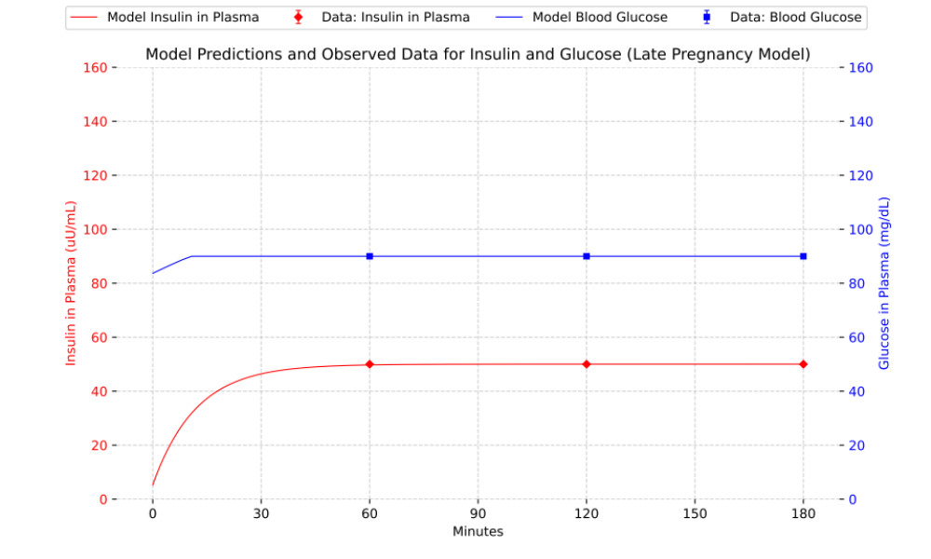

Supplemental Figure 2. Tornado plots of sensitivity analysis results of 20% changes to parameters in the (a) early pregnancy (12-16 weeks gestation) OGTT model, (b) early pregnancy hyperinsulinemic-euglycemic clamp model, (c) late pregnancy (32-36 weeks gestation) OGTT model, and (d) late pregnancy hyperinsulinemic-euglycemic clamp model. Parameters that were estimated via optimization are noted with an asterisk. Opportunities to improve model fit with data (i.e., decrease total MAPE) are shown in green bars and parameter changes that make model fit worse are shown in red bars.
a)
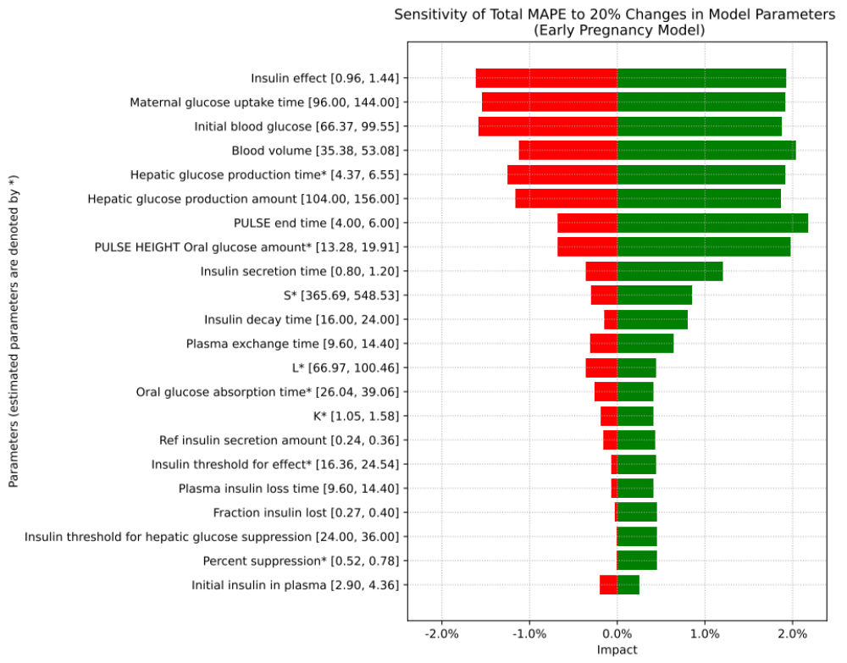

b)
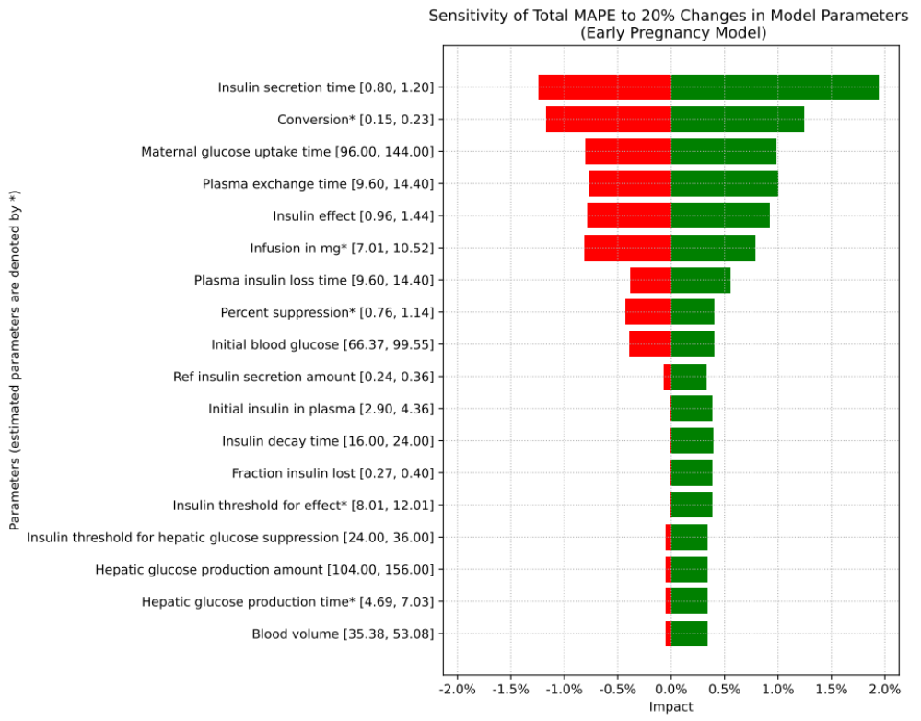

c)
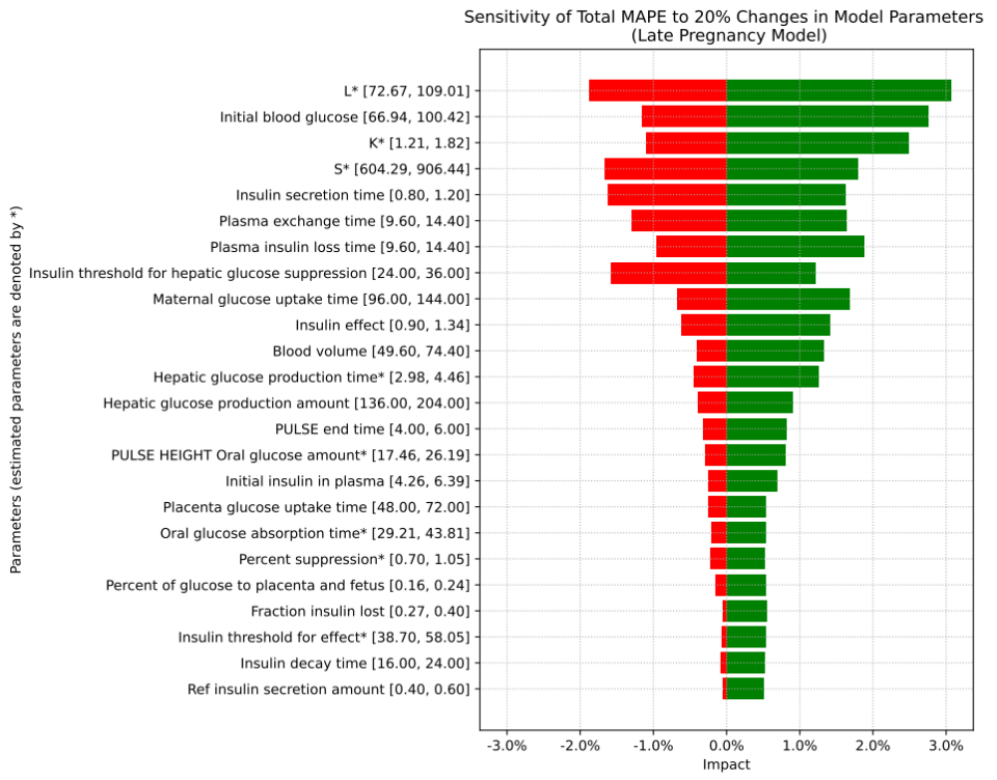

d)
