Examining immune-inflammatory mechanisms of probiotic supplementation in depression: secondary findings from a randomized clinical trial

Supplementary information (SI)

Supplementary Methods

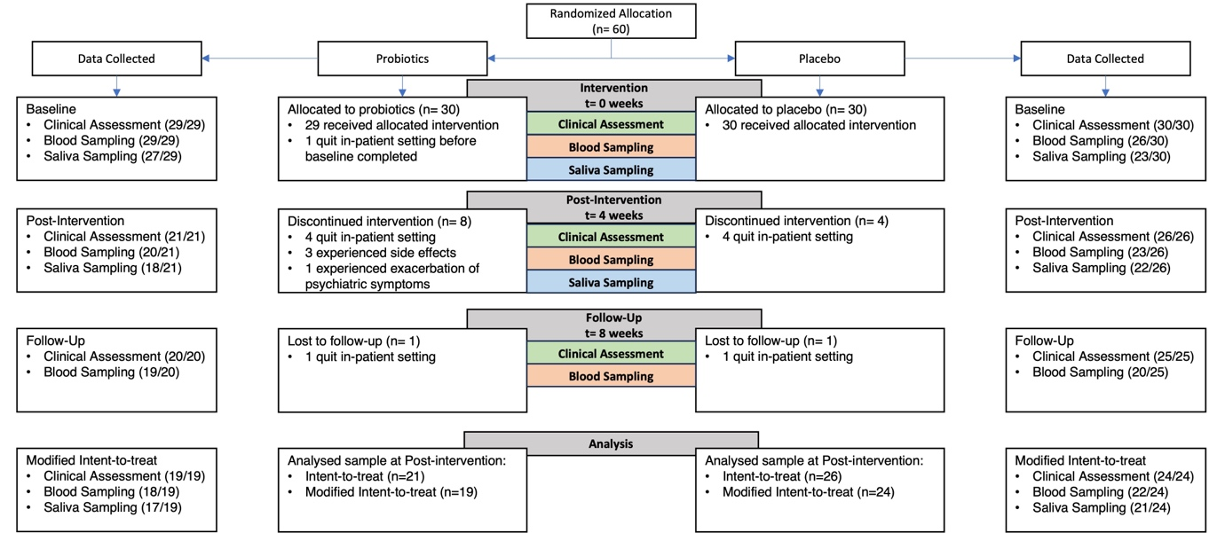
Supplementary Figure 1. CONSORT diagram on study procedure capturing all available data and performed analysis.

Treatment as Usual
To monitor the received treatment as usual, medication intake was extracted for each study participant from the clinic information system. Antidepressant and antipsychotic medications were transformed into dose equivalents based on the defined daily dose (DDD) method, which is described as the “assumed average maintenance dose per day for a drug used for its main indication in adults» ¹. For each participant, detailed information is depicted in Table S1. Different antidepressants and antipsychotics were summarized using the DDD. Furthermore, the specific period of intake was considered as the drugs were not necessarily administered over the whole study period.

Supplementary Table 1. Antidepressant and antipsychotic medication per patient in mean defined daily dose (DDD) over the four-week intervention period. Only patients that finished the intervention are included.

Group | Patient ID | Name | DDD
Probiotics | Patient 1 | mirtazapine, fluoxetine, trimipramine, lithium, olanzapine, chlorprothixene, quetiapine | 3.45
Probiotics | Patient 2 | venlafaxine, lithium, quetiapine | 0.76
Probiotics | Patient 3 | venlafaxine, quetiapine | 2.33
Probiotics | Patient 4 | lithium, quetiapine | 0.75
Probiotics | Patient 5 | bupropion, trazodone | 1.47
Probiotics | Patient 6 | venlafaxine, trazodone, quetiapine | 2.47
Probiotics | Patient 7 | quetiapine | 0.01
Probiotics | Patient 8 | sertraline, quetiapine | 3.22
Probiotics | Patient 9 | escitalopram | 2.00
Probiotics | Patient 10 | venlafaxine, quetiapine | 4.02
Probiotics | Patient 11 | duloxetine, quetiapine | 1.12
Probiotics | Patient 12 | lithium, citalopram, quetiapine, olanzapine | 4.33
Probiotics | Patient 13 | duloxetine, quetiapine | 1.04
Probiotics | Patient 14 | duloxetine | 0.50
Probiotics | Patient 15 | mirtazapine, sertraline, quetiapine | 5.26
Probiotics | Patient 16 | venlafaxine, quetiapine | 3.10
Probiotics | Patient 17 | sertraline, mirtazapine | 3.25
Probiotics | Patient 18 | bupropion, trimipramine, clotiapine, pipamperone | 0.93
Probiotics | Patient 19 | duloxetine | 0.50
Probiotics | Patient 20 | bupropion, quetiapine | 1.13
Probiotics | Patient 21 | duloxetine | 1.00
Placebo | Patient 1 | vortioxetine, quetiapine | 1.57
Placebo | Patient 2 | sertraline, vortioxetine, clotiapine | 1.91
Placebo | Patient 3 | duloxetine, olanzapine | 3.00
Placebo | Patient 4 | venlafaxine, olanzapine, clotiapine | 3.02
Placebo | Patient 5 | duloxetine, risperidone, quetiapine | 1.03
Placebo | Patient 6 | agomelatine | 1.74
Placebo | Patient 7 | venlafaxine | 2.73
Placebo | Patient 8 | mirtazapine, quetiapine | 1.06
Placebo | Patient 9 | bupropion | 1.00
Placebo | Patient 10 | bupropion | 0.45
Placebo | Patient 11 | vortioxetine | 1.00
Placebo | Patient 12 | fluoxetine, olanzapine | 1.45
Placebo | Patient 13 | escitalopram, olanzapine | 2.97
Placebo | Patient 14 | lithium, olanzapine, pipamperone | 0.77
Placebo | Patient 15 | venlafaxine, vortioxetine, olanzapine | 3.99
Placebo | Patient 16 | duloxetine | 1.55
Placebo | Patient 17 | mirtazapine | 1.50
Placebo | Patient 18 | trazodone, bupropion | 0.60
Placebo | Patient 19 | trazodone, bupropion, duloxetine | 1.30
Placebo | Patient 20 | escitalopram | 2.00
Placebo | Patient 21 | escitalopram, lithium | 4.00
Placebo | Patient 22 | venlafaxine, mirtazapine, bupropion, clotiapine | 2.61
Placebo | Patient 23 | vortioxetine, quetiapine, olanzapine, chlorprothixene | 1.54
Placebo | Patient 24 | fluoxetine, agomelatine, pipamperone, quetiapine | 5.26
Placebo | Patient 25 | vortioxetine | 2.07
Placebo | Patient 26 | vortioxetine, clotiapine, quetiapine | 2.27
Notes. DDD = defined daily dose.

Supplementary results

Supplementary Table 2. Concentration of inflammation markers at each time point and results of LMMs.

Measure |  | Probiotic  (n=18) | Placebo  (n=22) | ANOVA*
 |  | Probiotic  (n=18) | Placebo  (n=22) | Effect | df | MS | F | p
IL-1βª | Baseline | 0.002 (0.003) | 0.001 (0.002) | Group | 1 | 0.00 | 0.23 | 0.96
IL-1βª | Post-Intervention | 0.002 (0.003) | 0.001 (0.002) | Time | 2 | 0.00 | 0.23 | 0.27
IL-1βª | Follow-Up | 0.002 (0.002) | 0.002 (0.002) | Group*Time | 2 | 0.00 | 0.57 | 0.57
IL-6ª | Baseline | 0.1 (0.08) | 0.1 (0.08) | Group | 1 | 0.00 | 0.24 | 0.63
IL-6ª | Post-Intervention | 0.11 (0.07) | 0.1 (0.07) | Time | 2 | 0.01 | 1.08 | 0.34
IL-6ª | Follow-Up | 0.13 (0.1) | 0.12 (0.08) | Group*Time | 2 | 0.01 | 0.77 | 0.47
MIFª | Baseline | 169.15 (106.21) | 251.19 (88.84) | Group | 1 | 2.91 | 1.31 | 0.25
MIFª | Post-Intervention | 145.2 (64.28) | 215.1 (126.58) | Time | 2 | 25.85 | 11.67 | 0.00
MIFª | Follow-Up | 306.35 (87.91) | 253.16 (78.77) | Group*Time | 2 | 10.32 | 4.66 | 0.01
CRP^{b} | Baseline | 1.78 (1.36) | 1.11 (0.82) | Group | 1 | 0.02 | 9.57 | 0.00
CRP^{b} | Post-Intervention | 1.93 (1.4) | 1.1 (0.68) | Time | 2 | 0.00 | 1.07 | 0.35
CRP^{b} | Follow-Up | 1.54 (1.15) | 1.16 (0.79) | Group*Time | 2 | 0.00 | 0.25 | 0.78
Measures are presented as mean (SD); IL-1β = Interleukin 1β; IL-6 = Interleukin 6; MIF = Macrophage Inhibitory Factor; CRP = C-reactive protein; ª in pg/ml, ^{b} in mg/l; *ANOVA estimates are based on Tukey transformed values; df = degrees of freedom; MS = mean squares; p value < 0.05 significant.

Supplementary Table 3. Concentration of gut-related hormones at each time point and results of LMMs.

Measure |  | Probiotic  (n=18) | Placebo  (n=22) | ANOVA*
 |  | Probiotic  (n=18) | Placebo  (n=22) | Effect | df | MS | F | p
Ghrelinª | Baseline | 7.92 (6.26) | 8.43 (6) | Group | 1 | 0.01 | 0.14 | 0.71
Ghrelinª | Post-Intervention | 12.5 (7.28) | 6.7 (4.99) | Time | 2 | 0.1 | 2.86 | 0.06
Ghrelinª | Follow-Up | 7.47 (4.24) | 7.14 (6.35) | Group*Time | 2 | 0.16 | 4.36 | 0.02
Leptin^{b} | Baseline | 0.014 (0.013) | 0.01 (0.011) | Group | 1 | 0.58 | 0.24 | 0.45
Leptin^{b} | Post-Intervention | 0.018 (0.018) | 0.013 (0.015) | Time | 2 | 0.02 | 4.18 | 0.02
Leptin^{b} | Follow-Up | 0.018 (0.018) | 0.032(0.034) | Group*Time | 2 | 0.00 | 1.12 | 0.33
Measures are presented as mean (SD); ª in pg/ml, ^{b} in mg/l; *ANOVA estimates are based on Tukey transformed values; df = degrees of freedom; MS = mean squares; p value < 0.05 significant.

Supplementary Table 4. Concentration of cortisol at each time point and results of LMMs.

Measure |  | Probiotic  (n=17) | Placebo  (n=21) | ANOVA*
 |  | Probiotic  (n=17) | Placebo  (n=21) | Effect | df | MS | F | p
Evening | Baseline | 1.03 (0.49) | 1 (0.37) | Group | 1 | 0.00 | 0.05 | 0.82
Cortisolª | Post-Intervention | 1.05 (0.67) | 1.02 (0.55) | Time | 1 | 0.00 | 0.00 | 0.97
 |  |  |  | Group*Time | 1 | 0.00 | 0.00 | 0.97
Waking | Baseline | 8.05 (4.36) | 6.55 (3.72) | Group | 1 | 0.12 | 1.05 | 0.31
Cortisolª | Post-Intervention | 6.41 (4.33) | 6.91 (4.91) | Time | 1 | 0.15 | 1.31 | 0.26
 |  |  |  | Group*Time | 1 | 0.1 | 0.89 | 0.35
CARª | Baseline | 7.09 (6.86) | 7.99 (5.71) | Group | 1 | 7.86 | 0.17 | 0.68
CARª | Post-Intervention | 9.3 (8.64) | 6.85 (7.47) | Time | 1 | 5.72 | 0.13 | 0.72
CARª |  |  |  | Group*Time | 1 | 57.28 | 1.26 | 0.27
Measures are presented as mean (SD); CAR = Cortisol Awakening Response; ª in nmol/l; *ANOVA estimates are based on Tukey transformed values; df = degrees of freedom; MS = mean squares; p value < 0.05 significant.

Supplementary Table 5. Appetite measures at each time point and results of LMMs.

Measure |  | Probiotic  (n=19) | Placebo  (n=24) | ANOVA
 |  | Probiotic  (n=19) | Placebo  (n=24) | Effect | df | MS | F | p
Satiety | Baseline | 4.76 (2.73) | 4.55 (2.72) | Group | 1 | 0.00 | 0.23 | 1
Satiety | Post-Intervention | 3.81 (2.01) | 3.83 (2.48) | Time | 2 | 0.42 | 1.64 | 0.2
Satiety | Follow-Up | 3.75 (1.91) | 3.92 (2.9) | Group*Time | 2 | 0.02 | 0.07 | 0.93
Hunger | Baseline | 4.29 (2.28) | 5 (2.64) | Group | 1 | 0.96 | 1.63 | 0.21
Hunger | Post-Intervention | 4.38 (2) | 5.17 (2.53) | Time | 2 | 1.24 | 2.1 | 0.13
Hunger | Follow-Up | 4.58 (1.68) | 6.31 (2.84) | Group*Time | 2 | 0.73 | 1.24 | 0.3
Felling of | Baseline | 2.35 (1.93) | 3.35 (2.62) | Group | 1 | 0.03 | 0.52 | 0.48
fullness | Post-Intervention | 2.31 (2.02) | 2.66 (1.88) | Time | 2 | 0.12 | 1.9 | 0.16
 | Follow-Up | 3.75 (2.6) | 2.92 (2.47) | Group*Time | 2 | 0.06 | 0.97 | 0.38
Desire to | Baseline | 3.82 (2.65) | 5.05 (2.91) | Group | 1 | 1.19 | 1.67 | 0.2
eat | Post-Intervention | 3.44 (2.61) | 5.11 (2.74) | Time | 2 | 0.27 | 0.39 | 0.68
 | Follow-Up | 3.92 (1.88) | 4.92 (3.4) | Group*Time | 2 | 0.23 | 0.33 | 0.72
Measures are presented as mean (SD); df = degrees of freedom; MS = mean squares; p value < 0.05 significant.

Supplementary Figures

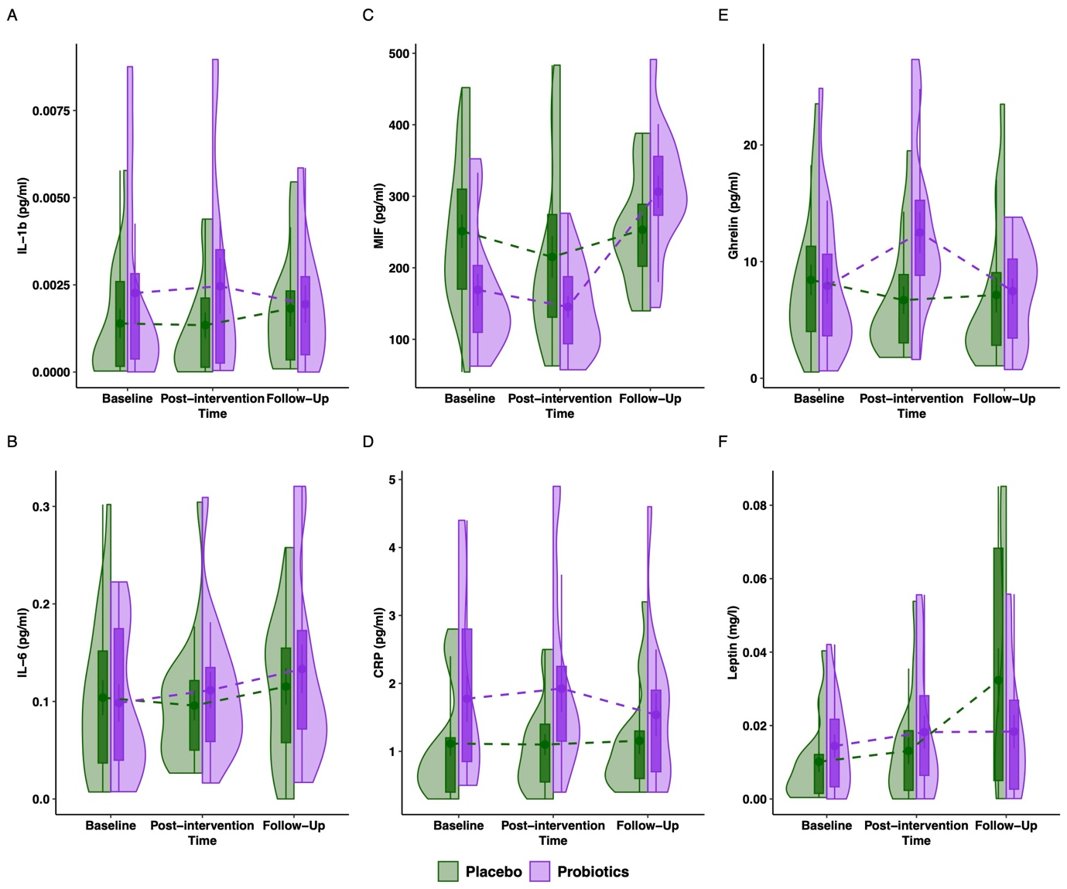
sFigure 2. Blood concentration levels of blood measures in the probiotics and placebo groups from baseline to post-intervention (week 4) and follow-up assessment (week 8). Concentration levels are presented as boxplots of Median [IQR].

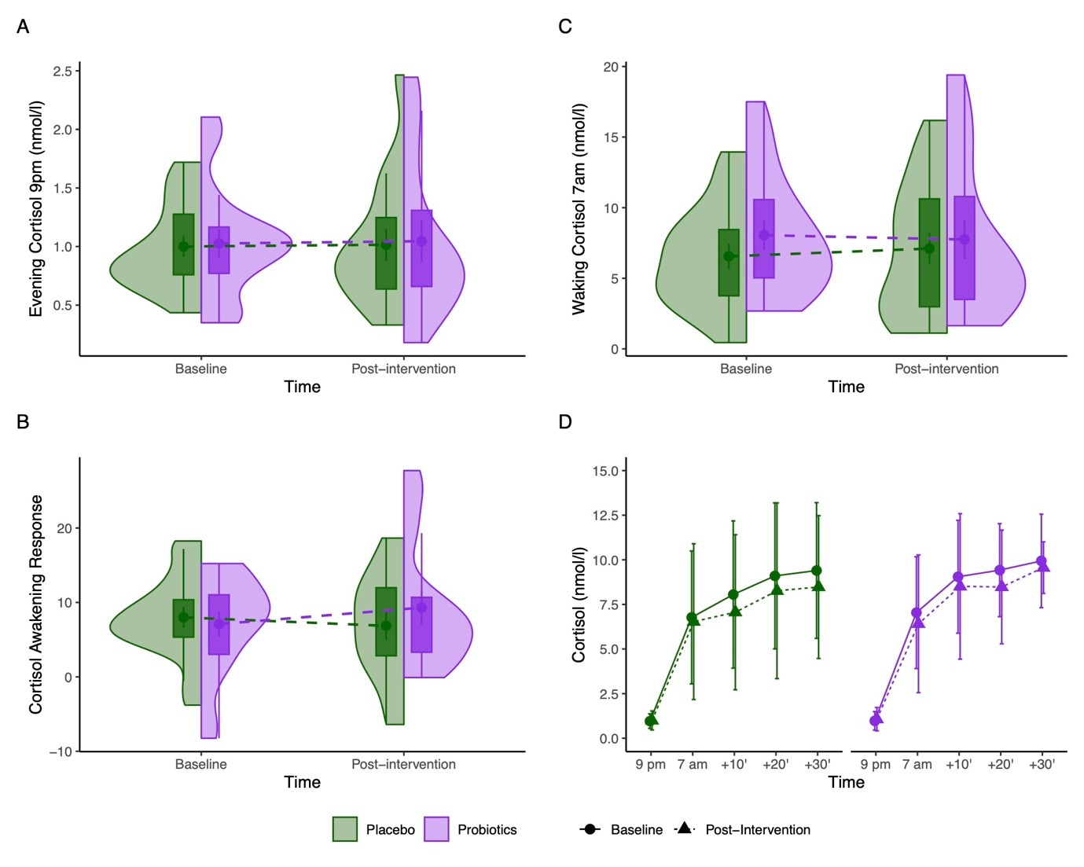
sFigure 3. Saliva-based cortisol measures in the probiotics and placebo groups from baseline to post-intervention (week 4). Cortisol concentration in A and C are presented as boxplots of Median [IQR]. The cortisol awakening response (AUC_{i}) in B is presented as boxplots of Median [IQR]. Cortisol concentrations in D are presented as M (SE).
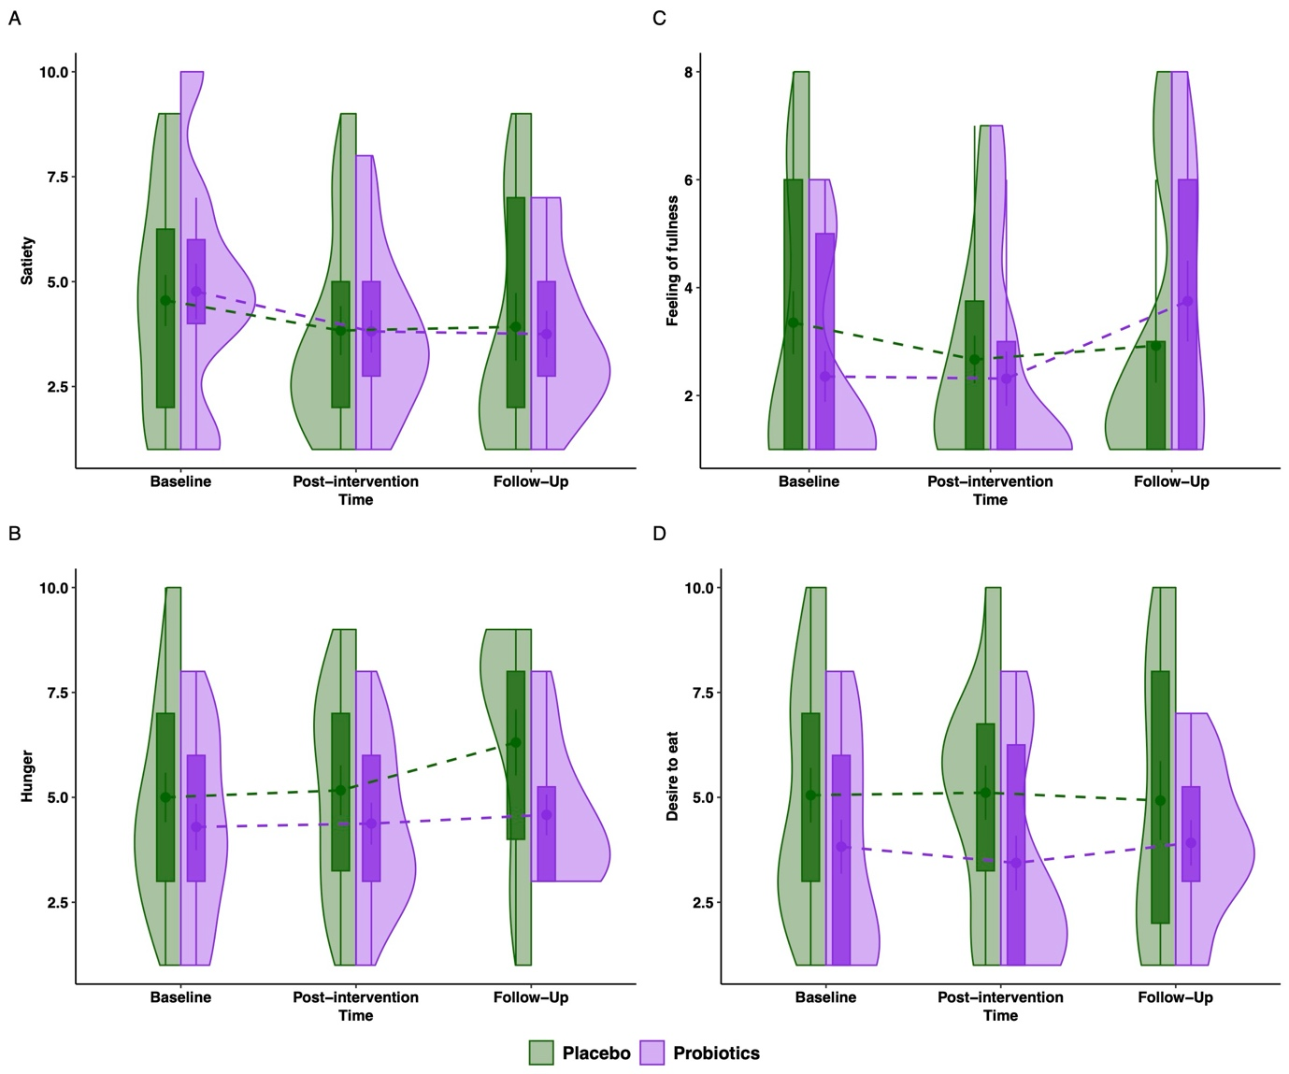
sFigure 4. Subjective appetite ratings in the probiotics and placebo groups from baseline to post-intervention (week 4) and follow-up assessment (week 8). Appetite scores are presented as boxplots of Median [IQR], and anchored by the descriptions “not at all” = 0, “extremely” = 10.

Supplementary References

1. World Health Organization. WHO Collaborating Centre for Drug Statistics Methodology: ATC classification index with DDDs, 2020. Preprint at (2019).

