 | Fresh Street Bradford  Phone: 01274435387  hello@mylivingwell.co.uk

17.03.2022

Hi,

Here are this week’s vouchers. This week’s recipe is great for batch-cooking, eat some now and use food containers to freeze the rest!

See over for this week’s recipe: Winter Vegetable Soup

You can spend your vouchers with any of these fruit and veg sellers:
Solly’s Fruit and Veg Market Stall (Oastler Shopping Centre, John St, BD1 3SR). Open: Monday to Saturday, 8am-6pm

Sandale Community Hub and Shop (42-46 Reevy Road West, BD6 3LX)
Open: Mon, Tues & Thurs, 8am to 3pm; Wed - 9am to 2pm; Sun - 10am to 2pm.

Mobile Fruit and Veg Van. Look out for Ash Hussain's van on Sundays at these times. Roy Road at 11am, Denham Drive at 12pm and Brafferton Arbour at 1pm. Ash will beep his horn to let you know he has arrived.
Remember: The more fruit and veg we eat (especially veg), the healthier we are and the longer we live. Five portions of fresh fruit and veg a day is good (but seven is even better!).

Best wishes

Jo, Michael, Jayne and Megan
The Living Well service team in partnership with Fresh Street

For more information see www.freshstreet.uk or contact Fresh Street Bradford.

Winter Vegetable Soup

Ingredients  200g red lentils  2 carrots  3 sticks celery  2 leeks  Tomato puree  4 garlic cloves  1 vegetable stock cube  Dried parsley and coriander  Seasonings (e.g., salt, pepper, chilli) | 
Servings: 4

To Make

Wash, cut and prepare all vegetables.
Tip all ingredients in large pan, pour over boiling water, then stir well.
Cover and leave to simmer for 30 minutes until vegetables and lentils are tender.
Pour into bowl to eat straightaway, or mash or blend one third if you like your soup to be ‘thick’.

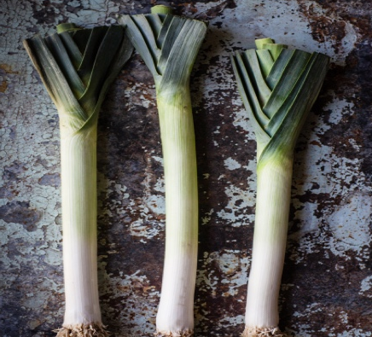
Serve with toasted bread of your choice.

Did you know…Leeks are rich in antioxidants and Vitamin K and will increase the strength of your immune and nervous system.


