Supplementary appendix

Table S1. The number of episodes obtained from the RedMIVA database for each province, year and AMR profile.

Variable | Group | Susceptible | 3GCRKp | MDR-3GCRKp | CRKp | MDR-CRKp | Total
Gender | Male | 42,093 (69.6%) | 4,950 (8.2%) | 11,748 (19.4%) | 255 (0.4%) | 1,405 (2.3%) | 60,451
 | Female | 57,877 (81.9%) | 4,033 (5.7%) | 7,913 (11.2%) | 149 (0.2%) | 736 (1.0%) | 70,708
Hospital status | Not addmited | 40,268 (84.3%) | 2,611 (5.5%) | 4,611 (9.7%) | 41 (0.1%) | 235 (0.5%) | 47,766
 | Addmited | 59,702 (71.6%) | 6,372 (7.6%) | 15,050 (18.0%) | 363 (0.4%) | 1,906 (2.3%) | 83,393
Province | ALC | 37,252 (78.7%) | 2,979 (6.3%) | 6,117 (12.9%) | 96 (0.2%) | 901 (1.9%) | 47,345
 | CAS | 8,654 (77.5%) | 640 (5.7%) | 1,793 (16.1%) | 17 (0.2%) | 64 (0.6%) | 11,168
 | VLC | 54,063 (74.4%) | 5,364 (7.4%) | 11,751 (16.2%) | 291 (0.4%) | 1,176 (1.6%) | 72,645
Submission year | 2010 | 4,169 (87.7%) | 151 (3.2%) | 402 (8.5%) | 5 (0.1%) | 27 (0.6%) | 4,754
 | 2011 | 5,165 (89.2%) | 212 (3.7%) | 399 (6.9%) | 2 (0.0%) | 12 (0.2%) | 5,79
 | 2012 | 5,744 (87.7%) | 290 (4.4%) | 493 (7.5%) | 9 (0.1%) | 12 (0.2%) | 6,548
 | 2013 | 5,782 (84.3%) | 382 (5.6%) | 656 (9.6%) | 8 (0.1%) | 30 (0.4%) | 6,858
 | 2014 | 6,689 (78.8%) | 505 (6.0%) | 1,197 (14.1%) | 27 (0.3%) | 66 (0.8%) | 8,484
 | 2015 | 7,735 (77.7%) | 648 (6.5%) | 1,419 (14.3%) | 11 (0.1%) | 143 (1.4%) | 9,956
 | 2016 | 7,853 (75.5%) | 641 (6.2%) | 1,596 (15.3%) | 39 (0.4%) | 270 (2.6%) | 10,399
 | 2017 | 8,139 (72.5%) | 744 (6.6%) | 2,077 (18.5%) | 47 (0.4%) | 218 (1.9%) | 11,225
 | 2018 | 8,565 (69.4%) | 973 (7.9%) | 2,488 (20.2%) | 54 (0.4%) | 255 (2.1%) | 12,335
 | 2019 | 9,502 (73.4%) | 1,060 (8.2%) | 2,139 (16.5%) | 41 (0.3%) | 202 (1.6%) | 12,944
 | 2020 | 8,613 (72.9%) | 1,011 (8.6%) | 1,948 (16.5%) | 32 (0.3%) | 204 (1.7%) | 11,808
 | 2021 | 10,217 (73.6%) | 1,000 (7.2%) | 2,294 (16.5%) | 55 (0.4%) | 323 (2.3%) | 13,889
 | 2022 | 11,797 (73.0%) | 1,366 (8.4%) | 2,553 (15.8%) | 74 (0.5%) | 379 (2.3%) | 16,169
Total |  | 99,970 (76.2%) | 8,983 (6.8%) | 19,661 (15.0%) | 404 (0.3%) | 2,141 (1.6%) | 131,159

Table S2. Odds ratios (OR) for the proportion of antimicrobial resistant episodes for each age group compared to the age group [0,10].

Age group | OR | 95% CI | p-value
(10, 20] | 2.55 | 1.96 - 3.29 | < 0.001
(20, 30] | 3.64 | 2.97 - 4.46 | < 0.001
(30, 40] | 4.93 | 4.16 - 5.87 | < 0.001
(40, 50] | 5.47 | 4.69 - 6.42 | < 0.001
(50, 60] | 5.61 | 4.84 - 6.53 | < 0.001
(60, 70] | 6.06 | 5.24 - 7.04 | < 0.001
(70, 80] | 6.15 | 5.32 - 7.14 | < 0.001
(80, 90] | 6.58 | 5.69 - 7.66 | < 0.001
(90, 100] | 7.62 | 6.36 - 9.15 | < 0.001
(100, 110] | 2.15 | 0.22 - 7.97 | 0.317

Table S3. Number of episodes obtained from the RedMIVA database for each hospital.

Hospital code | beds | Province | Susceptible | 3GCRKp | MDR-3GCRKp | CRKp | MDR-CRKp | Total
H1 | >= 400 beds | VLC | 7,681 (80.5%) | 540 (5.7%) | 1,182 (12.4%) | 16 (0.2%) | 117 (1.2%) | 9,536
H2 | >= 400 beds | VLC | 13,355 (85.5%) | 632 (4.0%) | 1,340 (8.6%) | 65 (0.4%) | 236 (1.5%) | 15,628
H3 | >= 400 beds | VLC | 6,060 (53.0%) | 1,466 (12.8%) | 3,408 (29.8%) | 91 (0.8%) | 416 (3.6%) | 11,441
H4 | >= 400 beds | VLC | 6,720 (80.1%) | 653 (7.8%) | 941 (11.2%) | 27 (0.3%) | 53 (0.6%) | 8,394
H5 | < 400 beds | ALC | 804 (54.7%) | 160 (10.9%) | 440 (29.9%) | 15 (1.0%) | 51 (3.5%) | 1,47
H6 | < 400 beds | ALC | 2,704 (79.9%) | 253 (7.5%) | 405 (12.0%) | 5 (0.1%) | 18 (0.5%) | 3,385
H7 | < 400 beds | VLC | 4,821 (69.4%) | 479 (6.9%) | 1,598 (23.0%) | 20 (0.3%) | 30 (0.4%) | 6,948
H8 | < 400 beds | ALC | 2,174 (80.5%) | 172 (6.4%) | 346 (12.8%) | 2 (0.1%) | 7 (0.3%) | 2,701
H9 | >= 400 beds | ALC | 8,631 (77.2%) | 717 (6.4%) | 1,511 (13.5%) | 14 (0.1%) | 304 (2.7%) | 11,177
H10 | < 400 beds | CAS | 266 (41.3%) | 48 (7.5%) | 298 (46.3%) | 8 (1.2%) | 24 (3.7%) | 644
H11 | < 400 beds | VLC | 2,747 (63.2%) | 438 (10.1%) | 1,003 (23.1%) | 24 (0.6%) | 133 (3.1%) | 4,345
H12 | < 400 beds | VLC | 3,523 (80.6%) | 277 (6.3%) | 547 (12.5%) | 5 (0.1%) | 18 (0.4%) | 4,37
H13 | < 400 beds | VLC | 2,991 (78.1%) | 277 (7.2%) | 503 (13.1%) | 6 (0.2%) | 51 (1.3%) | 3,828
H14 | >= 400 beds | CAS | 4,111 (74.9%) | 313 (5.7%) | 1,028 (18.7%) | 6 (0.1%) | 28 (0.5%) | 5,486
H15 | < 400 beds | VLC | 2,017 (70.7%) | 222 (7.8%) | 558 (19.6%) | 8 (0.3%) | 46 (1.6%) | 2,851
H16 | < 400 beds | ALC | 1,436 (84.4%) | 75 (4.4%) | 185 (10.9%) | 0 (0.0%) | 6 (0.4%) | 1,702
H17 | < 400 beds | VLC | 867 (71.4%) | 117 (9.6%) | 204 (16.8%) | 8 (0.7%) | 19 (1.6%) | 1,215
H18 | < 400 beds | ALC | 6,571 (81.8%) | 416 (5.2%) | 662 (8.2%) | 26 (0.3%) | 358 (4.5%) | 8,033
H19 | < 400 beds | ALC | 3,769 (91.1%) | 190 (4.6%) | 154 (3.7%) | 6 (0.1%) | 18 (0.4%) | 4,137
H20 | >= 400 beds | ALC | 3,499 (75.2%) | 353 (7.6%) | 744 (16.0%) | 9 (0.2%) | 49 (1.1%) | 4,654
H21 | < 400 beds | ALC | 404 (37.2%) | 152 (14.0%) | 492 (45.3%) | 6 (0.6%) | 31 (2.9%) | 1,085
H22 | < 400 beds | ALC | 1,954 (85.0%) | 84 (3.7%) | 250 (10.9%) | 5 (0.2%) | 7 (0.3%) | 2,3
H23 | >= 400 beds | ALC | 2,602 (79.6%) | 178 (5.4%) | 441 (13.5%) | 4 (0.1%) | 42 (1.3%) | 3,267
H24 | < 400 beds | VLC | 303 (48.5%) | 93 (14.9%) | 182 (29.1%) | 16 (2.6%) | 31 (5.0%) | 625
H25 | < 400 beds | CAS | 1,950 (85.3%) | 143 (6.3%) | 187 (8.2%) | 1 (0.0%) | 6 (0.3%) | 2,287
H26 | < 400 beds | CAS | 731 (80.4%) | 39 (4.3%) | 134 (14.7%) | 0 (0.0%) | 5 (0.6%) | 909
H27 | < 400 beds | VLC | 523 (99.4%) | 2 (0.4%) | 1 (0.2%) | 0 (0.0%) | 0 (0.0%) | 526
H28 | < 400 beds | VLC | 2,004 (83.3%) | 132 (5.5%) | 247 (10.3%) | 5 (0.2%) | 19 (0.8%) | 2,407
H29 | < 400 beds | VLC | 420 (95.5%) | 10 (2.3%) | 10 (2.3%) | 0 (0.0%) | 0 (0.0%) | 440
H30 | < 400 beds | ALC | 2,704 (78.7%) | 229 (6.7%) | 487 (14.2%) | 4 (0.1%) | 10 (0.3%) | 3,434
H31 | < 400 beds | CAS | 1,596 (86.6%) | 97 (5.3%) | 146 (7.9%) | 2 (0.1%) | 1 (0.1%) | 1,842
H32 | < 400 beds | VLC | 20 (87.0%) | 1 (4.3%) | 2 (8.7%) | 0 (0.0%) | 0 (0.0%) | 23
H33 | < 400 beds | VLC | 11 (16.2%) | 25 (36.8%) | 25 (36.8%) | 0 (0.0%) | 7 (10.3%) | 68

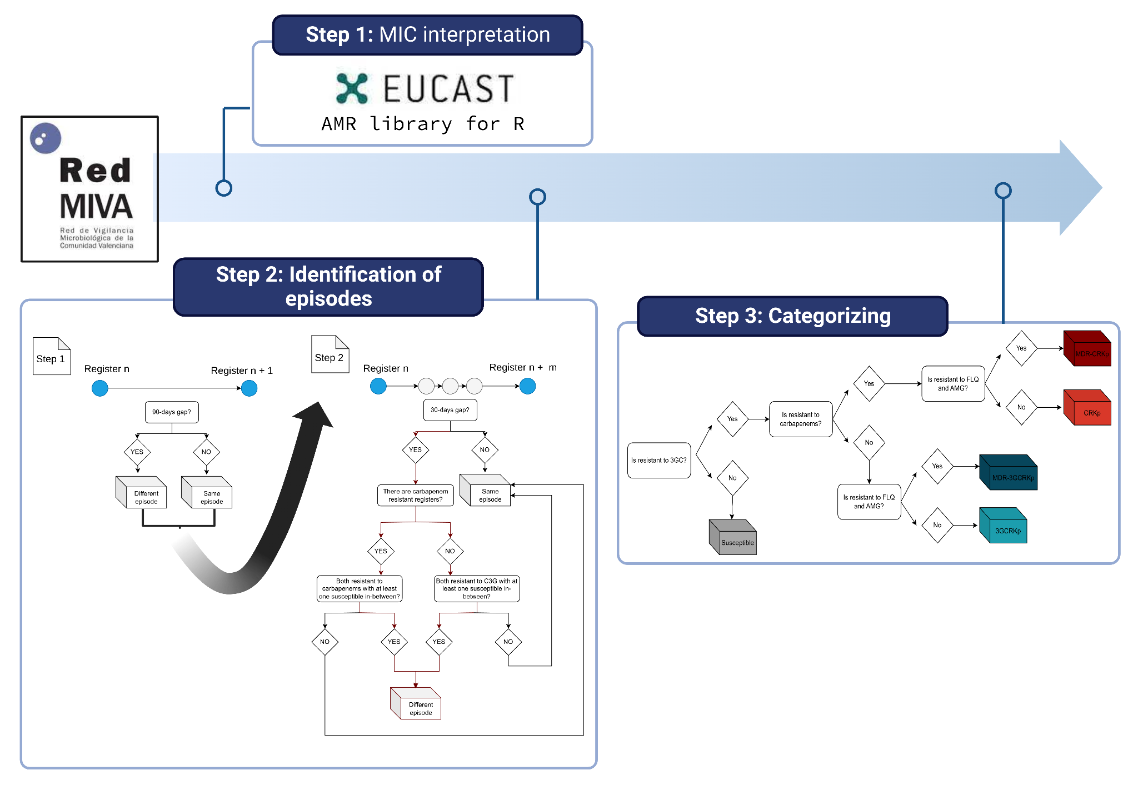

Figure S1. Scheme for the algorithm used to curate the data fetched from the RedMIVA database.

