Supplement: Figures
Figure S.1.
Need to communicate predicted by Extraversion, RR_{LOS,} and Agreeableness
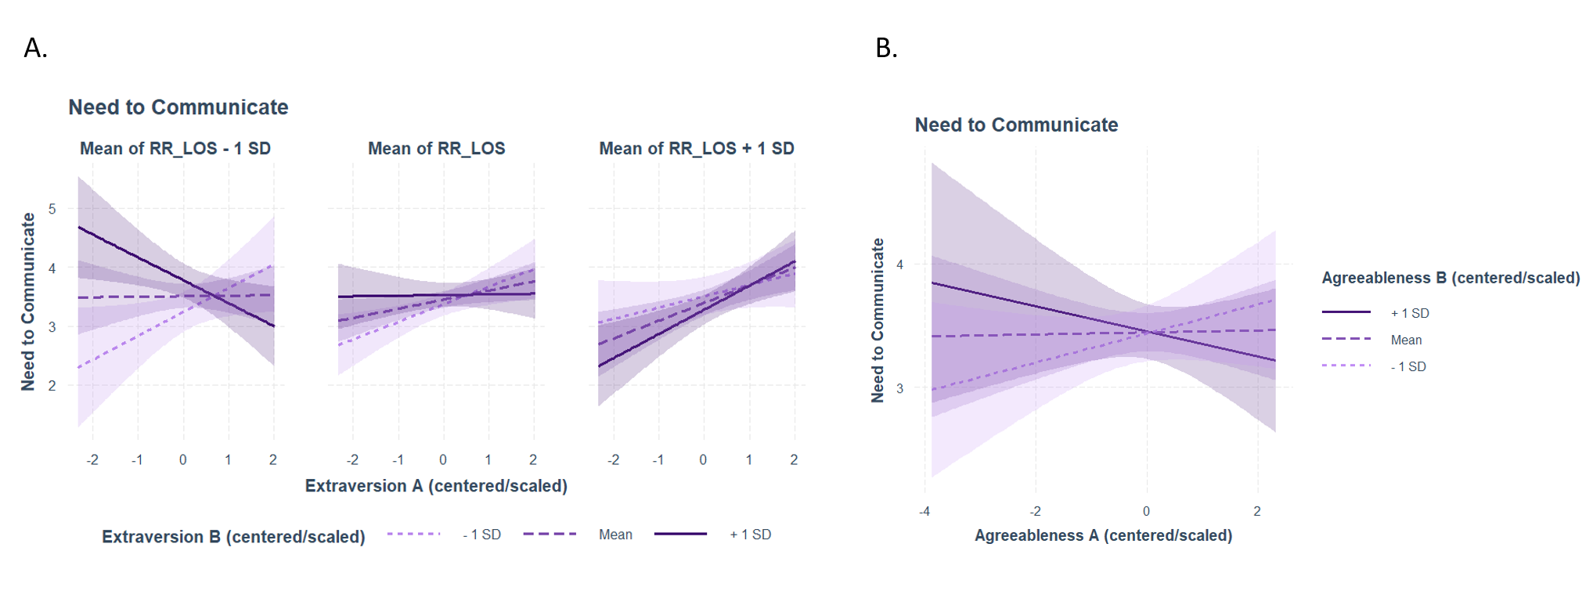
Note: Panel A shows the effects of the Extraversion scores of both conversation partners and RR_{LOS} (-1SD, mean, and +1SD) on the reported need to communicate (y-axis) (Table S1, Model 1). Panel B shows the effects of the Agreeableness scores of both conversation partners on the reported need to communicate (y-axis) (Table S4, Model 1).

Figure S.2.
Use of the partner’s behavior as a guide predicted by Extraversion, LAM_{ard,} and Agreeableness
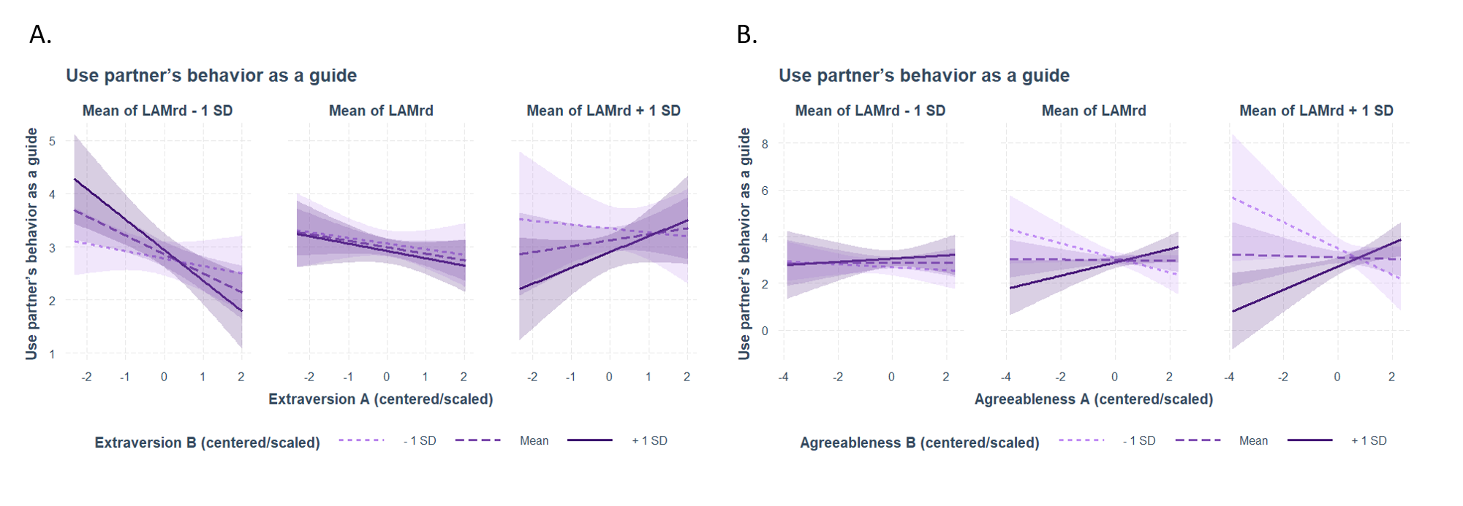
Note: Panel A shows the effects of the Extraversion scores of both conversation partners and LAM_{ard} (-1SD, mean, and +1SD) on the reported use of the partner’s behavior as a guide (y-axis) (Table S2, Model 2). Panel B shows the effects of the Agreeableness scores of both conversation partners and LAM_{ard} (-1SD, mean, and +1SD) on the reported use of the partner’s behavior as a guide (y-axis) (Table S5, Model 2).

Figure S.3.
Attempt to lead the conversation predicted by Agreeableness and Q_{DCRP}
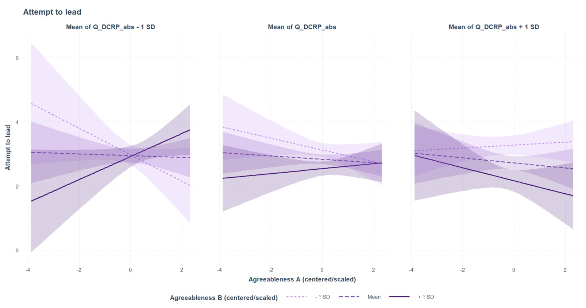
Note: The figure shows the effects of the Agreeableness scores of both conversation partners and Q_{DCRP} (-1SD, mean, and +1SD) on the reported attempt to lead the conversation (y-axis) (Table S6, Model 3).

Figure S.4.
Interaction perceived as smooth/natural/relaxed predicted by Agreeableness and RR_{LOS,} and the reported Desire to interact in the future predicted by Extraversion
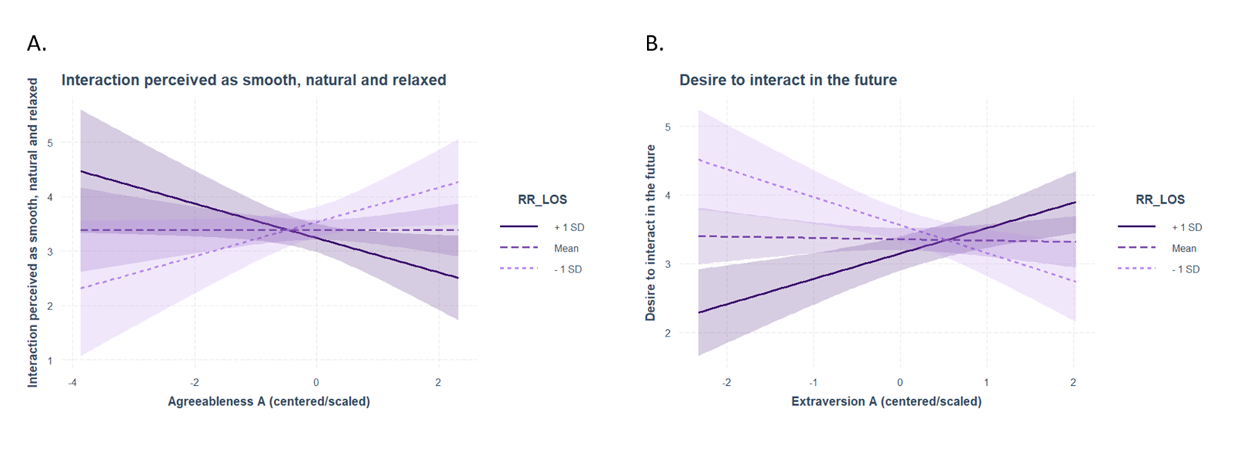
Note: Panel A shows the effects of the Agreeableness of one conversation partner and RR_{LOS} (-1SD, mean, and +1SD) on the reported interaction perceived as smooth/natural/relaxed (y-axis) (Table S4, Model 6). Panel B shows the effects of the Extraversion scores of one conversation partner and RR_{LOS} (-1SD, mean, and +1SD) on the reported desire to interact in the future (y-axis) (Table S1, Model 10).

Figure S.5.
Enjoyment of the interaction predicted by Extraversion, RR_{LOS}, LAM_{ard,} and Q_{DCRP}
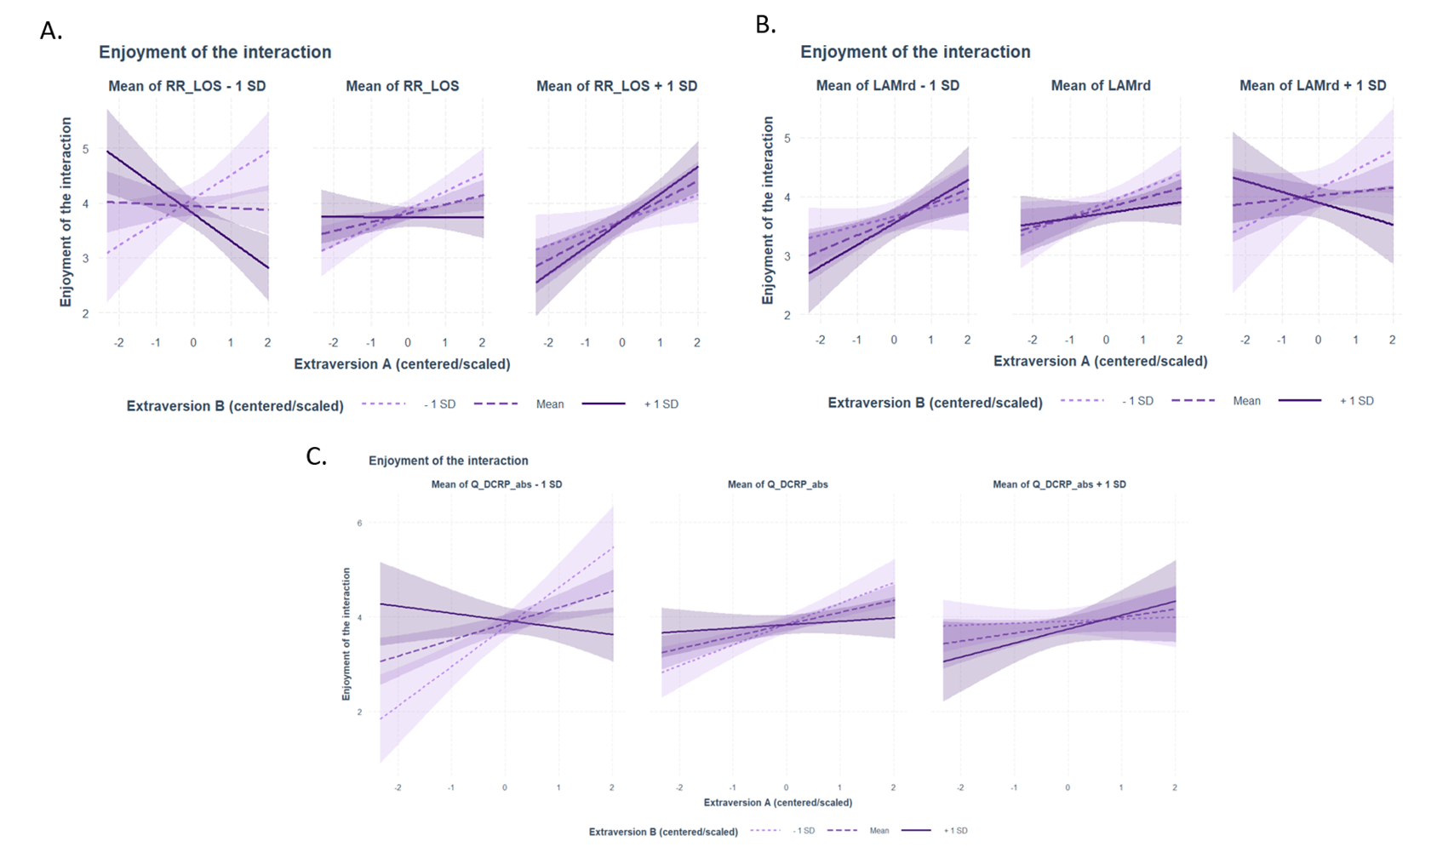
Note: Panel A shows the effects of the Extraversion scores of both conversation partners and RR_{LOS} (-1SD, mean, and +1SD) on the enjoyment of the interaction (y-axis) (Table S1, Model 11). Panel B shows the effects of the Extraversion scores of both conversation partners and LAM_{ARD} (-1SD, mean, and +1SD) on the enjoyment of the interaction (y-axis) (Table S2, Model 11). Panel C shows the effects of the Extraversion scores of both conversation partners and Q_{DCRP} (-1SD, mean, and +1SD) on the enjoyment of the interaction (y-axis) (Table S3, Model 11).

Figure S.6.
Liked the other person predicted by Extraversion and RR_{LOS}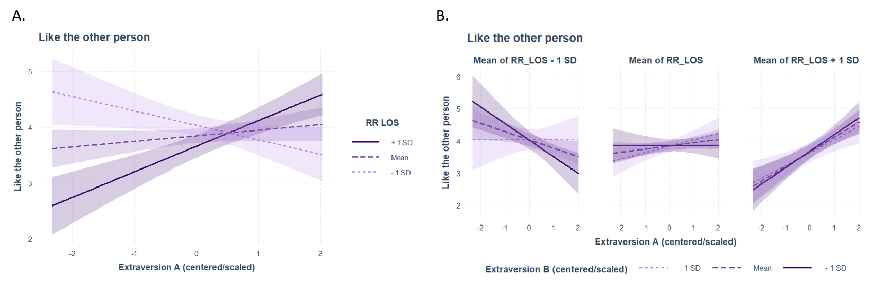
Note: Panel A shows the effects of the Extraversion scores of one conversation partner and RR_{LOS} (-1SD, mean, and +1SD) on the reported liking of the other person (y-axis) (Table S1, Model 14). Panel B shows the effects of the Extraversion scores of both conversation partners and RR_{LOS} (-1SD, mean, and +1SD) on the reported liking of the other person (y-axis) (Table S1, Model 14).

Figure S.7.
Perceived partner as empathic and understanding predicted by Extraversion and LAM_{ARD}
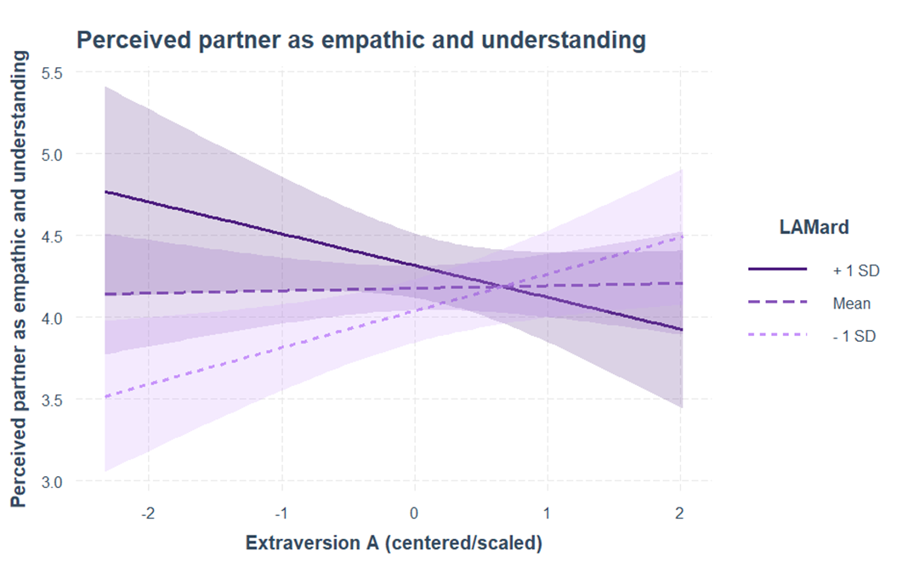
Note: The figure shows the effects of the Extraversion scores of one conversation partner and LAM_{ard} (-1SD, mean, and +1SD) on the reported perception of the partner as empathic and understanding (y-axis) (Table S2, Model 15).

