Table 1

Key ideas of the circular approximation to trigonometry.
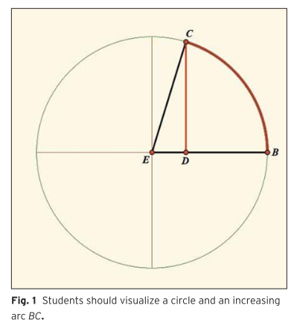 | 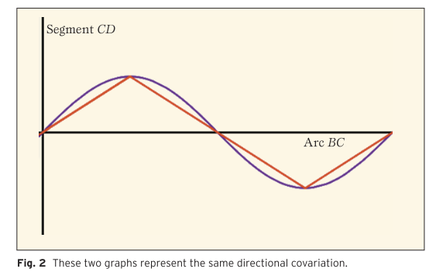
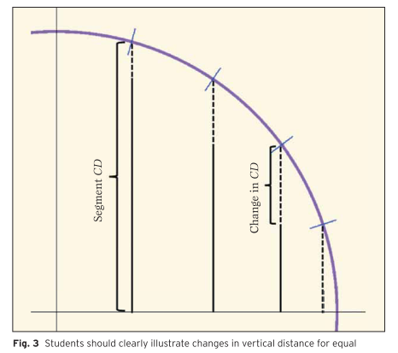 | 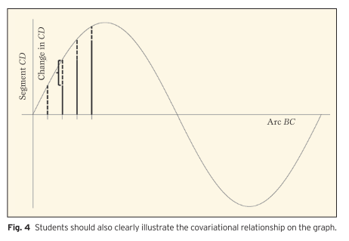
Source: Moore and LaForest (2014)

Table 2

Dynamic Ferris wheel computer environment.
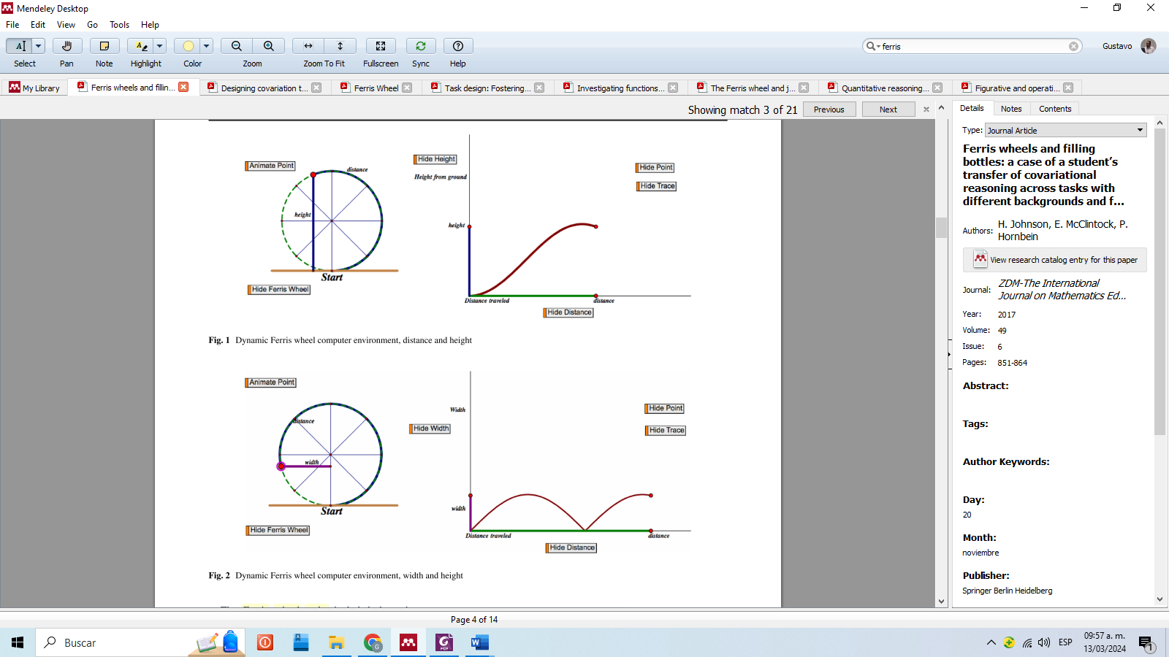
Source: Johnson (2015a)

Table 6. GeoGebra Applets
Applet 1  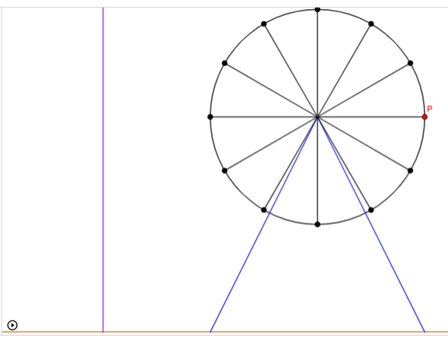  https://www.geogebra.org/m/spkdgrma | Applet 2  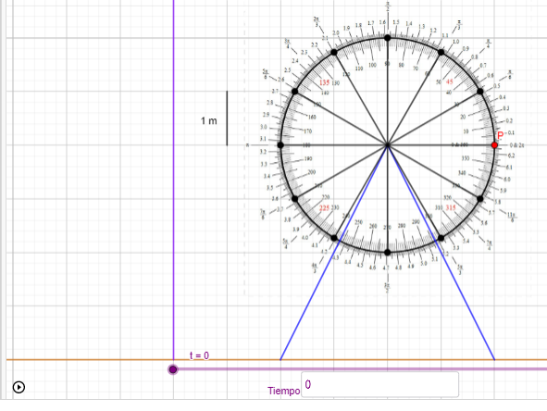  https://www.geogebra.org/m/vm5pqc9b
Applet 3  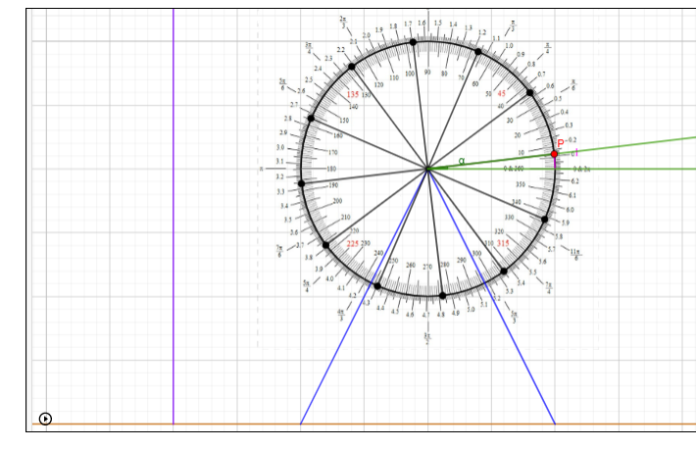  https://www.geogebra.org/m/vfdgptvq | Applet 4  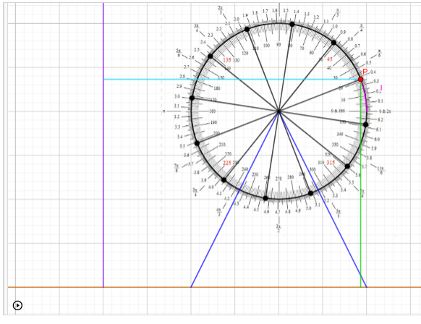  https://www.geogebra.org/m/xdeqh3tk
Applet 5  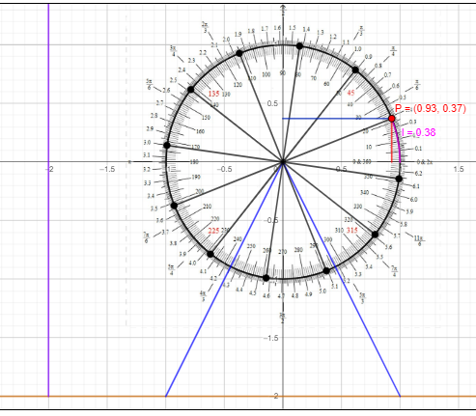  https://www.geogebra.org/m/sjp8sqfw | Applet 6  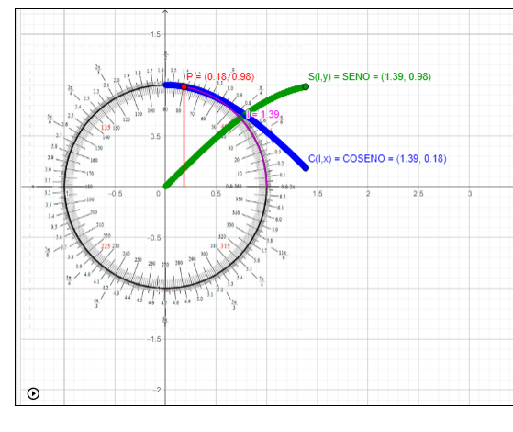  https://www.geogebra.org/m/zqrgsgtm

Table 7. Hypothetical learning trajectory
Hypothetical learning process | Task design | Task learning hypothesis
Step 1: Students should develop, at minimum, the level of gross coordination of values covariational reasoning, with some covariant relationships in circular motion. | Task 1. Designed for students to identify quantities, variables, and functions using Applet 1, and to create graphs of the identified functions. | Hypothesis 1. The visualization and manipulation of the simulation of the movement of a Ferris wheel in GeoGebra Applet 1 enhances the perception of some changing qualities, quantities, variables, and covariant relationships present in the simulation.
Step 2: Students should develop, at minimum, the level of coordination of values covariational reasoning, with some covariant relationships in circular motion. | Task 2. Designed for students to construct graphs of covariant relationships using Applet 2, which incorporates measuring instruments for distances, time, and angles in degrees and radians. | Hypothesis 2. The visualization and manipulation of the simulation of a Ferris wheel’s movement in GeoGebra Applet 2 that incorporates measuring instruments fosters the construction of a system of covariant relationships and the anticipation of creating a discrete collection of ordered pairs (x, y).  The above with two or more of the following variables: the height at which the passenger is located, the distance of the passenger from the building, the distance traveled by the passenger, the rotation angles of the passenger, and the elapsed time.
Step 3. Students should conceive angle measurements in radians as arc lengths on a unit circle and develop, at minimum, the level of coordination of values covariational reasoning with angles and arc lengths in radians. | Task 3. Designed for students to construct a table of values with angles and arc lengths, and to identify how these variables are related. This is achieved through interaction with Applet 3, which incorporates geometric constructions to represent angles and arcs. | Hypothesis 3. The visualization and manipulation of the simulation of a Ferris wheel’s movement in GeoGebra Applet 3, which includes a protractor in degrees and radians, facilitates the quantification of angles and arc lengths, and the identification of covariant relationships between these variables.
Step 4. Students should develop, at minimum, the level of chunky continuous covariational reasoning with the variables: (1) arc length vs. height, and (2) arc length vs. distance to the building. | Task 4. Designed for students to construct the graphs of the functions: (1) passenger height as a function of the arc length traveled by the passenger; and (2) distance from the building to the passenger as a function of the arc length traveled by the passenger. This is achieved through interaction with Applet 4. | Hypothesis 4. The visualization of the simulation of a Ferris wheel’s movement in GeoGebra Applet 4 that incorporates geometric constructions to represent arc lengths, heights reached by a passenger from the ground level, and their distances to a building promotes the perception of changes in the value of these variables in a continuous and simultaneous manner.
Step 5. Students should develop, at minimum, the level of chunky continuous covariational reasoning of the sine and cosine functions. | Task 5. Designed for students to construct and define the graphs of the functions: y-coordinate of P as a function of the arc length traveled by P; and x-coordinate of P as a function of the arc length traveled by P. This is achieved through interaction with Applet 5. | Hypothesis 5. The visualization of the simulation of a Ferris wheel’s movement in GeoGebra Applet 5 that incorporates geometric constructions to represent arc lengths, x-coordinates, and y-coordinates of a point P promotes the perception of changes in the value of these variables in a continuous and simultaneous manner.
Step 6. Students should develop the level of smooth continuous covariational reasoning of the sine and cosine functions. | Task 6. Designed for students to define the sine and cosine functions based on the information provided by Applet 6, which shows how the sketches of these functions' graphs are made as a point P moves along the unit circle. | Hypothesis 6. The visualization of the simulation of a Ferris wheel’s movement in GeoGebra Applet 6 that incorporates geometric constructions to represent arc lengths (l), x-coordinates (x), and y-coordinates (y) of a moving point $P(x,y)$, as well as the trace of a point $S(l,y)$ and a point $C\left(l,x\right)$, promotes the development of covariational conceptions of the sine and cosine functions

Source: Own creation

