Supplementary Figures

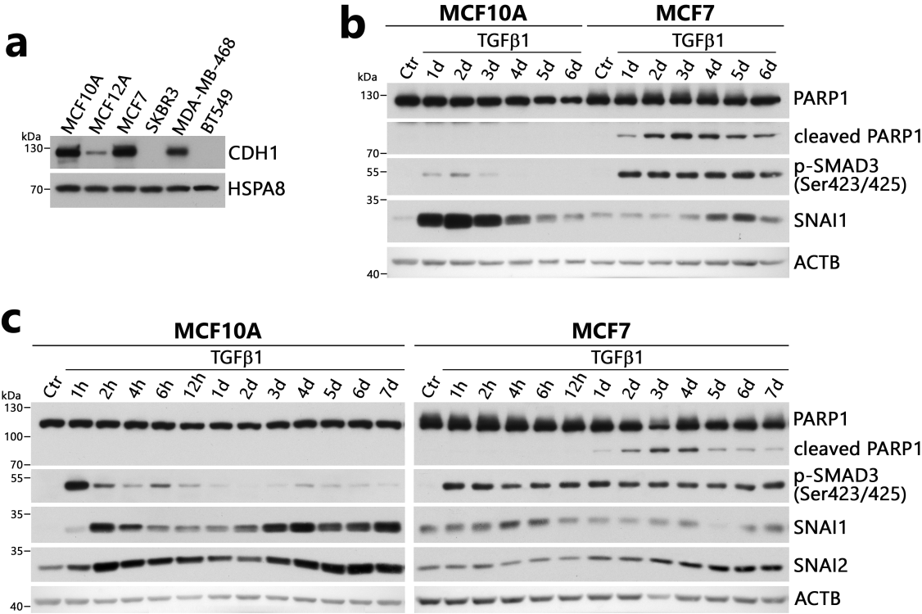
Figure S1. Response of breast epithelial cells to TGFβ1 treatment analyzed by Western blot. (a) Expression levels of the epithelial marker CDH1 in a panel of breast epithelium-derived cells. (b and c) Response of MCF10A and MCF7 cells to TGFβ1 treatment. Cells were treated with TGFβ1 (10nM) continuously for 6 or 7 days. Starting from day 1, half of the medium was replaced daily with fresh TGFβ1. The levels of indicated proteins were analyzed in total protein extracts (A) or nuclear extracts (B, C). HSPA8 or ACTB were used as loading controls.

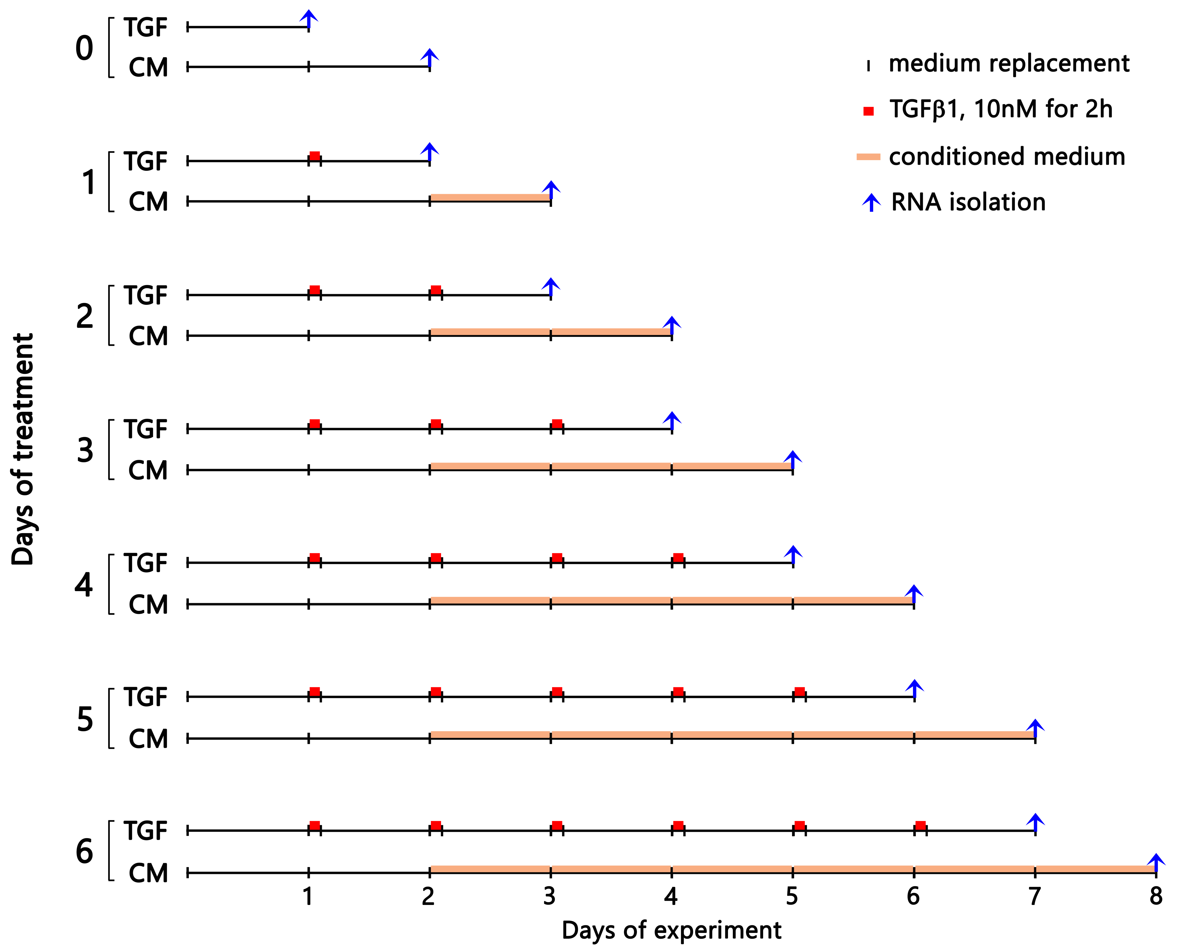
Figure S2. Scheme for treating and harvesting cells for RNA-seq analysis. Conditioned media from cells directly treated with TGFβ1 for 2 hours (TGF) were harvested daily 22 hours after replacing the media with fresh media and administrated to other cells (CM). The cells were seeded in an amount that allowed them to be harvested at 70-80% confluence.
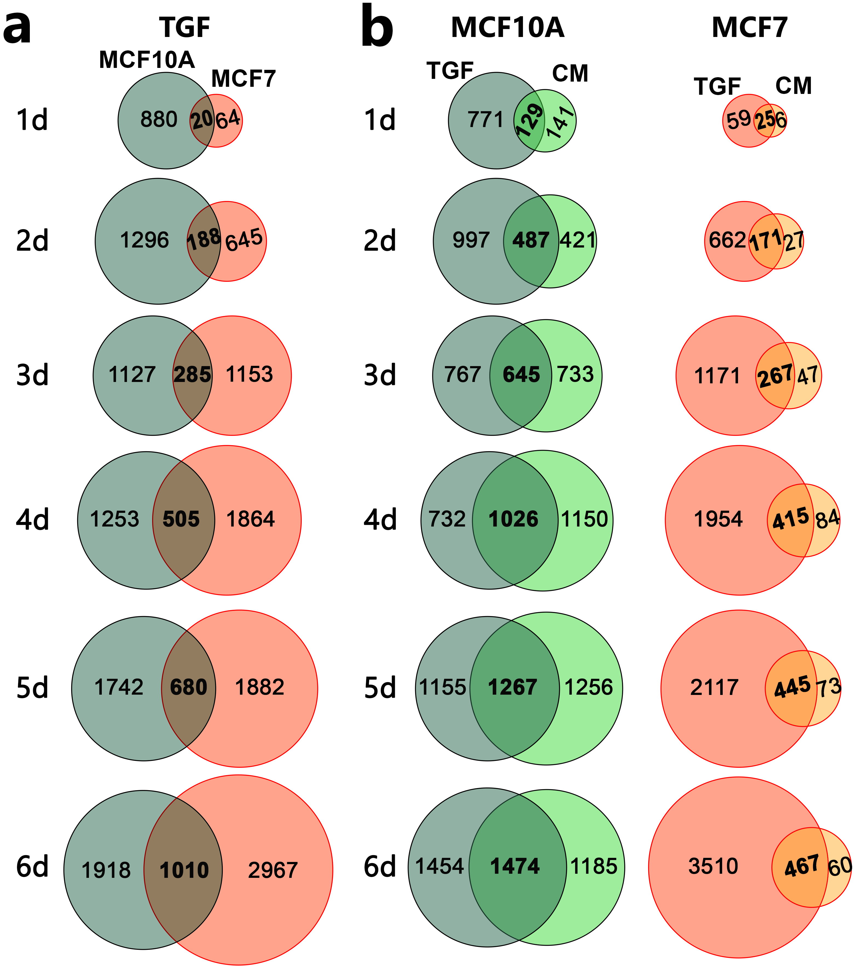
Figure S3. Comparison of global transcriptional changes (RNA-seq analyses) in MCF10A and MCF7 cells after direct TGFβ1 (TGF) or conditioned medium (CM) treatment. (a) Overlap of genes affected after TGFβ1 treatment in both cell lines. (b) Overlap of genes affected after TGFβ1 (TGF) or conditioned medium (CM) treatment. Cells were treated according to the scheme shown in Figure S2.

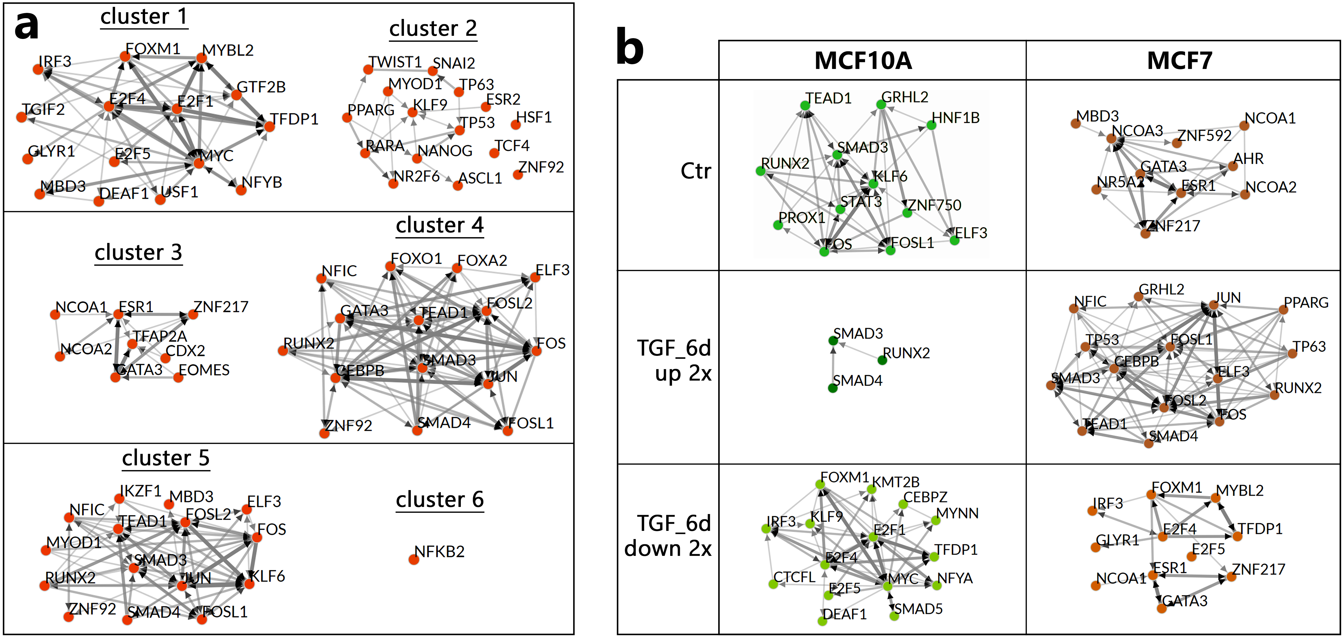
Figure S4. Networks of upstream regulators (predicted using the ChEA3_ReMap) of genes identified by RNA-seq analyses in TGFβ1-treated MCF10A and MCF7 cells. (a) Transcription factors associated with gene sets from clusters 1-6 shown in Figure 2C and Supplementary Data 2. (b) Transcription factors associated with genes differentiating untreated (Ctr) MCF10A and MCF7 cells (10-fold difference), stimulated (up 2x), or repressed (down 2x) on the sixth day of TGFβ1 stimulation (TGF_6d). FET p-value < 0.05; the top 15 factors are shown with.

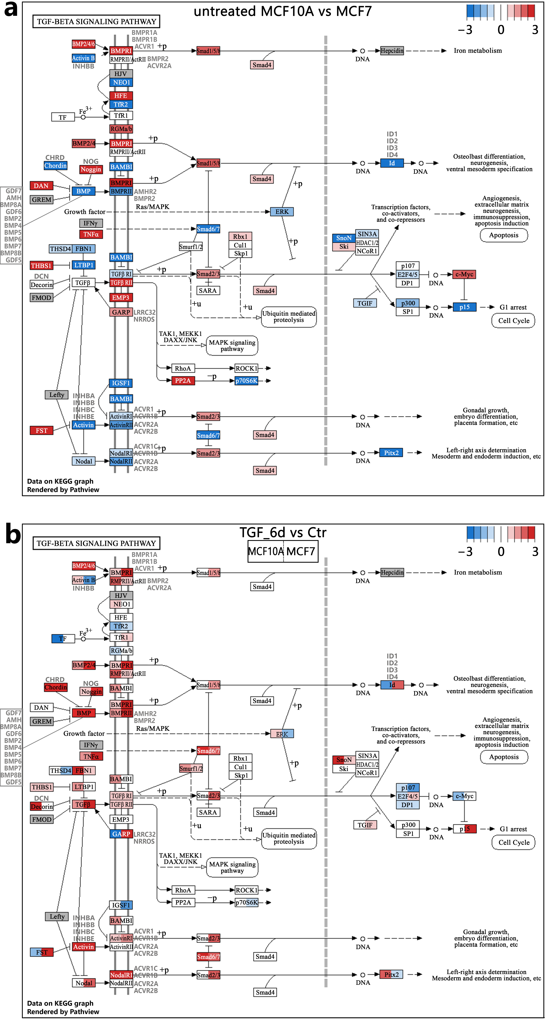
Figure S5. Comparison of the TGF-beta signaling pathway in MCF10A and MCF7 cells. (a) Comparison of the transcript levels in untreated cells. Bar scale legend is log2 fold change in MCF10A vs MCF7 (red means higher expression in MCF10A, blue – in MCF7). (b) Comparison of log2-fold changes on the sixth day of TGFβ1 stimulation in MCF10A (left part of each rectangle) and MCF7 (right part of each rectangle) cells. Gene expression data from the RNA-seq experiment were mapped to the TGF-beta signaling pathway in the KEGG database (ID: hsa04350; https://www.kegg.jp/pathway/hsa04350). Colors indicate gene up-regulation (red) and down-regulation (blue); grey indicates the missing data. The color scale was truncated to values within the range of -3 to 3. The regular map notation is available at https://www.kegg.jp/kegg/document/help_pathway.html.

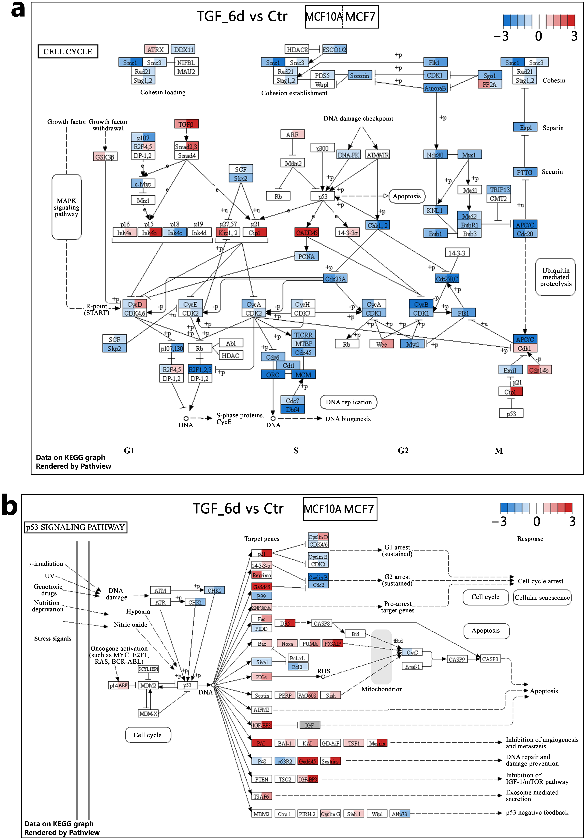
Figure S6. Changes in expression of genes related to the cell cycle network (a) and the p53 signaling pathway (b) on the sixth day of TGFβ1 stimulation in MCF10A (left part of each rectangle) and MCF7 (right part of each rectangle) cells. Log2-fold changes from the RNA-seq experiment were mapped to the KEGG pathways: Cell cycle (ID: hsa04110; https://www.kegg.jp/pathway/hsa04110) and p53 signaling pathway (ID: hsa04115; https://www.kegg.jp/pathway/hsa04115). Colors indicate gene upregulation (red) and downregulation (blue); grey indicates the missing data. The color scale was truncated to values within the range of -3 to 3. The regular map notation is available at https://www.kegg.jp/kegg/document/help_pathway.html.
Figure S7. Time trends in the expression of genes related to cell cycle progression in MCF10A and MCF7 cells. Examples of: (a) transcriptional regulators, (b) cyclins and inhibitor of cyclin-dependent kinase CDKN2C, (c) cell division cycle proteins, (d) cell division cycle associated proteins, (e) DNA polymerases, (f) proteins involved in chromosomal replication, and (g) proteins involved in DNA repair. Cells were treated according to the scheme shown in Figure S2. TGF, direct TGFβ1 treatment; CM, conditioned medium treatment. *** padj < 0.0001, ** padj < 0.001, * padj < 0.05 (significance of differences was marked for the entire run if the adjusted p-value vs Ctr reached a given value at least at one experimental point). Supplementary to Figure 4.

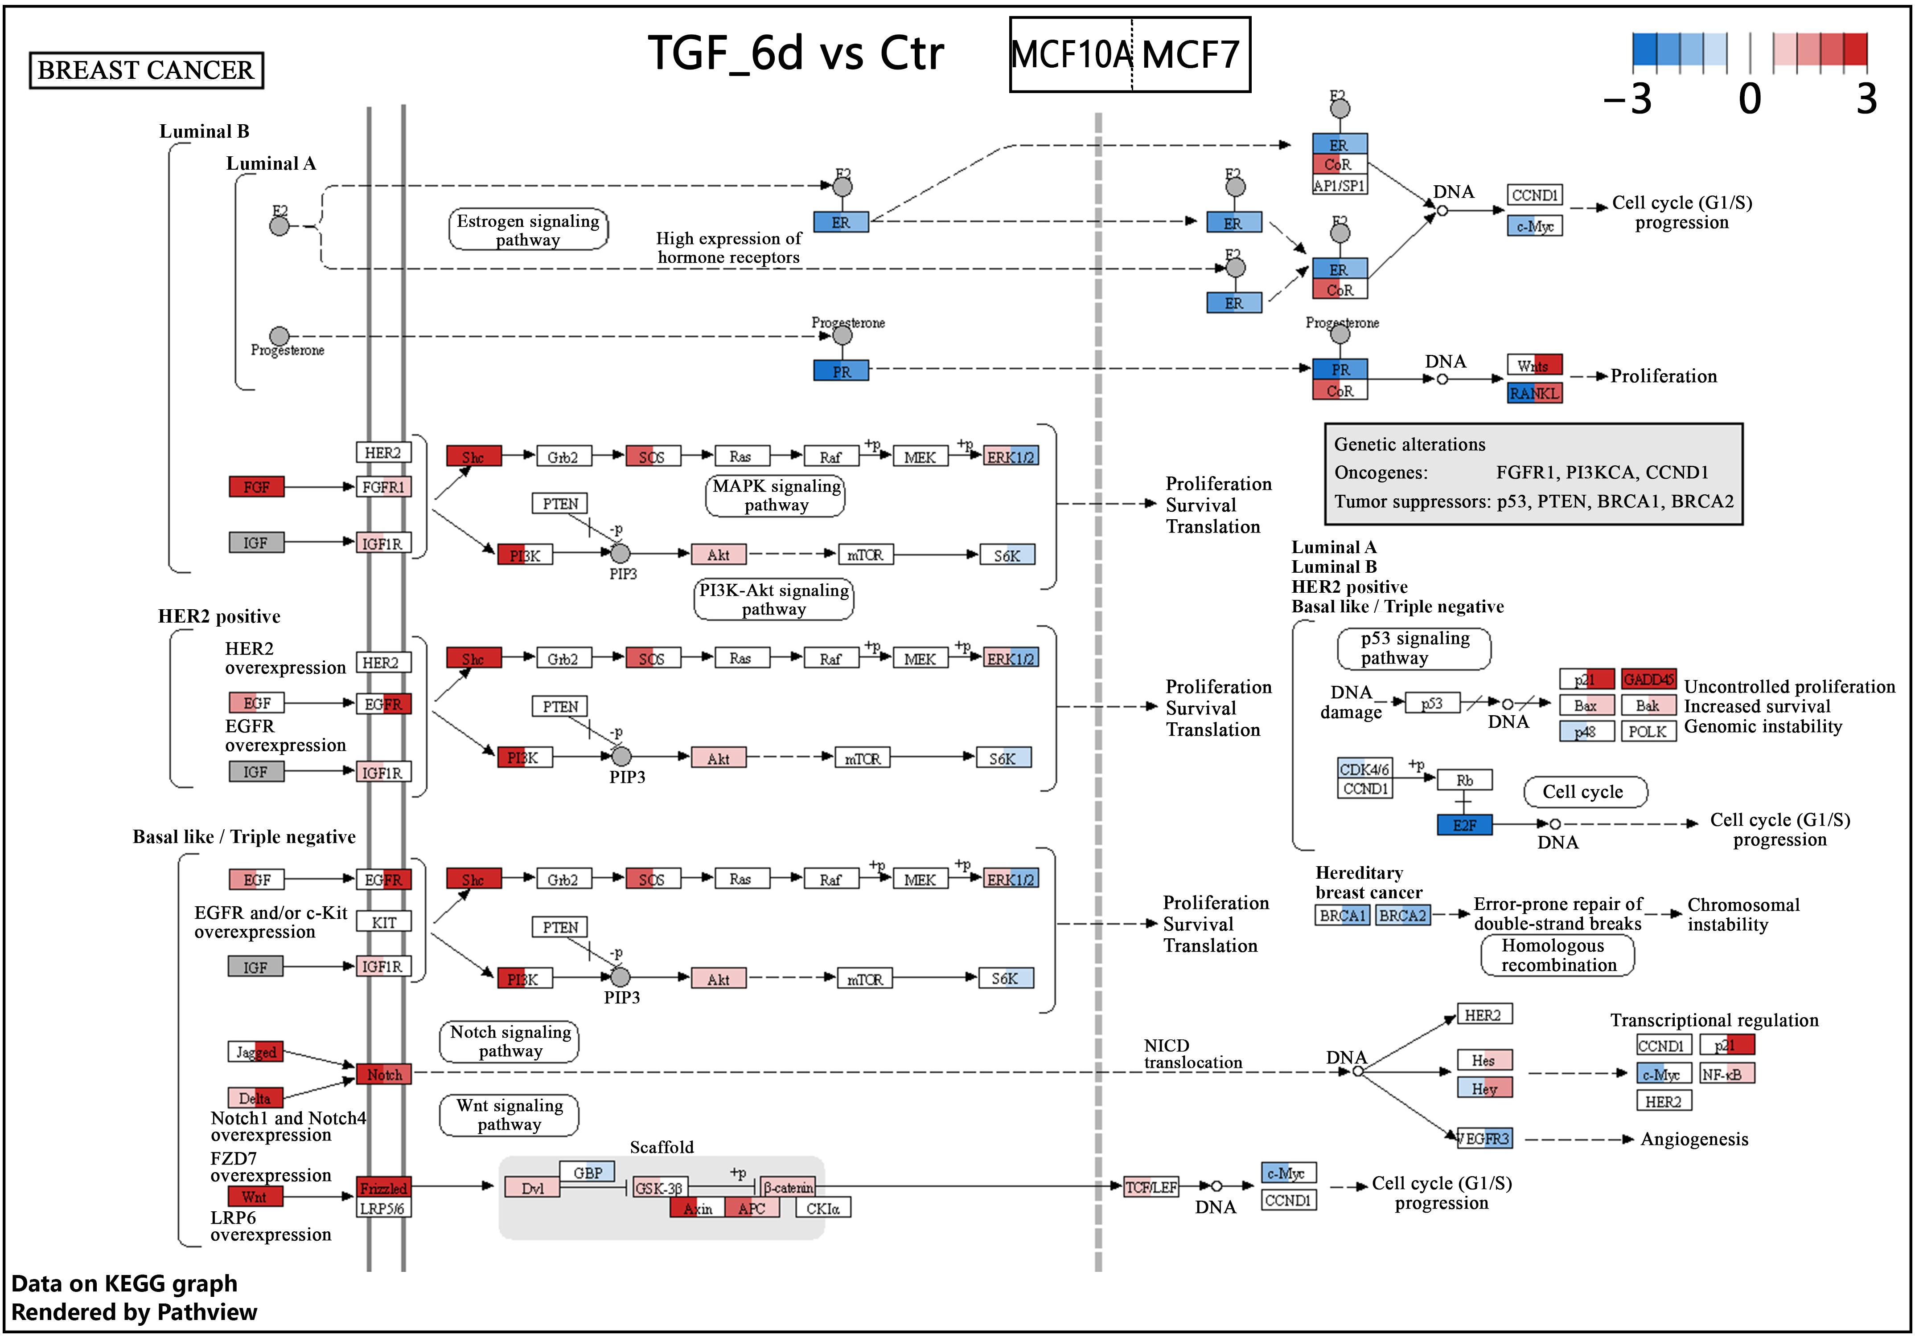
Figure S8. Changes in expression of genes related to the breast cancer network on the sixth day of TGFβ1 stimulation in MCF10A (left part of each rectangle) and MCF7 (right part of each rectangle) cells. Log2-fold changes from the RNA-seq experiment were mapped to the Breast Cancer network (ID: hsa05224; https://www.kegg.jp/pathway/hsa05224) in the KEGG database. Colors indicate gene upregulation (red) and downregulation (blue); grey indicates the missing data. The color scale was truncated to values within the range of -3 to 3. The regular map notation is available at https://www.kegg.jp/kegg/document/help_pathway.html.

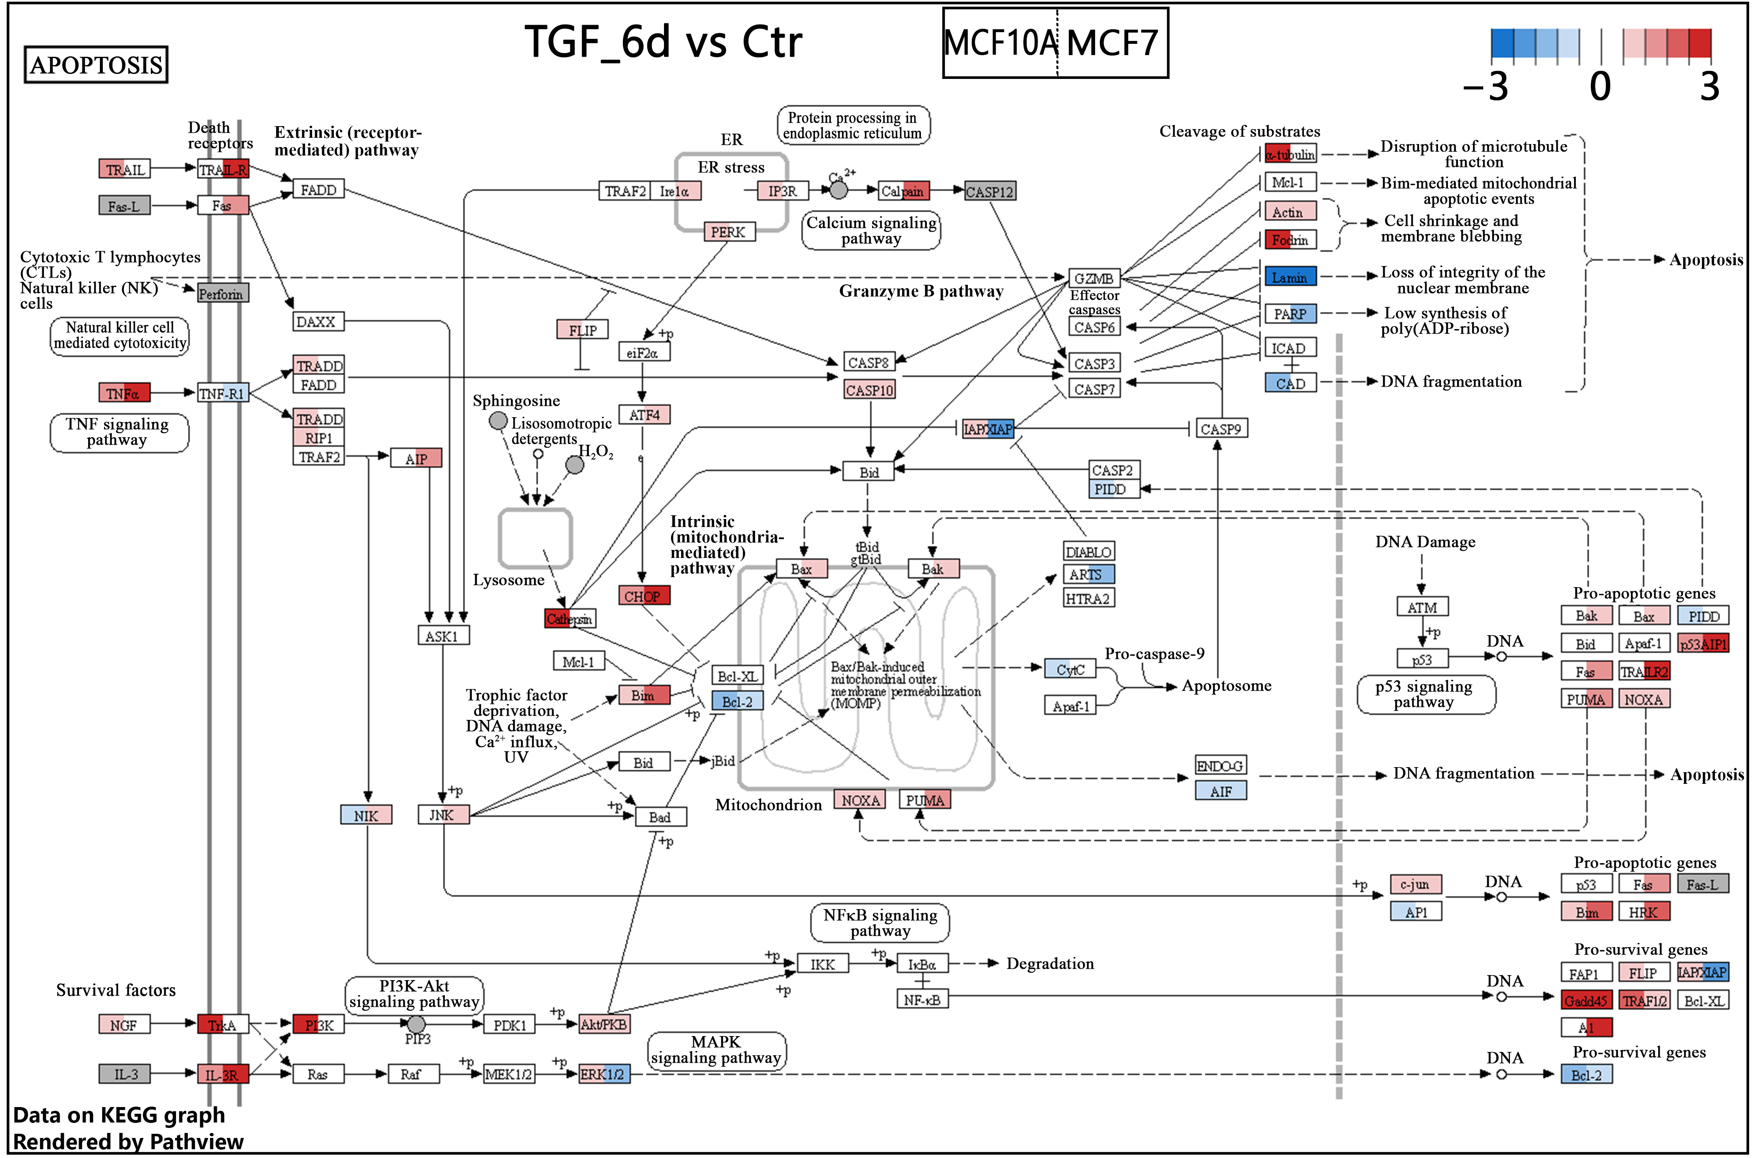
Figure S9. Changes in expression of genes related to the apoptosis network on the sixth day of TGFβ1 stimulation in MCF10A (left part of each rectangle) and MCF7 (right part of each rectangle) cells. Log2-fold changes from the RNA-seq experiment were mapped to the Apoptosis network (ID: hsa04210; https://www.kegg.jp/pathway/hsa04210) in the KEGG database. Colors indicate gene upregulation (red) and downregulation (blue); grey indicates the missing data. The color scale was truncated to values within the range of -3 to 3. The regular map notation is available at https://www.kegg.jp/kegg/document/help_pathway.html.

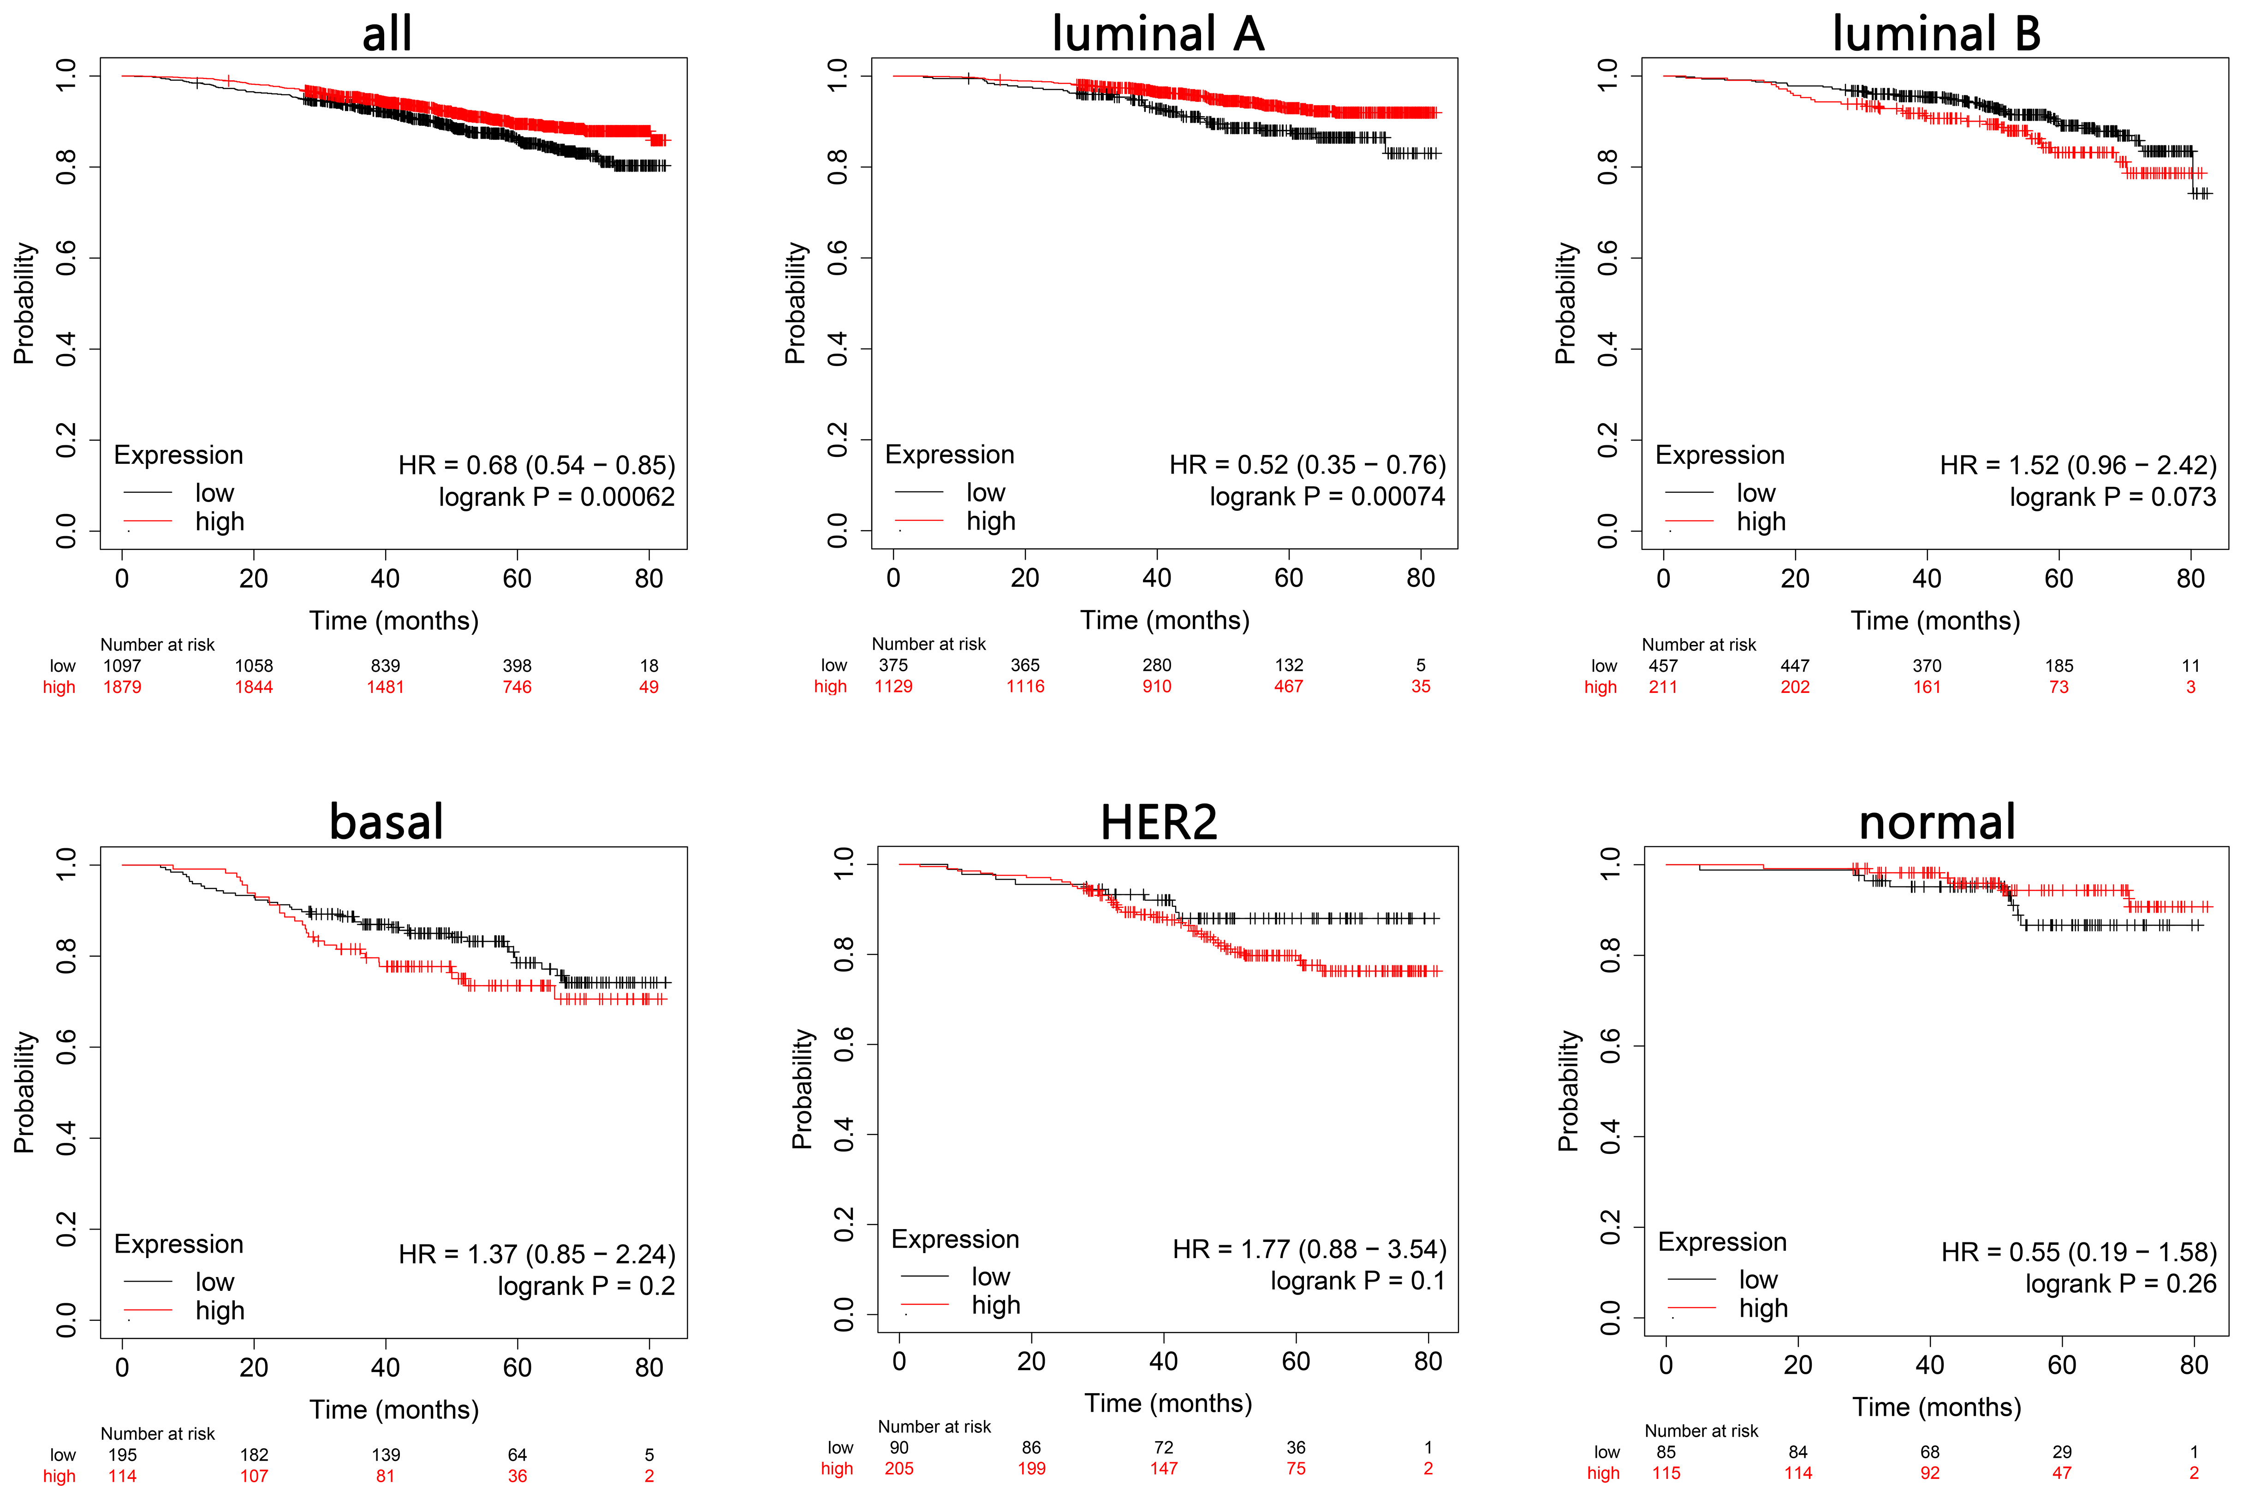
Figure S10. Effect of TGFB1 transcript levels on overall survival in breast cancer patients analyzed using the Kaplan Meier Plotter available at https://kmplot.com/analysis/index.php?p=service&cancer=breast_rnaseq_gse96058 (Győrffy 2021) (accessed March 2024). Patients (n=2976) were split by “Auto select best cutoff”. All patients were analyzed (all) or analysis was restricted to PAM50 subtypes: luminal A (n=1,504), luminal B (n=668), basal (n=309), HER2 (n=295), and normal (n=200).

