Supplementary information for Antibiotic resistance gene dynamics in the commensal infant gut microbiome over the first year of life
Pål Trosvik¹*, Hanna Theodora Noordzij¹, Eric Jacques de Muinck^{1,2}
¹ Centre for Ecological and Evolutionary Synthesis, Department of Biosciences, University of Oslo
² Department of Pharmacy, University of Oslo
*E-mail correspondence: pal.trosvik@ibv.uio.no

Figures S1-13
Tables S1-12

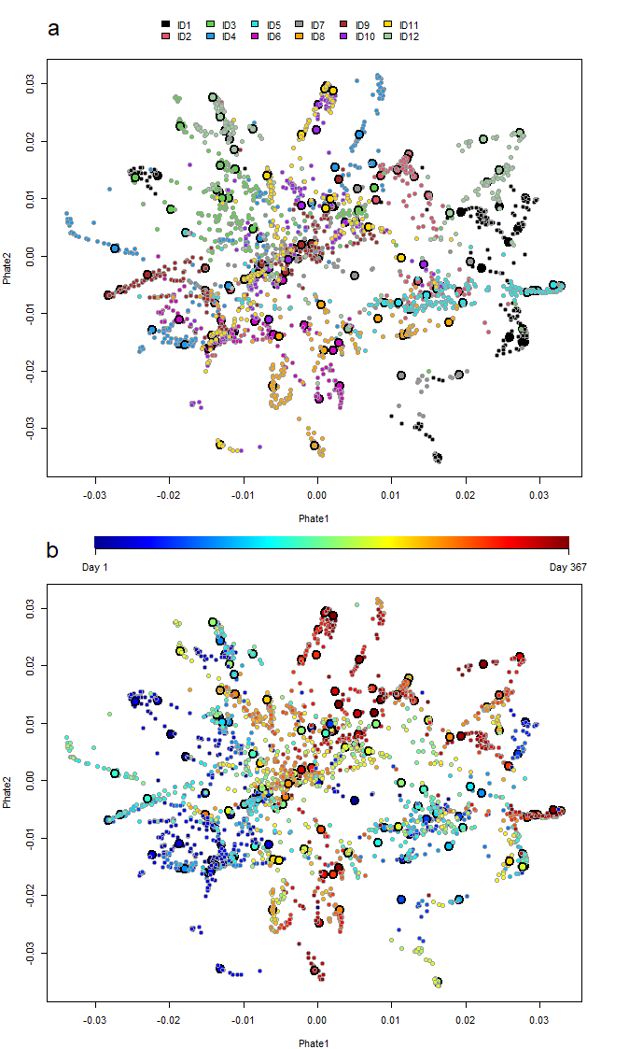
Fig. S1. Sample selection for shotgun metagenomic sequencing. The panels show PHATE dimensionality reduction and visualization of 2684 fecal samples collected from 12 healthy infant over the first year of life, analyzed by 16S rRNA gene sequencing (de Muinck and Trosvik 2018). Samples that were selected for shotgun metagenome sequencing shown in enhanced size and outlined in black. Seven outlying data points, all corresponding to early ID9 samples, have been omitted from the figure for better visualization. In (a) color coding is according to the individual from which samples were collected. In (b) color coding is according to day after birth of sampling.

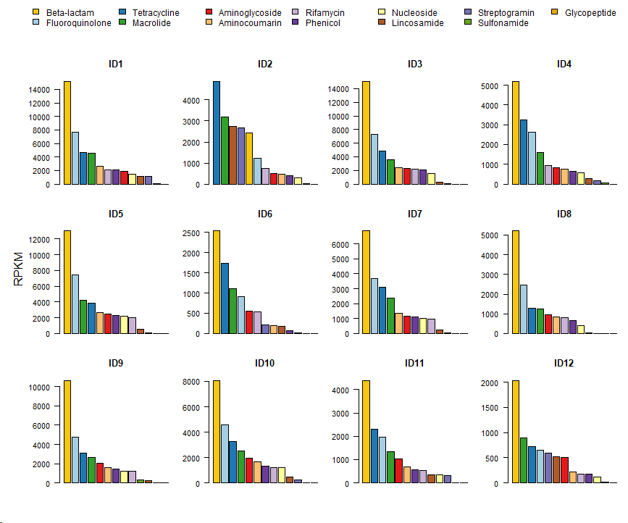

Fig. S2. The overall main drug class to which resistance was the most prevalent was beta-lactam antibiotics. The main classes of antibiotics ranked by abundance summed over the first year of life for all 12 infants in the sampling cohort. The color scheme is the same as in Fig. 2.

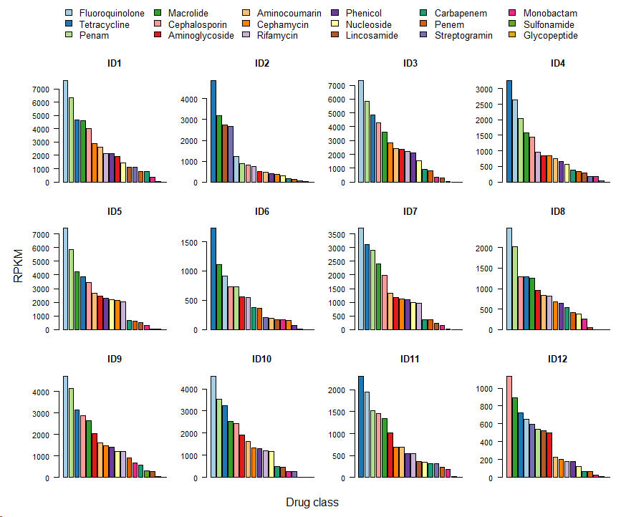
Fig. S3. The most abundant resistance class in seven of the infants was fluoroquinolone after splitting beta-lactam into sub-classes (carbapenem, penam, penem, cephalosporin, cephamycin and monobactam). The 18 main classes of antibiotic ranked by abundance summed over the first year of life for all 12 infants in the sampling cohort. The color scheme is the same as in Fig. 3.

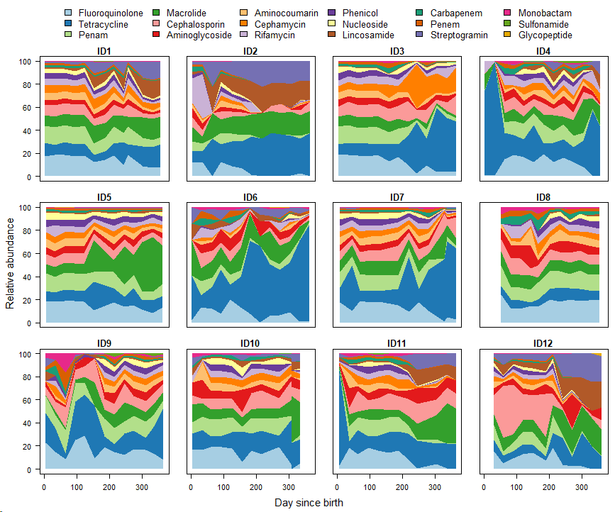

Fig. S4. Relative abundance patterns of ARGs were quite stable, but with a tendency towards expansion of tetracycline, lincosamide and streptogramin resistance genes at later time points. Percent relative abundance of the main drug resistance classes over the first year of life in the 12 infants in the cohort. The color scheme is the same as in Fig. 3.

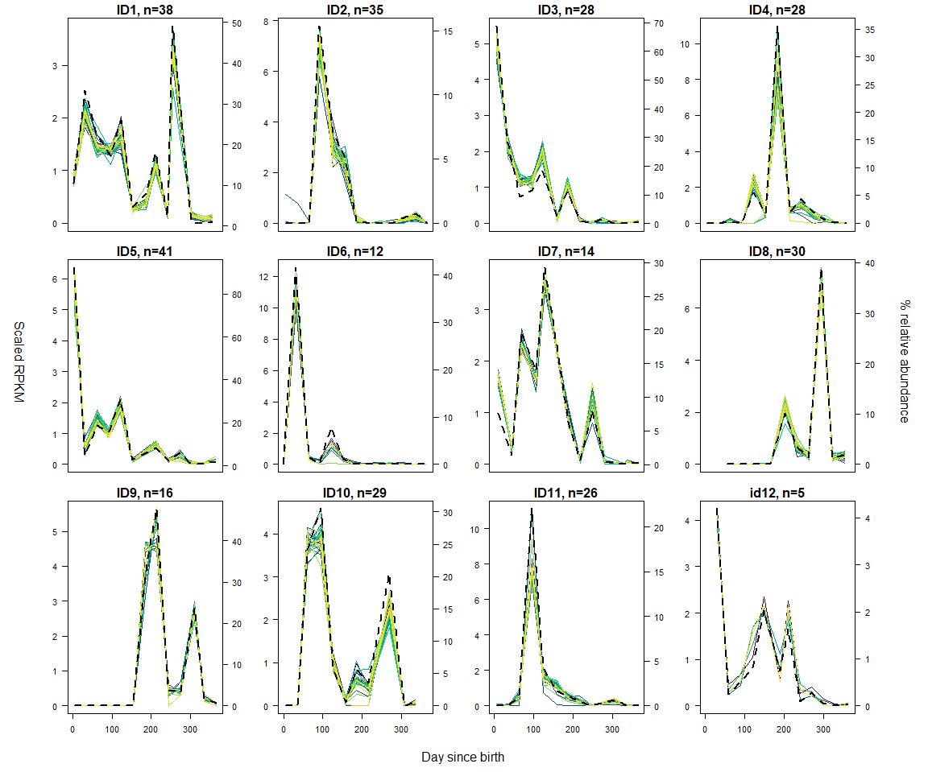
Fig. S5. ARGs assigned to E. coli by matching gene dynamics with the dynamics of the E. coli populations in 11 of the 12 infants. Plots of dominant ARG carrier taxa relative abundance (right axes, dotted black lines) and ARGs with highly correlated (Pearson correlation >0.97) dynamics (left axes, colored lines). Since we did not observe sufficient amounts of E. coli in ID6 to make a meaningful estimate of the correlation, results for K.pneumoniae are shown instead. The ARG normalized abundances, originally in units of RPKM (reads per kilobase of reference sequence per million sample reads), have been scaled to a mean of 1 by dividing with the individual ARG means. The number of ARGs with a correlation of >0.97 is indicated above each panel (see Table S5. for the list of 43 unique ARGs assigned to E. coli by contemporaneous correlation).

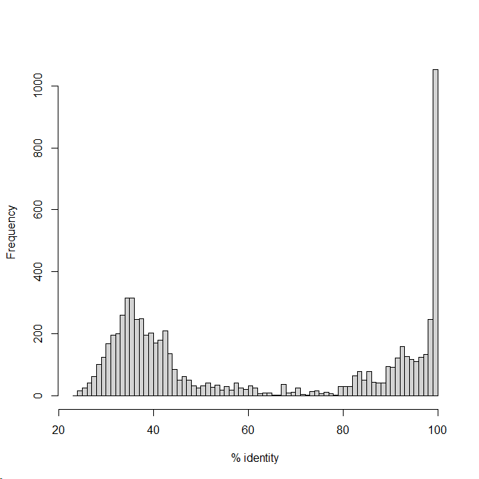
Figure S6. Bimodal distribution of amino acid sequence identities of all 7150 putative ARGs annotated to MAGs in all 12 infants.
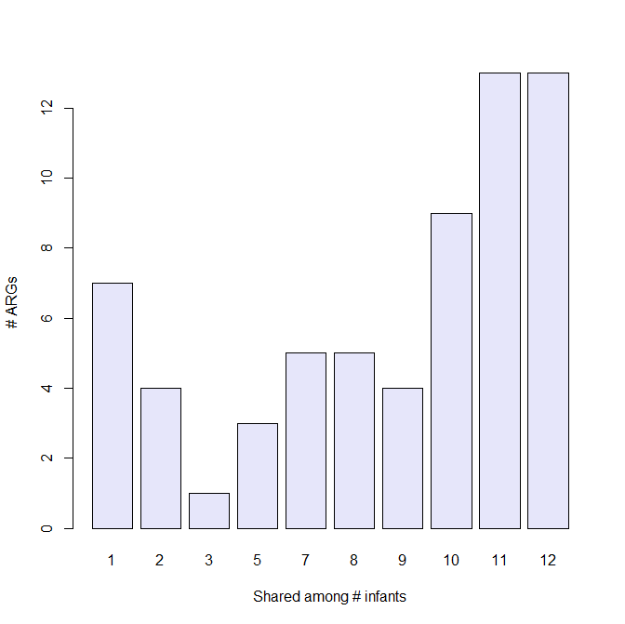
Fig. S7. E. coli pan and core resistome based on MAG annotation. The mean number of ARGs annotated to the E. coli MAGs was 44 (range 32-51), with 13 genes found in all 12 infants and 7 in only a single individual.

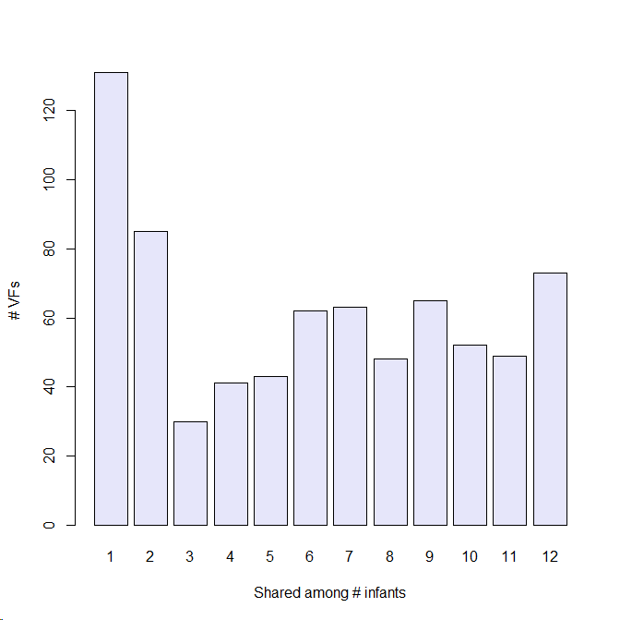
Fig. S8. Pan and core complement of virulence factors (VFs). 742 unique VF genes were identified in the full dataset with 73 of these genes shared between all 12 infants and 131 unique to a single child.
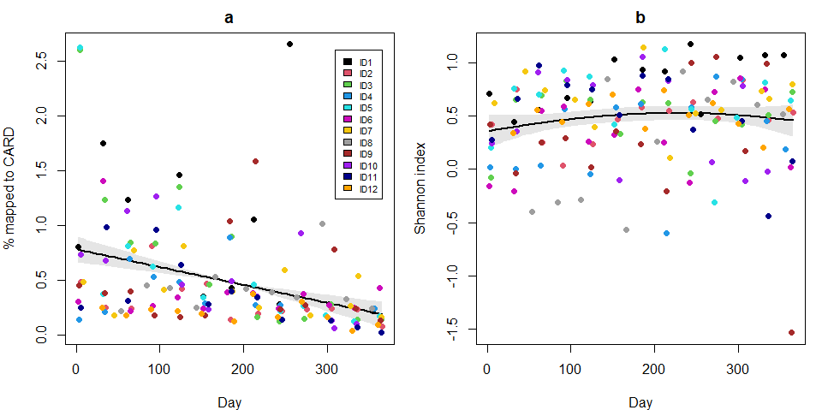
Fig. S9. The proportion of reads mapping to the VF database showed a significant negative time trend over the first year of life, but not in VF diversity. (a) Percentage of sequence reads mapping to the VFDB database plotted against day after birth of sample collection. (b) Diversity of ARGs over time, as measured by Shannon entropy. The trend lines represent generalized additive models, with five degrees of freedom for the regression spline in order to accommodate significant non-linearities in the predictor-response relationships. The grey shaded areas represent 95% confidence intervals. The dots are color coded according to individual provenance of samples as indicated in (a). The GAM in (a) is highly significant (p<0.001), while (b) is not significant (p=0.28). For (a) estimated degrees of freedom (edf) is 1, indicating a linear relationship.

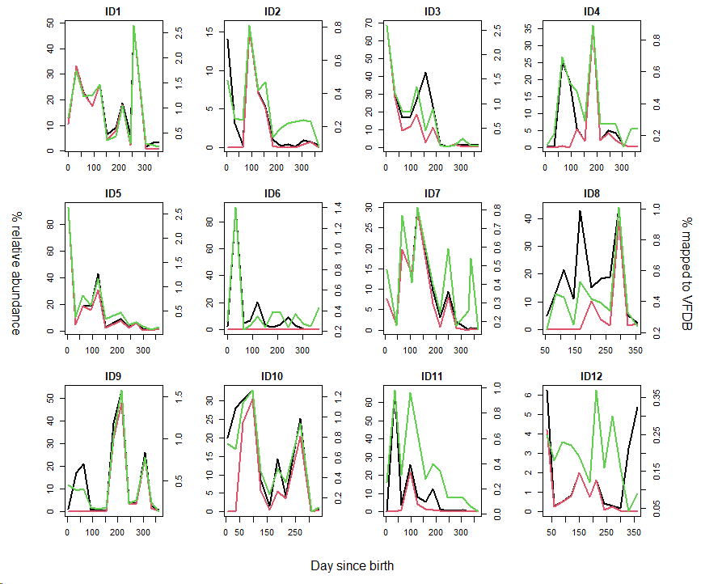
Fig. S10. Overall VF carriage correlated strongly with E. coli relative abundances. Relative abundances of Proteobacteria (black lines) and E. coli (red lines) are indicated on the left side y-axes. Percentages of sequence reads (green lines) mapped to VFDB are indicated on the right-side axes.

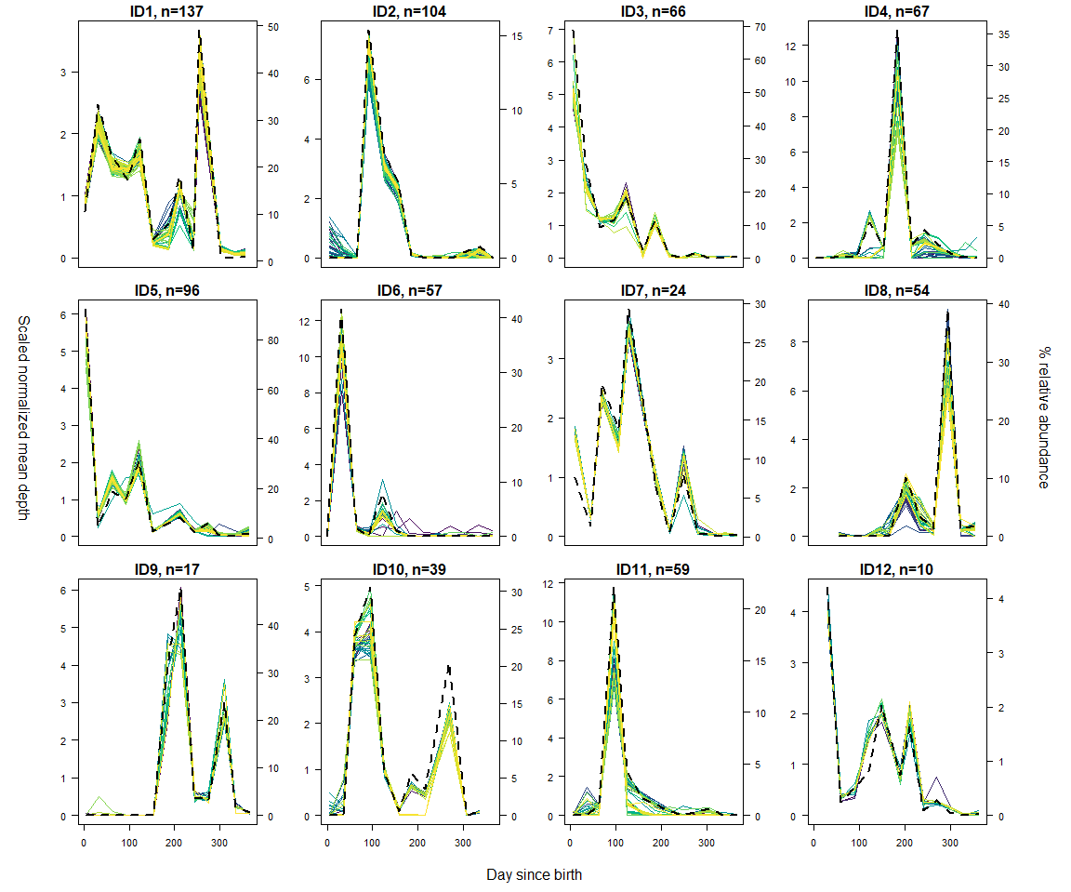

Fig. S11. A mean of 61 individual VF genes (range 10-137) showed strong contemporaneous correlation with E. coli population dynamics. Plots of E. coli relative abundances (right axes, dotted black lines) and VF genes with highly correlated (R²>0.97) dynamics (left axes, colored lines). Since we did not observe sufficient amounts of E. coli in ID6 to make a meaningful estimate of the correlation, results for K.pneumoniae are shown instead for this infant. The normalized VF gene mean read depths have been scaled to a mean of 1 by dividing with the individual VF gene means. The number of VF genes with a correlation R²>0.97 is indicated above each panel.

Fig. S12. Variation among individuals in linkages between resistance mechanisms and MGE categories. Proportion of ARG resistance mechanism per mobility category type with <10 Kb distance between ARGs and MGEs for all infants. ARGs annotated on the same contig with several MGEs are shown in each MGE category. ARGs with multiple resistance mechanisms are counted multiple times. The numbers in the bar represent the total of ARG resistance mechanisms within the (MGE) category. Numbers at the x-axis represent the IDs of the infants.

Fig.S13. Differences in the distributions of all ARGs mapped to contigs and MGE-linked ARGs in relation to the main drug classes. (a) Proportion of ARGs’ drug class per mobility type with <10 Kb distance between ARGs and MGEs. The numbers in the bar represent the total ARGs within the (MGE) category. (b) Counts of ARG classes from a. ARGs annotated on the same contig with several MGEs are shown in each (MGE) category. Corresponding paired Wilcox tests per drug class are found in Table S11 and Table S12.

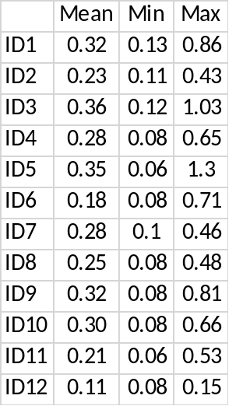
Table S1. Mean percentage and range of DNA sequence reads mapping to CARD for each of the 12 infants.

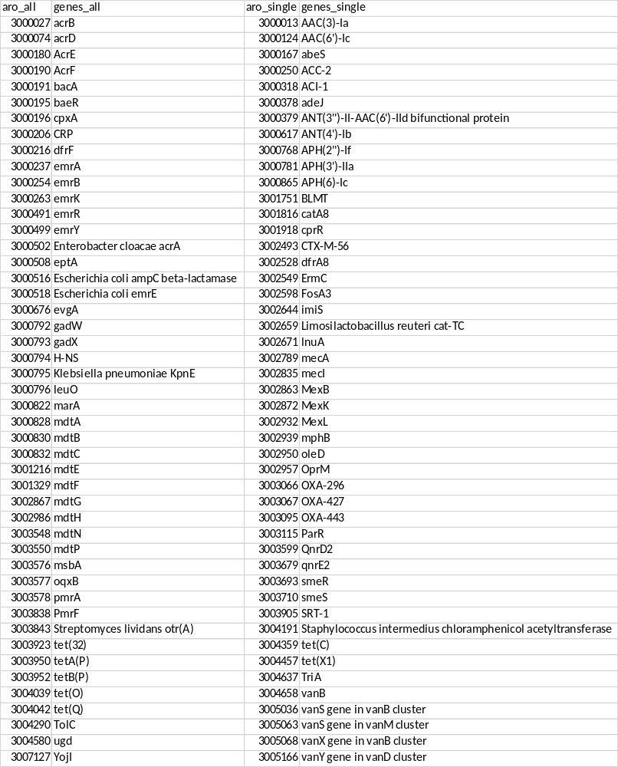
Table S2. Core (genes_all) and singleton (genes_single) resistome. Of the 260 uniquely identified ARGs, 47 were found in all 12 infants, and 47 were unique to a single child

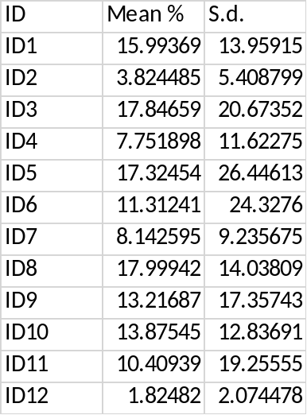
Table S3. ID12 had the lowest mean relative abundance of Proteobacteria. Mean overall relative abundance and standard deviations for Proteobacteria in each of the 12 infants.

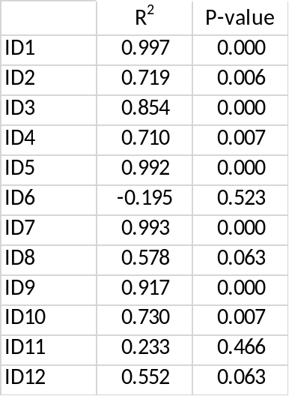
Table S4. Contemporaneous Pearson’s correlations between the phylum Proteobacteria and the species E. coli in each of the 12 infants.

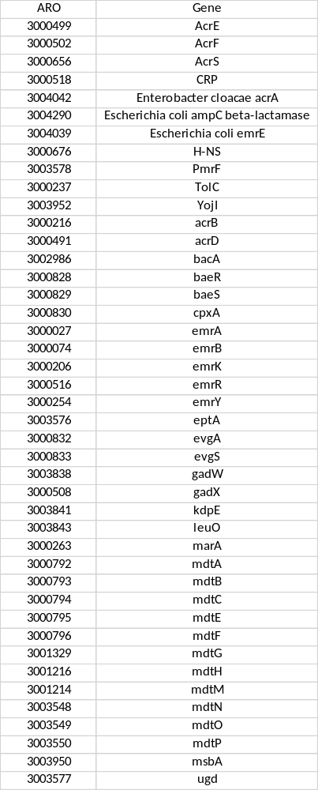
Table S5. Unique ARGs assigned to E. coli by contemporaneous correlation.

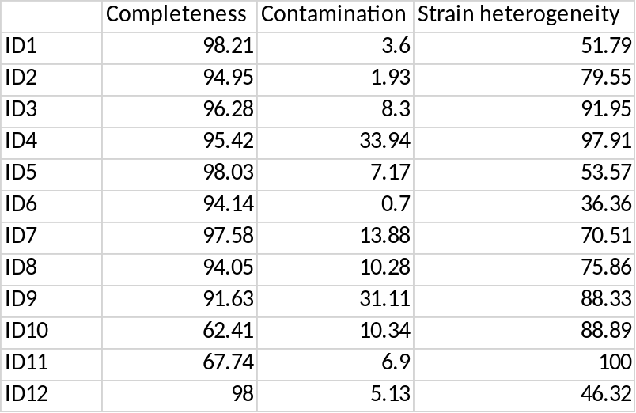
Table S6. Quality assessment of E. coli MAGs.
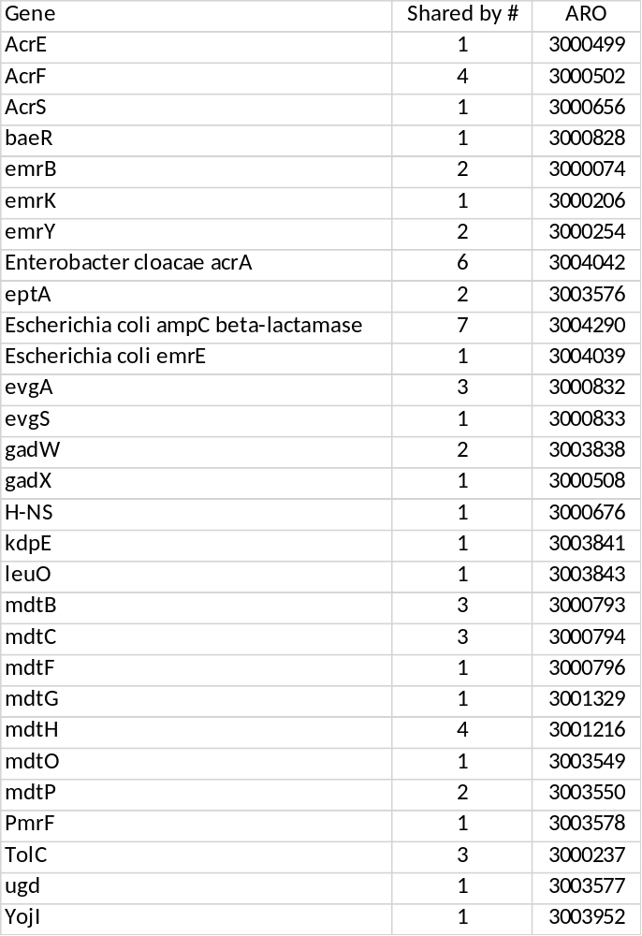

Table S7. ARGs assigned to E. coli by contemporaneous correlation in an infant and not annotated on the corresponding E. coli MAG.

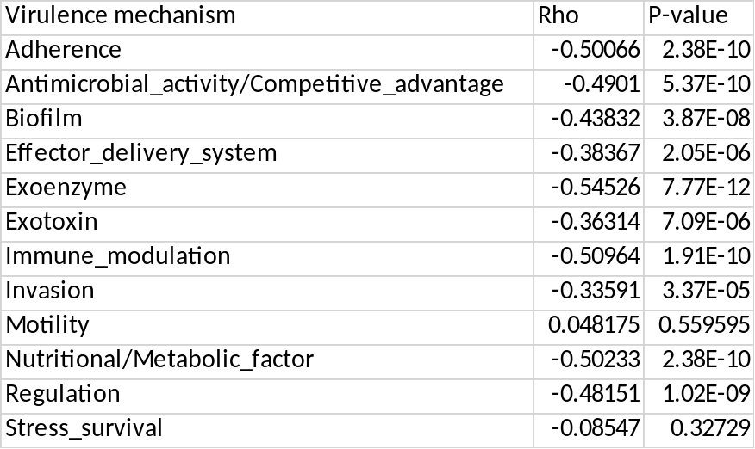
Table S8. Spearman correlation tests for time trends in normalized abundances of genes in the observed virulence categories. P-values were adjusted with the Benjamini-Hochberg method in order to account for multiple hypothesis testing.

species | % of mobile ARGs
Escherichia coli | 30.40
Enterobacter hormaechei_A | 5.16
Citrobacter freundii | 4.74
Klebsiella pneumoniae | 3.91
Citrobacter_A farmeri | 3.35
Klebsiella michiganensis | 3.07
Citrobacter portucalensis | 2.65
Phytobacter diazotrophicus | 2.09
Staphylococcus aureus | 1.95
Klebsiella variicola | 1.67
Citrobacter_A amalonaticus | 1.53
Bacteroides uniformis | 1.26
Enterobacter kobei | 1.26
Enterococcus faecalis | 1.12

Table S9. Proteobacteria, and E. coli in particular, carry the highest percentage of contigs with at least one ARG in close proximity to an MGE (<10 kbp). Percentage of mobile ARGs assigned to individual MAGs.

ARG Resistance Mechanism | Mobility | Mean (s.d) | P-value
Efflux | Total MGE | 62.1 (8) | NA
Efflux | Plasmid | 67.5 (7.5) | 0.0046
Efflux | Phage | 68.3 (6.5) | 0.0056
Efflux | IGE | 22.2 (14.3) | 0.0046
Efflux | CE | 55 (22.8) | 0.2976
Drug Inactivation | Total MGE | 12.7 (5.5) | NA
Drug Inactivation | Plasmid | 10 (5) | 0.0108
Drug Inactivation | Phage | 7.5 (4.9) | 0.0046
Drug Inactivation | IGE | 47.3 (20.9) | 0.0046
Drug Inactivation | CE | 22.7 (14.9) | 0.3168
Target alteration | Total MGE | 19.2 (3) | NA
Target alteration | Plasmid | 18.7 (3.2) | 0.7915
Target alteration | Phage | 18.7 (5.5) | 0.8241
Target alteration | IGE | 23.9 (15.6) | 0.8042
Target alteration | CE | 17.4 (10) | 0.0649
Target protection | Total MGE | 3.5 (0.8) | NA
Target protection | Plasmid | 1.7 (0.4) | 0.0161
Target protection | Phage | 3.3 (1.4) | 0.8241
Target protection | IGE | 18.7 (11.2) | 0.0306
Target protection | CE | 20.4 (10.3) | 0.0191
Target replacement | Total MGE | 2.9 (2.6) | NA
Target replacement | Plasmid | 3.9 (2.5) | 0.2905
Target replacement | Phage | 3.1 (2.5) | 0.8241
Target replacement | IGE | 15.6 (8.5) | 0.2976
Target replacement | CE | 7.7 (NA) | NA
Reduced permeability | Total MGE | 4.9 (NA) | NA
Reduced permeability | Plasmid | 5.2 (NA) | NA
Reduced permeability | Phage | 5.4 (NA) | NA
Reduced permeability | IGE | NaN (NA) | NA
Reduced permeability | CE | NaN (NA) | NA

Table S10. Resistance mechanism profiles within MGE categories differed significantly compared to the total pool of MGE-linked ARGs. Paired Wilcox tests for the proportion of ARG resistance mechanisms for all infants of a specific MGE category compared to the proportion of the same resistance mechanism of the total MGE of all infants. P-values were adjusted with the Benjamini-Hochberg procedure.

ARG Drug Class | Mobility | Mean (s.d) | P-value
Aminoglycoside | Total | 13.6 (4.8) | NA
Aminoglycoside | Mobile ARG | 10.3 (7.3) | 0.0059
Betalactam | Total | 23.6 (8.7) | NA
Betalactam | Mobile ARG | 32.3 (16.2) | 0.0034
Glycopeptide | Total | 5.7 (5.3) | NA
Glycopeptide | Mobile ARG | 9.3 (12.1) | 0.3059
Lincosamide | Total | 11.1 (4.5) | NA
Lincosamide | Mobile ARG | 11.1 (6.6) | 1
Macrolide | Total | 9.4 (5.1) | NA
Macrolide | Mobile ARG | 12 (8.8) | 0.0726
Streptogramin | Total | 9.2 (3.9) | NA
Streptogramin | Mobile ARG | 11.3 (8.5) | 0.3059
Tetracycline | Total | 11.4 (5.3) | NA
Tetracycline | Mobile ARG | 6.6 (5.2) | 0.0059

Table S11. Differences in the distributions of all ARGs mapped to contigs and MGE-linked ARGs in relation to the main drug classes. Paired Wilcox tests for the proportion of ARG drug classes for all infants of the mobile ARGs compared to the proportion of the same drug class of the total ARGs of all infants. Tests where done when both groups had >4 infants with the specific drug class. P-values were adjusted with the Benjamini-Hochberg procedure.

Drug Class | Mobility | mean (s.d) | adjusted
aminoglycoside | Total MGE | 10.3 (7.3) | NA
aminoglycoside | Plasmid | 13.2 (11.2) | 0.2161
aminoglycoside | Phage | 7.6 (14.8) | NA
aminoglycoside | IGE | 10.9 (10.2) | 0.6681
aminoglycoside | CE | 2.5 (8.7) | NA
betalactam | Total MGE | 32.3 (16.2) | NA
betalactam | Plasmid | 46.2 (27.9) | 0.0455
betalactam | Phage | 33.8 (18.7) | 0.3954
betalactam | IGE | 27.3 (28.8) | 0.3501
betalactam | CE | 29.8 (30.4) | 0.6745
lincosamide | Total MGE | 11.1 (6.6) | NA
lincosamide | Plasmid | 6 (7.4) | 0.0455
lincosamide | Phage | 15.5 (12.7) | 0.2161
lincosamide | IGE | 9.5 (8.6) | 0.2506
lincosamide | CE | 13.4 (10.8) | 0.3671
macrolide | Total MGE | 12 (8.8) | NA
macrolide | Plasmid | 13 (13.5) | 0.6745
macrolide | Phage | 7.8 (8.2) | 0.0455
macrolide | IGE | 12.6 (9.4) | 0.8385
macrolide | CE | 8.4 (9.2) | 0.0455
streptogramin | Total MGE | 11.3 (8.5) | NA
streptogramin | Plasmid | 9.3 (10.6) | 0.2161
streptogramin | Phage | 15.5 (12.7) | 0.0745
streptogramin | IGE | 9.5 (8.6) | 0.2358
streptogramin | CE | 13.4 (10.8) | 0.2506
tetracycline | Total MGE | 6.6 (5.2) | NA
tetracycline | Plasmid | 0 (0) | NA
tetracycline | Phage | 6.8 (9.6) | 0.8385
tetracycline | IGE | 16.1 (15.1) | 0.0455
tetracycline | CE | 17.8 (20.5) | 0.0745

Table S12. Differences between the full distribution of MGE-linked ARGs and MGE categories. Paired Wilcox tests for the proportion of ARG drug classes for all infants of a specific MGE category compared to the proportion of the same drug class of the total MGE of all infants. Tests were done when both groups had >4 infants with the specific drug class. P-values were adjusted with the Benjamini-Hochberg procedure.

