Associations Between Body Mass Index and All-Cause Mortality Among Individuals with Psoriasis: Results from the NHANES database retrospective cohort study

Supplementary Materials

Contents
Figure S1. Kaplan–Meier survival analysis among individuals with psoriasis. 2
Table S1. Baseline characteristics among all participants. 3
Table S2. Baseline characteristics of psoriatic individuals based on obese status after Propensity Score-Matching (PSM). 4
Table S3. Baseline characteristics of psoriatic individuals based on obese status before and after PSM combined with the exclusion of participants who died within the first two years of follow-up. 5
Table S4. Mortality rate according to various causes of death, based on BMI category among individuals with psoriasis. 6
Table S5. Multivariate Cox Regression for all-cause mortality in individuals without psoriasis. 7
Table S6. Multivariate Cox Regression for severity of psoriasis in individuals with psoriasis. 8
Table S7. Fisher's exact test for mortality rate differences between individuals with mild psoriasis and those with moderate-to-severe psoriasis, based on BMI category. 9
Table S8 Sensitivity analyses among psoriatic individuals. 10

Figure S1. Kaplan–Meier survival analysis among individuals with psoriasis.
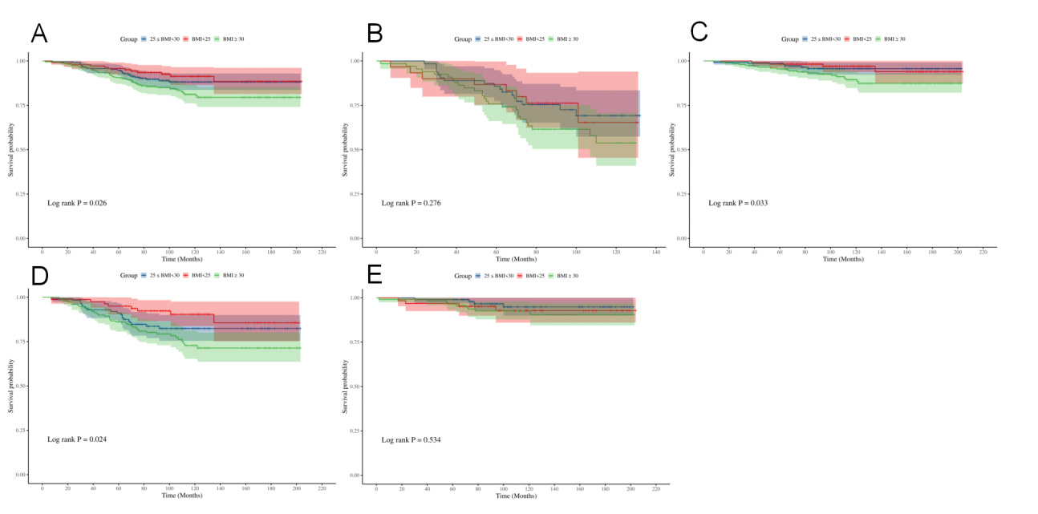
A. Kaplan–Meier survival analysis of all individuals with psoriasis; B. Kaplan–Meier survival analysis of psoriatic individuals age>60; C. Kaplan–Meier survival analysis of psoriatic individuals age≤60; D. Kaplan–Meier survival analysis of psoriatic smokers; E. Kaplan–Meier survival analysis of psoriatic non-smokers.

Table S1. Baseline characteristics among all participants.

 | Without psoriasis | With psoriasis | p Value
 | (n=22258) | (n=618) | p Value
Age, years old | 45.84±16.98 | 49.31±16.25 | <0.001
Male, n% | 10695(48.05) | 289(46.76) | 0.528
Race/Ethnicity |  |  | <0.001
Mexican American | 3598(16.17) | 51(8.25)
Other Hispanic | 1815(8.15) | 48(7.77)
Non-Hispanic White | 9660(43.40) | 375(60.68)
Non-Hispanic Black | 4945(22.22) | 83(13.43)
Other Race | 2240(10.06) | 51(9.87)
Educational attainment |  |  | 0.103
Less than 9th grade | 2157(9.69) | 41(6.63)
9-11th grade | 3300(14.83) | 82(13.27)
High school | 5042(22.65) | 139(22.49)
Some college or AA degree | 6700(30.10) | 198(32.04)
College graduate or above | 5059(22.73) | 158(25.57)
PIR | 2.52±1.65 | 2.60±1.70 | 0.282
BMI, kg/m² | 28.91±6.94 | 29.18±5.78 | 0.589
Hypertension | 4441(19.95) | 136(22.01) | 0.569
Diabetes | 1496(6.72) | 40(6.47) | 0.753
Dyslipidemia | 3875(17.41) | 131(21.20) | 0.125
Smoking | 9817(44.11) | 344(55.66) | <0.001
Drinking | 7695(34.57) | 219(35.44) | 0.289
Abbreviation: AA, the associate in arts degree. PIR, poverty income ratio.

Table S2. Baseline characteristics of psoriatic individuals based on obese status after Propensity Score-Matching (PSM).

 | Non-obese | Obese | p Value
 | (n=326) | (n=241) | p Value
Age, years old | 49.22 ± 17.04 | 49.94 ± 15.10 | 0.595
Male, n% | 161 (49.39) | 107 (44.40) | 0.240
Race/Ethnicity |  |  | 0.181
Mexican American | 18(5.52) | 16(6.64)
Other Hispanic | 24(7.36) | 21(8.71)
Non-Hispanic White | 221(67.79) | 148 (61.41)
Non-Hispanic Black | 38(11.66) | 43(17.84)
Other Race | 25(7.67) | 13(5.39)
Educational attainment |  |  | 0.124
Less than 9th grade | 20(6.13) | 14(5.81)
9-11th grade | 47(14.42) | 31(12.86)
High school | 72 (22.09) | 57(23.65)
Some college or AA degree | 94(28.83) | 90(37.34)
College graduate or above | 93(28.53) | 49(20.33)
PIR | 2.69 ± 1.69 | 2.47 ± 1.62 | 0.117
Hypertension | 69(21.17) | 50(20.75) | 0.787
Diabetes | 22(6.75) | 13(5.39) | 0.860
Dyslipidemia | 70(21.47) | 46(19.09)
Smoking | 185(56.75) | 138(57.26) | 0.903
Drinking | 101(30.98) | 93(38.59) | 0.056
Severity of psoriasis |  |  | 0.908
Mildly | 267(81.90) | 193(80.12)
Moderate-to-severe | 59(18.10) | 48(19.88)

Abbreviation: AA, the associate in arts degree. PIR, poverty income ratio.

Table S3. Baseline characteristics of psoriatic individuals based on obese status before and after PSM combined with the exclusion of participants who died within the first two years of follow-up.
 | Before PSM |  |  |  | After PSM
 | non-Obese | Obese | p value |  | non-Obese | Obese | p value
 | (n=348) | (n=258) | p value |  | (n=318) | (n=234) | p value
Age, years old | 48.62 ± 16.87 | 49.39 ± 15.08 | 0.555 |  | 48.66 ± 16.81 | 49.29 ± 14.99 | 0.647
Male, n% | 172 (49.43) | 108 (41.86) | 0.065 |  | 160 (50.31) | 102 (43.59) | 0.118
Race/Ethnicity |  |  | 0.001 |  |  |  | 0.366
Mexican American | 18 (5.17) | 33 (12.79) |  |  | 18 (5.66) | 17 (7.26)
Other Hispanic | 25 (7.18) | 22 (8.53) |  |  | 23 (7.23) | 20 (8.55)
Non-Hispanic White | 221 (63.51) | 146 (56.59) |  |  | 216 (67.92) | 145 (61.97)
Non-Hispanic Black | 38 (10.92) | 44 (17.05) |  |  | 38 (11.95) | 39 (16.67)
Other Race | 46 (13.22) | 13 (5.04) |  |  | 23 (7.23) | 13 (5.56)
Educational attainment |  |  | 0.052 |  |  |  | 0.077
Less Than 9th Grade | 22 (6.32) | 18 (6.98) |  |  | 19 (5.97) | 13 (5.56)
9-11th Grade | 47 (13.51) | 34 (13.18) |  |  | 45 (14.15) | 29 (12.39)
High School | 77 (22.13) | 60 (23.26) |  |  | 72 (22.64) | 55 (23.50)
Some College or AA degree | 97 (27.87) | 94 (36.43) |  |  | 88 (27.67) | 88 (37.61)
College Graduate or above | 105 (30.17) | 52 (20.16) |  |  | 94 (29.56) | 49 (20.94)
PIR | 2.73 ± 1.67 | 2.44 ± 1.61 |  |  | 2.71 ± 1.68 | 2.52 ± 1.62 | 0.194
Hypertension | 76(21.84) | 56(21.71) | 0.037 |  | 67(21.07) | 50(21.37) | 0.922
Diabetes | 25(7.18) | 15(5.81) | 0.850 |  | 22(6.92) | 13(5.56) | 0.847
Dyslipidemia | 78(22.41) | 51(19.77) | 0.908 |  | 69(21.70) | 45(19.23) | 0.757
Smoking | 190 (54.60) | 145 (56.20) | 0.695 |  | 180 (56.60) | 134 (57.26) | 0.877
Drinking | 113(32.47) | 102(39.53) | 0.067 |  | 94(29.56) | 87(37.18) | 0.076
Severity of psoriasis |  |  | 0.685 |  |  |  | 0.876
mildly | 285(81.89) | 210(81.22) |  |  | 276(81.90) | 187(79.99)
moderate-to-severe | 63 (18.11) | 48 (18.78) |  |  | 42 (18.10) | 47(20.01)

Table S4. Mortality rate according to various causes of death, based on BMI category among individuals with psoriasis.

 | BMI<25  (n=142) | 25≤BMI<30  (n=211) | BMI≥30  (n=265) | Adjusted p-value
No. of subjects
CVD-related mortality | 3(19%) | 3(19%) | 10(63%) | 0.005
Malignant neoplasms | 3(11%) | 10(36%) | 15(54%) | 0.887
Chronic lower respiratory  diseases | 0 | 3(75%) | 1(25%)
Accidents | 1(33%) | 1(33%) | 1(33%)
Cerebrovascular diseases | 0 | 1(33%) | 2(67%)
Alzheimer’s disease | 0 | 0 | 0
Diabetes | 0 | 1(25%) | 3(75%)
Influenza and pneumonia | 2(100%) | 0 | 0
Nephritis, nephrotic  syndrome and nephrosis | 0 | 0 | 3(100%)
All other causes | 3(17%) | 4(22%) | 11(61%) | 0.009
All p values were adjusted for age, sex, race/ethnicity, education level, family income-to-poverty ratio, previous drinking and smoking histories, and current psoriatic severity, where appropriate.

Table S5. Multivariate Cox Regression for all-cause mortality in individuals without psoriasis.

 |  | HR | 95% CI | p Value
BMI
 | Crude | 1.001 | 0.994-1.007 | 0.822
 | Model 1 | 1.003 | 0.996-1.010 | 0.390
 | Model 2 | 0.996 | 0.964-1.008 | 0.553

Table S6. Multivariate Cox Regression for severity of psoriasis in individuals with psoriasis.

 |  | HR | 95% CI | p Value
BMI
 | Crude | 1.046 | 1.011-1.081 | 0.009
 | Model 1 | 1.054 | 1.019-1.091 | 0.002
 | Model 2 | 1.057 | 1.003-1.113 | 0.038
BMI≥30
vs. BMI <30 | Crude | 2.139 | 1.178-3.884 | 0.012
 | Model 1 | 2.611 | 1.423-4.793 | 0.002
 | Model 2 | 6.369 | 2.037-19.915 | 0.001

Table S7. Fisher's exact test for mortality rate differences between individuals with mild psoriasis and those with moderate-to-severe psoriasis, based on BMI category.

Group | Fisher’s exact test p-value
Mild Psoriasis (Lean) | Reference
MtS Psoriasis (Overweight) | 0.371
Mild Psoriasis (Overweight) | Reference
MtS Psoriasis (Obese) | 0.032
Mild Psoriasis (Lean) | Reference
MtS Psoriasis (Obese) | 0.045
Abbreviation: MtS, Moderate-to-severe.

Table S8 Sensitivity analyses among psoriatic individuals.

 |  | Adjusted HR | 95% CI | p Value
(1). Excluding participants who died in the first two years of follow-up |  | 1.082 | 1.045-1.228 | <0.001
(2). After propensity score matching |  | 1.040 | 1.010-1.070 | 0.004
(3). After propensity score matching as well as excluding participants who died in the first two years of follow-up |  | 1.050 | 1.020-1.080 | 0.002

