Supplementary Material

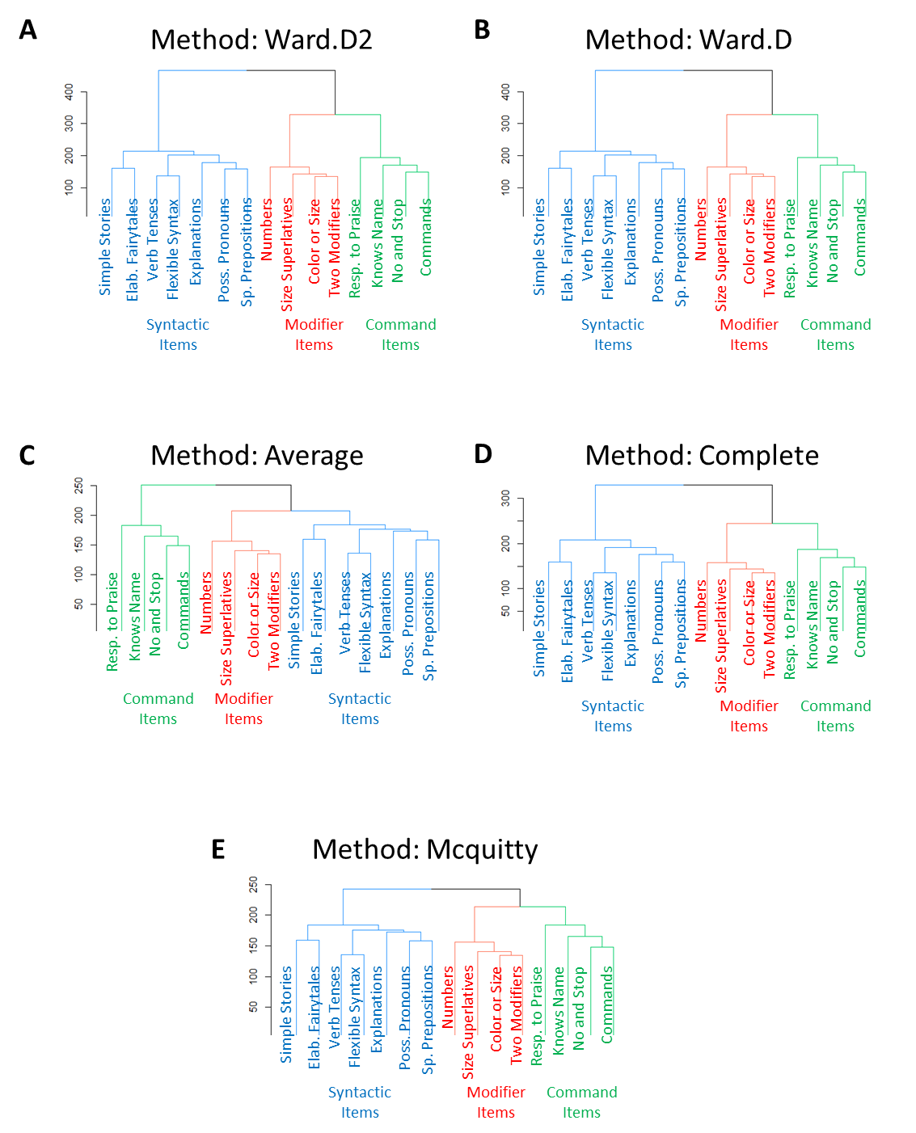
Figure S1. The three-cluster solution of the 15 language comprehension abilities was stable across different evaluation methods. A: Ward.D2. B: Ward.D. C: Average. D: Complete. E: Mcquitty.

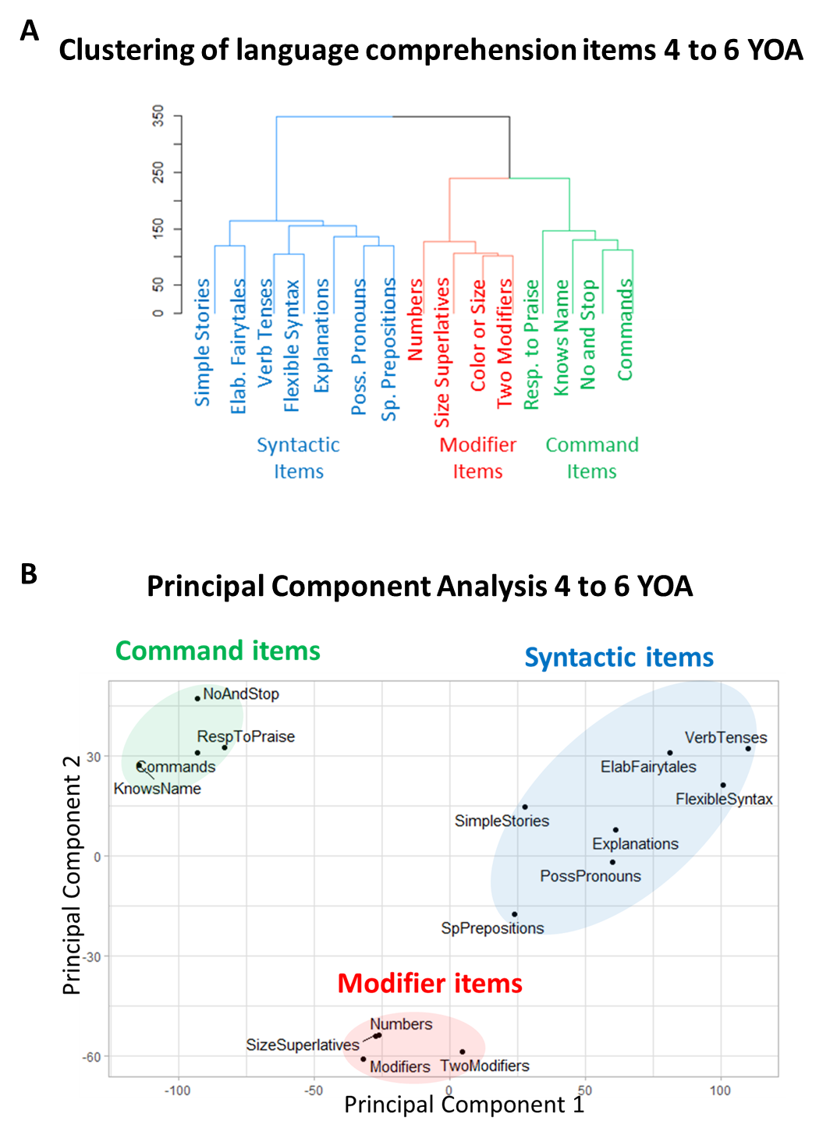
Figure S2. Clustering analysis of language comprehension items limited to 31,988 participants (4 to 6 years of age). (A) The dendrogram representing the hierarchical clustering of language comprehension abilities. (B) Principal component analysis of the 15 language comprehension abilities shows a clear separation between command, modifier, and prepositional items. Principal component 1 accounts for 40.8% of the variance in the data. Principal component 2 accounts for 11.1% of the variance in the data.

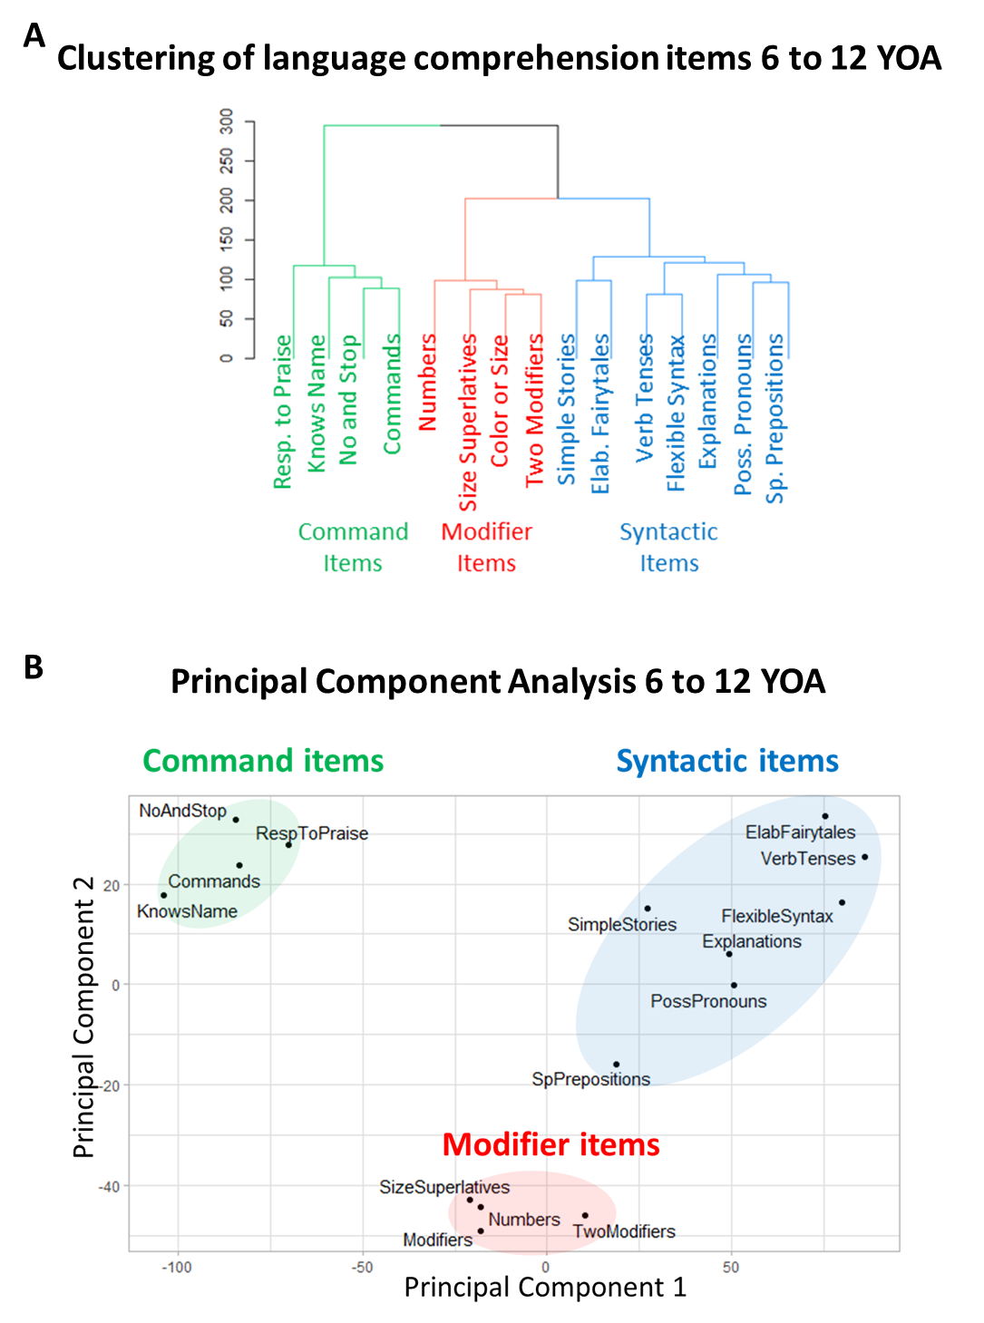
Figure S3. Clustering analysis of language comprehension items limited to 20,694 participants (6 to 12 years of age). (A) The dendrogram representing the hierarchical clustering of language comprehension abilities. (B) Principal component analysis of the 15 language comprehension abilities shows a clear separation between command, modifier, and prepositional items. Principal component 1 accounts for 44.7% of the variance in the data. Principal component 2 accounts for 10.8% of the variance in the data.

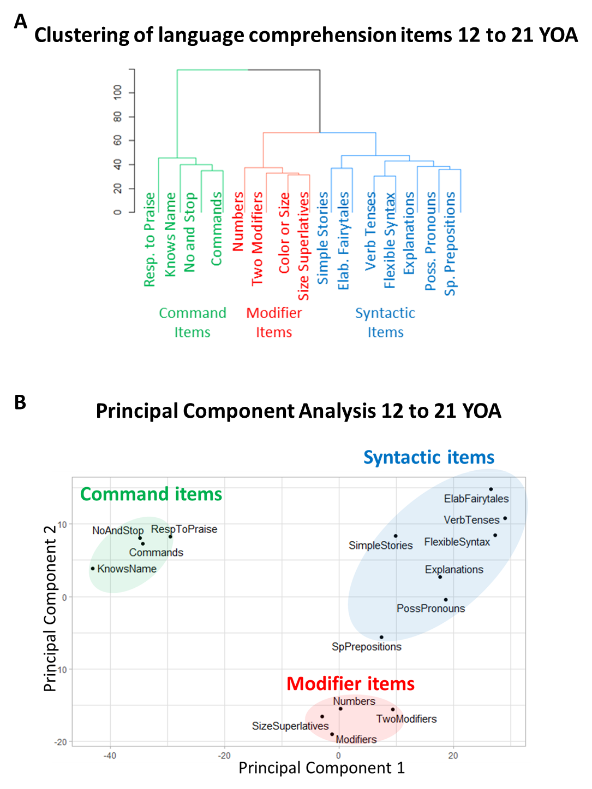
Figure S4. Clustering analysis of language comprehension items limited to 2,876 participants (12 to 21 years of age). (A) The dendrogram representing the hierarchical clustering of language comprehension abilities. (B) Principal component analysis of the 15 language comprehension abilities shows a clear separation between command, modifier, and prepositional items. Principal component 1 accounts for 45.9% of the variance in the data. Principal component 2 accounts for 10.1% of the variance in the data.

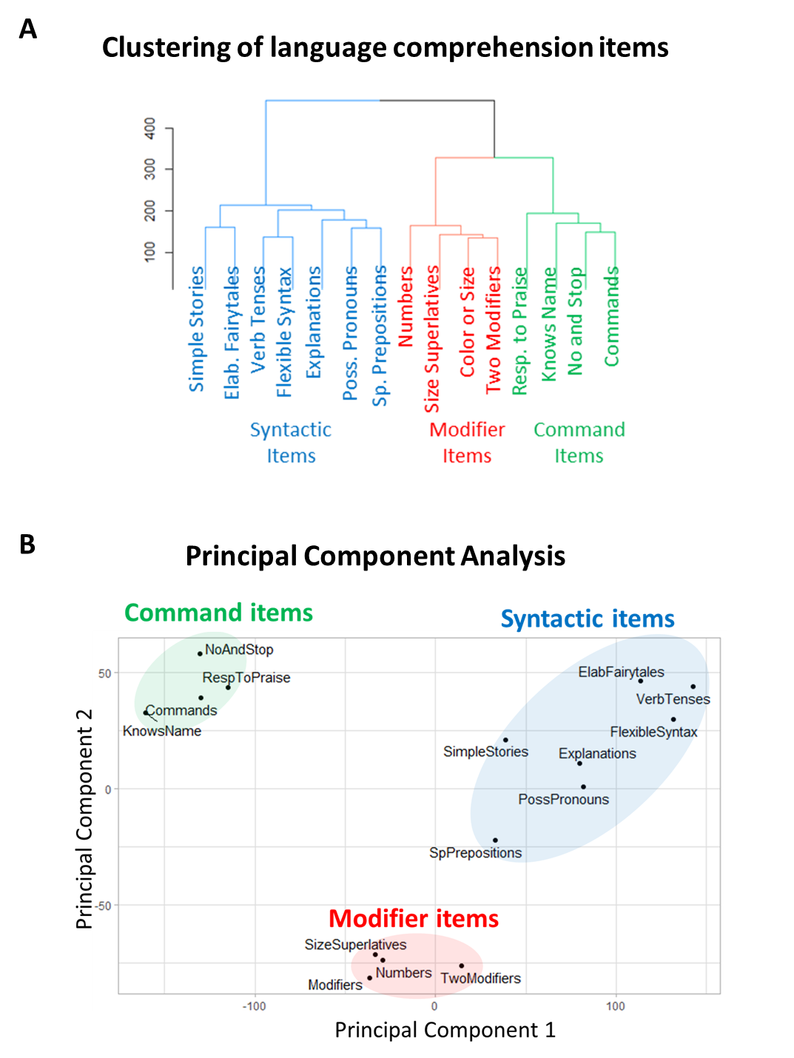
Figure S5. Clustering analysis of language comprehension items (55,558 participants, 4 to 21 years of age, first evaluation). (A) The dendrogram representing the hierarchical clustering of language comprehension abilities. (B) Principal component analysis of the 15 language comprehension abilities shows a clear separation between command, modifier, and prepositional items. Principal component 1 accounts for 45.9% of the variance in the data. Principal component 2 accounts for 10.1% of the variance in the data.

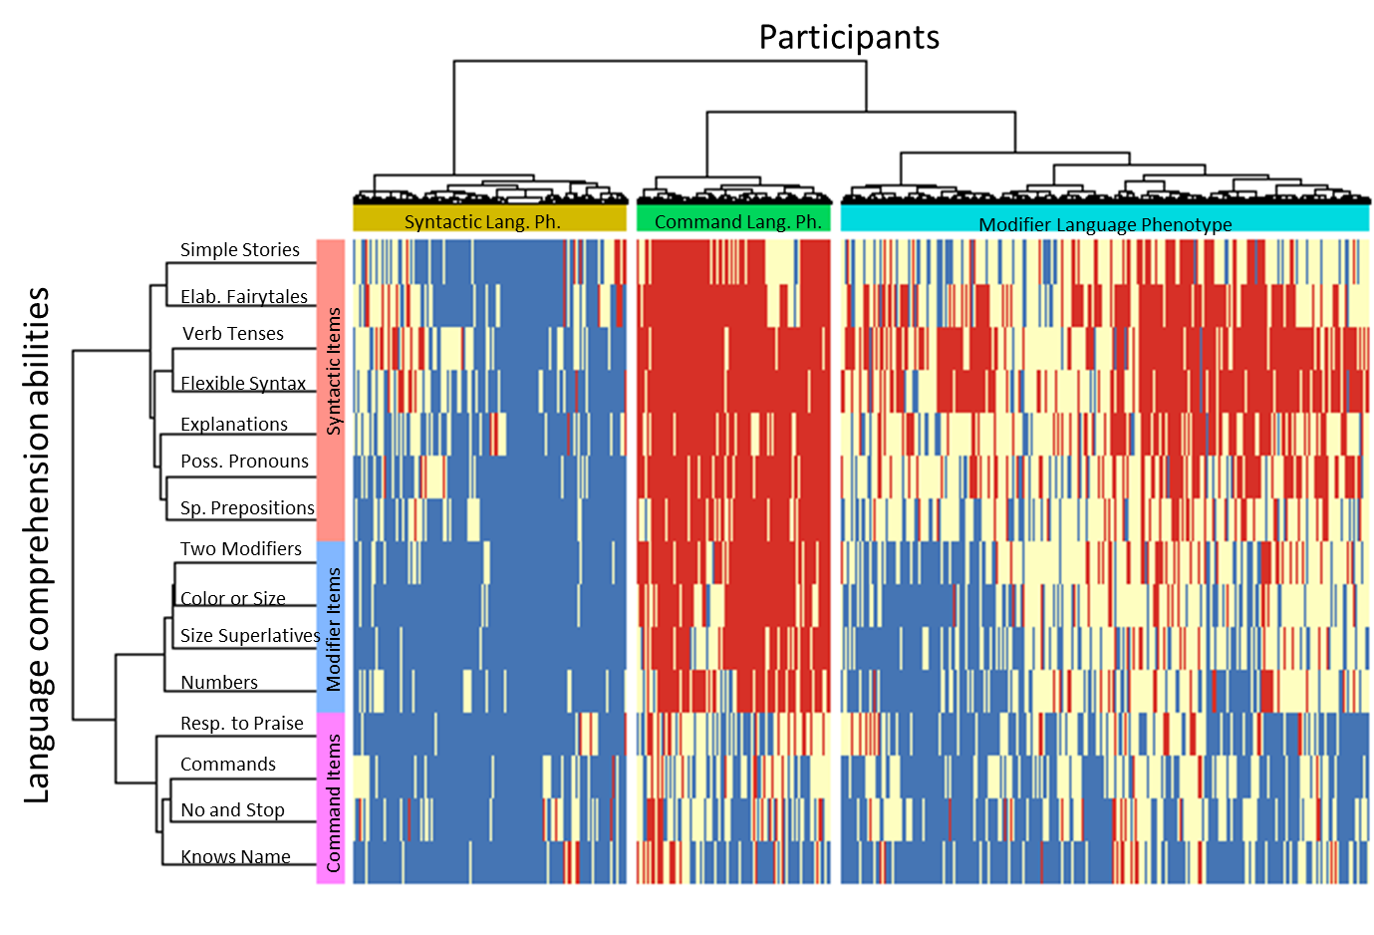Figure S6. Two-dimensional heatmap relating 31,988 participants (4 to 6 years of age) to their language comprehension abilities. The 15 language comprehension abilities are shown as rows. The dendrogram representing language comprehension abilities is shown on the left. Participants are shown as 31,988 columns. The dendrogram representing participants is shown on the top. Blue color indicates the presence of a skill (the “very true” answer), red indicates the lack of skill (the “not true” answer), and white indicates the “somewhat true” answer.

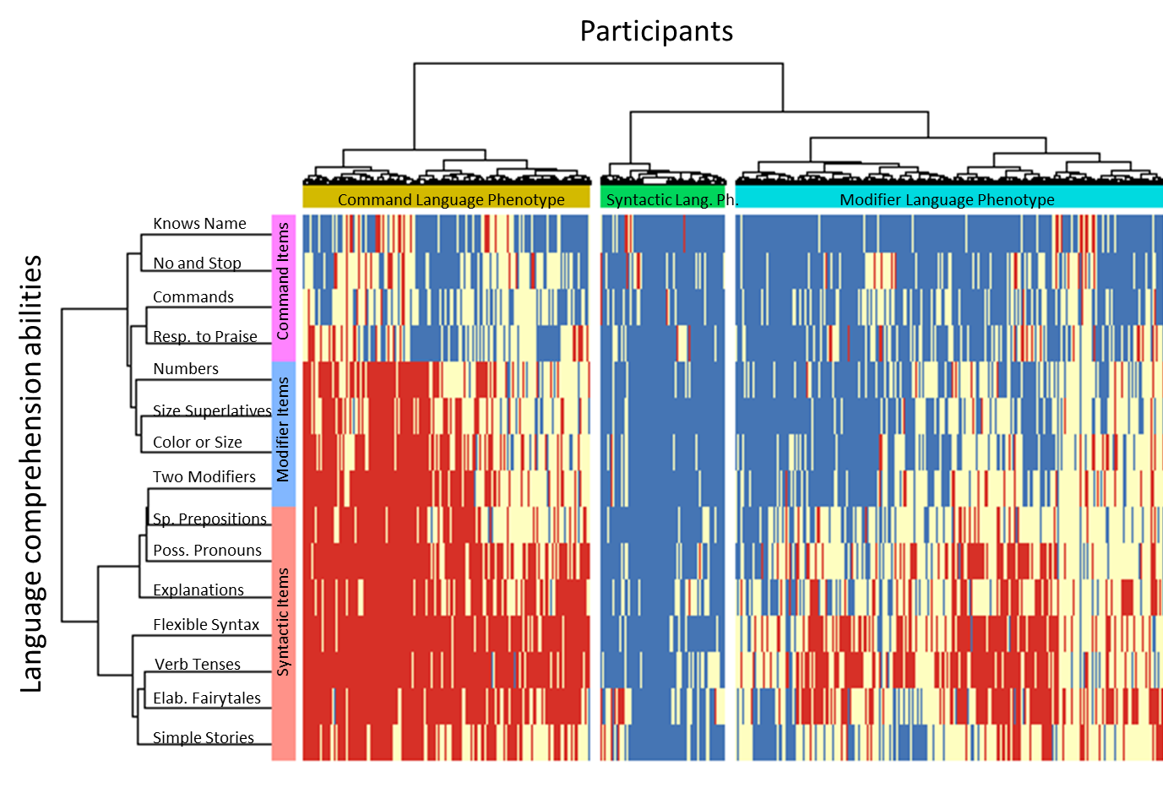
Figure S7. Two-dimensional heatmap relating 20,694 participants (6 to 12 years of age) to their language comprehension abilities. The 15 language comprehension abilities are shown as rows. The dendrogram representing language comprehension abilities is shown on the left. Participants are shown as 20,694 columns. The dendrogram representing participants is shown on the top. Blue color indicates the presence of a skill (the “very true” answer), red indicates the lack of skill (the “not true” answer), and white indicates the “somewhat true” answer.

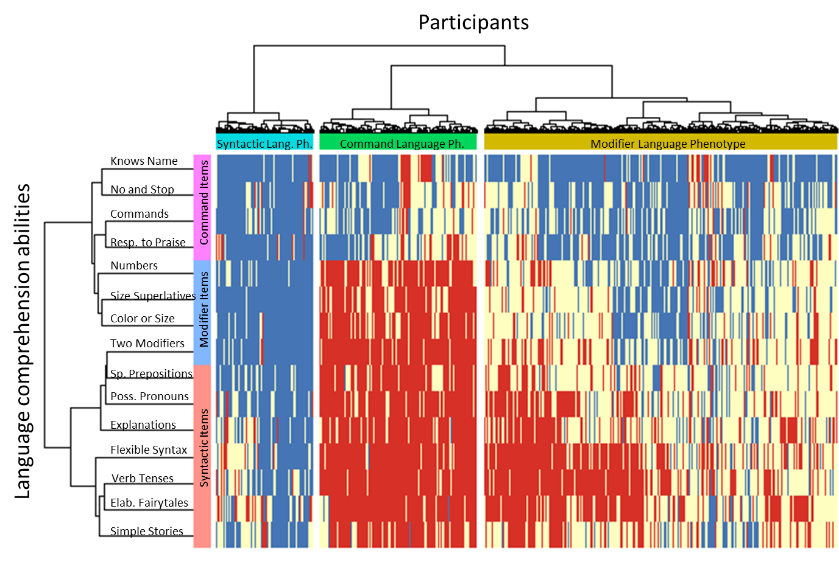Figure S8. Two-dimensional heatmap relating 2,876 participants (12 to 21 years of age) to their language comprehension abilities. The 15 language comprehension abilities are shown as rows. The dendrogram representing language comprehension abilities is shown on the left. Participants are shown as 2,876 columns. The dendrogram representing participants is shown on the top. Blue color indicates the presence of a skill (the “very true” answer), red indicates the lack of skill (the “not true” answer), and white indicates the “somewhat true” answer.

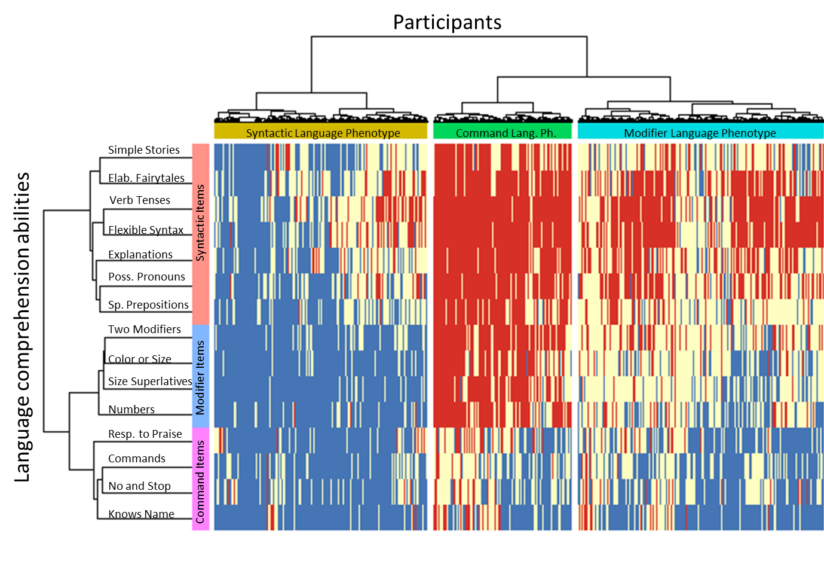
Figure S9. Two-dimensional heatmap relating 55,558 participants (4 to 21 years of age, first evaluation) to their language comprehension abilities. The 15 language comprehension abilities are shown as rows. The dendrogram representing language comprehension abilities is shown on the left. Participants are shown as 55,558 columns. The dendrogram representing participants is shown on the top. Blue color indicates the presence of a skill (the “very true” answer), red indicates the lack of skill (the “not true” answer), and white indicates the “somewhat true” answer.

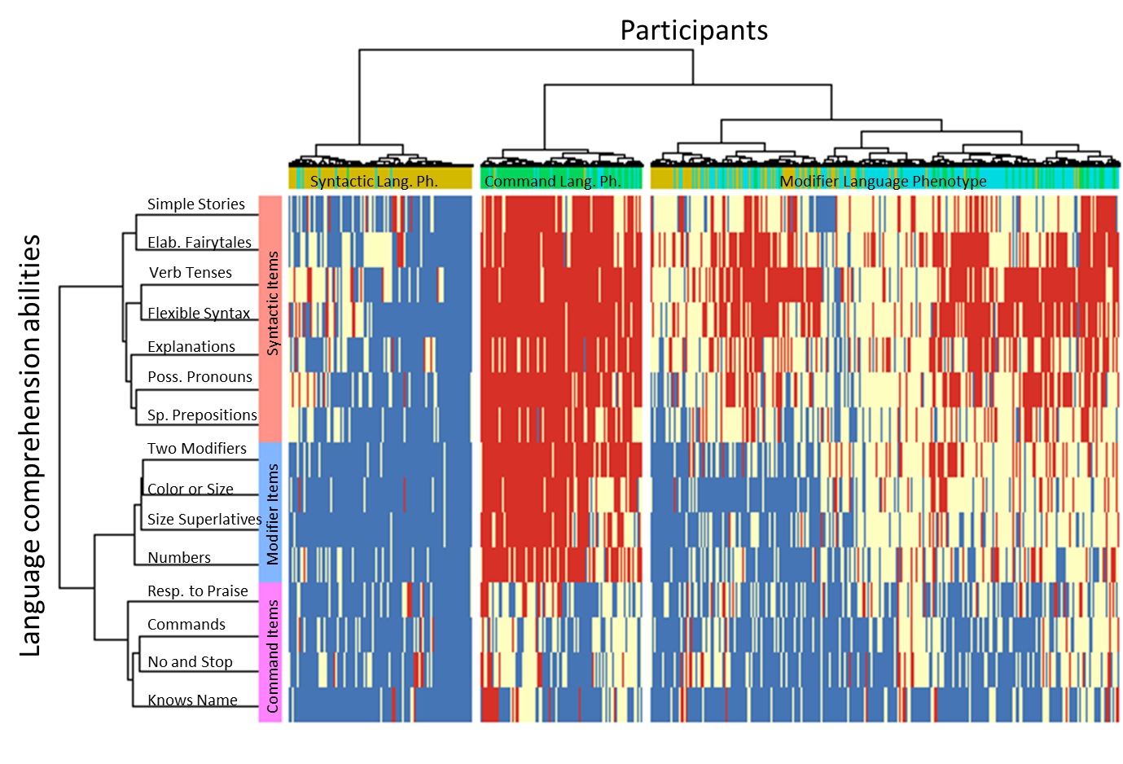
Figure S10. Two-dimensional heatmap relating 55,558 participants (4 to 21 years of age, last evaluation) to their language comprehension abilities. This heatmap uses Manhattan distance metric unlike heatmaps above that use Euclidean distance metric. The 15 language comprehension abilities are shown as rows. The dendrogram representing language comprehension abilities is shown on the left. Participants are shown as 55,558 columns. The dendrogram representing participants is shown on the top. Blue color indicates the presence of a skill (the “very true” answer), red indicates the lack of skill (the “not true” answer), and white indicates the “somewhat true” answer.

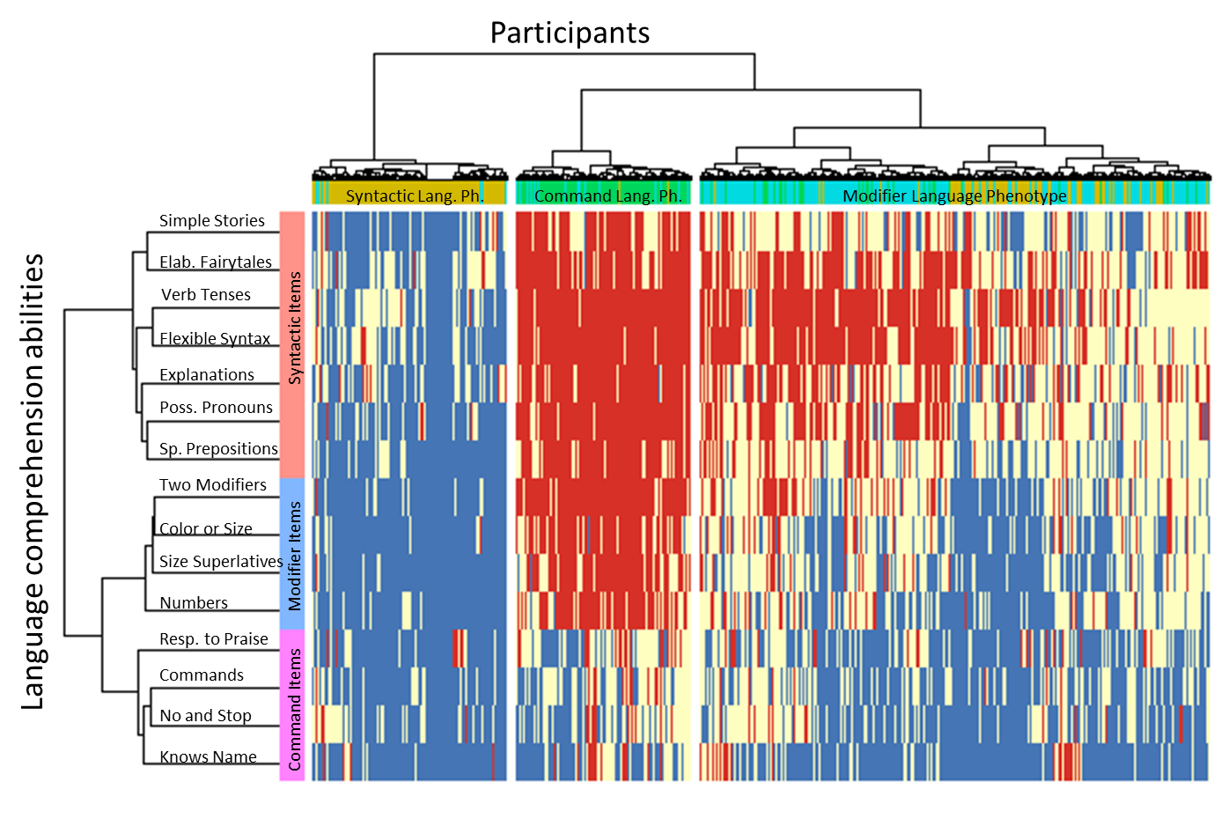
Figure S11. Two-dimensional heatmap relating 55,558 participants (4 to 21 years of age, last evaluation) to their language comprehension abilities. This heatmap uses Minkowski distance metric. The 15 language comprehension abilities are shown as rows. The dendrogram representing language comprehension abilities is shown on the left. Participants are shown as 55,558 columns. The dendrogram representing participants is shown on the top. Blue color indicates the presence of a skill (the “very true” answer), red indicates the lack of skill (the “not true” answer), and white indicates the “somewhat true” answer.

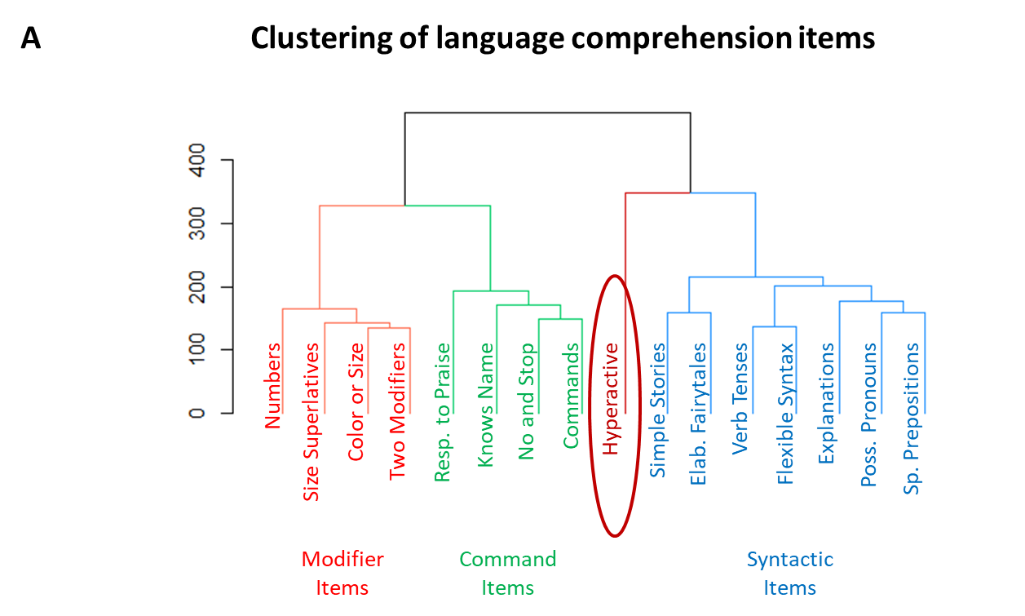

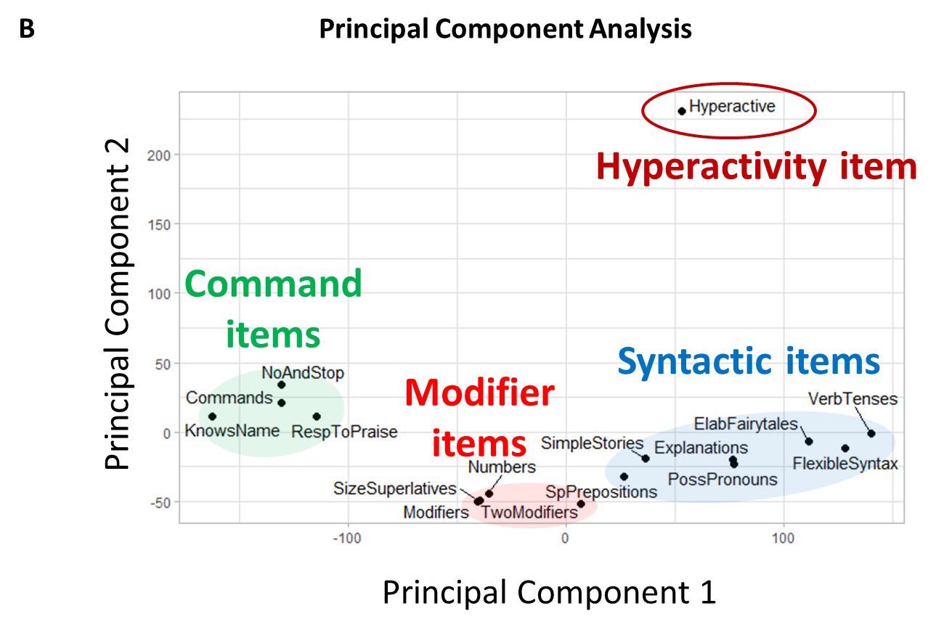
Figure S12. The clustering solution of the 15 language comprehension abilities along with the “hyperactivity” item (55,558 participants, 4 to 21 years of age, last evaluation). (A) The dendrogram representing the hierarchical clustering. (B) Principal component analysis. Principal component 1 accounts for 36.1% of the variance in the data. Principal component 2 accounts for 16.9% of the variance in the data. The hyperactivity item clusters into its own group at a significant distance from the three language clusters, confirming that hyperactivity item is not related to language comprehension abilities.
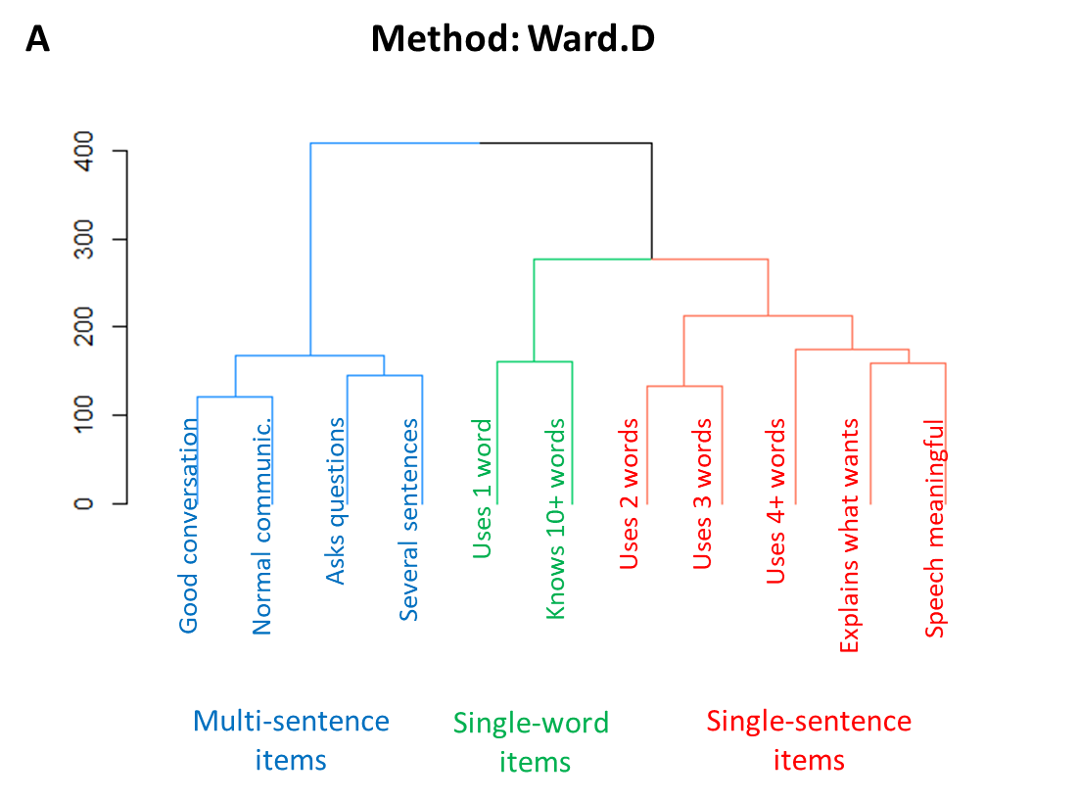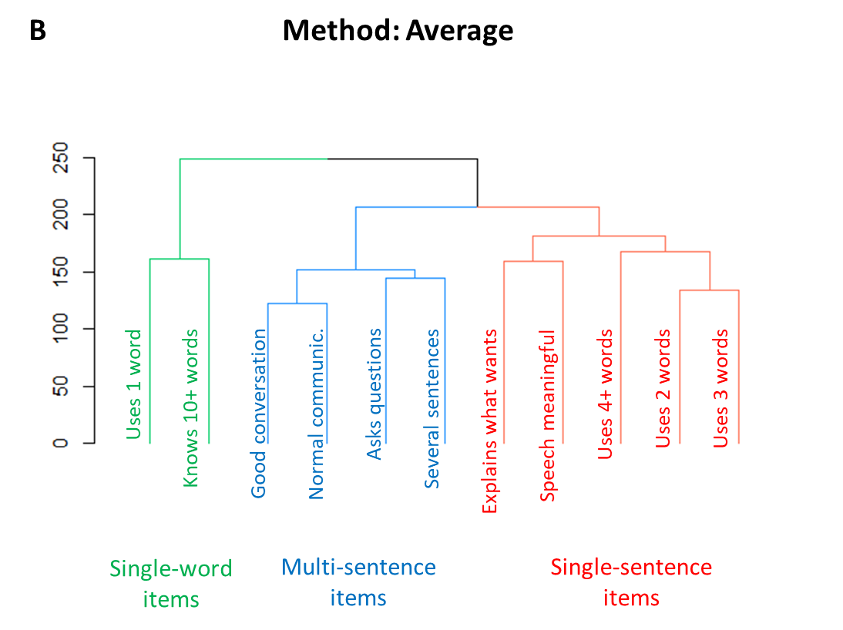

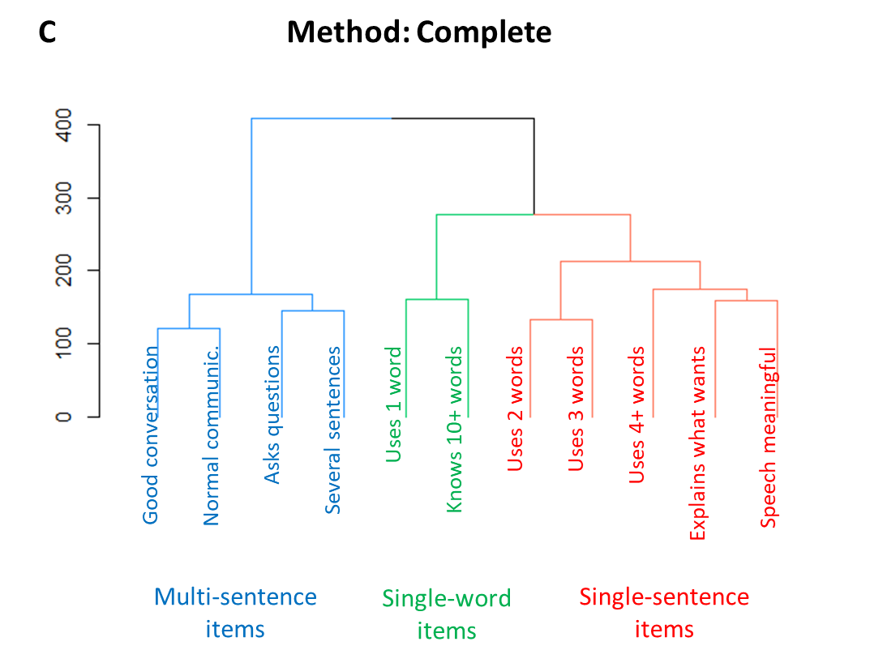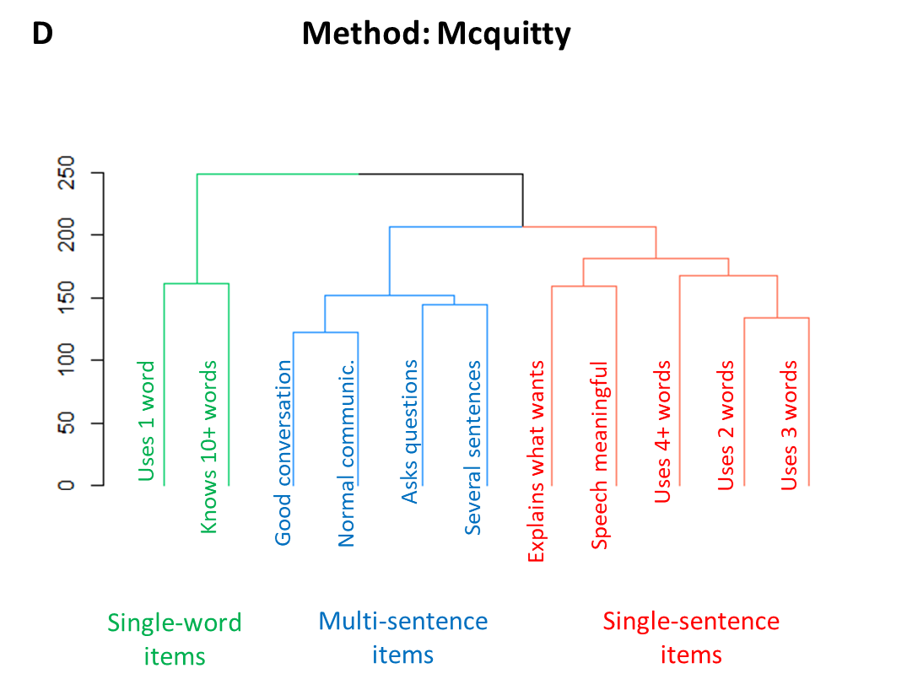

Figure S13. The three-cluster solution of the 11 expressive language abilities was stable across different evaluation methods. A: Ward.D. B: Average. C: Complete. D: Mcquitty.

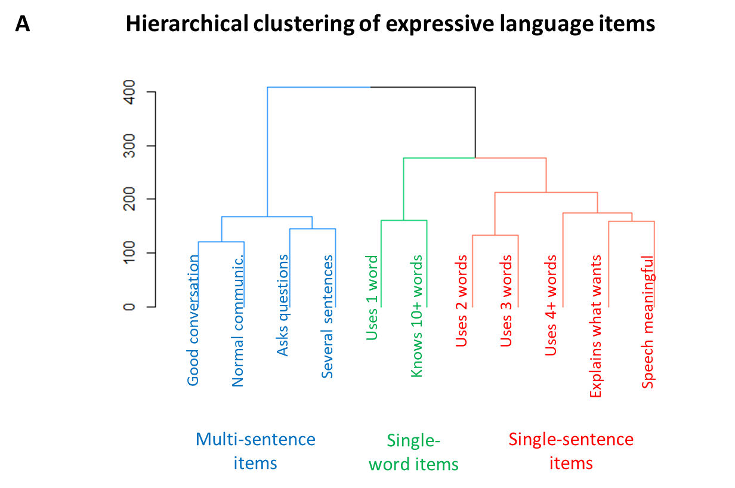
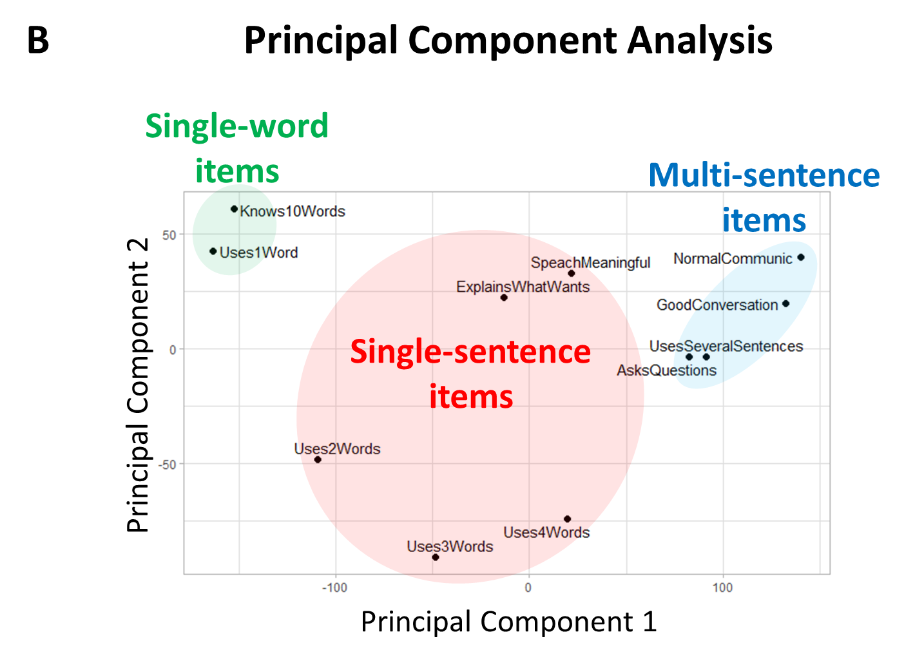
Figure S14. Clustering analysis of expressive language items (55,558 participants, 4 to 21 years of age, first evaluation). (A) The dendrogram representing the hierarchical clustering of expressive language abilities. (B) Principal component analysis of the 11 expressive language abilities. Principal component 1 accounts for 51.8% of the variance in the data. Principal component 2 accounts for 11.1% of the variance in the data.
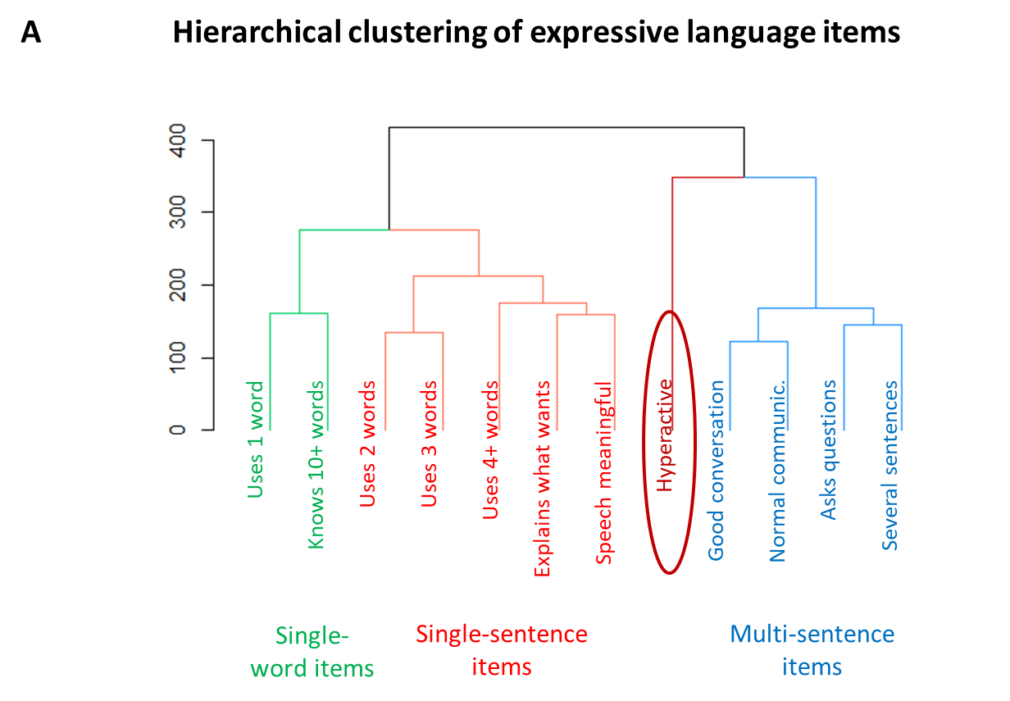
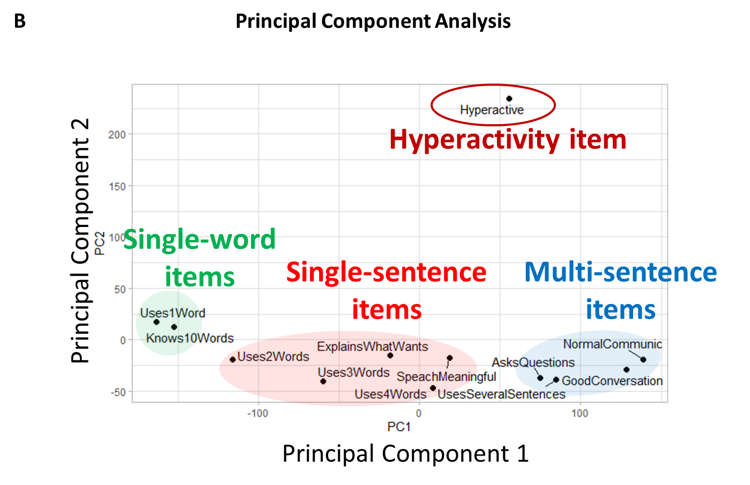
Figure S15. The clustering solution of the 11 language comprehension abilities along with the “hyperactivity” item (55,558 participants, 4 to 21 years of age, last evaluation). (A) The dendrogram representing the hierarchical clustering. (B) Principal component analysis. Principal component 1 accounts for 41.1% of the variance in the data. Principal component 2 accounts for 22.1% of the variance in the data. The hyperactivity item clusters into its own group at a significant distance from the three language clusters, confirming that hyperactivity item is not related to expressive language abilities.

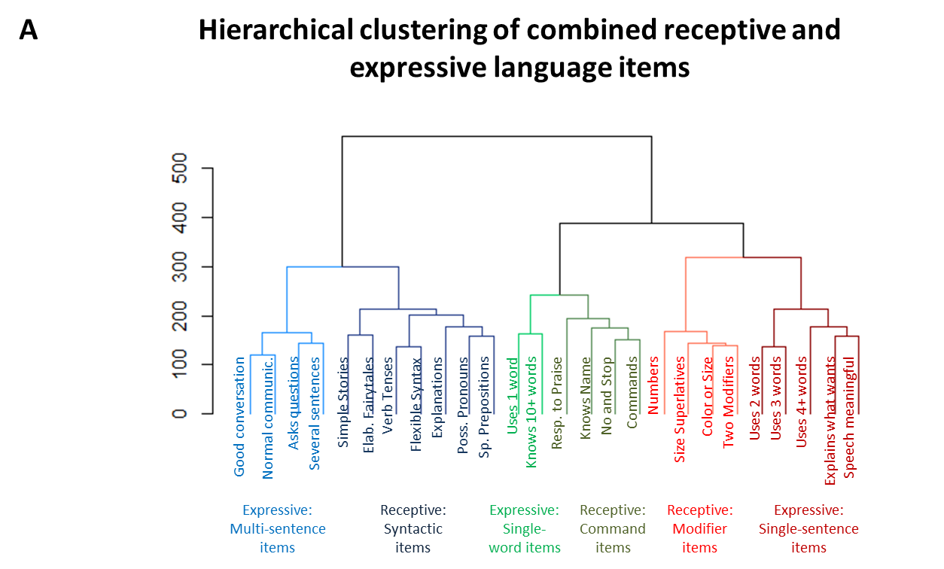

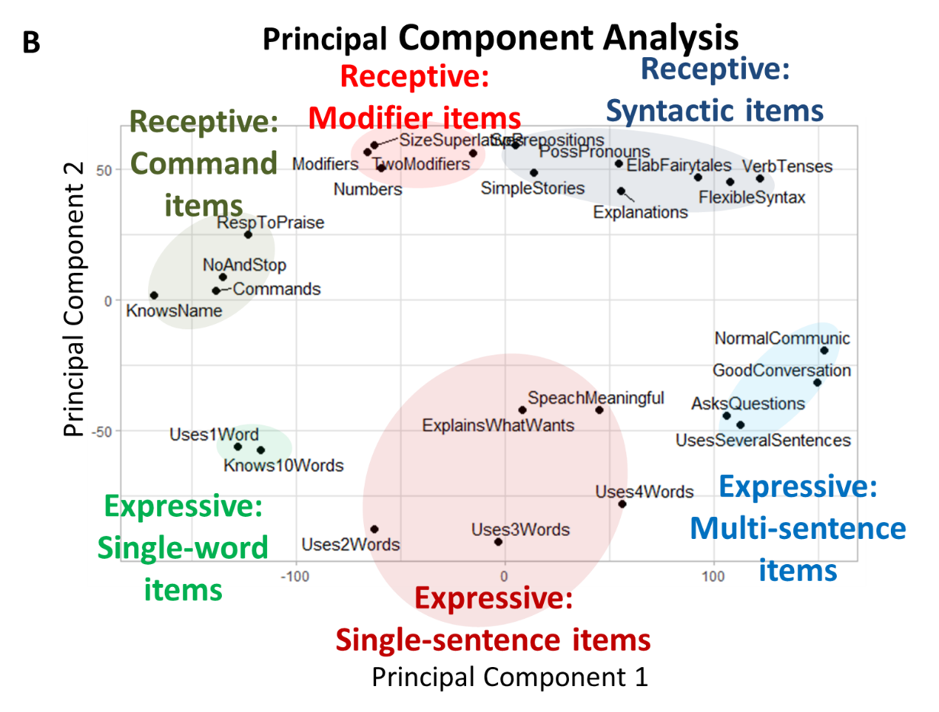
Figure S16. Clustering analysis of 15 receptive language and 11 expressive language items (55,558 participants, 4 to 21 years of age, first evaluation). (A) The dendrogram representing the hierarchical clustering of expressive and receptive language abilities. (B) Principal component analysis all expressive and receptive language abilities. Principal component 1 accounts for 38% of the variance in the data. Principal component 2 accounts for 10.6% of the variance in the data.

