Alarming patterns of mature forest loss in the Brazilian Atlantic Forest

Silvana Amaral, Jean Paul Metzger, Luis Fernando Guedes Pinto, Marcos Rosa, Bruno Vargas Adorno, Gabriel Crivellaro Gonçalves.
Supplementary Materials

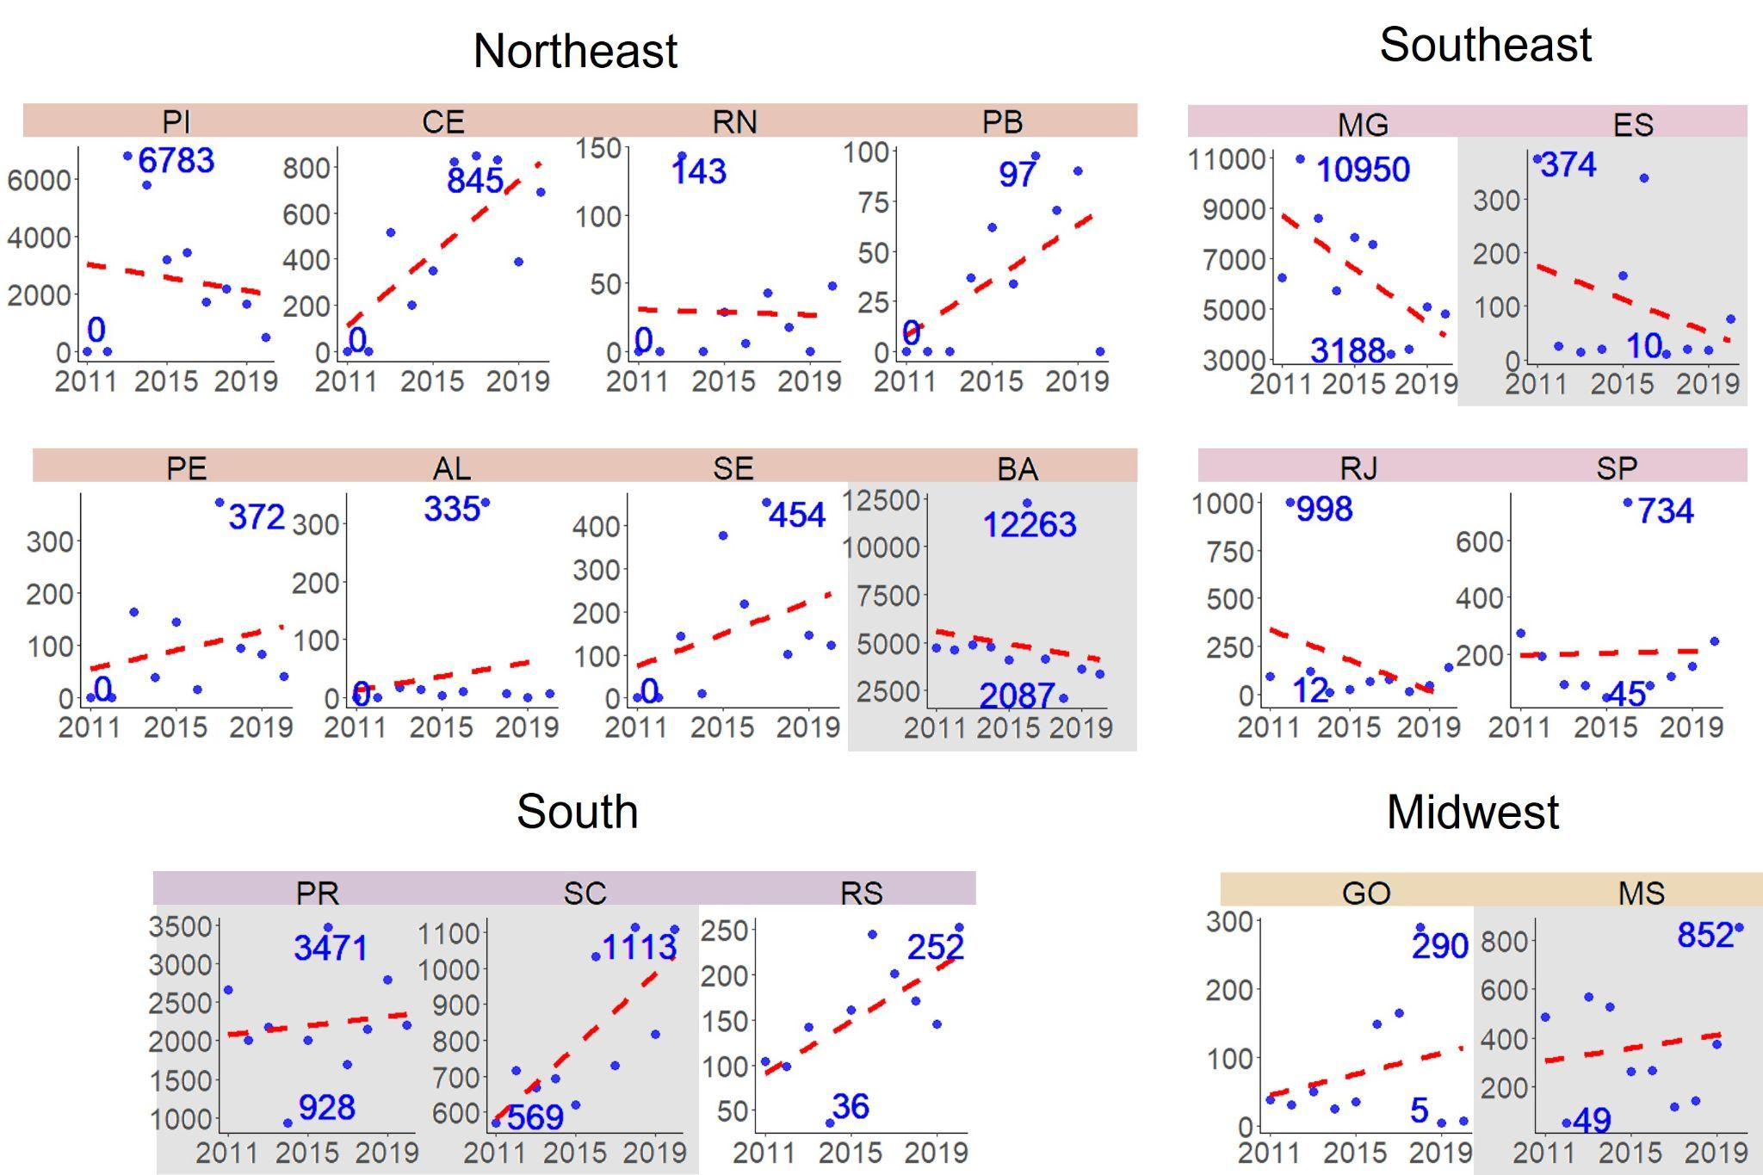
Fig.S1|Atlantic Forest deforestation trends per Brazilian states from 2010 to 2020. The grey background was found as a not significant trend (chi-squared test, α=0.05), considering the difference between the accumulated deforested area of the first (2011-2015) and last five (2016-2020) years; the Y axis is the area (hectare), X-axis the years, dashed red line is the trend line, maximum and minimum values are labeled in blue.

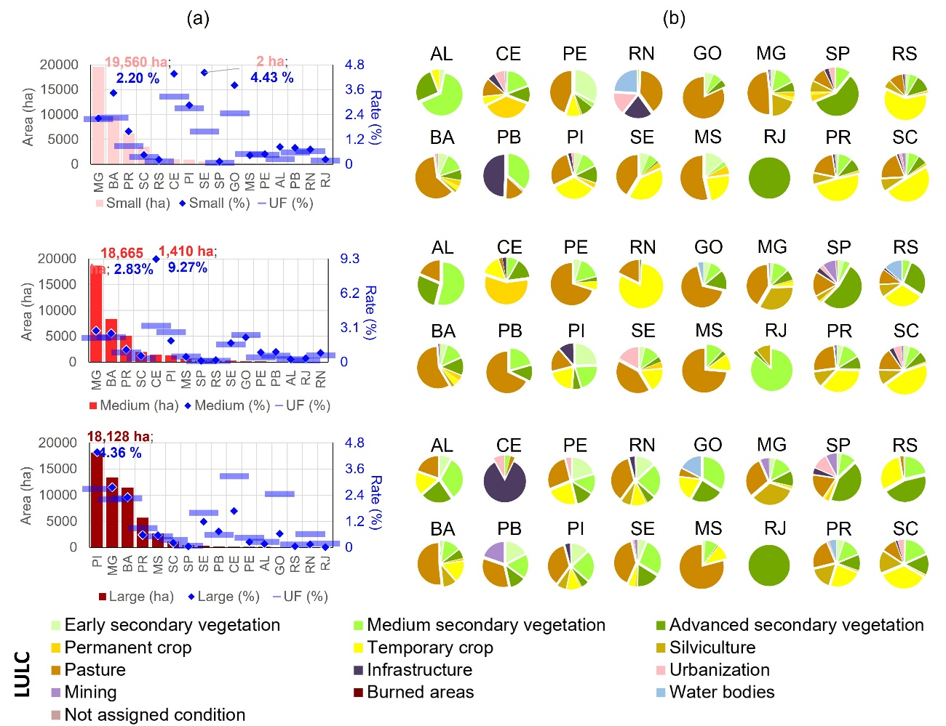Fig. S2|Atlantic Forest deforestation in private properties (a) total deforestation area and rate and (b) observed land use and cover in 2021 by state.

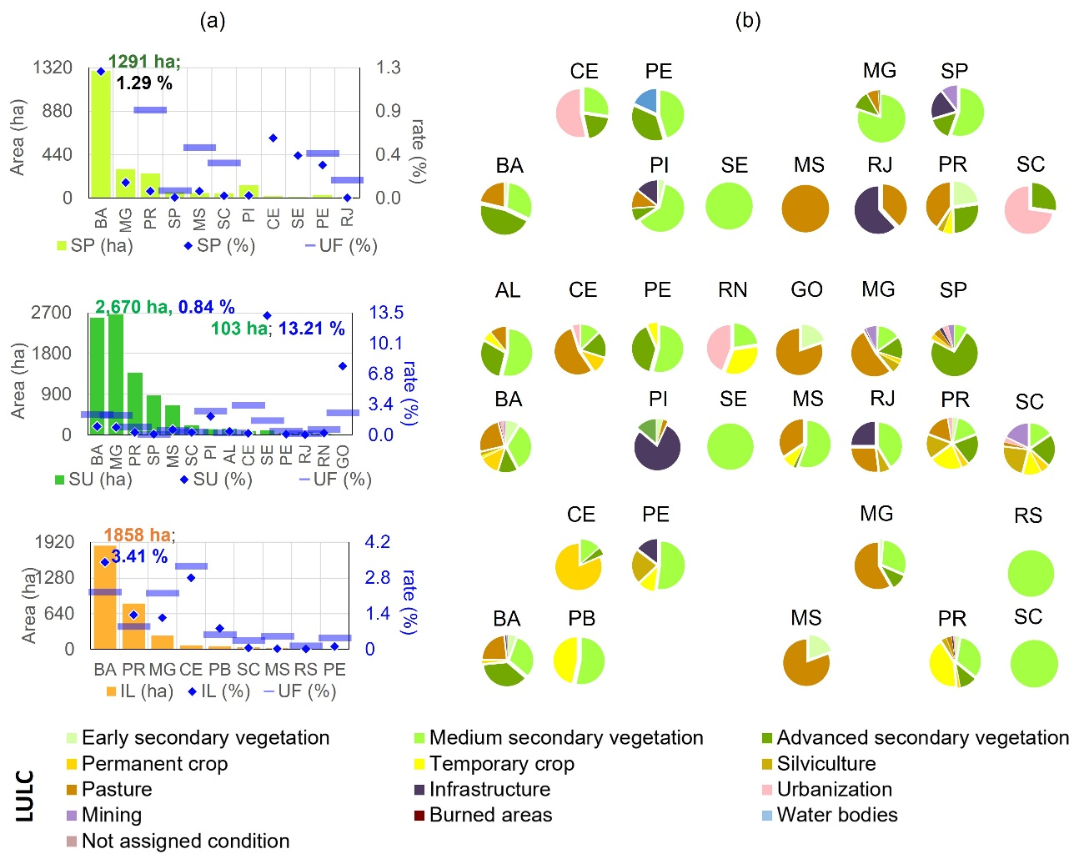Fig. S3|Atlantic Forest deforestation in strictly protected areas (SP), protected areas with sustainable use (SU), and indigenous land (IL). (a) total deforestation area and rate and (b) observed land use and cover in 2021, by land tenure and state.
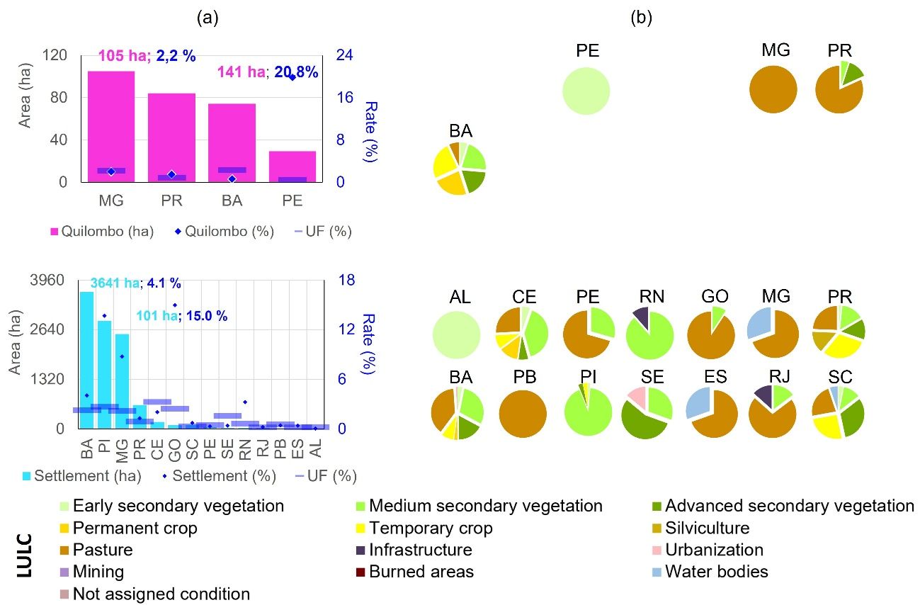Fig. S4|Atlantic Forest deforestation in quilombola lands and rural settlement projects. (a) total deforestation area and rate and(b) observed land use and cover in 2021 by state.

Table S1| Differences in median, 1st quartile, and 1st decile deforestation area distribution between BA-MG and PR hotspots associated with small, medium, and large private properties within BA-MG and PR hotspots.
 | Median (ha) |  | 1st quartile (ha) |  | 1st decile (ha)
 | observed | calculated | observed | calculated | observed | calculated
northern (n=3168) | 6.92 | - | 4.44 | - | 3.55 | -
southern (n=1942) | 5.34 | - | 3.91 | - | 3.34 | -
difference | 1.58 | 0.27 | 0.53 | 0.13 | 0.21 | 0.09
p-value | 0* |  | 0* |  | 0*
* Difference in deforestation between small, medium, and large properties is significant (α = 0.05). The calculated difference refers to the statistic value obtained with the permutation hypothesis test.

Table S2| Deforestation area associated with small, medium, and large private properties within BA-MG and PR-SC hotspots.
Hotspot | Small |  | Medium |  | Large |  | p-value
Hotspot | Absolute | Relative | Absolute | Relative | Absolute | Relative | p-value
northern | 12091 ha | 36.10% | 12109 ha | 36.10% | 9331 ha | 27.80% | 0.505
southern | 4845 ha | 47.10% | 970.66 ha | 27.80% | 930.97 ha | 25.20% | 0.0134
* Difference in deforestation between small, medium, and large properties is significant according to the Chi-squared test (α = 0.05)

Table S3| Legend and classification key for each Land use and cover.
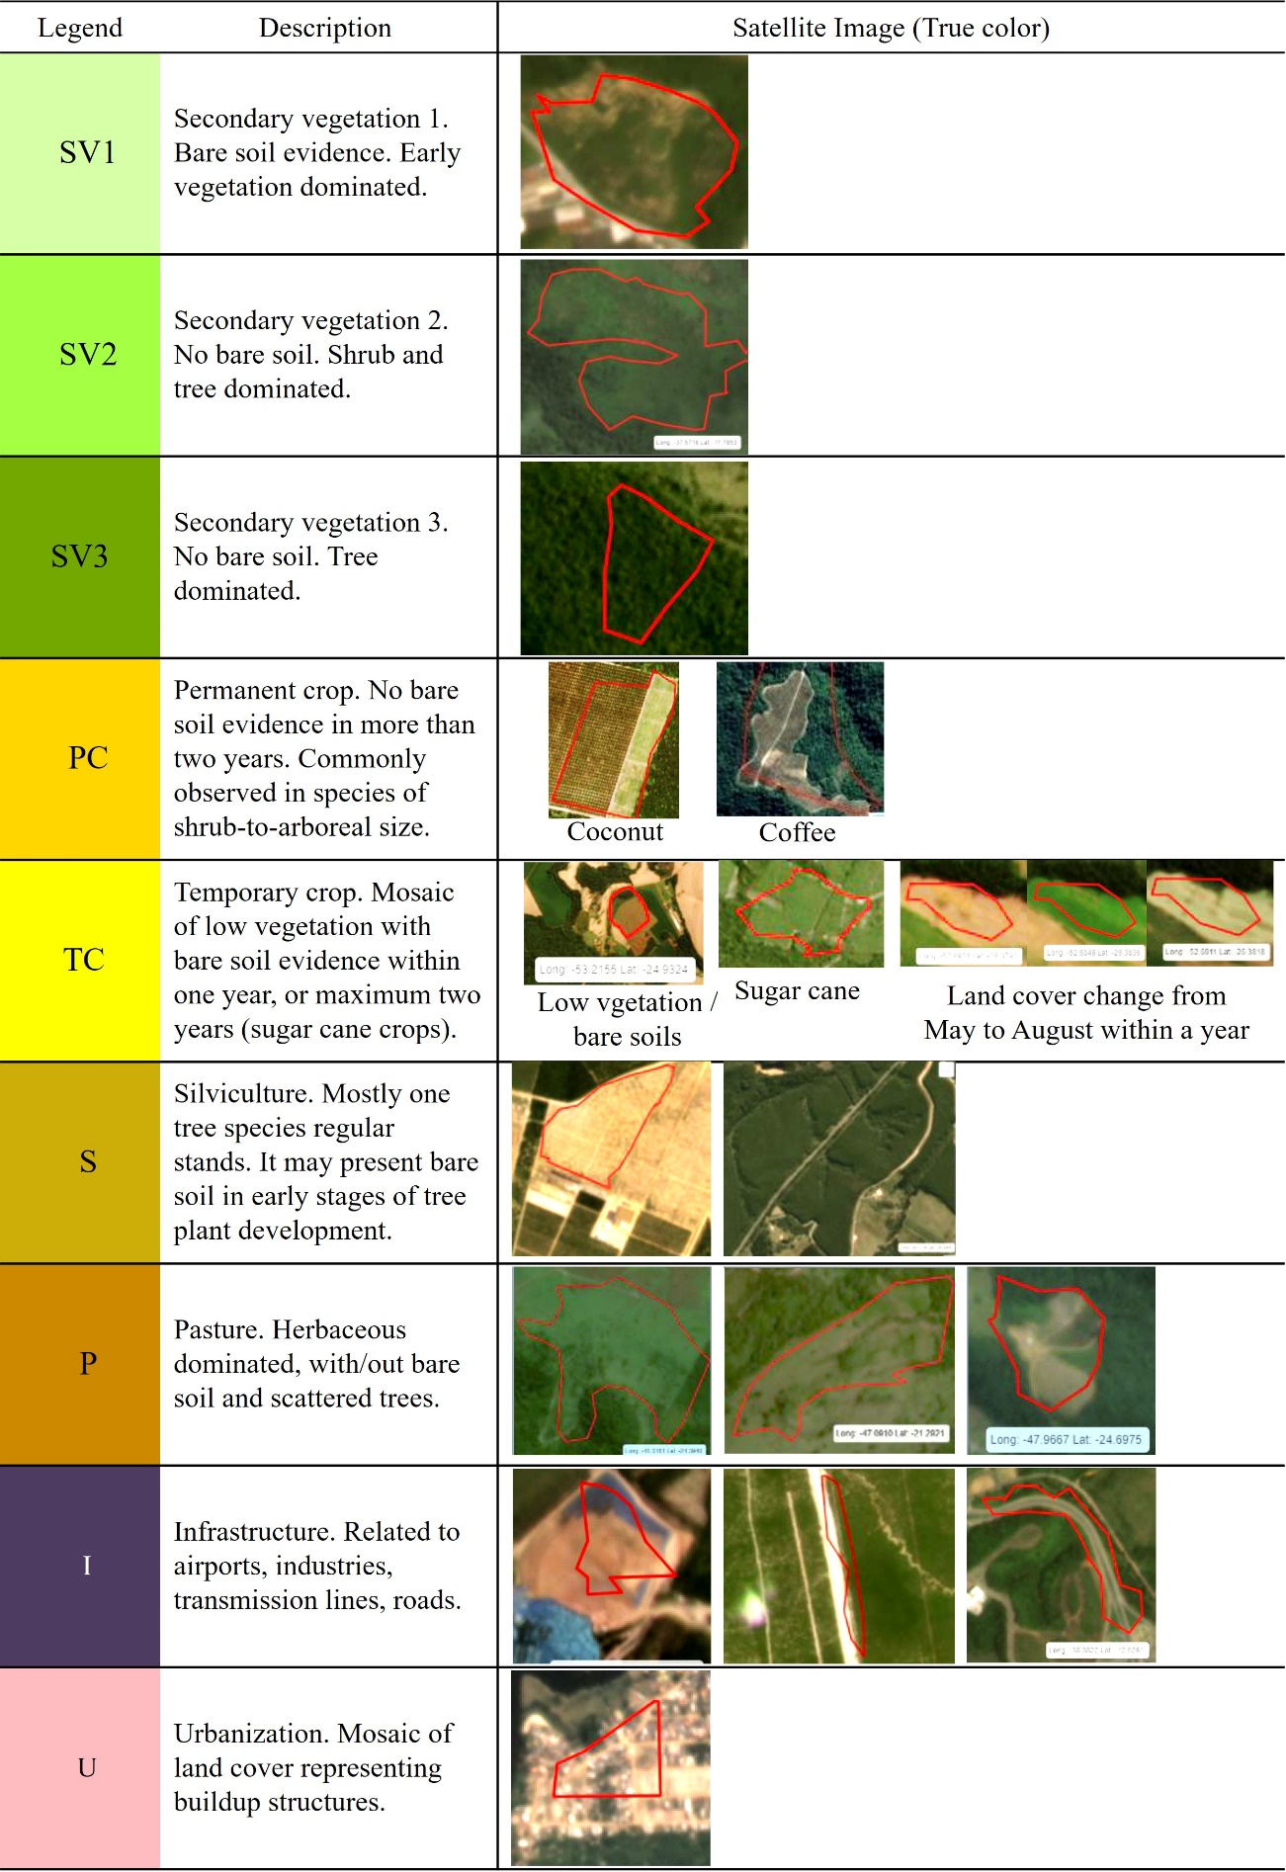
(to be continued)

Table 3| Continuing.
