Supporting Information

Photoelectrochemical Ni-Catalyzed Cross-Coupling of Aryl Bromides with Amine at Ultra-Low Potential
Jinghao Wang,‡ Siyang Li,‡ Caoyu Yang, Huiwen Gao, Lulu Zuo, Zhiyu Guo, Pengqi Yang, Yuheng Jiang, Jian Li* Li-Zhu Wu* and Zhiyong Tang*
*Email of corresponding author: lijian1991@mail.ipc.ac.cn lzwu@mail.ipc.ac.cn zytang@nanoctr.cn

1. Materials and methods 2
2. General experimental procedures 3
3. Comparison between different methods 4
4. Linear sweep voltammograms 5
5. Cyclic voltammograms 6
6. Control experiments and radical trapping experiment 8
7. Computational details 10
8. References 32
9. Characterization data for all products 34
10. ¹H and ¹³C Spectra of all products 48

1. Materials and methods
¹H NMR spectra were recorded using a Bruker Avance DPX 400 MHz instrument with tetramethylsilane (TMS) as an internal standard. ¹³C NMR spectra were obtained at 101 MHz and referenced to the internal solvent signals. Multiplicities were indicated, where s (singlet), d (doublet), t (triplet), q (quartet), m (multiplet) and coupling constants (J) were in Hertz (Hz). Electrospray ionization (ESI) high-resolution mass spectra (HR-MS) were recorded on a Q EXACTIVE (Thermo Fisher) mass spectrometer. Commercially available reagents and solvents were used without further purification. The linear sweep voltammetry and cyclic voltammetry curves were achieved on a CHI 760E potentiostat. Photoelectrochemical experiments were carried out with 465 nm blue light emitting diode (LED). Figure S1 was the schematic diagram for the reaction setup. Thin layer chromatography (TLC) was attained with glass 0.25 mm silica gel plates. Flash chromatography columns were packed with 200-300 mesh silica gel in petroleum ether.
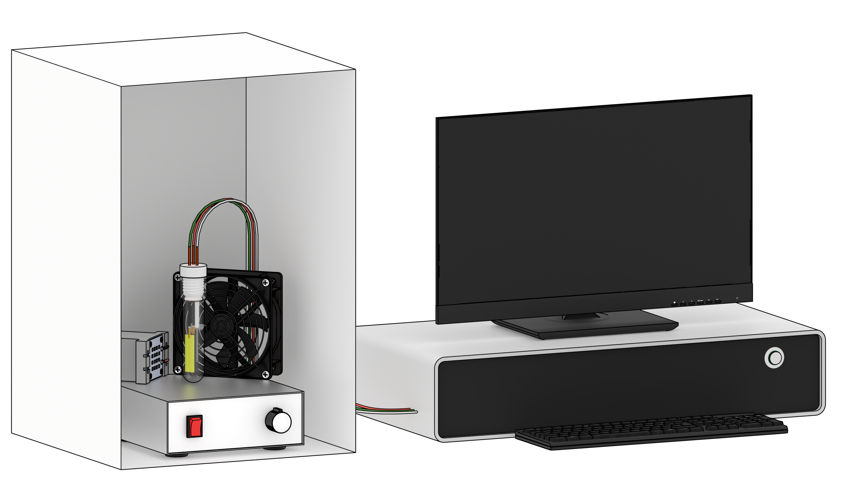
Figure S1. Schematic diagram of home-made reaction setup for photoelectrocatalysis.

2. General experimental procedures
2.1 Preparation of BiVO₄ electrode
The BiVO₄ electrode was prepared by a electrodeposition-calcination method. First, fluorine-doped tin oxide (FTO) substrates were sonicated with acetone, ethanol and water for 30 min each. Bi(NO₃)₃·5H₂O (0.04 M) and KI (0.4 M) were dissolved in 60 mL distilled water to form a clear solution. Then, HNO₃ was added to adjust pH value to 1.7. Next, 0.23 M p-benzoquinone ethanol solution (25 mL) was added to above mixed solution and stirred vigorously for 20 min. The electrodeposition was carried out in a three-electrode cell using a constant potential of -0.1 V vs Ag/AgCl for 600 seconds at room temperature, where FTO, Pt and Ag/AgCl were employed as working electrode, counter electrode and reference electrode, respectively. After the electrodeposition, a uniform red-brown film (BiOI) was formed on the FTO substrate. Then, 200 μL of a DMSO solution containing 0.2 M vanadyl acetylacetonate was placed on the BiOI electrode, and the electrode was calcined at 450°C for 1 h with a heating rate of 2°C min⁻¹. After being cooled down to room temperature, the electrode was soaked in 1.0 M NaOH solution to remove the excess V₂O₅. Finally, the BiVO₄ electrode was rinsed with distilled water and dried with N₂ gas.
2.2 General procedure for the photoelectrocatalysis
In a nitrogen-filled glove box, an oven-dried photoelectrochemical cell equipped with a stir bar was charged with NiBr₂·glyme (0.02 mmol, 10 mol%), dtbbpy (0.03 mmol, 15 mol%), DABCO (0.4 mmol, 2 equiv), LiBr (0.2 M), methyl 4-bromobenzoate (0.2 mmol) and acetone (5 mL). The mixture was stirred at room temperature for 1 minute. Then, N-methylaniline (0.4 mmol, 2 equiv) was added. The vial was sealed with the home-made cap, which was equipped with a BiVO₄ photoanode (1.2 cm × 2.5 cm), a nickel foam cathode (1.0 cm × 3.0 cm) and an Ag/AgNO₃ reference electrode, and then brought out of the glove box. After pre-stirring the resulting mixture for 1 minute, photoelectrocatalysis was performed at a constant potential of -0.4 V vs. Ag/AgNO₃ for 12 h. When the reaction was finished, the entire reaction mixture was then transferred to a silica gel column and purified with a mixture of hexane and ethyl acetate to give the corresponding products.

3. Comparison between different methods
Table S1. Species proportion, yield and selectivity of photochemical (PC), electrochemical (EC), and photoelectrochemical (PEC) Ni catalysis.
Method | Proportion (%) |  |  | Yield of Product (%) | Selectivity (%)
Method | Reactant (2) | By-products | Product (3) | Yield of Product (%) | Selectivity (%)
PC | 100 | 0 | 0 | 0 | N/A
EC | 74.7 | 9.7 | 15.6 | 15.6 | 61.8
PEC | 10.0 | 8.0 | 82.0 | 82.0 | 89.1
Reaction conditions: PC: standard condition without electricity; EC: standard condition without light irradiation, the bias was raised to +1.5 V vs. Ag/AgNO₃; PEC: standard condition: BiVO₄ photoanode (1.2 cm × 2.5 cm), Ni foam cathode (1.0 cm ×3.0 cm), Ag/AgNO₃ as reference electrode, 1 (0.4 mmol), 2 (0.2 mmol), LiBr (0.2 M), NiBr₂·glyme (0.02 mmol), dtbbpy (0.03 mmol), DABCO (2 equiv), acetone (5.0 mL), E = –0.4 V vs Ag/AgNO₃, blue LED, 12 h, N₂.
The proportion of species X (X = 2, 3) was determined by the following formula:
$$Proportion\left(X\right)=\frac{n\left(X\right)}{n_{0}\left(2\right)}×100\%,$$
where $n\left(X\right)$ was the amount of substance of species X determined by ¹H NMR spectrum, and $n_{0}\left(2\right)$ was the amount of substance of the reactant 2 before the reaction.
The proportion of by-products was estimated using the following formula:
$$Proportion\left(by\text{-}products\right)=100\%-Proprotion\left(2\right)-Proportion\left(3\right).$$
The yield of product 3 was equivalent with the proportion of 3 because their definition was identical.
The selectivity of the reaction was determined using the following formula:
$$Selectivity=\frac{n(3)}{n_{0}\left(2\right)-n(2)}×100\%=\frac{Proportion(3)}{100\%-Proportion(2)}×100\%$$

4. Linear sweep voltammograms
Figure S2. LSV curves of BiVO₄ photoanode under irradiation (pink), dark (black) and in the absent of DABCO (blue).
The LSV curves are recorded in acetone that contains NiBr₂·glyme (0.02 mmol), dtbbpy (0.03 mmol), DABCO (0.4 mmol), LiBr (0.2 M), methyl 4-bromobenzoate (0.2 mmol) and N-methylaniline (0.4 mmol). BiVO₄, Ni foam and, Ag/AgNO₃ are employed as working electrode, counter electrode and reference electrode, respectively. The scan rate is set to be 100 mV/s.

5. Cyclic voltammograms
Figure S3. CV curves of blank electrolyte (black), in the presence of DABCO (0.005 M, orange), N-methylaniline (0.005 M, blue), and the mixture of DABCO and N-methylaniline (pink).
The cyclic voltammetry (CV) is carried out with a Shanghai Chenhua CHI760E workstation. A glassy-carbon electrode is used as the working electrode, a Pt plate is employed as the counter electrode and an Ag/AgNO₃ electrode is utilized as the reference electrode in acetone. The measurements are carried out at a scan rate of 100 mV s^{–1}. The operation temperature is 298 K. ^{n}Bu₄NPF₆ (0.1M) is selected as the electrolyte.

Figure S4. CV curves of blank electrolyte (black), methyl 4-bromobenzonate (denoted as Ar-Br, 0.005 M, blue), NiBr₂ glyme + dtbbpy (denoted as NiL, 0.005M [Ni] + 0.0075M L, orange), and the mixture of Ar-Br and NiL (pink).
The cyclic voltammetry (CV) is carried out with a Shanghai Chenhua CHI760E workstation. A glassy-carbon electrode is used as the working electrode, a Pt plate is employed as the counter electrode and an Ag/AgNO₃ electrode is utilized as the reference electrode in acetone. The measurements are carried out at a scan rate of 100 mV s^{–1}. The operation temperature is 298 K. ^{n}Bu₄NPF₆ (0.1M) is selected as the electrolyte.

6. Control experiments and radical trapping experiment
a) H cell experiments:
In a nitrogen-filled glove box, an oven-dried H cell cathode-chamber equipped with a stir bar was charged with NiBr₂·glyme (0.02 mmol, 10 mol%), dtbbpy (0.03 mmol, 15 mol%), DABCO (0.4 mmol, 2 equiv), LiBr (0.2 M), methyl 4-bromobenzoate (0.2 mmol) and acetone (6 mL). The anode-chamber equipped with a stir bar was charged with LiBr (0.2 M) and acetone (6 mL). The mixture was stirred at room temperature for 1 minutes, and N-methylaniline (0.4 mmol, 2 equiv) was sequentially added. The H cell was sealed with the home-made cap equipped with BiVO₄ photoanode (1.2 cm × 2.5 cm), nickel foam cathode (1.0 cm × 3.0 cm) and Ag/AgNO₃ reference electrode, and then brought out of glove box. After pre-stirring the mixture for 1 minute, photoelectrocatalysis was performed at a constant potential of -0.4 V vs. Ag/AgNO₃ for 12 h. After the reaction was finished, the yield of product was detected by ¹H NMR analysis using benzhydrol as the internal standard.
b) Radical capture:
In a nitrogen-filled glove box, an oven-dried photoelectrochemical cell equipped with a stir bar was charged with NiBr₂·glyme (0.02 mmol, 10 mol%), dtbbpy (0.03 mmol, 15 mol%), DABCO (0.4 mmol, 2 equiv), LiBr (0.2 M), methyl 4-bromobenzoate (0.2 mmol), BHT (0.4 mmol, 2 equiv) and acetone (5 mL). The mixture was stirred at room temperature for 1 minutes, and N-methylaniline (0.4 mmol, 2 equiv) was sequentially added. The vial was sealed with the home-made cap equipped with BiVO₄ photoanode (1.2 cm × 2.5 cm), nickel foam cathode (1.0 cm × 3.0 cm) and Ag/AgNO₃ reference electrode, and then brought out of glove box. After pre-stirring the mixture for 1 minute, photoelectrocatalysis was performed at a constant potential of -0.4 V vs. Ag/AgNO₃ for 12 h. After the reaction was finished, the yield of product was measured by ¹H NMR analysis using benzhydrol as the internal standard.
c) Control experiments:
In a nitrogen-filled glove box, an oven-dried photoelectrochemical cell equipped with a stir bar was charged with DABCO (0.4 mmol, 2 equiv), LiBr (0.2 M) and acetone (5 mL). The mixture was stirred at room temperature for 1 minutes, and N-methylaniline (0.2 mmol) was sequentially added. The vial was sealed with the home-made cap equipped with BiVO₄ photoanode (1.2 cm × 2.5 cm), nickel foam cathode (1.0 cm × 3.0 cm) and Ag/AgNO₃ reference electrode, and then brought out of glove box. After pre-stirring the mixture for 1 minute, photoelectrocatalysis was performed at a constant potential of -0.4 V vs. Ag/AgNO₃ for 6 h. After the reaction was finished, the yield of product was detected by ¹H NMR analysis using benzhydrol as the internal standard.

7. Computational details
Density functional theory (DFT) calculations were carried out using Gaussian 16 programs^{[1]} throughout this manuscript. Geometric optimizations were performed using M06-L functional^{[2]}. The standard 6-31+G** basis was set^{[3-5]} for H, C, N and O atoms. For the Ni and Br atoms, the SDD basis set and its corresponding effective core potential^{[6-7]} were used. Harmonic vibration frequency calculations were performed for all stationary points to confirm them as a local minima or a transition state. The intrinsic reaction coordinate (IRC) scheme^{[8-9]} was applied for the calculations of the reaction coordinates to confirm whether or not the transition states were directly connected to the reactants and products. Approximate solvent effects were taken into consideration based on the SMD continuum solvation model^{[10]} in all calculations.
Table S2. Energetics for all species involved (in Hartree)
Model | E | Thermal Correction | G
Br anion | -13.536815 | -0.016176 | -13.552991
N-Methylaniline 1 | -326.895042 | 0.11406 | -326.780982
methyl-4-bromobenzoate 2 | -472.870695 | 0.094943 | -472.775752
3 | -785.796635 | 0.224158 | -785.572477
DABCO 6 | -345.307097 | 0.152228 | -345.154869
DABCO cation radical 7 | -345.136868 | 0.153039 | -344.983829
protonated DABCO 8 | -345.777256 | 0.168507 | -345.608749
NMe radical 9 | -326.247377 | 0.099287 | -326.148090
11 | -994.328203 | 0.325594 | -994.002609
12 | -1467.232027 | 0.446722 | -1466.785305
13 | -1453.825425 | 0.450577 | -1453.374848
14 | -1780.111461 | 0.573748 | -1779.537713
15 | -1780.723489 | 0.58684 | -1780.136649
HAT TS | -672.031324 | 0.28152 | -671.749804
TS1 | -1467.210624 | 0.447288 | -1466.763336
TS2 | -1780.087894 | 0.572893 | -1779.515001
TS2' | -1780.722231 | 0.590079 | -1780.132152
TS3 | -1780.094887 | 0.575259 | -1779.519628

Figure S5. Computed energy profile of hydrogen atom transfer (HAT) process.

Cartesian coordinate for all species involved (in angstrom)
1
C -1.87807900 -0.98966900 0.03977500
C -2.30726500 0.34166600 0.03384100
C -1.34914500 1.35342200 -0.01106800
C 0.01256300 1.05622200 -0.04956100
C 0.44730100 -0.28284000 -0.05384600
C -0.52600000 -1.30231600 -0.00362400
H -2.60658900 -1.79620700 0.08016800
H -3.36600000 0.58157100 0.06750900
H -1.65990100 2.39572400 -0.01026600
H 0.73899400 1.86323700 -0.07754400
H -0.20112900 -2.34090000 -0.00056400
N 1.78488200 -0.61497100 -0.14305700
H 2.00611400 -1.55046800 0.16682600
C 2.81516100 0.36806500 0.09761200
H 2.71294100 0.87184700 1.07124200
H 3.78656200 -0.12672900 0.06529700
H 2.80762000 1.13942500 -0.68003600

2
C 0.80290800 1.27277500 0.00000500
C 1.39261500 0.01246000 0.00000100
C 0.64075800 -1.15793900 -0.00001800
C -0.74673600 -1.05853000 -0.00002600
C -1.36890600 0.19574300 -0.00002000
C -0.58456600 1.35459100 -0.00000800
H 1.40712100 2.17346900 0.00001300
H 1.12083500 -2.13053600 -0.00002500
H -1.34502400 -1.96350600 -0.00003700
H -1.07115200 2.32534000 -0.00000300
Br 3.33149800 -0.11698000 0.00000800
C -2.84187000 0.34937600 -0.00003300
O -3.42165700 1.42299400 0.00000000
O -3.47898000 -0.83518900 0.00000000
C -4.91259200 -0.75929300 0.00003800
H -5.26093000 -1.79080300 0.00005000
H -5.26889700 -0.23860800 0.89160300
H -5.26894400 -0.23861200 -0.89151200

3
C 0.32940400 0.69957300 -0.00665200
C -0.00840800 -0.63123700 0.33819100
C -0.72878300 1.59574100 -0.28387700
C -1.32778700 -1.03619000 0.37953500
H 0.77234000 -1.33992300 0.59231100
C -2.04780100 1.17350600 -0.24089400
H -0.51724100 2.62733600 -0.54099100
C -2.37733300 -0.14980300 0.08488400
H -1.56764200 -2.05924800 0.65617200
H -2.83612000 1.88460700 -0.46817700
C -3.75792500 -0.64222900 0.14104500
O -4.08271000 -1.78945100 0.41834300
O -4.66427100 0.31947300 -0.15154800
C -6.03250000 -0.10220000 -0.11527400
H -6.61962600 0.77721400 -0.37736000
H -6.21073300 -0.90311900 -0.83699300
H -6.30433000 -0.45192900 0.88371500
N 1.63867400 1.13777500 -0.02024700
C 2.74335400 0.24729000 -0.03169900
C 1.90648100 2.56446600 -0.13083700
C 3.82686300 0.46974900 0.82736900
C 2.78598500 -0.83428100 -0.92119900
H 2.97746300 2.73632900 -0.03710000
H 1.58658700 2.95566400 -1.10467500
H 1.39152100 3.12613400 0.65528600
C 4.93148700 -0.37803700 0.79678300
H 3.79726400 1.30416400 1.52327400
C 3.88752100 -1.68498700 -0.93649000
H 1.95635500 -1.00021500 -1.60304800
C 4.96639300 -1.46207700 -0.07989700
H 5.76325000 -0.19442500 1.47167700
H 3.90753900 -2.51799900 -1.63427100
H 5.82679600 -2.12489100 -0.09837500

6
C -0.76485900 0.59574500 -1.24804800
C 0.78079200 0.66365800 -1.20329900
H -1.11491400 -0.02109500 -2.08388100
H -1.20743200 1.59203400 -1.36242300
H 1.22976600 0.17438400 -2.07537600
H 1.13593800 1.70056600 -1.18469500
C -0.77647400 -1.37272300 0.10351800
H -1.13546200 -1.78514000 1.05363600
H -1.21889400 -1.96654900 -0.70465900
C 0.76963400 -1.37999600 0.03151200
H 1.20941500 -1.89445200 0.89374700
H 1.12591600 -1.88505900 -0.87381000
C 0.76811100 0.71127100 1.18395500
H 1.11527600 0.17736100 2.07620900
H 1.21559200 1.71177400 1.20059800
C -0.77724700 0.78197600 1.13240800
H -1.22830900 0.38246700 2.04809200
H -1.12721700 1.81388100 1.01254300
N 1.28688700 -0.00282200 0.00680800
N -1.28680400 0.00285600 -0.00684400

7
C -0.81010700 1.32236200 -0.35195700
C 0.79970200 1.34283500 -0.29395200
H -1.14266200 1.56058800 -1.36304900
H -1.20366300 2.04593900 0.36331300
H 1.18904000 1.66151200 -1.26185900
H 1.12853500 2.02015000 0.49524500
C -0.80259000 -0.97125200 -0.97016300
H -1.12888700 -1.96825000 -0.67096100
H -1.19676400 -0.71637900 -1.95476600
C 0.80707800 -0.92082600 -1.01448900
H 1.20278600 -1.91563800 -0.80565200
H 1.13510300 -0.57441600 -1.99536100
C 0.80793000 -0.41340700 1.30566400
H 1.14213300 -1.43416800 1.49535100
H 1.19843500 0.26685300 2.06385200
C -0.80197600 -0.35966300 1.32494600
H -1.19005000 -1.34247600 1.59584300
H -1.13444600 0.39532200 2.03845200
N 1.22529700 0.00448000 -0.00148300
N -1.22526500 -0.00438400 0.00138300

8
C -0.72511600 -1.17817500 0.79857900
C 0.80026200 -1.24132100 0.60489700
H -1.02133300 -1.00743500 1.83539400
H -1.24844700 -2.05564400 0.41620100
H 1.29461800 -1.38171200 1.56918900
H 1.07448400 -2.07902500 -0.04194600
C -0.71104400 1.28114400 0.63524100
H -1.01946000 2.09140100 -0.02795300
H -1.21540300 1.39283000 1.59609800
C 0.81675300 1.14450400 0.75563200
H 1.30424700 2.04978100 0.38562300
H 1.11219600 1.00217500 1.79866400
C 0.78609500 0.08256200 -1.38559200
H 1.07227200 1.05741000 -1.78937300
H 1.26061400 -0.68994300 -1.99562300
C -0.74282700 -0.09029900 -1.41121700
H -1.25871100 0.68686100 -1.97675800
H -1.05869700 -1.06966400 -1.77563000
N 1.29881700 -0.00786200 -0.01387300
N -1.21413200 0.00759200 0.01321400
H -2.23391600 0.01437000 0.02548900

9
C -1.84912200 -0.98865200 0.00003400
C -2.24337900 0.35642600 0.00004900
C -1.27323700 1.36862200 -0.00001700
C 0.07493300 1.05513500 -0.00004200
C 0.50164800 -0.30799700 -0.00003600
C -0.50633200 -1.31819300 -0.00005000
H -2.60027600 -1.77383100 0.00005000
H -3.29863600 0.61510600 0.00012700
H -1.58358100 2.41034200 -0.00005900
H 0.81349900 1.85138000 -0.00012800
H -0.18183800 -2.35591900 -0.00006700
N 1.78392100 -0.72842200 -0.00004000
C 2.80861200 0.28024000 0.00003500
H 2.74689000 0.93613100 0.88134900
H 3.79189200 -0.19566900 -0.00096900
H 2.74586300 0.93793000 -0.87985400

11
Ni -1.86862700 -1.42415800 -0.00254000
Br -4.12282200 -2.08219200 0.00340200
N 0.06212700 -1.64645100 -0.00556300
C 0.74350800 -2.80599400 -0.00729300
C 0.78371500 -0.48929700 -0.00264900
C 2.12875500 -2.87469500 -0.00574400
H 0.13987400 -3.70964700 -0.00976000
C 2.17378900 -0.49623500 -0.00047500
C 2.88928000 -1.69940300 -0.00184400
H 2.59777700 -3.85249900 -0.00724000
H 2.70761000 0.45012200 0.00282300
C -0.03334300 0.73189300 -0.00151300
C 0.48720000 2.02147600 -0.00123700
N -1.37352900 0.50537800 -0.00099500
C -0.35916300 3.13608300 0.00000400
H 1.56399400 2.16229200 -0.00217100
C -2.19143200 1.56689100 0.00009100
C -1.73454000 2.87819300 0.00069600
H -3.25558600 1.34349900 0.00055000
H -2.46197200 3.68268900 0.00167900
C 4.41235500 -1.68586900 0.00235500
C 0.23105100 4.54000300 0.00010000
C 4.90420700 -0.95420900 1.25875100
H 5.99942400 -0.93368100 1.27348000
H 4.55190700 0.08191600 1.29157100
H 4.56351400 -1.45676000 2.17046400
C 4.99483200 -3.09712400 -0.00387900
H 4.69455600 -3.65992400 -0.89433100
H 6.08794200 -3.04144900 -0.00103600
H 4.69056000 -3.66946300 0.87909400
C 4.91246300 -0.93983800 -1.24224800
H 6.00776000 -0.92041300 -1.25002000
H 4.57687500 -1.43116800 -2.16193000
H 4.56176400 0.09707500 -1.26499200
C 1.10647800 4.71485000 1.24844900
H 1.93216600 3.99610400 1.27167200
H 1.54045300 5.72056400 1.26093900
H 0.52124500 4.58820700 2.16567400
C 1.10025700 4.71716700 -1.25230000
H 0.51046700 4.59206400 -2.16681400
H 1.53408000 5.72294800 -1.26519500
H 1.92587200 3.99851100 -1.28085500
C -0.85263200 5.61500800 0.00377200
H -1.49436100 5.55189600 -0.88160900
H -1.49068500 5.54946900 0.89163700
H -0.38579500 6.60494300 0.00410800

12
Ni -0.35997500 -1.06312500 0.01432900
Br -0.88970400 -3.26507100 -0.77604500
N 1.65511300 -1.22426100 -0.18429100
C 2.36785100 -2.35276300 -0.22594500
C 2.30922200 -0.04053700 -0.24968600
C 3.75085500 -2.36446100 -0.34909800
H 1.79509200 -3.27420600 -0.16149200
C 3.69221500 0.01530900 -0.38240600
C 4.45189000 -1.15889900 -0.43912600
H 4.26082400 -3.32081600 -0.37364600
H 4.18704800 0.97999300 -0.43559900
C 1.44918800 1.14345900 -0.12932900
C 1.93089200 2.44740700 -0.13126800
N 0.12486200 0.88464700 0.02659600
C 1.06978600 3.53422000 0.05466200
H 2.99370300 2.61842400 -0.27138000
C -0.70778200 1.91378500 0.22347000
C -0.28083500 3.23385900 0.24707700
H -1.75496900 1.66754100 0.36825700
H -1.01877700 4.01021700 0.41368000
C 5.96495200 -1.07883800 -0.58390300
C 1.62008900 4.95267900 0.05404900
C 6.53953900 -0.31269000 0.61573900
H 7.62912600 -0.24830000 0.52546500
H 6.14976100 0.70884200 0.67329500
H 6.30768200 -0.81862100 1.55900100
C 6.60695100 -2.46244000 -0.64039800
H 6.24276800 -3.04778500 -1.49149900
H 7.69064700 -2.35716000 -0.75018600
H 6.42113700 -3.03688400 0.27329100
C 6.30094300 -0.32082900 -1.87535700
H 7.38768500 -0.24700900 -1.98924800
H 5.90321900 -0.83786700 -2.75520500
H 5.89698100 0.69664000 -1.86810100
C 2.64807300 5.08633100 1.18619400
H 3.48542000 4.39215700 1.06173100
H 3.05589900 6.10266100 1.19637100
H 2.19079600 4.89531900 2.16283300
C 2.31064300 5.21775100 -1.29054800
H 1.60691400 5.12475400 -2.12463100
H 2.71707200 6.23456700 -1.30300000
H 3.14006000 4.52538400 -1.46685900
C 0.51996200 5.99059700 0.25923200
H -0.23541300 5.94739700 -0.53272300
H 0.01291500 5.86444200 1.22175900
H 0.95774900 6.99338000 0.24513800
C -2.24707900 -0.73081900 -0.14163200
C -2.62466300 -0.20620200 -1.38116500
C -3.18823700 -0.89603900 0.87129900
C -3.93923200 0.19906100 -1.58872400
H -1.89943100 -0.09495500 -2.18552400
C -4.50498000 -0.48989400 0.65847600
H -2.89701700 -1.32306300 1.82620200
C -4.89078300 0.06458600 -0.56921900
H -4.23994100 0.61991400 -2.54461000
H -5.23595200 -0.60764400 1.45303400
C -6.27293000 0.51219300 -0.83915400
O -6.65033900 1.00270300 -1.89230200
O -7.09089000 0.32157000 0.21515800
C -8.44992600 0.73501000 0.01719400
H -8.96384600 0.51363200 0.95152900
H -8.49958000 1.80503600 -0.19744000
H -8.90549300 0.17948300 -0.80580800
Br -0.17865100 -1.27509600 2.52526100

13
Ni 0.37095500 -1.15122600 0.06457600
Br 0.88010700 -3.46858700 0.08492100
N -1.61924400 -1.36124900 0.01227000
C -2.33910800 -2.49068400 -0.01063100
C -2.29358700 -0.18302800 -0.00941800
C -3.72658500 -2.50702700 -0.05789700
H -1.76348900 -3.41203500 0.00903800
C -3.68238500 -0.13118000 -0.05483400
C -4.44126800 -1.30628200 -0.08266900
H -4.23086200 -3.46678400 -0.07506700
H -4.17940600 0.83409700 -0.06977300
C -1.42993300 0.99833000 0.01907400
C -1.90985400 2.30203500 0.01076600
N -0.09290500 0.72515200 0.05767600
C -1.03949800 3.39557300 0.04759800
H -2.98222800 2.46625200 -0.02254300
C 0.74873300 1.77395300 0.09055100
C 0.32391100 3.09420500 0.08800300
H 1.80698300 1.54005000 0.12098600
H 1.07813100 3.87284100 0.11882100
C -5.96068800 -1.23508600 -0.14395800
C -1.59001800 4.81374200 0.04459000
C -6.37106800 -0.49884700 -1.42680300
H -7.46296500 -0.43396000 -1.48441900
H -5.97469900 0.52126300 -1.45571200
H -6.01621600 -1.02602600 -2.31891500
C -6.59674000 -2.62292500 -0.14631900
H -6.35035200 -3.18727600 0.75947400
H -7.68591400 -2.52499400 -0.18911100
H -6.28386800 -3.21530000 -1.01278300
C -6.47810800 -0.45485800 1.07209600
H -7.57148400 -0.39961000 1.03852200
H -6.19332900 -0.94410900 2.00973800
H -6.09492400 0.57045100 1.09375800
C -2.41444200 5.02612500 -1.23244100
H -3.25774800 4.33059800 -1.29377700
H -2.82037100 6.04330700 -1.24685500
H -1.79977100 4.89474800 -2.12940200
C -2.49896900 4.99803000 1.26761400
H -1.94680000 4.84350800 2.20081700
H -2.90337400 6.01586100 1.27885600
H -3.34559200 4.30387000 1.25538100
C -0.47624200 5.85609600 0.09442000
H 0.13037600 5.76223900 1.00151300
H 0.19134000 5.78279000 -0.77076400
H -0.91375800 6.85918800 0.09099000
C 2.21883400 -0.83117800 0.09654400
C 2.91292200 -0.68103900 1.30897300
C 2.93809000 -0.65690200 -1.09754500
C 4.26302200 -0.34800300 1.32831900
H 2.39267400 -0.82103900 2.25551300
C 4.28968900 -0.32442800 -1.08702300
H 2.43660100 -0.77683400 -2.05700000
C 4.96881900 -0.16169000 0.13043400
H 4.79054100 -0.22717600 2.27168900
H 4.82359800 -0.18890100 -2.02366500
C 6.39630200 0.19463200 0.20407200
O 7.02706700 0.34696900 1.24065000
O 6.95763600 0.34224200 -1.01655700
C 8.34829900 0.68690300 -1.01066100
H 8.63638700 0.76869600 -2.05798500
H 8.50929300 1.63937200 -0.49986400
H 8.93739000 -0.09003500 -0.51733700

14
Ni -0.36159700 -0.63617100 0.47766900
N 1.63561800 -1.05914700 0.27299800
C 2.19629100 -2.25097900 0.47604200
C 2.42436800 -0.00537400 -0.02997500
C 3.56680700 -2.45906900 0.38327100
H 1.50282200 -3.05296900 0.72268600
C 3.80404100 -0.14468900 -0.13853200
C 4.41106600 -1.38978600 0.06779500
H 3.95624100 -3.45532900 0.56028400
H 4.41393700 0.72112200 -0.37799300
C 1.70214800 1.26478900 -0.20037200
C 2.32413700 2.46670600 -0.51828500
N 0.36030000 1.19623200 -0.00254600
C 1.58686300 3.65082300 -0.62962900
H 3.39777900 2.48234100 -0.67955300
C -0.35401500 2.32315500 -0.09733300
C 0.21174500 3.55406400 -0.40193800
H -1.42171600 2.23064400 0.08159900
H -0.43706400 4.42089100 -0.45764700
C 5.92313000 -1.52655300 -0.05294900
C 2.29052700 4.95485600 -0.97676000
C 6.59317000 -0.58562400 0.95770000
H 7.68205500 -0.67550900 0.88137700
H 6.33293100 0.46215900 0.77608100
H 6.30462800 -0.83404000 1.98462500
C 6.39146600 -2.95404300 0.21818700
H 5.96190100 -3.66804600 -0.49257100
H 7.48032300 -3.00507800 0.12072700
H 6.13395300 -3.28356200 1.23045300
C 6.34682700 -1.12634800 -1.47277900
H 7.43389700 -1.21393100 -1.57390100
H 5.88415100 -1.77552800 -2.22394000
H 6.07316700 -0.09167800 -1.70344000
C 3.34423200 5.25159800 0.09896500
H 4.09526800 4.45762400 0.16331600
H 3.86512100 6.18480200 -0.14041400
H 2.88400500 5.36452200 1.08635100
C 2.98681700 4.79790200 -2.33551100
H 2.26518300 4.57850400 -3.12972300
H 3.50367600 5.72769700 -2.59592200
H 3.73168900 3.99571300 -2.32195600
C 1.31600500 6.12698300 -1.05268400
H 0.55384000 5.97574400 -1.82459100
H 0.80615000 6.29774900 -0.09857700
H 1.86363000 7.04072500 -1.30329900
C -2.22708000 -0.20041300 0.29062100
C -2.68999500 -0.03669400 -1.02067900
C -3.10490600 0.01889800 1.35529200
C -4.00074500 0.36385400 -1.26402600
H -2.02704800 -0.21432800 -1.86762500
C -4.41817100 0.41900800 1.11567100
H -2.75932400 -0.11124900 2.37834700
C -4.87744000 0.59800000 -0.19674600
H -4.35791000 0.49805600 -2.28191600
H -5.09017800 0.59337200 1.95107000
C -6.25776800 1.02412100 -0.50452300
O -6.69738300 1.19774900 -1.63119400
O -7.00056100 1.20709100 0.60637600
C -8.35362200 1.62165000 0.37551300
H -8.80433400 1.71893900 1.36226300
H -8.37939500 2.58033500 -0.14781700
H -8.89058900 0.87439700 -0.21337200
Br 0.01009300 -0.16683800 2.98798500
N -0.91916300 -2.49420900 0.47769600
C -1.13179400 -3.06083900 -0.75961800
C -1.76034100 -2.96915700 1.55454100
C -1.94726200 -4.20447800 -0.95689900
C -0.47817800 -2.53599600 -1.90607600
H -1.50922100 -4.01079200 1.80249500
H -1.57478900 -2.36308500 2.44445900
H -2.83767800 -2.93734700 1.32259100
C -2.06286200 -4.79485300 -2.21255000
H -2.47516400 -4.64358200 -0.11667000
C -0.61486800 -3.12624800 -3.15376300
H 0.13528400 -1.63998300 -1.80915000
C -1.40436800 -4.26858900 -3.32405500
H -2.68780700 -5.67877400 -2.32115000
H -0.10081200 -2.68732300 -4.00585900
H -1.50823200 -4.72998900 -4.30180400

15
Ni -0.30868700 -0.70939400 0.16193000
N 1.65379400 -1.17409200 0.05903500
C 2.27564600 -2.33783400 0.28500500
C 2.43873200 -0.09329100 -0.18588900
C 3.65362900 -2.49640600 0.27404300
H 1.65757200 -3.20682600 0.49503600
C 3.82716500 -0.18122700 -0.21072300
C 4.47688400 -1.39679200 0.01995400
H 4.06091200 -3.48206100 0.46905000
H 4.41359100 0.71097900 -0.40522800
C 1.70536500 1.15633500 -0.38697200
C 2.32402900 2.37463300 -0.64445300
N 0.34975000 1.04932400 -0.28501100
C 1.58141700 3.54859900 -0.79688300
H 3.40593000 2.41230500 -0.72286200
C -0.36938100 2.17614900 -0.43019600
C 0.19607800 3.41755900 -0.67961300
H -1.44455200 2.07644100 -0.34092400
H -0.46776200 4.26914500 -0.77939300
C 5.99671300 -1.47335200 -0.00945800
C 2.28482800 4.86853600 -1.07607900
C 6.56637900 -0.52667000 1.05584900
H 7.66066200 -0.57397800 1.04674400
H 6.27732200 0.51364400 0.87469500
H 6.22400800 -0.80397800 2.05857400
C 6.50044700 -2.88766100 0.26712700
H 6.13882200 -3.60378500 -0.47866100
H 7.59429700 -2.89897200 0.23349200
H 6.19626700 -3.24379300 1.25720400
C 6.49133300 -1.03151300 -1.39335400
H 7.58513700 -1.07730000 -1.42880300
H 6.10027000 -1.68272300 -2.18256300
H 6.19399100 -0.00333000 -1.62335400
C 3.27885800 5.15645600 0.05730600
H 4.04181200 4.37555900 0.13919400
H 3.79299000 6.10487400 -0.13212300
H 2.76896100 5.23495000 1.02343000
C 3.05135400 4.74937300 -2.40042500
H 2.37284900 4.54570800 -3.23585700
H 3.57687800 5.68684000 -2.61219200
H 3.79735100 3.94855200 -2.36652500
C 1.29920000 6.02968200 -1.17606400
H 0.58115300 5.88827200 -1.99089400
H 0.73687300 6.16922700 -0.24659000
H 1.84573400 6.95688500 -1.37460900
C -2.10935000 -0.16237900 0.10448200
C -2.83173400 -0.17696000 -1.10001100
C -2.75595400 0.31127200 1.25803800
C -4.15033800 0.26541100 -1.15290000
H -2.36318700 -0.53917500 -2.01550300
C -4.07558800 0.75343900 1.21343800
H -2.20600700 0.33112200 2.20034200
C -4.78793000 0.73588400 0.00371200
H -4.70328000 0.25187500 -2.08940000
H -4.55871600 1.11595700 2.11683900
C -6.18483200 1.19646500 -0.10394100
O -6.84085900 1.20359500 -1.13568800
O -6.68244700 1.62111000 1.07776000
C -8.03785800 2.08470200 1.03825100
H -8.27766300 2.38215400 2.05828600
H -8.13481100 2.93870200 0.36353700
H -8.70972200 1.28811200 0.70985800
Br 0.45852900 -0.29428600 3.17520400
N -0.94179900 -2.60825100 0.40735300
C -1.49211600 -3.12129900 -0.82747600
C -1.74710700 -2.84573400 1.61974900
C -2.83130700 -3.49083100 -0.94607900
C -0.64672500 -3.20096100 -1.93964700
H -1.92627600 -3.91720500 1.76166100
H -1.19474800 -2.42849800 2.46552600
H -2.70205700 -2.32695800 1.54268600
C -3.32092500 -3.92617800 -2.17910000
H -3.50086200 -3.43044500 -0.09429100
C -1.14041500 -3.64429200 -3.16130600
H 0.39498400 -2.90083600 -1.84402100
C -2.48412200 -4.00447700 -3.28880500
H -4.36806700 -4.20396100 -2.26418100
H -0.47413100 -3.70217000 -4.01765800
H -2.87164500 -4.34397000 -4.24504900
H -0.06017700 -3.09462700 0.55663900

TS_HAT
C -2.25973000 1.37481800 0.04695600
C -3.71159100 0.85550700 -0.00526300
H -2.03508300 1.88489200 0.98920100
H -2.03531500 2.06047500 -0.77564400
H -4.30494400 1.27580000 0.81258500
H -4.19496800 1.13323600 -0.94742200
C -1.49284400 -0.64189300 1.13868400
H -0.86893800 -1.52829400 0.98472500
H -1.10035300 -0.09466500 2.00175200
C -2.98323500 -1.00617800 1.29563300
H -3.10646500 -2.08294500 1.44722000
H -3.42606800 -0.49374700 2.15563600
C -3.07800800 -1.17658600 -1.08453700
H -3.01745700 -2.26091300 -0.94658800
H -3.70502400 -0.98441100 -1.96060900
C -1.67420200 -0.56212400 -1.27029900
H -0.90292500 -1.32668900 -1.40896800
H -1.63030400 0.12428400 -2.12162500
N -3.73765900 -0.60920200 0.09920800
N -1.33030600 0.22082700 -0.05847700
C 3.15510400 -1.86758300 -0.07397200
C 4.43987600 -1.32024100 0.05542400
C 4.61044000 0.07151200 0.12956200
C 3.52064100 0.91594800 0.07672400
C 2.20694500 0.37536300 -0.05535300
C 2.05141400 -1.04208900 -0.12944700
H 3.02720800 -2.94388700 -0.13296500
H 5.30595400 -1.97422600 0.09725900
H 5.60840000 0.48724800 0.23030200
H 3.65785600 1.99053400 0.13695300
H 1.05442700 -1.46018500 -0.23566000
N 1.10678700 1.14461100 -0.11695400
H -0.02735300 0.66332900 -0.12296400
C 1.18494300 2.58115800 -0.05179000
H 1.81253000 2.98041600 -0.85653400
H 0.18240100 2.99718400 -0.14755800
H 1.61613700 2.91324400 0.90052800

TS1
Ni 0.75771100 -1.74834700 0.62611900
N -0.39900300 -0.16616600 1.18983100
N 2.02210700 -0.20055100 0.20230100
C -1.65277400 -0.25150200 1.64058700
C -2.48712100 0.85302800 1.75981600
C -2.01476900 2.11859200 1.39950100
C 3.54454100 2.10646700 -0.33802300
C 4.07466700 0.82316100 -0.49915800
C 3.28772800 -0.28723600 -0.22231900
C 0.09417900 1.04957400 0.86010200
C -0.68801300 2.19653200 0.95704300
C 2.22092100 2.18595800 0.11089300
C 1.48697300 1.03502000 0.37646600
H -1.99166400 -1.25292700 1.89995500
H -3.49894100 0.70530800 2.12110000
H 5.09288100 0.66737100 -0.83770100
H 3.67926700 -1.29342600 -0.34933200
C -0.14001800 -1.94936100 -1.19481300
C -1.38617900 -2.52695900 -0.88193700
C -0.05919100 -0.82205400 -2.03651300
C -2.54123400 -1.82830500 -1.20105200
H -1.43239800 -3.45696000 -0.32451200
C -1.22452700 -0.15106000 -2.35645300
H 0.90576000 -0.44119400 -2.35630200
C -2.47728600 -0.61898400 -1.91507800
H -3.50338000 -2.22226000 -0.88724500
H -1.17988600 0.76605200 -2.93836900
H -0.27166400 3.15668500 0.66654700
H 1.76044800 3.15754700 0.26262400
Br 1.51552500 -3.31108700 -1.30194300
Br 0.33469800 -3.36525200 2.41176000
C -2.87534200 3.37395200 1.44637100
C 4.33161400 3.37913300 -0.61872600
C 4.39922100 4.21775700 0.66501100
H 4.96347100 5.13743600 0.47683900
H 3.40350100 4.50522100 1.01775600
H 4.90098600 3.67212300 1.47130800
C 5.75292700 3.07942500 -1.08794800
H 5.76362600 2.50130200 -2.01807900
H 6.28035100 4.01949900 -1.27711700
H 6.32404600 2.52540200 -0.33529100
C 3.60782800 4.18251000 -1.70795300
H 4.16068500 5.10438900 -1.91789700
H 3.53469100 3.61263500 -2.64048100
H 2.59511500 4.46434800 -1.40199400
C -4.28640400 3.08121800 1.95039600
H -4.28261500 2.67922800 2.96923000
H -4.86954900 4.00727400 1.96179800
H -4.81101300 2.36779600 1.30481600
C -2.21944100 4.40501000 2.37413400
H -2.12981200 4.02054100 3.39581500
H -1.21951700 4.68734900 2.02903200
H -2.82824500 5.31491900 2.40767500
C -2.96877900 3.95340200 0.02805100
H -1.98451000 4.22672200 -0.36607800
H -3.42195500 3.23471300 -0.66381800
H -3.58908900 4.85619700 0.03339700
C -3.66926000 0.17941000 -2.23082800
O -3.68356100 1.14912000 -2.97730200
O -4.77307600 -0.26592600 -1.58872100
C -5.97481700 0.46434000 -1.86486500
H -6.75587600 -0.02159400 -1.28153000
H -5.87242700 1.50910300 -1.56056200
H -6.21729500 0.42209600 -2.92946400

TS2
Ni 0.20170900 -1.30143900 -0.58695900
Br 0.59850100 -3.62092600 -0.26090800
N -1.79429100 -1.40895500 -0.60057900
C -2.57187800 -2.49591900 -0.52967000
C -2.40161500 -0.19611200 -0.62890400
C -3.95810400 -2.43535900 -0.46689800
H -2.04508300 -3.44645000 -0.50785800
C -3.78369100 -0.06596400 -0.56282000
C -4.60411500 -1.19629400 -0.47044600
H -4.51377800 -3.36468400 -0.40852500
H -4.22848700 0.92431800 -0.58227000
C -1.47599800 0.93330600 -0.73749800
C -1.87971500 2.26211700 -0.76848200
N -0.15914800 0.58486800 -0.80886800
C -0.94908700 3.29990100 -0.89038700
H -2.93705800 2.49273800 -0.68191100
C 0.73742800 1.57603300 -0.94899200
C 0.38918300 2.91785200 -1.00021100
H 1.77842900 1.27880200 -1.01157700
H 1.18409700 3.64775300 -1.10763800
C 2.06254100 -1.06826400 -0.59488300
C 2.75179600 -0.77351500 0.59208800
C 2.79444900 -1.08321000 -1.79368100
C 4.10797900 -0.46785800 0.58222300
H 2.21939800 -0.77148900 1.54243500
C 4.15391500 -0.78296400 -1.81258200
H 2.29799000 -1.32259200 -2.73314400
C 4.82684800 -0.46399600 -0.62263300
H 4.62788400 -0.22715600 1.50733500
H 4.69907700 -0.79200900 -2.75251200
C 1.31112700 2.45605500 2.81185300
C 2.24100000 1.88776600 3.69389000
C 2.05145300 0.57856900 4.15663600
C 0.96201800 -0.17017100 3.74079600
C 0.00701500 0.38355800 2.83578900
C 0.21298500 1.72484300 2.39834900
H 1.45142300 3.47290400 2.45107800
H 3.10588300 2.45959400 4.01909500
H 2.77358700 0.14147000 4.84194500
H 0.84105100 -1.18906800 4.09760100
H -0.52471100 2.14975800 1.72046900
N -1.07664000 -0.25300500 2.33901600
C -1.28992800 -1.61481000 2.75067200
H -1.33485500 -1.72264000 3.84513100
H -2.23369600 -1.97833200 2.33345500
H -0.48839900 -2.28264000 2.39554700
C 6.26029300 -0.12642100 -0.58548500
O 6.88650200 0.15709000 0.42594200
O 6.83246800 -0.15931000 -1.80957100
C 8.22886200 0.15994500 -1.83937100
H 8.52640400 0.08507500 -2.88455600
H 8.40234400 1.17360500 -1.47000500
H 8.80070600 -0.54687200 -1.23329700
C -1.40977100 4.74914700 -0.86094200
C -2.44395700 4.98012000 -1.96984400
C -2.05833600 5.01930900 0.50469300
C -0.24792400 5.71988500 -1.05498100
H -3.32119800 4.33597400 -1.85202800
H -2.78944700 6.01909600 -1.94501300
H -2.01443400 4.79044700 -2.95938500
H -1.34241600 4.86534800 1.32029800
H -2.40766400 6.05636700 0.55304200
H -2.91963600 4.36665200 0.68220500
H 0.50058900 5.62451600 -0.26059100
H 0.25458900 5.56875300 -2.01640900
H -0.62240100 6.74799200 -1.03366500
C -6.11502600 -1.03707600 -0.37408300
C -6.62174300 -0.27804400 -1.60767900
C -6.82734700 -2.38509900 -0.29684800
C -6.44571200 -0.22760500 0.88760100
H -7.70844100 -0.15504400 -1.54691400
H -6.17871000 0.72018100 -1.68413800
H -6.39455000 -0.82197700 -2.53087100
H -6.52332800 -2.95857800 0.58533500
H -7.90777500 -2.22389800 -0.22975400
H -6.63854600 -2.99857900 -1.18432500
H -7.53022100 -0.10093500 0.97480100
H -6.09060100 -0.73620800 1.79050500
H -5.99427300 0.76957300 0.86119300

TS2’
Ni 0.32498300 -0.71317600 -0.61641900
Br 0.39717500 -2.17115200 -2.83394400
N -1.62173300 -1.09651400 -0.50578900
C -2.22196400 -2.29243200 -0.58296100
C -2.39248700 -0.01109200 -0.24440000
C -3.57888000 -2.47464000 -0.36065800
H -1.58080500 -3.12809900 -0.85575200
C -3.76104900 -0.12719300 -0.01314000
C -4.38982500 -1.37460800 -0.05519800
H -3.98555000 -3.47704500 -0.43493700
H -4.34122300 0.76521200 0.20201100
C -1.65952300 1.25178300 -0.27388100
C -2.26470900 2.49638300 -0.13771000
N -0.31728400 1.12132300 -0.50450300
C -1.52749700 3.67767600 -0.25310200
H -3.33369800 2.54085800 0.04906300
C 0.39135500 2.25957800 -0.63915100
C -0.16358200 3.52432000 -0.52383700
H 1.44857000 2.14203800 -0.84802100
H 0.48991000 4.38057500 -0.65083200
C 2.14517100 -0.23071900 -0.50497800
C 2.57185900 0.37588500 0.69157200
C 3.11825100 -0.47535500 -1.48850800
C 3.90738500 0.69045500 0.91534400
H 1.84545000 0.60612700 1.47136300
C 4.45700700 -0.14971100 -1.27929200
H 2.82276100 -0.94366900 -2.42446800
C 4.87036000 0.42842200 -0.06978500
H 4.22064800 1.14334400 1.85359600
H 5.18973200 -0.35112100 -2.05623400
C -0.37905000 -0.97613700 3.94749500
C 0.80686800 -0.94468600 4.68640800
C 1.97383800 -1.44792300 4.11753500
C 1.97067300 -1.96984900 2.82321100
C 0.78842000 -1.97997300 2.07618500
C -0.39075900 -1.48715900 2.65514400
H -1.30275800 -0.60021500 4.37975400
H 0.81552100 -0.54039000 5.69450400
H 2.90324100 -1.43950500 4.68129900
H 2.89338000 -2.35199400 2.39898100
H -1.31617600 -1.50718700 2.08381700
N 0.75329800 -2.42809200 0.72142700
C 1.86310700 -3.28238300 0.28842400
H 1.97504800 -4.16006200 0.93699200
H 1.66430600 -3.59308900 -0.73886200
H 2.79618400 -2.71538300 0.29429500
C 6.27494800 0.77833600 0.20862700
O 6.67792500 1.27880100 1.24907400
O 7.09628200 0.48480100 -0.82310600
C 8.47771300 0.80210600 -0.61307300
H 8.99005700 0.51033500 -1.52902900
H 8.60597000 1.87228700 -0.43365500
H 8.87802100 0.24421000 0.23693200
C -2.21068600 5.02895900 -0.09711700
C -3.33300900 5.14985100 -1.13704600
C -2.81767000 5.11837900 1.30978600
C -1.23415300 6.18646800 -0.28945000
H -4.09263300 4.37159900 -1.01025700
H -3.83157600 6.11990900 -1.03512700
H -2.94004400 5.07726300 -2.15687000
H -2.04538200 5.03625100 2.08220800
H -3.32293400 6.08188700 1.43803900
H -3.55631300 4.32884800 1.48388200
H -0.42181200 6.16243400 0.44487700
H -0.78871100 6.18282900 -1.29010400
H -1.76355400 7.13644600 -0.16624400
C -5.88642300 -1.48436800 0.20539000
C -6.63669400 -0.66019500 -0.85018600
C -6.37319400 -2.92983100 0.13961300
C -6.19558400 -0.91990700 1.59843900
H -7.71603500 -0.72661500 -0.67554600
H -6.35778100 0.39799000 -0.81456400
H -6.43430800 -1.03025300 -1.86102600
H -5.87703500 -3.56262100 0.88340900
H -7.44839300 -2.96250900 0.34125900
H -6.20899100 -3.37262500 -0.84852300
H -7.27052800 -0.98865000 1.79716600
H -5.67118100 -1.47987100 2.38035400
H -5.90856000 0.13305500 1.68480700
H -0.11838700 -2.93180400 0.57535000

TS3
Ni -0.32744100 -0.70052400 0.52262800
N 1.71666000 -1.04311300 0.25991400
C 2.36919500 -2.19432100 0.42910900
C 2.42879900 0.06923100 -0.02750900
C 3.74950600 -2.30647800 0.31147300
H 1.75323800 -3.05945300 0.66938400
C 3.81378400 0.03001400 -0.15608200
C 4.51047500 -1.17346600 0.00762400
H 4.21013900 -3.27712500 0.45833500
H 4.36086000 0.94041500 -0.38140800
C 1.62464700 1.29825600 -0.17181600
C 2.16537200 2.54459500 -0.47055100
N 0.29230900 1.14256000 0.02484500
C 1.34877000 3.67745000 -0.56693900
H 3.23524100 2.63892900 -0.62952000
C -0.49925700 2.21597800 -0.06262400
C -0.01912400 3.48654600 -0.35111300
H -1.55949800 2.04160500 0.11069800
H -0.72328000 4.30935900 -0.40223300
C 6.02552900 -1.19911500 -0.14585400
C 1.96425000 5.03136200 -0.89294900
C 6.64867900 -0.25628900 0.89253300
H 7.73935300 -0.26279200 0.79213500
H 6.30885500 0.77627000 0.76244800
H 6.40121300 -0.56872200 1.91271300
C 6.59662900 -2.60046400 0.05403100
H 6.19717500 -3.31273100 -0.67590200
H 7.68355900 -2.57305800 -0.07080100
H 6.38814500 -2.98770300 1.05707000
C 6.39096900 -0.71082500 -1.55435900
H 7.47909500 -0.71783300 -1.67920200
H 5.95850100 -1.35870700 -2.32447200
H 6.04186000 0.31098800 -1.73556900
C 3.01465300 5.37206600 0.17283600
H 3.81821100 4.62922700 0.20569900
H 3.46844300 6.34331300 -0.05152500
H 2.56559100 5.43092400 1.17004900
C 2.64757500 4.94886500 -2.26500600
H 1.92913200 4.70009900 -3.05346700
H 3.09982400 5.91521900 -2.51258300
H 3.44239400 4.19588800 -2.27967500
C 0.91735600 6.14156900 -0.92728500
H 0.15591700 5.96305100 -1.69398400
H 0.41039400 6.25516000 0.03686300
H 1.40350800 7.09412400 -1.15974500
C -2.25115800 -0.71505600 0.23994800
C -2.63161500 -0.40812000 -1.08786900
C -3.16878100 -0.44904800 1.28033000
C -3.84611200 0.20391900 -1.34665100
H -1.96007100 -0.61683500 -1.91626600
C -4.38333400 0.15807900 1.00650800
H -2.90002600 -0.66620600 2.30895500
C -4.74771100 0.49891800 -0.30979700
H -4.11394800 0.46488000 -2.36754600
H -5.05867000 0.38376200 1.82696100
C -6.01941300 1.14455000 -0.64424000
O -6.36926600 1.46973600 -1.77256700
O -6.79803300 1.35491500 0.44491700
C -8.05547800 1.98591100 0.18125200
H -8.54871400 2.07826200 1.14829600
H -7.90926600 2.97433000 -0.26159700
H -8.66211100 1.37687200 -0.49367500
Br -0.09013400 -0.23781200 3.03209200
N -1.30528400 -2.37472000 0.43912900
C -1.24143500 -3.13393500 -0.72992800
C -1.83586500 -3.03069400 1.61903400
C -1.88884900 -4.38116800 -0.85334000
C -0.49927100 -2.66820000 -1.83532100
H -1.31078500 -3.98005900 1.77686500
H -1.65422900 -2.40229000 2.49185900
H -2.91386500 -3.23637200 1.54236200
C -1.77696800 -5.12492900 -2.02546600
H -2.47442300 -4.77538500 -0.02942600
C -0.39837400 -3.41638400 -3.00155600
H 0.01368900 -1.70896200 -1.77201200
C -1.03505800 -4.65487500 -3.10882900
H -2.28262800 -6.08553800 -2.08887400
H 0.18737200 -3.02868300 -3.83133100
H -0.95490200 -5.24009700 -4.02025900

8. References
[1] Gaussian 16, Revision C.01, Frisch, M. J.; Trucks, G. W.; Schlegel, H. B.; Scuseria, G. E.; Robb, M. A.; Cheeseman, J. R.; Scalmani, G.; Barone, V.; Petersson, G. A.; Nakatsuji, H.; Li, X.; Caricato, M.; Marenich, A. V.; Bloino, J.; Janesko, B. G.; Gomperts, R.; Mennucci, B.; Hratchian, H. P.; Ortiz, J. V.; Izmaylov, A. F.; Sonnenberg, J. L.; Williams-Young, D.; Ding, F.; Lipparini, F.; Egidi, F.; Goings, J.; Peng, B.; Petrone, A.; Henderson, T.; Ranasinghe, D.; Zakrzewski, V. G.; Gao, J.; Rega, N.; Zheng, G.; Liang, W.; Hada, M.; Ehara, M.; Toyota, K.; Fukuda, R.; Hasegawa, J.; Ishida, M.; Nakajima, T.; Honda, Y.; Kitao, O.; Nakai, H.; Vreven, T.; Throssell, K.; Montgomery, J. A., Jr.; Peralta, J. E.; Ogliaro, F.; Bearpark, M. J.; Heyd, J. J.; Brothers, E. N.; Kudin, K. N.; Staroverov, V. N.; Keith, T. A.; Kobayashi, R.; Normand, J.; Raghavachari, K.; Rendell, A. P.; Burant, J. C.; Iyengar, S. S.; Tomasi, J.; Cossi, M.; Millam, J. M.; Klene, M.; Adamo, C.; Cammi, R.; Ochterski, J. W.; Martin, R. L.; Morokuma, K.; Farkas, O.; Foresman, J. B.; Fox, D. J. Gaussian, Inc., Wallingford CT, 2016.
[2] Y. Zhao, and D. G. Truhlar, J. Chem. Phys., 125 (2006) 194101.
[3] W. J. Hehre, R. Ditchfield and J.A. Pople, J. Chem. Phys., 56 (1972) 2257.
[4] M. M. Francl, W. J. Pietro, W. J. Hehre, J. S. Binkley, M. S. Gordon, D. J. DeFrees and J. A. Pople, J. Chem. Phys., 77 (1982) 3654.
[5] T. Clark, J. Chandrasekhar and P. v. R. Schleyer, J. Comp. Chem., 4 (1983) 294.
[6] M. Dolg, U. Wedig, H. Stoll, and H. Preuss, J. Chem. Phys., 86 (1987) 866.
[7] A. Bergner, M. Dolg, W. Kuechle, H. Stoll, and H. Preuss, Mol. Phys., 80 (1993) 1431.
[8] K. Fukui, J. Phys. Chem., 74 (1970) 4161.
[9] K. Fukui, Acc. Chem. Res., 14 (1981) 363.
[10] A. V. Marenich, C. J. Cramer, and D. G. Truhlar, J. Phys. Chem. B, 113 (2009) 6378.

9. Characterization data for all products
methyl 4-(methyl(phenyl)amino)benzoate (3):
The compound was prepared according to the general procedure. Yield: 37.6 mg, 78%. ¹H NMR (400 MHz, Chloroform-d) δ 7.94 – 7.83 (m, 2H), 7.47 – 7.37 (m, 2H), 7.28 – 7.19 (m, 3H), 6.84 – 6.75 (m, 2H), 3.88 (s, 3H), 3.39 (s, 3H). ¹³C NMR (101 MHz, Chloroform-d) δ 167.22, 152.54, 147.52, 131.00, 129.80, 125.89, 125.34, 119.16, 113.79, 51.61, 40.22. HRMS (ESI): Calculated for C₁₅H₁₆NO₂ [M+H]⁺: 242.1176; found: 242.1177.
1-(4-(methyl(phenyl)amino)phenyl)ethan-1-one (16):
The compound was prepared according to the general procedure. Yield: 34.6 mg, 77%. ¹H NMR (400 MHz, Chloroform-d) δ 7.87 – 7.77 (m, 2H), 7.41 (t, J = 7.8 Hz, 2H), 7.27 – 7.17 (m, 3H), 6.75 (d, J = 8.9 Hz, 2H), 3.37 (s, 3H), 2.50 (s, 3H). ¹³C NMR (101 MHz, Chloroform-d) δ 196.45, 152.69, 147.28, 130.20, 129.88, 127.16, 126.14, 125.67, 113.46, 40.24, 26.11. HRMS (ESI): Calculated for C₁₅H₁₆NO [M+H]⁺: 226.1226; found: 226.1222.
N-methyl-N-phenyl-[1,1'-biphenyl]-4-amine (17):
The compound was prepared according to the general procedure. Yield: 34.7 mg, 67%. ¹H NMR (400 MHz, Chloroform-d) δ 7.64 – 7.57 (m, 2H), 7.57 – 7.51 (m, 2H), 7.49 – 7.40 (m, 2H), 7.39 – 7.28 (m, 3H), 7.14 (d, J = 7.3 Hz, 2H), 7.10 (d, J = 8.4 Hz, 2H), 7.05 (t, J = 7.3 Hz, 1H), 3.40 (s, 3H). ¹³C NMR (101 MHz, Chloroform-d) δ 148.80, 148.35, 140.89, 133.44, 129.31, 128.72, 127.77, 126.59, 126.57, 121.98, 121.49, 119.64, 40.28. HRMS (ESI): Calculated for C₁₉H₁₈N [M+H]⁺: 260.1434; found: 260.1428.
N-methyl-N-phenyl-4-(trifluoromethyl)aniline (18):
The compound was prepared according to the general procedure. Yield: 36.1 mg, 72%. ¹H NMR (400 MHz, Chloroform-d) δ 7.48 – 7.36 (m, 4H), 7.25 – 7.17 (m, 3H), 6.87 (d, J = 8.6 Hz, 2H), 3.37 (s, 3H). ¹³C NMR (101 MHz, Chloroform-d) δ 151.49, 147.74, 129.78, 126.20 (q, J_{C-F} = 3.8 Hz), 125.28, 124.93, 119.91 (d, J_{C-F} = 32.6 Hz), 114.81, 40.20. ¹⁹F NMR (377 MHz, Chloroform-d) δ -61.23. HRMS (ESI): Calculated for C₁₄H₁₃F₃N [M+H]⁺: 252.0995; found: 252.0991.
4-chloro-N-methyl-N-phenylaniline (19):
The compound was prepared according to the general procedure. Yield: 29.5 mg, 68%. ¹H NMR (400 MHz, Chloroform-d) δ 7.35 – 7.29 (m, 2H), 7.25 – 7.19 (m, 2H), 7.10 – 6.99 (m, 3H), 6.96 – 6.89 (m, 2H), 3.31 (s, 3H). ¹³C NMR (101 MHz, Chloroform-d) δ 148.66, 147.67, 129.37, 129.05, 125.58, 122.22, 121.44, 120.63, 40.34. HRMS (ESI): Calculated for C₁₃H₁₃ClN [M+H]⁺: 218.0731; found: 218.0731.
N-methyl-4-(methylthio)-N-phenylaniline (20):
The compound was prepared according to the general procedure. Yield: 27.5 mg, 60%. ¹H NMR (400 MHz, Chloroform-d) δ 7.35 – 7.23 (m, 4H), 7.04 (d, J = 7.5 Hz, 2H), 7.04 – 6.94 (m, 3H), 3.32 (s, 3H), 2.49 (s, 3H). ¹³C NMR (101 MHz, Chloroform-d) δ 148.82, 147.15, 129.46, 129.25, 121.49, 120.87, 120.54, 40.27, 17.67. HRMS (ESI): Calculated for C₁₄H₁₆NS [M+H]⁺: 230.0998; found: 230.0992.
4-(methyl(phenyl)amino)benzonitrile (21):
The compound was prepared according to the general procedure. Yield: 24.1 mg, 58%. ¹H NMR (400 MHz, Chloroform-d) δ 7.50 – 7.40 (m, 4H), 7.33 – 7.24 (m, 1H), 7.27 – 7.18 (m, 2H), 6.78 – 6.71 (m, 2H), 3.37 (s, 3H). ¹³C NMR (101 MHz, Chloroform-d) δ 151.96, 146.78, 133.26, 130.07, 126.45, 126.21, 120.35, 113.83, 99.29, 40.16. HRMS (ESI): Calculated for C₁₄H₁₃N₂ [M+H]⁺: 209.1073; found: 209.1071.
4-(tert-butyl)-N-methyl-N-phenylaniline (22):
The compound was prepared according to the general procedure. Yield: 24.1 mg, 50%. ¹H NMR (400 MHz, Chloroform-d) δ 7.38 – 7.30 (m, 2H), 7.33 – 7.23 (m, 2H), 7.08 – 6.96 (m, 4H), 6.92 (tt, J = 7.3, 1.1 Hz, 1H), 3.33 (s, 3H), 1.35 (s, 9H). ¹³C NMR (101 MHz, Chloroform-d) δ 149.21, 146.39, 144.81, 129.05, 126.08, 121.25, 120.21, 118.97, 40.24, 34.21, 31.48. HRMS (ESI): Calculated for C₁₇H₂₂N [M+H]⁺: 240.1747; found: 240.1743.
4-(9H-carbazol-9-yl)-N-methyl-N-phenylaniline (23):
The compound was prepared according to the general procedure. Yield: 40.5 mg, 58%. ¹H NMR (400 MHz, Chloroform-d) δ 8.17 (d, J = 7.7 Hz, 2H), 7.47 – 7.36 (m, 8H), 7.33 – 7.29 (m, 2H), 7.29 – 7.21 (m, 2H), 7.21 – 7.08 (m, 3H), 3.46 (s, 3H). ¹³C NMR (101 MHz, Chloroform-d) δ 148.60, 148.34, 141.33, 129.54, 129.45, 127.99, 125.78, 123.09, 123.02, 122.75, 120.22, 119.56, 119.04, 109.84, 40.45. HRMS (ESI): Calculated for C₂₅H₂₁N₂ [M+H]⁺: 349.1699; found: 349.1688.
methyl 3-(methyl(phenyl)amino)benzoate (24):
The compound was prepared according to the general procedure. Yield: 29.6 mg, 61%. ¹H NMR (400 MHz, Chloroform-d) δ 7.69 – 7.65 (m, 1H), 7.62 – 7.55 (m, 1H), 7.38 – 7.30 (m, 3H), 7.20 – 7.12 (m, 1H), 7.14 – 7.02 (m, 3H), 3.91 (s, 3H), 3.37 (s, 3H). ¹³C NMR (101 MHz, Chloroform-d) δ 167.29, 149.14, 148.56, 131.15, 129.47, 129.01, 123.33, 122.71, 122.17, 121.38, 119.29, 52.10, 40.34. HRMS (ESI): Calculated for C₁₅H₁₆NO₂ [M+H]⁺: 242.1176; found: 242.1173.
N-methyl-N-phenyl-[1,1'-biphenyl]-3-amine (25):
The compound was prepared according to the general procedure. Yield: 37.3 mg, 72%. ¹H NMR (400 MHz, Chloroform-d) δ 7.63 – 7.56 (m, 2H), 7.49 – 7.41 (m, 2H), 7.40 – 7.31 (m, 4H), 7.30 – 7.27 (m, 1H), 7.26 – 7.18 (m, 1H), 7.15 – 7.10 (m, 2H), 7.07 – 6.99 (m, 2H), 3.41 (s, 3H). ¹³C NMR (101 MHz, Chloroform-d) δ 149.44, 148.97, 142.37, 141.36, 129.55, 129.29, 128.69, 127.29, 127.18, 121.55, 120.80, 120.09, 119.09, 118.99, 40.38. HRMS (ESI): Calculated for C₁₉H₁₈N [M+H]⁺: 260.1434; found: 260.1430.
3-fluoro-N-methyl-N-phenylaniline (26):
The compound was prepared according to the general procedure. Yield: 28.5 mg, 71%. ¹H NMR (400 MHz, Chloroform-d) δ 163.71 (d, J = 243.2 Hz), 150.81 (d, J = 10.3 Hz), 148.27, 129.97 (d, J = 10.1 Hz), 129.52, 123.71, 123.66, 112.76 (d, J = 2.4 Hz), 105.93 (d, J = 21.4 Hz), 104.16 (d, J = 25.0 Hz), 40.29. ¹³C NMR (101 MHz, Chloroform-d) δ 163.71 (d, J_{C-F} = 243.2 Hz), 150.81 (d, J_{C-F} = 10.3 Hz), 148.27, 129.97 (d, J_{C-F} = 10.1 Hz), 129.52, 123.71, 123.66, 112.76 (d, J_{C-F} = 2.4 Hz), 105.93 (d, J_{C-F} = 21.4 Hz), 104.16 (d, J_{C-F} = 25.0 Hz), 40.29. ¹⁹F NMR (377 MHz, Chloroform-d) δ -112.54. HRMS (ESI): Calculated for C₁₃H₁₃FN [M+H]⁺: 202.1027; found: 202.1025.
3-chloro-N-methyl-N-phenylaniline (27):
The compound was prepared according to the general procedure. Yield: 32.6 mg, 75%. ¹H NMR (400 MHz, Chloroform-d) δ 7.29 – 7.23 (m, 2H), 7.09 – 6.96 (m, 4H), 6.81 (t, J = 2.2 Hz, 1H), 6.78 – 6.71 (m, 1H), 6.69 (dd, J = 8.3, 2.1 Hz, 1H), 3.22 (s, 3H). ¹³C NMR (101 MHz, Chloroform-d) δ 149.20, 147.19, 133.74, 128.87, 128.49, 122.44, 122.30, 118.46, 116.40, 114.72, 39.22. HRMS (ESI): Calculated for C₁₃H₁₃ClN [M+H]⁺: 218.0731; found: 218.0731.
3-(methyl(phenyl)amino)benzonitrile (28):
The compound was prepared according to the general procedure. Yield: 19.1 mg, 46%. ¹H NMR (400 MHz, Chloroform-d) δ 7.46 – 7.36 (m, 2H), 7.31 – 7.27 (m, 1H), 7.25 – 7.13 (m, 3H), 7.12 – 7.01 (m, 3H), 3.34 (s, 3H). ¹³C NMR (101 MHz, Chloroform-d) δ 149.41, 147.52, 129.90, 129.69, 124.92, 124.80, 121.92, 120.09, 119.38, 118.69, 112.83, 40.17. HRMS (ESI): Calculated for C₁₄H₁₃N₂ [M+H]⁺: 209.1073; found: 209.1071.
N,3,5-trimethyl-N-phenylaniline (29):
The compound was prepared according to the general procedure. Yield: 21.5 mg, 51%. ¹H NMR (400 MHz, Chloroform-d) δ 7.33 – 7.24 (m, 2H), 7.02 (d, J = 7.4 Hz, 2H), 6.95 (t, J = 7.3 Hz, 1H), 6.69 (d, J = 12.9 Hz, 3H), 3.32 (s, 3H), 2.30 (s, 6H).¹³C NMR (101 MHz, Chloroform-d) δ 149.23, 149.02, 138.84, 129.08, 123.54, 120.64, 119.83, 118.87, 40.31, 21.46. HRMS (ESI): Calculated for C₁₅H₁₈N [M+H]⁺: 212.1434; found: 212.1431.
3-chloro-5-fluoro-N-methyl-N-phenylaniline (30):
The compound was prepared according to the general procedure. Yield: 29.1 mg, 62%. ¹H NMR (400 MHz, Chloroform-d) δ 7.36 – 7.26 (m, 2H), 7.17 – 7.04 (m, 3H), 6.49 – 6.46 (m, 1H), 6.42 (dt, J = 8.3, 2.1 Hz, 1H), 6.29 (dt, J = 11.9, 2.3 Hz, 1H), 3.21 (s, 3H). ¹³C NMR (101 MHz, Chloroform-d) δ 162.42 (d, J_{C-F} = 245.2 Hz), 150.11 (d, J_{C-F} = 11.9 Hz), 146.35, 134.18 (d, J_{C-F} = 13.7 Hz), 128.81, 124.44, 124.22, 110.01 (d, J_{C-F} = 2.7 Hz), 104.67 (d, J_{C-F} = 25.6 Hz), 99.71 (d, J_{C-F} = 25.8 Hz), 39.29. ¹⁹F NMR (377 MHz, Chloroform-d) δ -111.20. HRMS (ESI): Calculated for C₁₃H₁₂ClFN [M+H]⁺: 236.0637; found: 236.0635.
N-methyl-N-phenyl-[1,1':3',1''-terphenyl]-5'-amine (31):
The compound was prepared according to the general procedure. Yield: 45.5 mg, 68%. ¹H NMR (400 MHz, Chloroform-d) δ 7.70 – 7.62 (m, 4H), 7.53 – 7.41 (m, 5H), 7.44 – 7.32 (m, 4H), 7.30 – 7.26 (m, 2H), 7.24 – 7.16 (m, 2H), 7.10 – 7.01 (m, 1H), 3.48 (s, 3H). ¹³C NMR (101 MHz, Chloroform-d) δ 149.85, 148.94, 142.84, 141.40, 129.38, 128.75, 127.44, 127.29, 121.82, 121.12, 119.18, 117.75, 40.52. HRMS (ESI): Calculated for C₂₅H₂₂N [M+H]⁺: 336.1747; found: 336.1745.
N-methyl-N-phenylaniline (32):
The compound was prepared according to the general procedure. Yield: 19.7 mg, 54%. ¹H NMR (400 MHz, Chloroform-d) δ 7.35 – 7.25 (m, 4H), 7.05 (d, J = 7.6 Hz, 4H), 6.98 (t, J = 7.3 Hz, 2H), 3.34 (s, 3H). ¹³C NMR (101 MHz, Chloroform-d) δ 149.03, 129.18, 121.25, 120.44, 40.24. HRMS (ESI): Calculated for C₁₃H₁₄N [M+H]⁺: 184.1121; found: 184.1120.
N-methyl-N-phenylnaphthalen-2-amine (33):
The compound was prepared according to the general procedure. Yield: 34.3 mg, 74%. ¹H NMR (400 MHz, Chloroform-d) δ 7.77 (d, J = 8.3 Hz, 1H), 7.76 – 7.68 (m, 2H), 7.49 – 7.40 (m, 1H), 7.39 – 7.29 (m, 4H), 7.24 (dd, J = 8.9, 2.4 Hz, 1H), 7.18 – 7.10 (m, 2H), 7.09 – 7.00 (m, 1H), 3.46 (s, 3H). ¹³C NMR (101 MHz, Chloroform-d) δ 149.10, 146.63, 134.70, 129.30, 129.13, 128.58, 127.55, 126.74, 126.26, 123.72, 121.96, 121.82, 121.41, 114.60, 40.63. HRMS (ESI): Calculated for C₁₇H₁₆N [M+H]⁺: 234.1277; found: 234.1274.
N-methyl-N-phenylbenzo[b]thiophen-5-amine (34):
The compound was prepared according to the general procedure. Yield: 34.2 mg, 72%. ¹H NMR (400 MHz, Chloroform-d) δ 7.80 (d, J = 8.7 Hz, 1H), 7.56 (d, J = 2.2 Hz, 1H), 7.47 (d, J = 5.4 Hz, 1H), 7.34 – 7.24 (m, 3H), 7.17 (dd, J = 8.7, 2.2 Hz, 1H), 7.00 (d, J = 7.9 Hz, 2H), 6.93 (t, J = 7.4 Hz, 1H), 3.40 (s, 3H). ¹³C NMR (101 MHz, Chloroform-d) δ 149.59, 146.28, 140.90, 134.14, 129.12, 127.22, 123.71, 123.04, 121.04, 120.10, 118.47, 116.69, 40.76. HRMS (ESI): Calculated for C₁₅H₁₄NS [M+H]⁺: 240.0841; found: 240.0839.
N-methyl-N-phenylbenzofuran-5-amine (35):
The compound was prepared according to the general procedure. Yield: 33.0 mg, 74%. ¹H NMR (400 MHz, Chloroform-d) δ 7.65 (d, J = 2.2 Hz, 1H), 7.49 (d, J = 8.8 Hz, 1H), 7.40 (d, J = 2.2 Hz, 1H), 7.28 – 7.19 (m, 2H), 7.13 (dd, J = 8.8, 2.3 Hz, 1H), 6.89 – 6.78 (m, 3H), 6.75 (dd, J = 2.2, 1.0 Hz, 1H), 3.35 (s, 3H). ¹³C NMR (101 MHz, Chloroform-d) δ 152.04, 150.01, 145.69, 144.65, 128.93, 128.41, 122.33, 118.57, 117.13, 116.08, 112.10, 106.70, 40.90. HRMS (ESI): Calculated for C₁₅H₁₄NO [M+H]⁺: 224.1070; found: 224.1067.
ethyl 5-(methyl(phenyl)amino)benzofuran-2-carboxylate (36):
The compound was prepared according to the general procedure. Yield: 40.7 mg, 69%. ¹H NMR (400 MHz, Chloroform-d) δ 7.53 (d, J = 8.6 Hz, 1H), 7.48 (d, J = 0.9 Hz, 1H), 7.39 (d, J = 2.3 Hz, 1H), 7.27 – 7.21 (m, 3H), 6.96 – 6.86 (m, 3H), 4.47 (q, J = 7.1 Hz, 2H), 3.36 (s, 3H), 1.46 (t, J = 7.1 Hz, 3H). ¹³C NMR (101 MHz, Chloroform-d) δ 159.56, 152.31, 149.59, 146.32, 145.68, 129.14, 127.92, 124.71, 119.97, 117.90, 115.98, 113.75, 113.01, 61.52, 40.90, 14.36. HRMS (ESI): Calculated for C₁₈H₁₈NO₃ [M+H]⁺: 296.1281; found: 296.1276.
N-methyl-N-phenyldibenzo[b,d]thiophen-2-amine (37):
The compound was prepared according to the general procedure. Yield: 34.7 mg, 60%. ¹H NMR (400 MHz, Chloroform-d) δ 8.09 – 8.02 (m, 1H), 8.00 (d, J = 8.7 Hz, 1H), 7.86 – 7.79 (m, 1H), 7.49 – 7.32 (m, 5H), 7.22 – 7.03 (m, 4H), 3.44 (s, 3H). ¹³C NMR (101 MHz, Chloroform-d) δ 148.92, 148.36, 140.96, 138.71, 135.69, 129.43, 128.97, 125.44, 124.36, 122.66, 122.38, 121.90, 121.88, 120.68, 117.43, 112.05, 40.66. HRMS (ESI): Calculated for C₁₉H₁₆NS [M+H]⁺: 290.0998; found: 290.0992.
N-methyl-N-phenyl-9H-fluoren-3-amine (38):
The compound was prepared according to the general procedure. Yield: 30.3 mg, 56%. ¹H NMR (400 MHz, Chloroform-d) δ 7.72 (t, J = 8.2 Hz, 2H), 7.53 (d, J = 7.4 Hz, 1H), 7.38 (t, J = 7.5 Hz, 1H), 7.36 – 7.22 (m, 4H), 7.14 – 7.03 (m, 3H), 7.03 – 6.94 (m, 1H), 3.88 (s, 2H), 3.40 (s, 3H). ¹³C NMR (101 MHz, Chloroform-d) δ 149.32, 148.27, 144.71, 142.91, 141.71, 135.72, 129.19, 126.73, 125.73, 124.87, 120.86, 120.43, 120.08, 119.88, 119.18, 117.83, 40.58, 36.98. HRMS (ESI): Calculated for C₂₀H₁₈N [M+H]⁺: 272.1434; found: 272.1425.
methyl 4-(methyl(p-tolyl)amino)benzoate (39):
The compound was prepared according to the general procedure. Yield: 33.1 mg, 65%. ¹H NMR (400 MHz, Chloroform-d) δ 7.89 – 7.78 (m, 2H), 7.21 (d, J = 8.0 Hz, 2H), 7.10 (d, J = 8.3 Hz, 2H), 6.75 – 6.66 (m, 2H), 3.85 (s, 3H), 3.33 (s, 3H), 2.37 (s, 3H). ¹³C NMR (101 MHz, Chloroform-d) δ 167.30, 152.74, 144.89, 135.46, 130.99, 130.46, 126.25, 118.56, 113.08, 51.57, 40.27, 21.01. HRMS (ESI): Calculated for C₁₆H₁₈NO₂ [M+H]⁺: 256.1332; found: 256.1328.
methyl 4-((4-chlorophenyl)(methyl)amino)benzoate (40):
The compound was prepared according to the general procedure. Yield: 25.9 mg, 47%. ¹H NMR (400 MHz, Chloroform-d) δ 7.95 – 7.83 (m, 2H), 7.44 – 7.34 (m, 2H), 7.19 – 7.11 (m, 2H), 6.87 – 6.76 (m, 2H), 3.89 (s, 3H), 3.36 (s, 3H). ¹³C NMR (101 MHz, Chloroform-d) δ 167.09, 152.20, 146.12, 131.06, 130.27, 129.89, 126.72, 119.94, 114.43, 51.68, 40.23. HRMS (ESI): Calculated for C₁₅H₁₅ClNO₂ [M+H]⁺: 276.0786; found: 276.0787.
3-chloro-N-(4-fluorophenyl)-N-methylaniline (41):
The compound was prepared according to the general procedure. Yield: 21.2 mg, 45%. ¹H NMR (400 MHz, Chloroform-d) δ 7.19 – 7.02 (m, 5H), 6.84 – 6.76 (m, 2H), 6.71 – 6.63 (m, 1H), 3.28 (s, 3H). ¹³C NMR (101 MHz, Chloroform-d) δ 159.69 (d, J_{C-F} = 244.0 Hz), 150.42, 144.29 (d, J_{C-F} = 2.9 Hz), 134.85, 129.92, 126.56 (d, J_{C-F} = 8.1 Hz), 118.72, 116.44 (d, J_{C-F} = 22.4 Hz), 115.75, 114.08, 40.50. ¹⁹F NMR (377 MHz, Chloroform-d) δ -118.00. HRMS (ESI): Calculated for C₁₃H₁₂ClFN [M+H]⁺: 236.0637; found: 236.0635.
3-chloro-N-(4-chlorophenyl)-N-methylaniline (42):
The compound was prepared according to the general procedure. Yield: 28.1 mg, 56%. ¹H NMR (400 MHz, Chloroform-d) δ 7.33 – 7.26 (m, 2H), 7.18 (t, J = 8.0 Hz, 1H), 7.07 – 7.00 (m, 2H), 6.96 – 6.87 (m, 2H), 6.86 – 6.78 (m, 1H), 3.30 (s, 3H). ¹³C NMR (101 MHz, Chloroform-d) δ 149.89, 146.86, 134.91, 130.10, 129.51, 128.03, 123.70, 120.50, 118.50, 116.74, 40.33. HRMS (ESI): Calculated for C₁₃H₁₂Cl₂N [M+H]⁺: 252.0341; found: 252.0341.
methyl 4-(methyl(m-tolyl)amino)benzoate (43):
The compound was prepared according to the general procedure. Yield: 28.5 mg, 56%. ¹H NMR (400 MHz, Chloroform-d) δ 7.89 – 7.81 (m, 2H), 7.35 – 7.22 (m, 1H), 7.06 – 6.96 (m, 3H), 6.80 – 6.69 (m, 2H), 3.85 (s, 3H), 3.34 (s, 3H), 2.35 (s, 3H).¹³C NMR (101 MHz, Chloroform-d) δ 167.27, 152.63, 147.45, 139.79, 130.98, 129.59, 126.61, 126.24, 122.98, 118.91, 113.64, 51.59, 40.21, 21.40. HRMS (ESI): Calculated for C₁₆H₁₈NO₂ [M+H]⁺: 256.1332; found: 256.1328.
methyl 4-((3-chlorophenyl)(methyl)amino)benzoate (44):
The compound was prepared according to the general procedure. Yield: 23.1 mg, 42%. ¹H NMR (400 MHz, Chloroform-d) δ 7.98 – 7.86 (m, 2H), 7.32 (d, J = 8.0 Hz, 1H), 7.20 (t, J = 2.1 Hz, 1H), 7.19 – 7.11 (m, 1H), 7.13 – 7.05 (m, 1H), 6.92 – 6.85 (m, 2H), 3.90 (s, 3H), 3.38 (s, 3H). ¹³C NMR (101 MHz, Chloroform-d) δ 167.01, 152.00, 148.84, 135.13, 131.08, 130.58, 124.58, 124.51, 122.60, 120.76, 115.64, 51.74, 40.18. HRMS (ESI): Calculated for C₁₅H₁₅ClNO₂ [M+H]⁺: 276.0786; found: 276.0786.
methyl 4-((3-bromophenyl)(methyl)amino)benzoate (45):
The compound was prepared according to the general procedure. Yield: 19.1 mg, 30%. ¹H NMR (400 MHz, Chloroform-d) δ 7.97 – 7.89 (m, 2H), 7.35 (t, J = 2.0 Hz, 1H), 7.32 – 7.29 (m, 1H), 7.25 (t, J = 7.9 Hz, 1H), 7.16 – 7.11 (m, 1H), 6.93 – 6.85 (m, 2H), 3.90 (s, 3H), 3.38 (s, 3H). ¹³C NMR (101 MHz, Chloroform-d) δ 167.02, 151.97, 148.98, 131.08, 130.87, 127.53, 127.45, 123.14, 123.09, 120.75, 115.58, 51.74, 40.20. HRMS (ESI): Calculated for C₁₅H₁₅BrNO₂ [M+H]⁺: 320.0281; found: 320.0281.
N-(3-chlorophenyl)-N-methylnaphthalen-2-amine (46):
The compound was prepared according to the general procedure. Yield: 23.0 mg, 43%. ¹H NMR (400 MHz, Chloroform-d) δ 7.85 – 7.72 (m, 3H), 7.53 – 7.44 (m, 2H), 7.46 – 7.37 (m, 1H), 7.31 – 7.27 (m, 1H), 7.18 (t, J = 8.1 Hz, 1H), 7.00 (t, J = 2.2 Hz, 1H), 6.95 – 6.85 (m, 2H), 3.44 (s, 3H).¹³C NMR (101 MHz, Chloroform-d) δ 150.28, 145.76, 134.87, 134.52, 130.16, 130.02, 129.12, 127.62, 127.07, 126.41, 124.68, 123.30, 120.24, 118.60, 118.49, 116.78, 40.56. HRMS (ESI): Calculated for C₁₇H₁₅ClN [M+H]⁺: 268.0888; found: 268.0887.
methyl 4-(indolin-1-yl)benzoate (47):
The compound was prepared according to the general procedure. Yield: 19.2 mg, 38%. ¹H NMR (400 MHz, Chloroform-d) δ 8.03 (d, J = 8.9 Hz, 2H), 7.31 (d, J = 8.0 Hz, 1H), 7.24 (d, J = 8.8 Hz, 3H), 7.16 (t, J = 7.7 Hz, 1H), 6.87 (t, J = 7.3 Hz, 1H), 4.05 (t, J = 8.4 Hz, 2H), 3.92 (s, 3H), 3.19 (t, J = 8.3 Hz, 2H). ¹³C NMR (101 MHz, Chloroform-d) δ 166.96, 147.78, 145.31, 131.97, 131.11, 127.15, 125.31, 121.05, 120.32, 115.33, 109.61, 51.81, 51.78, 28.05. HRMS (ESI): Calculated for C₁₆H₁₆NO₂ [M+H]⁺: 254.1176; found: 254.1172.
methyl 4-(3,4-dihydroquinolin-1(2H)-yl)benzoate (48):
The compound was prepared according to the general procedure. Yield: 31.0 mg, 58%. ¹H NMR (400 MHz, Chloroform-d) δ 8.01 – 7.92 (m, 2H), 7.26 – 7.20 (m, 2H), 7.18 – 7.10 (m, 2H), 7.10 – 7.01 (m, 1H), 6.94 – 6.85 (m, 1H), 3.92 (s, 3H), 3.71 (t, J = 6.1 Hz, 2H), 2.82 (t, J = 6.4 Hz, 2H), 2.05 (p, J = 6.3 Hz, 2H). ¹³C NMR (101 MHz, Chloroform-d) δ 166.92, 152.17, 142.11, 130.89, 129.28, 128.58, 126.33, 122.31, 121.03, 119.60, 118.98, 51.81, 49.25, 27.43, 23.58. HRMS (ESI): Calculated for C₁₇H₁₈NO₂ [M+H]⁺: 268.1332; found: 268.1327.
methyl 4-(6-methyl-3,4-dihydroquinolin-1(2H)-yl)benzoate (49):
The compound was prepared according to the general procedure. Yield: 22.5 mg, 40%. ¹H NMR (400 MHz, Chloroform-d) δ 7.98 – 7.87 (m, 2H), 7.23 – 7.15 (m, 2H), 7.08 (d, J = 8.2 Hz, 1H), 6.96 (s, 1H), 6.93 – 6.86 (m, 1H), 3.90 (s, 3H), 3.68 (t, J = 6.1 Hz, 2H), 2.76 (t, J = 6.4 Hz, 2H), 2.30 (s, 3H), 2.02 (p, J = 6.3 Hz, 2H). ¹³C NMR (101 MHz, Chloroform-d) δ 166.98, 152.33, 139.36, 130.85, 130.82, 129.71, 129.12, 126.95, 121.57, 119.57, 118.68, 51.75, 49.06, 27.34, 23.74, 20.65. HRMS (ESI): Calculated for C₁₈H₂₀NO₂ [M+H]⁺: 282.1489; found: 282.1486.
methyl 4-(6-chloro-3,4-dihydroquinolin-1(2H)-yl)benzoate (50):
The compound was prepared according to the general procedure. Yield: 35.5 mg, 59%. ¹H NMR (400 MHz, Chloroform-d) δ 8.00 – 7.93 (m, 2H), 7.25 – 7.17 (m, 2H), 7.10 (d, J = 2.2 Hz, 1H), 7.05 – 6.97 (m, 2H), 3.92 (s, 3H), 3.68 (t, J = 6.0 Hz, 2H), 2.79 (t, J = 6.4 Hz, 2H), 2.03 (p, J = 12.9, 6.3 Hz, 2H). ¹³C NMR (101 MHz, Chloroform-d) δ 166.79, 151.86, 140.85, 130.99, 129.83, 128.92, 126.33, 125.39, 122.92, 120.00, 119.91, 51.88, 49.33, 27.34, 23.17. HRMS (ESI): Calculated for C₁₇H₁₇ClNO₂ [M+H]⁺: 302.0942; found: 302.0941.
(7R,11R,E)-3,7,11,15-tetramethylhexadec-2-en-1-yl 4-(methyl(phenyl)amino)benzoate (51):
The compound was prepared according to the general procedure. Yield: 65.8 mg, 65%. ¹H NMR (400 MHz, Chloroform-d) δ 7.96 – 7.87 (m, 2H), 7.48 – 7.36 (m, 2H), 7.27 – 7.14 (m, 3H), 6.81 – 6.77 (m, 2H), 5.53 – 5.41 (m, 1H), 4.82 (d, J = 6.9 Hz, 2H), 3.39 (s, 3H), 2.05 (t, J = 7.8 Hz, 2H), 1.77 (s, 3H), 1.59 – 1.51 (m, 1H), 1.52 – 1.35 (m, 4H), 1.35 – 1.22 (m, 8H), 1.20 – 1.14 (m, 2H), 1.14 – 1.03 (m, 4H), 0.90 (s, 3H), 0.88 (d, J = 3.4 Hz, 6H), 0.87 (d, J = 3.9 Hz, 3H). ¹³C NMR (101 MHz, Chloroform-d) δ 166.79, 152.45, 147.59, 142.17, 131.02, 129.76, 125.73, 125.19, 119.65, 118.65, 113.92, 61.35, 40.22, 39.90, 39.39, 37.44, 37.38, 37.31, 36.66, 32.80, 32.68, 29.72, 27.99, 25.08, 24.81, 24.48, 22.70 (d, J = 9.5 Hz), 19.76 (d, J = 3.0 Hz), 16.48. HRMS (ESI): Calculated for C₃₄H₅₂NO₂ [M+H]⁺: 506.3993; found: 506.3976.
(1S,2R,5S)-2-isopropyl-5-methylcyclohexyl 4-(methyl(phenyl)amino)benzoate (52):
The compound was prepared according to the general procedure. Yield: 43.3 mg, 59%. ¹H NMR (400 MHz, Chloroform-d) δ 7.94 – 7.87 (m, 2H), 7.46 – 7.37 (m, 2H), 7.26 – 7.17 (m, 3H), 6.81 (d, J = 8.9 Hz, 2H), 4.90 (td, J = 10.8, 4.4 Hz, 1H), 3.39 (s, 3H), 2.20 – 2.09 (m, 1H), 1.99 (pd, J = 7.0, 2.7 Hz, 1H), 1.74 (dt, J = 14.7, 3.3 Hz, 2H), 1.65 – 1.48 (m, 2H), 1.23 – 1.02 (m, 2H), 0.93 (t, J = 6.9 Hz, 6H), 0.81 (d, J = 6.9 Hz, 3H). ¹³C NMR (101 MHz, Chloroform-d) δ 166.21, 152.43, 147.61, 130.96, 129.76, 125.68, 125.16, 120.04, 114.01, 74.01, 47.38, 41.15, 40.21, 34.42, 31.46, 26.54, 23.76, 22.09, 20.79, 16.64. HRMS (ESI): Calculated for C₂₄H₃₂NO₂ [M+H]⁺: 366.2428; found: 366.2413.
3-((5-(4-fluorophenyl)thiophen-2-yl)methyl)-N,4-dimethyl-N-phenylaniline (53):
The compound was prepared according to the general procedure. Yield: 37.2 mg, 48%. ¹H NMR (400 MHz, Chloroform-d) δ 7.54 – 7.47 (m, 2H), 7.31 – 7.24 (m, 2H), 7.14 (d, J = 8.1 Hz, 1H), 7.10 – 7.03 (m, 3H), 7.03 – 6.97 (m, 3H), 6.96 – 6.88 (m, 2H), 6.71 (d, J = 3.6 Hz, 1H), 4.10 (s, 2H), 3.33 (s, 3H), 2.32 (s, 3H). ¹³C NMR (101 MHz, Chloroform-d) δ 163.30, 160.85, 149.21, 147.19, 143.52, 141.47, 139.07, 131.27, 130.91 (d, J_{C-F} = 3.4 Hz), 130.14, 129.05, 127.12 (d, J_{C-F} = 7.9 Hz), 125.85, 123.34, 122.66, 120.34 (d, J_{C-F} = 48.9 Hz), 118.68, 115.71 (d, J_{C-F} = 21.8 Hz), 40.32, 34.33, 18.76. ¹⁹F NMR (377 MHz, Chloroform-d) δ -115.24. HRMS (ESI): Calculated for C₂₅H₂₃FNS [M+H]⁺: 388.1530; found: 388.1522.
N-(4-(methyl(phenyl)amino)phenyl)-3-phenylpropanamide (54):
The compound was prepared according to the general procedure. Yield: 30.4 mg, 46%. ¹H NMR (400 MHz, Chloroform-d) δ 7.38 – 7.31 (m, 5H), 7.30 – 7.22 (m, 5H), 7.06 – 6.89 (m, 5H), 3.30 (s, 3H), 3.09 (t, J = 7.6 Hz, 2H), 2.68 (t, J = 7.6 Hz, 2H). ¹³C NMR (101 MHz, Chloroform-d) δ 170.23, 149.06, 145.66, 140.68, 131.86, 129.14, 128.66, 128.43, 126.40, 121.95, 121.45, 120.62, 119.24, 40.33, 39.41, 31.67. HRMS (ESI): Calculated for C₂₂H₂₃N₂O [M+H]⁺: 331.1805; found: 331.1808.
methyl 4-((4-(5-(p-tolyl)-3-(trifluoromethyl)-1H-pyrazol-1-yl)phenyl)sulfonamido)benzoate (55):
The compound was prepared according to the general procedure. Yield: 53.6 mg, 52%. ¹H NMR (400 MHz, Chloroform-d) δ 7.95 (d, J = 8.7 Hz, 2H), 7.80 (d, J = 8.7 Hz, 2H), 7.43 (d, J = 8.7 Hz, 2H), 7.27 (s, 1H), 7.15 (d, J = 8.7 Hz, 4H), 7.05 (d, J = 8.1 Hz, 2H), 6.73 (s, 1H), 3.91 (s, 3H), 2.39 (s, 3H), 2.21 (s, 1H). ¹³C NMR (101 MHz, Chloroform-d) δ 211.19, 166.22, 145.28, 144.23 (d, J_{C-F} = 38.6 Hz), 142.98, 140.36, 139.88, 137.94, 131.18, 129.73, 128.66, 128.22, 126.88, 125.54, 119.76, 106.41 (d, J_{C-F} = 2.2 Hz), 52.21, 29.26, 21.29. ¹⁹F NMR (377 MHz, Chloroform-d) δ -62.52. HRMS (ESI): Calculated for C₂₅H₂₁F₃N₃O₄S [M+H]⁺: 516.1199; found: 516.1208.
isopropyl 2-methyl-2-(4-(4-(methyl(phenyl)amino)benzoyl)phenoxy)propanoate (56):
The compound was prepared according to the general procedure. Yield: 42.3 mg, 49%. ¹H NMR (400 MHz, Chloroform-d) δ 7.73 (d, J = 7.3 Hz, 4H), 7.48 – 7.39 (m, 2H), 7.29 – 7.20 (m, 3H), 6.91 – 6.85 (m, 2H), 6.84 – 6.78 (m, 2H), 5.11 (hept, J = 6.3 Hz, 1H), 3.41 (s, 3H), 1.67 (s, 6H), 1.23 (d, J = 6.3 Hz, 6H). ¹³C NMR (101 MHz, Chloroform-d) δ 194.11, 173.34, 158.68, 152.27, 147.40, 132.08, 131.97, 131.48, 129.84, 127.28, 125.94, 125.45, 117.21, 113.59, 69.24, 40.25, 25.40, 21.55. HRMS (ESI): Calculated for C₂₇H₃₀NO₄ [M+H]⁺: 432.2169; found: 432.2164.
methyl 2-(5-methoxy-2-methyl-1-(4-(methyl(phenyl)amino)benzoyl)-1H-indol-3-yl)acetate (57):
The compound was prepared according to the general procedure. Yield: 37.1 mg, 42%. ¹H NMR (400 MHz, Chloroform-d) δ 7.67 – 7.58 (m, 2H), 7.49 – 7.41 (m, 2H), 7.29 – 7.24 (m, 3H), 7.06 – 6.95 (m, 2H), 6.82 – 6.75 (m, 2H), 6.71 (dd, J = 9.0, 2.5 Hz, 1H), 3.87 (s, 3H), 3.72 (s, 3H), 3.70 (s, 2H), 3.42 (s, 3H), 2.44 (s, 3H). ¹³C NMR (101 MHz, Chloroform-d) δ 171.70, 168.89, 155.46, 152.92, 147.04, 136.14, 132.37, 131.33, 130.04, 129.95, 126.34, 125.96, 123.24, 114.63, 113.35, 111.28, 110.67, 100.78, 55.76, 52.08, 40.30, 30.30, 12.87. HRMS (ESI): Calculated for C₂₇H₂₇N₂O₄ [M+H]⁺: 443.1965; found: 443.1952.
N,6'-dimethyl-3-(4-(methylsulfonyl)phenyl)-N-phenyl-[2,3'-bipyridin]-5-amine (58):
The compound was prepared according to the general procedure. Yield: 57.5 mg, 67%. ¹H NMR (400 MHz, Chloroform-d) δ 8.43 – 8.36 (m, 2H), 7.87 (d, J = 8.4 Hz, 2H), 7.56 (dd, J = 8.0, 2.4 Hz, 1H), 7.49 – 7.36 (m, 4H), 7.26 (d, J = 7.2 Hz, 2H), 7.21 (t, J = 7.4 Hz, 1H), 7.14 (d, J = 2.8 Hz, 1H), 7.07 (d, J = 8.0 Hz, 1H), 3.45 (s, 3H), 3.09 (s, 3H), 2.54 (s, 3H). ¹³C NMR (101 MHz, Chloroform-d) δ 157.13, 149.88, 147.06, 145.79, 144.18, 144.02, 139.49, 138.29, 137.10, 134.24, 132.27, 130.44, 129.96, 127.65, 124.92, 124.41, 124.29, 122.62, 44.55, 40.08, 24.20. HRMS (ESI): Calculated for C₂₅H₂₄N₃O₂S [M+H]⁺: 430.1584; found: 430.1583.

10. ¹H and ¹³C Spectra of all products
¹H NMR (400 MHz, CDCl₃) spectrum of 3.
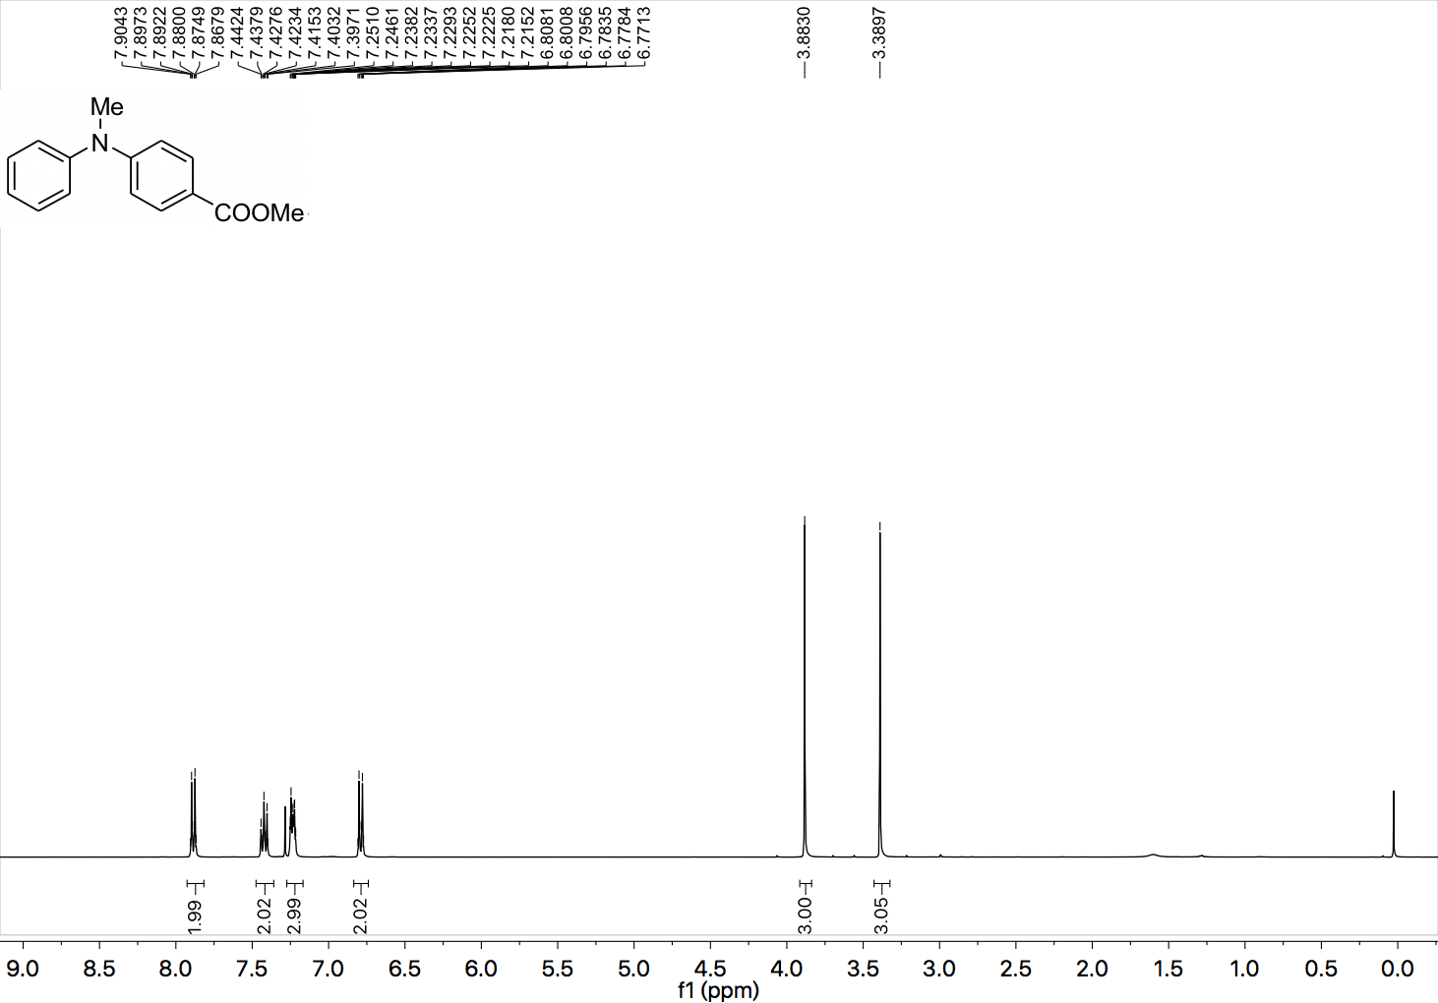

¹³C NMR (101 MHz, CDCl₃) spectrum of 3.

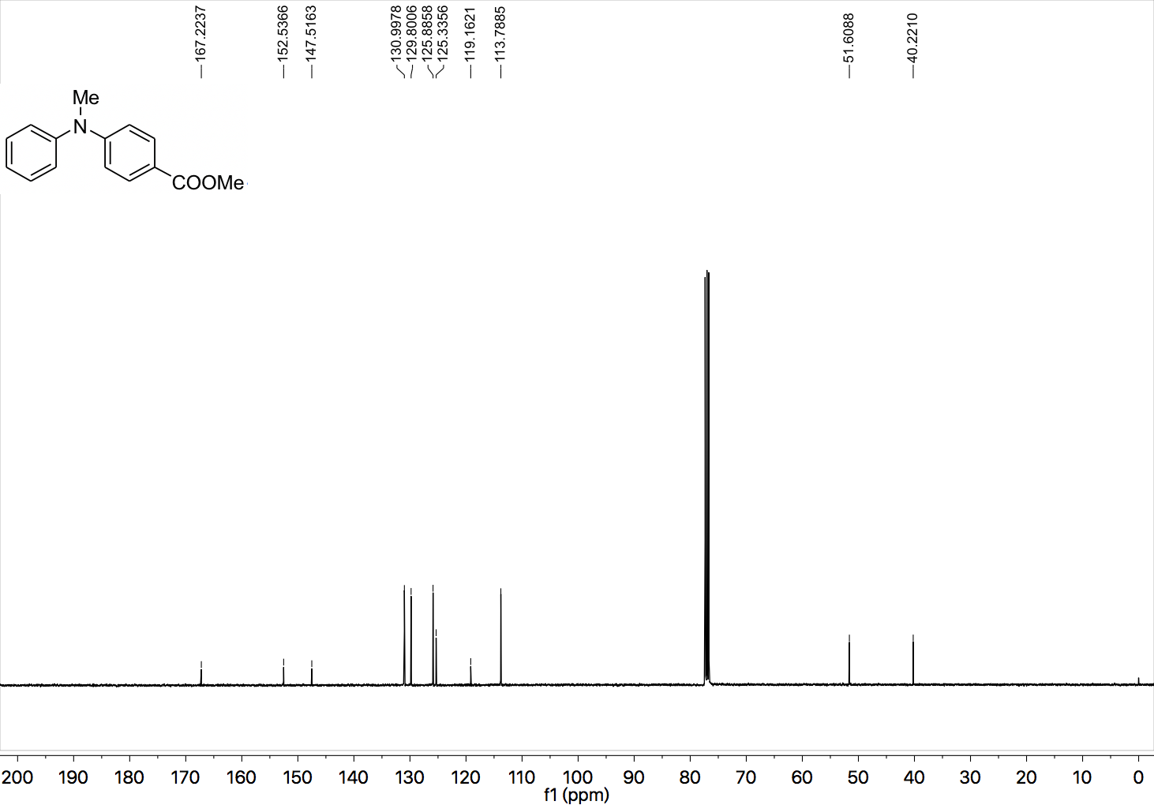
¹H NMR (400 MHz, CDCl₃) spectrum of 16.

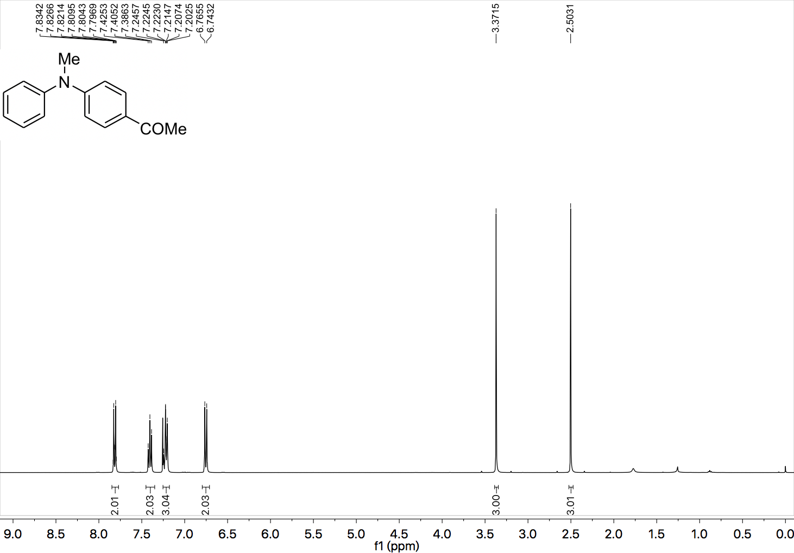

¹³C NMR (101 MHz, CDCl₃) spectrum of 16.

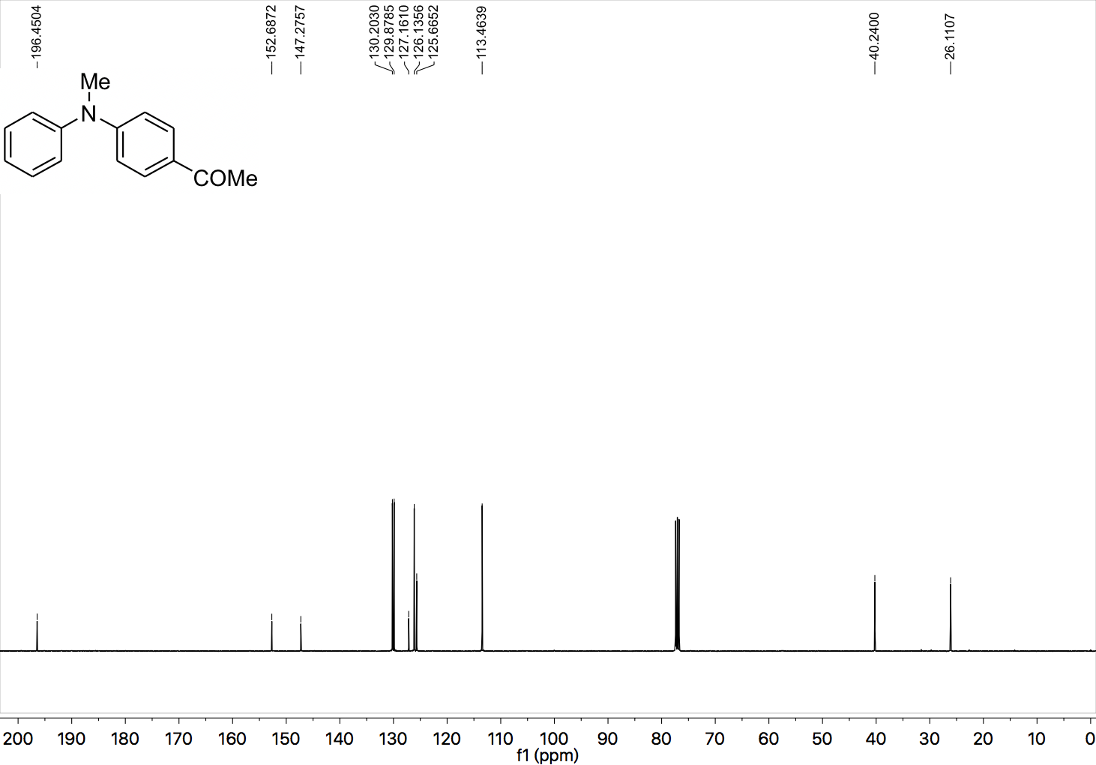

¹H NMR (400 MHz, CDCl₃) spectrum of 17.

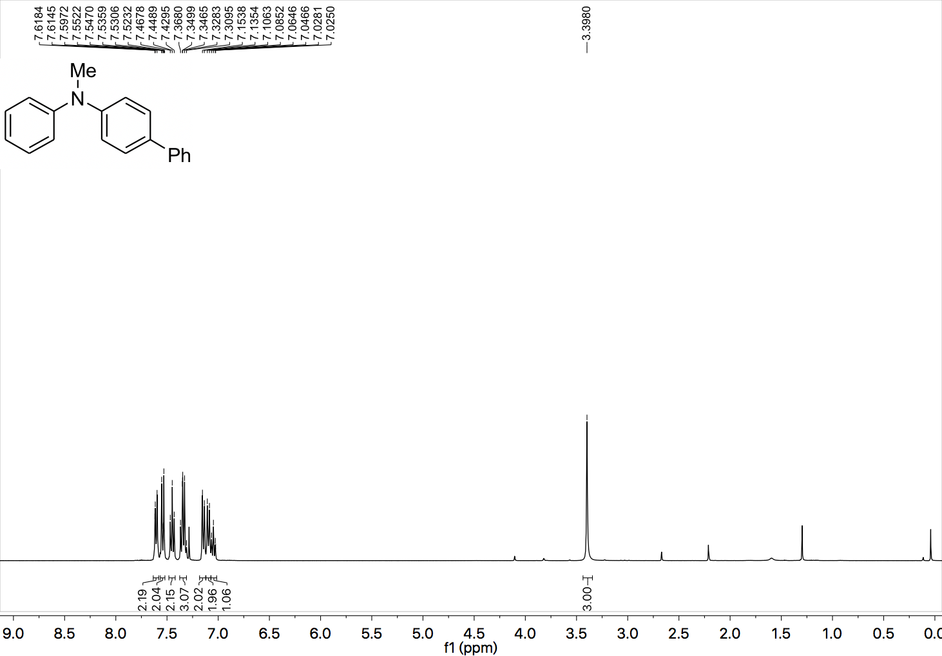

¹³C NMR (101 MHz, CDCl₃) spectrum of 17.

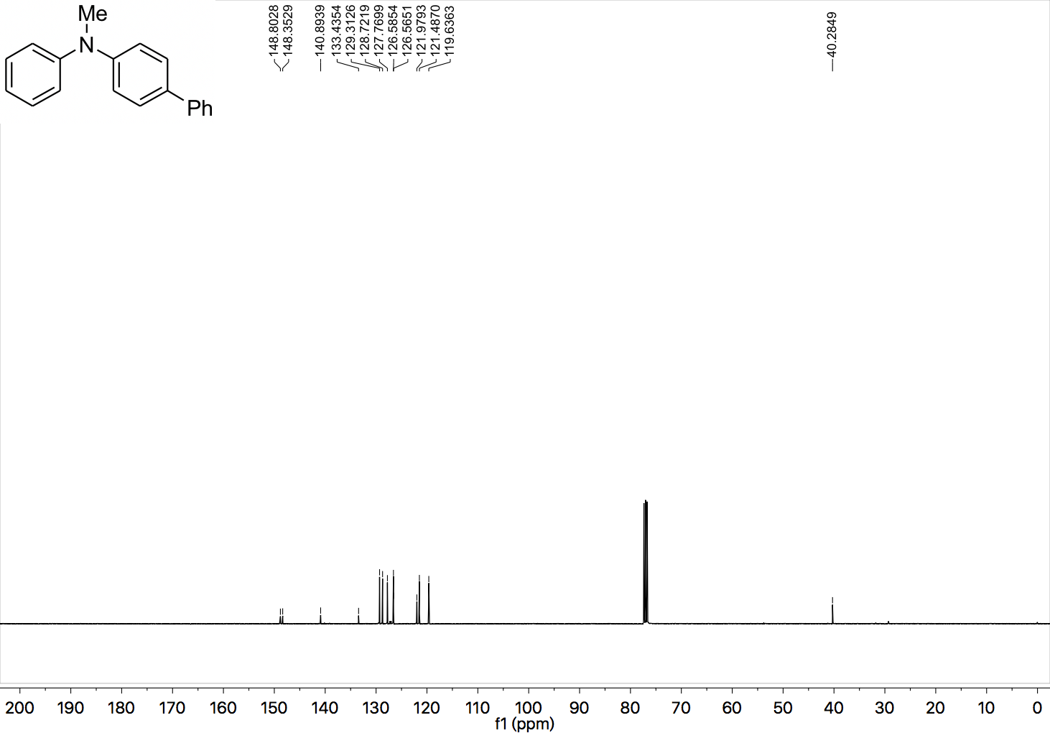

¹H NMR (400 MHz, CDCl₃) spectrum of 18.

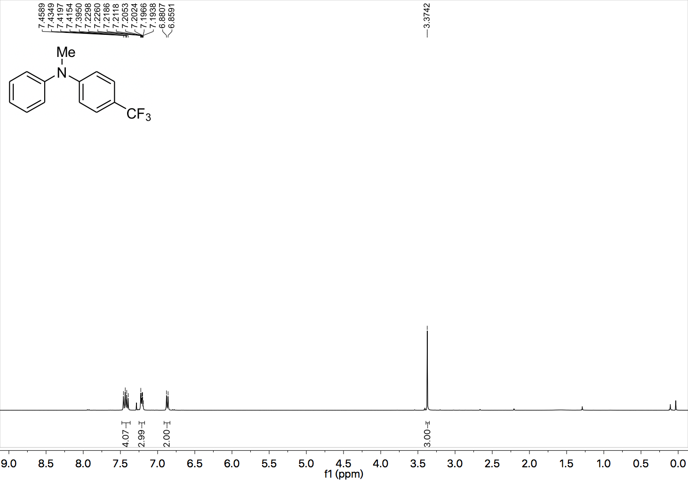

¹³C NMR (101 MHz, CDCl₃) spectrum of 18.

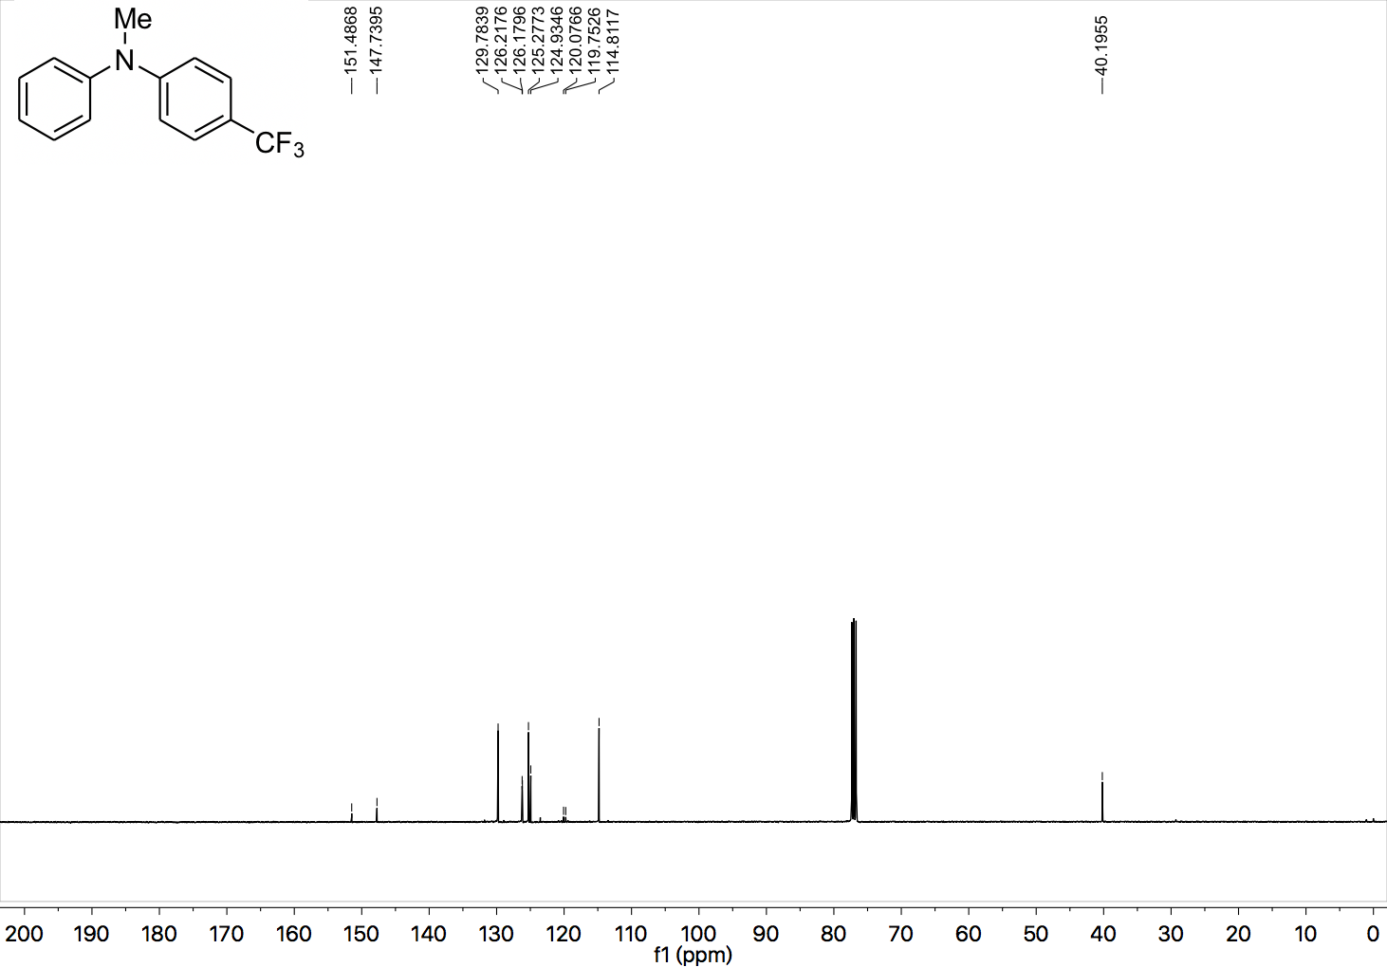

¹⁹F NMR (377 MHz, CDCl₃) spectrum of 18.

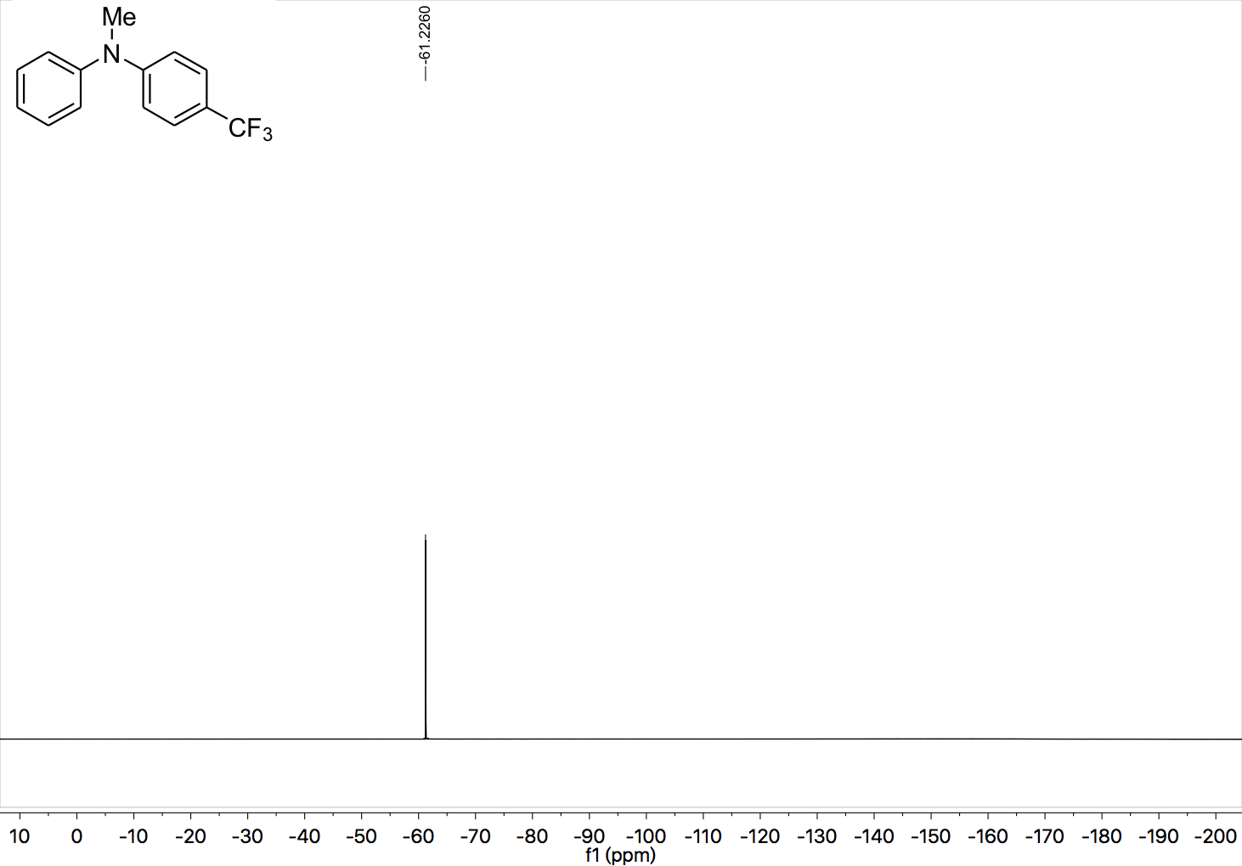

¹H NMR (400 MHz, CDCl₃) spectrum of 19.

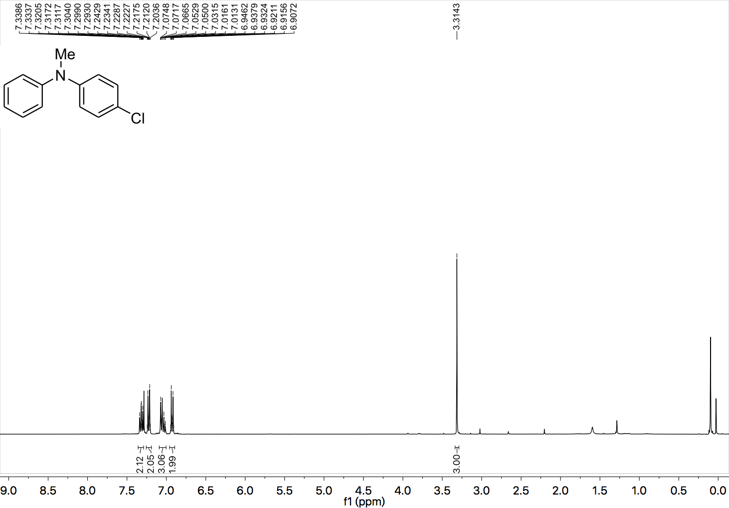

¹³C NMR (101 MHz, CDCl₃) spectrum of 19.

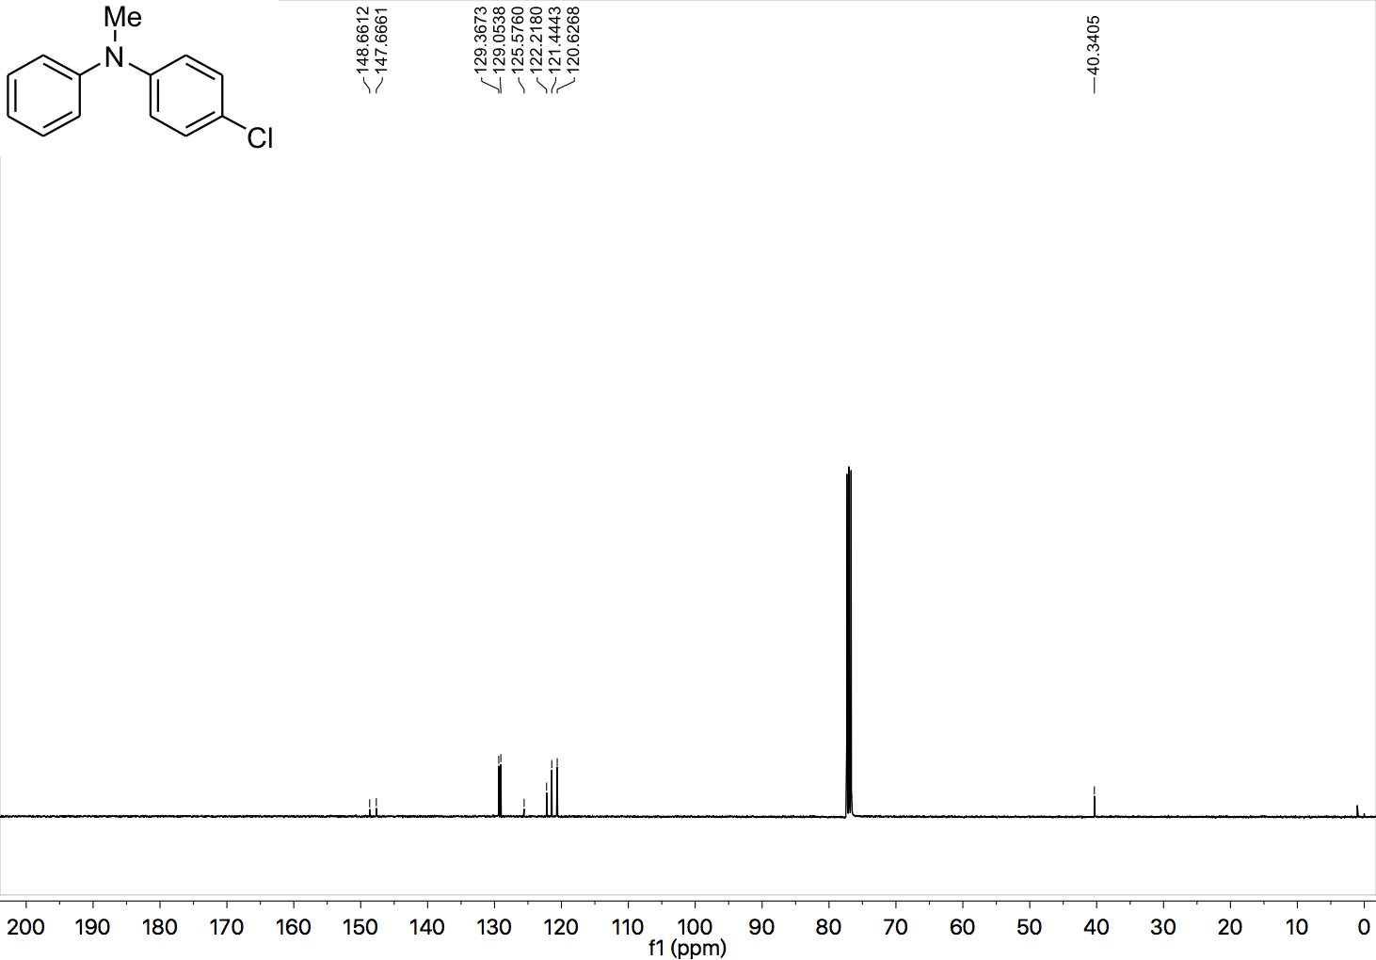

¹H NMR (400 MHz, CDCl₃) spectrum of 20.

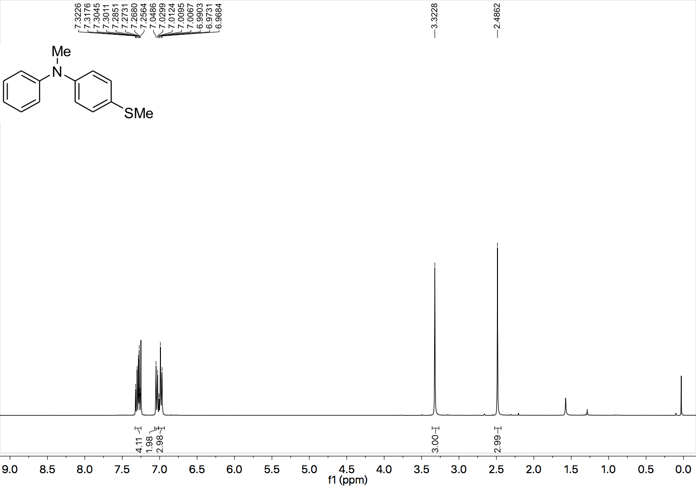

¹³C NMR (101 MHz, CDCl₃) spectrum of 20.

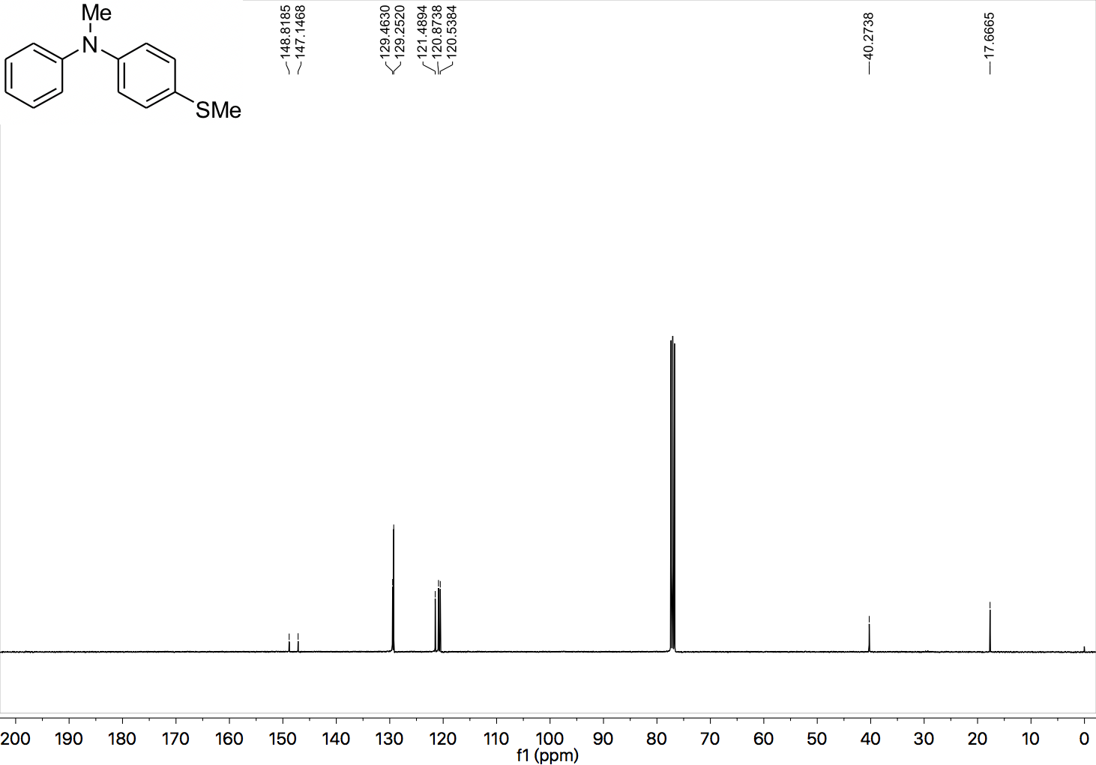

¹H NMR (400 MHz, CDCl₃) spectrum of 21.

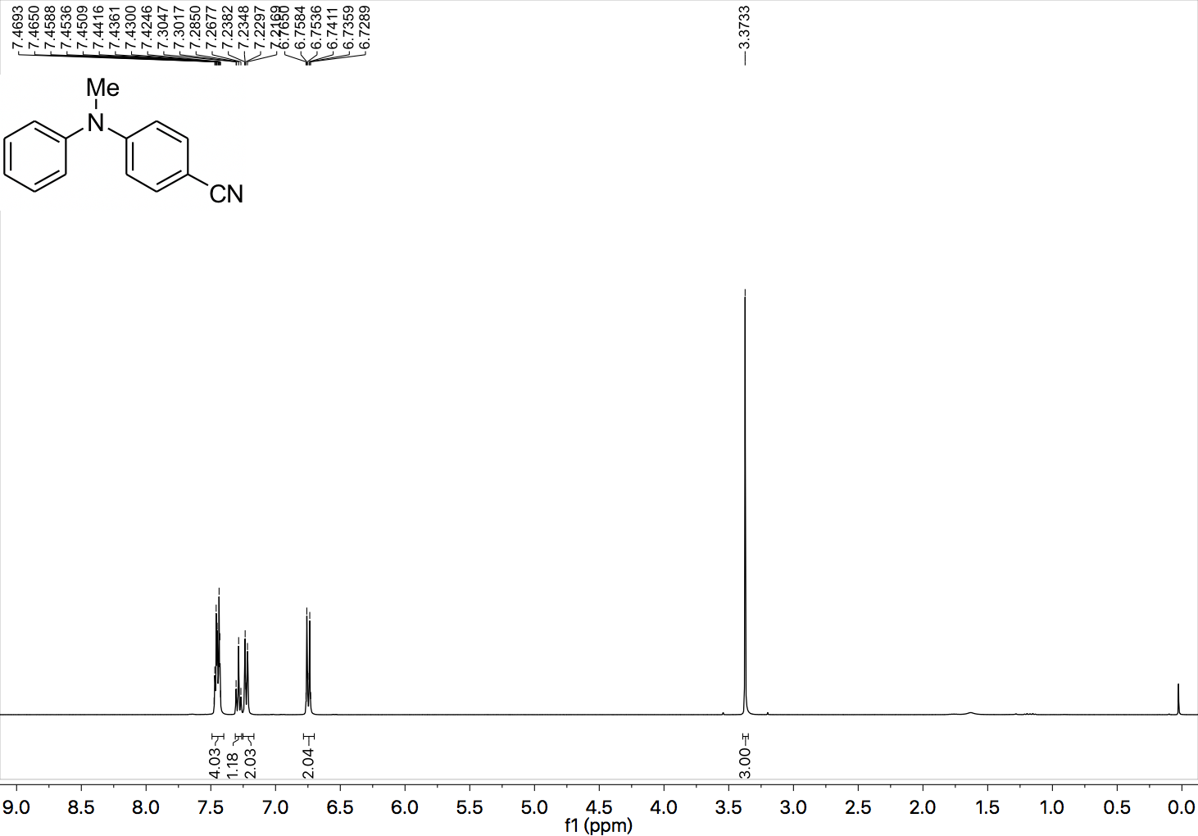

¹³C NMR (101 MHz, CDCl₃) spectrum of 21.

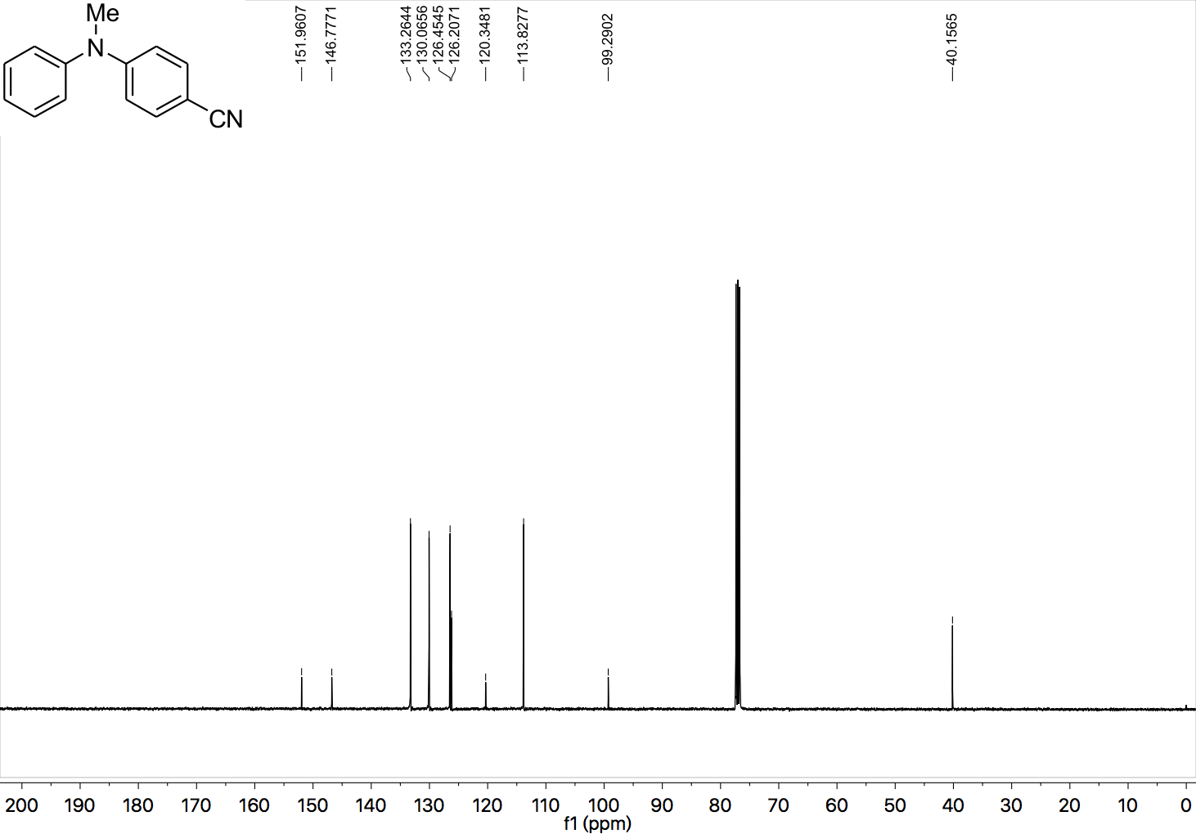

¹H NMR (400 MHz, CDCl₃) spectrum of 22.

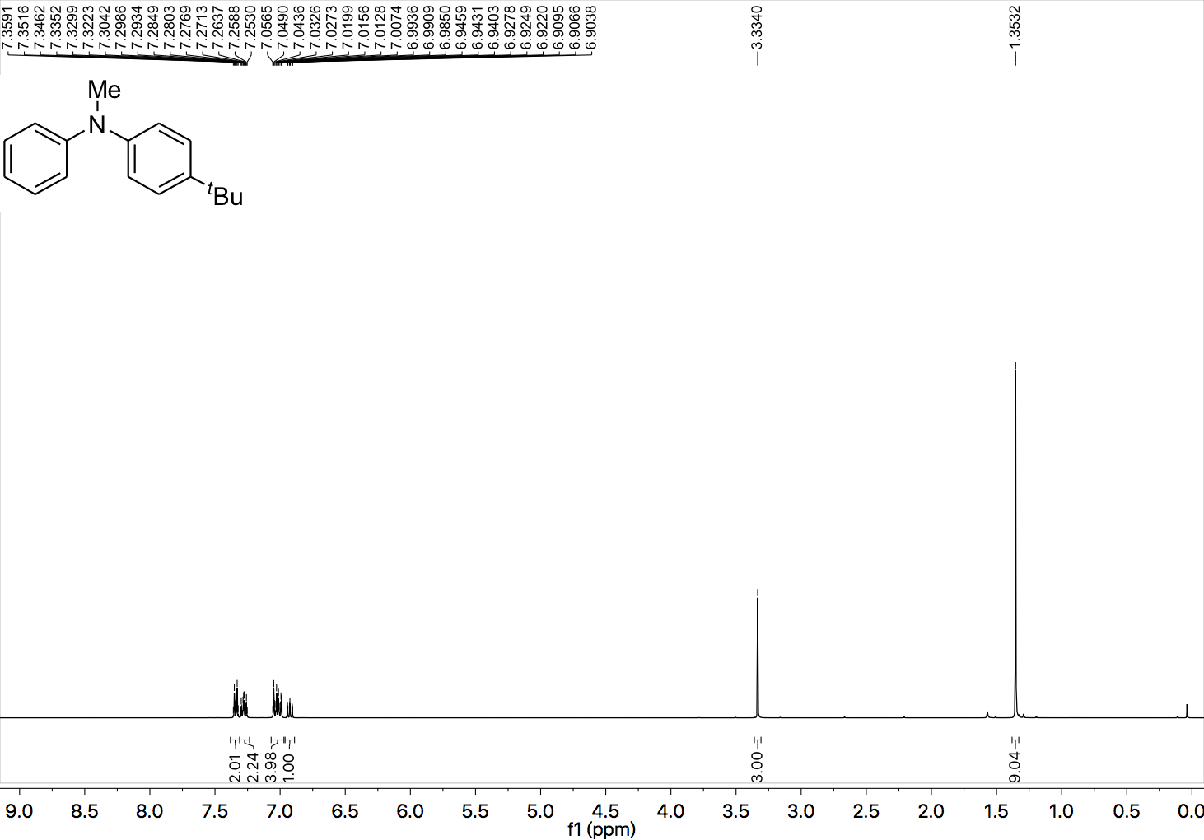

¹³C NMR (101 MHz, CDCl₃) spectrum of 22.

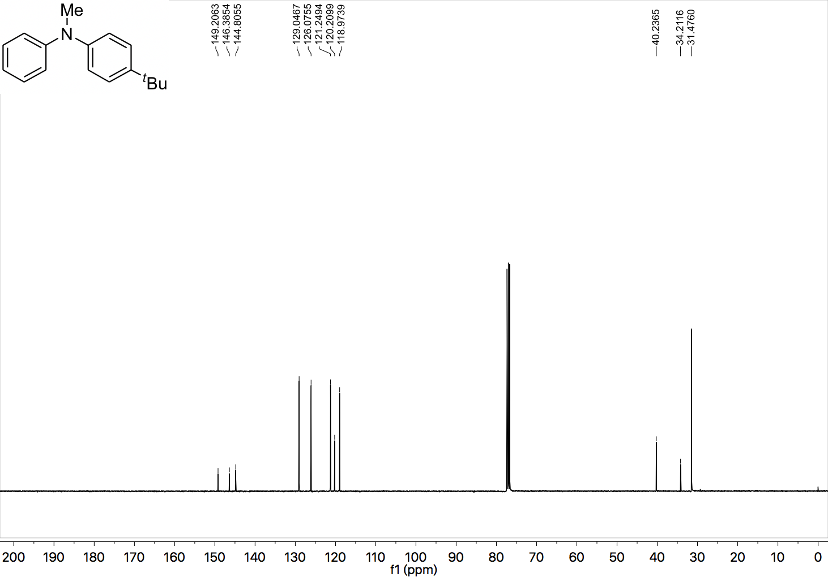

¹H NMR (400 MHz, CDCl₃) spectrum of 23.

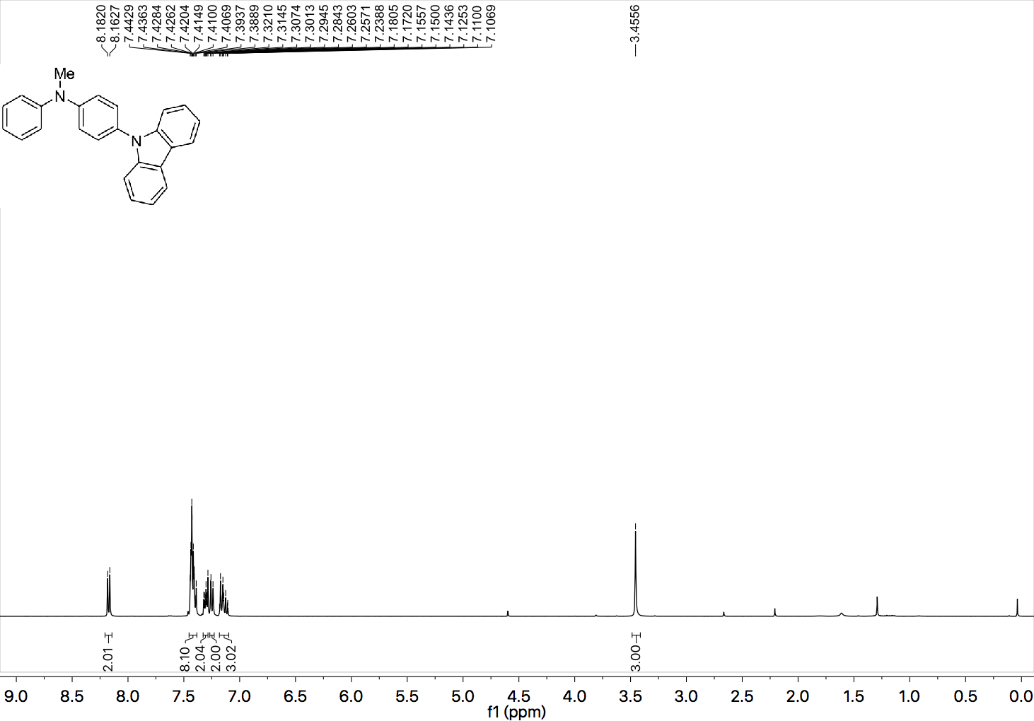

¹³C NMR (101 MHz, CDCl₃) spectrum of 23.

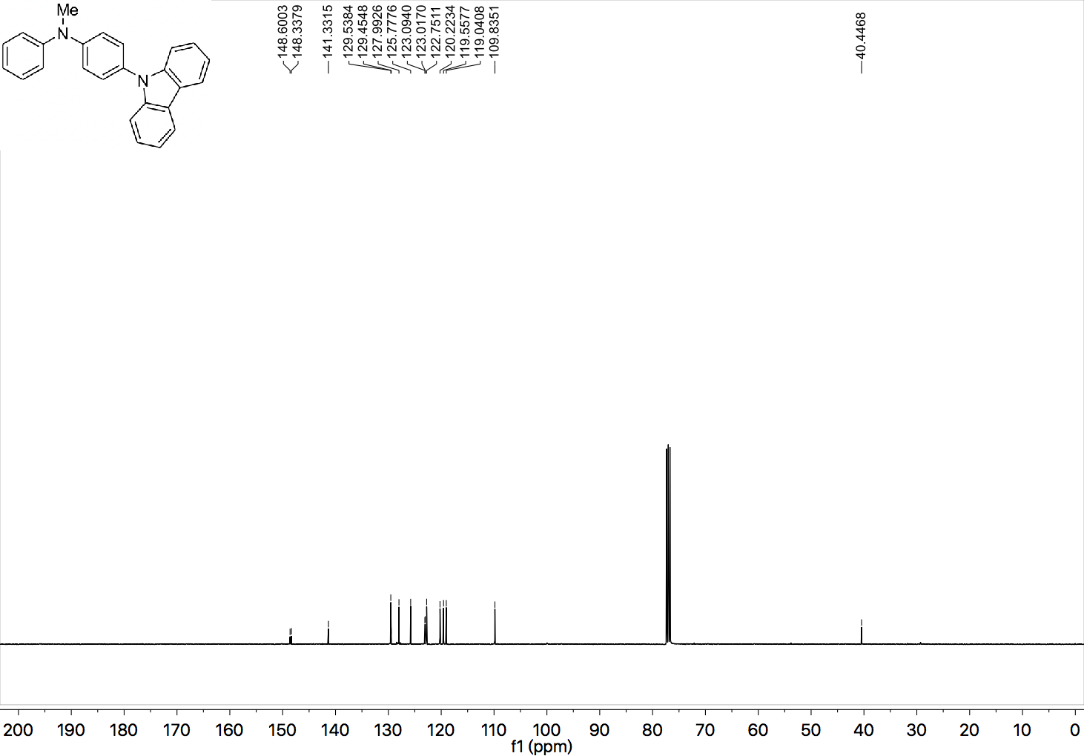

¹H NMR (400 MHz, CDCl₃) spectrum of 24.

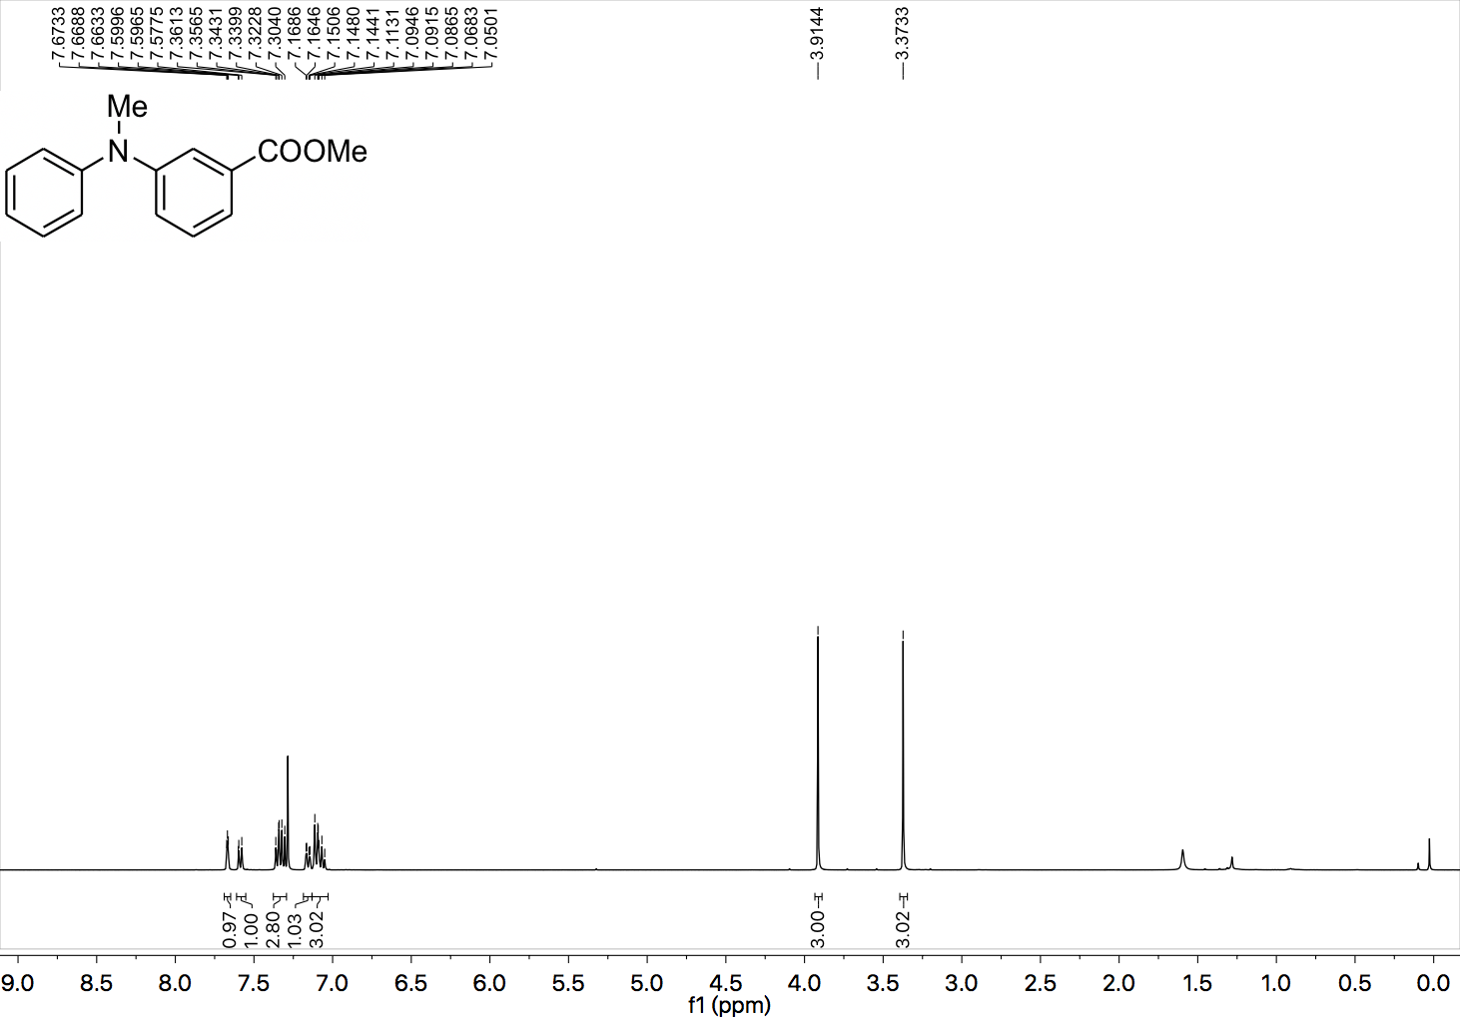

¹³C NMR (101 MHz, CDCl₃) spectrum of 24.

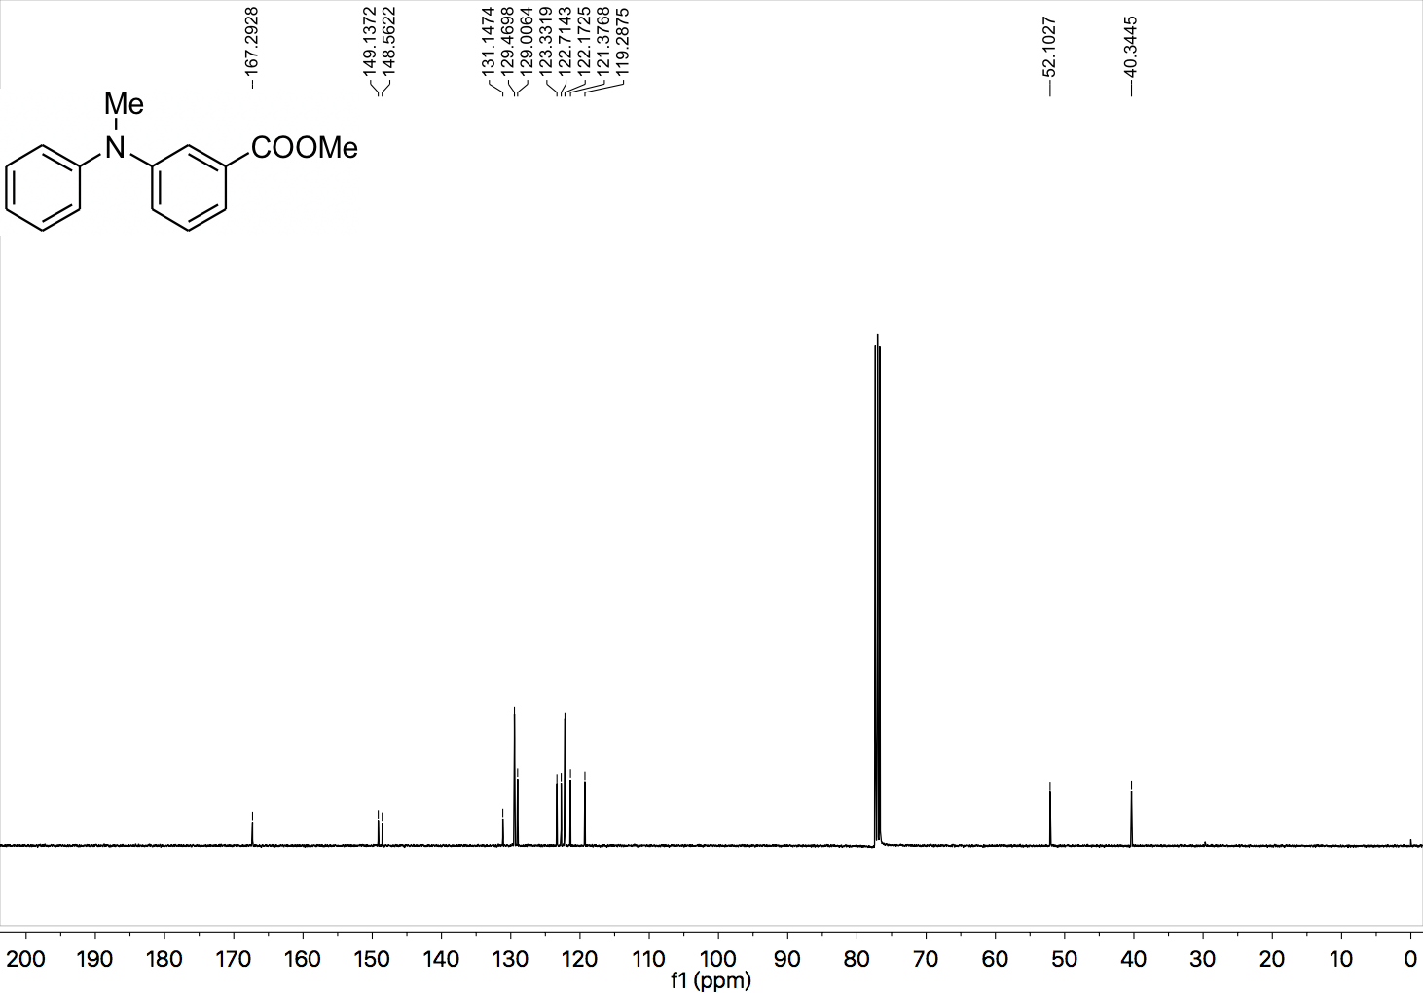

¹H NMR (400 MHz, CDCl₃) spectrum of 25.

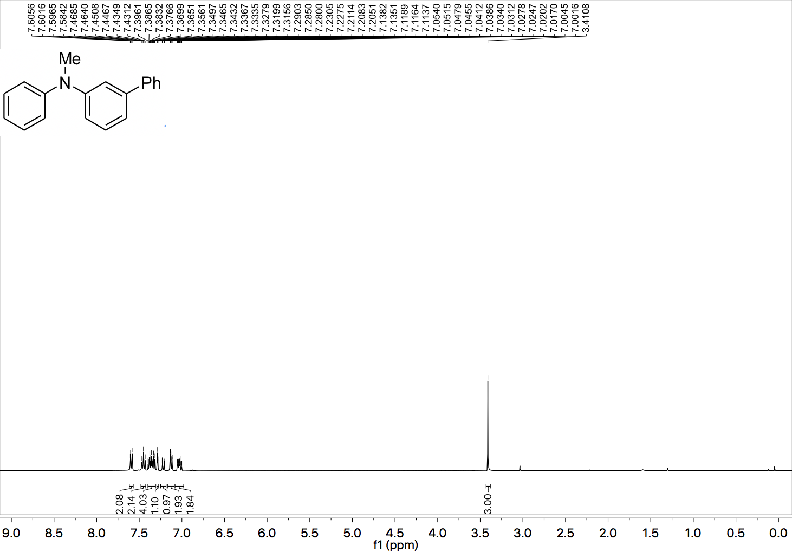

¹³C NMR (101 MHz, CDCl₃) spectrum of 25.

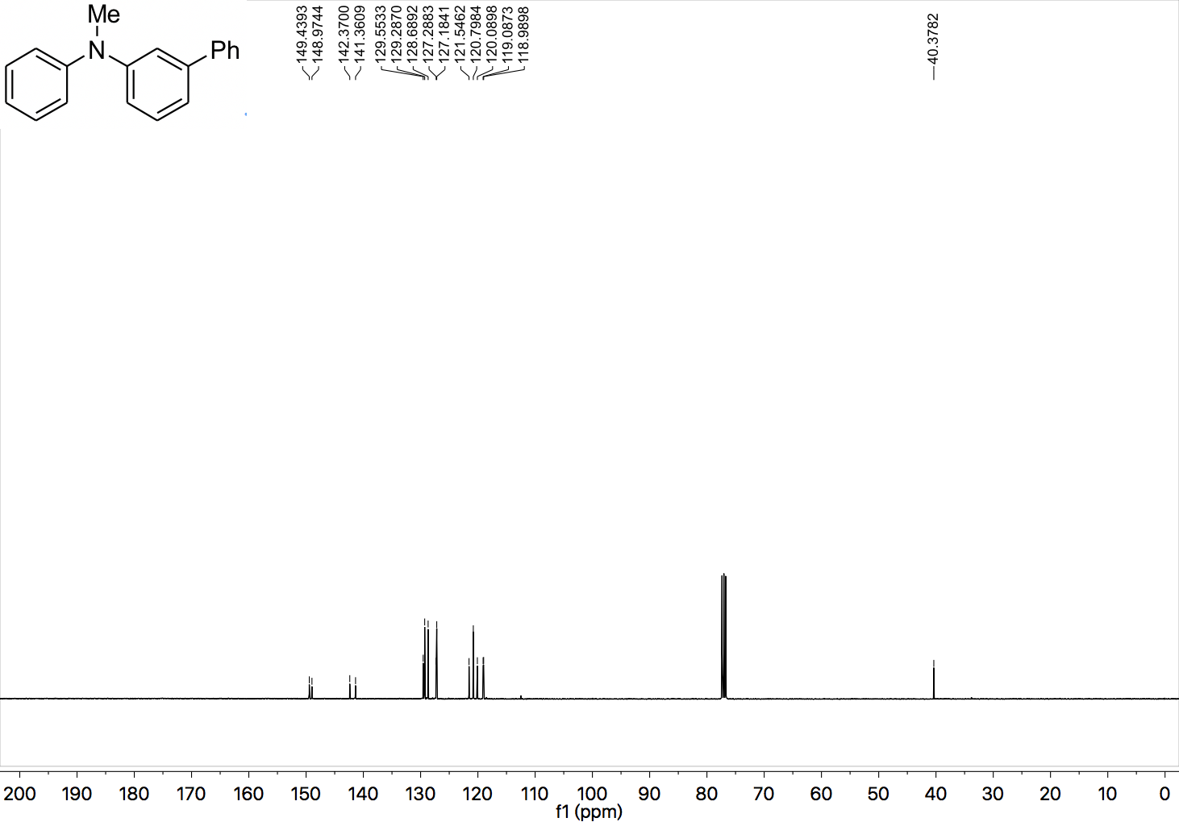

¹H NMR (400 MHz, CDCl₃) spectrum of 26.

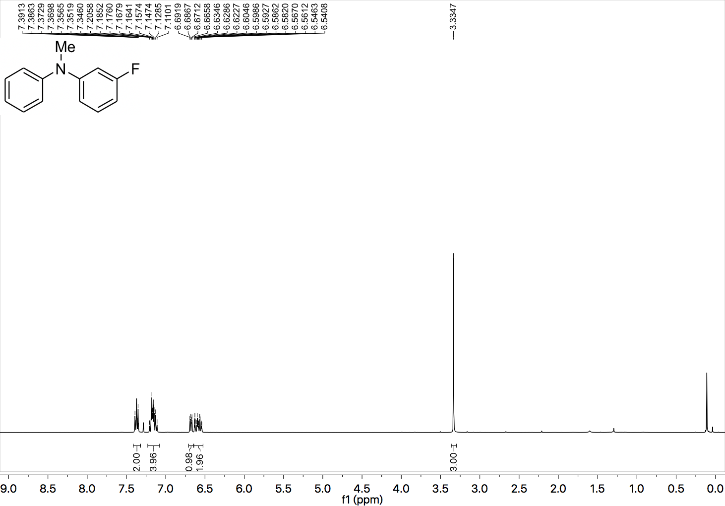

¹³C NMR (101 MHz, CDCl₃) spectrum of 26.

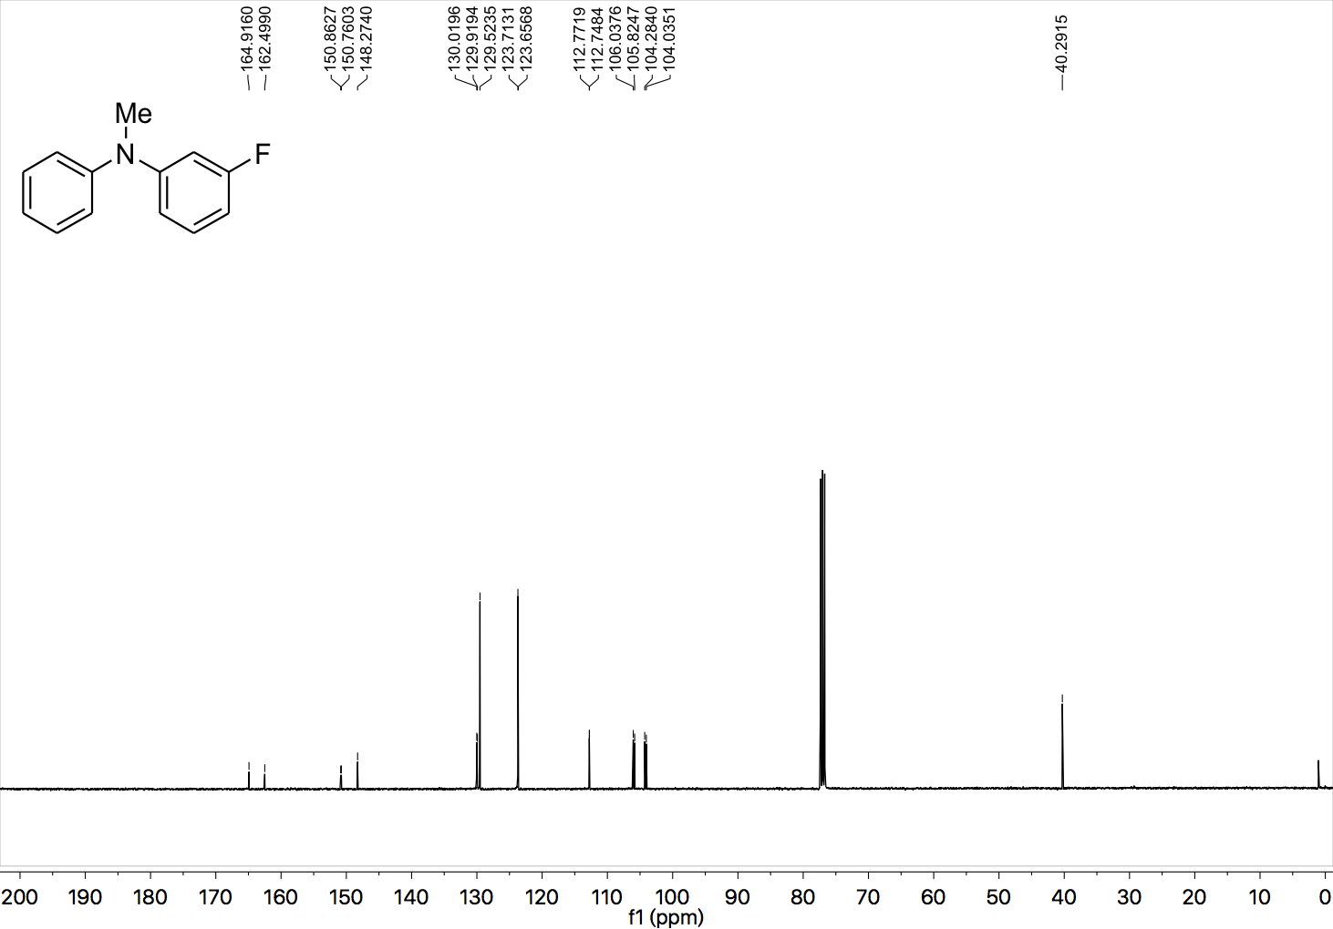

¹⁹F NMR (377 MHz, CDCl₃) spectrum of 26.

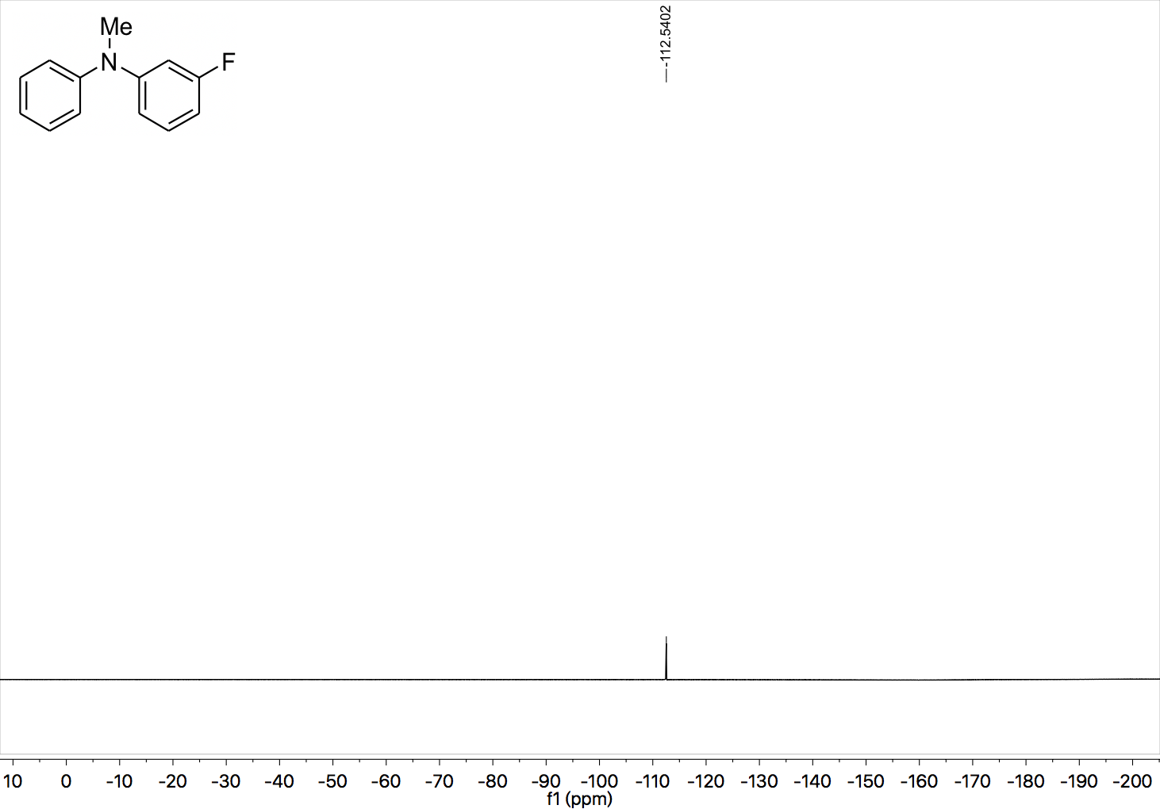

¹H NMR (400 MHz, CDCl₃) spectrum of 27.

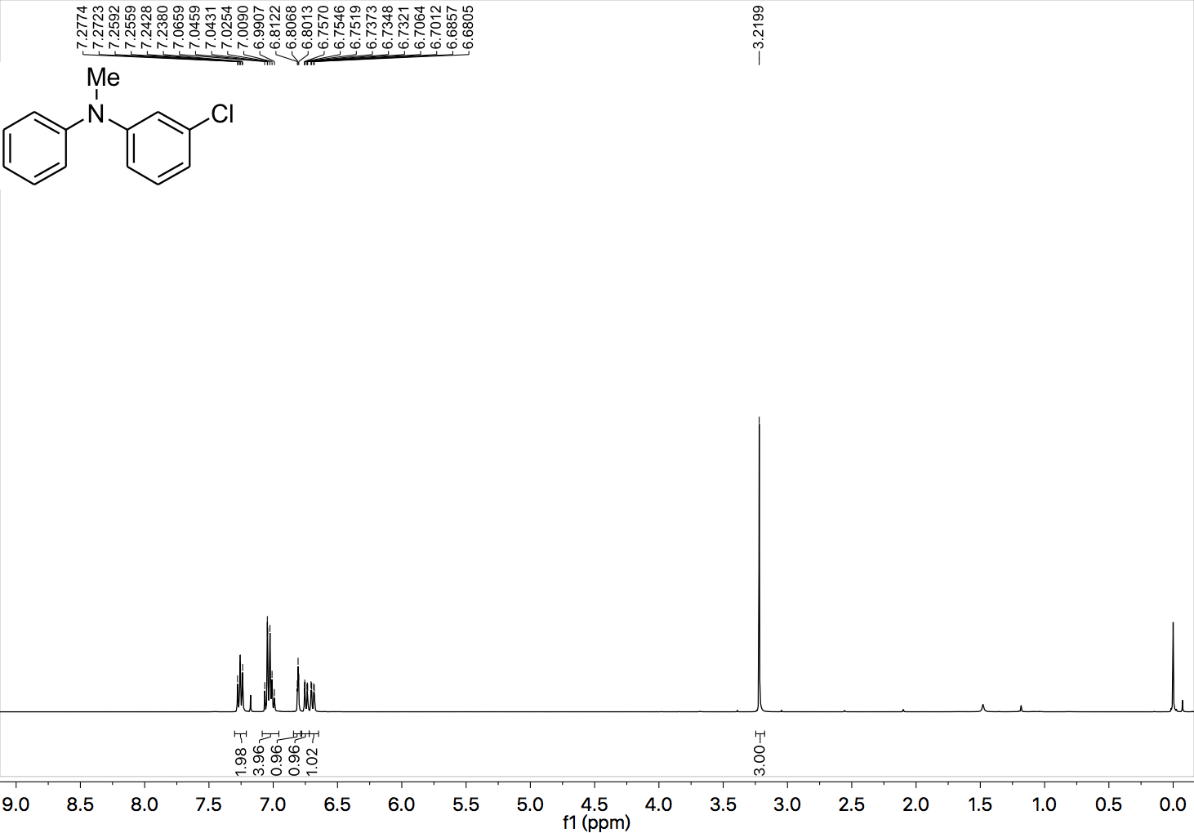

¹³C NMR (101 MHz, CDCl₃) spectrum of 27.

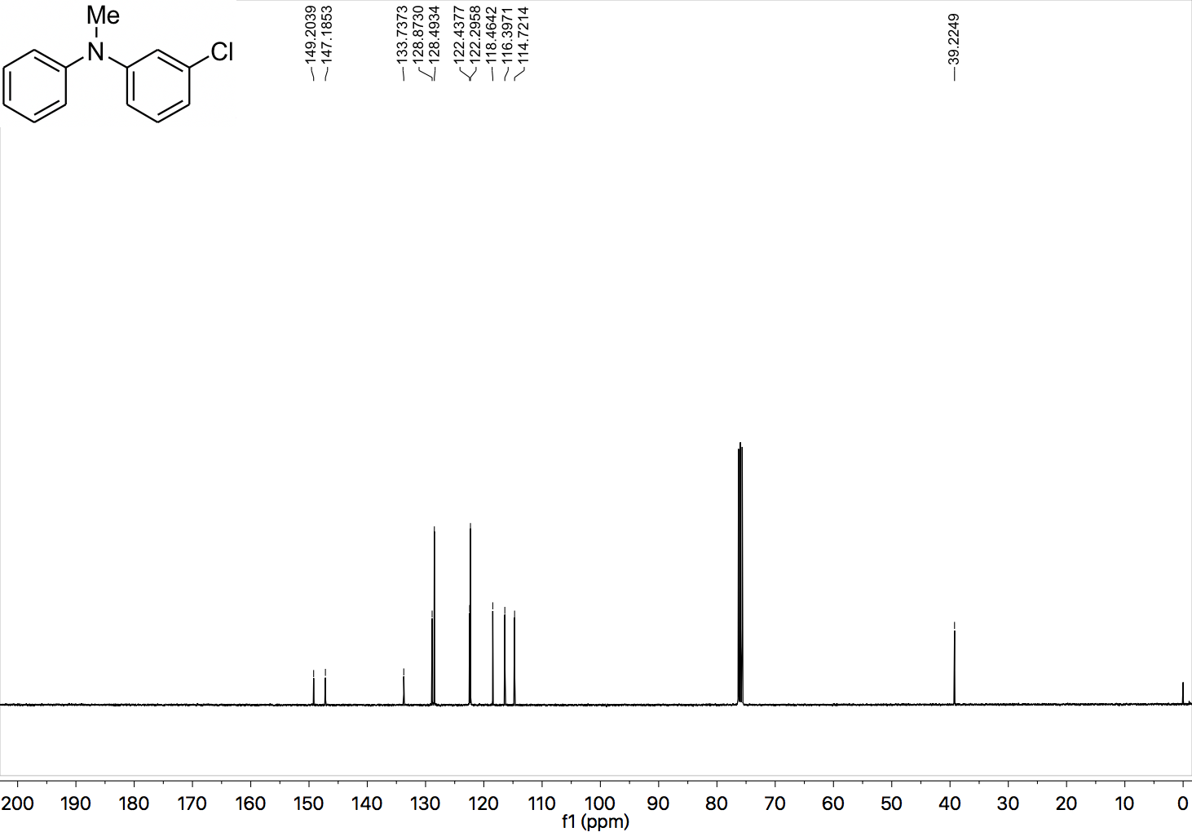

¹H NMR (400 MHz, CDCl₃) spectrum of 28.

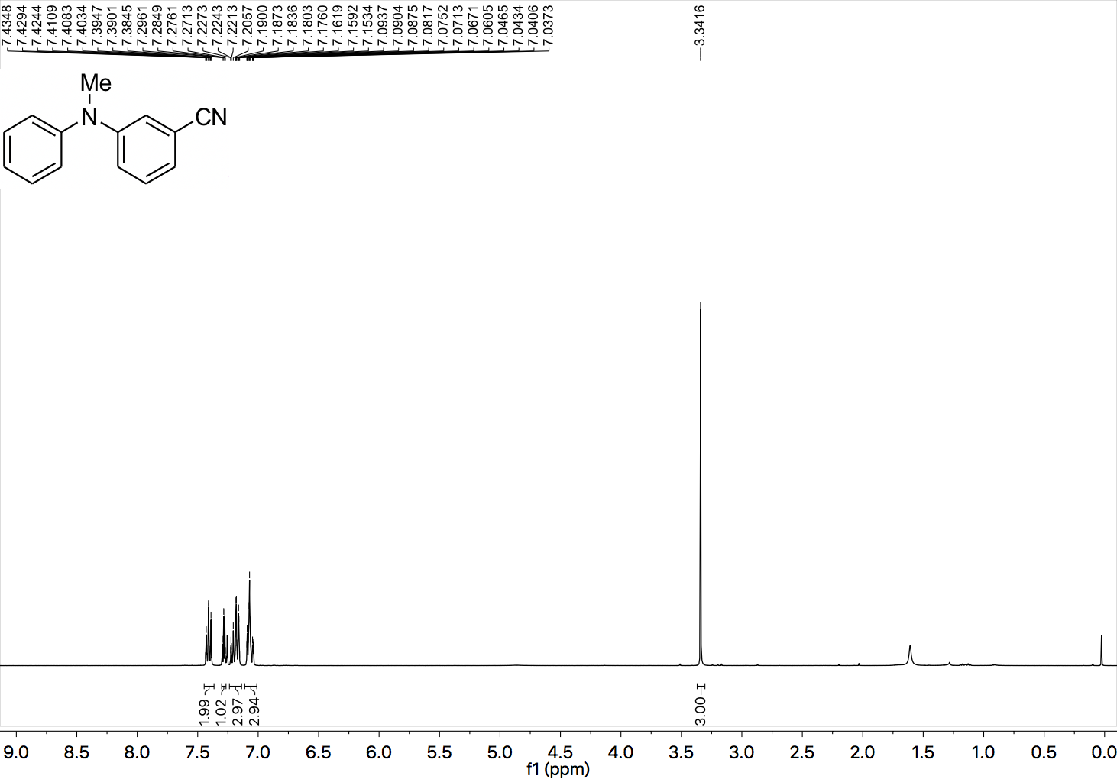

¹³C NMR (101 MHz, CDCl₃) spectrum of 28.

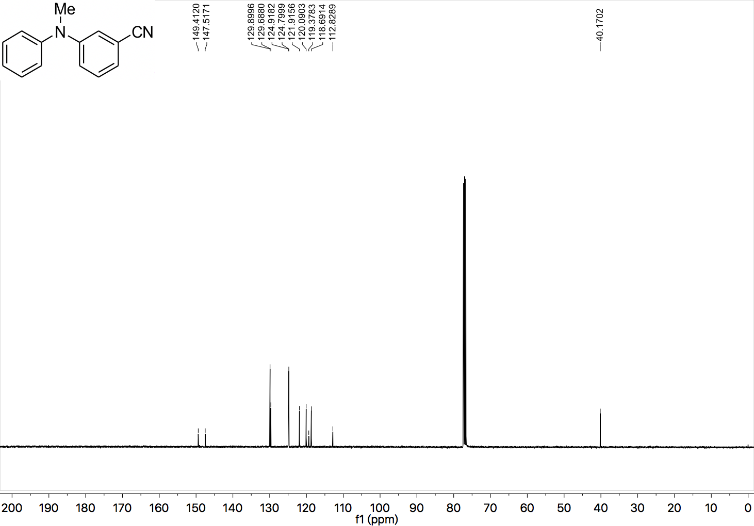

¹H NMR (400 MHz, CDCl₃) spectrum of 29.

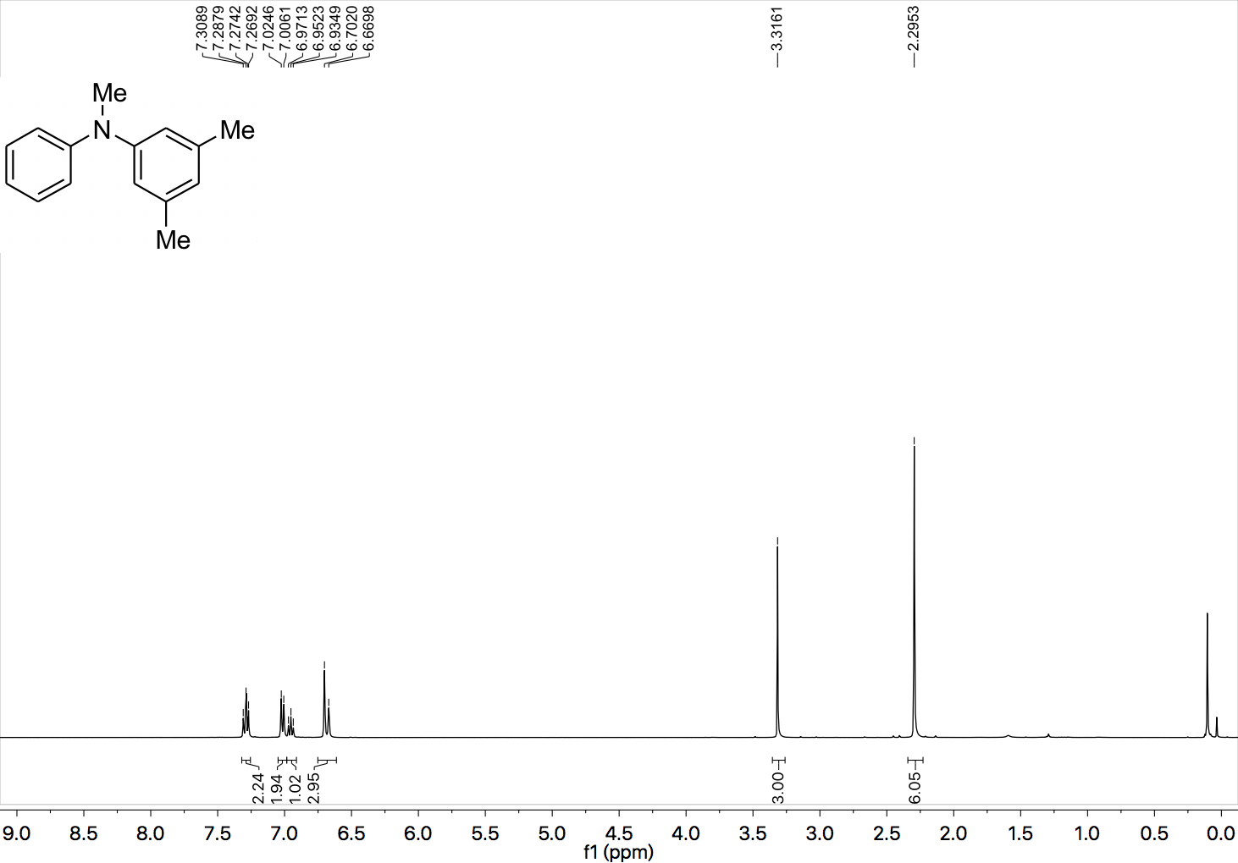

¹³C NMR (101 MHz, CDCl₃) spectrum of 29.

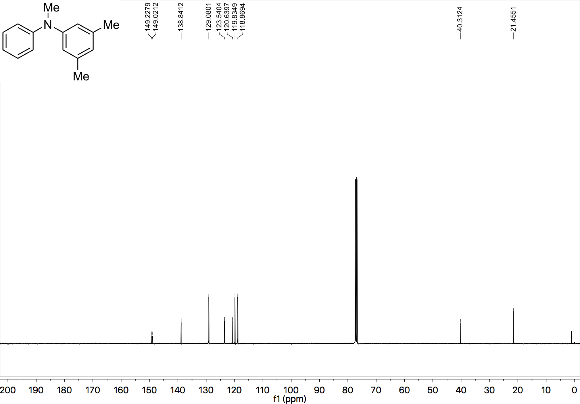

¹H NMR (400 MHz, CDCl₃) spectrum of 30.

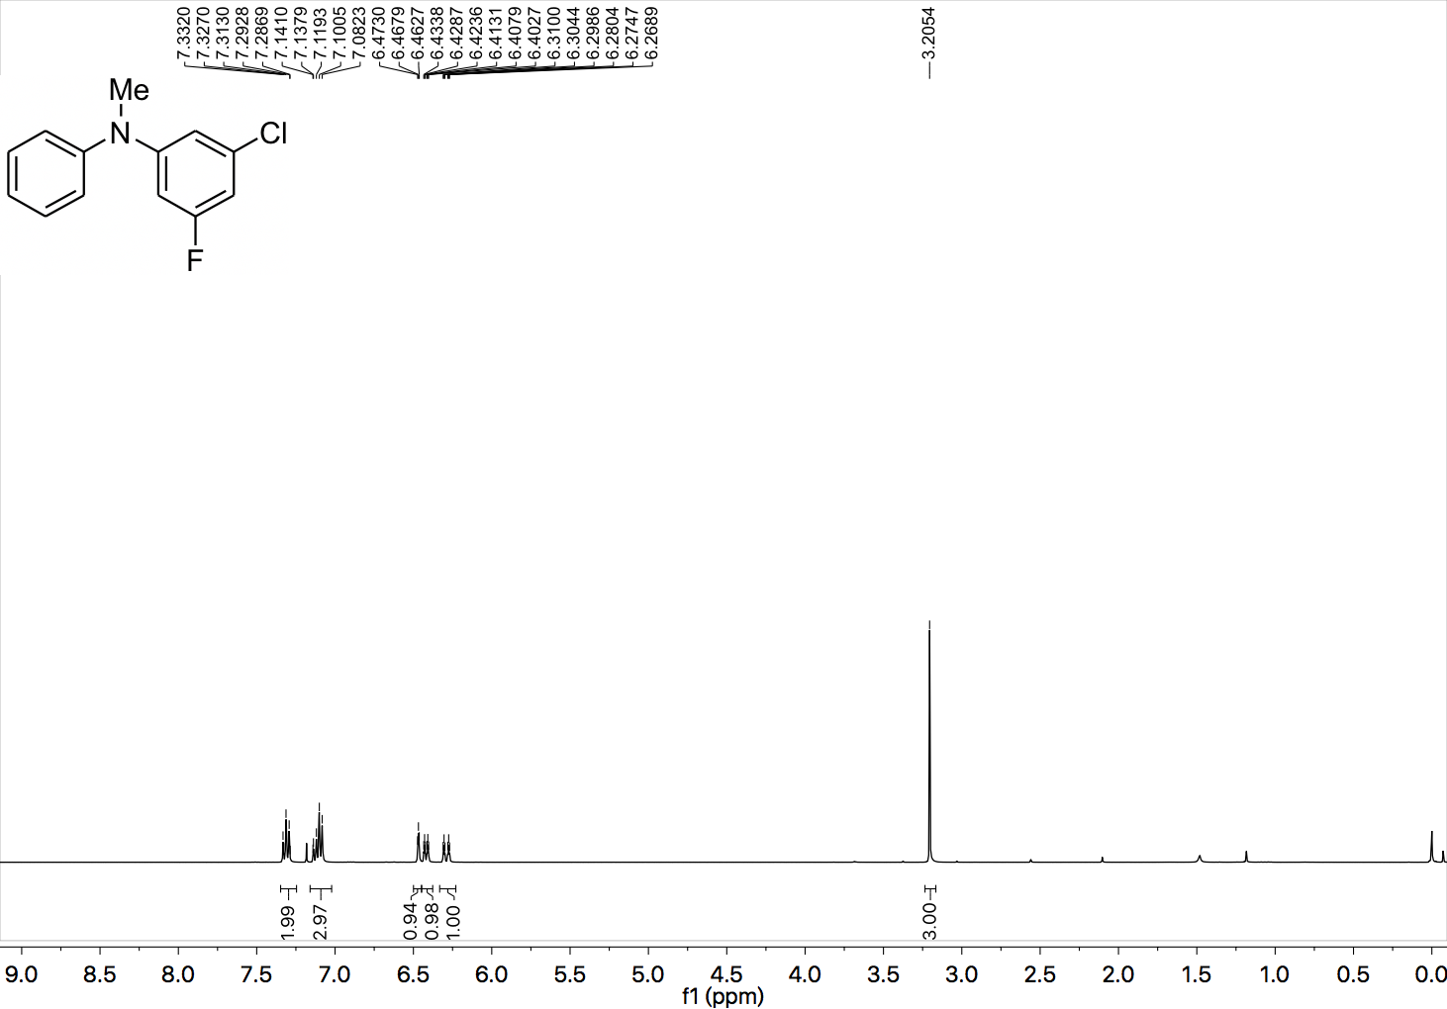

¹³C NMR (101 MHz, CDCl₃) spectrum of 30.

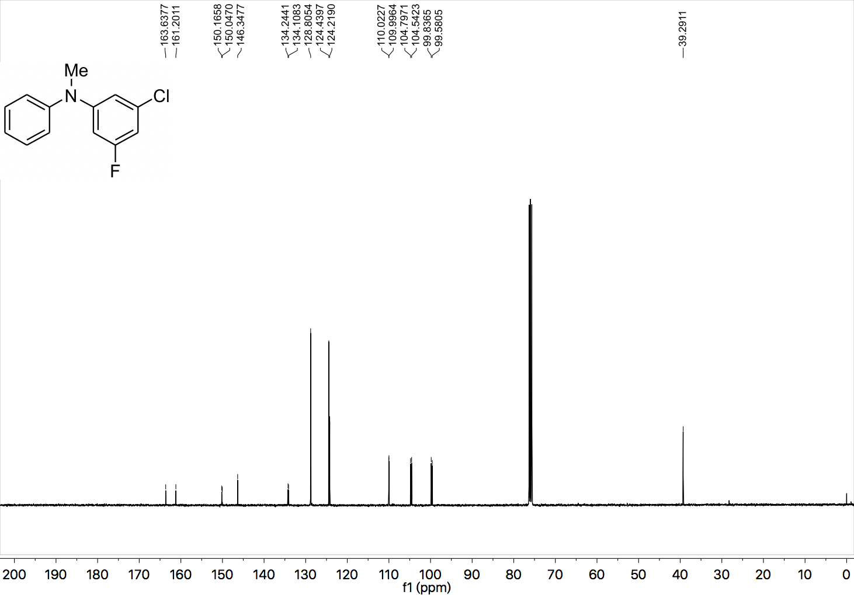

¹⁹F NMR (377 MHz, CDCl₃) spectrum of 30.

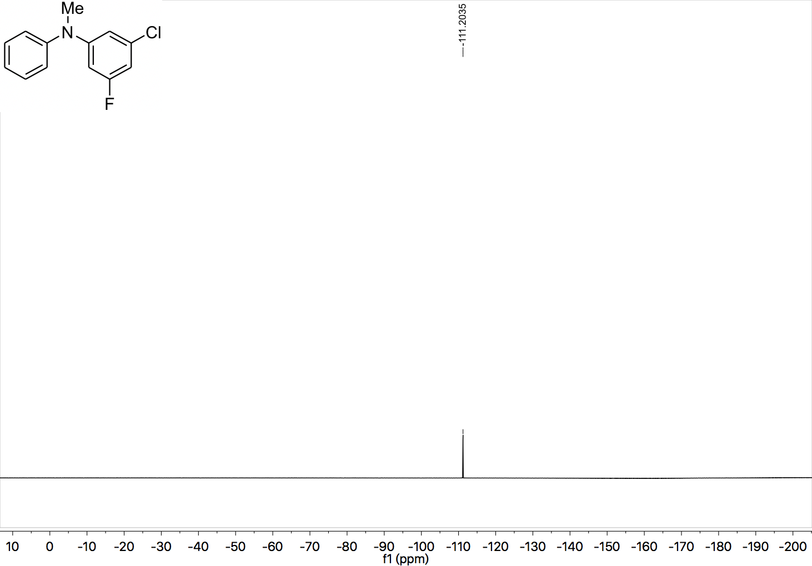

¹H NMR (400 MHz, CDCl₃) spectrum of 31.

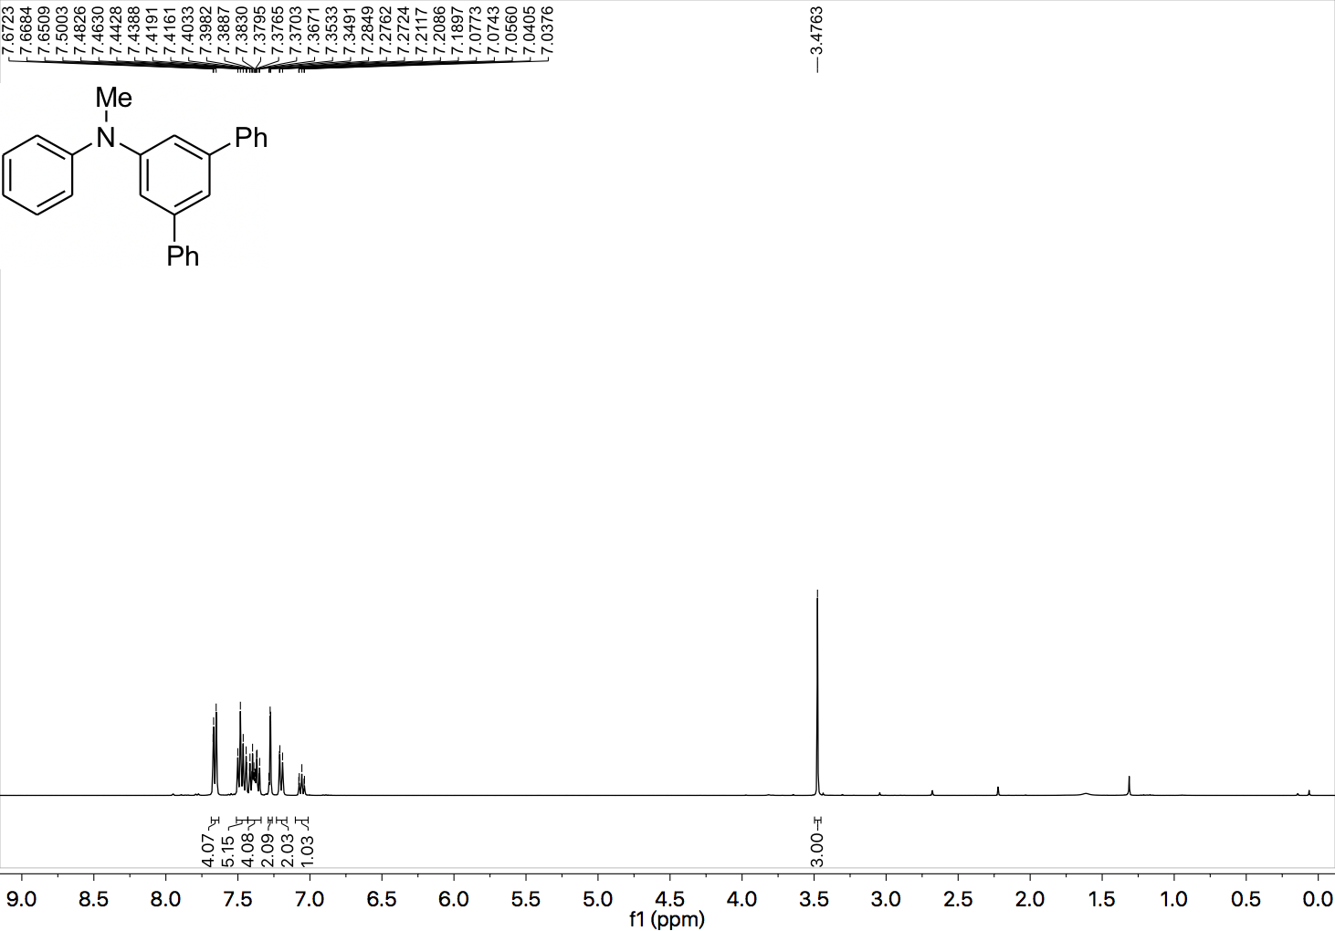

¹³C NMR (101 MHz, CDCl₃) spectrum of 31.

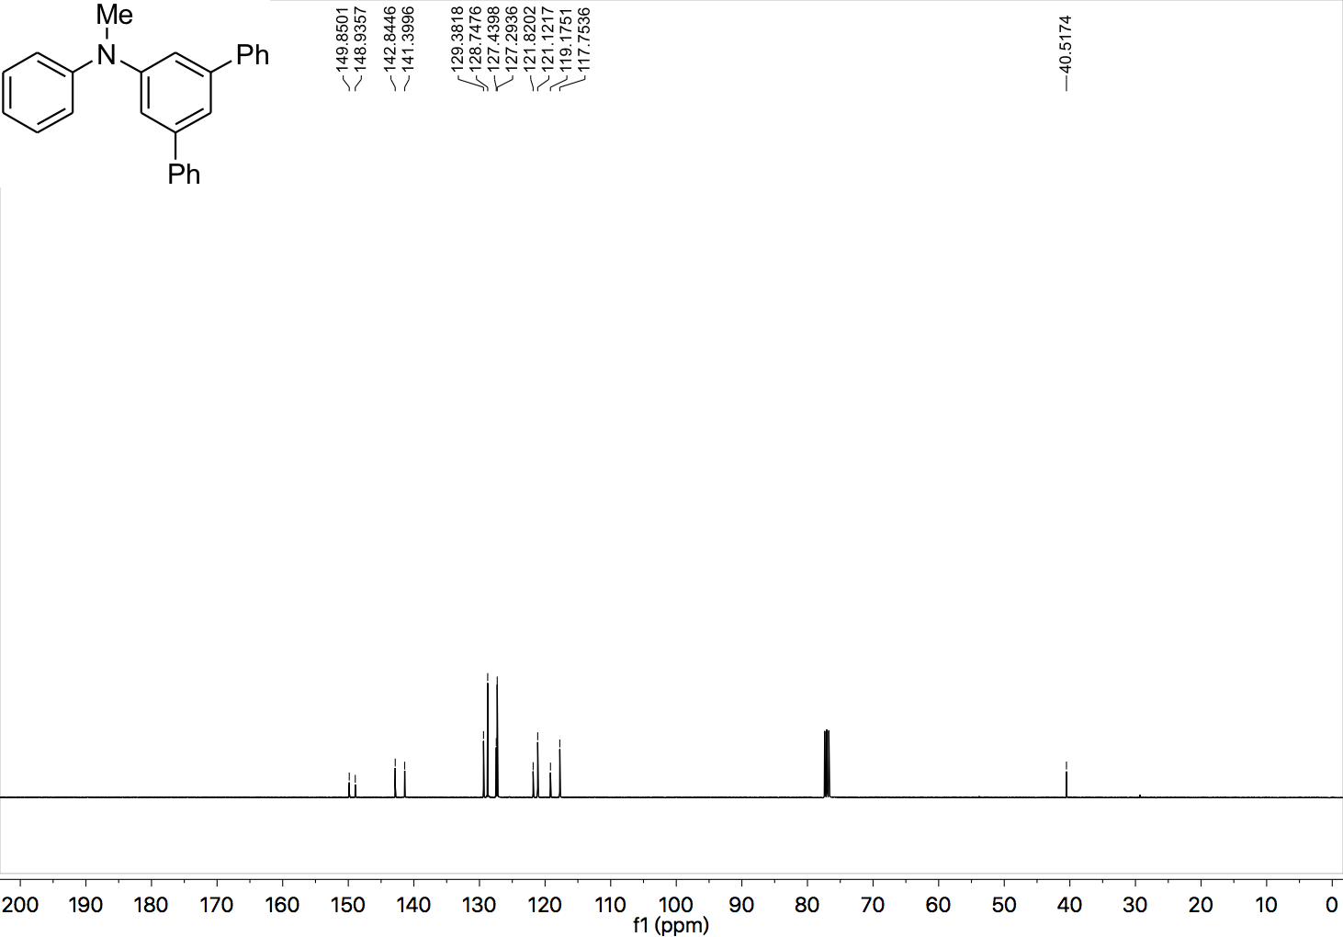

¹H NMR (400 MHz, CDCl₃) spectrum of 32.

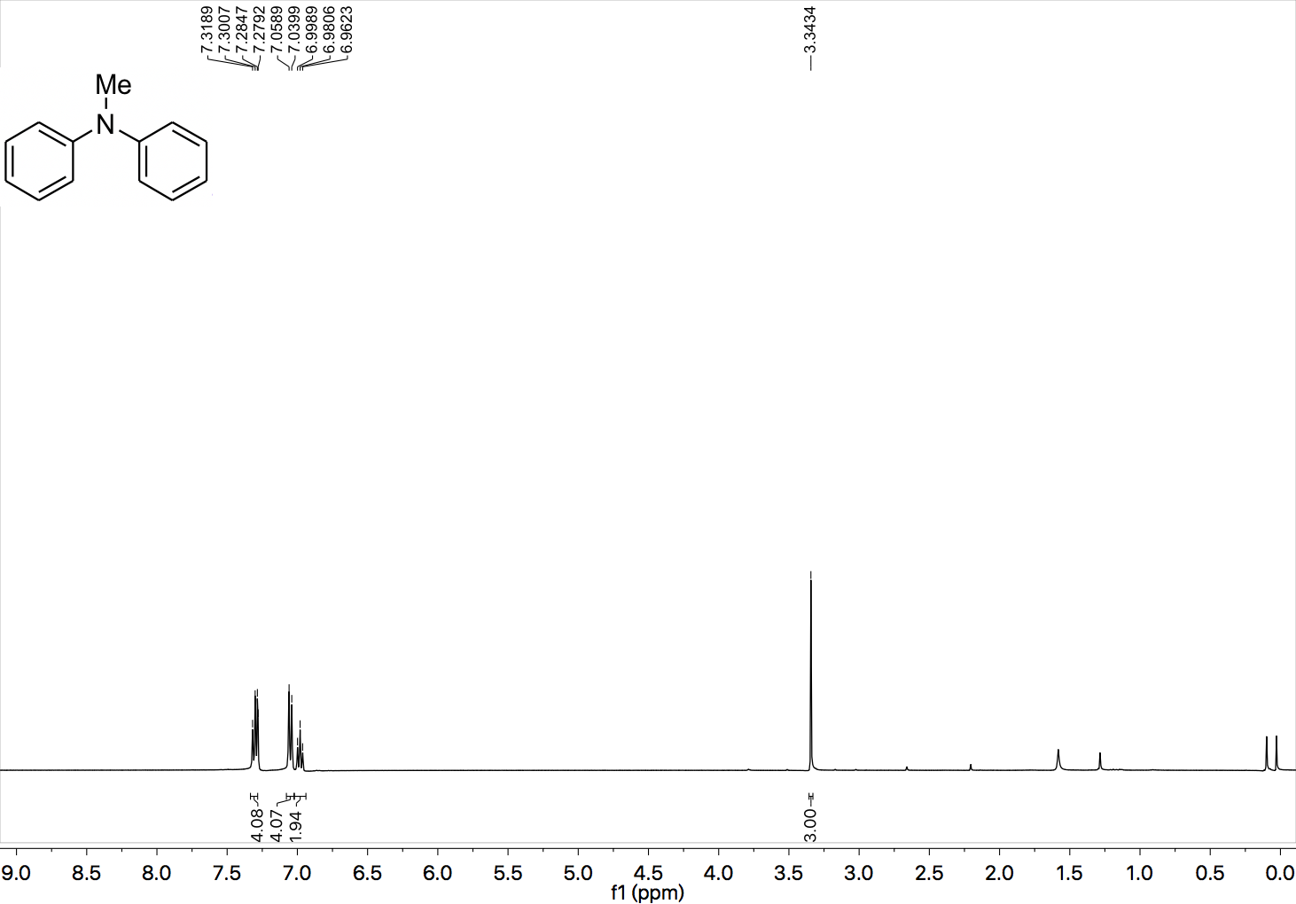

¹³C NMR (101 MHz, CDCl₃) spectrum of 32.

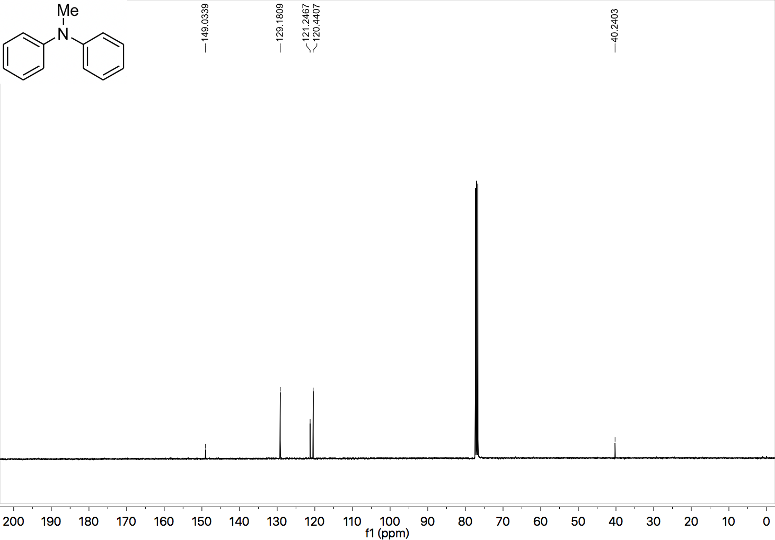

¹H NMR (400 MHz, CDCl₃) spectrum of 33.

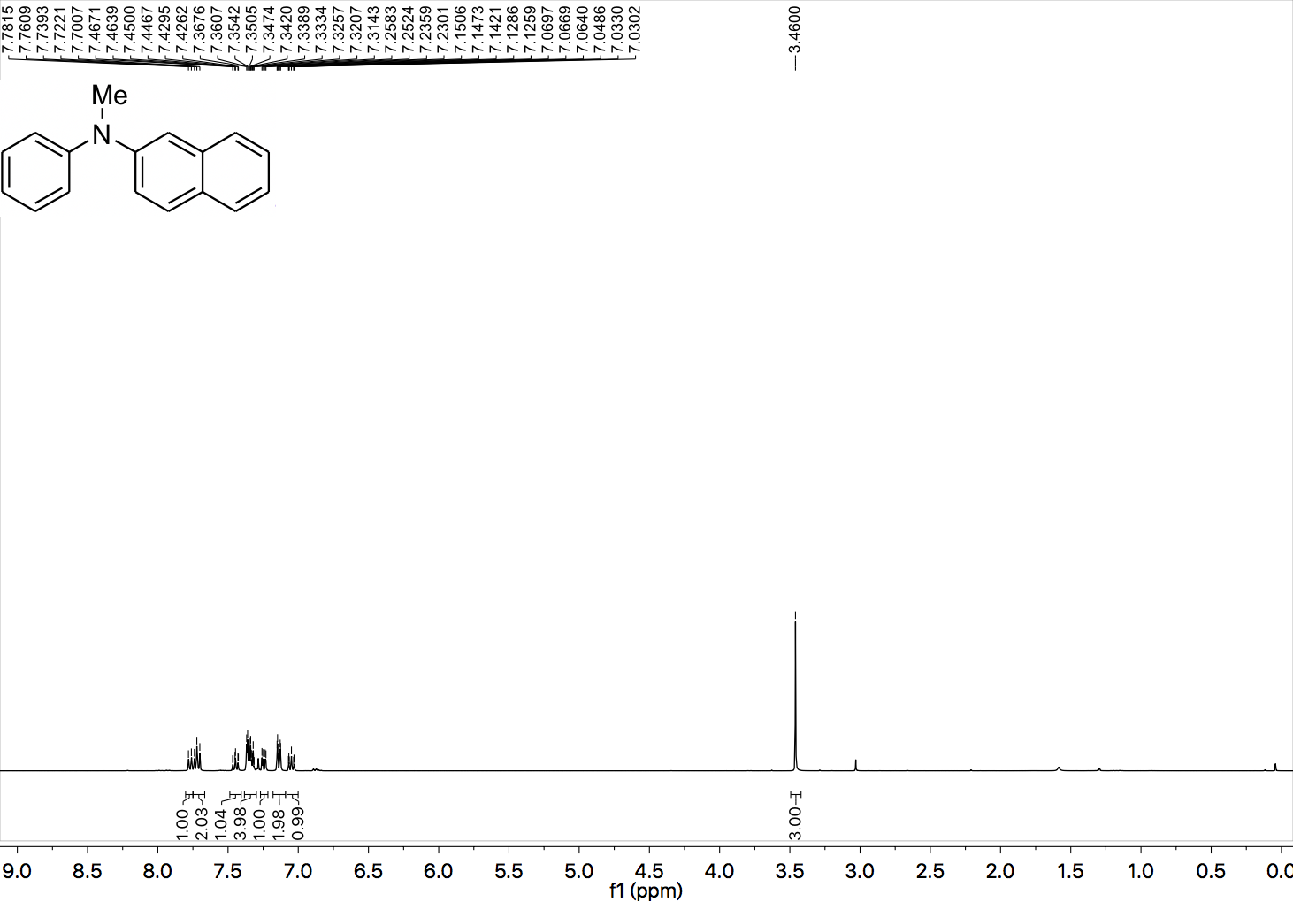

¹³C NMR (101 MHz, CDCl₃) spectrum of 33.

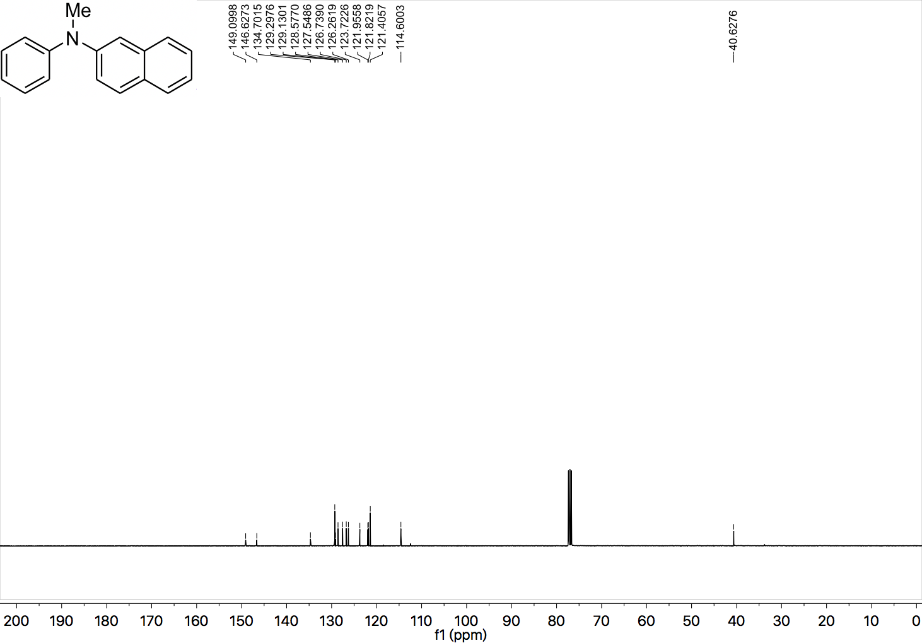

¹H NMR (400 MHz, CDCl₃) spectrum of 34.

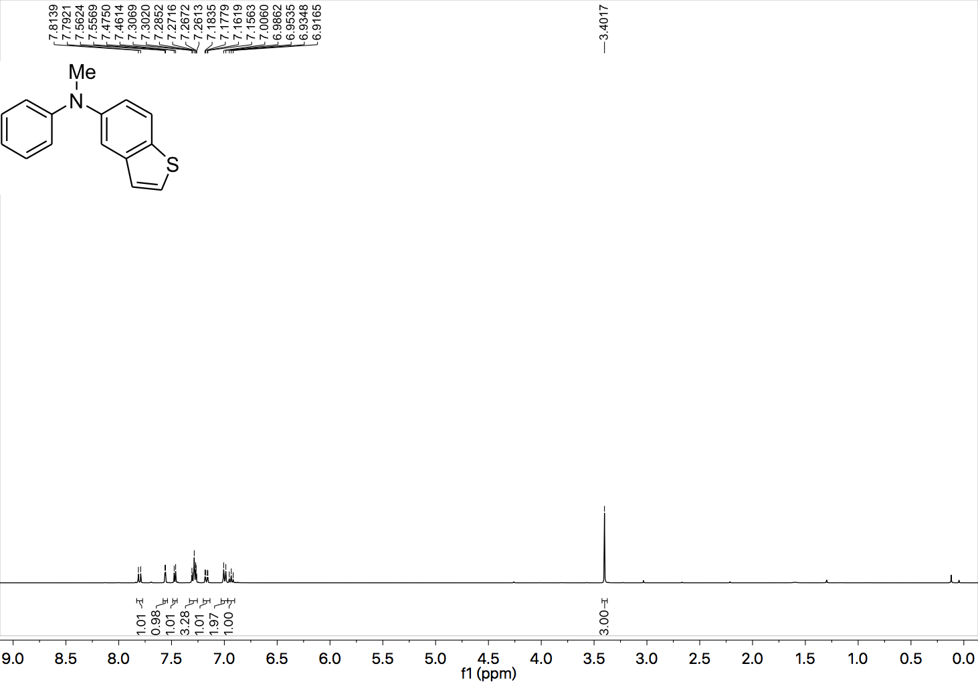

¹³C NMR (101 MHz, CDCl₃) spectrum of 34.

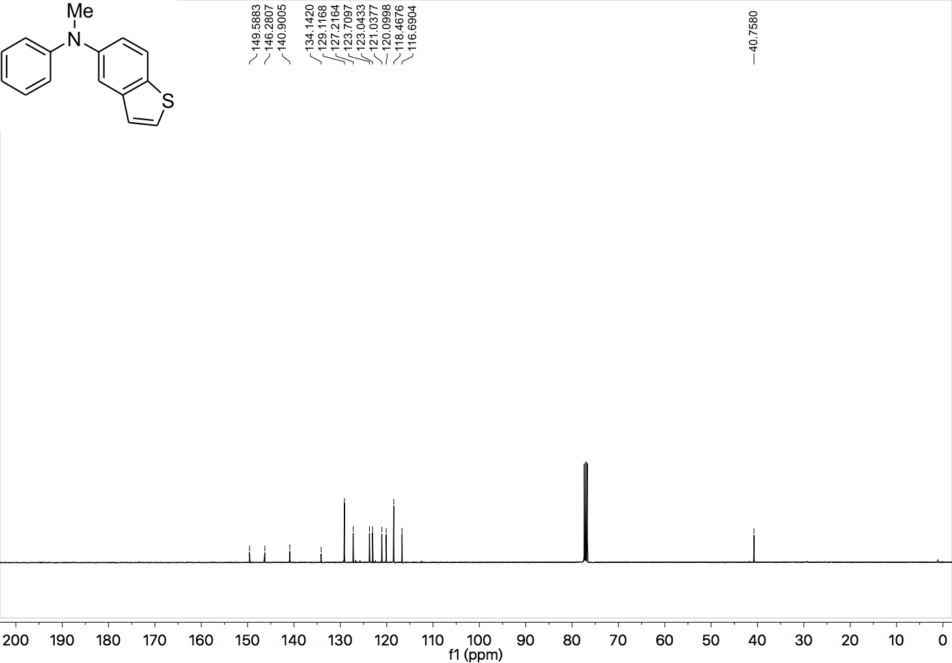

¹H NMR (400 MHz, CDCl₃) spectrum of 35.

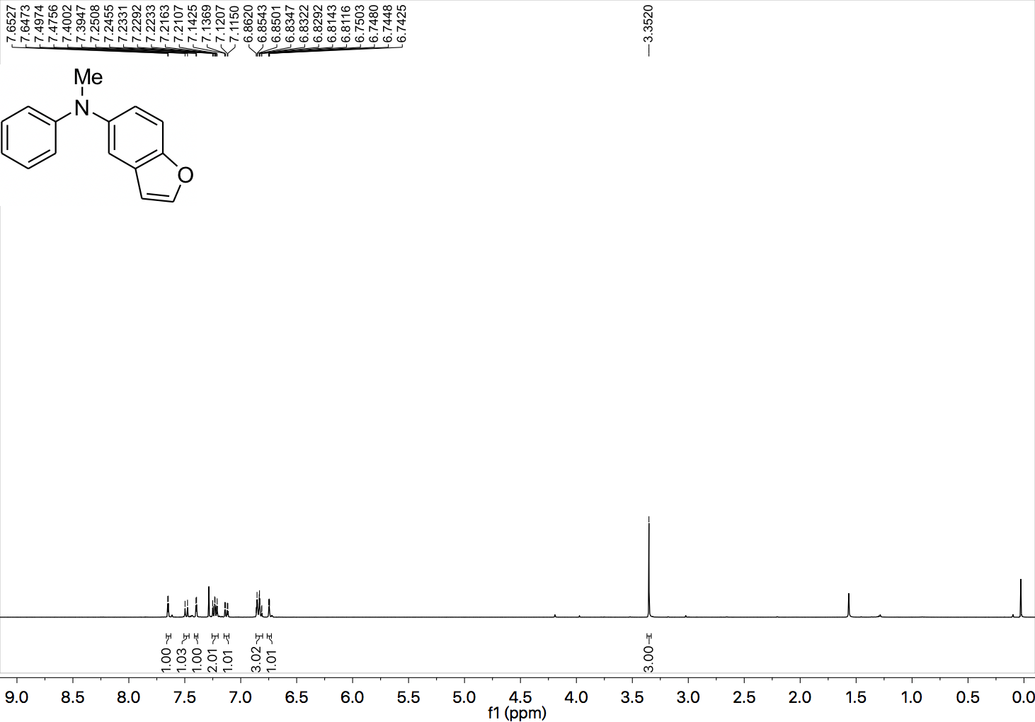

¹³C NMR (101 MHz, CDCl₃) spectrum of 35.

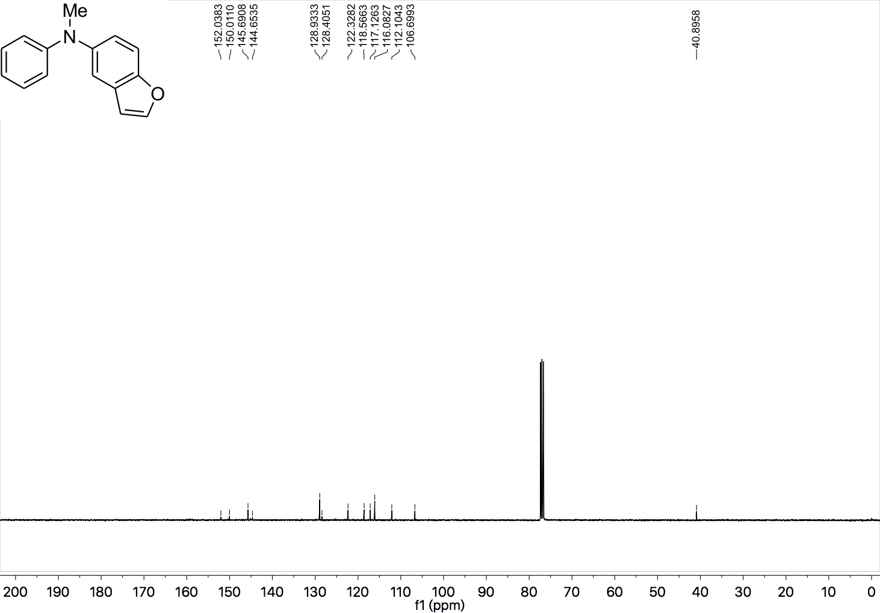

¹H NMR (400 MHz, CDCl₃) spectrum of 36.

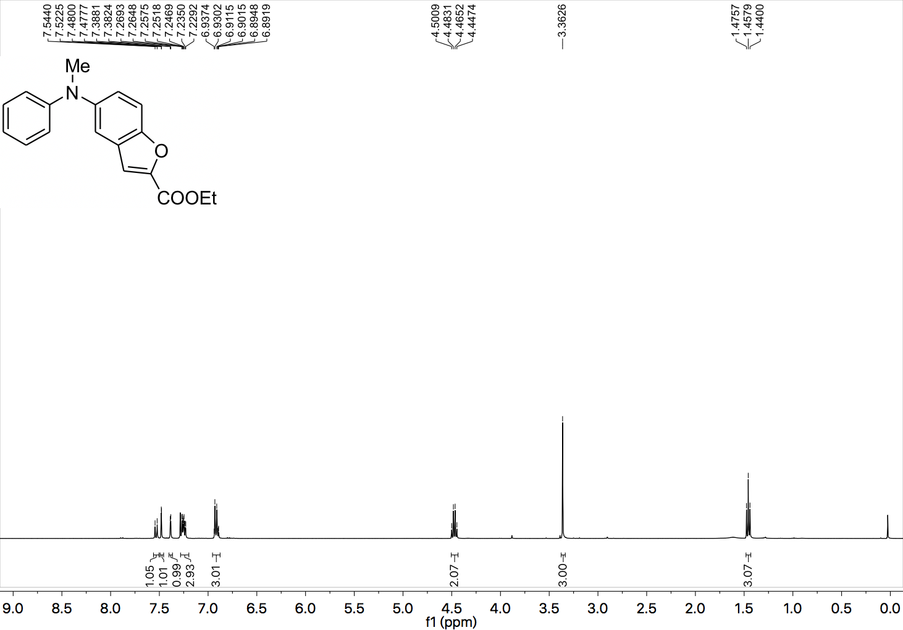

¹³C NMR (101 MHz, CDCl₃) spectrum of 36.

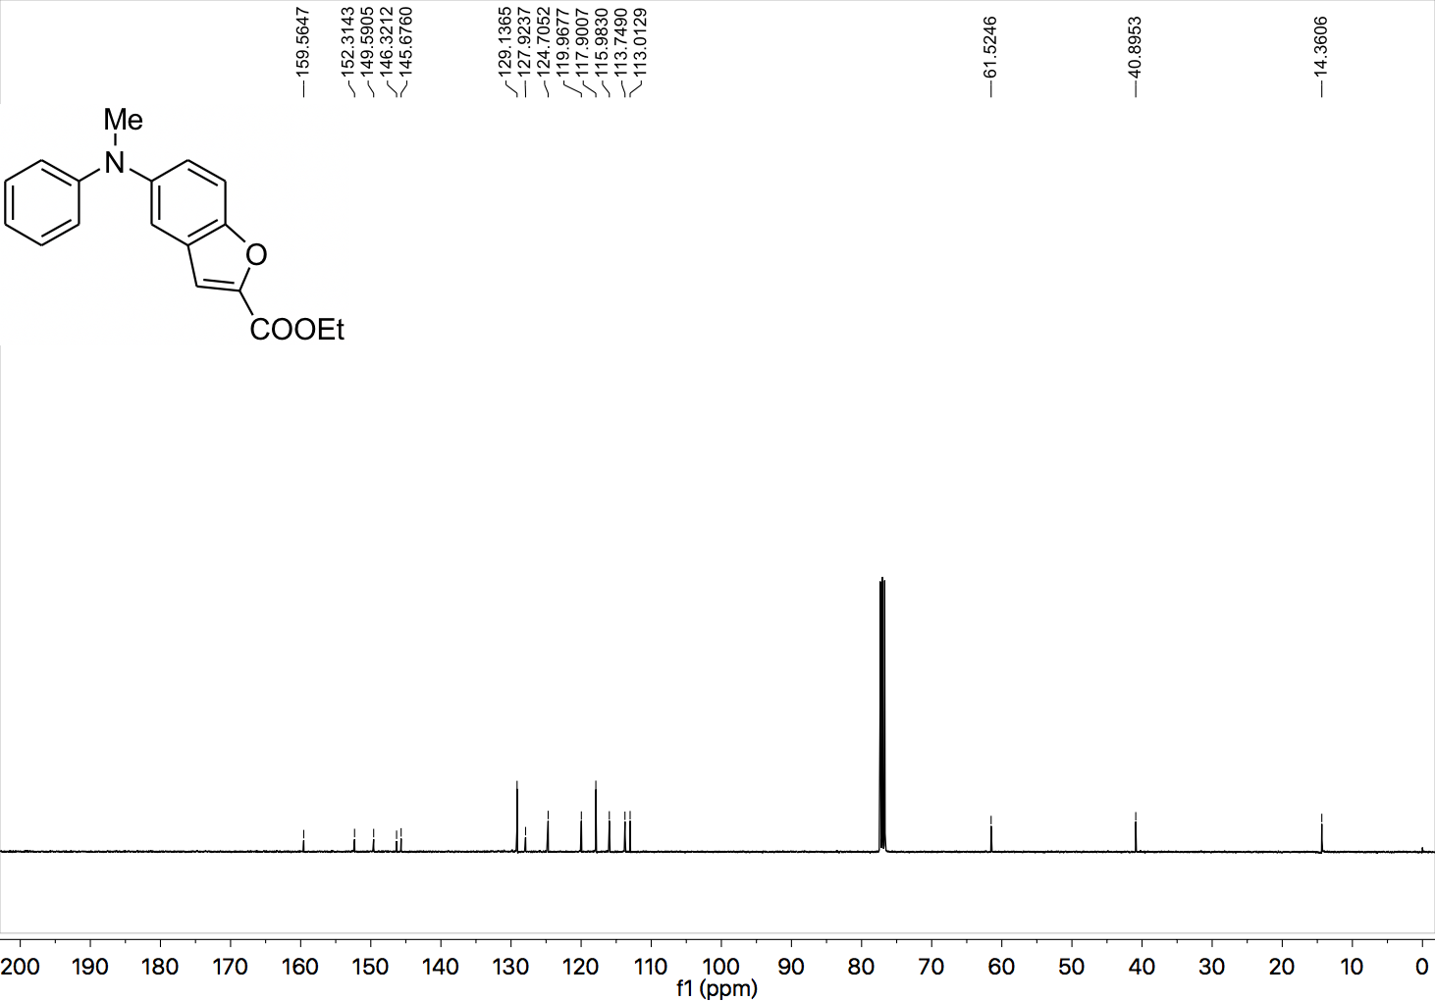

¹H NMR (400 MHz, CDCl₃) spectrum of 37.

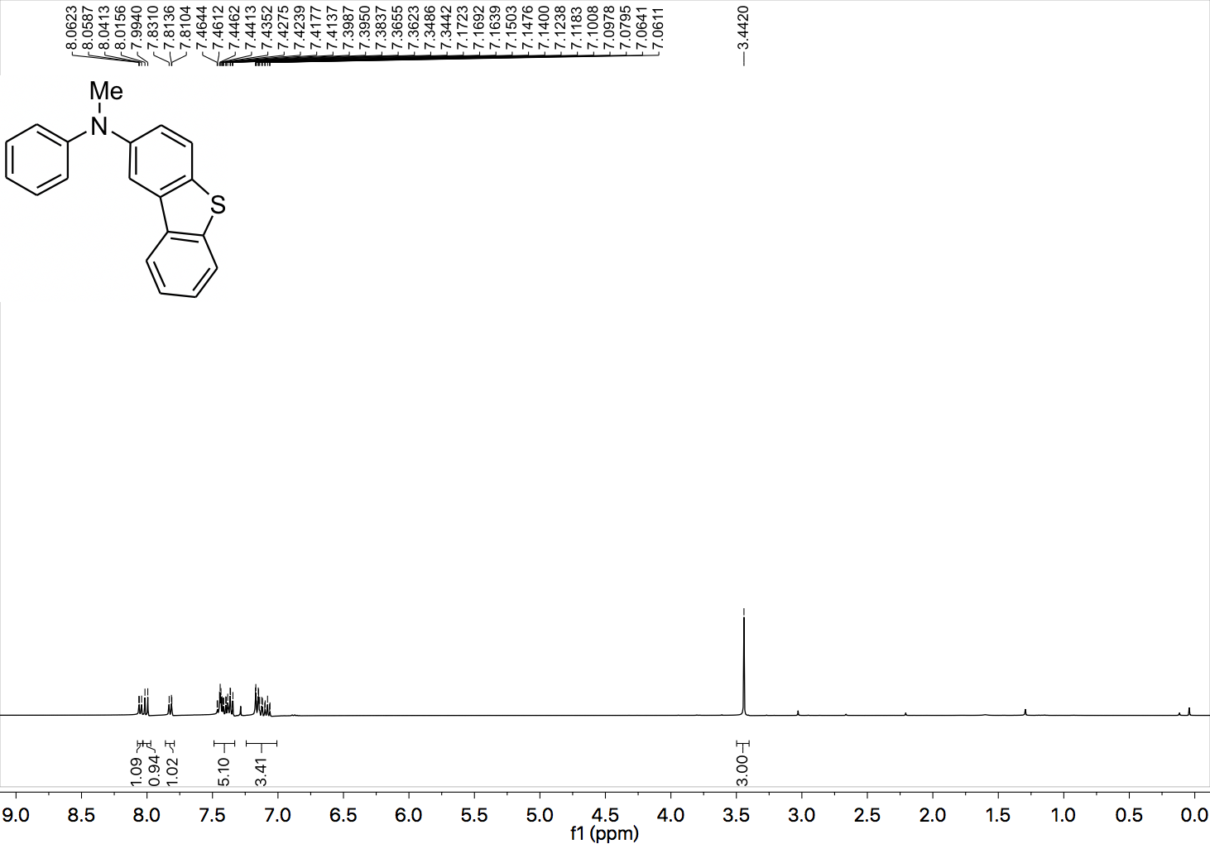

¹³C NMR (101 MHz, CDCl₃) spectrum of 37.

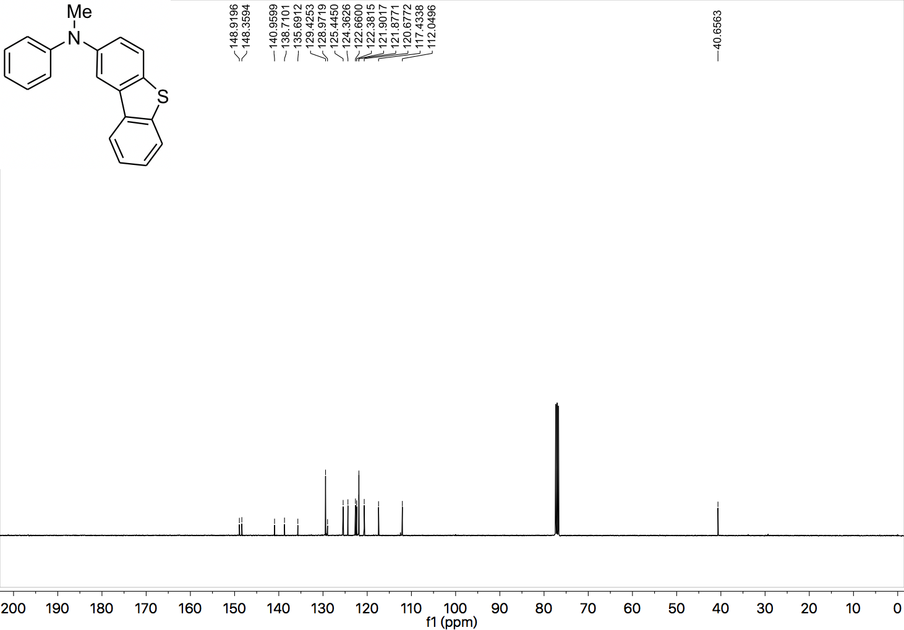

¹H NMR (400 MHz, CDCl₃) spectrum of 38.

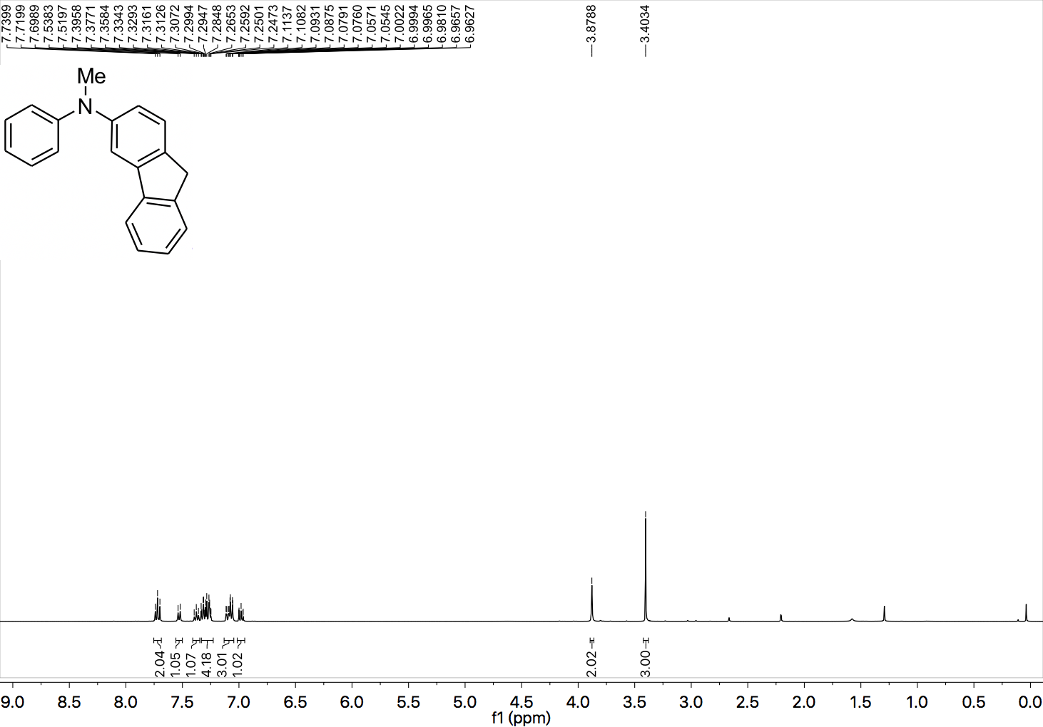

¹³C NMR (101 MHz, CDCl₃) spectrum of 38.

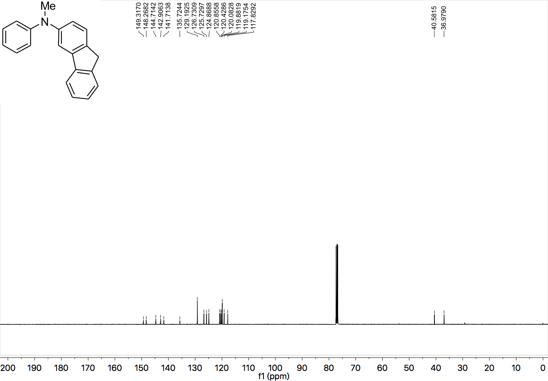

¹H NMR (400 MHz, CDCl₃) spectrum of 39.

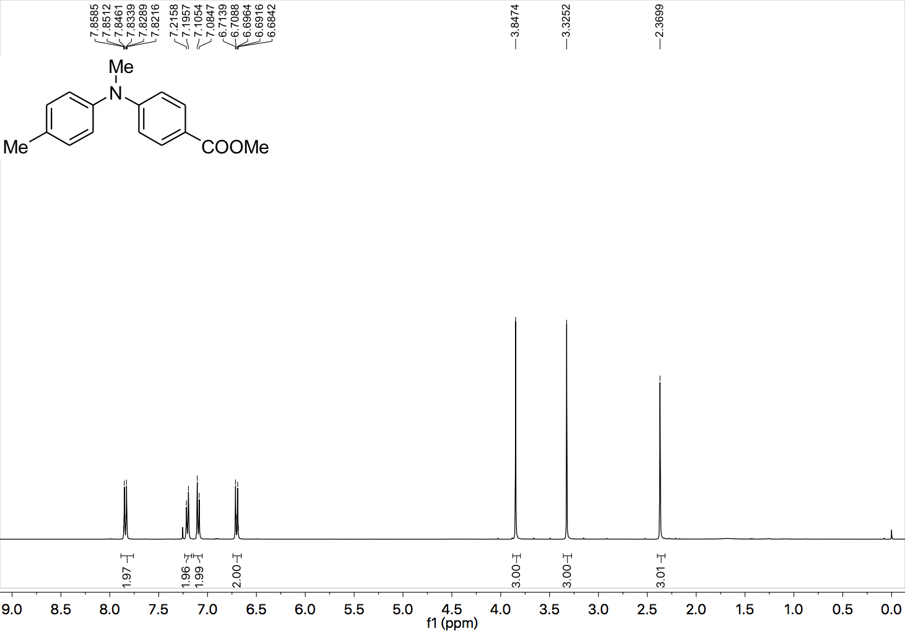

¹³C NMR (101 MHz, CDCl₃) spectrum of 39.

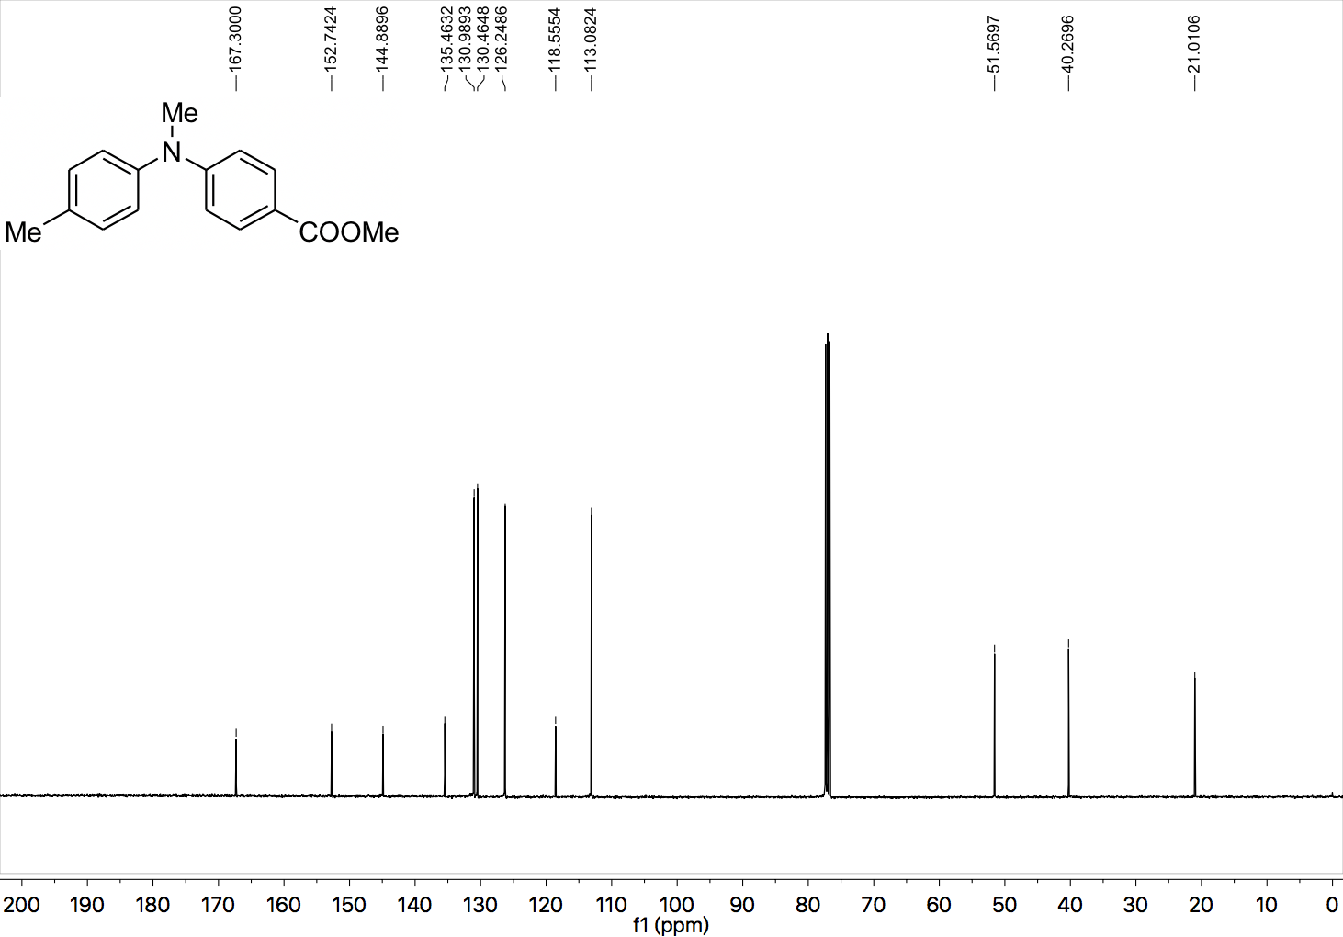

¹H NMR (400 MHz, CDCl₃) spectrum of 40.

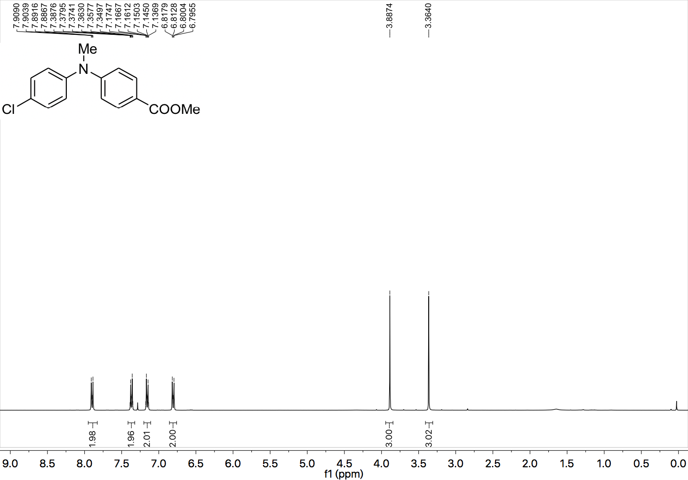

¹³C NMR (101 MHz, CDCl₃) spectrum of 40.

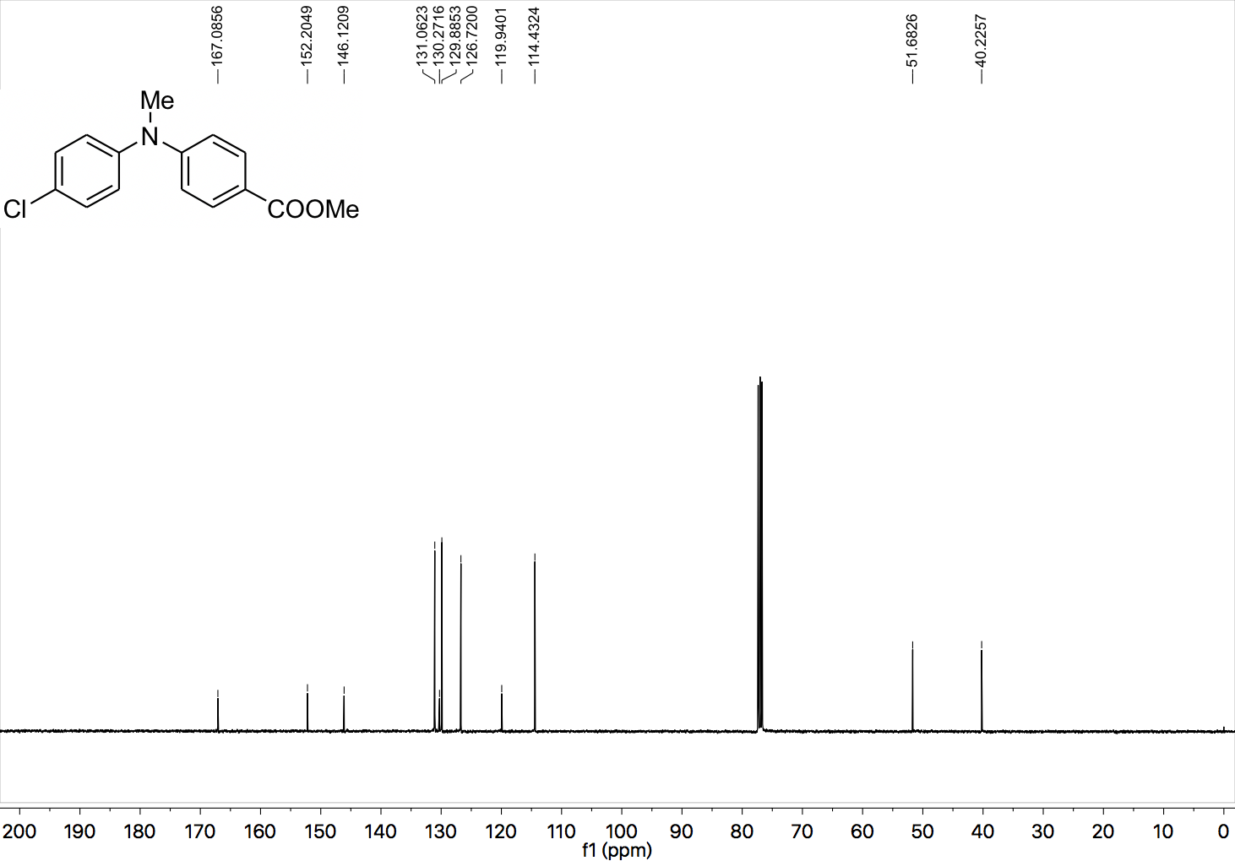

¹H NMR (400 MHz, CDCl₃) spectrum of 41.

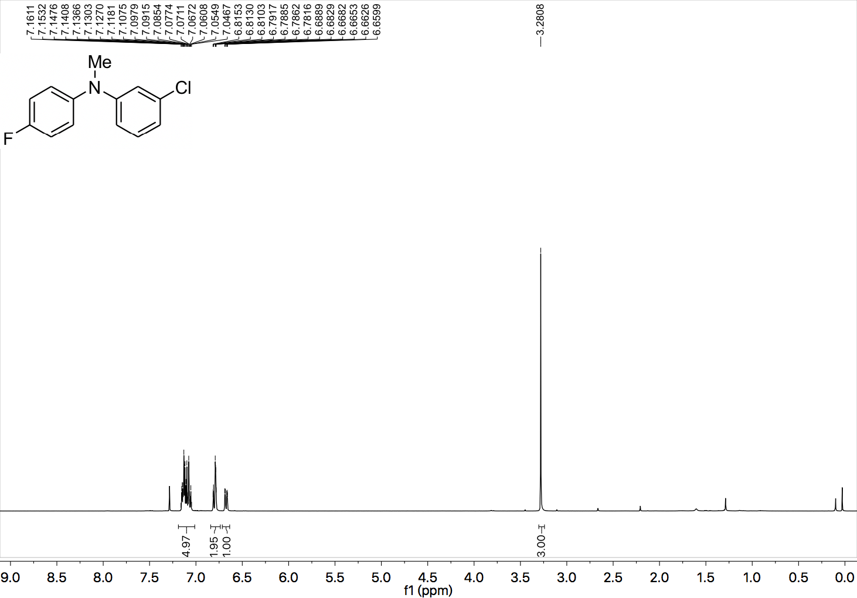

¹³C NMR (101 MHz, CDCl₃) spectrum of 41.

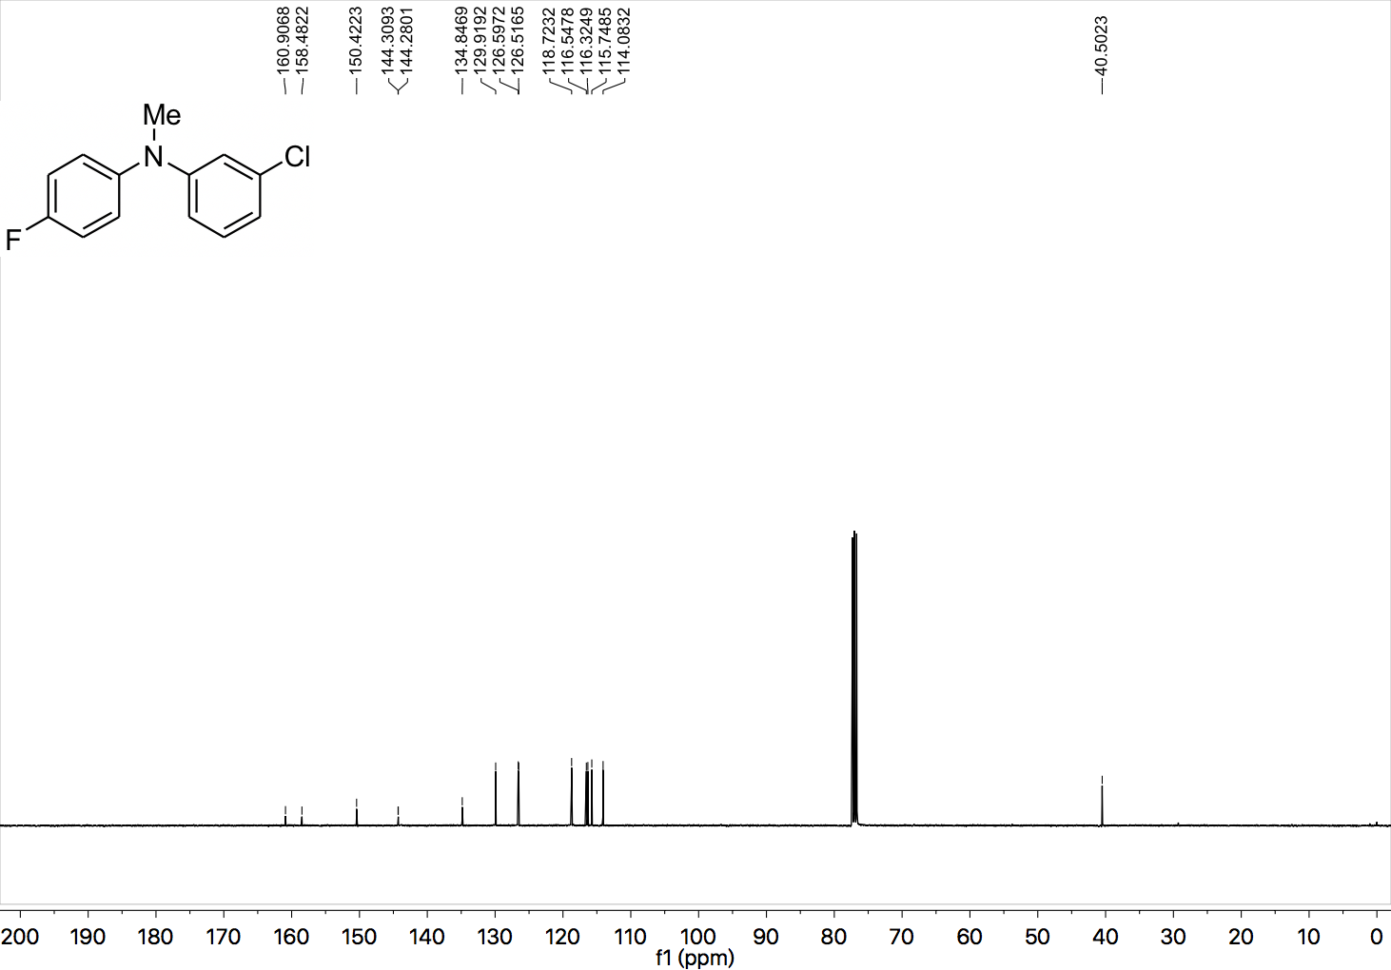

¹⁹F NMR (377 MHz, CDCl₃) spectrum of 41.

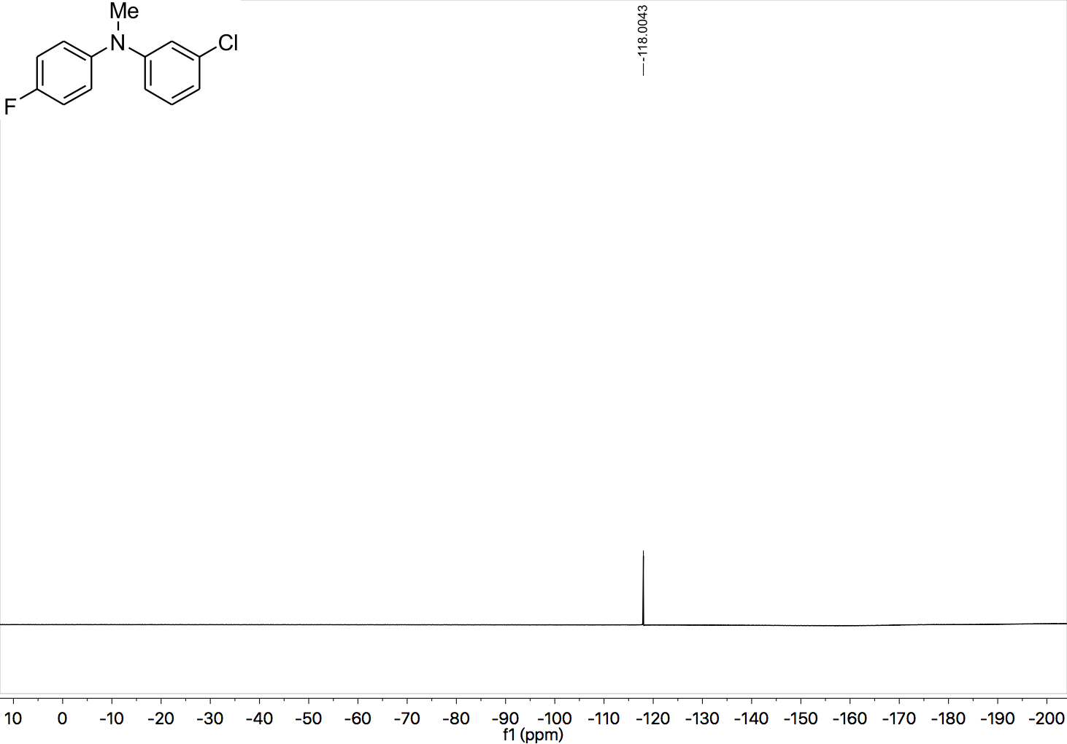

¹H NMR (400 MHz, CDCl₃) spectrum of 42.

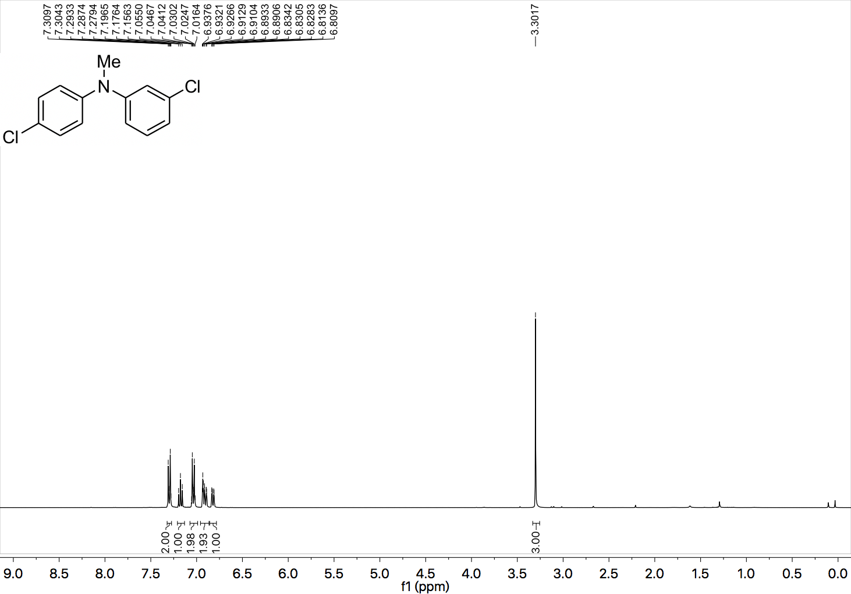

¹³C NMR (101 MHz, CDCl₃) spectrum of 42.

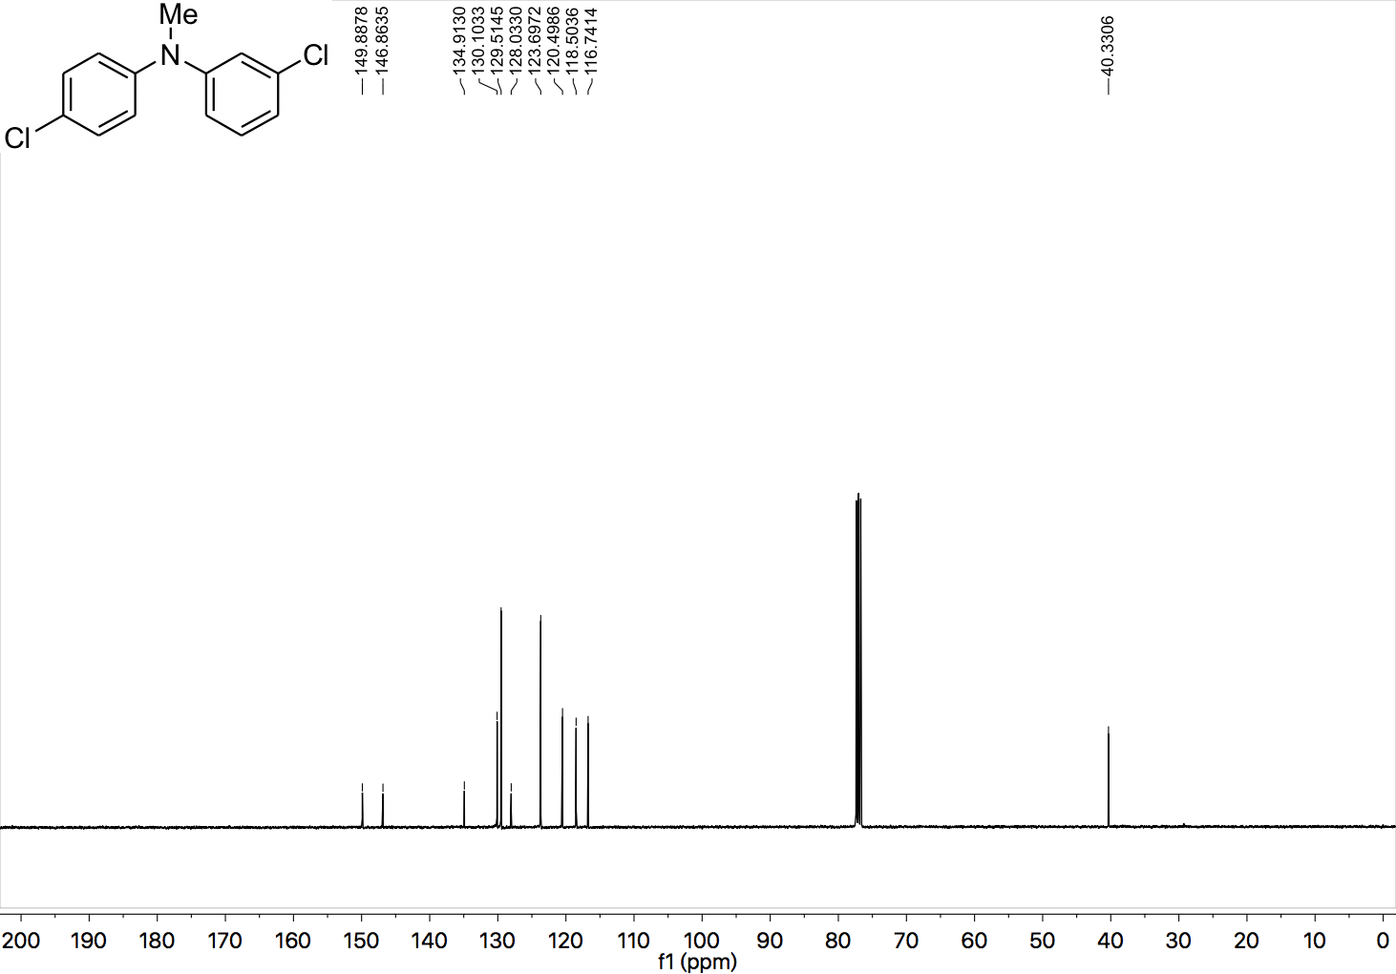

¹H NMR (400 MHz, CDCl₃) spectrum of 43.

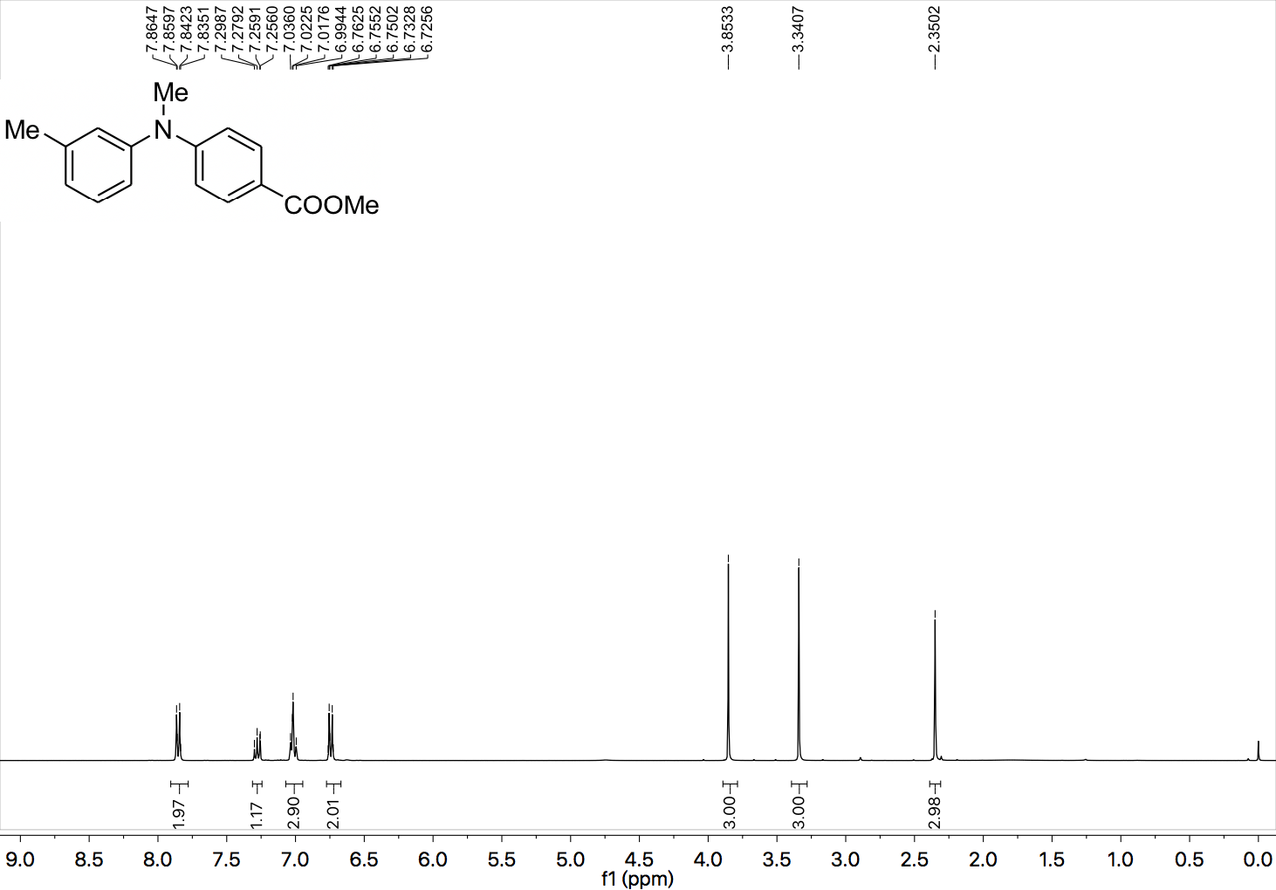

¹³C NMR (101 MHz, CDCl₃) spectrum of 43.

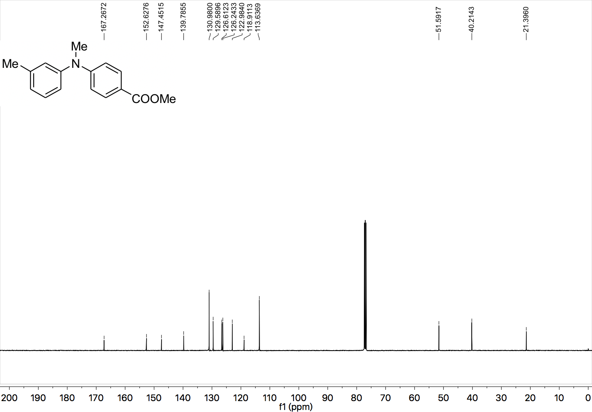

¹H NMR (400 MHz, CDCl₃) spectrum of 44.

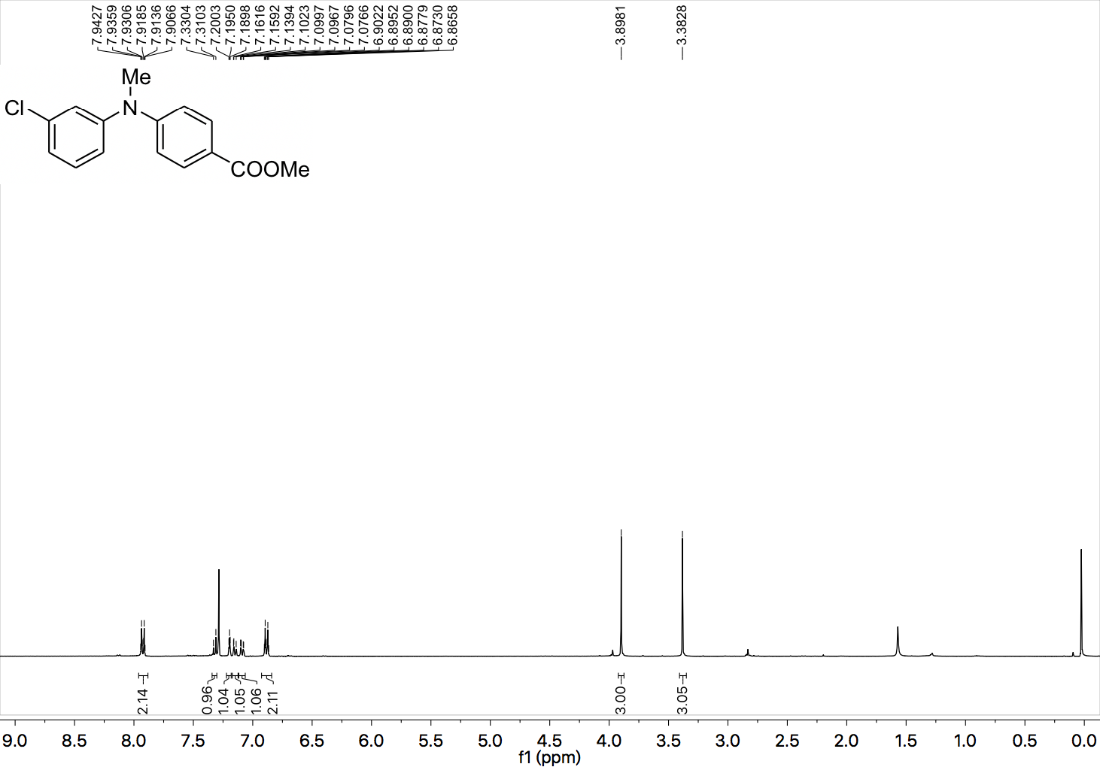

¹³C NMR (101 MHz, CDCl₃) spectrum of 44.

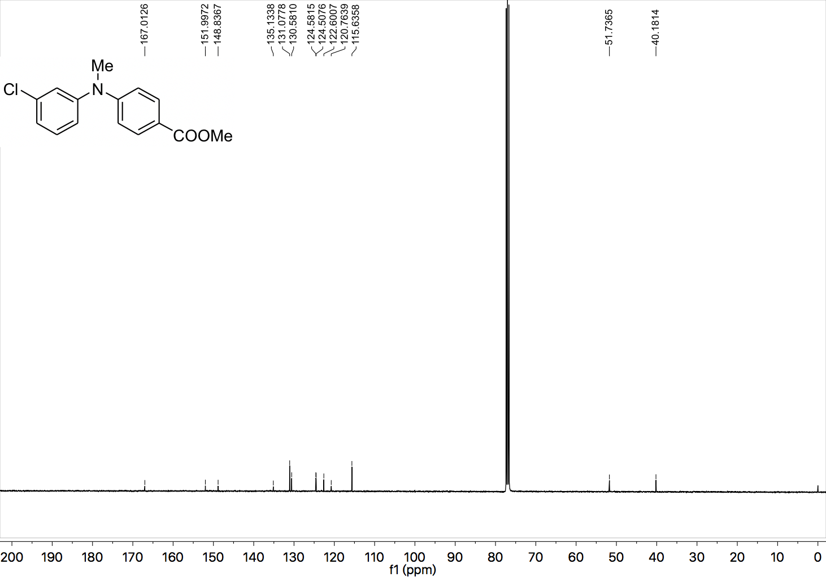

¹H NMR (400 MHz, CDCl₃) spectrum of 45.

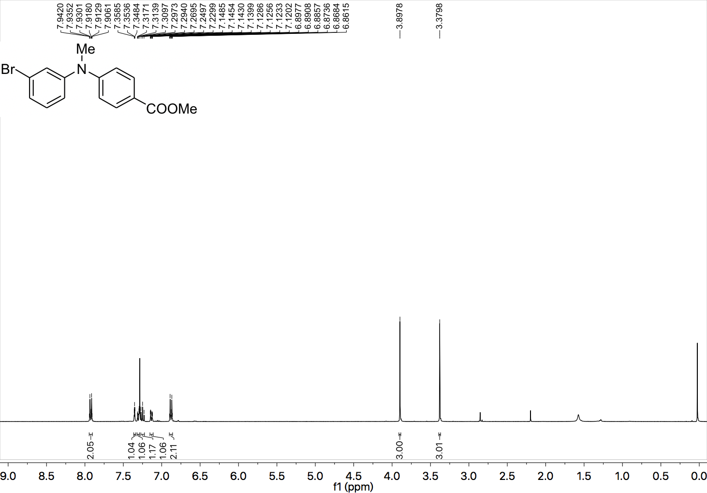

¹³C NMR (101 MHz, CDCl₃) spectrum of 45.

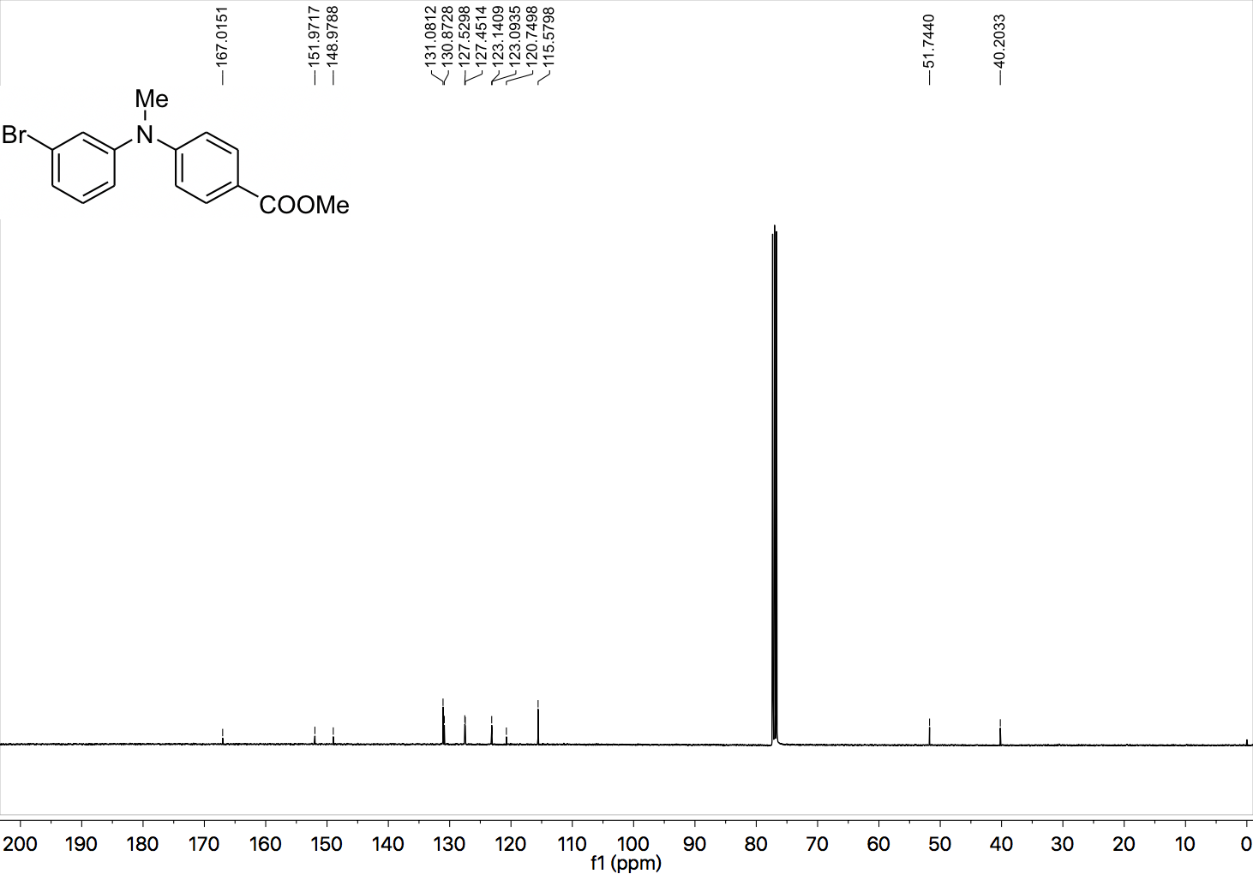

¹H NMR (400 MHz, CDCl₃) spectrum of 46.

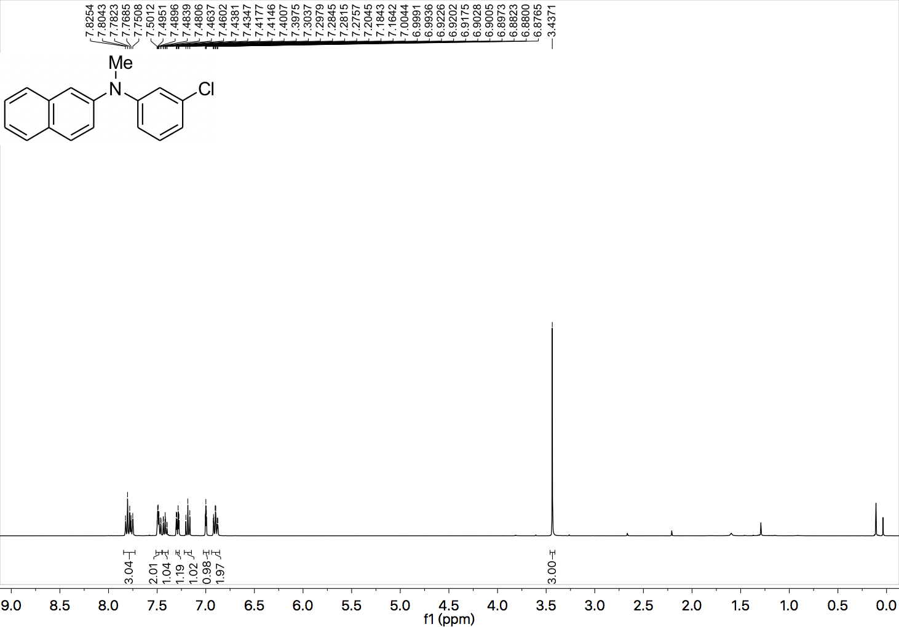

¹³C NMR (101 MHz, CDCl₃) spectrum of 46.

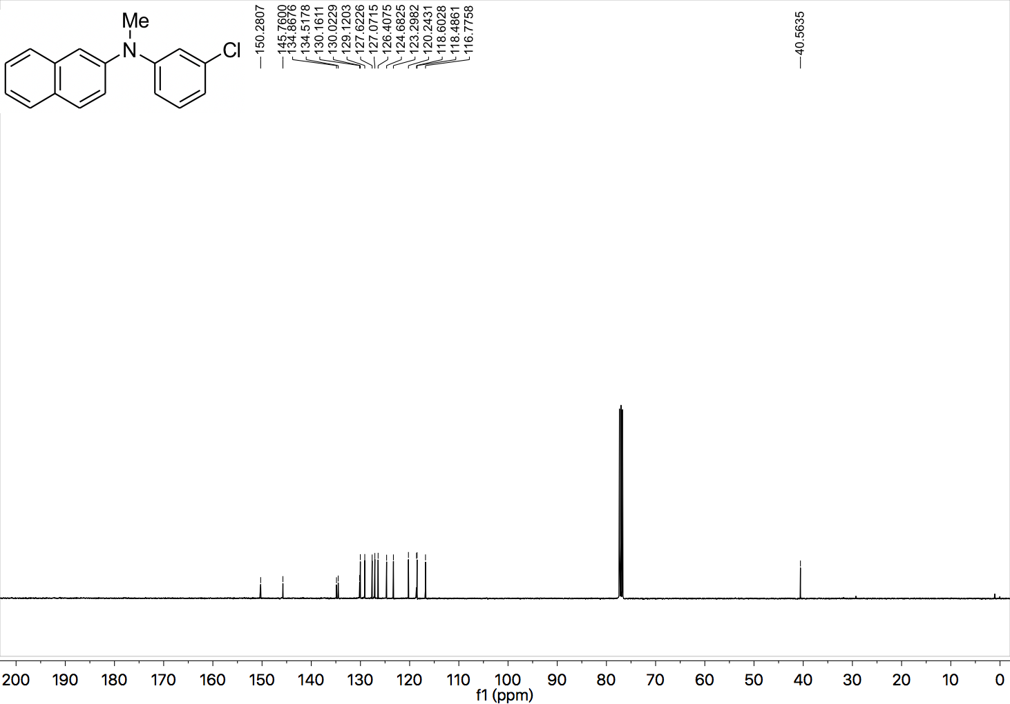

¹H NMR (400 MHz, CDCl₃) spectrum of 47.

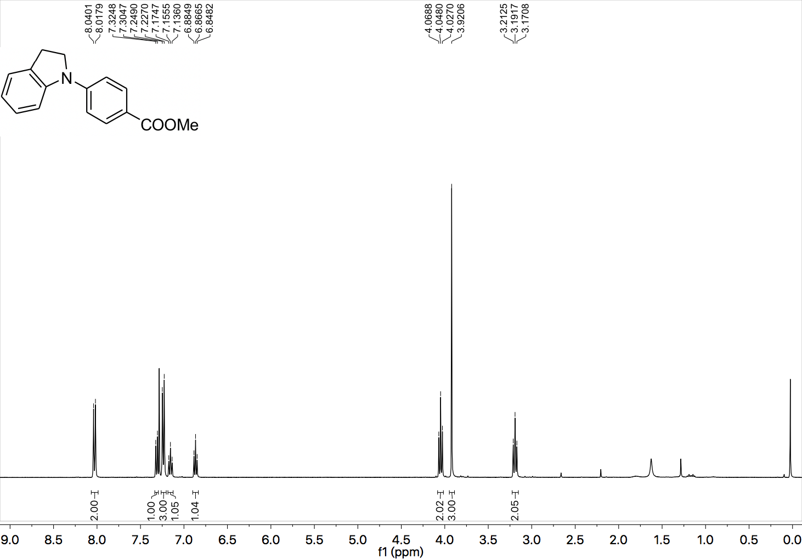

¹³C NMR (101 MHz, CDCl₃) spectrum of 47.

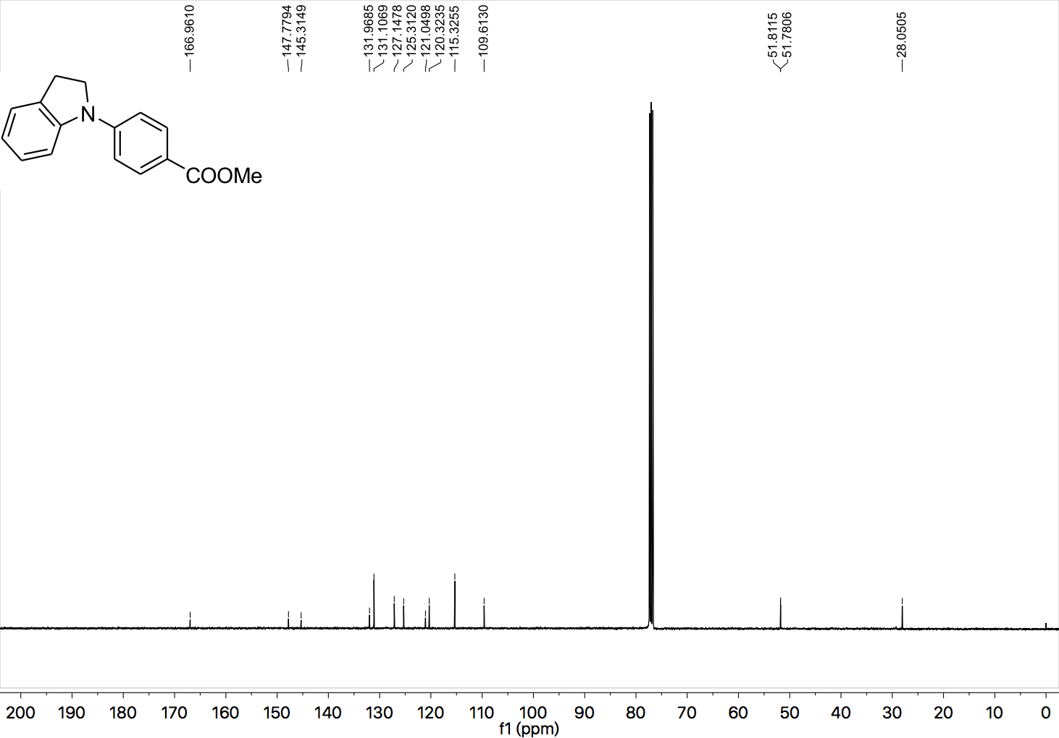

¹H NMR (400 MHz, CDCl₃) spectrum of 48.

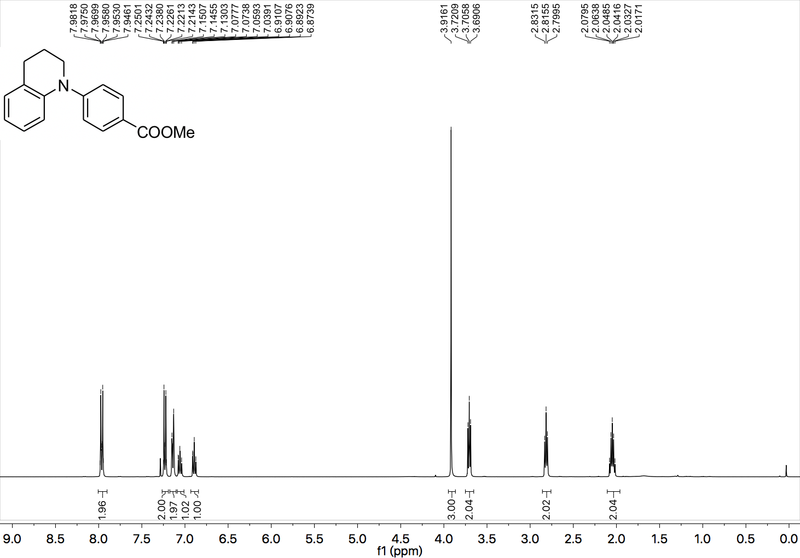

¹³C NMR (101 MHz, CDCl₃) spectrum of 48.

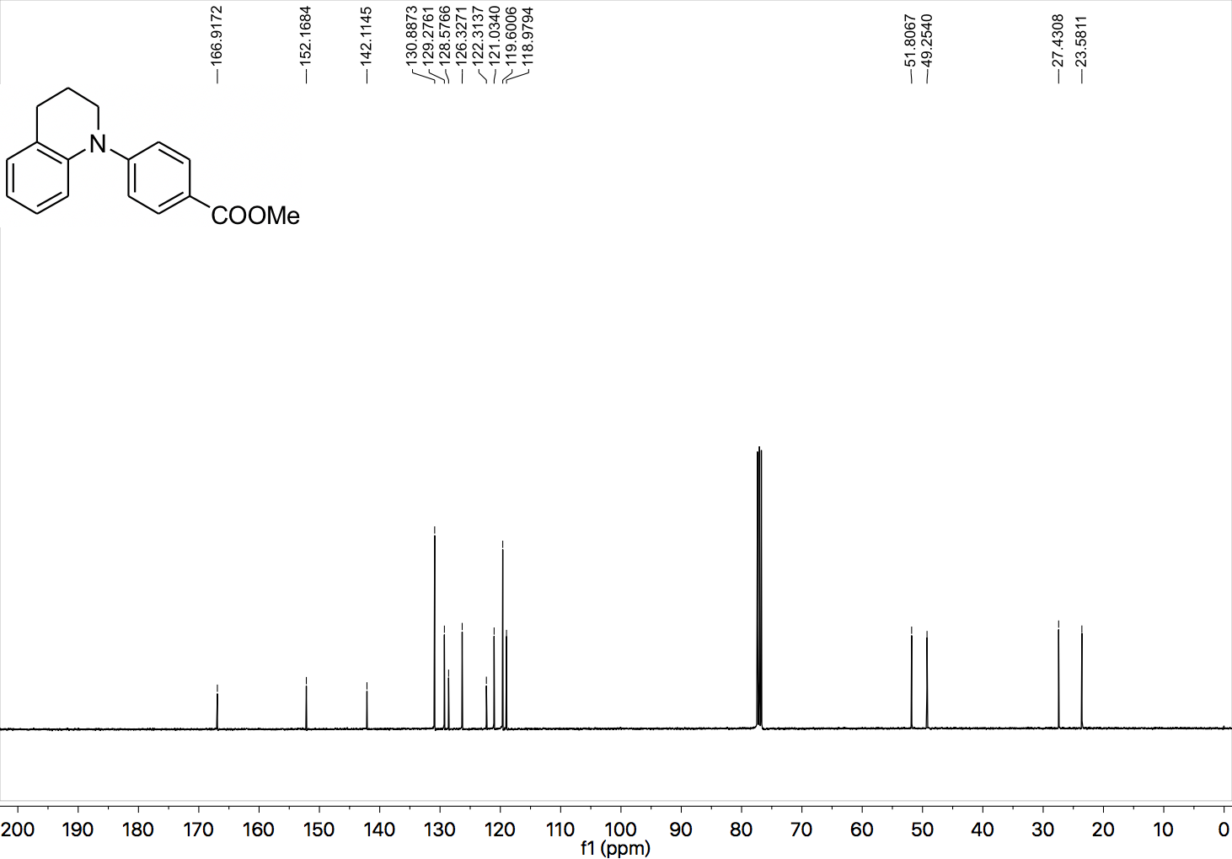

¹H NMR (400 MHz, CDCl₃) spectrum of 49.

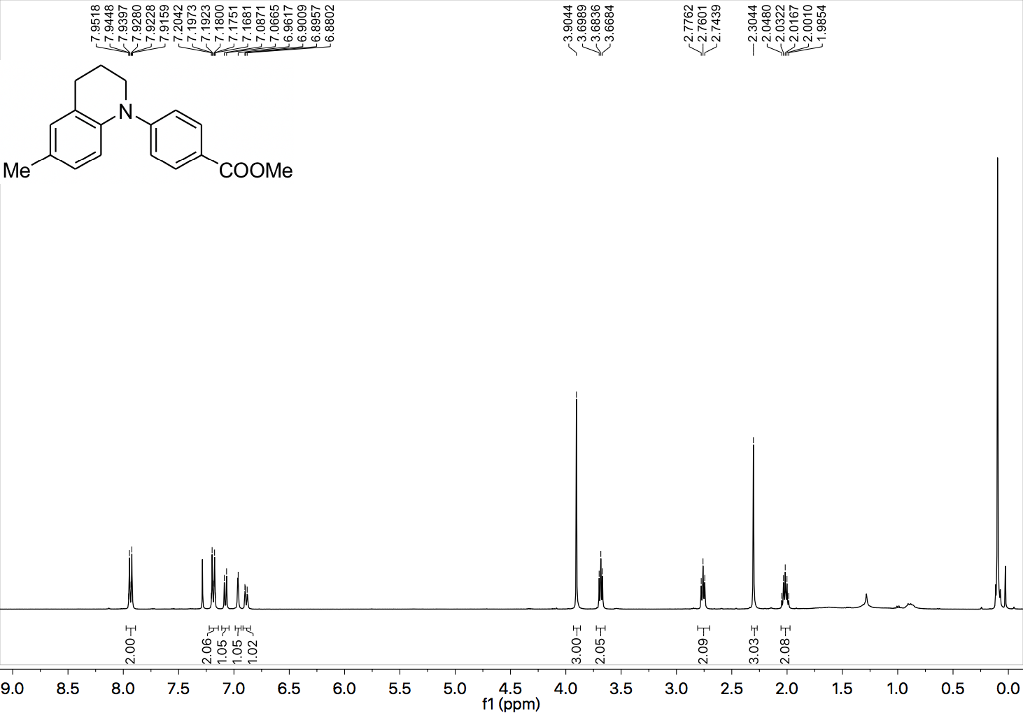

¹³C NMR (101 MHz, CDCl₃) spectrum of 49.

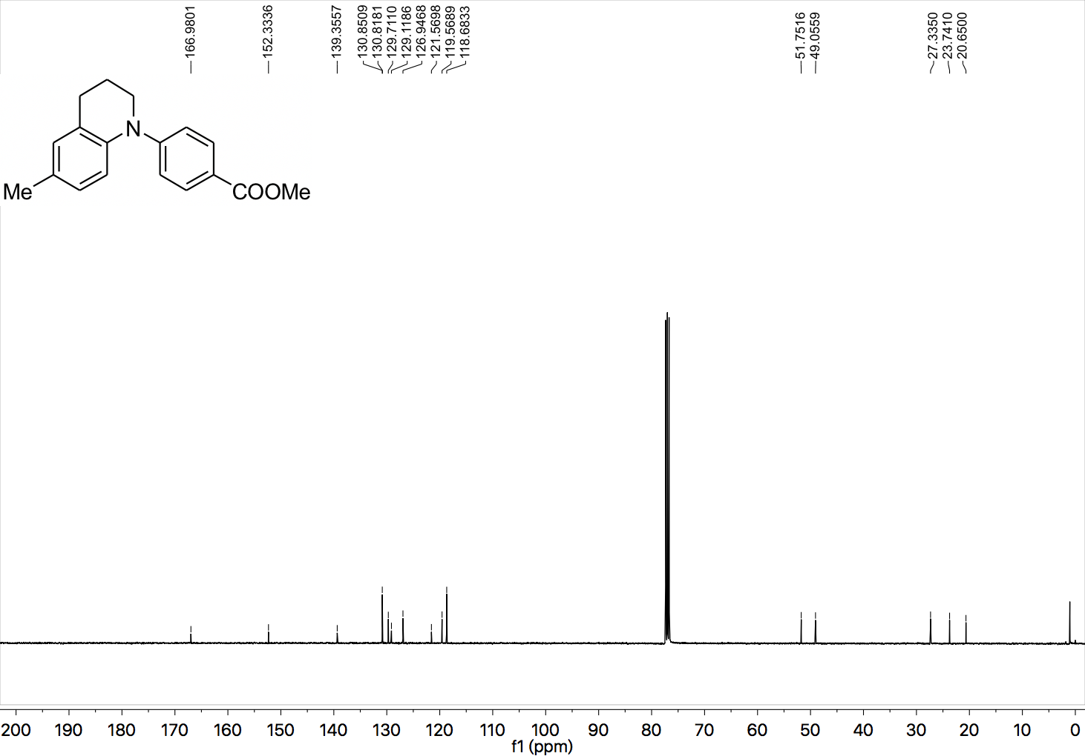

¹H NMR (400 MHz, CDCl₃) spectrum of 50.

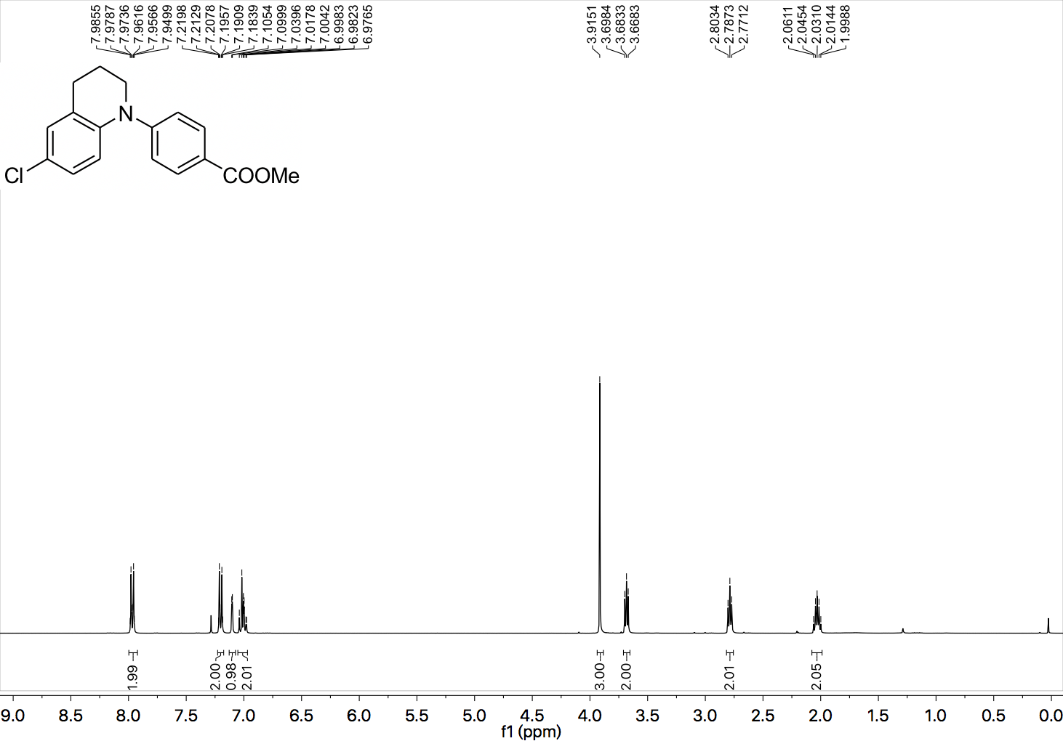

¹³C NMR (101 MHz, CDCl₃) spectrum of 50.

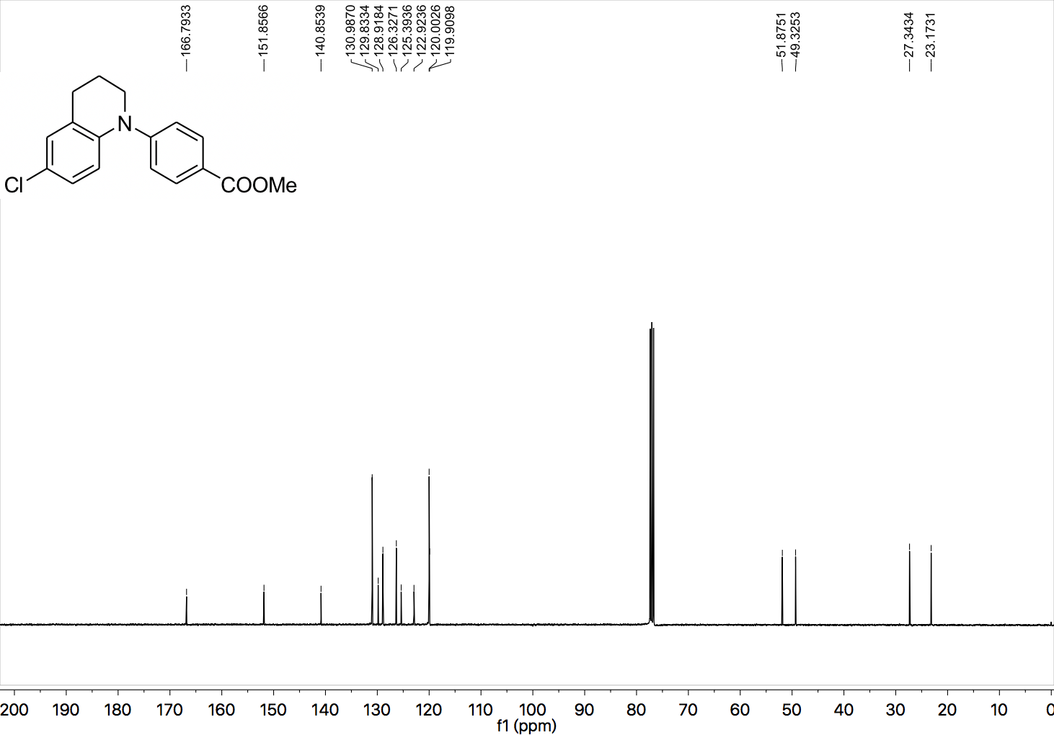

¹H NMR (400 MHz, CDCl₃) spectrum of 51.

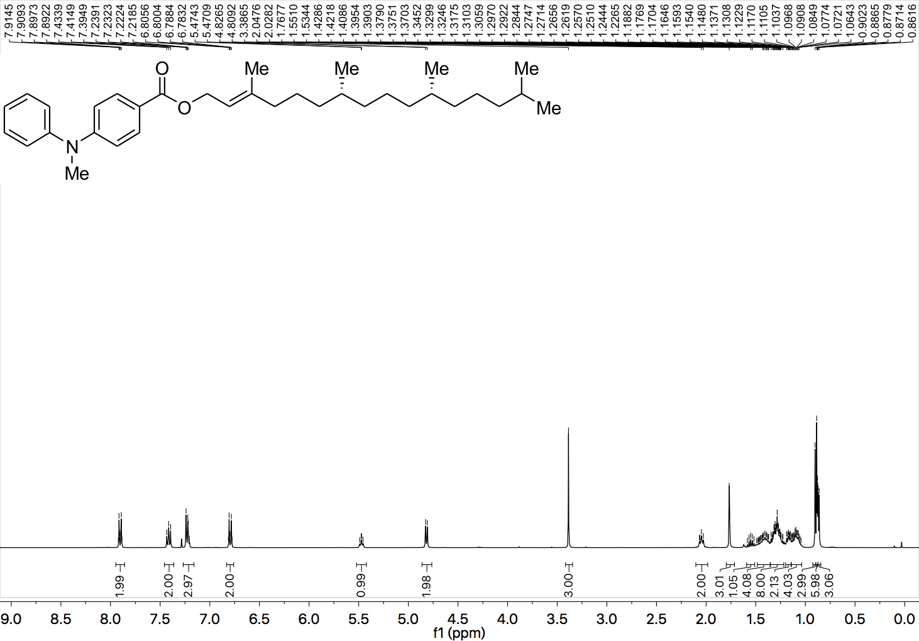

¹³C NMR (101 MHz, CDCl₃) spectrum of 51.

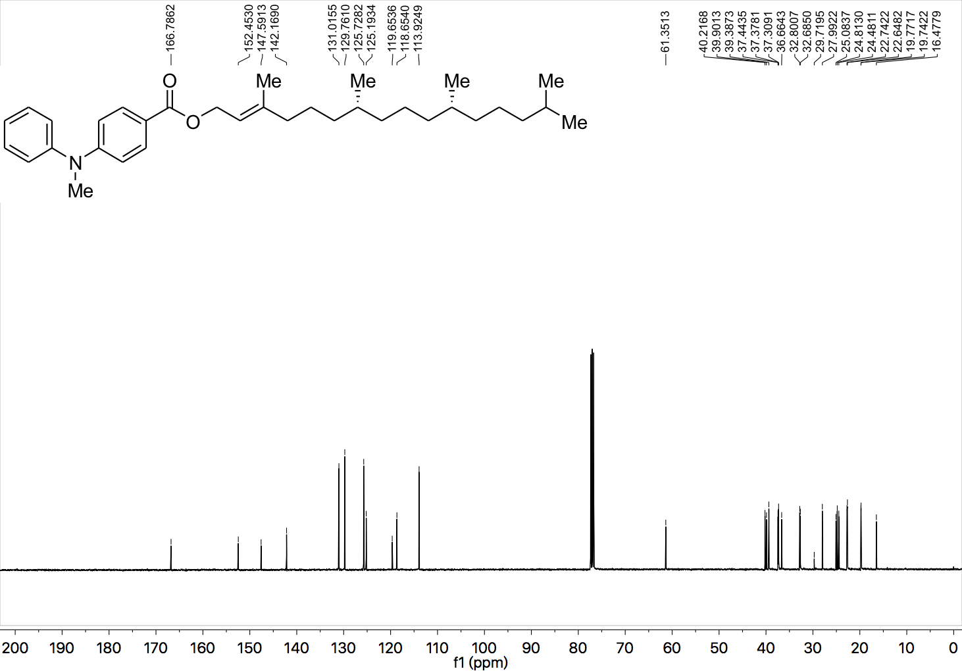

¹H NMR (400 MHz, CDCl₃) spectrum of 52.

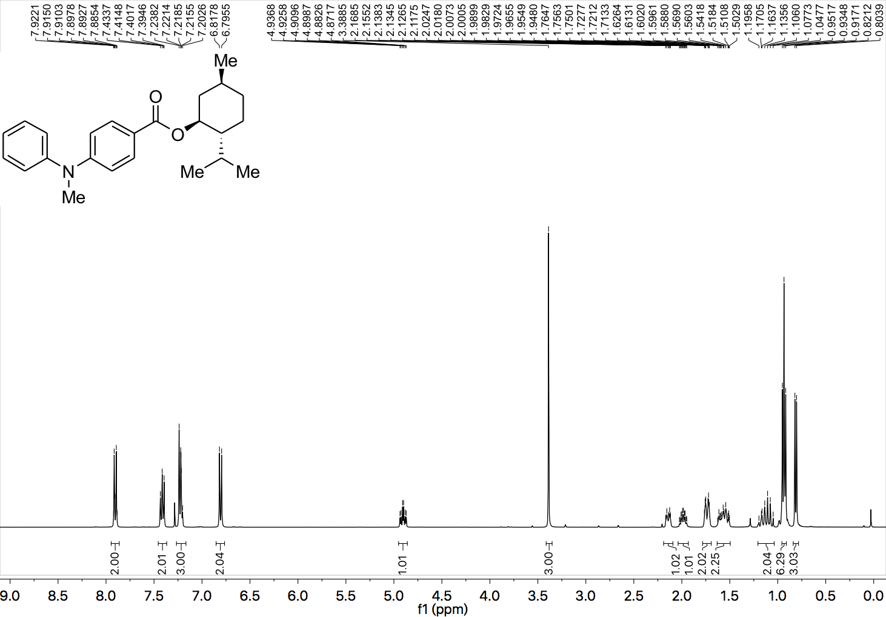

¹³C NMR (101 MHz, CDCl₃) spectrum of 52.

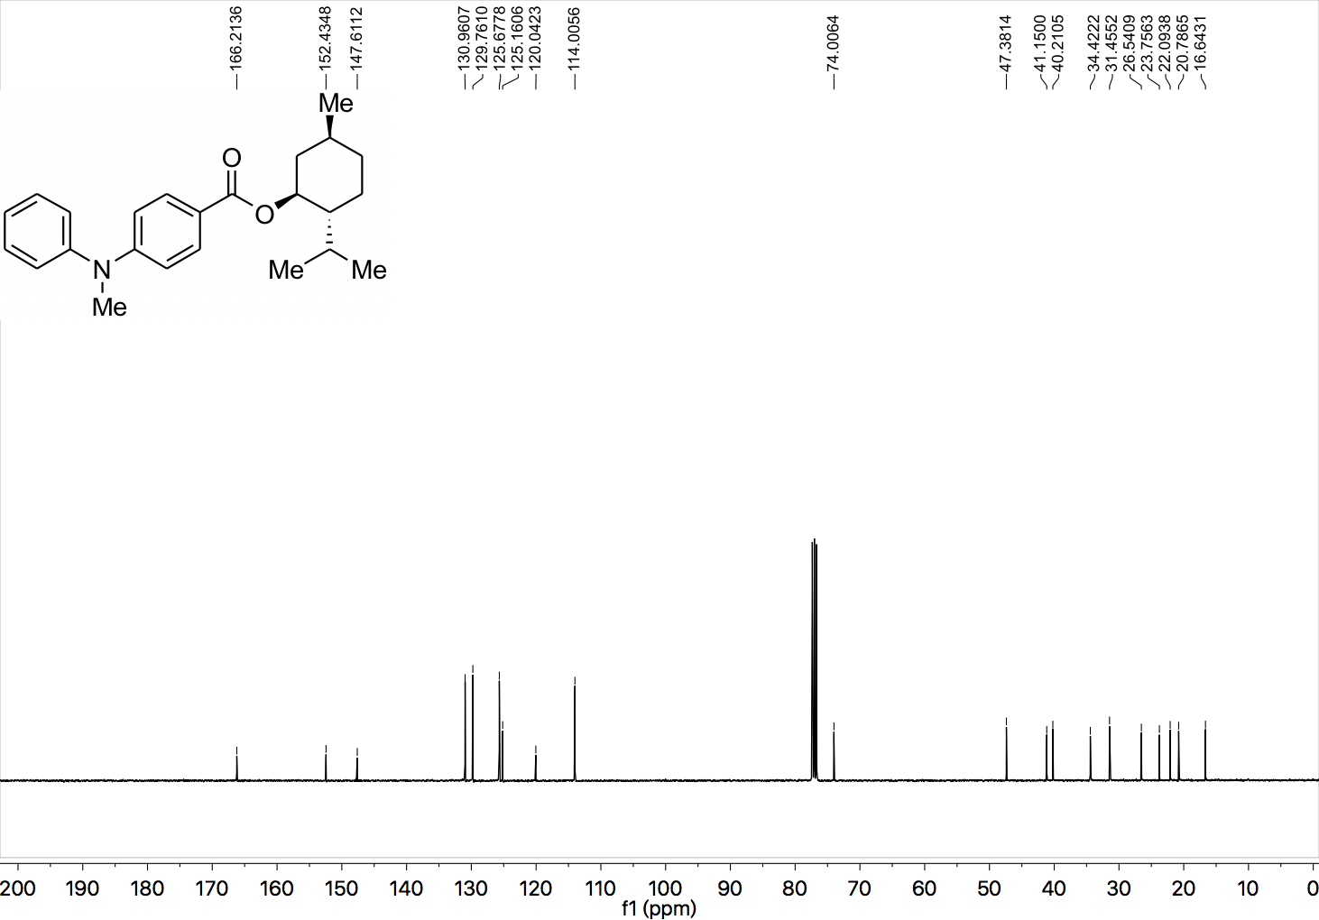

¹H NMR (400 MHz, CDCl₃) spectrum of 53.

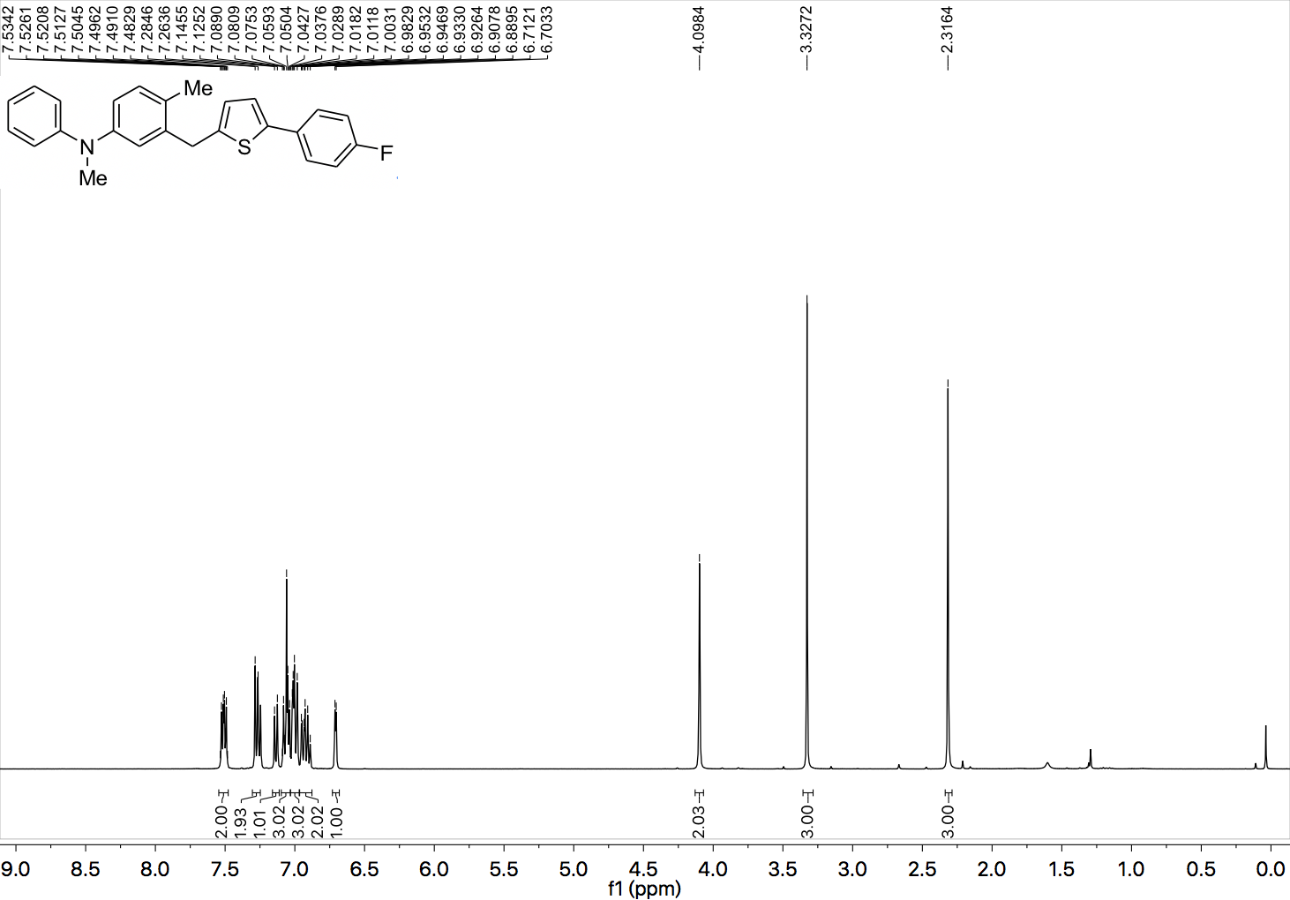

¹³C NMR (101 MHz, CDCl₃) spectrum of 53.

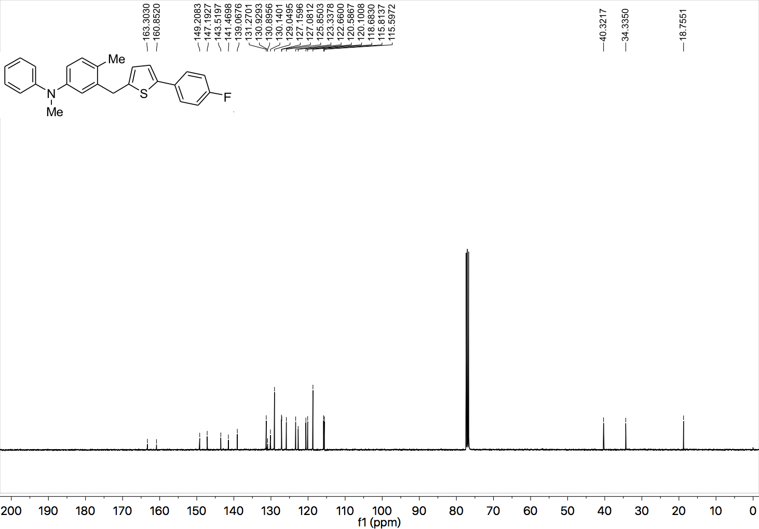

¹⁹F NMR (377 MHz, CDCl₃) spectrum of 53.

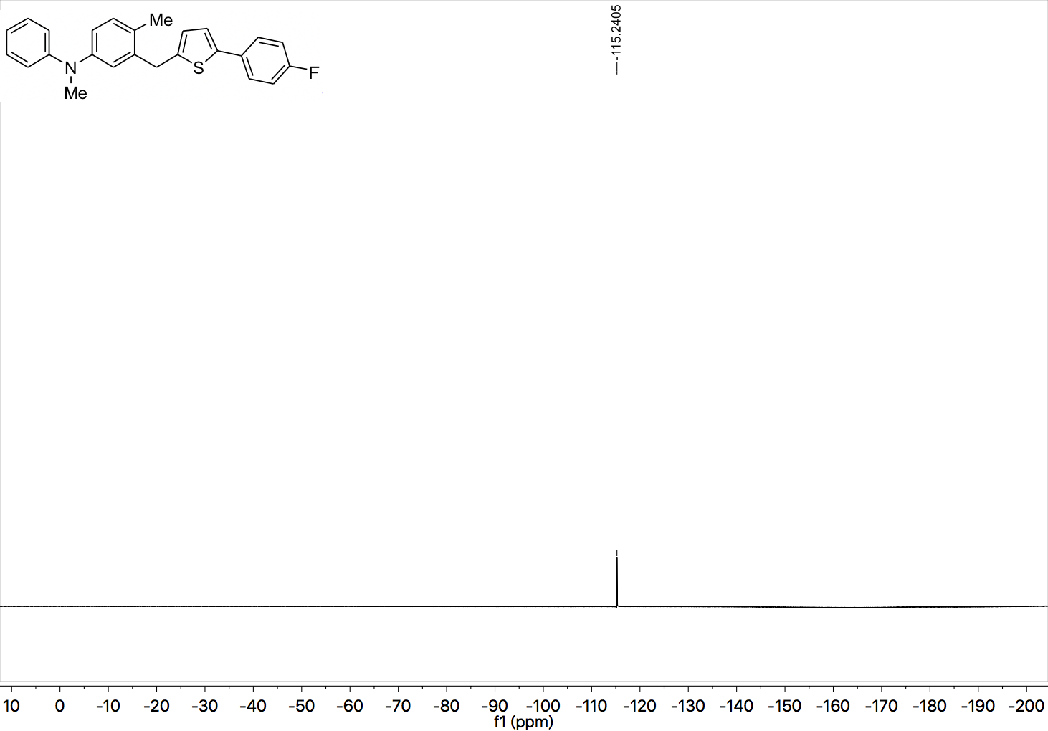

¹H NMR (400 MHz, CDCl₃) spectrum of 54.

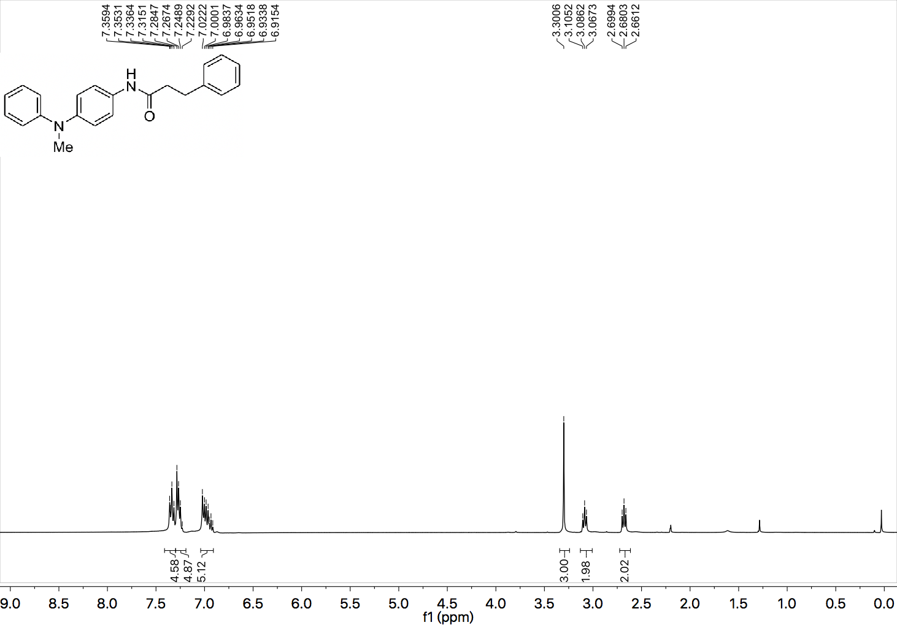

¹³C NMR (101 MHz, CDCl₃) spectrum of 54.

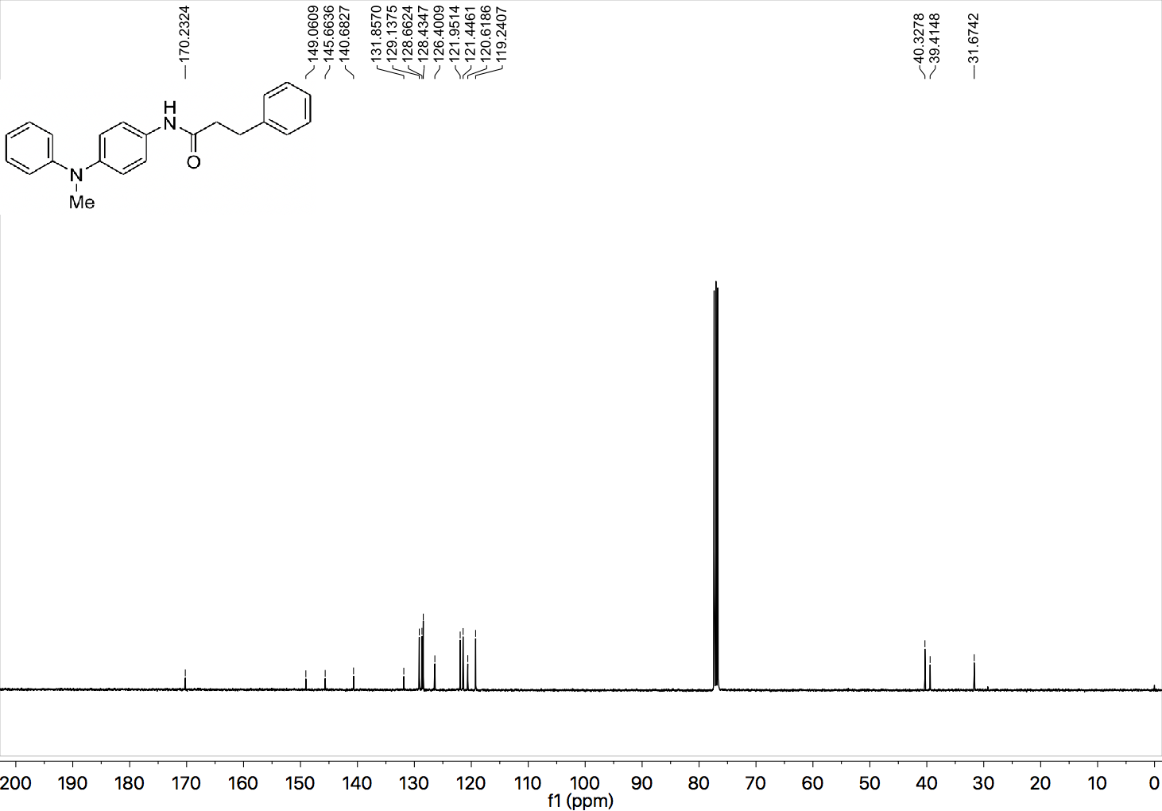

¹H NMR (400 MHz, CDCl₃) spectrum of 55.

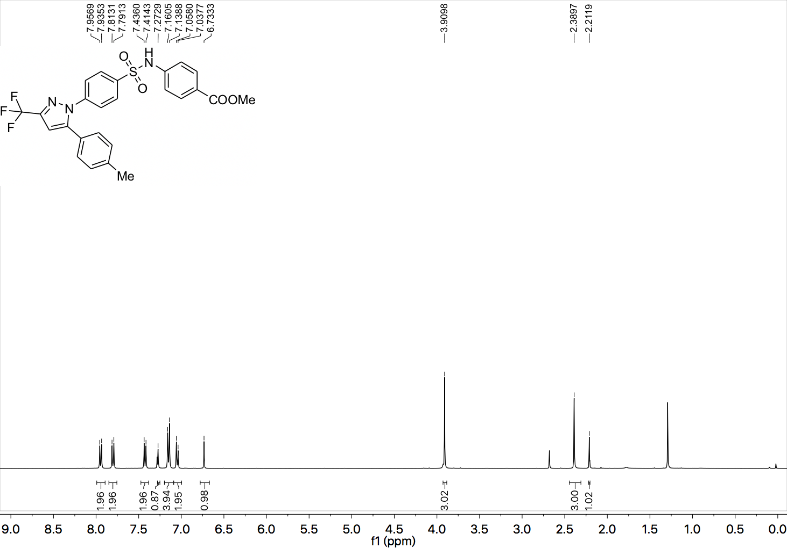

¹³C NMR (101 MHz, CDCl₃) spectrum of 55.

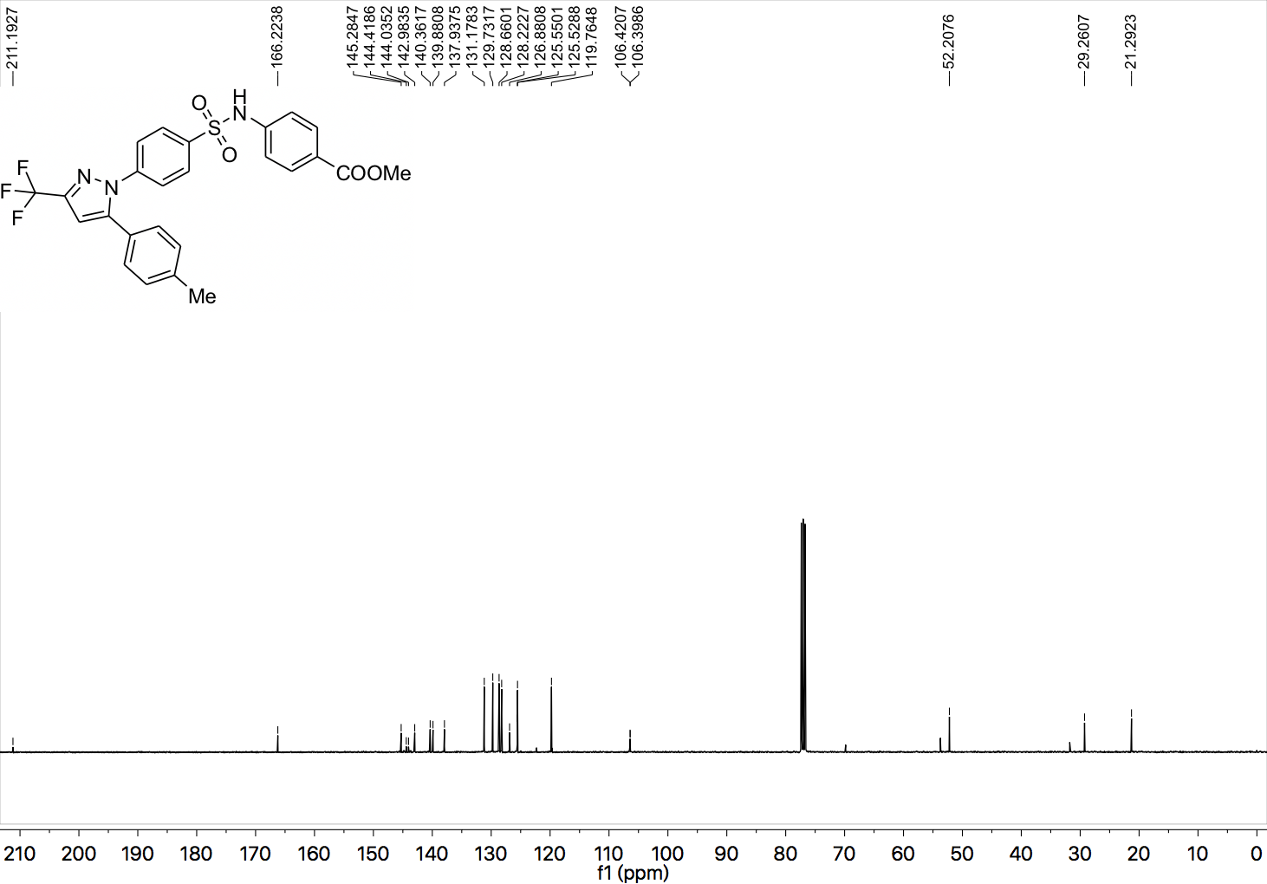

¹⁹F NMR (377 MHz, CDCl₃) spectrum of 55.

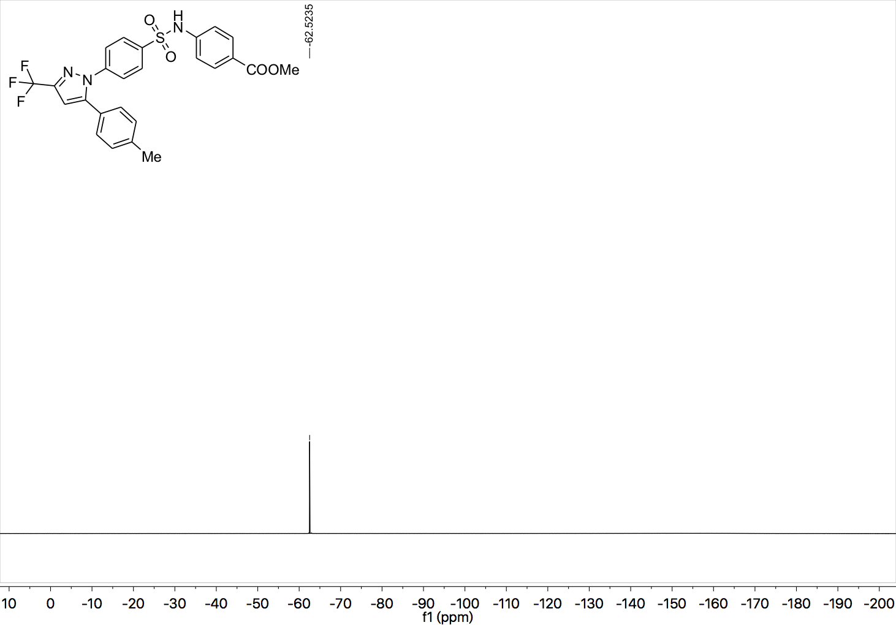

¹H NMR (400 MHz, CDCl₃) spectrum of 56.

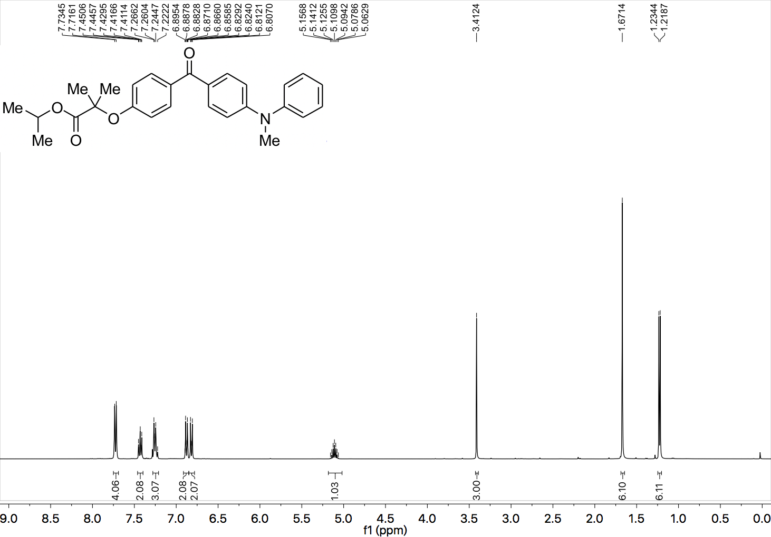

¹³C NMR (101 MHz, CDCl₃) spectrum of 56.

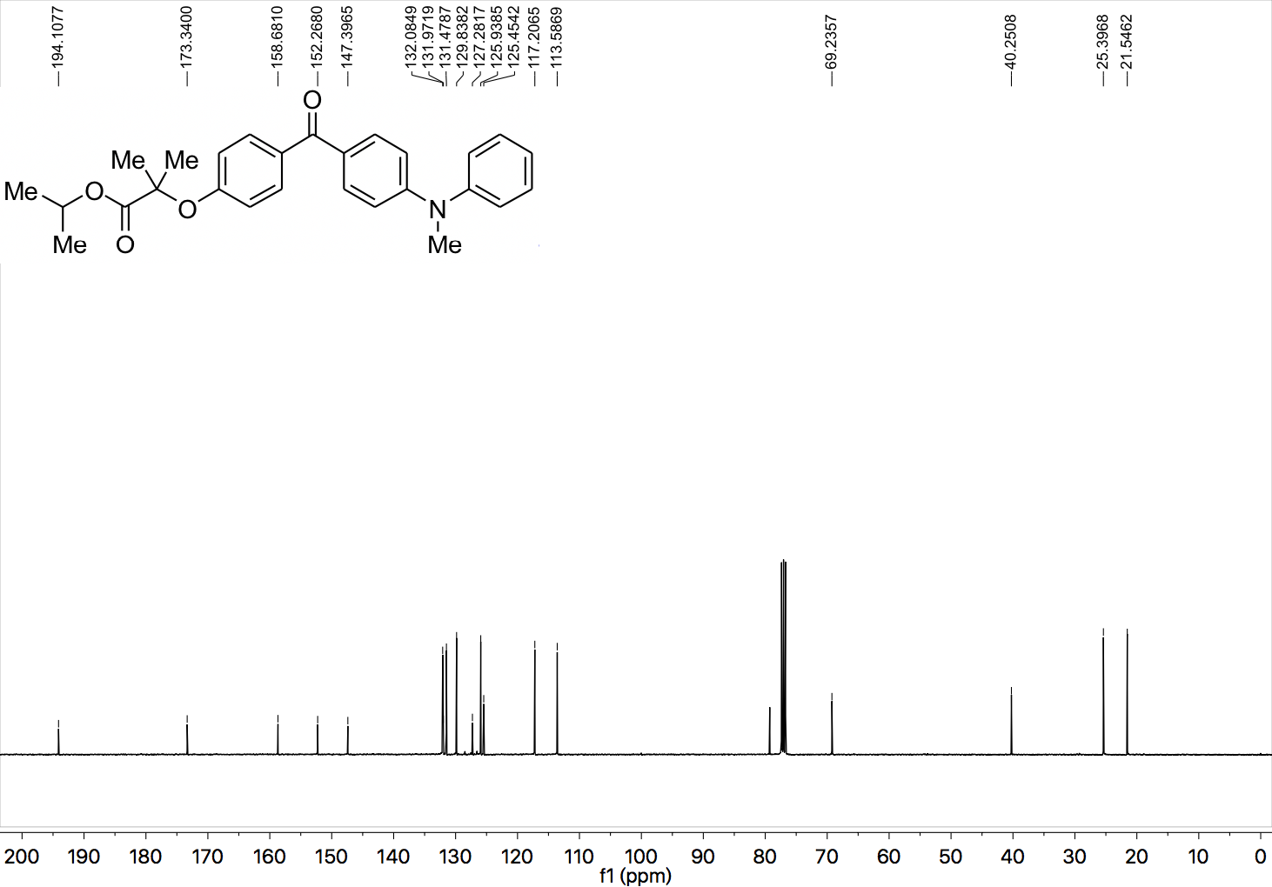

¹H NMR (400 MHz, CDCl₃) spectrum of 57.

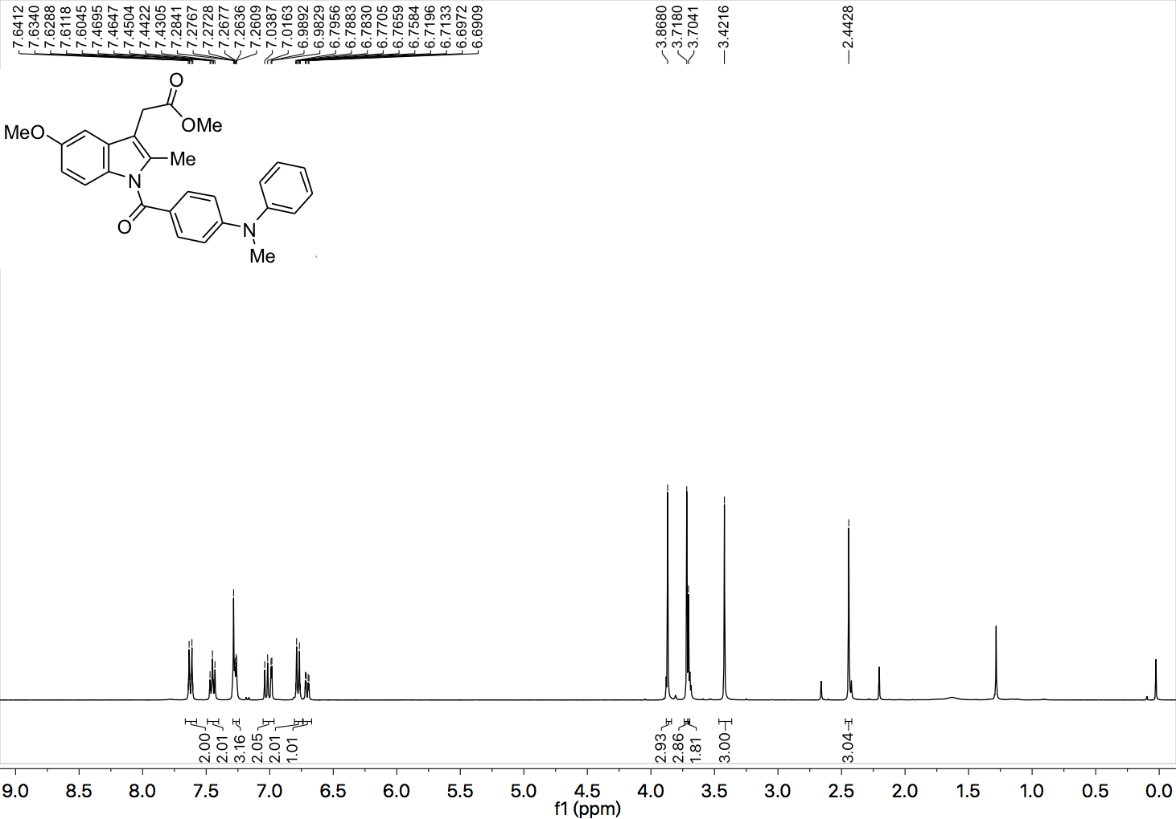

¹³C NMR (101 MHz, CDCl₃) spectrum of 57.

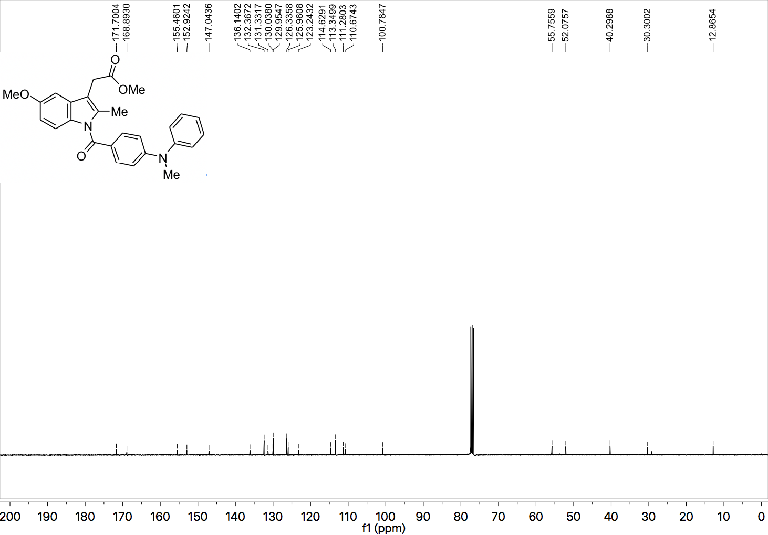

¹H NMR (400 MHz, CDCl₃) spectrum of 58.

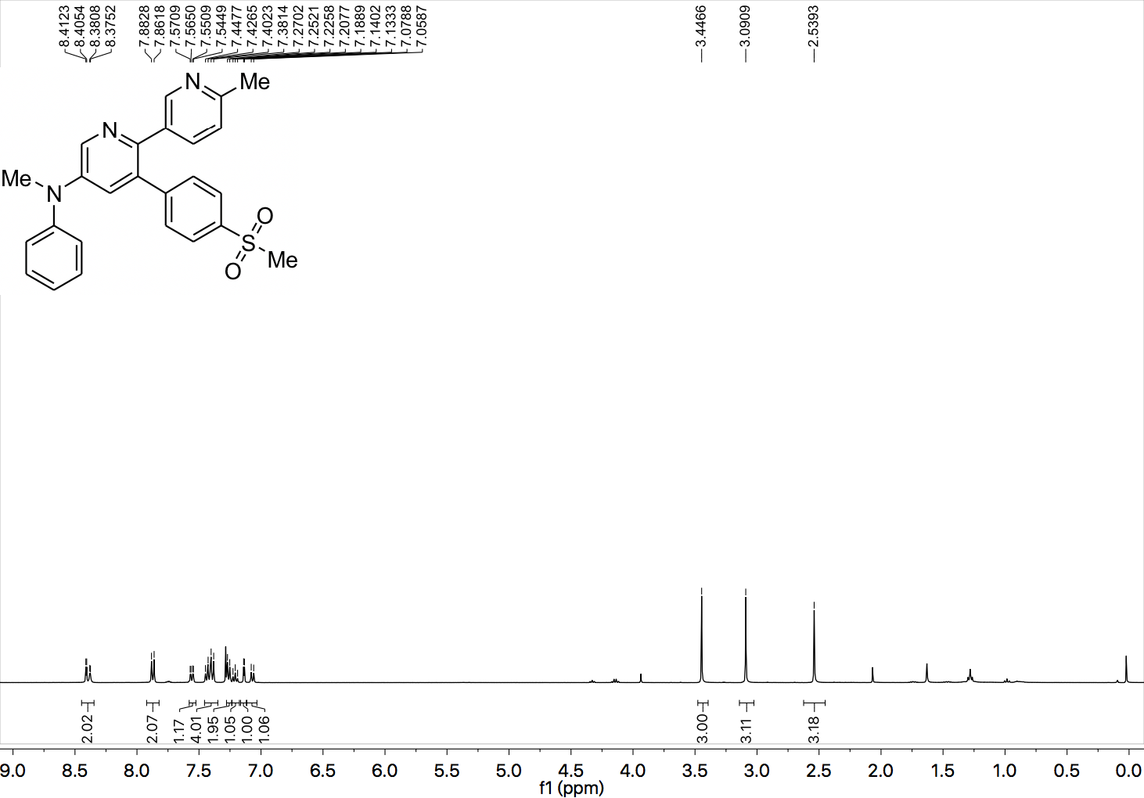

¹³C NMR (101 MHz, CDCl₃) spectrum of 58.

