Figure S1. Scatter plot of the genetic association with asthma(childhood onset) and melanoma using FinnGen database summary statistics. SNP, single nucleotide polymorphism;
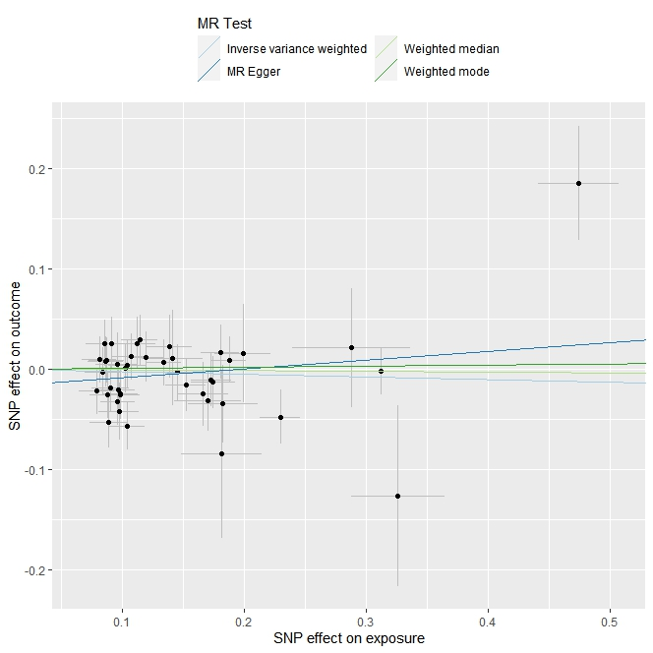
Figure S2. Leave-one-out sensitivity analysis for the MR genetic association with asthma(childhood onset) and melanoma using FinnGen database summary statistics.. MR, Mendelian randomization; IVW, Inverse variance weighted
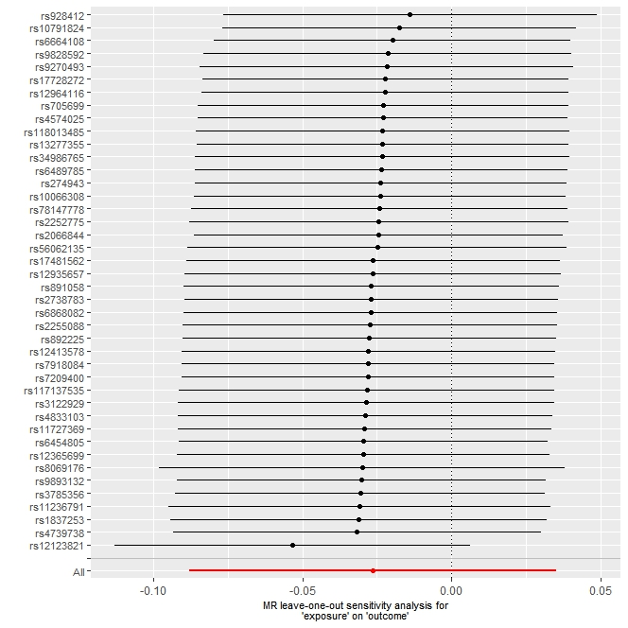
Figure S3. Scatter plot of the genetic association with asthma(adult onset) and melanoma using FinnGen database summary statistics. SNP, single nucleotide polymorphism;
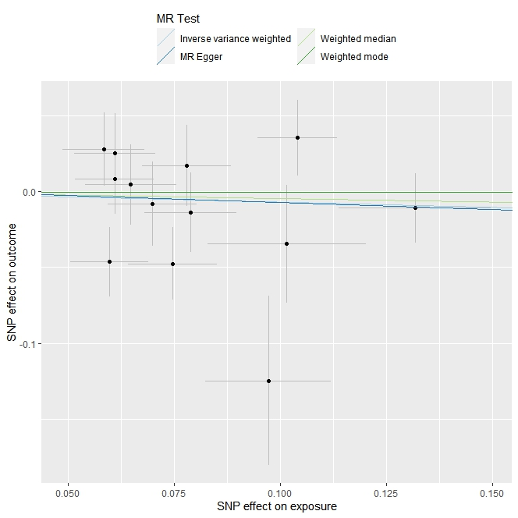
Figure S4. Leave-one-out sensitivity analysis for the MR genetic association with asthma(adult onset) and melanoma using FinnGen database summary statistics.. MR, Mendelian randomization; IVW, Inverse variance weighted
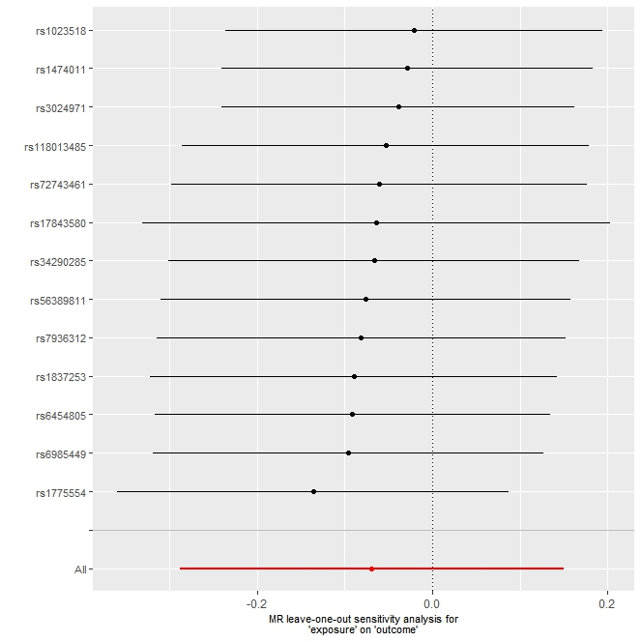
Figure S5. Scatter plot of the genetic association with asthma and melanoma using FinnGen database summary statistics. SNP, single nucleotide polymorphism;
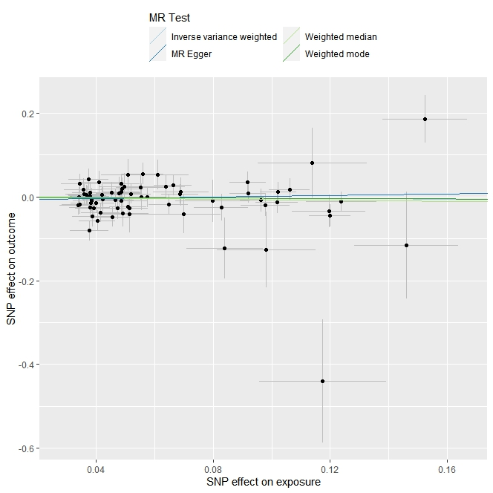
Figure S6. Leave-one-out sensitivity analysis for the MR genetic association with asthma(adult onset) and melanoma using FinnGen database summary statistics.. MR, Mendelian randomization; IVW, Inverse variance weighted
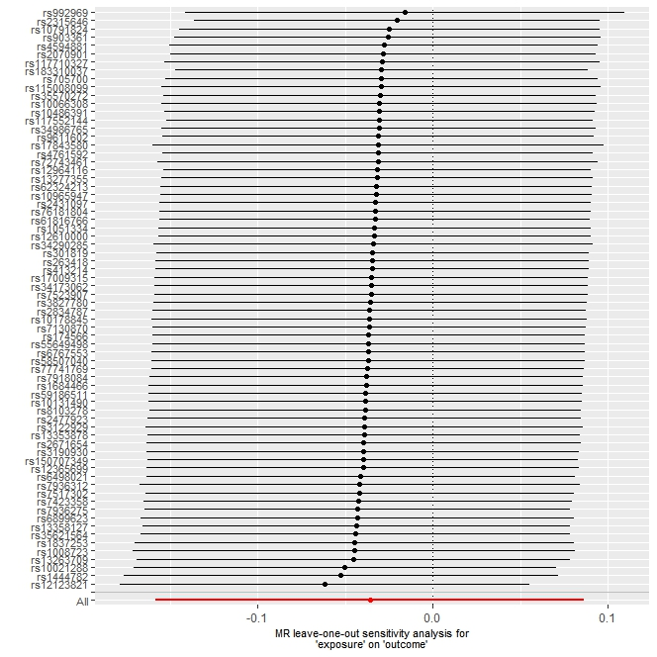

Table S1 Data origin.
Items | GWAS ID | Consortium | Sample size | Population
Asthma (childhood onset) | GCST008917 | UK Biobank | 394283 | Europeans
Asthma (adult onset) | GCST008918 | UK Biobank | 357157 | Europeans
Asthma | GCST008916 | UK Biobank | 368777 | Europeans
Melanoma | C3_MELANOMA_EXALLC | FinnGen | 32697 | Europeans

Table S2. Genetic instruments associated with child-onest asthma used in our Mendelian randomization studies

Table S3. Genetic instruments associated with adult-onest asthma used in our Mendelian randomization studies

Table S4. Genetic instruments associated with asthma used in our Mendelian randomization studies

Table S5. Summary on MR results of athma on melanoma risk
MR, Mendelian randomization; SNP, single-nucleotide polymorphism; OR, odds ratio;IVW, Inverse variance weighted

EXPOSURE | OUTCOME | MR RESULTS |  |  |  |  | HETEROGENEITY |  | PLEIOTROPY
EXPOSURE | OUTCOME | Methods | N SNPs | OR | 95%CI | P value | METHODS | P value | METHODS | P value
Asthma  (childhood onset) | FinnGen | MR-Egger | 42 | 1.091 | 0.944-1.261 | 0.244 | MR-Egger | 0.323 | MR-Egger intercept | 0.098
Asthma  (childhood onset) | FinnGen | Weighted median | 42 | 0.992 | 0.903-1.090 | 0.875 | IVW | 0.251
Asthma  (childhood onset) | FinnGen | IVW | 42 | 0.974 | 0.916-1.036 | 0.402
Asthma  (childhood onset) | FinnGen | Simple mode | 42 | 1.055 | 0.884-1.260 | 0.555
Asthma  (childhood onset) | FinnGen | Weighted mode | 42 | 1.011 | 0.892-1.145 | 0.868
Asthma  (adult onset) | FinnGen | MR-Egger | 13 | 0.912 | 0.402-2.072 | 0.831 | MR-Egger | 0.065 | MR-Egger intercept | 0.349
Asthma  (adult onset) | FinnGen | Weighted median | 13 | 0.954 | 0.731-1.245 | 0.729 | IVW | 0.094
Asthma  (adult onset) | FinnGen | IVW | 13 | 0.933 | 0.750-1.162 | 0.536
Asthma  (adult onset) | FinnGen | Simple mode | 13 | 1.094 | 0.719-1.666 | 0.682
Asthma  (adult onset) | FinnGen | Weighted mode | 13 | 0.996 | 0.740-1.340 | 0.98
Asthma | FinnGen | MR-Egger | 70 | 1.096 | 0.809-1.486 | 0.555 | MR-Egger | 0.016 | MR-Egger intercept | 0.371
Asthma | FinnGen | Weighted median | 70 | 0.935 | 0.800-1.093 | 0.401 | IVW | 0.017
Asthma | FinnGen | IVW | 70 | 0.965 | 0.854-1.090 | 0.565
Asthma | FinnGen | Simple mode | 70 | 1.035 | 0.770-1.390 | 0.822
Asthma | FinnGen | Weighted mode | 70 | 0.974 | 0.792-1.196 | 0.799

