Supplementary material appendix 1:

Plasma-engineered sugarcane bagasse: A novel strategy for efficient mercury removal from aqueous solutions

Angie Paola Santacruz-Salasª, Maria Lúcia Pereira Antunesª, Elidiane Cipriano Rangelª, Cláudia Hitomi Watanabeª, André Henrique Rosa^{a*}.

ª São Paulo State University (Unesp), Institue of Science and Technology, Av. 3 de março 511, 18087-315, Sorocaba-SP, Brazil

*Corresponding Author
E-mail address: andre.rosa@unesp.br
Experimental

Mercury Adsorption Study

The adsorption capacity of the adsorbents was calculated from the Equation 1:

$$Qe=v*(C_{i}-C_{f})/m$$ | (1)

Where:
Q_{e}: amount adsorbed (mg/g) at equilibrium (mg/g).
C_{i}: initial Hg concentration (mg/l)
C_{f}: final concentration of Hg (mg/l)
v: volume of the solution (l)
m: mass of the adsorbent (g)
The removal efficiency was calculated with the Equation 2 presented below

$$ER\left(\%\right)=(C_{i}-C_{f})/Ci*100$$ | (2)

Where:
ER: percentage of adsorbed Hg
C_{i}: initial concentration (mg/l)
C_{f}: final concentration (mg/l)

Adsorption Kinetics

Lagergren's Pseudo-First Order kinetics stands out as the most frequently utilized model for liquid-solid adsorption systems. This model characterizes the adsorption kinetics of a species on an adsorbent particle through the following non-linear equation (BENJELLOUN et al., 2021):

$$Q_{t= }Q_{e }(1- \exp^{-K_{l}t})$$ | (3)

Where
K₁: the equilibrium rate constant in the pseudo–first-order model (L/min).
Q_{e}: amount adsorbed at equilibrium (mg/g)
Q_{t}: amount adsorbed as a function of time (mg/g)
t: time (min) for each of the aliquots

In the Pseudo-Second Order kinetic model, adsorption takes place on two surface sites. This model, proposed by Blanchard in 1984, can be represented by the following non-linear equation (BENJELLOUN et al., 2021; GÓMEZ-HERRERA, 2021):

$$Q_{t= }(Q_{e}^{2}K_{2}t)/(1+Q_{e}^{2}K_{2}t)$$ | (4)

Where
K₂: the equilibrium rate constant of the pseudo–second-order model (g/mg min)
Q_{e}: amount adsorbed at equilibrium (mg/g)
Q_{t}: amount adsorbed as a function of time (mg/g)
t: time (min) for each of the aliquots

Adsorption isotherms

The Langmuir adsorption isotherm is based on the assumption of a homogeneous adsorbent surface, and its corresponding expression can be formulated as follows:

$$Q_{e= }(qmaxK_{L}C_{e})/1 + K_{L}C_{e}$$ | (5)

Where
K_{L}: Langmuir adsorption constant
Q_{e}: amount of solute adsorbed per unit mass of material at equilibrium (mg/g)
qmax_{t}: maximum adsorption capacity in the monolayer (mg/g)
Ce: concentration at equilibrium (mg/L)

The linear form of the Langmuir isotherm equation may be written as:

$$C_{e}{/Q}_{e}=(1/K_{L}qmax)+{(C}_{e}/qmax)$$ | (6)

The Freundlich isotherm is an equation that best describes a heterogeneous adsorbent surface. It may be written as:

$$Q_{e= }K_{f}C_{e}^{1/n}$$ | (7)

Where
K_{f}: Freundlich adsorption constant
Q_{e}: amount of solute adsorbed per unit mass of material at equilibrium (mg/g)
1/n: represents the heterogeneity factor.
Ce: concentration at equilibrium (mg/L)

The linear form of the Freundlich isotherm equation may be written as:

$${Log Q}_{e }= Log K_{f}*(1/n)\log{Ce}$$ | (8)

Results and discussion

Figure A1 - FTIR spectra of the of the as-received and the modified SB under various time intervals and pressures: (a) 80 W (b) 190 W and c) 300 W
A
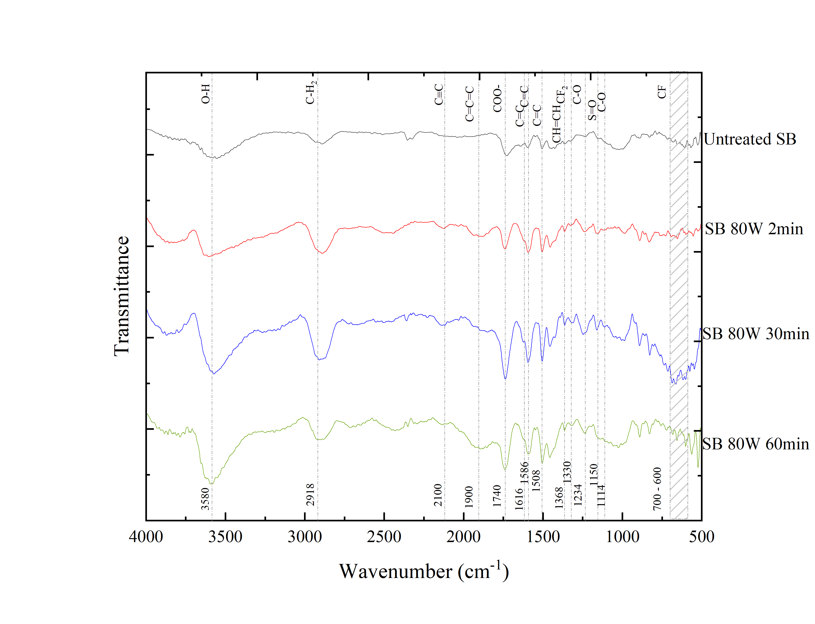
B
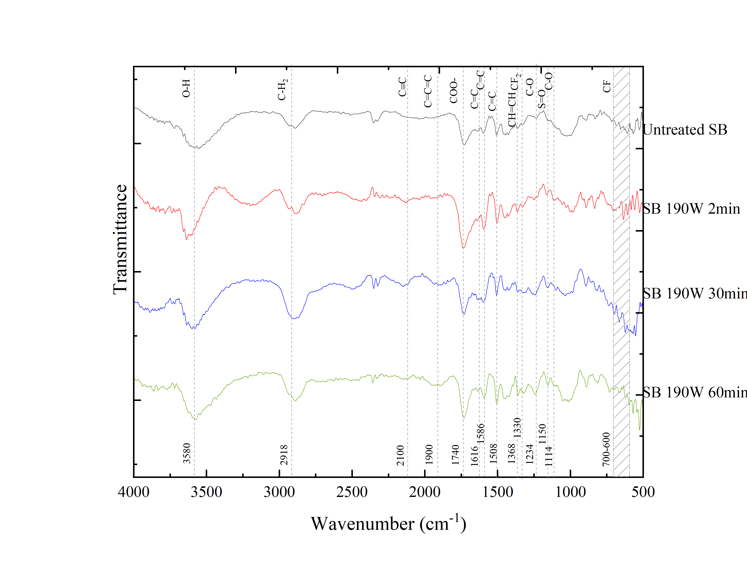
C
