Ultrasensitive determination of quercetin using electrochemical sensor based on nickel-doping Zinc-based zeolite imidazole frame with a four-point star morphology

Jianxia Gu^{*a}, Yankun Weiª, Yongxia Liª, Tingting Weiª, Zhanbin Jinª

ªDepartment of chemistry, Xinzhou Normal University, Xinzhou, Shanxi, China

Corresponding Authors
E-mail: 1583229616@qq.com (Jianxia Gu)

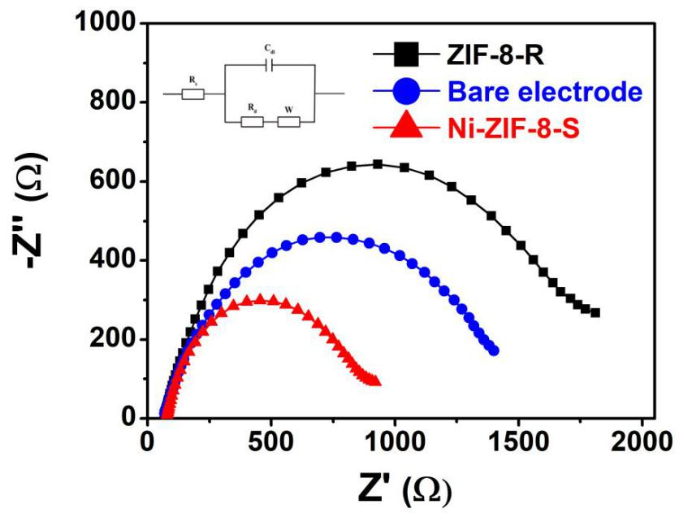
Fig. S1. Nyquist plot (EIS) of Star ZIF-8-R/GCE, GCE and Ni-ZIF-8-S/GCE in 0.1 M KCl solution containing 5 mM Fe (CN)₆^{3-/4-} with frequency range of 0.1-100 KHz.

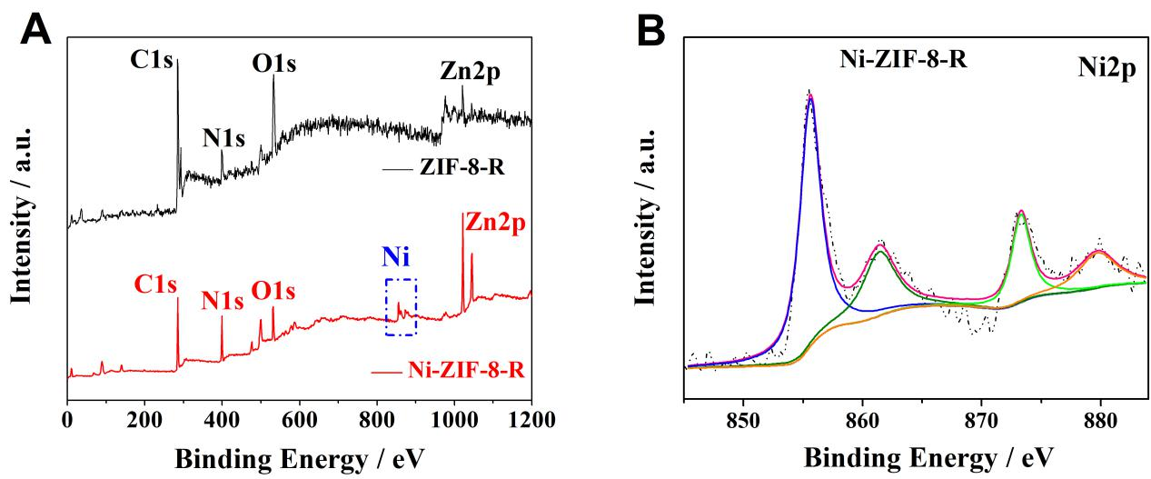
Fig. S2. (A) XPS spectra of prepared ZIF-8-R and Ni-ZIF-8-S. (B) Ni2p signal deconvolution.

Table S1 Effect of interferences on the oxidation peak current changes for quercetin determination on the Ni-ZIF-8-S.
Interferences | Concentration (μM) | Signal change (%)
Na⁺ | 1500 | 0.87
K⁺ | 1500 | 0.43
Ca²⁺ | 1500 | 0.52
Mg²⁺ | 1500 | 0.90
Ascorbic acid | 10 | 0.33
Uric acid | 10 | 0.64
Glucose | 10 | -0.12
Rutin | 5 | 0.59
Luteolin | 5 | 0.56

Table S2 DPV determination of quercetin on electrochemical sensor based on Ni-ZIF-8-S in the real sample of urine.
Samples | Amount added (nM) | Amount found (nM) | Recovery (%) | RSD (n=3, %)
1 | 10 | 9.8 | 98.0 | 1.56
1 | 10 | 9.9 | 99.0 | 1.56
1 | 10 | 9.6 | 96.0 | 1.56
2 | 50 | 48.5 | 97.0 | 2.06
2 | 50 | 48.4 | 96.8 | 2.06
2 | 50 | 50.2 | 100.4 | 2.06
3 | 100 | 100.3 | 100.3 | 1.95
3 | 100 | 101.1 | 101.1 | 1.95
3 | 100 | 97.4 | 97.4 | 1.95

