Appendix 2: Electronic survey (Daily 14-day questionnaire)

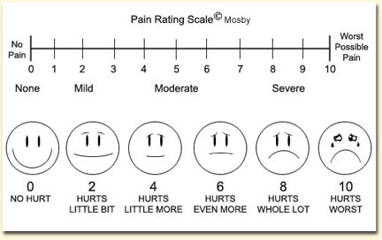

Pain diary 14-day questionnaire

Pain diary 14-day questionnaire
In this diary you will be asked to rate your pain each day while resting, eating and drinking, record any side effects, medications used and the number of medications used. Please complete this survey after eating dinner. Please record your answers over past 24hrs i.e. 7:00pm day before to 7:00pm today

Question Title

*1. Please write your full name

Question Title

*2. Please write your study ID number (located on your trial pack).
e.g if Study ID is #12, please write 12

Question Title

*3. On a scale of 0-10, please rate your pain while at rest over the past 24hrs?
0 | 1 | 2 | 3 | 4 | 5 | 6 | 7 | 8 | 9 | 10
0 | 1 | 2 | 3 | 4 | 5 | 6 | 7 | 8 | 9 | 10

Question Title

*4. On a scale of 0-10, please rate your pain while drinking over the past 24hrs?
0 | 1 | 2 | 3 | 4 | 5 | 6 | 7 | 8 | 9 | 10
0 | 1 | 2 | 3 | 4 | 5 | 6 | 7 | 8 | 9 | 10

Question Title

*5. On a scale of 0-10, please rate your pain while eating over past 24hrs?
0 | 1 | 2 | 3 | 4 | 5 | 6 | 7 | 8 | 9 | 10
0 | 1 | 2 | 3 | 4 | 5 | 6 | 7 | 8 | 9 | 10

Question Title

*6. Please record how many tablets of Endone (5mg) did you consume over past 24hrs? (7:00pm yesterday to 7:00pm today)
e.g 0 for none, 8 for eight

Question Title

*7. Please record how many tablets of Paracetamol (500mg) did you consume over past 24hrs? (7:00pm yesterday to 7:00pm today)
e.g 0 for none, 8 for eight

Question Title

*8. Please record how many powdered gargles you consumed over past 24hrs? (7:00pm yesterday to 7:00pm today)
e.g 0 for none, 4 for four
0
1
2
3
4

Question Title

*9. Did you take any other medications today (e.g. maxolon, coloxyl and senna) over the past 24hrs?
Next

10. If you answered yes, please record what medication you took and how many tablets you took over past 24hrs (7:00pm yesterday to 7:00pm today)?
e.g. 1 Maxolon, 2 ondansetron

Question Title

*11. Please select the box if you experienced any of the following side effects (more than one selection allowed)?
If you did not experience any side effects please select none.
Vomiting
Nausea
Diarrhoea
Constipation
Bleeding
Drowsy
Bad breath
None
Prev Done

