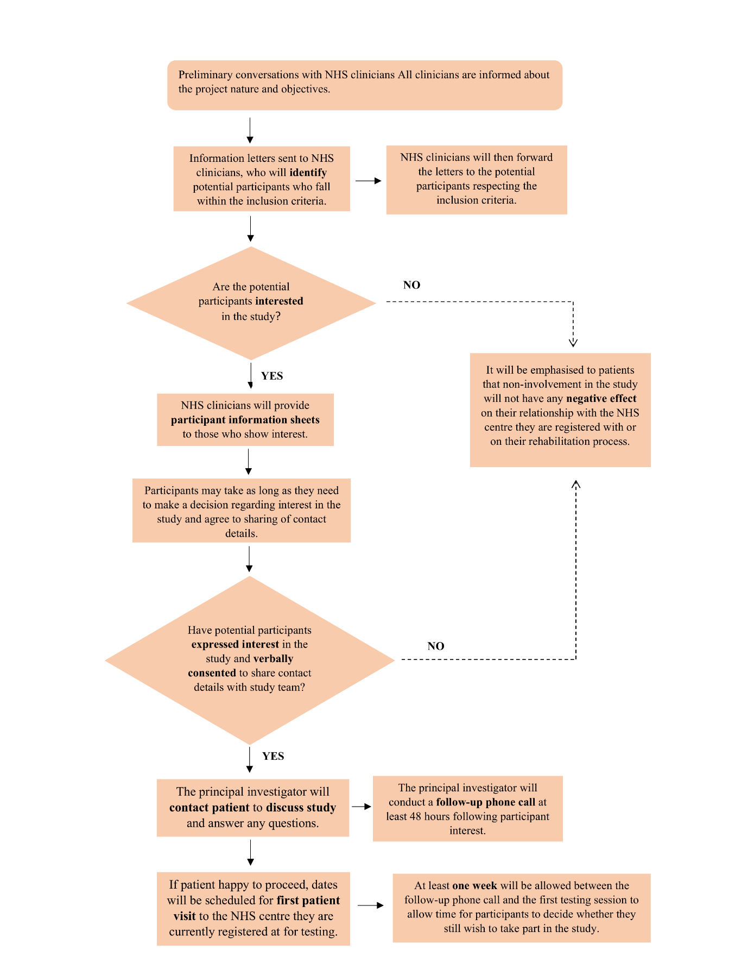
Supplementary Figure 1. Recruitment process flow chart.

Supplementary Table 1. Marker names and locations. On the amputated limb, the lower-limb markers will be placed taking into account the centre of rotation of the ankle on the prosthesis (and the knee where relevant for persons with transfemoral amputation), and the intact leg positions
Anatomical landmark | Marker name
Anatomical landmark | Left | Right
1. ASIS | LASIS | RASIS
2. PSIS | LPSIS | RPSIS
3. Greater Trochanter | LGT | RGT
4. Thigh cluster | LTH1, LTH2, LTH3, LTH4 | RTH1, RTH2, RTH3, RTH4
5. Lateral epicondyle femur | LFLE | RFLE
6. Medial epicondyle femur | LFME | RFME
7. Shank cluster | LSH1, LSH2, LSH3, LSH4 | RSH1, RSH2, RSH3, RSH4
8. Lateral malleolus fibula | LFLM | RFLM
9. Media malleolus tibia | LTMM | RTMM
10. MTP5 | LMTP5 | RMTP5
11. MTP1 | LMTP1 | RMTP1
12. Calcaneus | LCAL | RCAL
13. Seventh cervical vertebra | C7
14. Twelfth thoracic vertebra | T12
15. Sacral base | S1
16. Clavicle | LCLAV | RCLAV
17. Lateral side of head | LHEAD | RHEAD
18. Lateral epicondyle humerus | LHLE | RHLE
19. Wrist | LWR | RWR
20. Spine cluster | SP1, SP2, SP3, SP4
21. Lateral side of foot | LFTL | RFTL
22. Medial side of foot | LFTM | RFTM
ASIS, anterior superior iliac spine; PSIS, posterior superior iliac spine; MTP5, fifth metatarsal bone; MTP1, first metatarsal bone.

Supplementary Table 2. Online questionnaires assessing pain and psychological variables. A full version of the questionnaires is available in the appendix
Questionnaire | Variable being assessed
The Brief Pain Inventory | Pain location and its interference
Pain Catastrophising Scale | Interpretation of pain
Tampa Scale for Kinesiophobia (TSK) | Fear of movement
The Roland-Morris Disability Questionnaire | LBP
State Trait Anxiety Index Y form | Anxiety
Patient Health Questionnaire (PHQ-9) | Depression
Short Form 36 (SF-36) Health Survey Questionnaire | General health
International Physical Activity Questionnaire (IPAQ) | Physical activity levels

