Table S1: Nearest weather stations with available MIDAS Open weather data (Met Office, 2019) to each region of the UK where sample sites were located. Data were downloaded from each weather station to predict missing temperature data for sample sites.

Region of UK | MIDAS Open weather station
Scottish Highlands | Kinbrace Hatchery
North York Moors | Fylingdales
Peak District | Sheffield
East Anglia | Santon Downham
South Wales | Libanus
South West | Liscombe
South East | Alice Holt Lodge

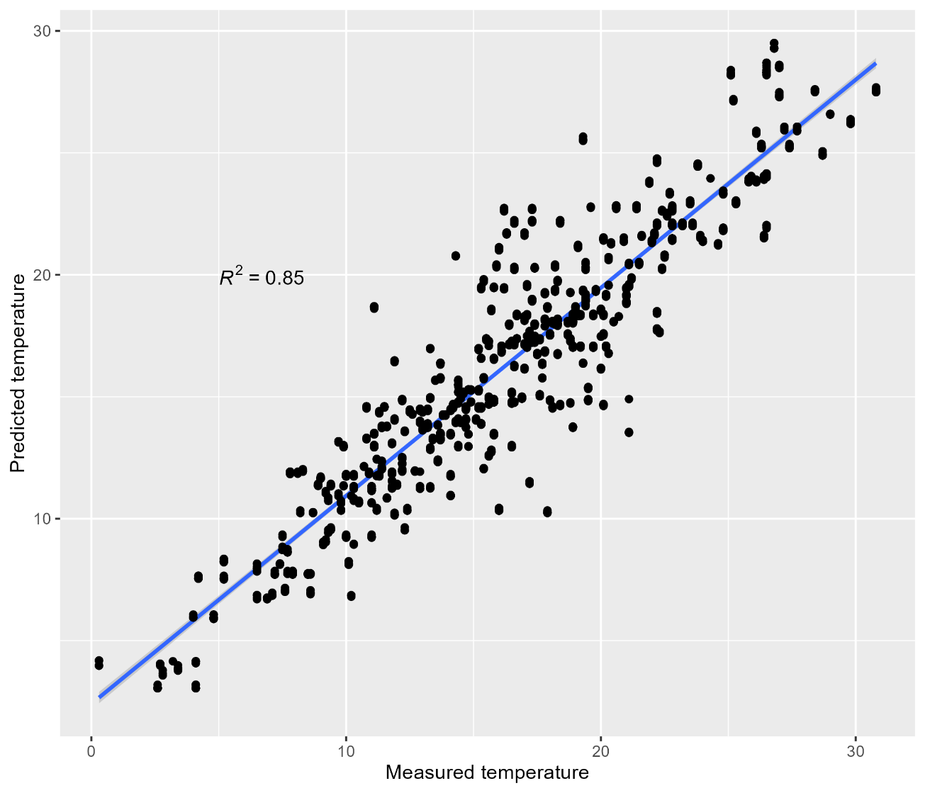

Figure S1: Correlation between air temperature measured at the time of sampling (Measured temperature) and temperature predicted using a linear model comparing measured temperature to MIDAS Open hourly air temperature data from the nearest hour to sampling (Predicted temperature), from the nearest weather station to each sample site (Table S1). K-fold cross validation was carried out by creating 5 models each using a different 80% of data and predicting temperature for the remaining 20% of data. Predictions were compared to the corresponding observed data. Plot shows all predictions across 5 models. Temperature is in ° Celsius.

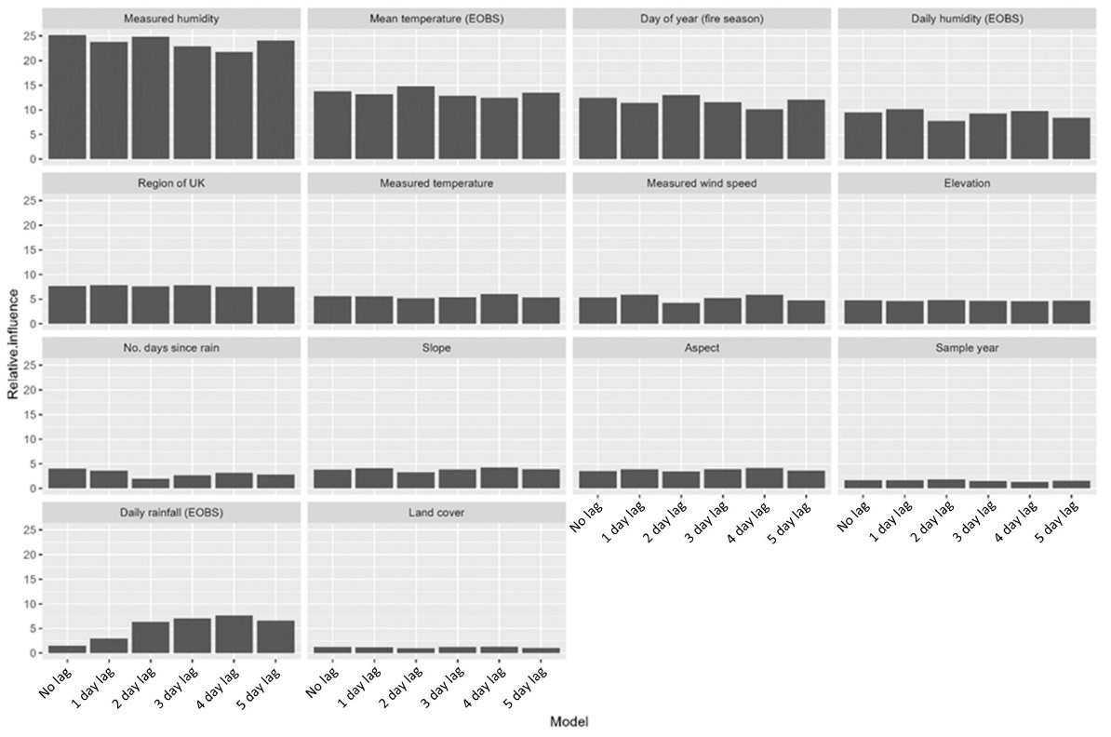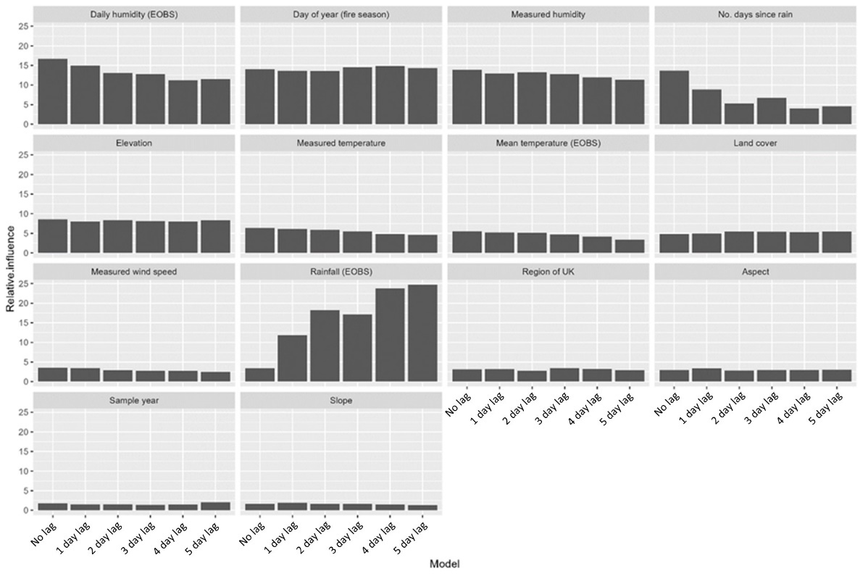

Figure S2: The relative influence of a series of variables on moisture content of (a) live heather canopy and (b) litter. Six boosted regression trees were carried out, each one with differing rainfall variable: total rainfall of sample day (no lag) and cumulative rainfall of sample day and 1-5 days prior to sample day (1 day lag – 5 day lag). Relative influence of rainfall increases as total rainfall of a greater number of prior days are included, so total rainfall of 5 previous 5 days was chosen to include in model. Models are preliminary so some variables are different to those used in final BRTs. BRTs have a learning rate of 5 and a learning rate of 0.001.
a)
b)
Table S2: Soil categories associated with sample sites taken from Soilscapes (Farewell et al., 2011).

Soilscapes category | Soilscapes description | Coarse/fine
3 | Shallow lime-rich soils over chalk or limestone | Coarse
6 | Freely draining slightly acid loamy soils | Coarse
10 | Freely draining slightly acid sandy soils | Coarse
11 | Freely draining sandy Beckland soils | Coarse
14 | Freely draining very acid sandy and loamy soils | Coarse
15 | Naturally wet very acid sandy and loamy soils | Coarse
16 | Very acid loamy upland soils with a wet peaty surface | Fine
19 | Slowly permeable wet very acid upland soils with a peaty surface | Fine
22 | Loamy soils with a naturally high groundwater | Fine
23 | Loamy and sandy soils with naturally high groundwater and a peaty surface | Fine
25 | Blanket bog peat soils | Fine

Table S3: Different parameters for learning rate (lr) and tree complexity (tc) can be assigned to BRTs. The learning rate determines the contribution of each tree to the final model, and tree complexity determines the complexity of interactions within the model. A lower learning rate generally results in better predictive ability of the model, but also requires much more computing power. We ran BRTs for two materials (heather live canopy (a) and litter (b)) using different learning rates (0.0005, 0.001, 0.005 and 0.01) and tree complexities (3, 4 and 5) to determine which parameters gave optimal model performance. Results did not show much difference between parameters so we chose a learning rate of 0.001 and a tree complexity of 5 to maximise the ability of the models to pick up interactions between predictor variables. The optimal number of trees is calculated automatically within the model using 10-fold cross validation in the function ‘gbm.step’ in the ‘dismo’ R package (Hijmans et al., 2015).

a)
lr | tc | CV deviance | CV correlation | Training data correlation | Mean total deviance | Mean residual deviance
0.0005 | 3 | 0.462 | 0.777 | 0.859 | 1.160 | 0.311
0.001 | 3 | 0.445 | 0.780 | 0.875 | 1.160 | 0.278
0.005 | 3 | 0.439 | 0.792 | 0.892 | 1.160 | 0.243
0.01 | 3 | 0.440 | 0.789 | 0.896 | 1.160 | 0.234
0.0005 | 4 | 0.447 | 0.783 | 0.873 | 1.160 | 0.284
0.001 | 4 | 0.443 | 0.788 | 0.882 | 1.160 | 0.265
0.005 | 4 | 0.439 | 0.784 | 0.904 | 1.160 | 0.217
0.01 | 4 | 0.440 | 0.797 | 0.890 | 1.160 | 0.246
0.0005 | 5 | 0.445 | 0.791 | 0.882 | 1.160 | 0.266
0.001 | 5 | 0.444 | 0.785 | 0.886 | 1.160 | 0.256
0.005 | 5 | 0.446 | 0.786 | 0.890 | 1.160 | 0.248
0.01 | 5 | 0.445 | 0.786 | 0.896 | 1.160 | 0.235
(b)
0.0005 | 3 | 0.070 | 0.748 | 0.879 | 0.154 | 0.037
0.001 | 3 | 0.066 | 0.755 | 0.902 | 0.154 | 0.030
0.005 | 3 | 0.064 | 0.779 | 0.947 | 0.154 | 0.017
0.01 | 3 | 0.070 | 0.754 | 0.943 | 0.154 | 0.018
0.0005 | 4 | 0.070 | 0.755 | 0.888 | 0.154 | 0.035
0.001 | 4 | 0.068 | 0.749 | 0.910 | 0.154 | 0.028
0.005 | 4 | 0.068 | 0.747 | 0.930 | 0.154 | 0.022
0.01 | 4 | 0.067 | 0.758 | 0.959 | 0.154 | 0.013
0.0005 | 5 | 0.070 | 0.740 | 0.891 | 0.154 | 0.034
0.001 | 5 | 0.071 | 0.731 | 0.914 | 0.154 | 0.027
0.005 | 5 | 0.069 | 0.746 | 0.952 | 0.154 | 0.016
0.01 | 5 | 0.066 | 0.742 | 0.978 | 0.154 | 0.007

Table S4: Relative influence (%) of fourteen variables (including Vapour Pressure Deficit) on the fuel moisture content (FMC) of three key fuel types calculated using boosted regression trees. Bold values in filled cells indicate variable with the largest influence on FMC for each fuel type. Variables: VPD = vapour pressure deficit, NDR = no. days since rain, 5DR = total rainfall of sample day and previous 5 days, WS = wind speed, LC = land cover type, ST = soil type, E = elevation, SL = slope, A = aspect, RUK = region of UK, MDT = mean temperature of sample day, NDVI = NDVI, TD = time of day, SY = sample year.
 | Heather live canopy | Heather dead canopy | Organic layer
VPD | 28.943 | 48.282 | 8.117
MDT | 19.234 | 8.000 | 12.034
NDVI | 12.958 | 5.077 | 4.778
5DR | 7.358 | 21.752 | 4.347
TD | 6.098 | 4.025 | 2.473
ST | 4.950 | 3.843 | 15.602
NDR | 4.377 | 1.360 | 1.620
A | 4.329 | 1.259 | 4.363
E | 3.365 | 0.368 | 27.523
SL | 3.203 | 0.173 | 3.946
RUK | 1.923 | 3.029 | 6.187
WS | 1.895 | 2.526 | 1.900
SY | 0.814 | 0.103 | 3.700
LC | 0.552 | 0.204 | 3.409

Table S5: Mean correlation between observed FMC values of testing data and their corresponding predicted FMC values based on models created using training data over 100 repetitions.
Fuel | Model containing VPD | Model containing relative humidity + temperature
Heather live canopy | 0.70 | 0.68
Heather dead canopy | 0.46 | 0.52
Organic layer | 0.68 | 0.67

Table S6: Relative influence (%) of fifteen variables on the fuel moisture content (FMC) of eighteen different fuel types calculated using boosted regression trees. Bold values in filled cells indicate variable with the largest influence on FMC for each fuel type. Variables: T = temperature, RH = relative humidity, NDR = no. days since rain, 5DR = total rainfall of sample day and previous 5 days, WS = wind speed, LC = land cover type, ST = soil type, E = elevation, SL = slope, A = aspect, RUK = region of UK, MDT = mean temperature of sample day, NDVI = NDVI, TD = time of day, SY = sample year. Variables associated with weather are coloured in blue, with landscape in green and with time in orange.

Fuel type | T | RH | NDR | 5DR | WS | LC | ST | E | SL | A | RUK | MDT | NDVI | TD | SY
Bracken dead leaves | 2.89 | 35.63 | 1.05 | 35.10 | 2.36 | 0.34 | 6.70 | 0.09 | 3.28 | 0.86 | 0.56 | 3.05 | 7.10 | 0.89 | 0.09
Bracken dead stem | 7.18 | 29.13 | 1.64 | 23.87 | 4.41 | 0.41 | 8.32 | 1.12 | 1.42 | 2.57 | 0.13 | 2.58 | 10.71 | 6.10 | 0.41
Bracken live leaves | 6.16 | 6.74 | 4.11 | 2.06 | 3.64 | 5.62 | 23.97 | 5.04 | 8.62 | 10.90 | 1.18 | 1.99 | 16.20 | 2.32 | 1.44
Bracken live stem | 4.92 | 4.80 | 3.06 | 3.28 | 3.53 | 2.83 | 22.76 | 8.97 | 10.69 | 7.73 | 0.90 | 2.37 | 21.33 | 2.05 | 0.77
Organic layer | 8.20 | 4.95 | 1.46 | 3.71 | 1.95 | 3.07 | 15.18 | 26.57 | 4.27 | 3.69 | 6.17 | 10.29 | 4.51 | 2.23 | 3.75
Gorse dead canopy | 13.13 | 8.32 | 1.14 | 25.24 | 7.71 | 0.06 | 3.47 | 0.37 | 3.75 | 2.73 | 0.51 | 3.61 | 5.34 | 22.96 | 1.66
Gorse dead stem | 7.93 | 20.05 | 1.09 | 36.77 | 3.72 | 0.03 | 4.93 | 0.81 | 1.56 | 1.30 | 0.73 | 3.60 | 3.32 | 13.79 | 0.38
Gorse live canopy | 2.22 | 2.36 | 0.42 | 0.82 | 2.15 | 0.06 | 1.63 | 0.70 | 1.40 | 0.89 | 0.62 | 2.10 | 1.77 | 82.81 | 0.04
Gorse live stem | 0.83 | 1.21 | 0.37 | 0.68 | 0.79 | 0.39 | 2.87 | 0.24 | 0.33 | 0.24 | 0.20 | 0.96 | 2.75 | 88.04 | 0.09
Heather dead canopy | 12.01 | 52.60 | 1.38 | 18.06 | 1.23 | 0.27 | 2.88 | 0.27 | 0.73 | 0.17 | 2.82 | 2.64 | 2.81 | 2.14 | 0.01
Heather dead stem | 21.32 | 34.50 | 3.41 | 7.90 | 4.91 | 2.23 | 4.17 | 0.56 | 2.61 | 0.76 | 4.92 | 3.55 | 2.95 | 6.12 | 0.08
Heather live canopy | 3.03 | 29.72 | 4.17 | 6.16 | 2.23 | 0.56 | 5.11 | 3.43 | 4.25 | 3.45 | 2.29 | 16.33 | 13.03 | 5.74 | 0.52
Heather live stem | 7.19 | 17.54 | 1.24 | 28.09 | 5.32 | 0.19 | 11.51 | 4.68 | 2.97 | 2.11 | 5.42 | 4.15 | 6.30 | 3.13 | 0.15
Litter | 8.73 | 26.31 | 6.42 | 26.99 | 1.52 | 4.70 | 7.44 | 5.38 | 0.82 | 0.79 | 0.59 | 3.80 | 1.59 | 1.56 | 3.36
Moor grass dead | 21.34 | 26.80 | 1.57 | 21.18 | 7.23 | 0.01 | 1.16 | 1.49 | 4.11 | 0.53 | 1.53 | 4.46 | 4.60 | 3.65 | 0.35
Moor grass live | 6.97 | 20.95 | 4.43 | 2.20 | 3.89 | 1.23 | 20.51 | 6.30 | 6.68 | 9.13 | 2.00 | 3.42 | 9.38 | 1.58 | 1.33
Moss | 7.83 | 26.49 | 8.99 | 26.45 | 1.31 | 2.13 | 4.98 | 0.75 | 0.55 | 2.10 | 1.17 | 9.45 | 1.73 | 0.95 | 5.11
Twigs | 5.95 | 17.28 | 7.06 | 41.01 | 4.08 | 0.00 | 6.58 | 1.64 | 5.05 | 1.82 | 0.71 | 4.11 | 2.35 | 2.21 | 0.16

Heather live canopy
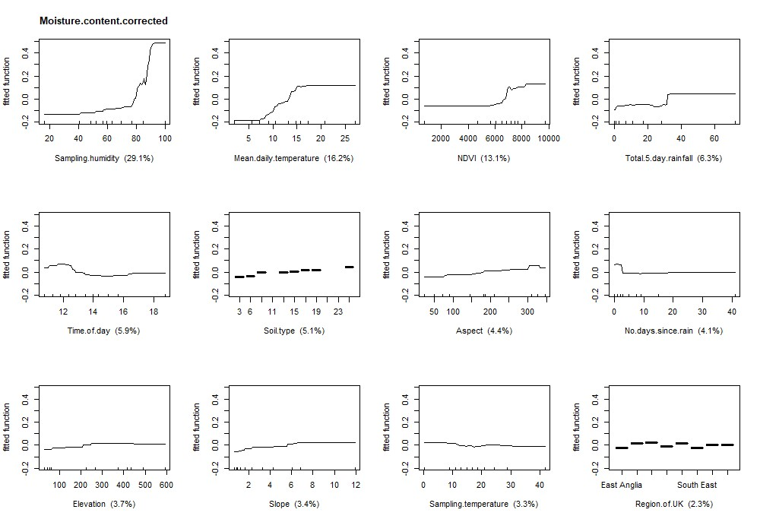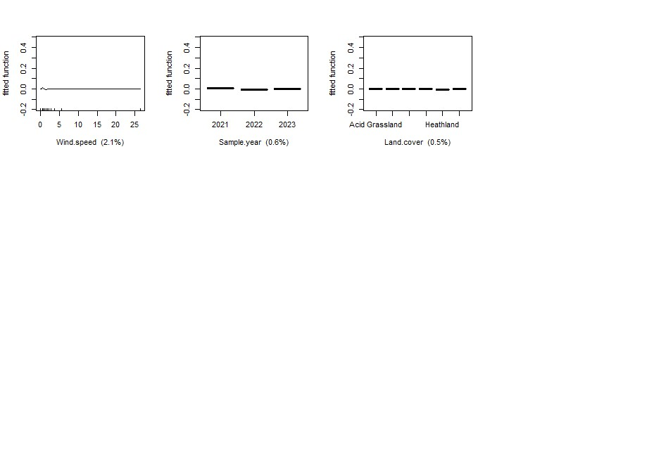

Heather live stem
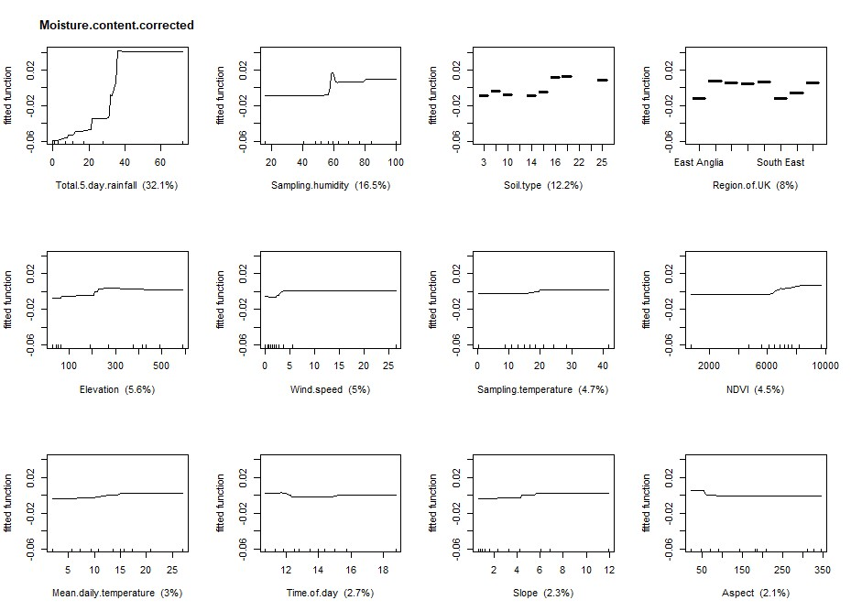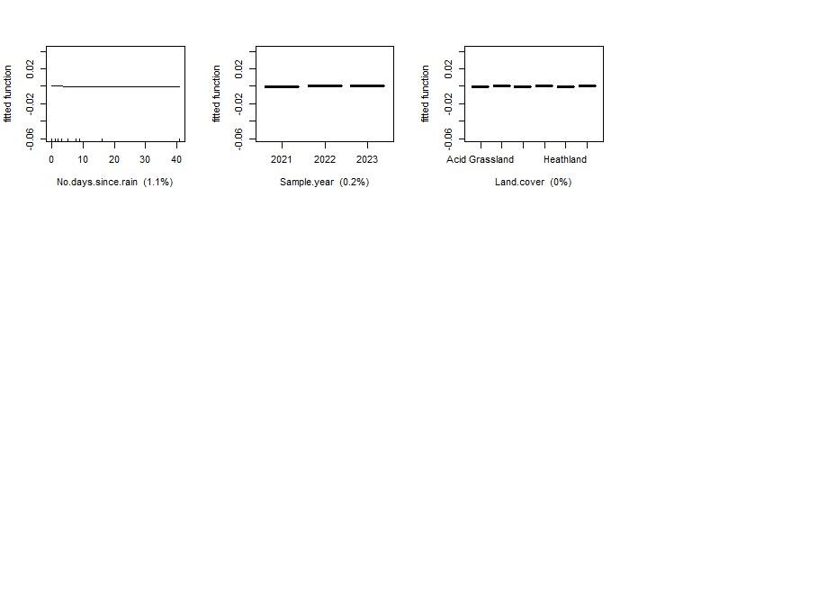

Heather dead canopy
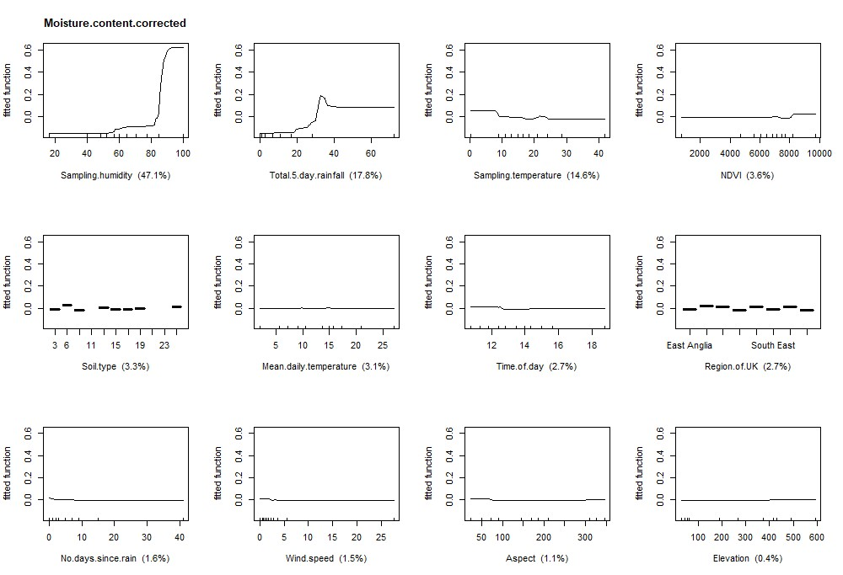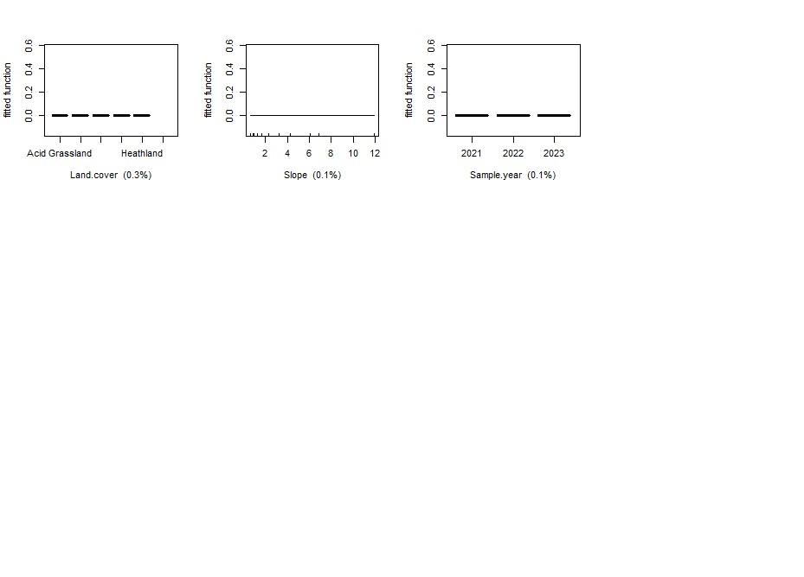

Heather dead stem
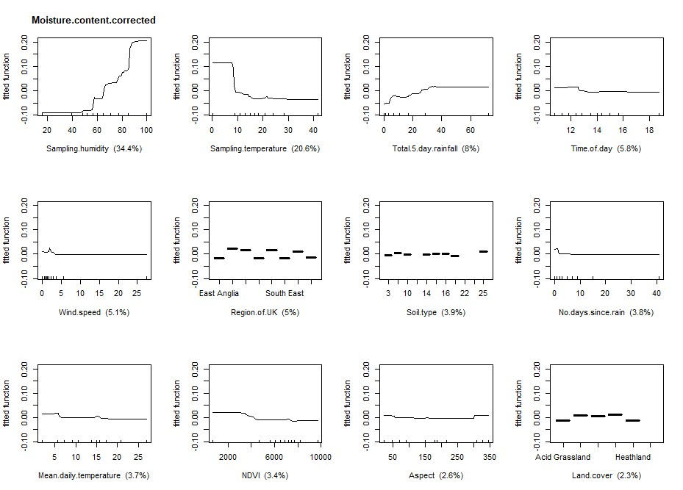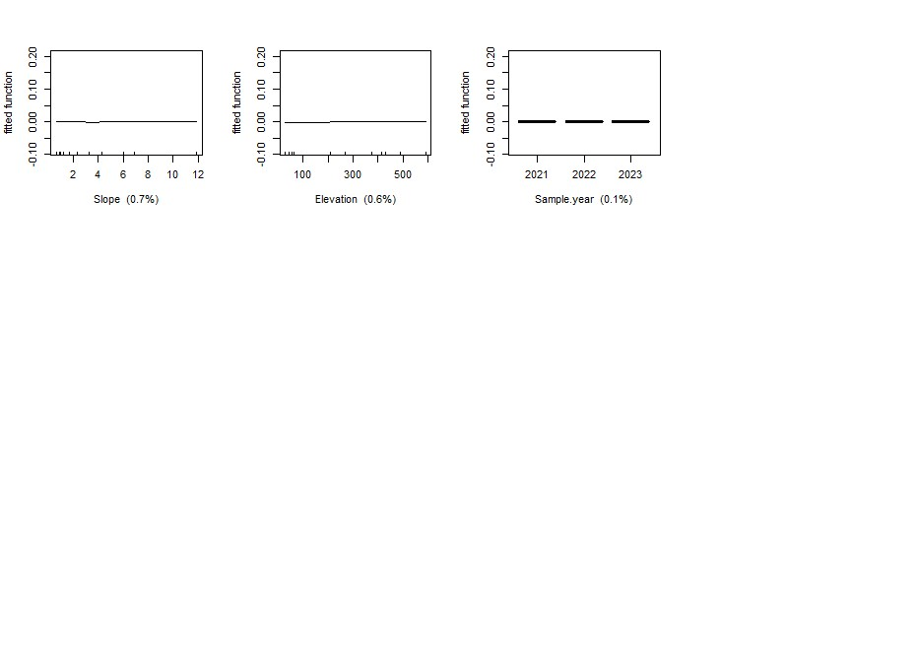

Gorse live canopy
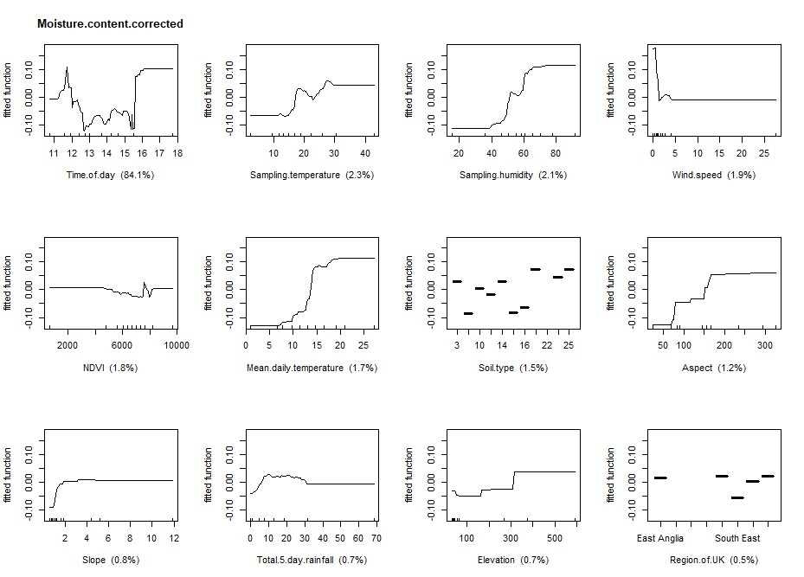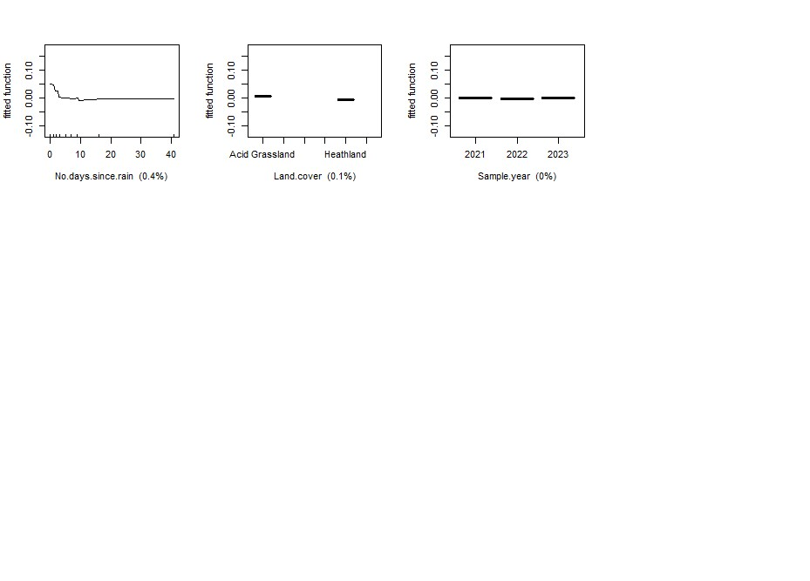

Gorse live stem
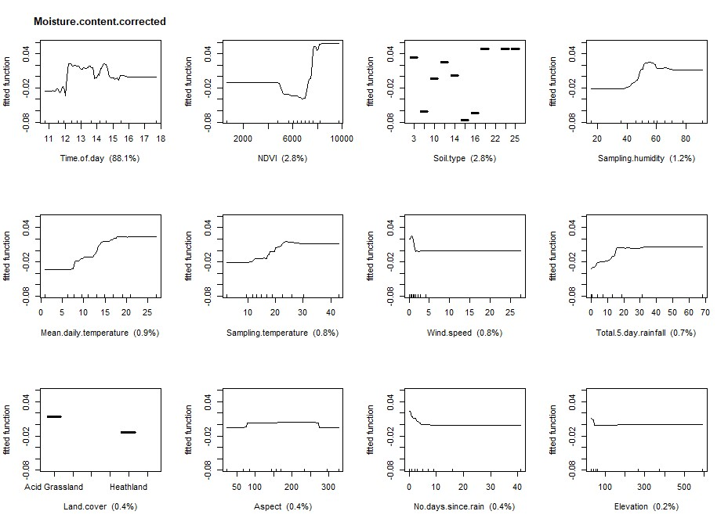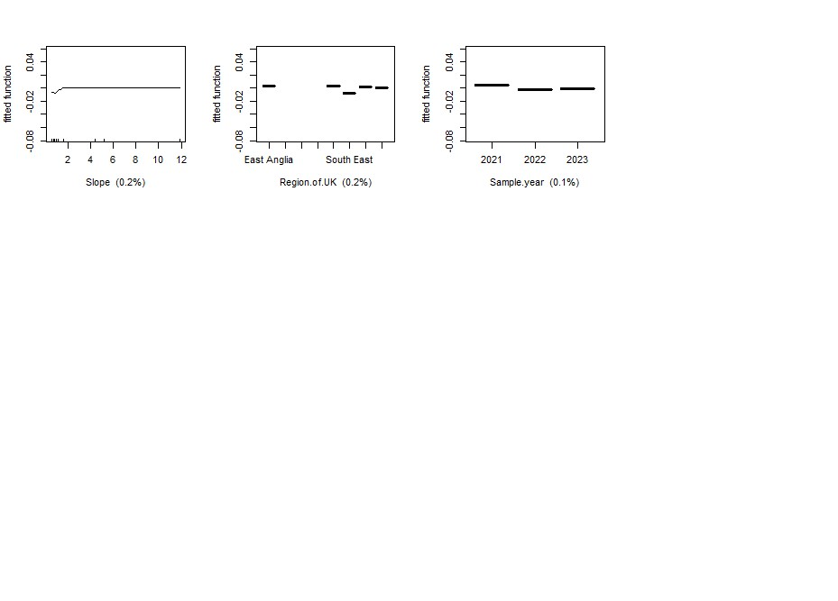

Gorse dead canopy
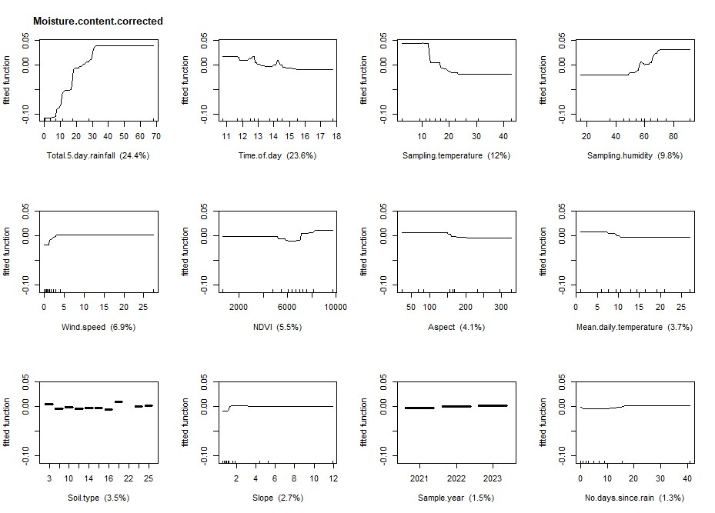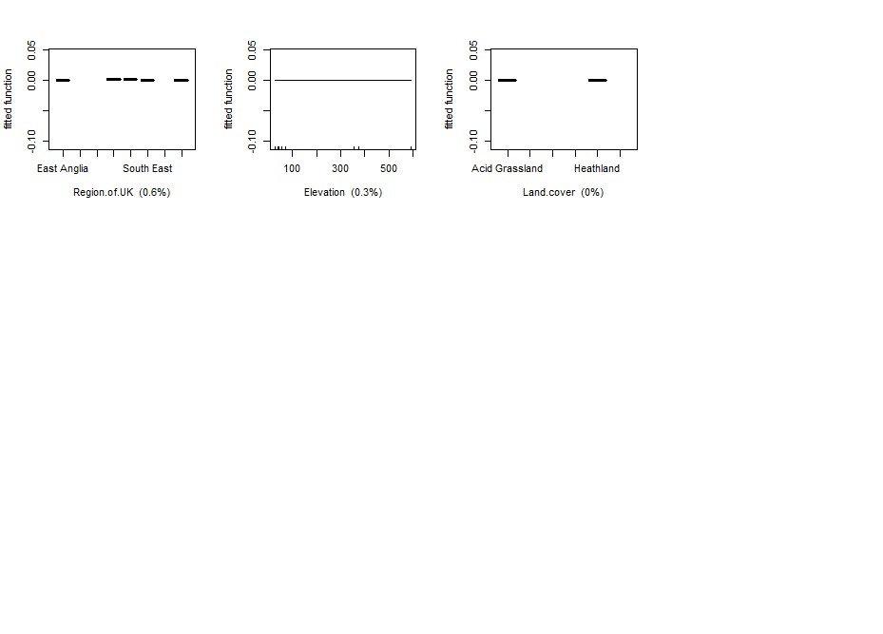

Gorse dead stem
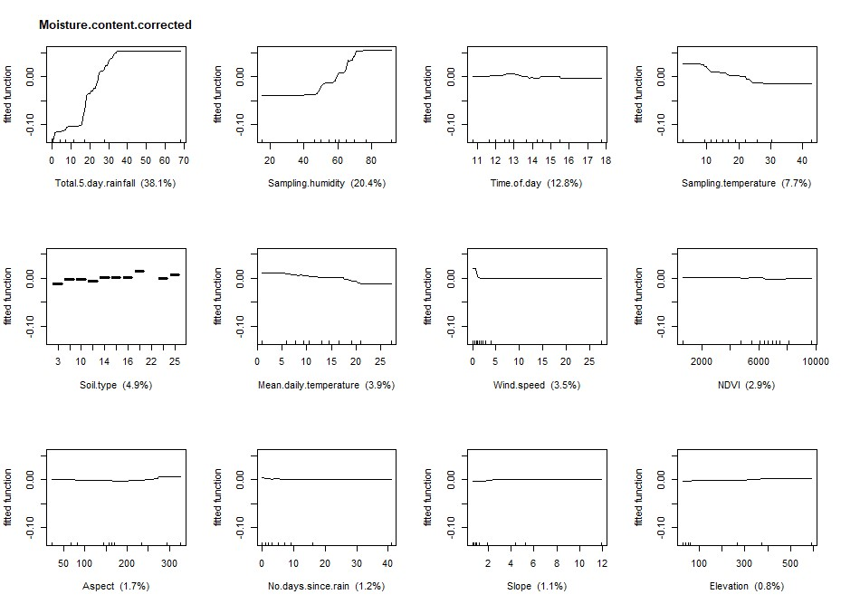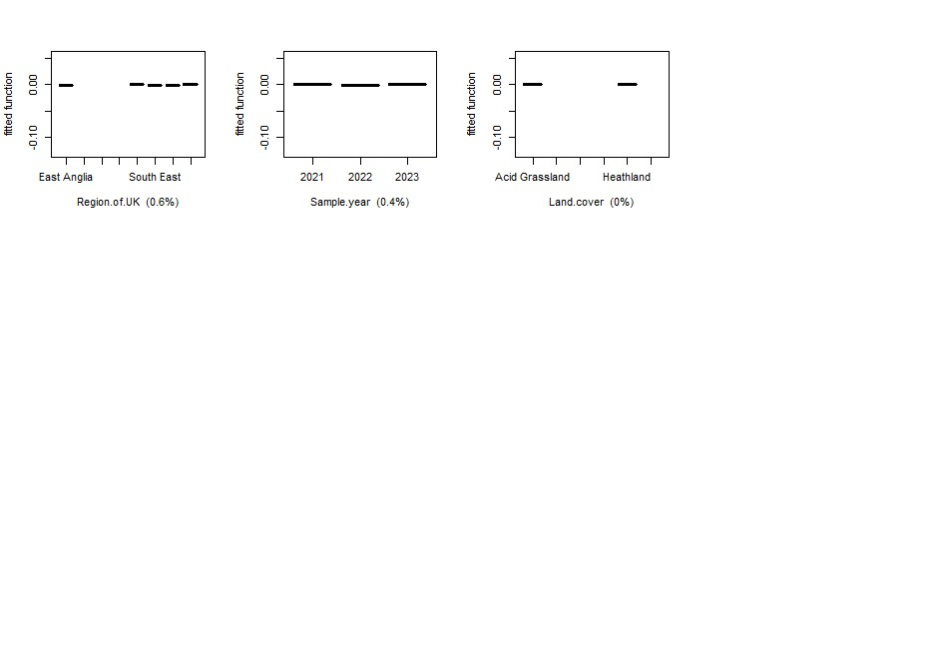

Bracken live leaves
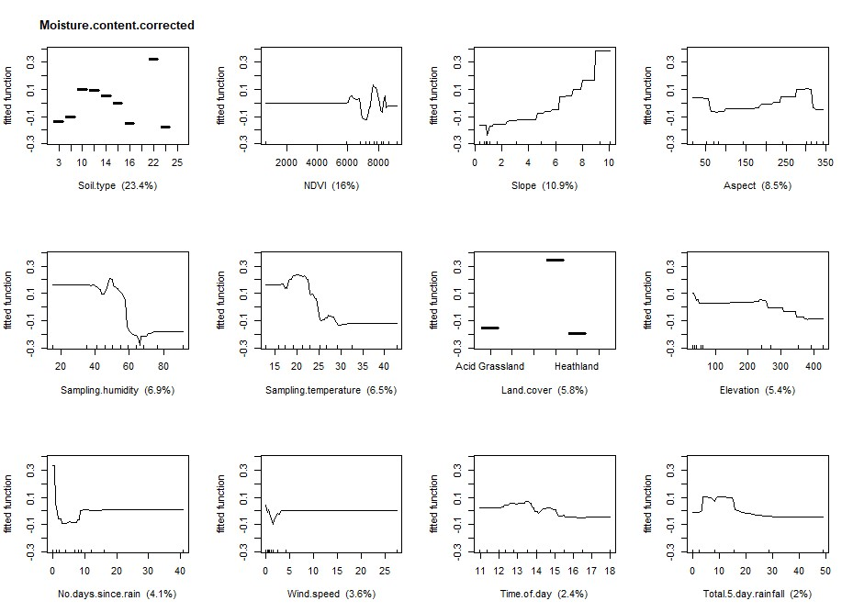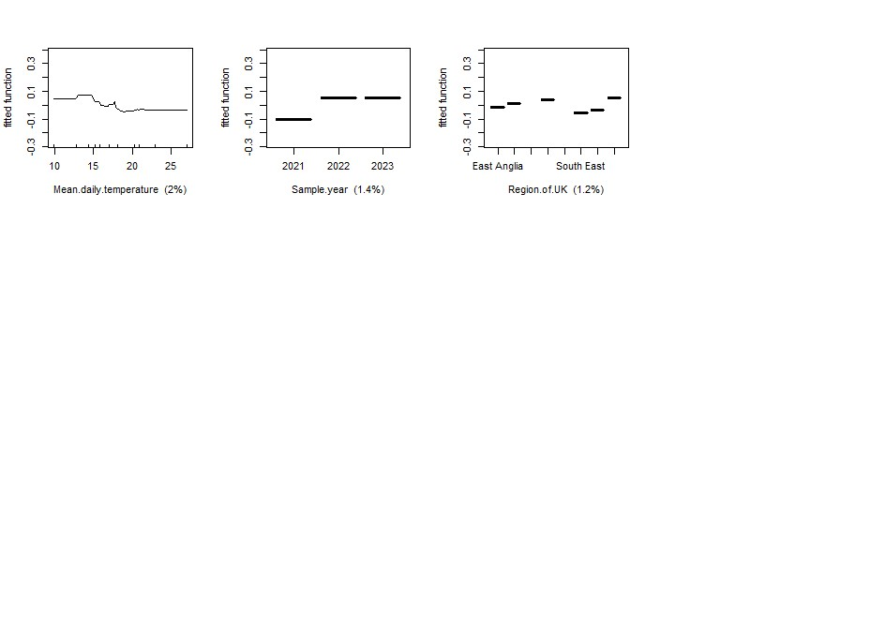

Bracken live stem
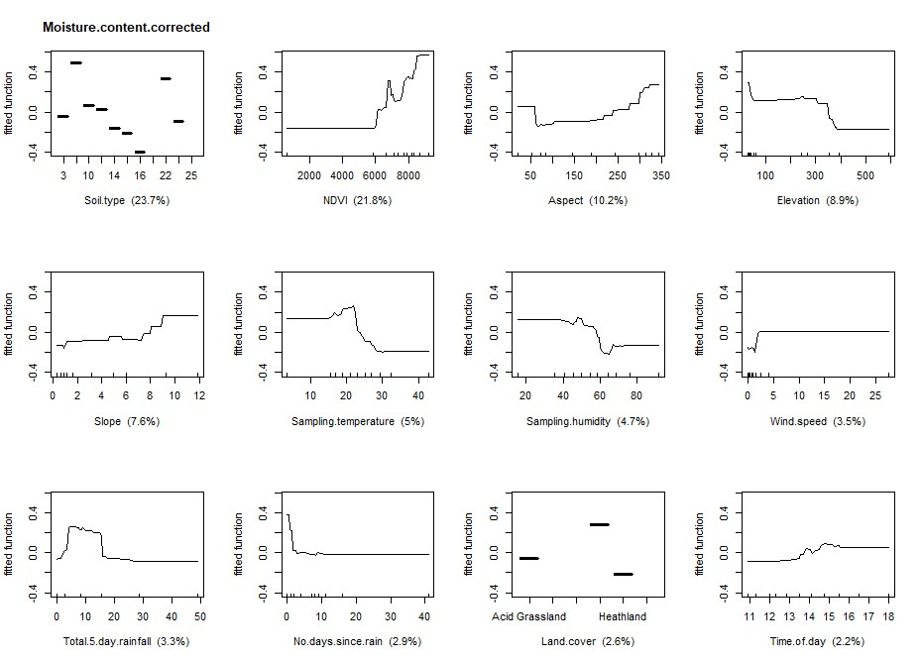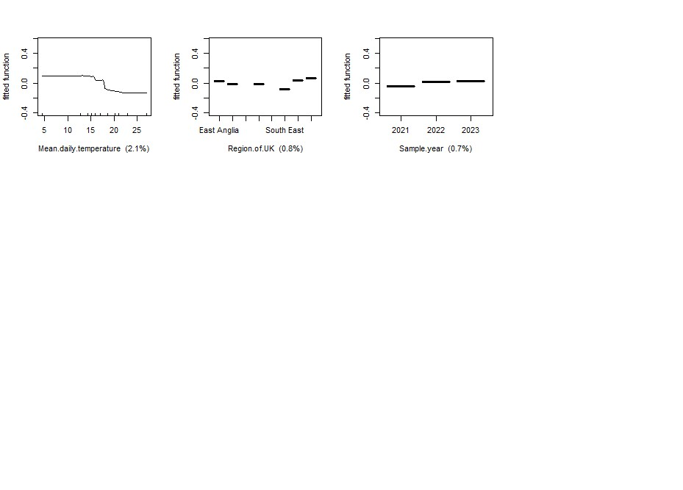

Bracken dead leaves
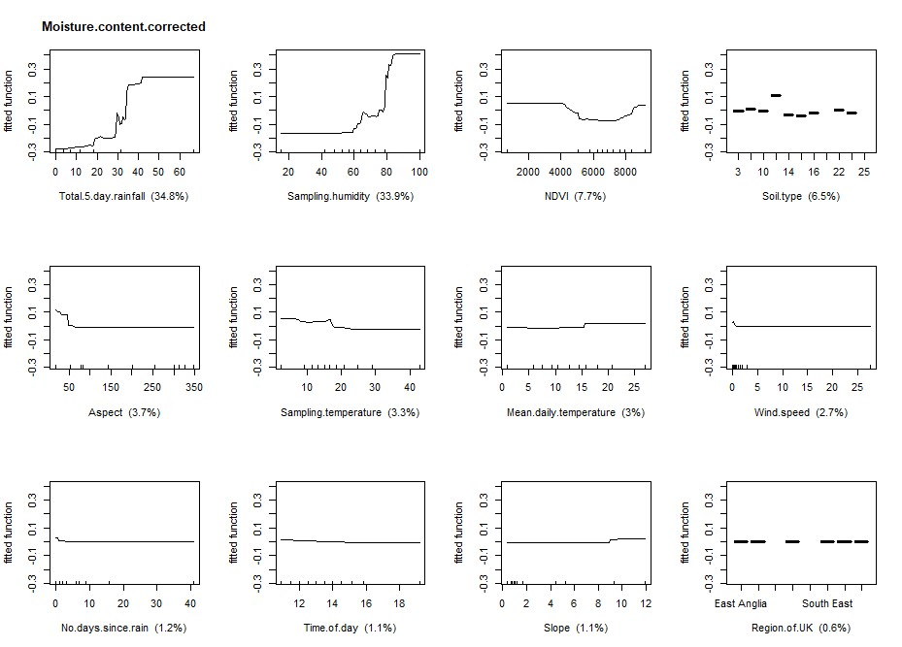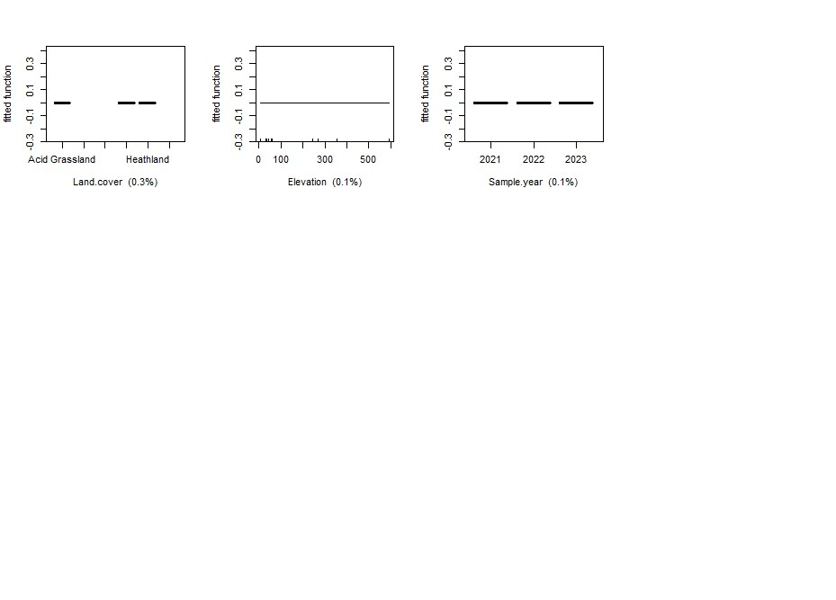

Bracken dead stem
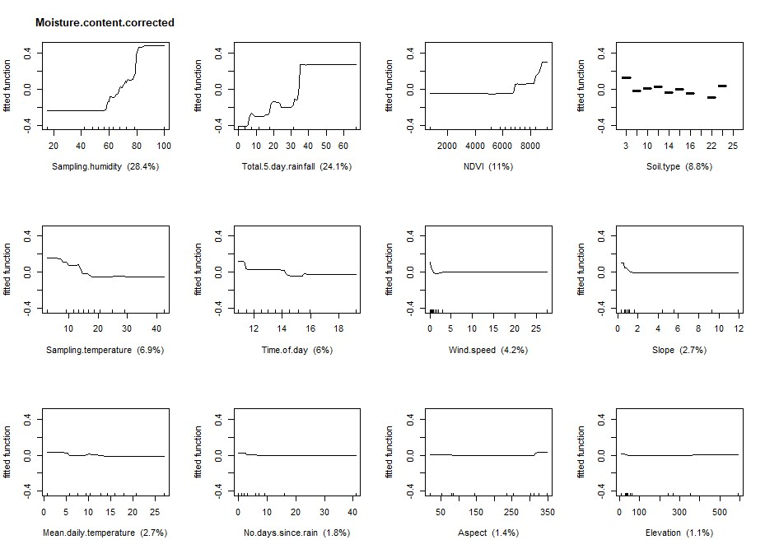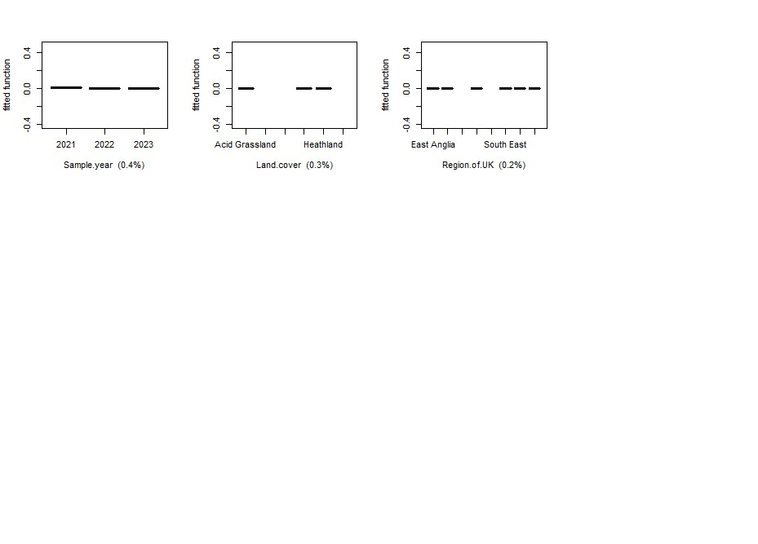

Moor grass live
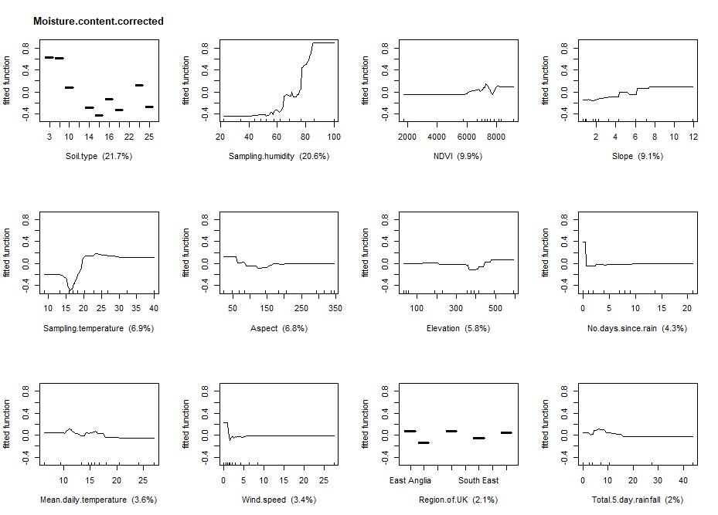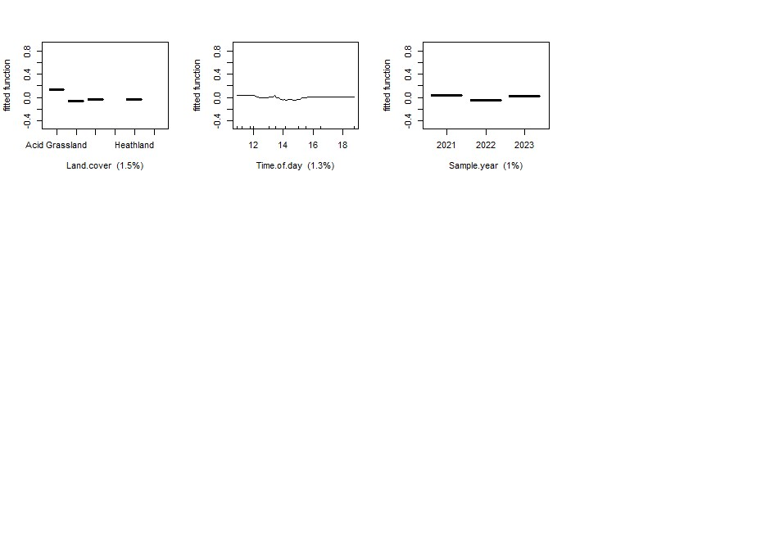

Moor grass dead
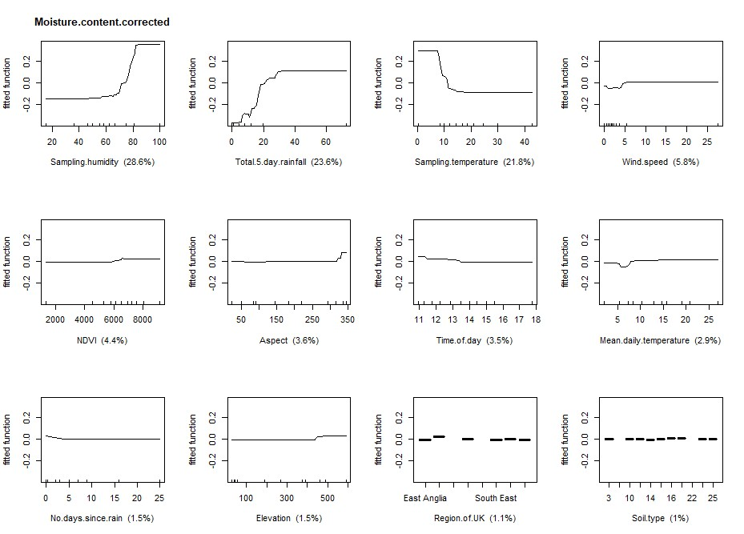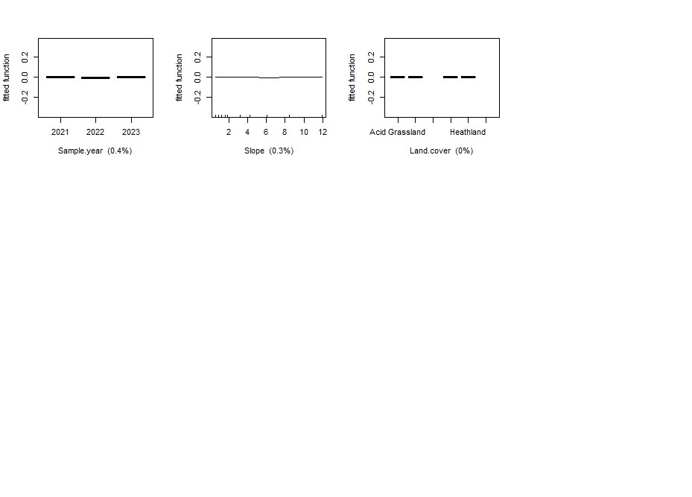

Litter
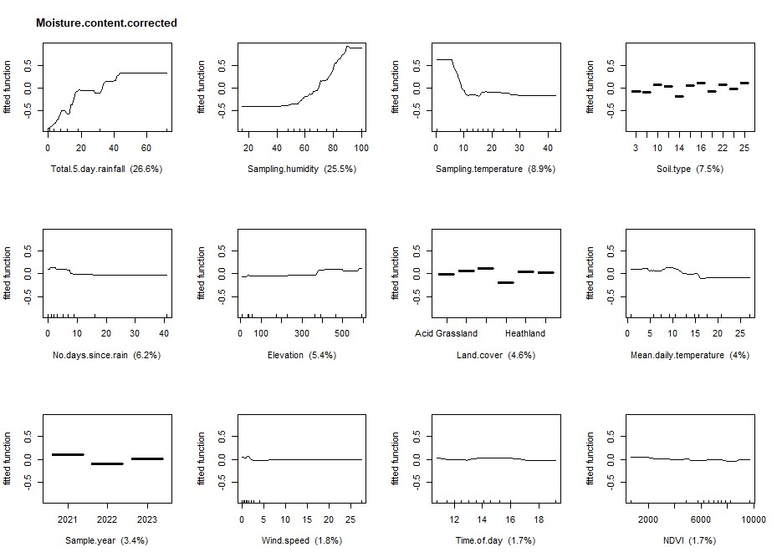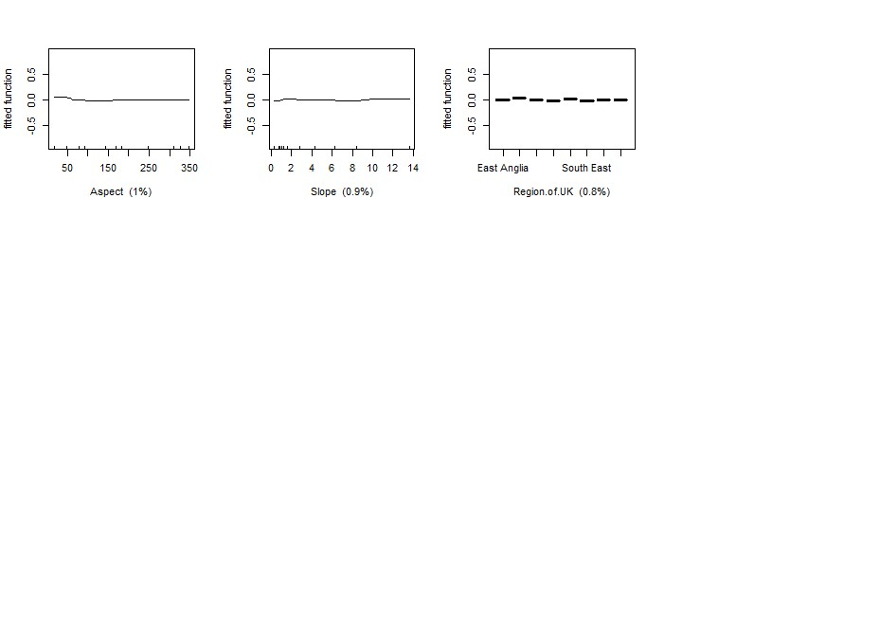

Organic layer
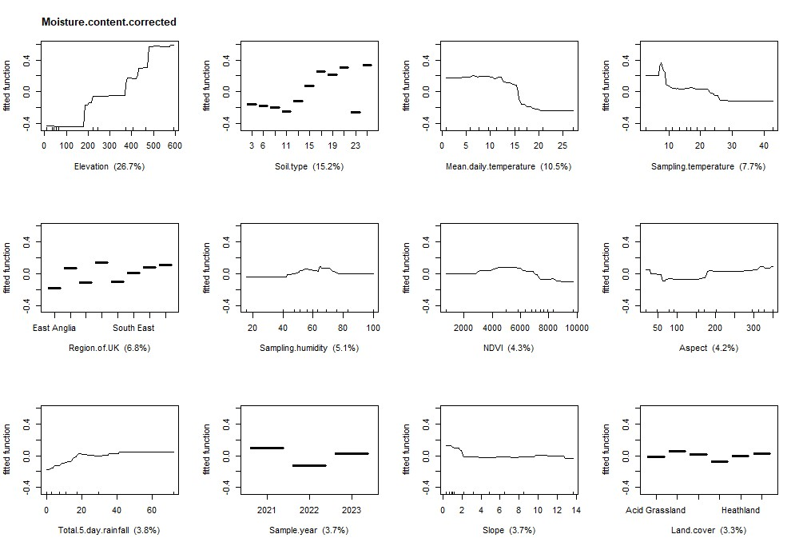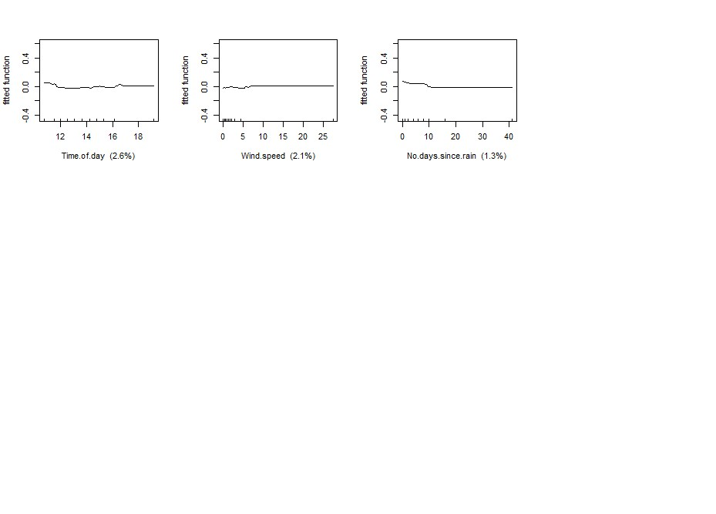

Moss
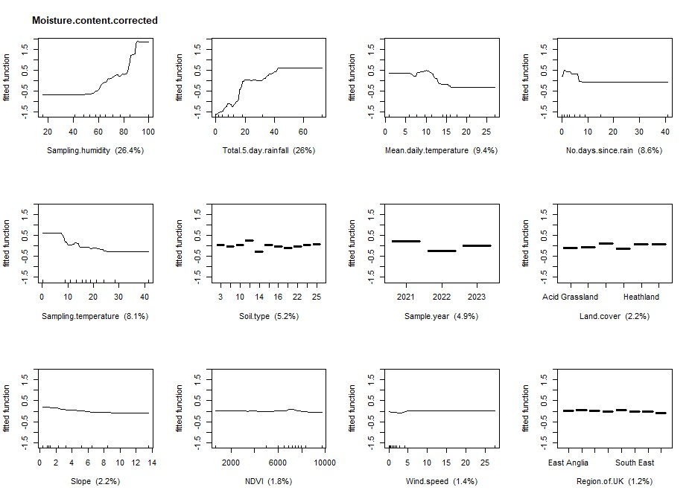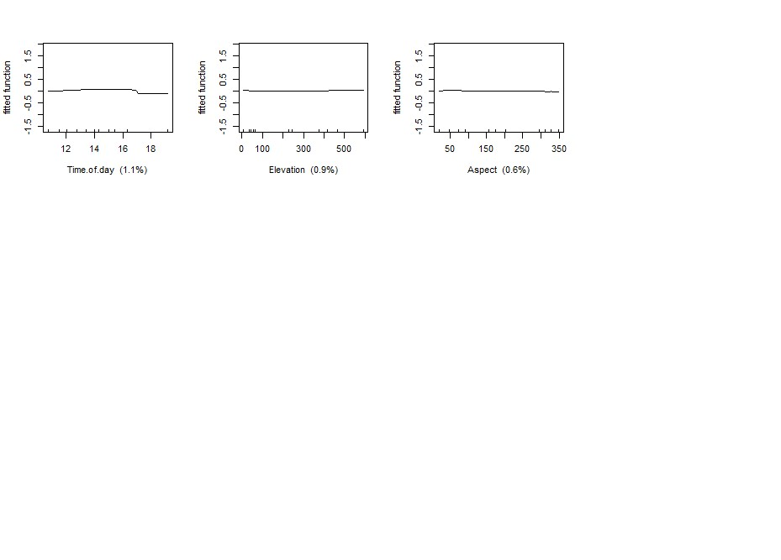

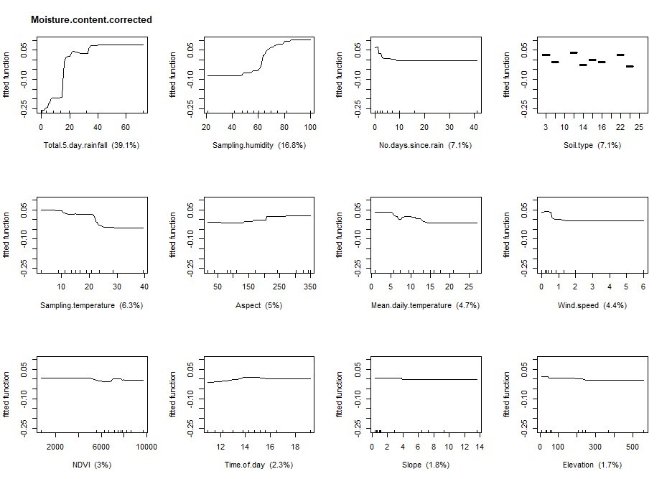
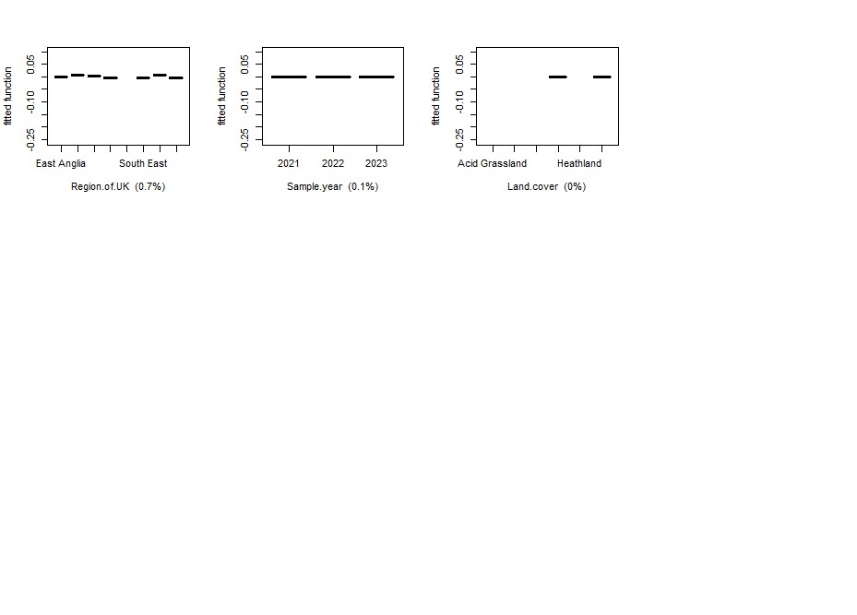
Twigs

Figure S3: Relationship between fuel moisture content and fifteen variables for eighteen sampled fuels. FMC is represented as a fitted function.

Heather live canopy
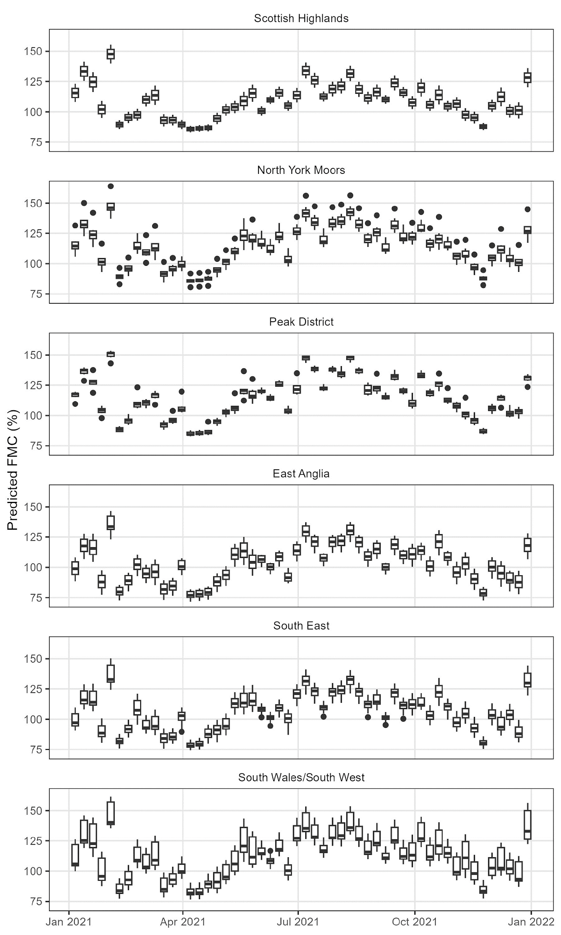
Heather live stem
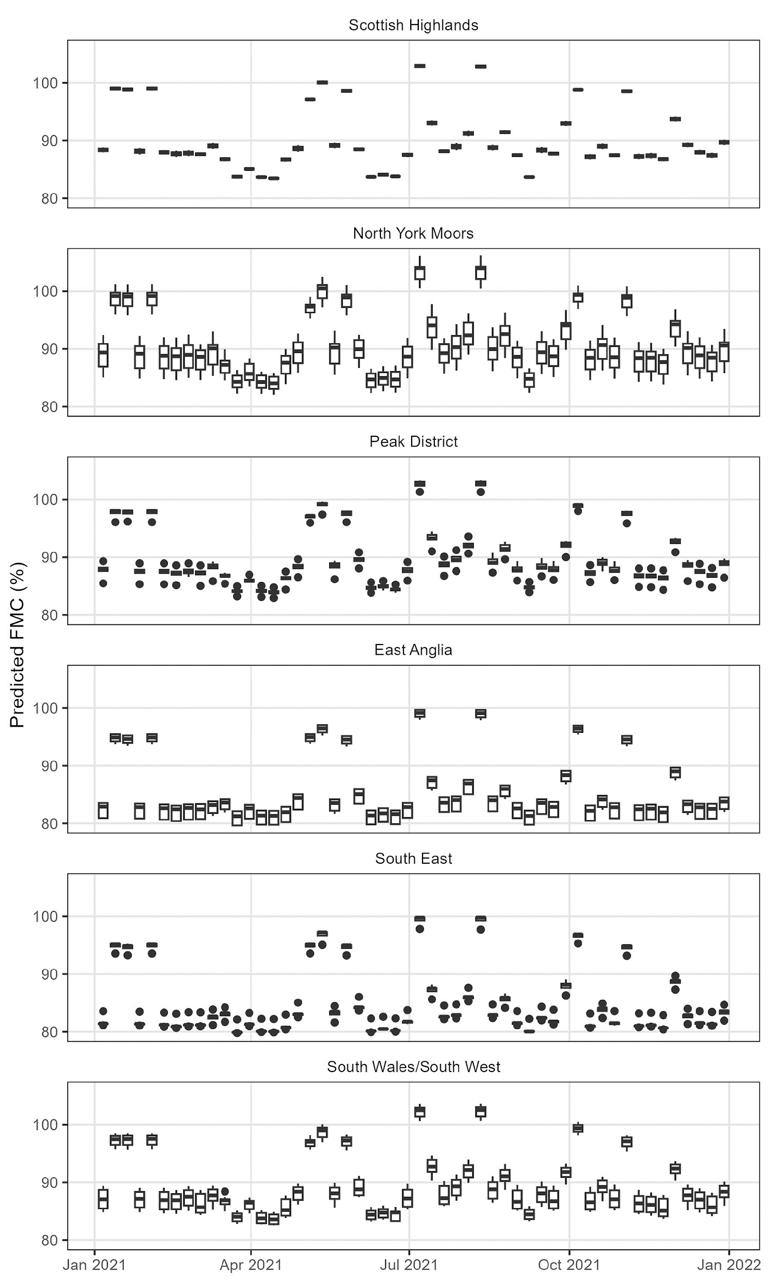
Heather dead canopy
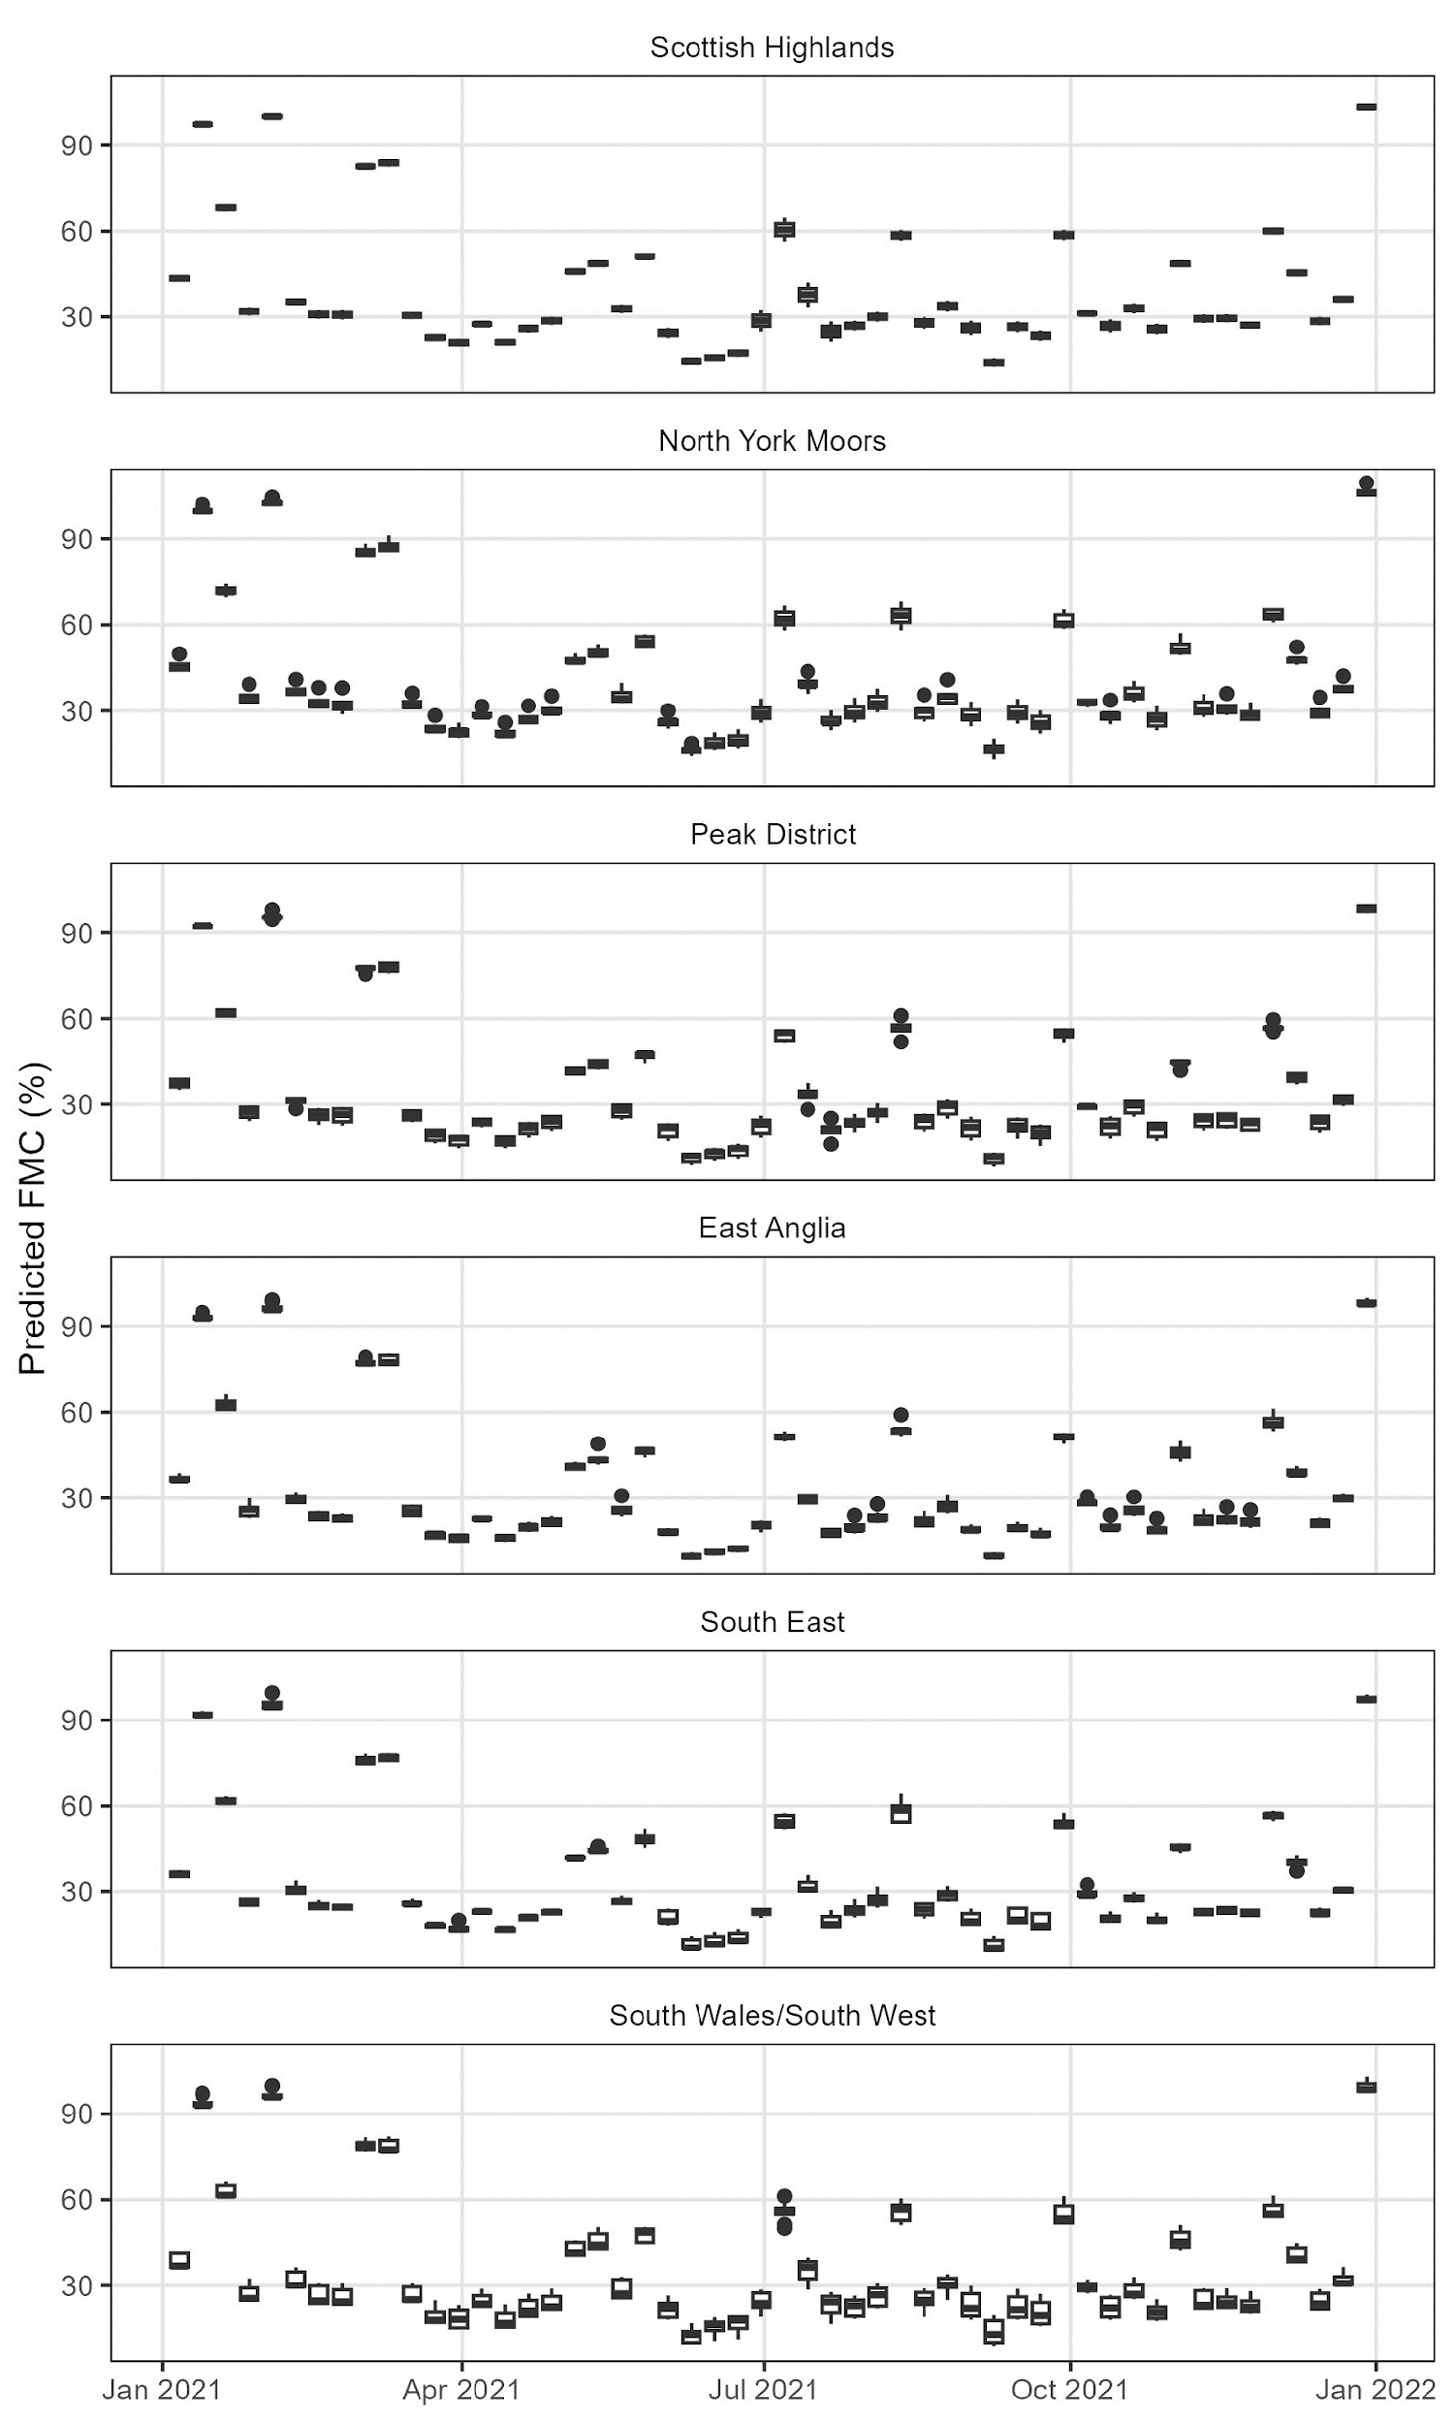
Heather dead stem
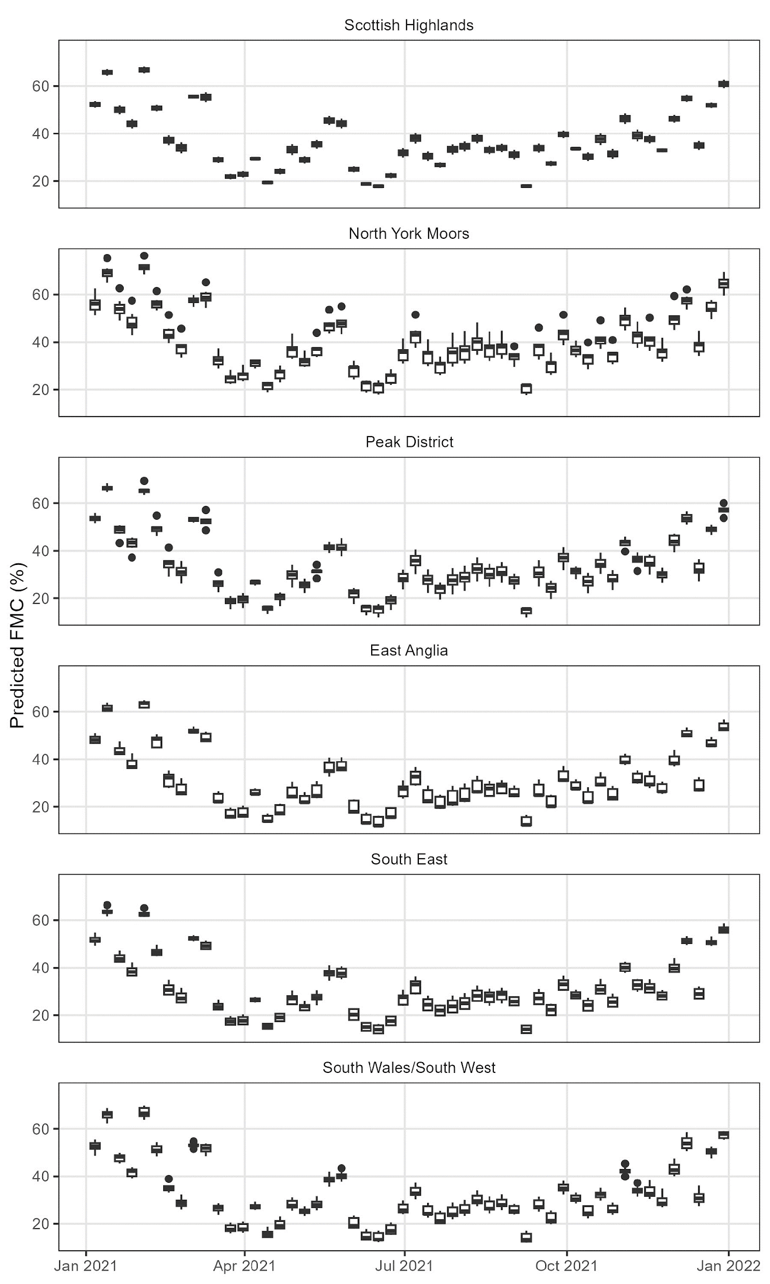
Gorse live canopy
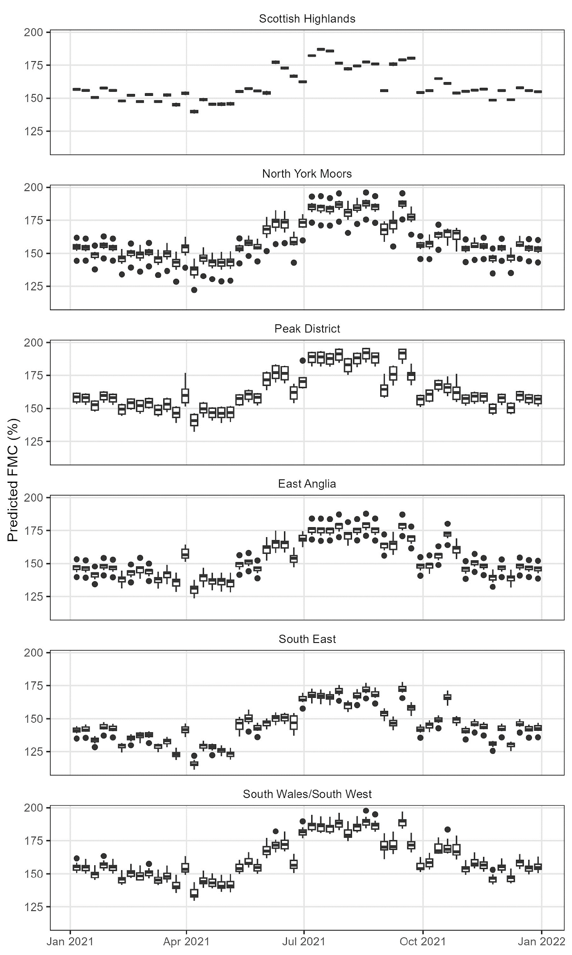
Gorse live stem
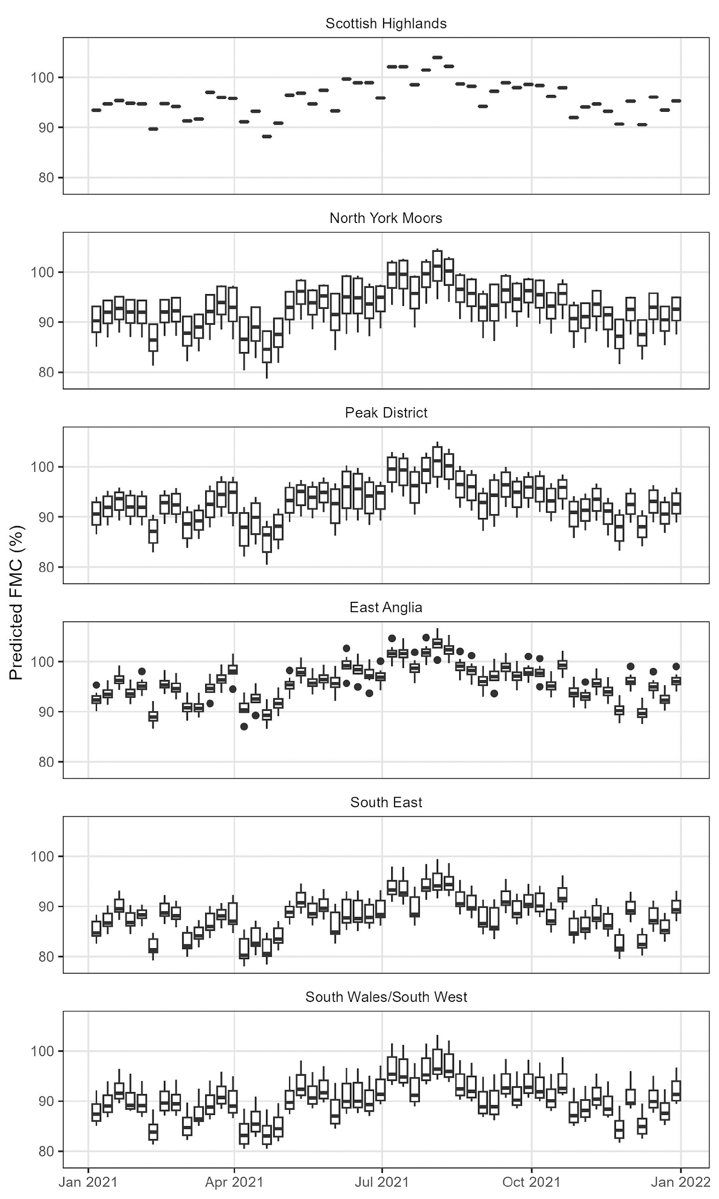
Gorse dead canopy
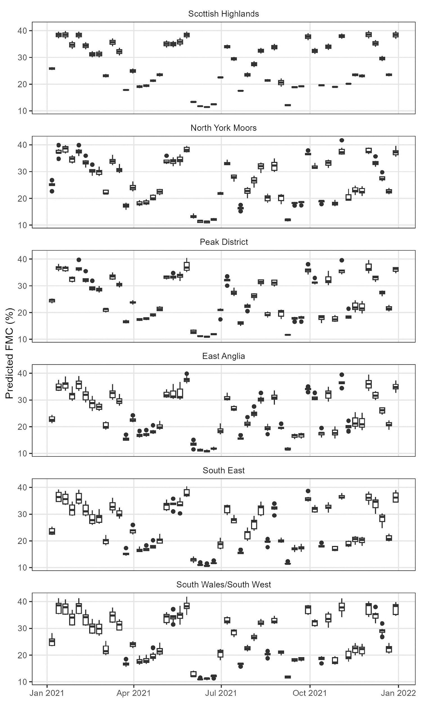
Gorse dead stem
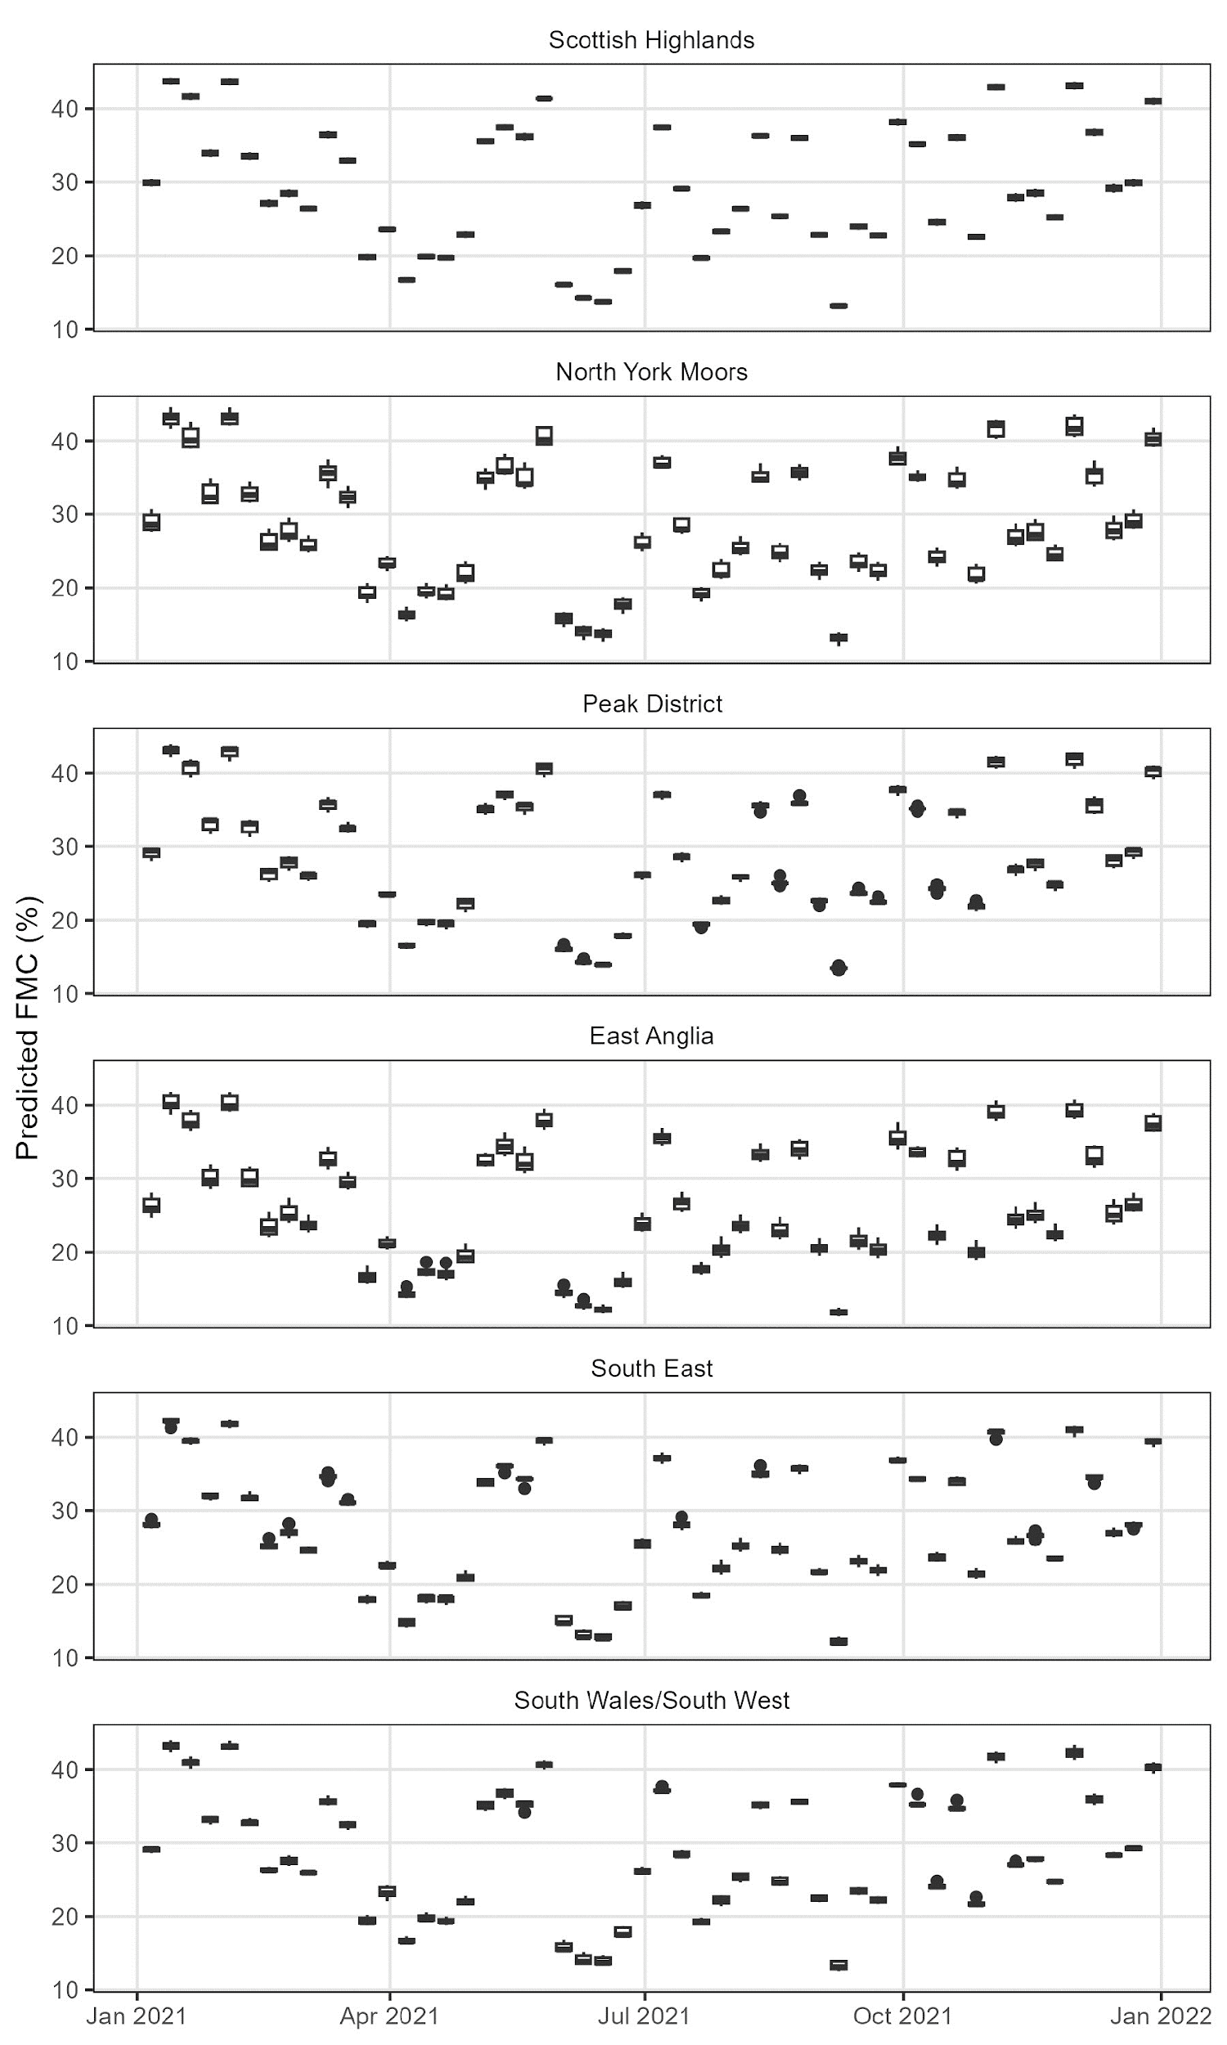
Bracken live leaves
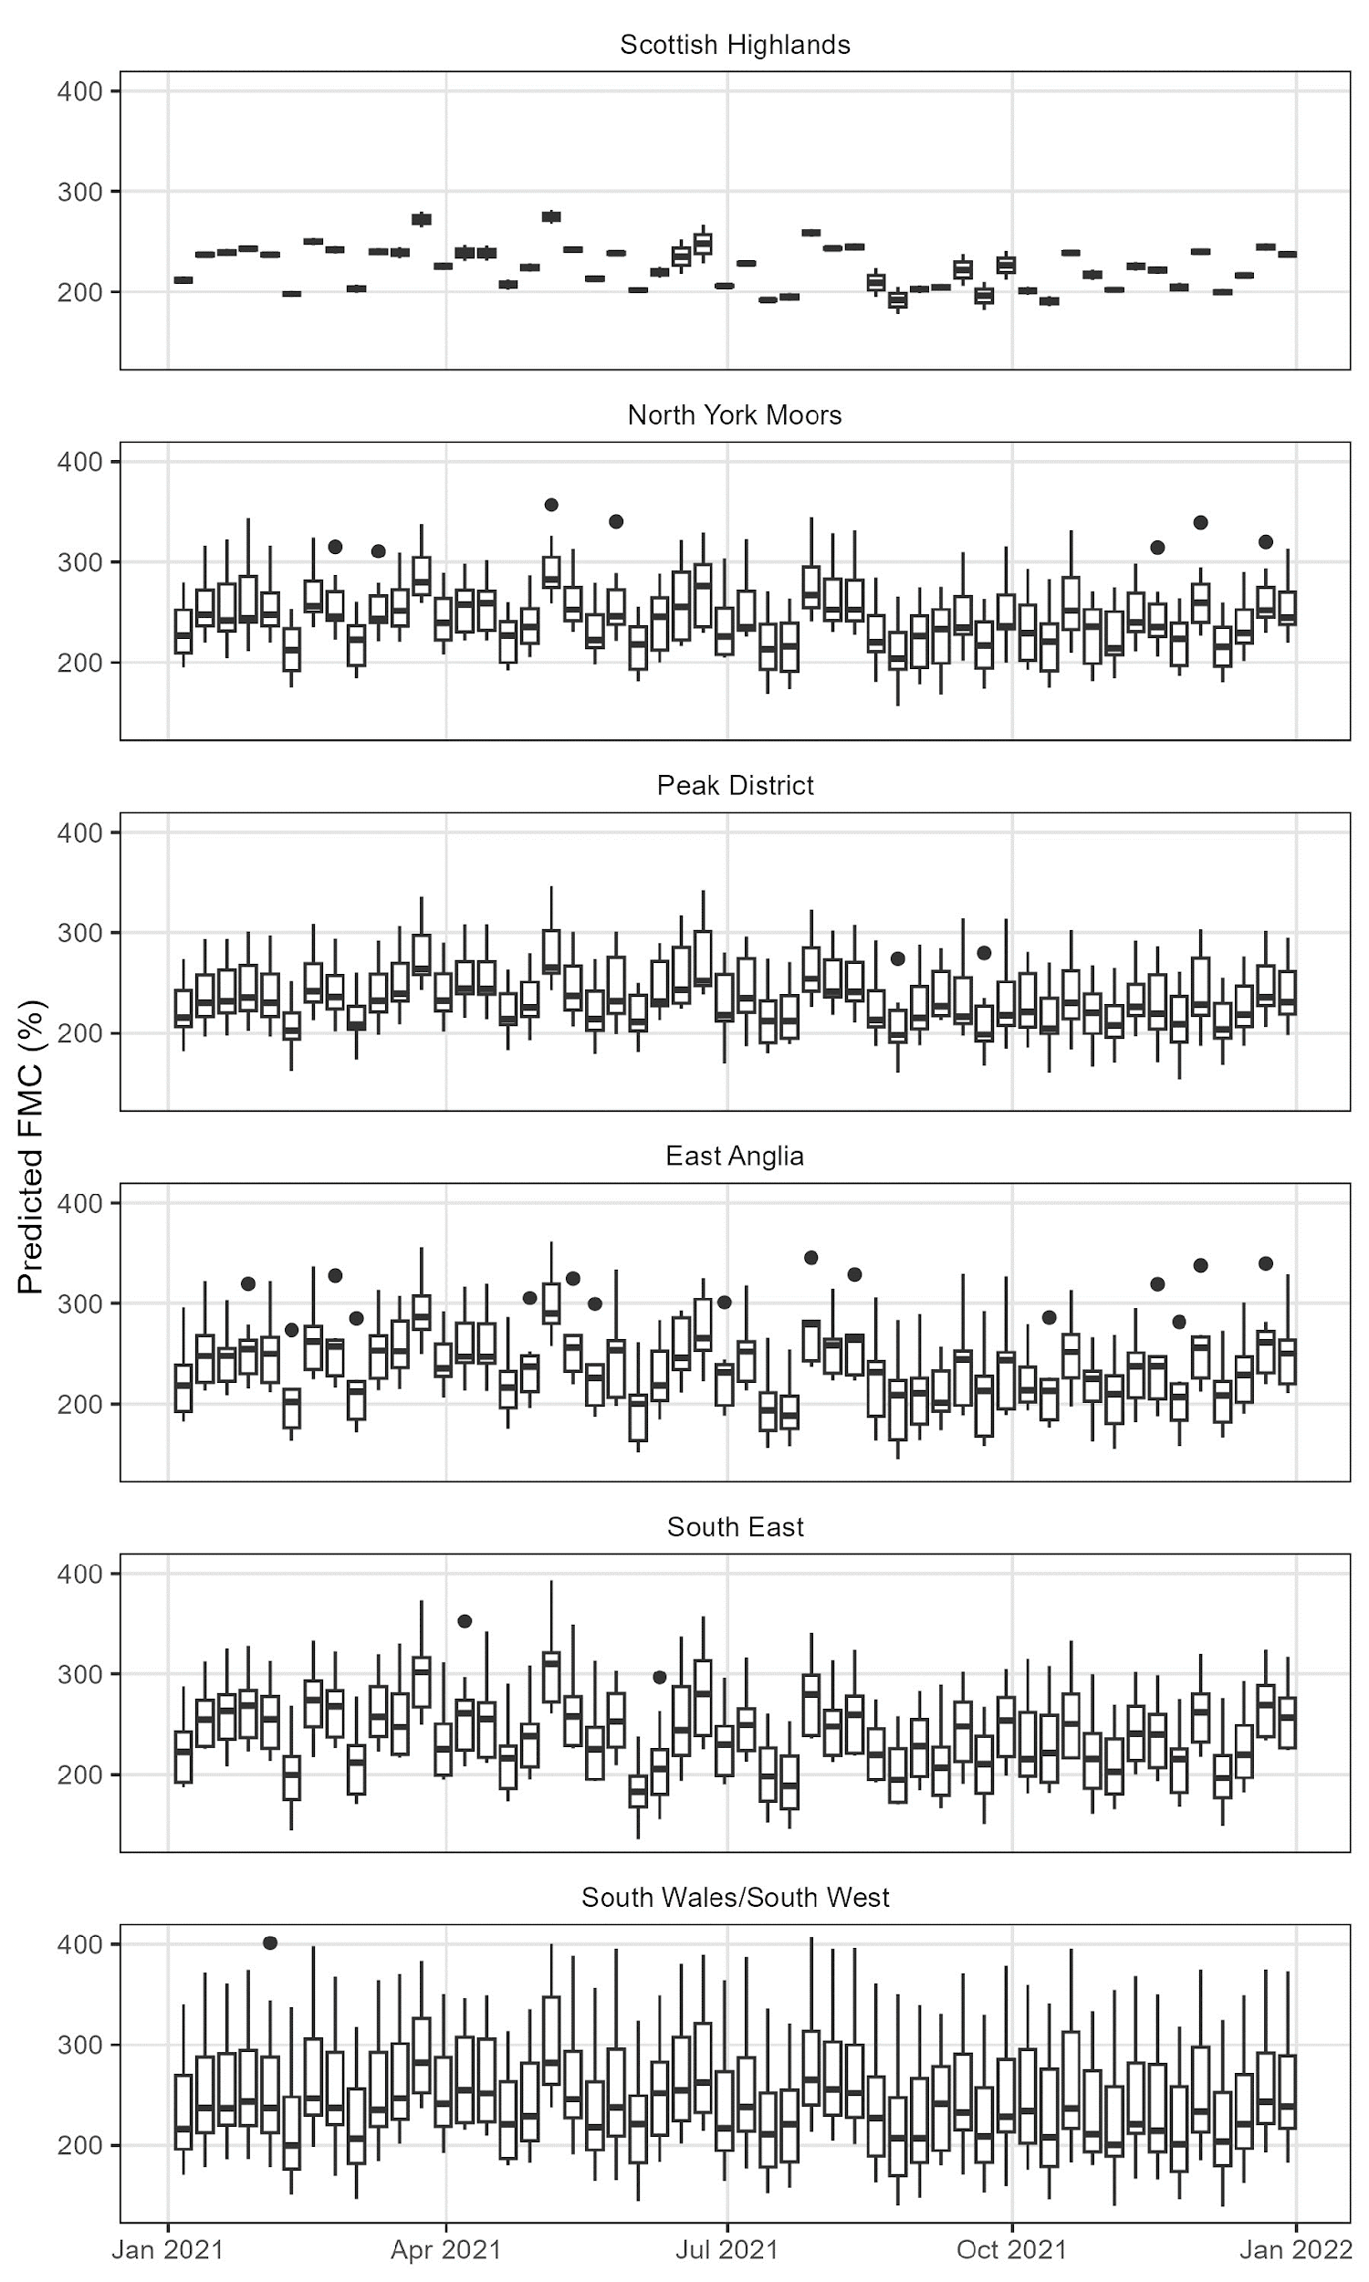
Bracken live stem
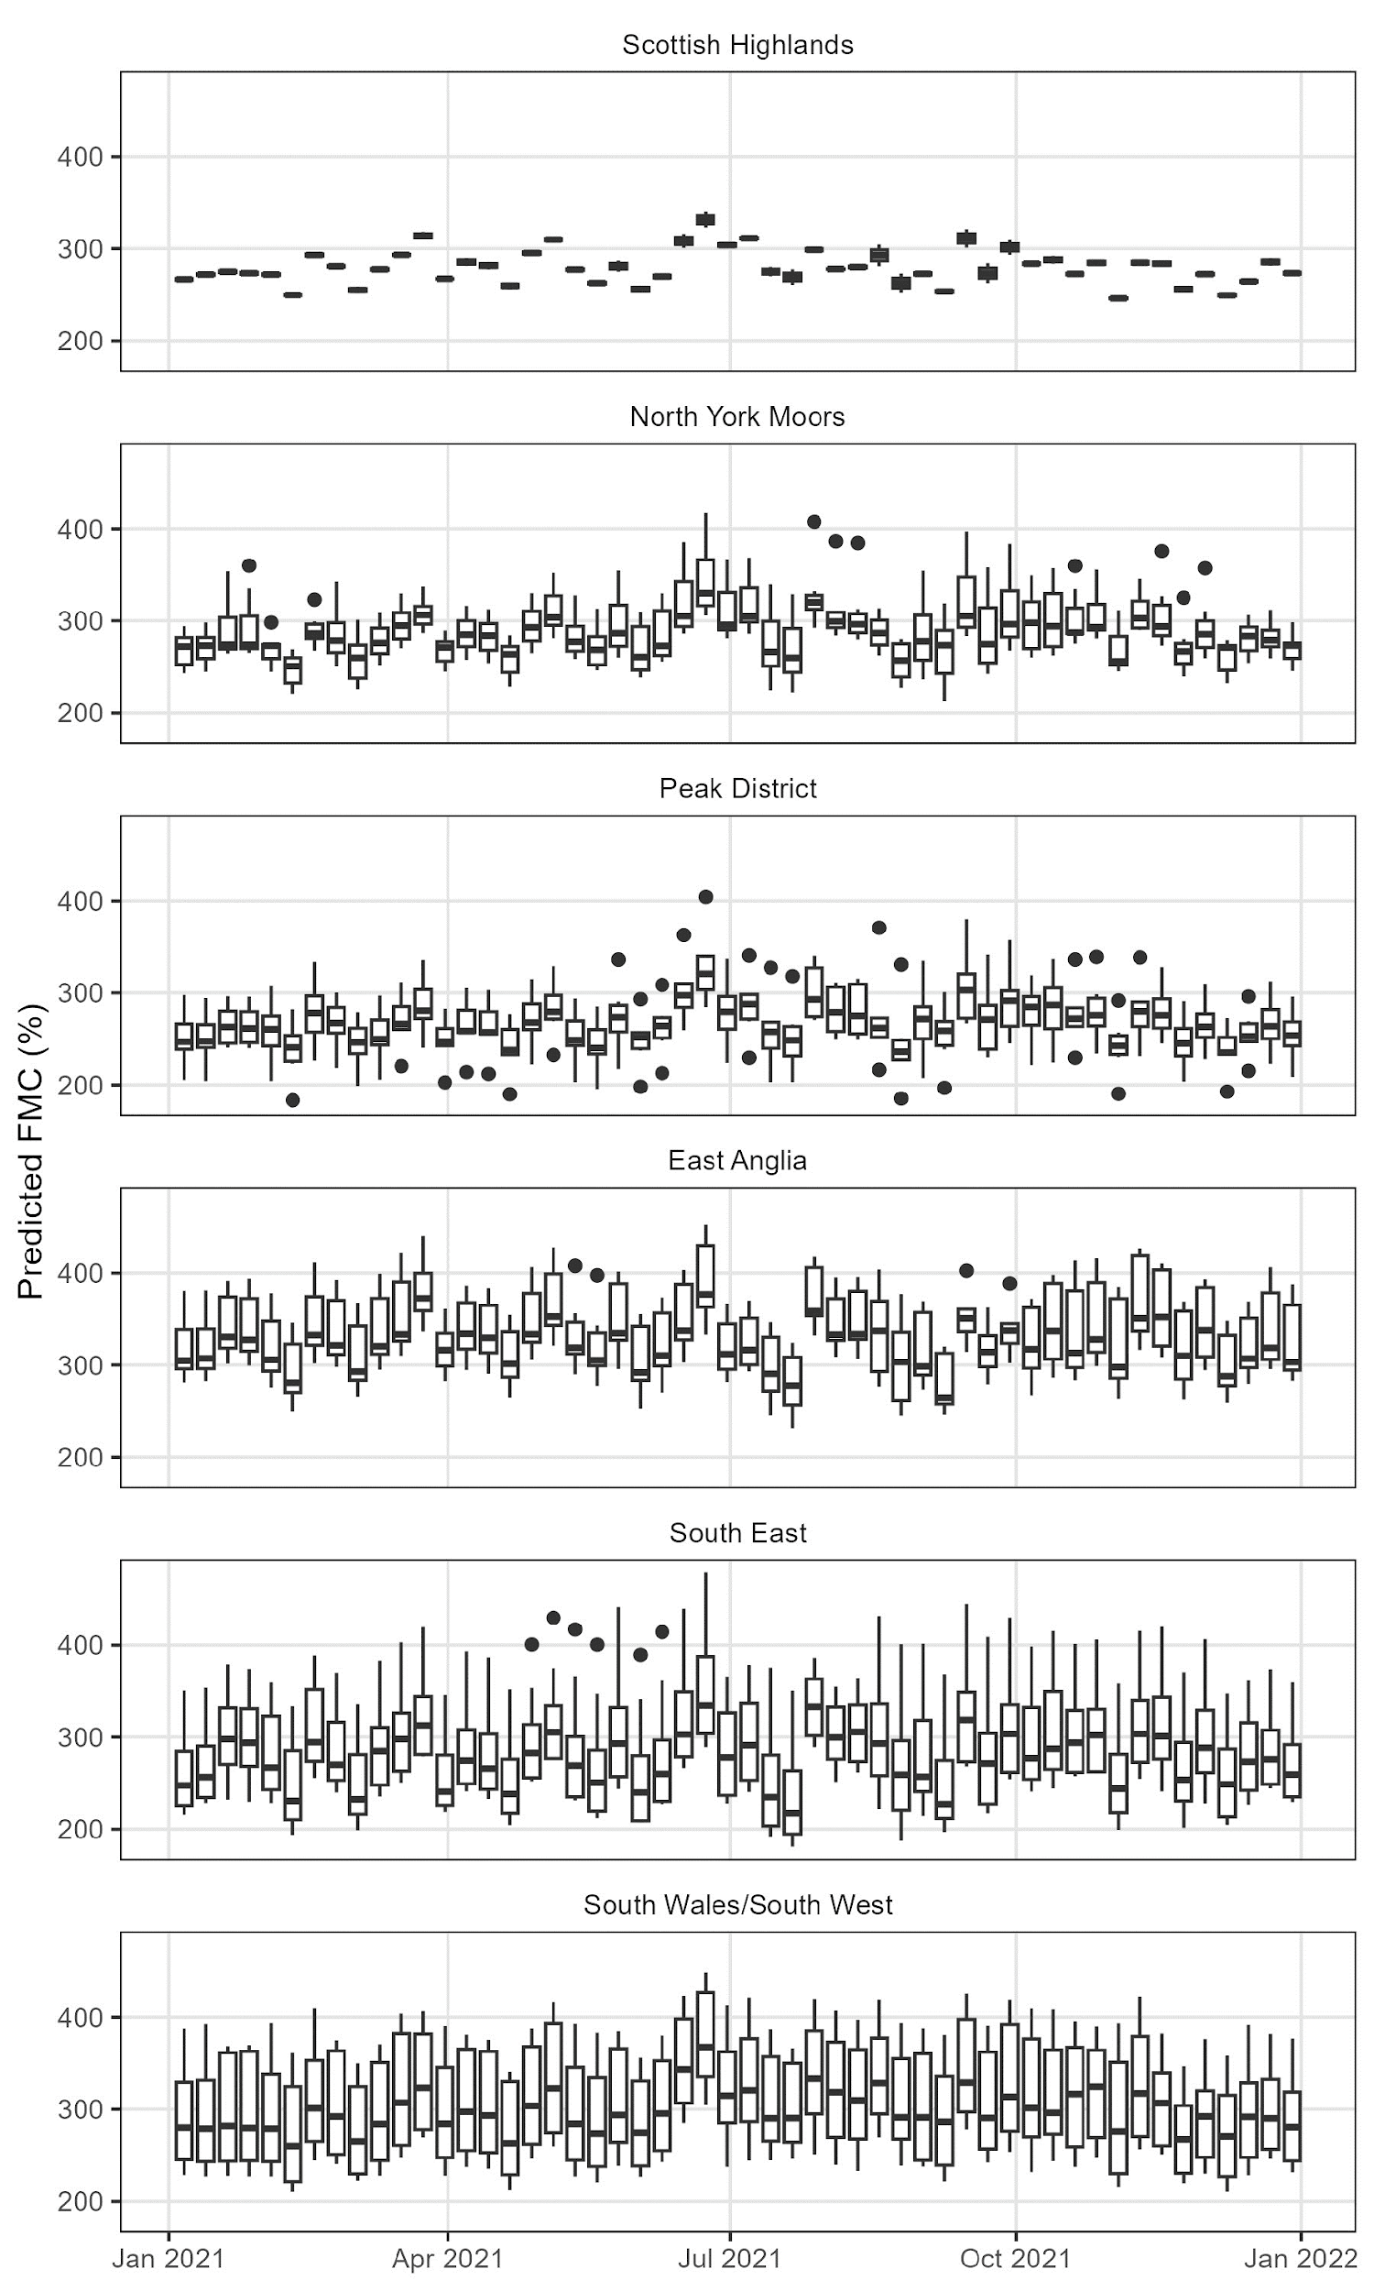
Bracken dead leaves
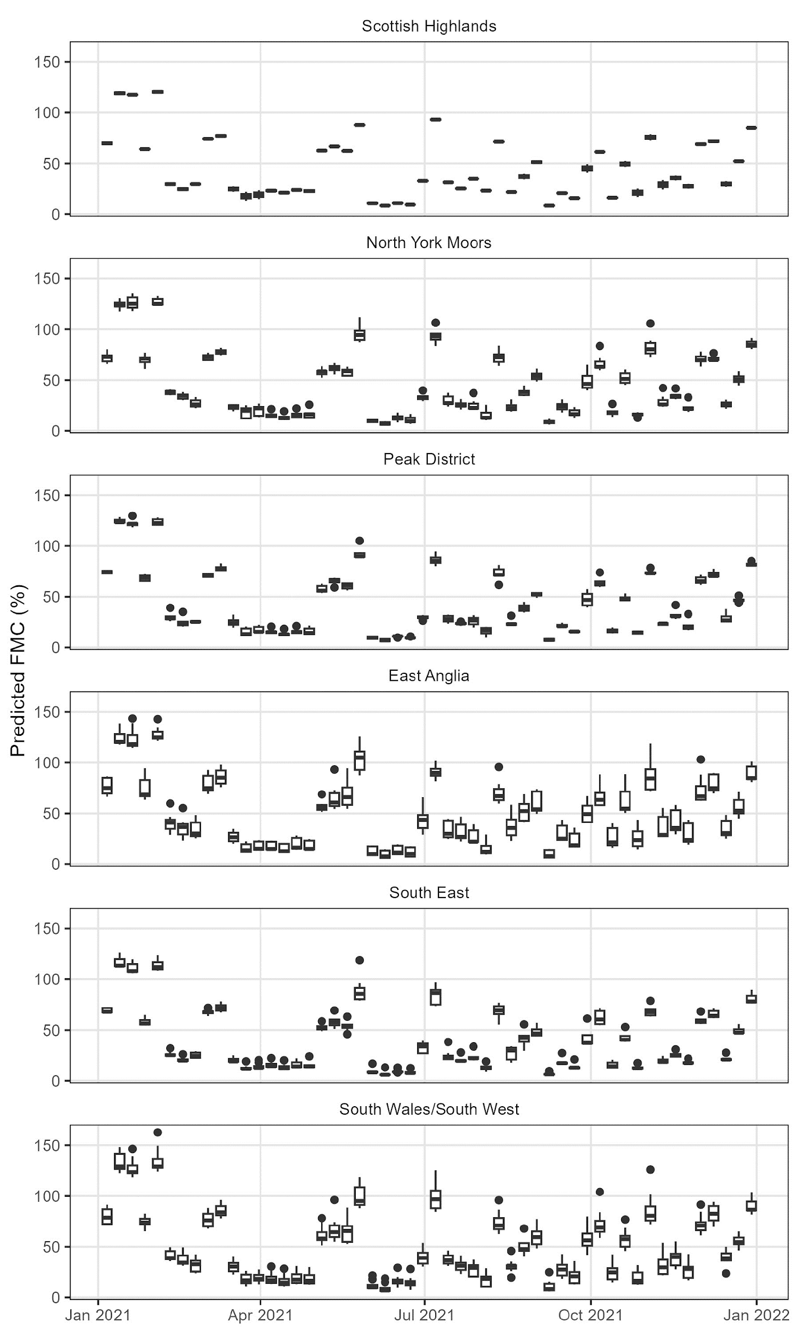
Bracken dead stem
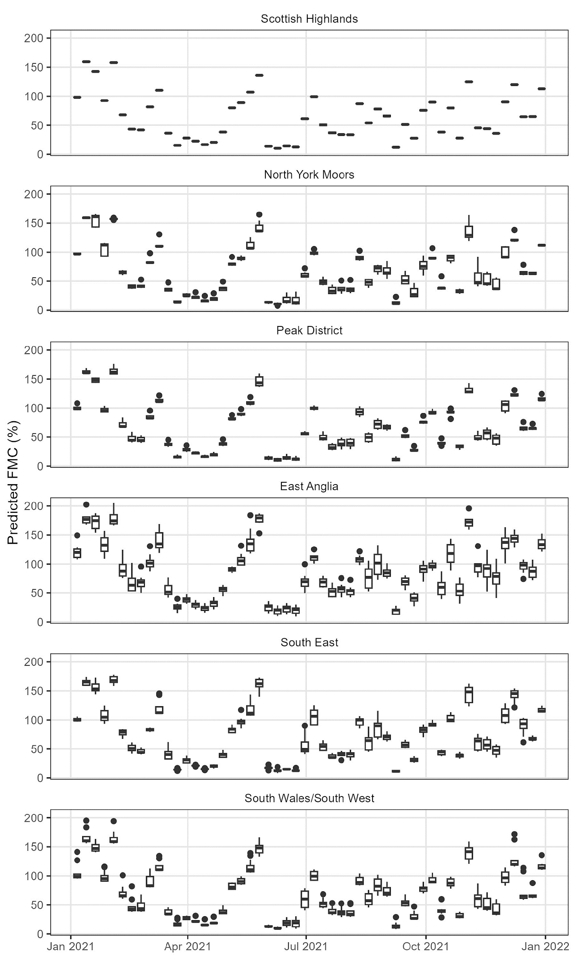
Moor grass live
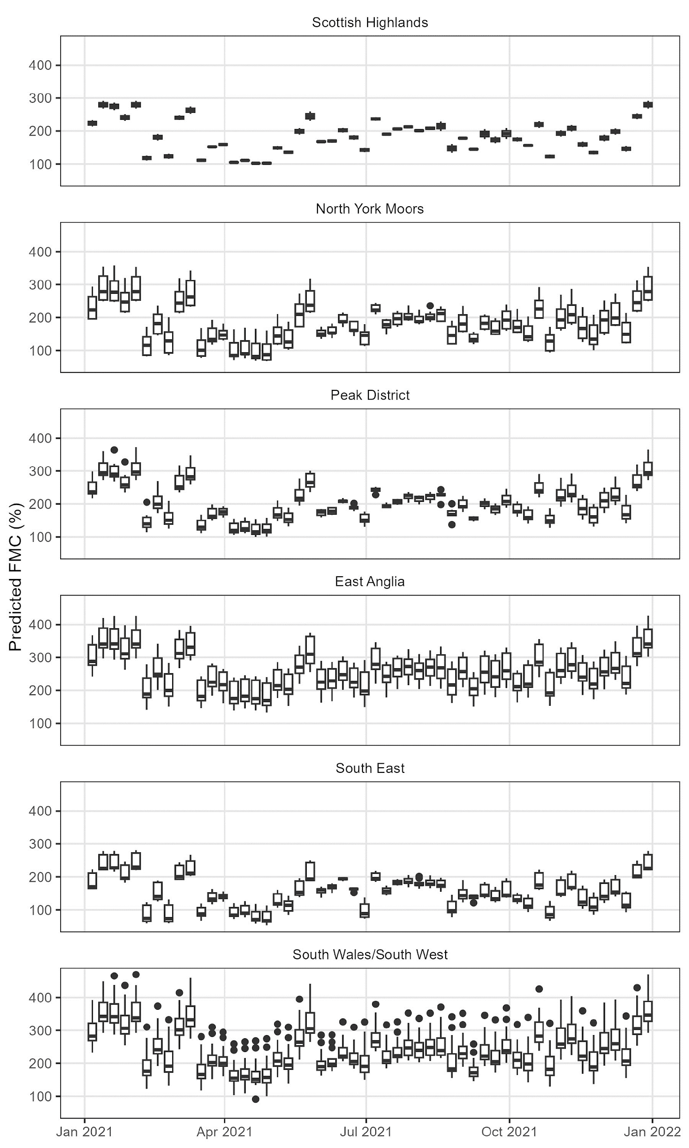
Moor grass dead
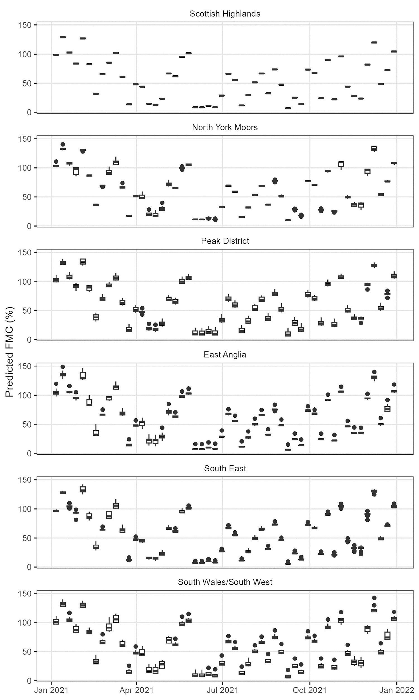
Litter
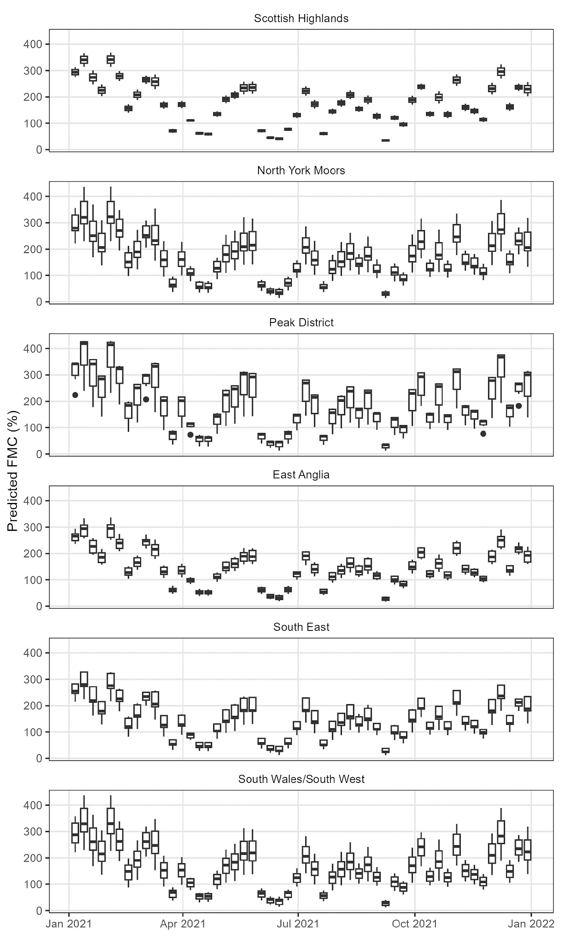
Organic layer
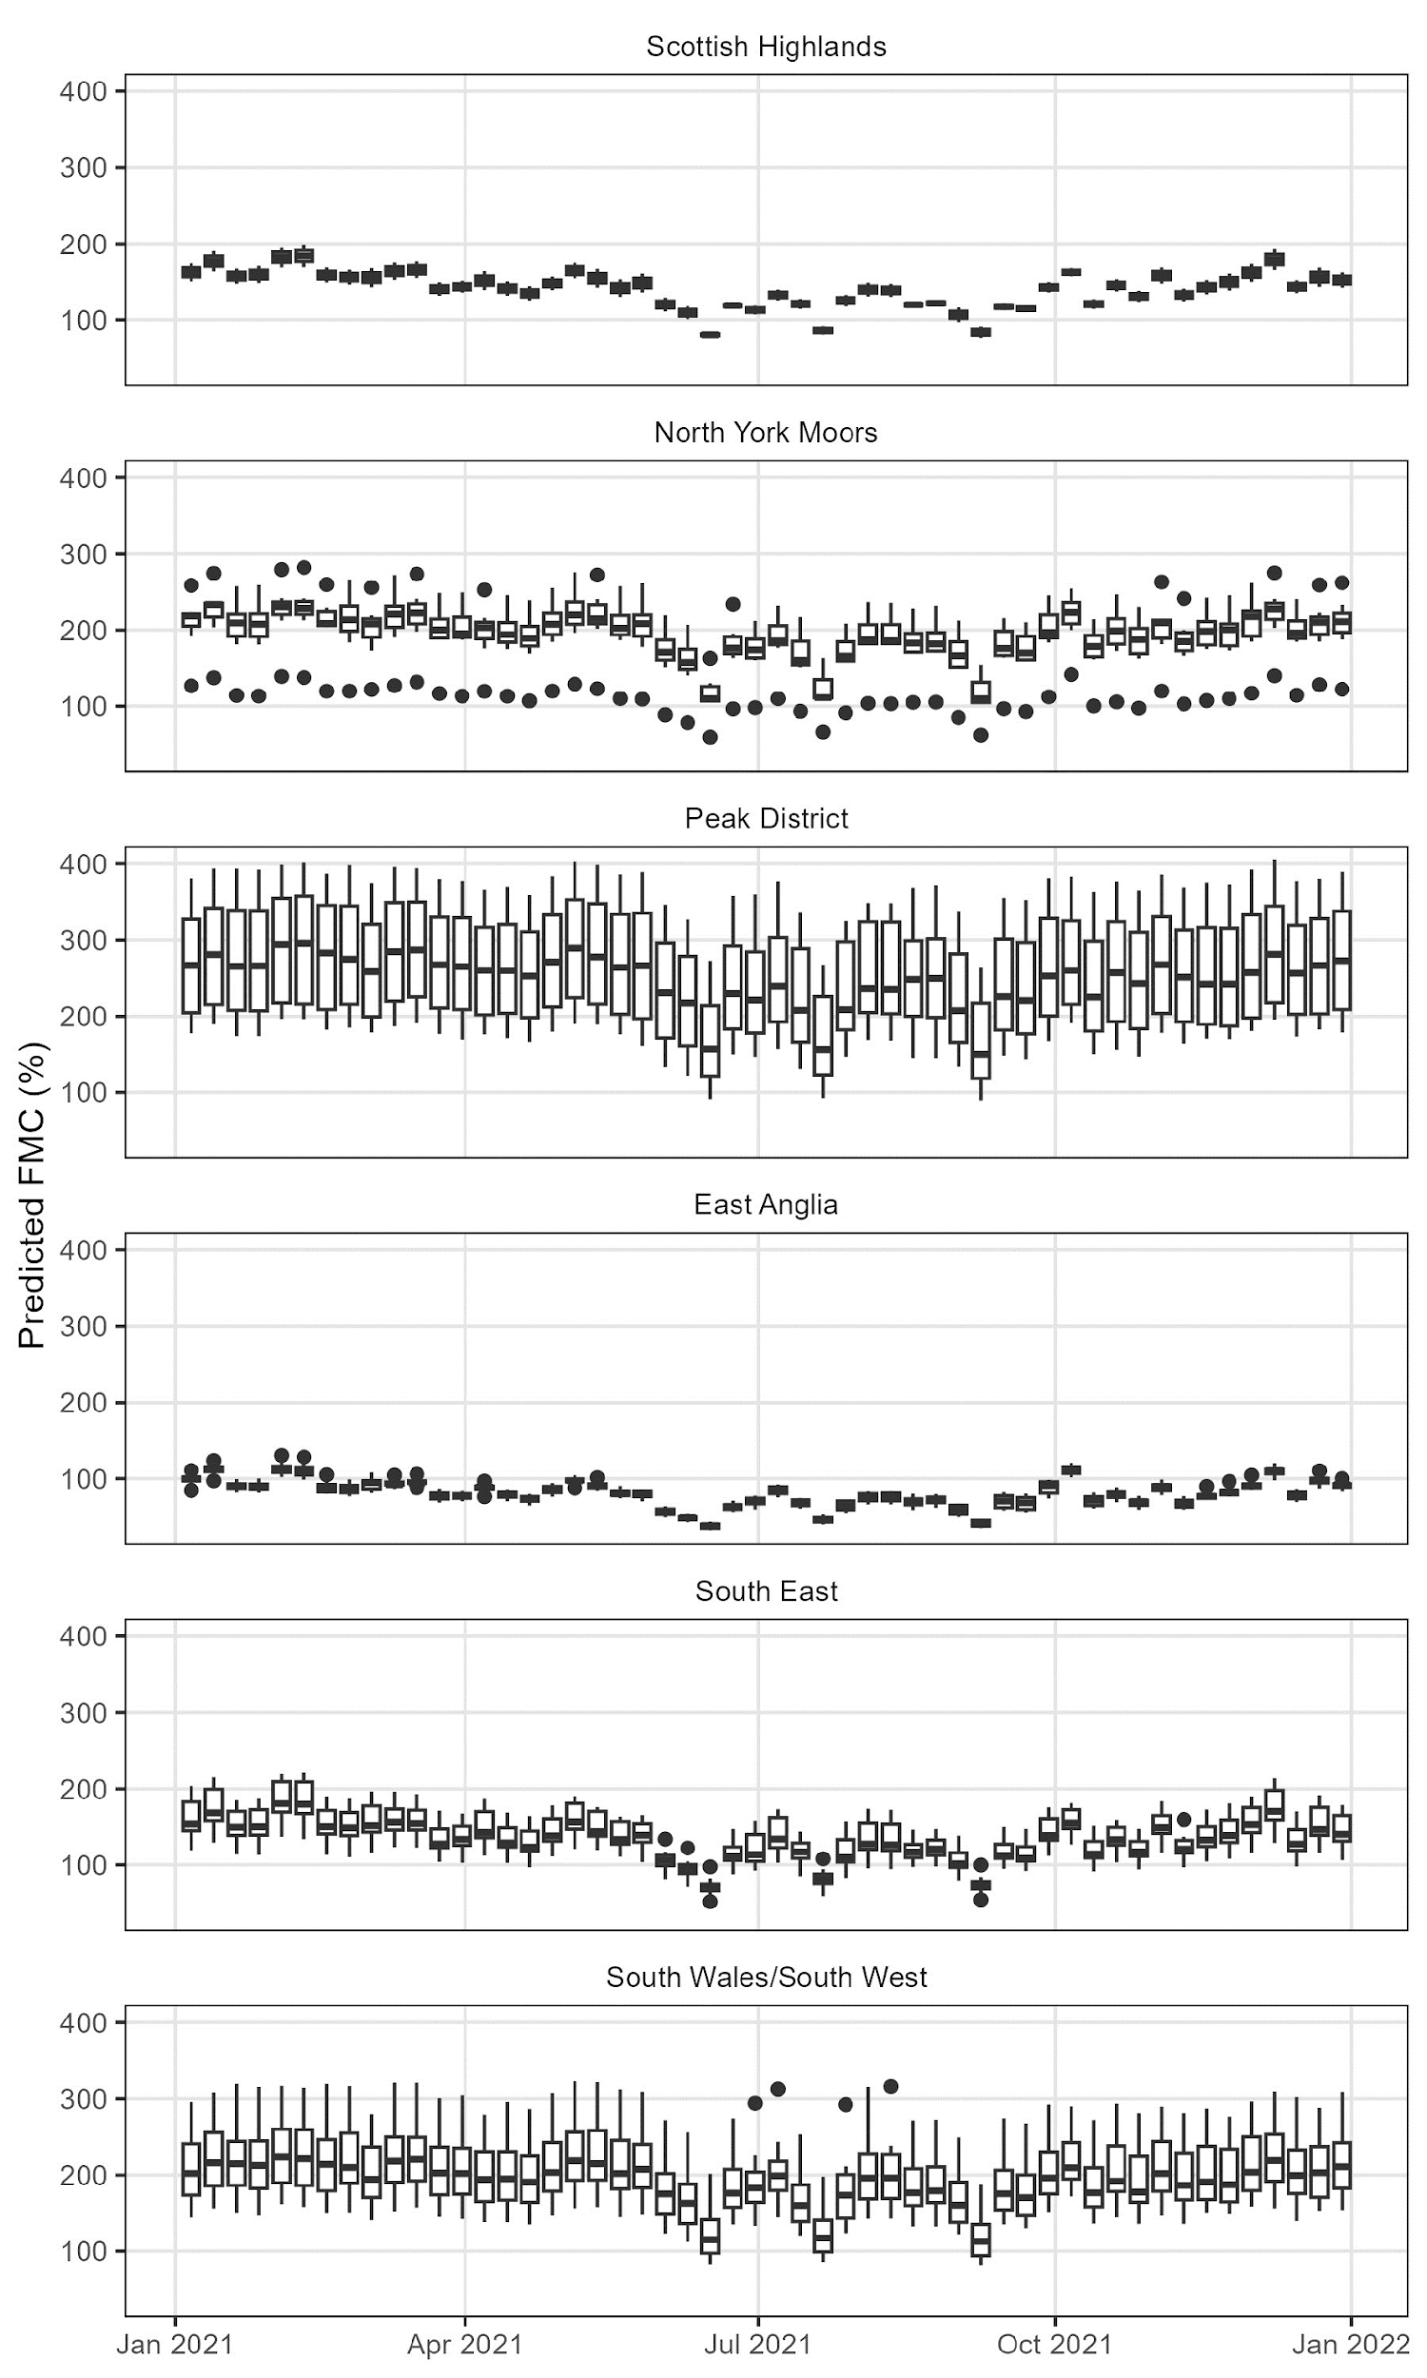
Moss
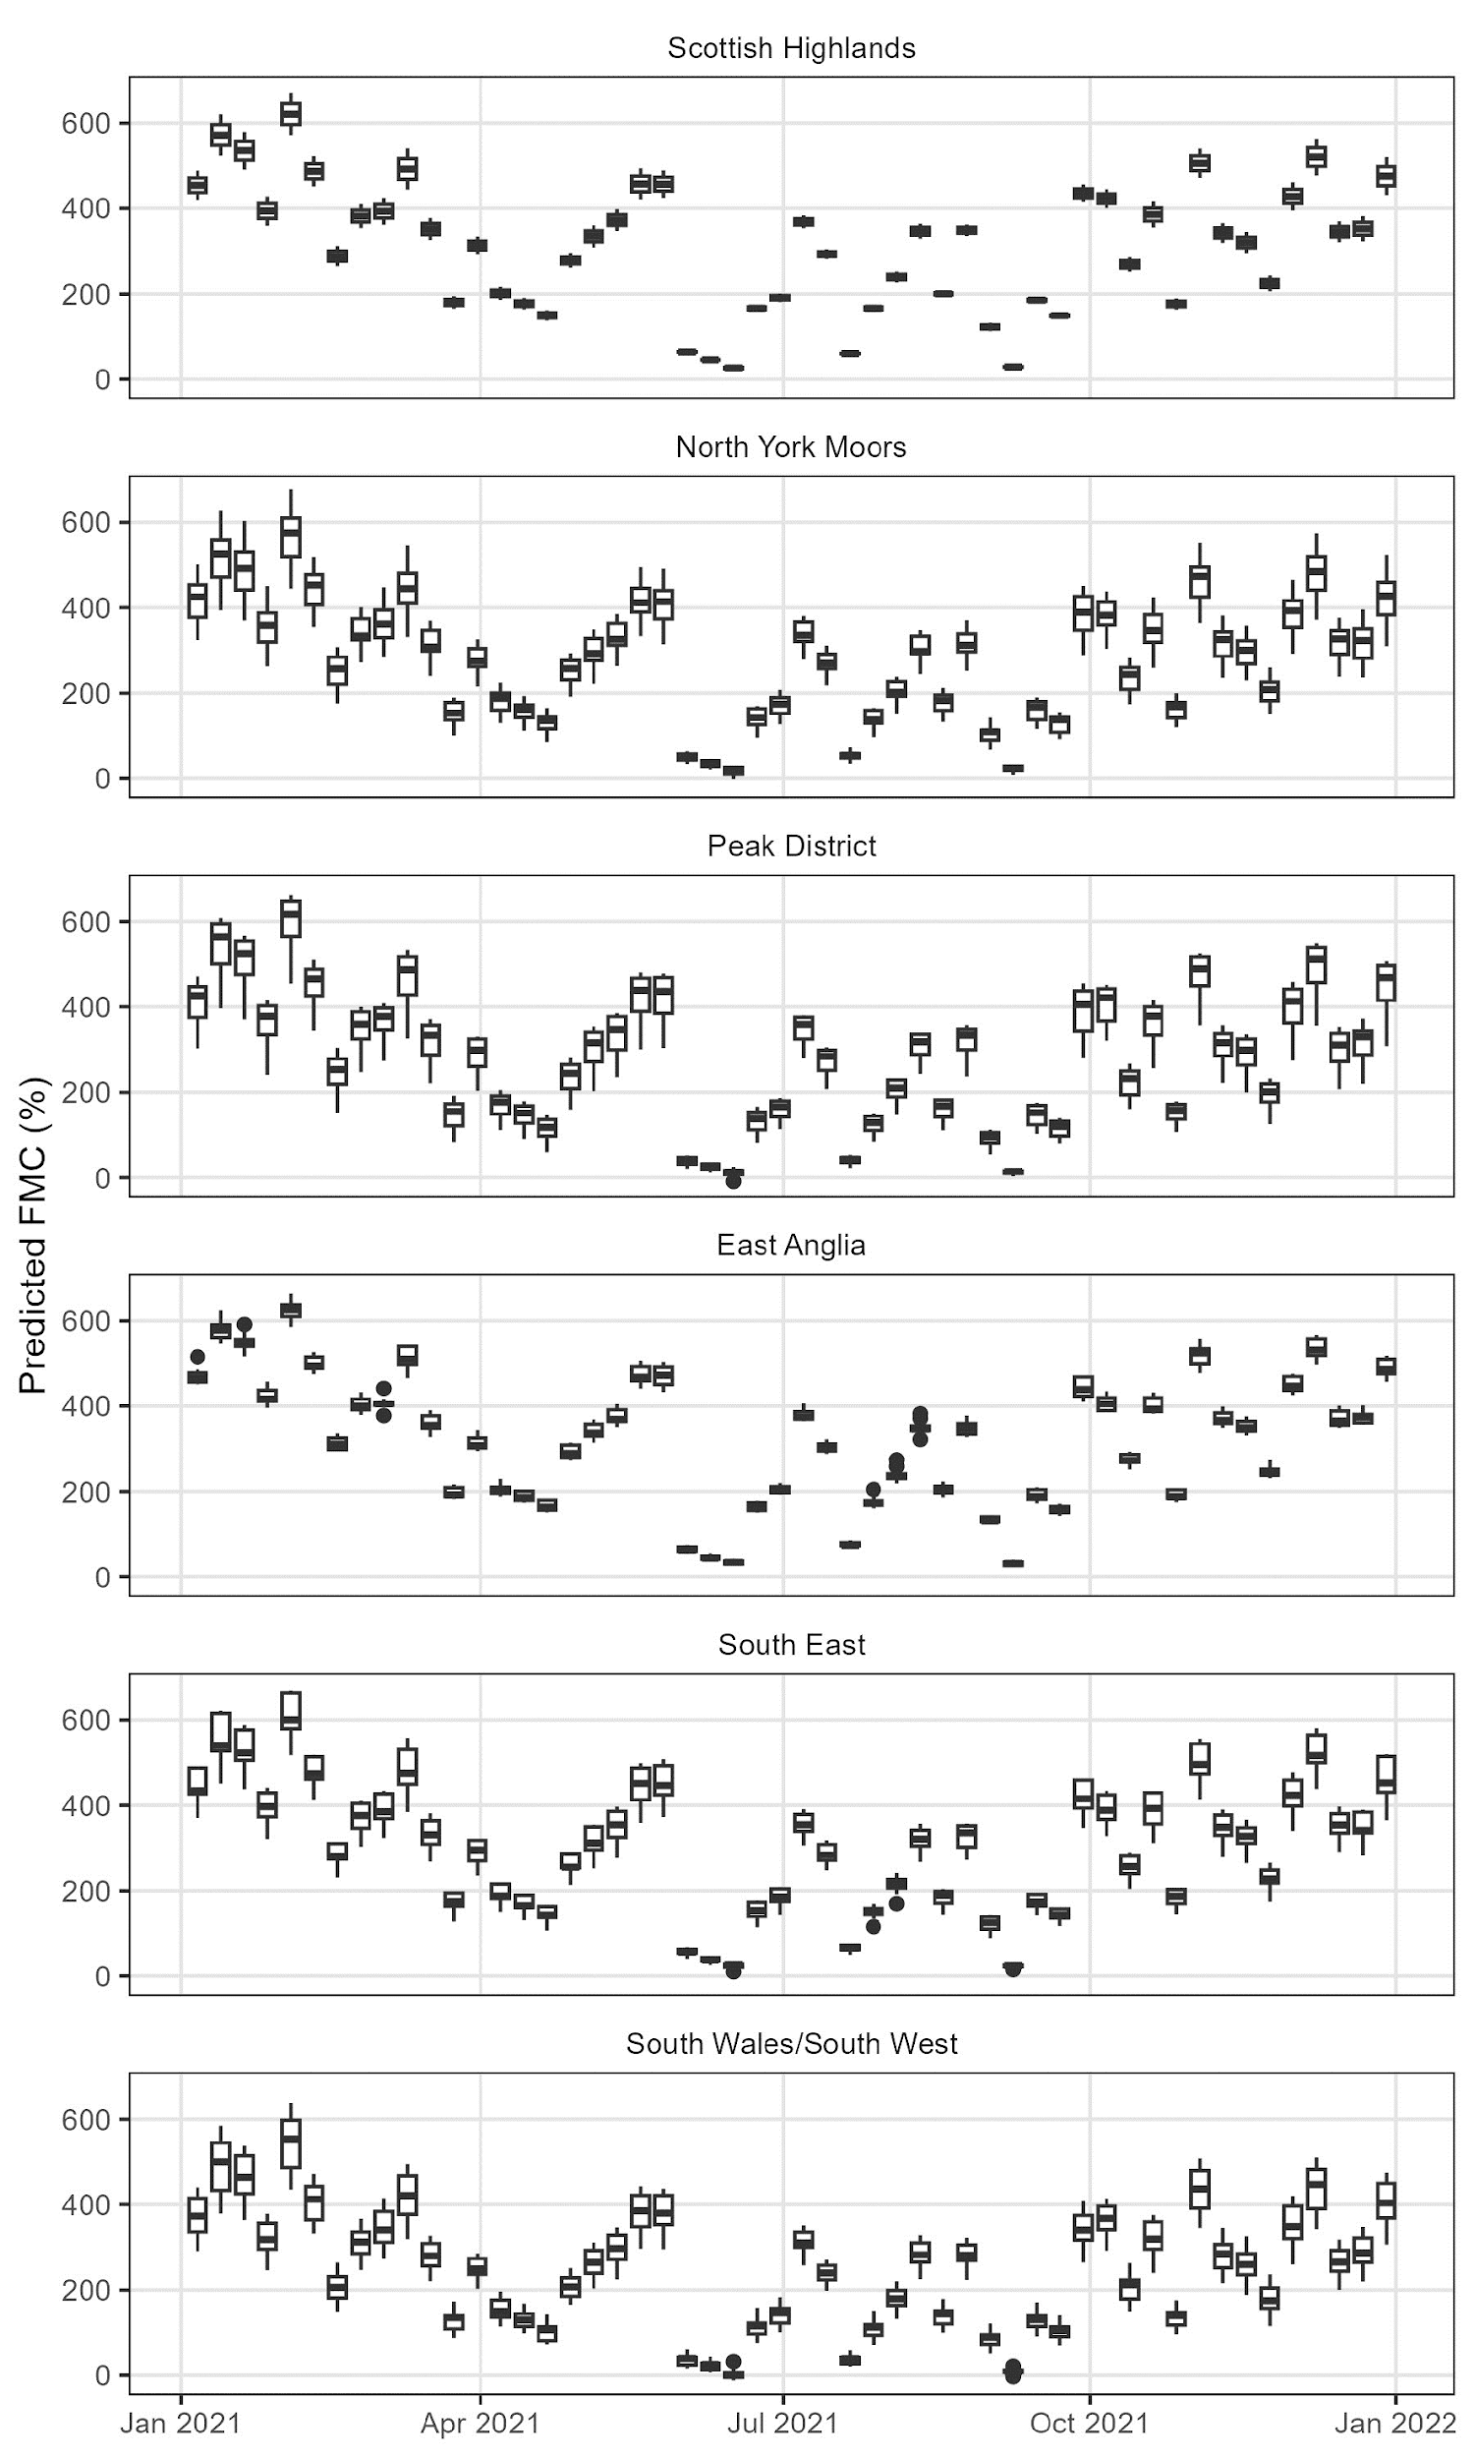
Twigs
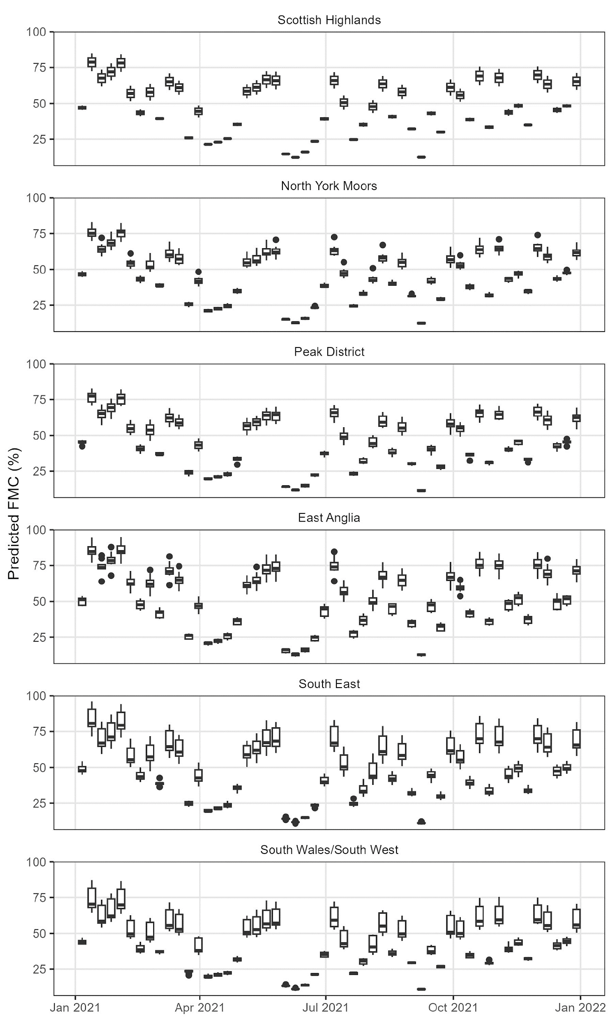
Figure S4: Predicted FMC for each week across sites within each region. Data was simulated by applying weather information from Marsden Moor to all sites. Time of day was set to 12 noon. NDVI was true to each sample site. Mean temperature of sample day was true to sample sites for live heather (canopy and stem and live gorse (canopy and stem) but for other fuels mean temperature was consistent across all sites.
References:
Farewell, T.S., Truckell, I.G., Keay, C.A. Hallett, S.H (2011) Use and applications of the Soilscapes datasets, Cranfield University
Hijmans, R.J., Phillips, S., Leathwick, J. and Elith, J. (2015) Dismo: Species Distribution Modeling. R Package Version 1.0-12. http://CRAN.R-project.org/package=dismo

