Supplementary Information

Advancements in Sustainable Conductors: Exploring the Potential of Polybutadiene-Based Urethane and Eutectic Gallium Indium Composites for Autonomous Self-Healing, Stretchable, and Deformation-Resistant Electrical Applications

Tran Duc Khanh,¹ Jinho Joo,^{1,2,*} Jong-Woong Kim^{1,3,4,*}
¹ Department of Smart Fab Technology, Sungkyunkwan University, 2066 Seobu-ro, Jangan-gu, Suwon 16419, Republic of Korea
² School of Advanced Materials Science & Engineering, Sungkyunkwan University, 2066 Seobu-ro, Jangan-gu, Suwon 16419, Republic of Korea
³ Department of Semiconductor Convergence Engineering, Sungkyunkwan University, 2066 Seobu-ro, Jangan-gu, Suwon 16419, Republic of Korea
⁴ School of Mechanical Engineering, Sungkyunkwan University, 2066 Seobu-ro, Jangan-gu, Suwon 16419, Republic of Korea
*Correspondence: Phone: +82 31 290 7441, E-mail: wyjd@skku.edu (J.-W. Kim)
*Correspondence: Phone: +82 31 290 7358, E-mail: jinho@skku.edu (J. Joo)

Characterization of materials and devices
The morphological characteristics of the samples were meticulously examined utilizing an optical microscope (OM; Model DM2700m, Leica Microsystems). Field emission scanning electron microscopy (FESEM; SEMIRON 5000, SERON TECHNOLOGIES INC., South Korea) was employed to scrutinize the surface morphology of the fabricated circuits. For quantitative assessment of the electrical properties, resistance and capacitance were accurately measured with an LCR meter (Model LCR 6100, GW Instek). X-ray diffraction (XRD) analyses to discern the chemical composition of both the pristine PBU and the composite were performed using an advanced XRD system (Model D8 ADVANCE, Bruker AXS GmbH). The hydrophilic nature of the composite surfaces was evaluated by measuring the water contact angle with a precision goniometer (Model Phoenix-10, Surface Electro Optics). The endurance of the composite under repetitive strain was rigorously tested using a custom-engineered stretching apparatus. Thermal response and distribution characteristics were scrutinized through the use of a digital multimeter (Model 34461A, Keysight Technologies) and an infrared (IR) camera (Model FLIR E8, Teledyne FLIR LLC). Atomic force microscopy (AFM) analyses to map the surface topology were conducted with an optical microscope equipped with a 10× objective lens, and surface data was diligently recorded with a system from Park Systems. For the electrical characterization and Joule heating studies, the samples were precisely cut into oblong shapes measuring 30 mm × 10 mm. In preparation for the wearable trials of the PBU-EGaIn composite as motion detectors, the specimens were trimmed to suitable dimensions and affixed to various body parts utilizing biocompatible double-sided adhesive tape. Copper wires were employed as conductive pathways to relay capacitance signals from the composite to the LCR meter for accurate measurement.

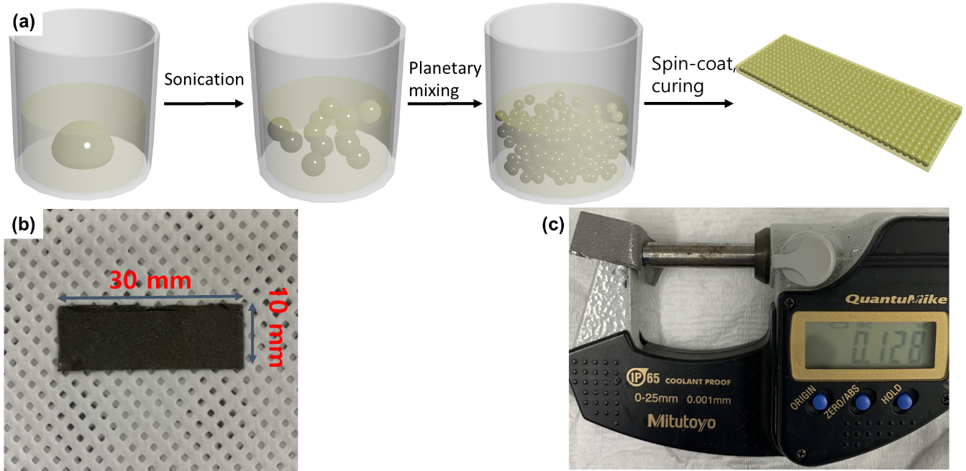
Figure S1. Detailed illustration of PBU-EGaIn composite synthesis: (a) A step-by-step schematic representation that outlines the sequential fabrication process of the PBU-EGaIn composite, highlighting critical stages from initial mixing to final setting; (b) Exact dimensional specifications of samples crafted for the purpose of cyclic strain testing, denoting uniform size and shape for experimental consistency; (c) A precise measurement of the composite’s thickness, post the curing phase, confirming a uniform cross-sectional measurement of 128 µm.

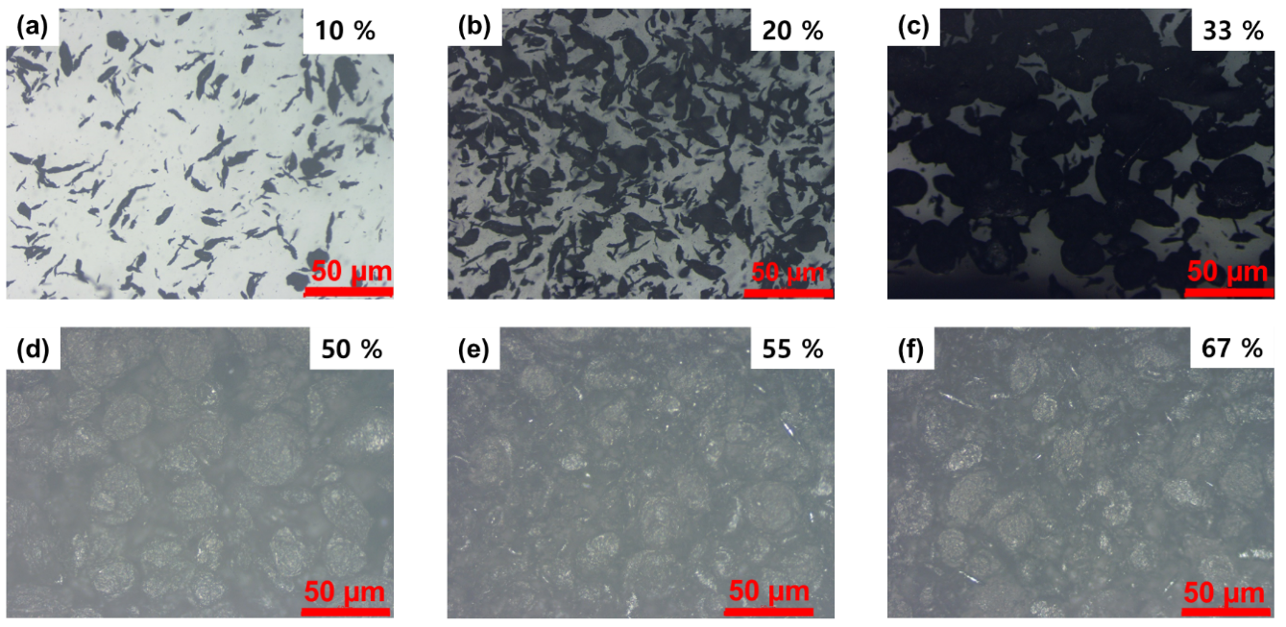
Figure S2. Variations in PBU-EGaIn composite visualized through optical imaging: Sequential images illustrating the PBU-EGaIn composite infused with varying percentages of EGaIn content, with all specimens subjected to a standardized mixing speed of 1000 rpm: (a) Composite with 10% EGaIn; (b) Composite with 20% EGaIn; (c) Composite with 33% EGaIn; (d) Composite with 50% EGaIn; (e) Composite with 55% EGaIn; (f) Composite with 67% EGaIn, each showcasing the morphological changes as the metal content increases.

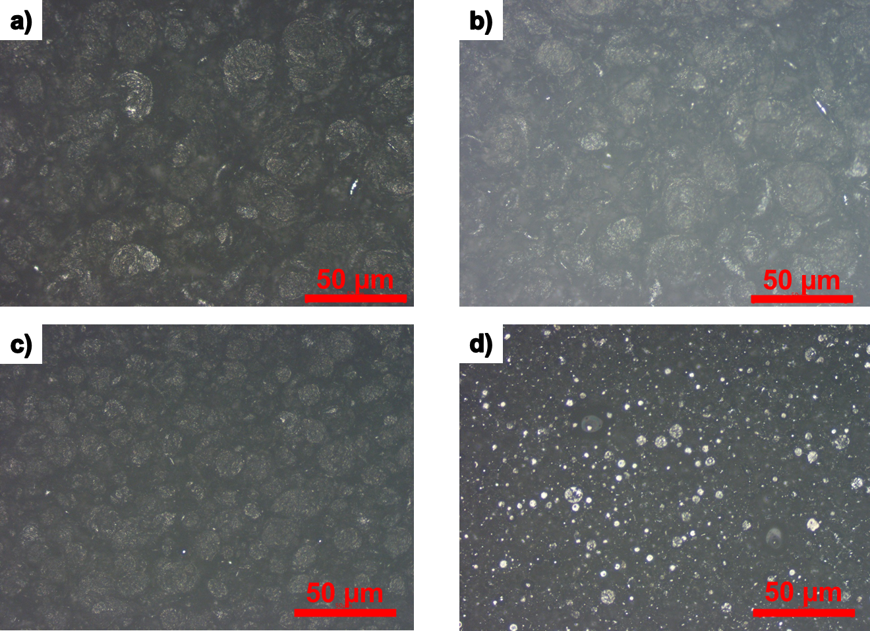
Figure S3. Microscale visualization of PBU-EGaIn composite mixtures: A set of OM images presenting the PBU-EGaIn composite at a fixed EGaIn weight percentage of 55%, subjected to different mixing speeds to illustrate the impact on the composite’s microstructure: (a) Mixed at 800 rpm; (b) Mixed at 1000 rpm; (c) Mixed at 1500 rpm; (d) Mixed at 2000 rpm, with a scale bar indicating 50 µm to facilitate comparison of the dispersion and homogeneity.

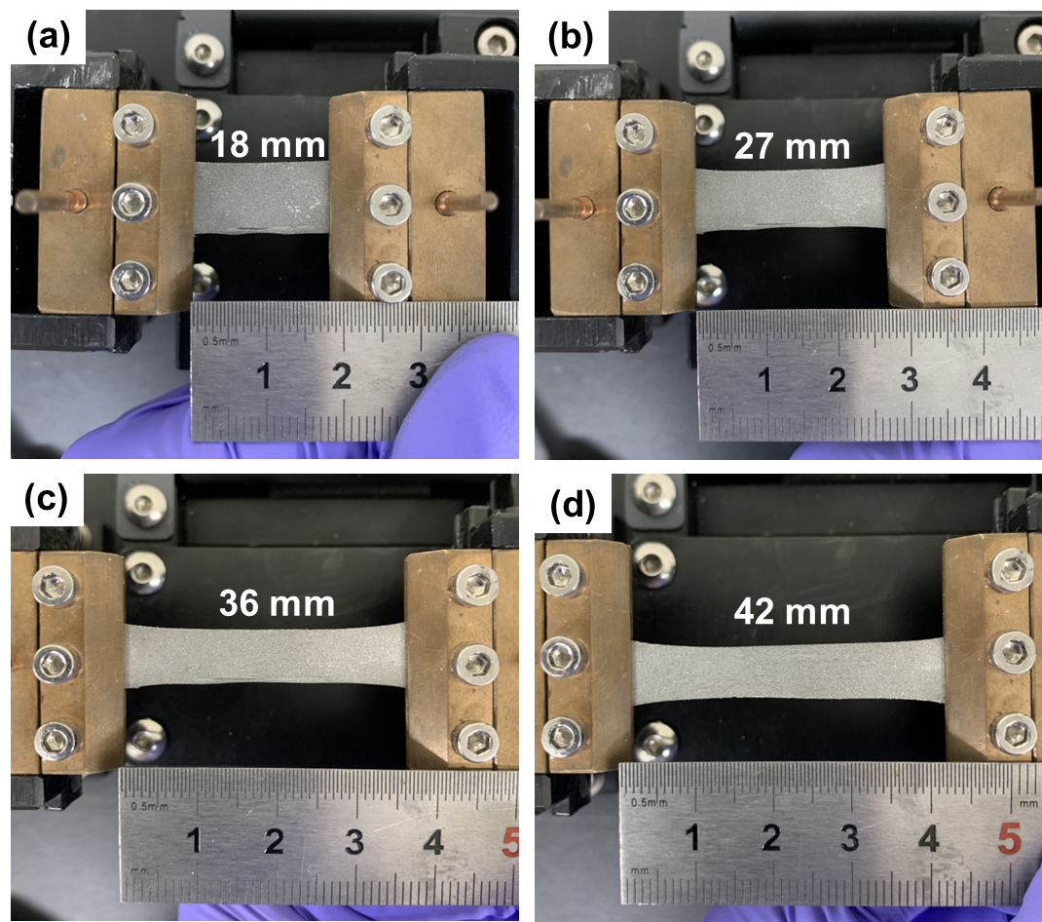
Figure S4. Quantitative digital assessment of PBU-EGaIn composite’s elasticity: Digital images capturing the PBU-EGaIn composite undergoing incremental stretching, demonstrating the material’s mechanical response and integrity at different levels of tensile strain: (a) Baseline state with no applied strain; (b) Moderate elongation at 50% strain; (c) Doubled extension at 100% strain; (d) Near-maximal stretch at 135% strain, highlighting the material’s adaptability.

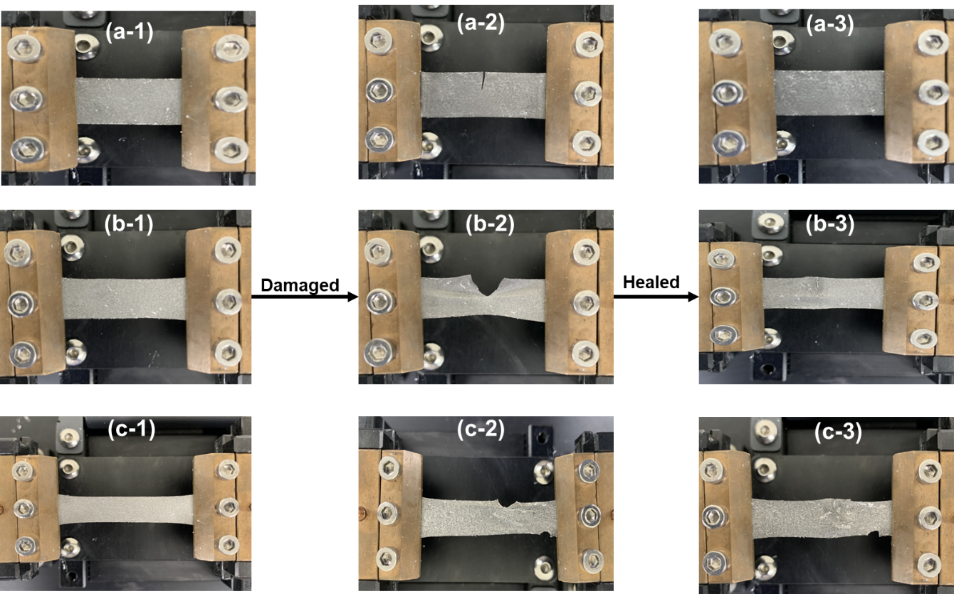
Figure S5. Comparative digital imaging of PBU-EGaIn composite’s deformation and subsequent recovery: Images that provide a comparative overview of the composite in various states of stress and recovery: (a) The undisturbed, pristine state prior to testing; (b) Composite extended to a 100% strain, illustrating its deformation; (c) Composite further deformed at 135% strain, visualizing the elasticity and limits of deformation prior to the initiation of the self-healing process.

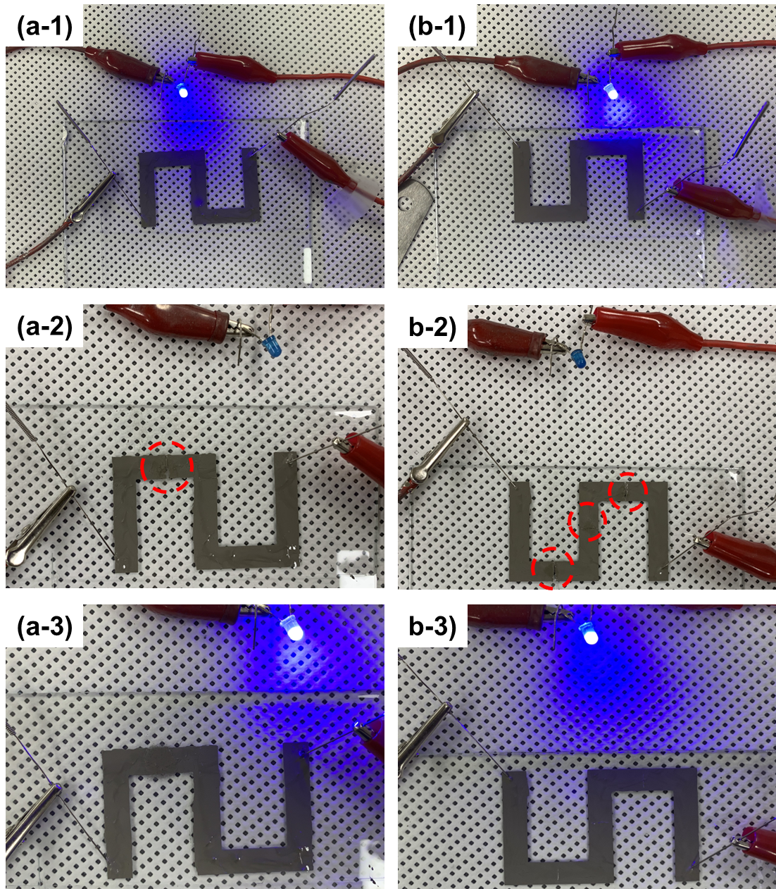
Figure S6. Sequential documentation of the self-healing phenomenon in patterned PBU-EGaIn composite: A series of digital images detailing the self-healing process in a patterned PBU-EGaIn composite, evidencing the autonomous repair mechanism: (a-1) The unblemished, initial state of the composite; (a-2) The induced damage marked by a single incision; (a-3) Post-healing state showing complete closure of the incision. (b-1) Pristine state for comparison; (b-2) The damaged state with three distinct cuts; (b-3) The healed state after self-repair, with the triad of cuts fully mended, demonstrating the composite's ability to restore electrical and structural continuity autonomously.
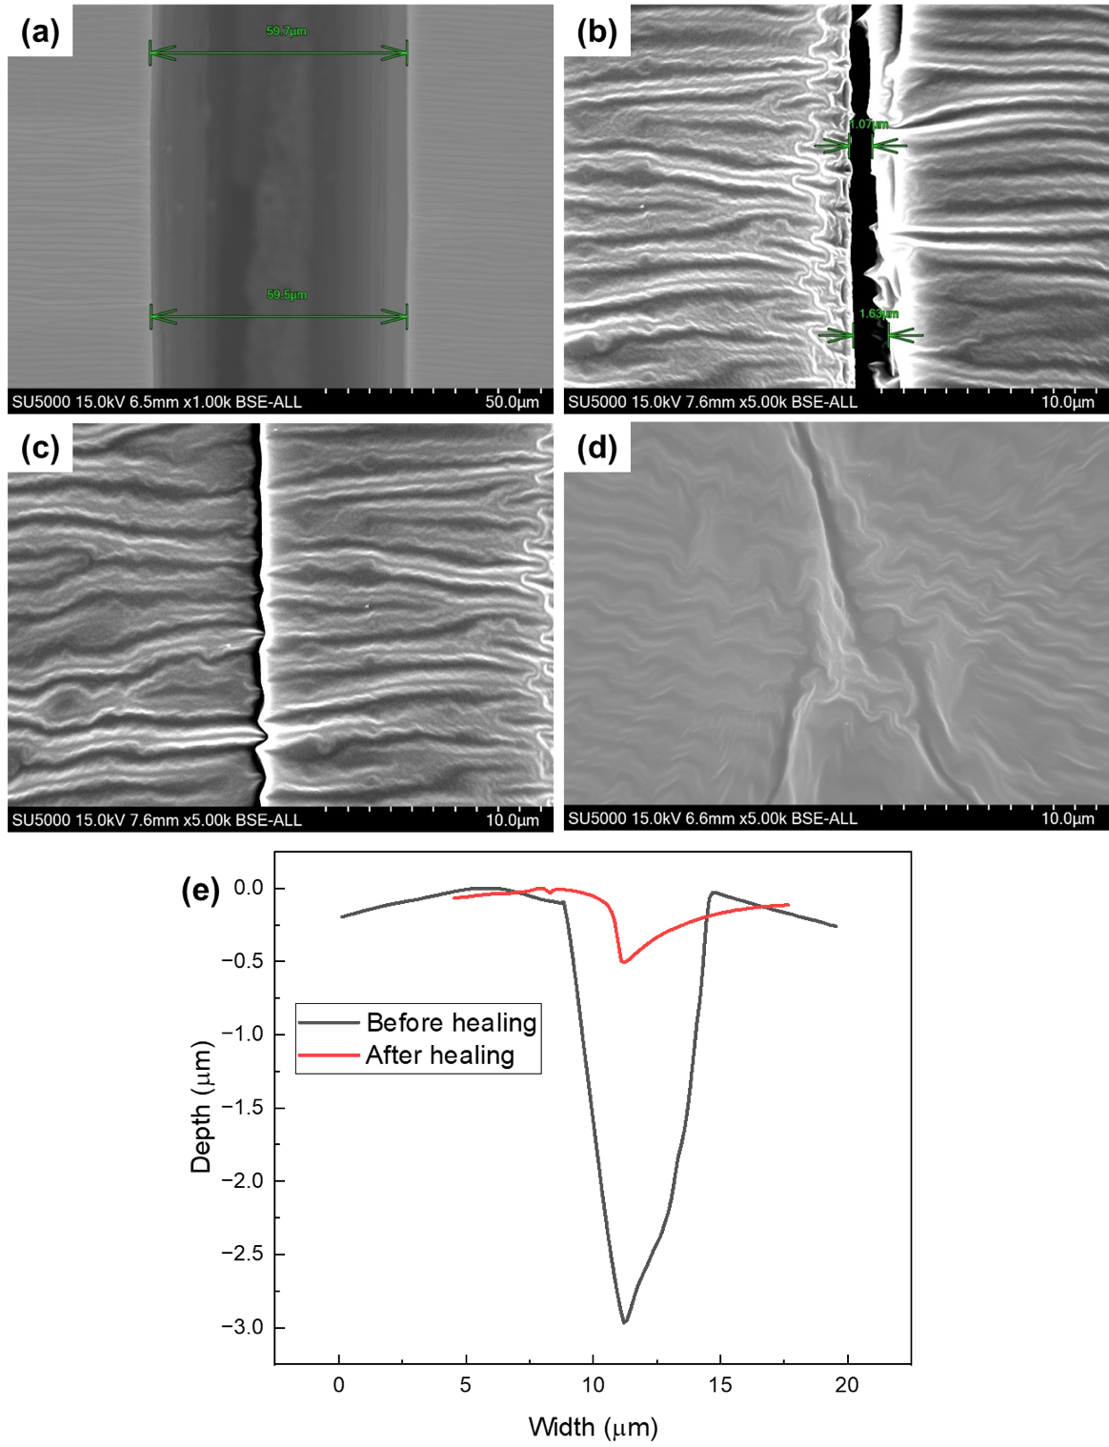

Figure S7. FESEM analysis of PBU/EGaIn composite surface morphologies: (a) Initial surface prior to the self-healing process, showcasing the topographical features and discrepancies; (b) Commencement of self-healing observed at the 5-minute mark, indicating the onset of surface modification; (c) Advanced healing stage with significant reduction in surface aberrations; (d) Completed healing process, with a surface that appears reconstituted, exhibiting minimal evidence of prior disruption; (e) AFM assessment delineating the depth and width measurements of the incision pre- and post-self-healing, providing quantitative validation of the self-reparation.

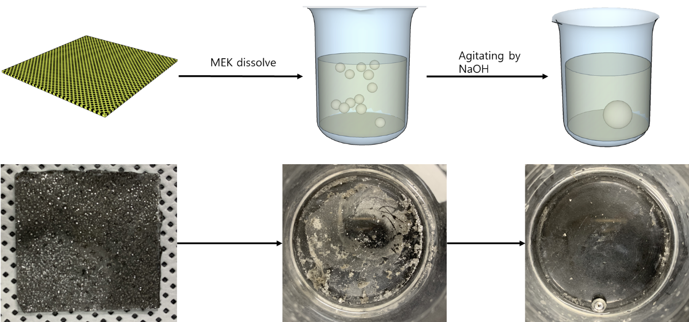
Figure S8. Recycling protocol for PBU-EGaIn composite: A systematic visual representation of the sequential steps involved in the recycling process, highlighting the material’s sustainable end-of-life treatment. This process showcases the composite's ability to be reclaimed and repurposed, reflecting its environmentally conscious design.

