S Table
Supplementary Table 1. Model comparison describing MPXV evolution. Marginal likelihood estimates of different models with (heterochronous) or without (isochronous) tip dates obtained using generalized stepping-stone sampling; 2lnBF values >10 indicate decisive support for model 1 vs models 2, 3 and 4.
Model | Marginal likelihood estimate | 2lnBF
1. Uncorrelated relaxed clock  Heterochronous | -247797.21 | -
2. Uncorrelated relaxed clock  Isochronous | -247804.31 | 14.2
3. Strict clock  Heterochronous | -247852.22 | 11
4. Strict clock  Isochronous | -247876.56 | 15.87

S figures
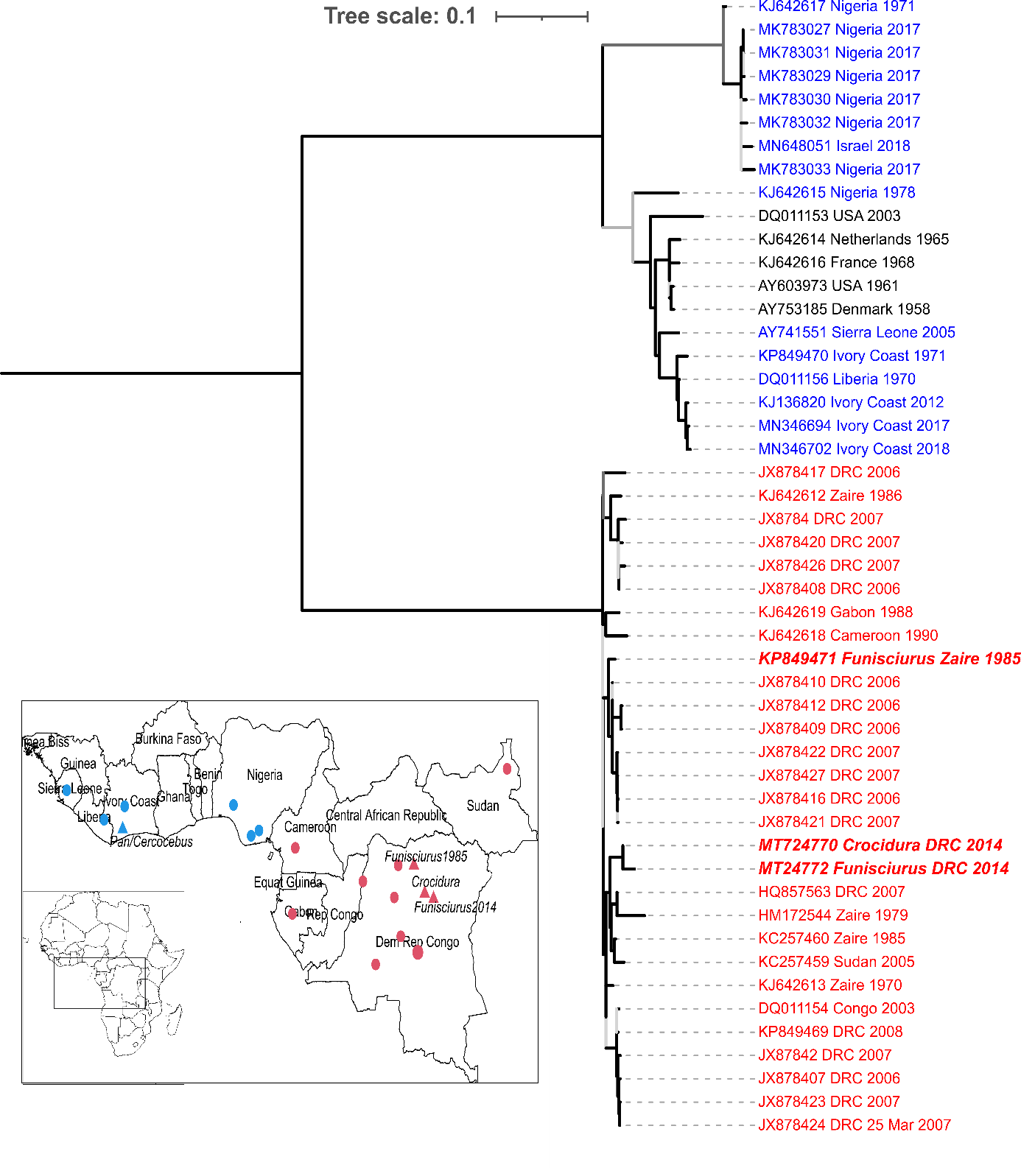
S. Fig 1: Phylogenetic tree from an alignment of monkeypox whole genome sequences and map of Africa to show sequence origin based on a maximum likelihood phylogenetic analysis. Sequences derived from specimens from the Congo Basin are in red, from West Africa in blue, the USA and Europe in black and wildlife derived sequences in bold italic. Human MPXV sequences are represented as dots on the map and animal sequences as triangles. The inner branch colours represent aLRT-branch support (grey is <0.95; black is ≥0.95).

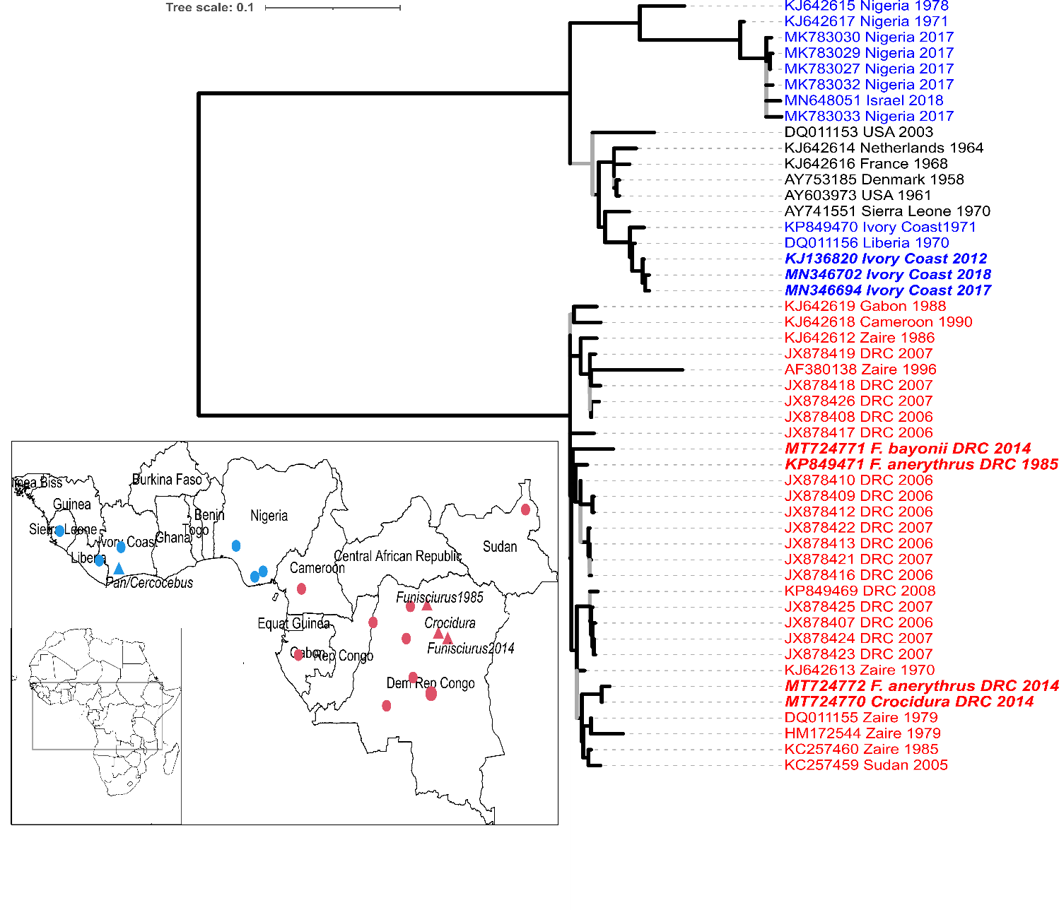
S. Fig 2: Phylogenetic tree from an alignment of monkeypox whole genome sequences and map of Africa to show sequence origin based on a maximum likelihood phylogenetic analysis. Sequences derived from specimens from the Congo Basin are in red (including the partially obtained sequence from F. bayonii), from West Africa in blue, the USA and Europe in black and wildlife derived sequences in bold italic. Human MPXV sequences are represented as dots on the map and animal sequences as triangles. The inner branch colours represent aLRT-branch support (grey is <0.95; black is ≥0.95).

