Support information for

Sustainable Biomass-based Filter for High-efficiency PM 0.3 Filtration
Qingxiang Wang ¹, Zhaoxuan Niu ¹, Wanli Cheng ¹, Ming Yang ², Jie Yan ¹, Jiqing Lu ¹, Haijiao Yu ¹, Yiying Yue ³, Yen Wei ⁴✉, Dong Wang ¹✉, Shichao Zhang ^{2,5}✉, Bin Ding ^{2,5}✉, Guangping Han ¹✉
¹ Key Laboratory of Bio-based Material Science and Technology (Ministry of Education), College of Material Science and Engineering, Northeast Forestry University, 150040 Harbin, China.
² State Key Laboratory for Modification of Chemical Fibers and Polymer Materials, College of Textiles, Donghua University, 201620 Shanghai, China.
³ College of Biology and the Environment, Nanjing Forestry University, 210037 Nanjing, China.
⁴ Key Laboratory of Bioorganic Phosphorus Chemistry & Chemical Biology (Ministry of Education), Department of Chemistry, Tsinghua University, 100084, Beijing, China.
⁵ Innovation Center for Textile Science and Technology, Donghua University, 200051 Shanghai, China.

Fig. S1. Composition of main amino acids in zein protein.

Fig. S2. Digital photos showing the zein protein solubility in ethanol solution with different concentration.

Fig. S3. Digital photo showing a strong protein film formed on the solution surface after evaporation in the atmosphere for ca. 2 hours.

Fig. S4. Theoretical ternary phase diagram for Zein/H₂O/ethanol

Fig. S5. Fiber diameter of (a) ribbon fiber, (b) rod fiber and (c) fiber with dual nets.

Fig. S6. TEM image of TEMPO-oxidized cellulose, (b) the size image of TEMPO-oxidized cellulose.

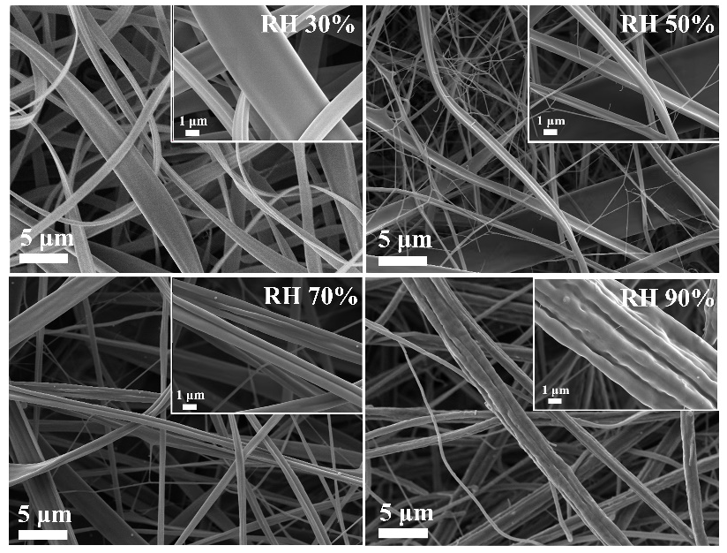
Fig. S7. SEM images of zein-based fibers under different relative humidity.

Supplementary Discussion
Supplementary discussion I
As illustrated in Fig. 1a and Fig. S1, the pristine zein protein with four levels of structures is bonded by strong interactions, such as hydrophobic interaction, disulfide and hydrogen bonding, and so forth. To destroy its three-dimensional entangled structure and expose plenty of functional groups, the zein was denatured in a mixture of ethanol and deionized water (weight ratio of 8:2). Through this denaturation process, the secondary, tertiary, and quaternary structures of zein molecules become unstable and unfolded, resulting in an extended and flexible conformation of the zein macromolecules. When zein was added to 80 wt% ethanol solution, the α-helix content of zein decreased significantly, and part of the helical structure changed into a more extended folding structure or a non-return curling structure, so that the spatial conformation of the protein tended to be stable. During the process of protein structure from agglomerate to stretch, zein exposed a large number of hydrophobic amino acids, which could not only improve the hydrophobic property of the membrane, but provide a site for electrostatic deposition of particles in the air and improve the filtration efficiency of the sample.
Supplementary discussion II
CNFs were prepared by adjusting the temperature, pH, TEMPO and the amount of sodium hypochlorite, and the carboxyl mass molar concentration of oxidized cellulose was measured by conductometric titration. The average diameter of cellulose after oxidation decreased slightly to about 7.5 nm. The strong intermolecular and intramolecular hydrogen bonds of cellulose were weakened due to the presence of charged groups. Moreover, after the treatment by ultrasonic, the hydrogen bonds of cellulose could be easily destroyed by high shear force, which was conducive to the defibrillation. XRD results showed that TEMPO oxidation had little effect on the crystallinity of cellulose. All of the samples in 14.8°, 16.7°, 22.6°, and 34.9° in cellulose and CNFs had obvious characteristic peak, and the diffraction intensity was higher after TEMPO oxidation, showing that CNFs had no substantial structural changes during the modification and both these two celluloses were in type I. Compared with the unmodified cellulose whose crystallinity index (CrI) was 68.9%, the CrI of the CNFs was 75.4%, calculated by the Segal method. The main cause was attributed to two aspects. First, TEMPO oxidation mainly occurred in the amorphous region of cellulose, where a large number of C6 hydroxyl groups were oxidized to carboxyl groups, resulted in dissolution of amorphous regions. Second, CNFs was treated by ultrasonic, which led to the destruction of the amorphous region of the cellulose during defibrillating.

Supplementary Method
Supplementary method I
Pretreatment of corn straw. Corn straw was used to fabricate the nanofibrils. Before use, the straw was cut into small sections, cleaned with distilled water, boiled it in boiling water for 1 h, and dried in an oven at 60 ℃. Then, the samples were smashed into the powder and passed through the 60-mesh screen. Sodium chlorite (NaClO₂, 80%), acetic acid and potassium hydroxide (KOH) were purchased from Aladdin Chemistry Co. Ltd. (Shanghai, China).
Preparation of CNFs. The cellulose was prepared by removing the lignin and hemicellulose from the corn straw powder selectively []. The straw powder was initially delignified with an aqueous solution of 1 wt. % NaClO₂ buffered with acetic acid for 5 h at 75 °C, and then further extracted by using a 5 wt. % KOH solution at 90 °C for 2 h to remove the hemicelluloses. The prepared cellulose was dispersed in 100 mL deionized water containing 0.016 g of TEMPO and 0.1 g NaBr. TEMPO oxidation was initiated by adding the desired amount of NaClO₂ solution (5 mmol/g of cellulose) and was continued at room temperature by stirring at 500 rpm. The pH of the system was maintained at 10 by adding 0.5 M NaOH and 0.5 M HCl. The reaction was quenched by adding 10 ml ethanol, and 0.5 M HCl was slowly dropped into the mixture to adjust the pH to 7. Finally, the resulting solution was filtered and freeze-dried to obtain the oxidized cellulose nanofibrils. For simplicity, we refer to this oxidized cellulose nanofibrils as CNFs. CNFs powder was dispersed in deionized water by ultrasonication at 300 W for 15 min in an ice-water bath. For further use, the resulting concentration of the CNFs suspension was 1 wt. %, the average diameter was about 7.7 nm, the crystallinity was 75.4% and the surface charge density was 1.4 mmol/g.
Supplementary method II
Fabrication of corn-based D-nets fabrics. The precursor solutions were prepared by dissolving zein (Macklin Biochemical Co. Ltd., Shanghai, China) and 0 or 1 wt.% CNFs in 80% ethanol solution in the ice-water bath. The zein concentrations in pure zein solutions were 25 wt. %, while CNFs concentrations in zein/CNFs solutions (25 wt. % zein) were 0, 1 wt. %, respectively. All fabrics were fabricated using a conventional ET-2535X spinning machine (Yong Kang Le Ye Co., Beijing, China). The solutions were extruded out from one 10-ml syringe at feed rate of 0.1 ml h ⁻¹, and the DC voltage of 15 kV with distance of 20 cm was supplied to the 20-G metal needle to form jets to assemble fibers. The aluminum foil wrapped on the grounded metal roller (80 rpm rotating speed) were utilized to collect the membranes. To control the uniformity of membranes, the syringes were uniformly placed on the injection pump which horizontally moved backwards and forwards (speed of 40 cm min⁻¹) within a fixed distance by using a mechanical slide unit. During electrospinning, the temperature of the device was fixed to 22 ℃, and relative humidity (RH) were adjusted to 30%, 50%, 70% and 90%, respectively.
Supplementary method III
Process of HCHO adsorption. Formaldehyde (HCHO, 37%) was purchased from Aladdin Chemistry Co. Ltd. (Shanghai, China). The dynamic HCHO adsorption experiment was carried out in a self-made fixed column reactor. The room temperature was maintained at 25±0.5 ℃. Gaseous HCHO was generated by bubbling, in which high purity nitrogen was used (0.2 L min⁻¹) through a HCHO solution (37%). The gas then flowed through CaCl₂ for drying. The sample weight was 0.06 g and the effective filtration area was a circle with a radius of 2 cm. The inlet concentration was set to 2.3 mg/L. The HCHO concentration in the sampling bottle was measured by a particle counter (PPM-400 ST) with chemical sensors for HCHO. The collection time was 240 min totally and the sampling interval was 40 min. The adsorption capacity for HCHO was evaluated by Eq. (1).
$$Q_{t}=\frac{Q_{f}C_{in}}{m}\int_{0}^{t}{(1-\frac{C_{out}}{C_{in}}})dt$$
where Q_{f} is the inlet feed flow rate, L min⁻¹; C_{in} is the HCHO inlet concentration, mg L⁻¹; m is the weight of the absorbent, g; and C_{out} is the HCHO concentration at the outlet, mg L⁻¹.

