Fig.S1. Histogram of frequency distribution of root-related traits in BLUP environment
Table S1. Analysis of traits at seedling stage about different cultivars under NCE and SCE
Type | Traits |  | Irrigated Cultivars |  |  | Dryland Cultivars |  |  | Landraces
Type |  |  | Range | Mean | CV % | Range | Mean | CV % | Range | Mean | CV %
NCE | SDW | mg | 13.41–15.98 | 14.36±0.42 | 2.91 | 13.60–15.64 | 14.31±0.39 | 2.74 | 13.74–14.82 | 14.13±0.24 | 1.73
 | RDW | mg | 2.50–9.10 | 4.80±0.93 | 19.45 | 3.00–7.10 | 4.53±0.80 | 17.54 | 2.43–6.16 | 3.55±0.66 | 18.48
 | DW | mg | 16.22–23.34 | 19.17±1.23 | 6.44 | 16.72–22.74 | 18.75±1.10 | 5.89 | 16.41–19.17 | 17.61±0.71 | 4.01
 | SFW | mg | 144.56–172.78 | 154.76±4.77 | 3.08 | 142.88–169.37 | 153.82±4.62 | 3.00 | 146.82–160.35 | 151.89±2.91 | 1.91
 | RFW | mg | 50.68–71.38 | 60.11±3.89 | 6.48 | 51.38–71.11 | 59.22±3.89 | 6.58 | 50.95–61.69 | 54.76±2.58 | 4.70
 | FW | mg | 196.64–244.77 | 214.59±8.20 | 3.82 | 196.49–239.68 | 212.83±7.89 | 3.70 | 199.35–222.19 | 207.84±5.13 | 2.47
 | MRL | cm | 14.27–19.59 | 16.56±1.03 | 6.20 | 13.92–19.37 | 16.31±1.02 | 6.23 | 13.65–17.95 | 15.42±0.89 | 5.76
 | TRL | cm | 36.59–58.78 | 44.71±4.24 | 9.48 | 35.61–56.64 | 44.47±3.94 | 8.86 | 33.43–46.01 | 38.82±2.82 | 7.26
 | RS | cm² | 7.27–10.07 | 8.40±0.50 | 6.01 | 7.48–9.89 | 8.35±0.49 | 5.90 | 6.90–8.49 | 7.72±0.33 | 4.32
 | RV | cm³ | 0.10–0.12 | 0.11±0.00 | 4.54 | 0.10–0.13 | 0.11±0.01 | 4.72 | 0.09–0.11 | 0.10±0.00 | 3.99
 | RD | cm | 0.44–0.49 | 0.46±0.01 | 2.29 | 0.44–0.49 | 0.46±0.01 | 2.07 | 0.44–0.50 | 0.47±0.01 | 2.25
 | RN |  | 2.79–4.67 | 3.91±0.31 | 7.84 | 2.73–4.67 | 3.95±0.33 | 8.36 | 3.01–4.17 | 3.65±0.23 | 6.18
SCE | SDW | mg | 11.19–22.57 | 16.13±1.75 | 10.84 | 10.67–20.44 | 16.12±1.89 | 11.74 | 9.33–15.28 | 12.02±1.67 | 13.86
 | RDW | mg | 10.30–16.83 | 11.09±0.80 | 7.18 | 9.96–11.93 | 10.96±0.33 | 3.04 | 9.85–11.00 | 10.41±0.27 | 2.58
 | DW | mg | 21.80–45.68 | 27.37±2.93 | 10.70 | 19.91–32.22 | 26.98±2.22 | 8.24 | 18.59–26.23 | 22.29±1.94 | 8.70
 | SFW | mg | 71.20–170.10 | 113.40±14.16 | 12.49 | 75.35–151.61 | 113.27±13.96 | 12.33 | 76.50–113.20 | 93.60±10.4 | 11.11
 | RFW | mg | 92.50–144.97 | 117.06±10.72 | 9.16 | 76.50–152.89 | 115.89±13.44 | 11.60 | 80.80–117.53 | 100.03±9.84 | 9.84
 | FW | mg | 163.20–313.17 | 230.72±22.99 | 9.96 | 148.71–294.58 | 229.31±25.43 | 11.09 | 155.70–229.82 | 192.51±19.75 | 10.26
 | MRL | cm | 14.00–18.30 | 16.16±0.96 | 5.94 | 13.72–18.12 | 16.23±0.92 | 5.66 | 13.94–18.36 | 16.20±0.95 | 5.85
 | TRL | cm | 69.97–156.81 | 106.35±15.52 | 14.60 | 58.19–135.12 | 104.71±13.86 | 13.23 | 72.38–125.98 | 96.23±13.67 | 14.21
 | RS | cm² | 8.77–15.52 | 12.51±1.34 | 10.72 | 7.53–16.46 | 12.40±1.57 | 12.65 | 8.61–13.36 | 10.83±1.27 | 11.73
 | RV | cm³ | 0.12–0.19 | 0.16±0.02 | 10.92 | 0.11–0.22 | 0.16±0.02 | 14.73 | 0.10–0.16 | 0.13±0.02 | 12.18
 | RD | cm | 0.37–0.53 | 0.43±0.03 | 7.18 | 0.38–0.50 | 0.43±0.02 | 5.69 | 0.38–0.49 | 0.42±0.03 | 7.37
 | RN |  | 3.55–6.34 | 5.21±0.42 | 8.13 | 3.37–6.26 | 5.21±0.45 | 8.70 | 3.90–5.60 | 4.85±0.34 | 7.09

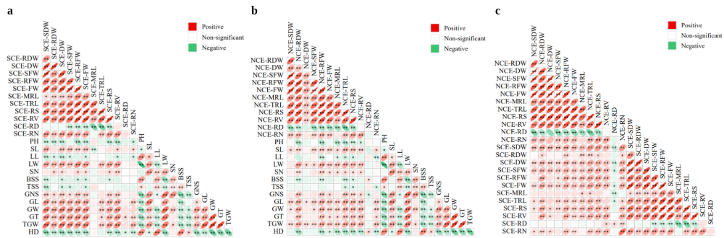
Fig.S2. Plot of correlation analysis. a:correlation analysis between seedling traits under SCE and adult agronomic traits. b:correlation analysis between seedling traits under NCE and adult agronomic traits. c:correlation analysis between SCE and NCE. ∗ and ∗∗ represent significance level of P < 0.05 and P < 0.01, respectively.

Table S2. Correlation analysis of root traits with agronomic traits in dryland cultivars and irrigated cultivars
Type | Trait | PH | SL | TGW | HD | GL | GW | GT | LL | LW | SN | BSS | TSS | GNS
Dryland | SDW | 0.406** | 0.054 | 0.303** | -0.041 | 0.105 | 0.13 | 0.174 | 0.088 | -0.212* | -0.187 | 0.013 | -0.07 | -0.230*
cultivars | RDW | 0.19 | 0.074 | 0.459** | 0.011 | 0.306** | 0.274** | 0.325** | 0.142 | 0.037 | -0.026 | 0.037 | 0.001 | -0.067
 | DW | 0.342** | 0.068 | 0.401** | -0.021 | 0.207* | 0.207* | 0.257* | 0.12 | -0.116 | -0.129 | 0.025 | -0.041 | -0.175
 | SFW | 0.387** | 0.078 | 0.365** | 0.046 | 0.179 | 0.206* | 0.261** | 0.128 | -0.116 | -0.075 | 0.056 | -0.105 | -0.167
 | RFW | 0.035 | 0.084 | 0.390** | 0.139 | 0.313** | 0.302** | 0.356** | 0.183 | 0.263** | 0.046 | -0.004 | -0.03 | 0.085
 | FW | 0.230* | 0.091 | .424** | 0.106 | .278** | .287** | .348** | 0.176 | 0.089 | -0.014 | 0.028 | -0.074 | -0.041
 | MRL | 0.218* | -0.156 | 0.151 | .281** | 0.155 | 0.184 | 0.157 | 0.103 | 0.104 | -0.037 | 0.023 | -0.041 | -0.084
 | TRL | 0.166 | 0.01 | .240* | 0.17 | 0.175 | 0.175 | 0.175 | 0.149 | 0.094 | -0.019 | -0.037 | -0.08 | -0.039
 | RS | 0.092 | 0.029 | .313** | 0.097 | .280** | .222* | .237* | 0.142 | 0.13 | 0.019 | -0.018 | 0.002 | 0.001
 | RV | 0.018 | 0.05 | .330** | 0.016 | .356** | .237* | .257* | 0.144 | 0.145 | 0.062 | -0.008 | 0.086 | 0.039
 | RD | -0.077 | -0.039 | -0.11 | -0.195 | 0.06 | -0.041 | -0.073 | -0.012 | -0.136 | -0.021 | -0.003 | 0.153 | -0.042
 | RN | 0.039 | -0.04 | .205* | -.236* | 0.106 | 0.028 | 0.038 | -0.132 | -.256* | -0.18 | -0.04 | 0.077 | -0.108
Irrigated | SDW | .315** | 0.041 | .239* | -0.197 | 0.08 | 0.142 | 0.141 | -0.021 | -0.175 | 0.043 | 0.126 | -0.081 | -0.051
cultivars | RDW | -0.008 | -0.075 | 0.02 | -0.008 | -0.102 | 0.124 | -0.081 | -0.028 | 0.03 | 0.158 | 0.069 | 0.165 | 0.028
 | DW | 0.131 | -0.044 | 0.122 | -0.092 | -0.05 | 0.166 | -0.006 | -0.032 | -0.052 | 0.15 | 0.113 | 0.103 | 0.001
 | SFW | .228* | 0.017 | 0.115 | -.251* | -0.015 | 0.118 | 0.067 | -0.044 | -0.099 | 0.012 | 0.094 | 0.07 | -0.025
 | RFW | -0.176 | -0.047 | 0.047 | -0.142 | 0.027 | 0.156 | 0.138 | -0.024 | .288** | 0.109 | 0.04 | 0.158 | -0.029
 | FW | 0.049 | -0.013 | 0.094 | -.225* | 0.004 | 0.151 | 0.112 | -0.04 | 0.087 | 0.063 | 0.077 | 0.123 | -0.03
 | MRL | -0.046 | -0.071 | -0.019 | -0.12 | .229* | -0.014 | -0.111 | -0.034 | 0.089 | -0.152 | -0.162 | .258* | -0.102
 | TRL | -0.052 | 0.038 | -0.045 | -0.127 | 0.151 | 0.038 | -0.102 | 0.072 | .206* | 0.074 | -0.076 | .219* | 0.102
 | RS | -0.089 | 0.016 | 0.078 | -0.134 | 0.15 | 0.126 | 0.026 | 0.041 | .215* | 0.145 | 0.041 | .233* | 0.041
 | RV | -0.07 | -0.002 | 0.172 | -0.07 | 0.049 | .214* | 0.157 | -0.024 | 0.157 | 0.2 | 0.194 | .223* | -0.084
 | RD | 0.008 | 0.018 | 0.061 | 0.104 | -0.132 | 0.023 | 0.134 | -0.028 | -0.111 | 0.068 | 0.193 | -0.118 | -0.072
 | RN | 0.056 | 0.058 | 0.015 | 0.071 | -0.02 | -0.119 | -0.072 | 0.01 | -.209* | 0.098 | .272** | -0.064 | 0.037

Fig.S3. Manhattan plot of root trait association analysis
Table S3. List of stable loci identified by SCVs association analysis in the association panel
SCV | Traits | Culture system | Chr | Pos | -log10(P) | R² (%)
Mg1B-1 | TRL | NCE | 1B | 21.41 | 1.6-1.79 | 6.44-6.84
 | RS | NCE | 1B | 21.41 | 1.38-2.01 | 6.35-7.27
 | RFW | NCE | 1B | 21.41 | 1.39-2.46 | 6.33-8.13
 | FW | NCE | 1B | 21.41 | 1.41-1.84 | 5.74-6.91
 | RN | SCE | 1B | 21.41 | 1.46-1.72 | 6.58-7.01
Mg1B-4 | TRL | NCE | 1B | 209.00 | 1.66-1.95 | 5.76-6.3
 | RS | NCE | 1B | 209.00 | 1.75-1.98 | 5.91-6.16
 | RFW | NCE | 1B | 209.00 | 1.97-2.11 | 6.07-6.47
 | FW | SCE | 1B | 209.00 | 1.41-1.7 | 5.91-6.49
 | RDW | SCE | 1B | 209.00 | 1.42-1.55 | 5.9-6.2
 | RN | SCE | 1B | 209.00 | 1.62-1.87 | 6.35-6.77
Mg1D-2 | DW | SCE | 1D | 68.90 | 1.39-1.68 | 5.87-6.39
 | FW | SCE | 1D | 68.90 | 1.39-1.45 | 5.84-5.98
 | SDW | SCE | 1D | 68.90 | 1.38-1.98 | 5.8-6.99
 | SFW | SCE | 1D | 68.90 | 1.4-1.59 | 5.85-6.26
Mg2B-12 | RFW | SCE | 2B | 695.59 | 1.33-1.94 | 4.77-5.89
 | DW | SCE | 2B | 695.59 | 1.45-1.98 | 4.95-5.96
 | RDW | SCE | 2B | 695.59 | 1.38-1.87 | 4.75-5.76
 | TRL | SCE | 2B | 695.59 | 1.32-1.67 | 4.79-5.35
Mg2B-6 | SDW | SCE | 2B | 531.89 | 1.33-1.57 | 5.68-6.17
 | DW | SCE | 2B | 531.89 | 1.59-1.61 | 6.16-6.25
 | FW | SCE | 2B | 531.89 | 1.32-1.7 | 5.69-6.48
Mg2B-9 | DW | NCE | 2B | 593.85 | 1.4-2.38 | 4.55-5.99
Mg3B-6 | RDW | NCE | 3B | 541.81 | 1.36-1.43 | 4.48-4.6
Mg4A-6 | MRL | SCE | 4A | 701.27 | 1.32-1.42 | 5.75-5.92
Mg4B-3 | RN | SCE | 4B | 32.99 | 1.48-1.65 | 5.04-5.35
Mg5B-9 | DW | SCE | 5B | 586.92 | 2.56-3.2 | 6.88-8.04
 | RDW | SCE | 5B | 586.92 | 2.89-2.92 | 7.37-7.59
Mg6A-10 | SDW | SCE | 6A | 602.06 | 1.46-1.76 | 5.94-6.59
Mg6A-8 | MRL | SCE | 6A | 544.96 | 1.46-2.33 | 6.05-7.9
Mg6A-9 | SDW | SCE | 6A | 584.29 | 1.51-1.66 | 6.16-6.24
 | DW | SCE | 6A | 584.29 | 1.56-1.6 | 6.03-6.35
Mr1A-1 | MRL | SCE | 1A | 60.34 | 1.44-2.04 | 4.97-6.11
 | MRL | SCE | 1A | 60.34 | 1.44-2.04 | 4.97-6.11
 | RD | SCE | 1A | 60.34 | 1.46-1.85 | 4.96-5.6
 | RFW | SCE | 1A | 60.34 | 1.48-2.24 | 5.01-6.37
 | RS | SCE | 1A | 60.34 | 1.48-1.66 | 5.03-5.32
 | TRL | SCE | 1A | 60.34 | 1.65-2.02 | 5.34-6.02
Mr1A-4 | FW | SCE | 1A | 153.59 | 1.42-1.76 | 4.91-5.51
 | RFW | SCE | 1A | 153.59 | 1.48-1.61 | 5.02-5.21
Mr1A-6 | FW | SCE | 1A | 394.95 | 1.42-1.76 | 4.91-5.51
 | RFW | SCE | 1A | 394.95 | 1.48-1.61 | 5.02-5.21
Mr1B-2 | SDW | SCE | 1B | 26.76 | 1.43-1.53 | 5.91-6.08
 | SFW | SCE | 1B | 26.76 | 1.66-1.69 | 6.44-6.47
Mr1B-3 | TRL | NCE/SCE | 1B | 69.79 | 1.39-2.59 | 5.86-8.75
 | RV | NCE/SCE | 1B | 69.79 | 1.37-2.43 | 5.98-7.19
 | RS | NCE/SCE | 1B | 69.79 | 1.75-2.76 | 6.1-9.07
 | RFW | NCE/SCE | 1B | 69.79 | 1.36-2.47 | 5.93-7.39
 | FW | NCE/SCE | 1B | 69.79 | 1.61-2.06 | 5.77-7.61
 | SFW | SCE | 1B | 69.79 | 1.58-2.16 | 6.41-7.77
 | RDW | SCE | 1B | 69.79 | 1.82-1.94 | 7.19-7.24
 | DW | SCE | 1B | 69.79 | 1.96-2.88 | 7.35-9.31
 | SDW | SCE | 1B | 69.79 | 1.5-3.14 | 6.24-9.86
 | RN | SCE | 1B | 69.79 | 1.71-2.55 | 6.8-8.89
Mr1D-5 | RV | SCE | 1D | 438.63 | 2.1-3.52 | 6.12-8.86
 | DW | SCE | 1D | 438.63 | 1.33-1.41 | 4.73-4.87
 | FW | SCE | 1D | 438.63 | 1.61-1.85 | 5.24-5.7
 | RD | SCE | 1D | 438.63 | 1.63-2.44 | 5.26-6.67
 | RDW | SCE | 1D | 438.63 | 1.32-2 | 4.74-5.94
 | RFW | SCE | 1D | 438.63 | 1.49-1.8 | 5.03-5.62
 | RN | SCE | 1D | 438.63 | 1.41-1.54 | 4.9-5.13
 | RS | SCE | 1D | 438.63 | 1.73-2.07 | 5.47-6.06
 | SFW | SCE | 1D | 438.63 | 1.37-1.51 | 4.83-5.06
Mr2B-11 | RN | SCE | 2B | 664.92 | 1.32-1.38 | 4.75-4.86
Mr2B-2 | SDW | SCE | 2B | 47.14 | 1.56-1.59 | 6.18-6.21
Mr2D-7 | SFW | SCE | 2D | 617.88 | 1.48-1.81 | 5.02-5.6
Mr3A-3 | SFW | SCE | 3A | 566.23 | 1.35-1.49 | 4.77-5.06
 | TRL | NCE/SCE | 3A | 566.23 | 1.33-1.68 | 4.74-5.38
 | RFW | NCE | 3A | 566.23 | 1.64-2.07 | 4.84-5.33
 | FW | NCE | 3A | 566.23 | 1.43-2.05 | 4.59-5.48
Mr3A-4 | SFW | SCE | 3A | 685.43 | 1.35-1.49 | 4.77-5.06
 | TRL | NCE/SCE | 3A | 685.43 | 1.33-1.68 | 4.75-5.38
 | RFW | NCE | 3A | 685.43 | 1.64-2.07 | 4.84-5.33
 | FW | NCE | 3A | 685.43 | 1.43-2.05 | 4.59-5.48
Mr4A-7 | MRL | NCE | 4A | 701.27 | 1.87-1.97 | 5.35-5.42
Mr4B-9 | RV | SCE | 4B | 587.36 | 1.32-2.21 | 5.68-7.57
Mr5B-11 | DW | SCE | 5B | 668.18 | 2.16-4.1 | 6.18-9.81
 | RDW | SCE | 5B | 668.18 | 4.69-5.01 | 10.86-11.76
Mr6A-2 | SDW | SCE | 6A | 40.05 | 1.45-1.95 | 5.93-6.94
 | DW | SCE | 6A | 40.05 | 1.39-1.77 | 5.82-6.58
 | SFW | SCE | 6A | 40.05 | 1.41-1.47 | 5.87-6.01
Mr6D-4 | RD | NCE | 6D | 224.50 | 2.1-2.52 | 5.57-6.5
 | SFW | NCE | 6D | 224.50 | 1.36-1.81 | 4.49-5.33
 | SDW | SCE | 6D | 224.50 | 1.5-2.42 | 5.01-6.7

Table S4. Summary of details of stable QTL detected in DH population
Traits | Name | Chr | Peak marker | LOD | R²(%) | References
SDW | QSdw.sxau-6B.1 | 6B | 6B_119509581 | 3.63 | 6.66
DW | QDw.sxau-1D | 1D | 1D_38382310 | 3.44 | 5.92 | Yang et al. 2021a
SFW | QSfw.sxau-5A.1 | 5A | 5A_579842013 | 3.14 | 5.80 | Yang et al. 2021a
 | QSfw.sxau-6B.1 | 6B | 6B_119509581 | 3.54 | 7.00
 | QSfw.sxau-6B.2 | 6B | 6B_63447875 | 3.69 | 6.30
 | QSfw.sxau-7B.2 | 7B | 7B_587518627 | 4.30 | 9.24
RFW | QRfw.sxau-1D | 1D | 1D_396164871 | 3.11 | 5.69
 | QRfw.sxau-6B.1 | 6B | 6B_32696502 | 3.78 | 7.19
 | QRfw.sxau-6B.2 | 6B | 6B_42744150 | 3.09 | 5.96 | Huang et al. 2020
FW | QFw.sxau-5A | 5A | 5A_581934034 | 3.46 | 5.88 | Yang et al. 2021a
 | QFw.sxau-7B | 7B | 7B_587518627 | 5.42 | 10.20
MRL | QMrl.sxau-3A | 3A | 3A_685137637 | 2.98 | 5.11
 | QMrl.sxau-6B.1 | 6B | 6B_681173770 | 5.34 | 11.03 | Yang et al2021a
 | QMrl.sxau-6B.2 | 6B | 6B_687067040 | 4.57 | 7.53 | Yang et al2021a
 | QMrl.sxau-7A.1 | 7A | 7A_109843429 | 2.91 | 5.18
 | QMrl.sxau-7A.2 | 7A | 7A_144391324 | 4.61 | 8.21
TRL | QTrl.sxau-6B.1 | 6B | 6B_555877548 | 6.54 | 11.34
 | QTrl.sxau-6B.2 | 6B | 6B_637367947 | 7.17 | 12.34
RV | QRv.sxau-5A | 5A | 5A_558969437 | 4.80 | 15.01
RD | QRd.sxau-1B.3 | 1B | 1B_564785896 | 5.34 | 8.51
 | QRd.sxau-4D | 4D | 4D_15772687 | 10.01 | 17.51 | Yang et al.2021a

Table S5. List of MTAs co-detected by SNP and SCV association analyses in the association panel
Traits | SNP | SCV | Culture system | PVE1 (R²%) | PVE2 (R²%)
SDW | 6A_597623440 | Mg6A-9 | NCE | 6.56 | 5.64
RDW | 6A_597623440 | Mr6A-11 | NCE | 7.74 | 5.21
 | 6A_602163428 | Mg6A-10 | SCE | 14.49 | 5.69
DW | 1A_59912834 | Mg1A-3 | SCE | 7.84 | 5.91
 | 2B_594170716 | Mg2B-9 | NCE | 5.30 | 5.99
 | 6A_602163428 | Mr6A-11 | SCE | 13.60 | 6.06
 | 6A_601950931 | Mg6A-9 | SCE | 9.98 | 6.35
 | 7A_692528466 | Mg7A-9 | NCE | 5.79 | 4.62
SFW | 6A_597623440 | Mg6A-9 | NCE | 7.52 | 5.81
RFW | 6A_597623440 | Mg6A-9 | NCE | 6.61 | 5.44
FW | 6A_597623440 | Mg6A-9 | NCE | 7.29 | 6.04
MRL | 3A_566130184 | Mr3A-3 | NCE | 4.64 | 5.99
RD | 3B_595513711 | Mg3B-8 | SCE | 6.59 | 5.68
 | 5A_502688179 | Mr5A-6 | SCE | 7.40 | 6.82

Table S6. List of QTL detected by both association panel and DH population
Traits | Name | Chr | Peak marker | LOD | R²(%)
SDW | QSdw.sxau-6B.2 | 6B | 6B_502090933 | 3.82 | 6.98
DW | QDw.sxau-1D | 1D | 1D_38382310 | 3.44 | 5.92
 | QDw.sxau-2A.3 | 2A | 2A_726132029 | 3.37 | 5.76
 | QDw.sxau-6B.2 | 6B | 6B_502090933 | 3.14 | 5.40
 | QDw.sxau-7B | 7B | 7B_587518627 | 2.62 | 4.84
MRL | QMrl.sxau-3A | 3A | 3A_685137637 | 2.98 | 5.11
TRL | QTrl.sxau-1B | 1B | 1B_520882694 | 4.35 | 7.54
 | QTrl.sxau-6B.1 | 6B | 6B_555877548 | 6.54 | 11.34
RD | QRd.sxau-1B.3 | 1B | 1B_564785896 | 5.34 | 8.51
 | QRd.sxau-4D | 4D | 4D_15772687 | 10.01 | 17.51

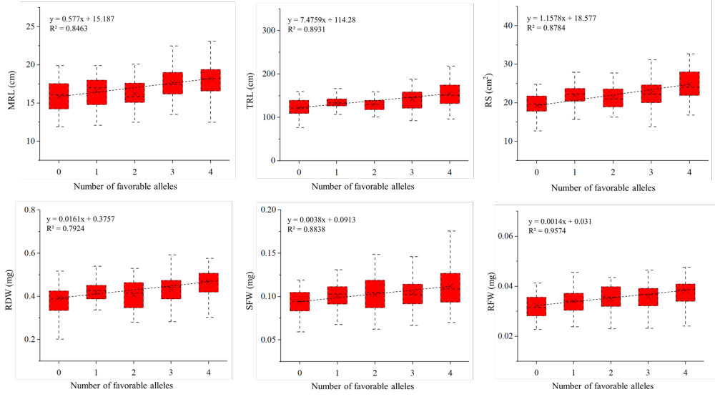
Fig. S4. Plot of effects of major QTL on seedling root traits in DH population.

Fig.5. Plot of effects of stable loci on seedling root traits in the association panel. Graphs a-l with horizontal coordinates 1-11 represent primary loci peak SNP markers 1A_592348186, 1B_110637082, 1D_43717444, 2A_327206091, 2B_771807820, 2D_584522338, 4B_526961846, 5D_450204045, 5D_359103858, 6A_597623440, and 7A_709975245, respectively.

Fig. S6. Plot of effects of stable SCVs on seedling root traits in the association panel. The horizontal coordinates 1-11 of graphs a-l represent SCV markers Mg1B-1, Mr1B-3, Mr5B-11, Mr1D-5, Mg1D-2, Mr1A-1, Mr2B-12, Mg2B-6, Mg6A-10, Mr3A-3, and Mr3A-4, respectively.

