The incidence of radiologically verified community-acquired pneumonia requiring hospitalisation among adults in southern Sweden, 2016 - 2018: a population-based study

Elisabeth Rünow, MD^{1,2}, Frida Valeur, MD², Gustav Torisson MD², Karin Hansen, MD^{1,2}, Christian Theilacker, MD ³, Kristian Riesbeck, MD^{1,4} and Jonas Ahl, MD^{1,4} *
¹Clinical Microbiology and ²Infectious Diseases, Department of Translational Medicine, Faculty of Medicine, Lund University, Malmö, Sweden
³Vaccines Global Medical Development, Scientific and Clinical Affairs, Pfizer, Collegeville, PA, USA
⁴Clinical Microbiology, Infection Control and Prevention, Laboratory Medicine Skåne, Lund, Sweden

* Corresponding author: Jonas Ahl, Dept. of Translational Medicine, Faculty of Medicine, Lund University, SE21428 Malmö, Sweden. E-mail address: jonas.ahl@med.lu.se

Running title: Incidence of hospitalized CAP

Figure S1. Map of County of Skåne and municipalities included.

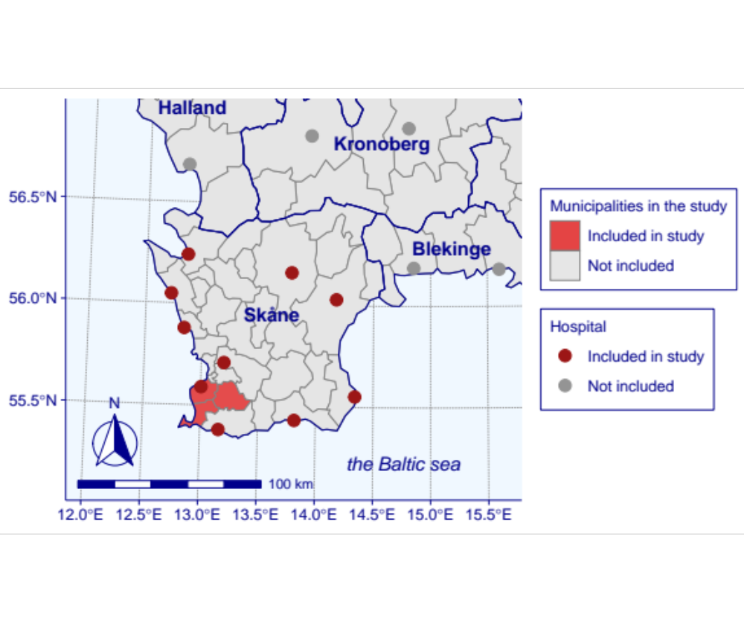

Description of clinical symptoms

Two of the following symptoms: Fever (oral temperature (≥38°C) or tympanic temperature (≥38.5°C), hypothermia (≤ 35.5°C), chills or rigors, pleuritic chest pain, cough, sputum production, dyspnea, tachypnea (respiratory rate >20/ min), malaise or abnormal auscultatory findings suggestive of pneumonia; rales or evidence of pulmonary consolidation.

