Supplementary information

Supplementary figure 1
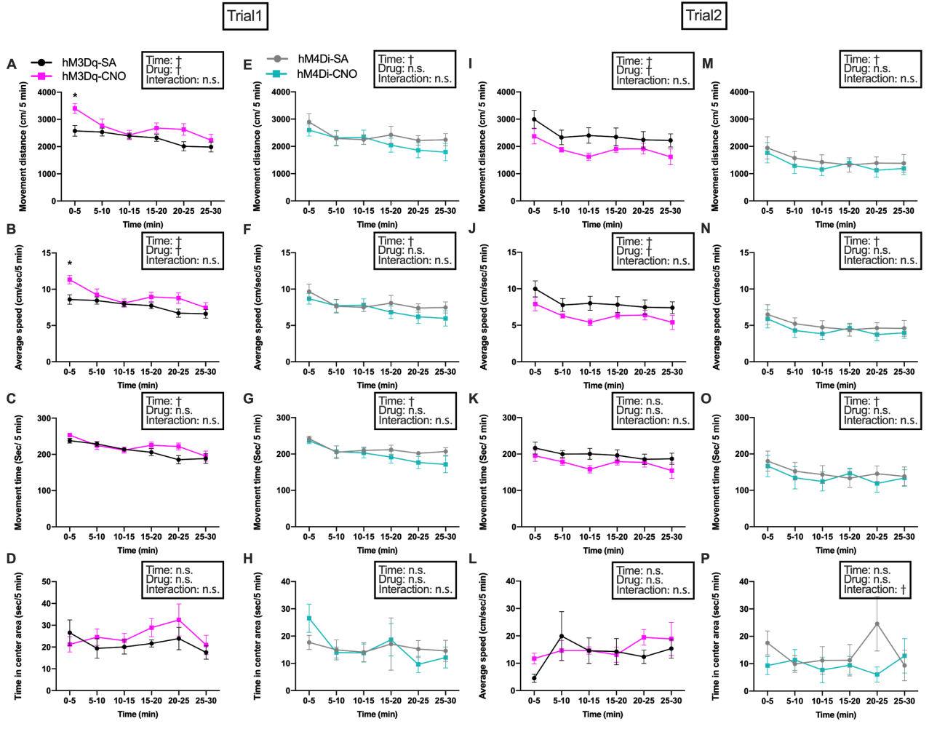

Fig. S1 Enhanced locomotor activity in the open field (OF) by chemogenetic HA^{TMN} neuron activation depended on environmental novelty
Locomotor parameters were compared in the OF among Hdc-hM3Dq mice (n = 6, A‒D, I‒L) and Hdc-hM4Di mice (n = 5, E‒H, M‒P) for 30 min after CNO or SA injection by two-way RM ANOVA with main factors trial number (A‒H: novel OF in trial 1, I‒P: non-novel OF in trial 2) and drug treatment (CNO or SA), followed by Sidak's post hoc tests. A, Total movement distance of Hdc-hM3Dq mice after CNO or SA injection during trial 1 (time: F = 7.48, P < 0.0001, drug: F = 5.77, P = 0.037, trial × drug interaction: F = 1.70, P = 0.15). B, Average speed of Hdc-hM3Dq mice after CNO or SA injection during trial 1 (time: F = 7.48, P < 0.0001; drug: F = 5.77, P = 0.037; interaction: F = 1.70, P = 0.15). C, Total movement time of Hdc-hM3Dq mice after CNO or SA injection during trial 1 (time: F = 8.77, P < 0.0001; drug: F = 2.91, P = 0.12; interaction: F = 1.46, P = 0.22). D, Time spent in the central area by Hdc-hM3Dq mice after CNO or SA injection during trial 1 (time: F = 1.27, P = 0.29; drug: F = 1.02, P = 0.34; interaction: F = 0.77, P = 0.58). E, Total movement distance of Hdc-hM4Di mice after CNO or SA injection during trial 1 (time: F = 9.92, P < 0.0001; drug: F = 0.46, P = 0.52; interaction: F = 1.80, P = 0.14). F, Average speed of Hdc-hM4Di mice after CNO or SA injection during trial 1 (time: F = 9.96, P < 0.0001; drug: F = 0.46, P = 0.52; interaction: F = 1.80, P = 0.13). G, Total movement time of Hdc-hM4Di mice after CNO or SA injection during trial 1 (time: F = 10.54, P < 0.0001; drug: F = 0.84, P = 0.39; interaction: F = 1.52, P = 0.21). H, Time spent in the central area by Hdc-hM4Di mice after CNO or SA injection during trial 1 (time: F = 1.94, P = 0.11; drug: F = 0.0017, P = 0.97; interaction: F = 0.87, P = 0.51). I, Total movement distance of Hdc-hM3Dq mice after CNO or SA injection during trial 2 (time: F = 3.44, P = 0.0096; drug: F = 5.05, P = 0.048; interaction: F = 0.31, P = 0.90). J, Average speed of Hdc-hM3Dq mice after CNO or SA injection during trial 2 (time: F = 3.44, P = 0.0096; drug: F = 5.05, P = 0.048; interaction F = 0.31, P = 0.90). K, Total movement time of Hdc-hM3Dq mice after CNO or SA injection during trial 2 (time: F = 2.05, P = 0.88; drug: F = 3.43, P = 0.094; interaction: F = 0.51, P = 0.77). L, Time spent in the centre area by Hdc-hM3Dq mice after CNO or SA injection during trial 2 (time: F = 2.22, P = 0.070; drug: F = 0.20, P = 0.67; interaction: F = 1.15, P = 0.35). M, Total movement distance of Hdc-hM4Di mice after CNO or SA injection during trial 2 (time: F = 7.38, P < 0.0001; drug: F = 0.26, P = 0.62; interaction: F = 0.63, P = 0.68). N, Average speed of Hdc-hM4Di mice after CNO or SA injection during trial 2 (time: F = 7.38, P < 0.0001, drug: F = 0.26, P = 0.62, interaction: F = 0.63, P = 0.68). O, Total movement time of Hdc-hM4Di mice after CNO or SA injection during trial 2 (time: F = 5.98, P = 0.0003; drug: F = 0.17, P = 0.74; interaction: F = 1.27, P = 0.30). P, Time spent in the centre area by Hdc-hM4Di mice after CNO or SA injection during trial 2 (time: F = 1.06, P = 0.40; drug: F = 0.54, P = 0.49; interaction: F = 3.45, P = 0.011). Data presented as mean ± S.E. † P < 0.05 by two-way RM ANOVA for ‘time’ and ‘drug’, * P < 0.05 by post hoc Sidak’s multiple comparisons test.

Supplementary figure 2
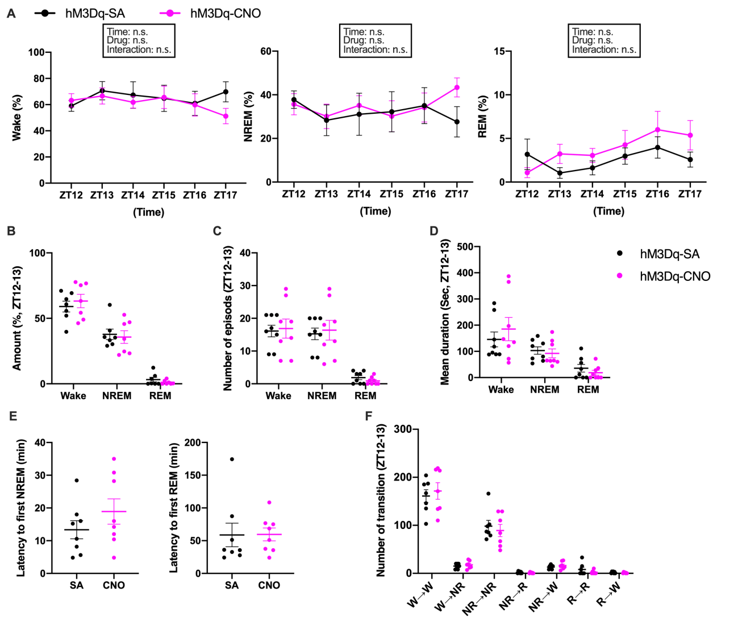
Fig. S2 Chemoactivation of HA^{TMN} neurons in Hdc-hM3Dq mice (n = 7) did not alter the sleep–wake cycle during dark periods.
All sleep parameters were compared by two-way RM ANOVA followed by Sidak's post hoc test except latencies and transitions, which were compared by Mann–Whitney U test. A, Hourly mean wake, NREM sleep and REM sleep times (% of total) after CNO or SA injection at ZT12 (wake – time: F = 0.52, P = 0.76; drug: F = 0.37, P = 0.55; interaction: F = 0.75, P = 0.59; NREM – time: F = 0.49, P = 0.78; interaction: F = 0.72, P = 0.61; drug: F = 0.20, P = 0.66; REM – time F = 2.02, P = 0.088; drug: F = 1.70, P = 0.22; interaction: F = 1.09, P = 0.37). B, Mean wake, NREM sleep and REM sleep times during ZT12–13 after CNO or SA injection at ZT12. C, Number of wake, NREM sleep and REM sleep episodes during ZT12–13 after CNO or SA injection at ZT12. D, Mean wake, NREM sleep and REM sleep times during ZT12–13 after CNO or SA injection at ZT12. E, Latency to first NREM and REM sleep episodes during ZT12–13 after CNO or SA injection at ZT12. F, Sleep–wake status transitions after CNO or SA injection at ZT12 (wake wake P = 0.62, wake NREM P = 0.88, NREM NREM P = 0.59, NREM REM P = 0.60, NREM wake P = 0.55, REM REM P = 0.64, REM wake P = 0.62; all by Mann–Whitney U test). All data expressed as mean ± S.E.
Supplementary figure 3
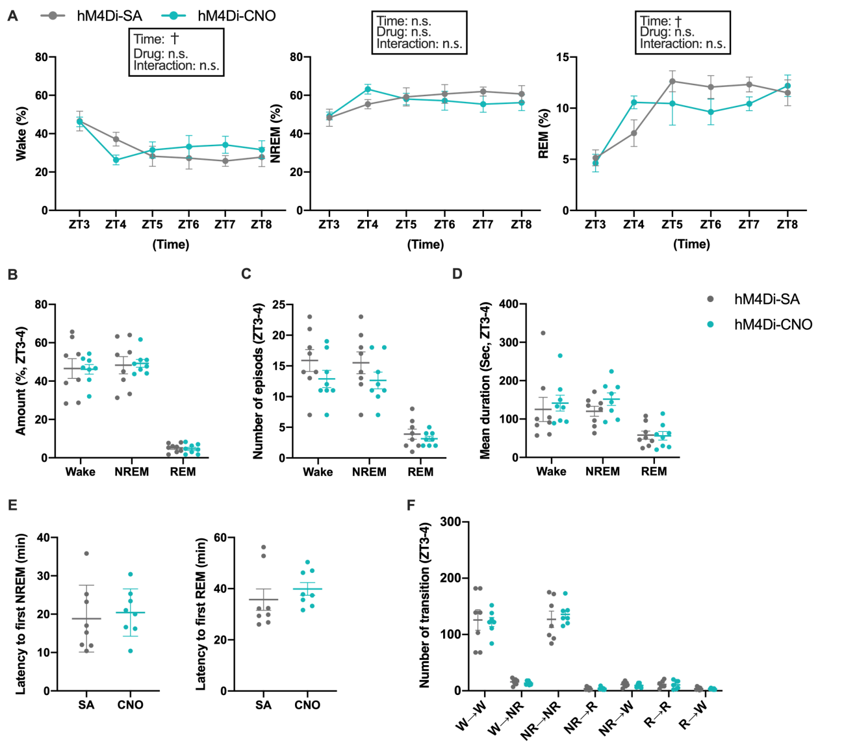
Fig. S3 Chemogenetic inhibition of HA^{TMN} neurons in Hdc-hM4Di mice (n = 8) did not alter the sleep–wake cycle during light periods.
All sleep parameters were compared by two-way RM ANOVA followed by Sidak's post hoc test except latencies and transitions, which were compared by Mann–Whitney U test. A, Hourly mean wake, NREM sleep and REM sleep times (% total) after CNO or SA injection at ZT3 (wake – time: F = 4.03, P = 0.0028; drug: F = 0.85, P = 0.37; interaction: F = 1.08, P = 0.38; NREM – time: F = 2.19, P = 0.065; drug: F = 0.36, P = 0.56; interaction: F = 0.86, P = 0.51; REM – time: F = 10.29, P < 0.0001; drug: F = 0.99, P = 0.34; interaction: F = 1.63, P = 0.16). B, Mean wake, NREM sleep and REM sleep times (% total) during ZT3–4 after CNO or SA injection at ZT3. C, Number of wake, NREM sleep and REM sleep episodes during ZT3–4 after CNO or SA injection at ZT3. D, Mean wake, NREM sleep and REM sleep durations (%total) during ZT3–4 after CNO or SA injection at ZT3. E, Latency to first NREM sleep and REM sleep episodes during ZT3–4 after CNO or SA injection at ZT3. F, Sleep–wake status transitions after CNO or SA injection at ZT3 (n = 7; wake wake P = 0.77, wake NREM P = 0.30, NREM NREM P = 0.56, NREM REM P = 0.79, NREM wake P = 0.47, REM REM P = 0.82, REM wake P = 0.95). All data expressed as mean ± S.E. † P < 0.05 by two-way RM ANOVA for ‘time’ and ‘drug’.

Supplementary figure 4
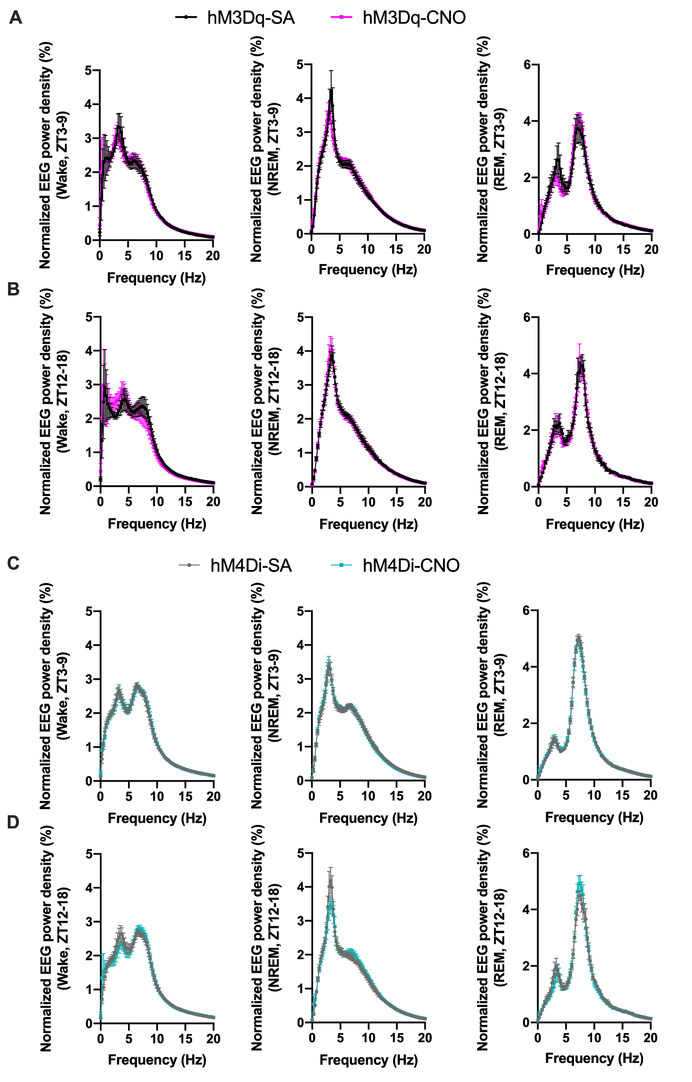
Fig. S4 Power spectra of wake and each sleep stage during dark and light periods after CNO administration to Hdc-hM3Dq and Hdc-hM4Di mice.
A, Power spectra of wake, NREM sleep and REM sleep periods for Hdc-hM3Dq mice during ZT3-9 after CNO or SA injection at ZT3 (n = 6; wake P = 0.85, NREM P = 0.85, REM P > 0.9999 all by Mann–Whitney U test). B, Power spectra of wake, NREM sleep and REM sleep periods for Hdc-hM3Dq mice during ZT12–18 after CNO or SA injection at ZT12 (n = 6; wake P = 0.99, NREM P = 0.91, REM P = 0.92, all by Mann–Whitney test). C, Power spectra of wake, NREM sleep and REM sleep periods for Hdc-hM4Di mice during ZT3–9 after CNO or SA injection at ZT3 (n = 7; wake P = 0.97, NREM P = 0.99, REM P = 0.93, all by Mann–Whitney U test). D, Power spectra of wake, NREM sleep and REM sleep periods for Hdc-hM4Di mice during ZT12–18 after CNO or SA injection at ZT12 (n = 7; wake P = 0.96, NREM P = 0.99, REM P = 0.78, all by Mann–Whitney U test).

Supplementary table 1
Table S1 Hourly mean number and duration of wake, NREM sleep and REM sleep episodes in Hdc-hM3Dq mice during the dark and light periods after CNO or SA injection
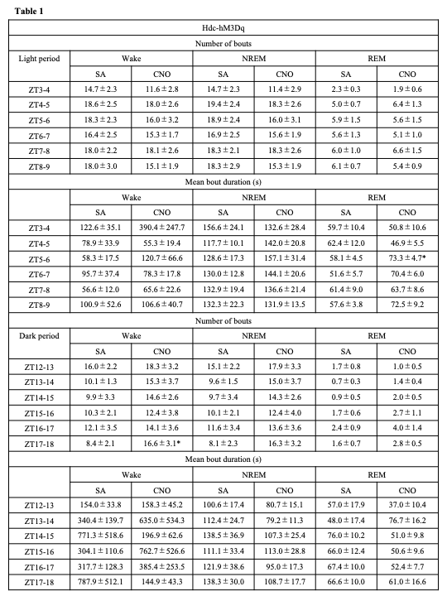
CNO or SA was administered i.p. at ZT3 for the light period test and at ZT12 for the dark period test.

Supplementary table 2
Table S2 Hourly mean number and duration of wake, NREM sleep and REM sleep episodes in Hdc-hM4Di mice during the dark and light periods after CNO or SA injection
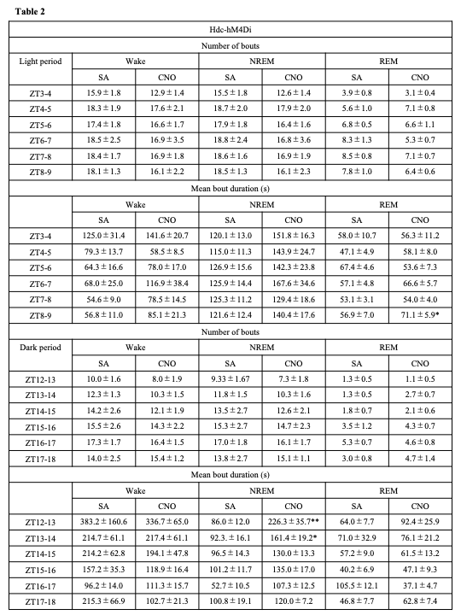
CNO or SA was administered intraperitoneally at ZT3 for the light period test and at ZT12 for the dark period test. Data presented as mean ± S.E.M. *P < 0.05, ** P < 0.01 by Mann–Whitney U test.

