Supplementary Information for

Role of Gasdermins in the Biogenesis of Apoptotic Cell–Derived Exosomes

Jaehark Hur, Yeon Ji Kim, Da Ae Choi, Dae Wook Kang, Jaeyoung Kim, Hyo Soon Yoo, Sk Abrar Shahriyar, Tamanna Mustajab, Junho Kim, Dong Young Kim, Yong-Joon Chwae*

*Corresponding author: soiloie0603@hanmail.net

Supplementary Figures and Legends

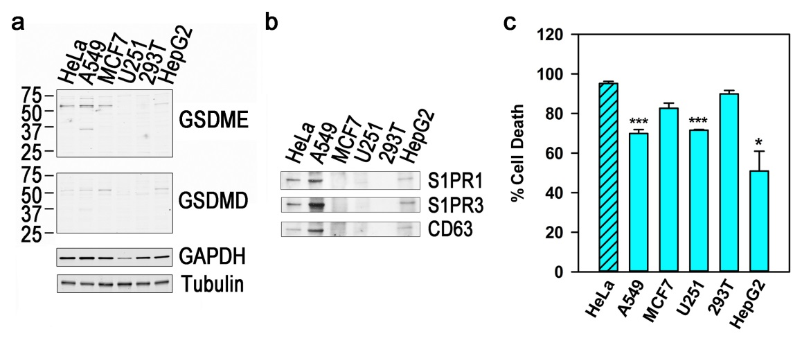
Figure S1. Comparison between the expression of GSDME and GSDMD and the release of apoptotic exosomes in various cell lines. (a) The expression of GSDME and GSDMD was inspected by western blotting. (b) The cells were treated with TNFα (50 ng/ml) and cycloheximide (25 μg/ml) for 48 hr. The exosomal fractions were prepared from the conditioned media and lysed with lysis buffer, with the volume adjusted for the cellular protein masses. Equal volumes of the exosomal fraction were western-blotted for the markers of apoptotic exosomes (CD63, S1PR1, and S1PR3). (c) % cell death was measured by the LDH assay. The experiments were performed in triplicate. The data are presented as mean ± SD and *P < 0.001, ***P < 0.05 in c.

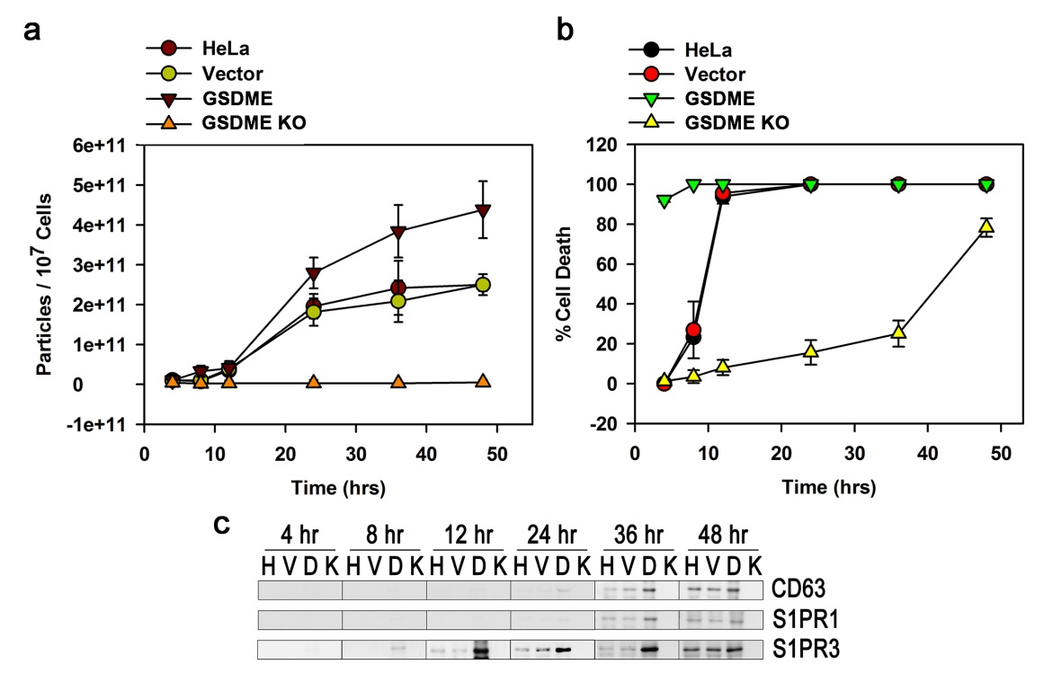

Figure S2. GSDME is a prerequisite for the biogenesis of apoptotic exosomes. Parental HeLa cells, cells infected with a control vector (vector), cells overexpressing GSDME (GSDME), and GSDME knockout cells (GSDMEKO) were incubated with staurosporine (1 μM) for the indicated times. (a) Conditioned media were prepared, and the number of apoptotic exosomes was measured by nanoparticle-tracking analysis (NTA). (b) Pyroptotic cell death was detected by the LDH assay. (c) The exosomal fractions were prepared and western-blotted for the markers of apoptotic exosomes (CD63, S1PR1, and S1PR3) (H: from parental HeLa cells; V: vector-infected HeLa cells; D: cells overexpressing GSDME; K: GSDME knockout cells). The experiments were performed in triplicate. The data are presented as mean ± SD in a and b.

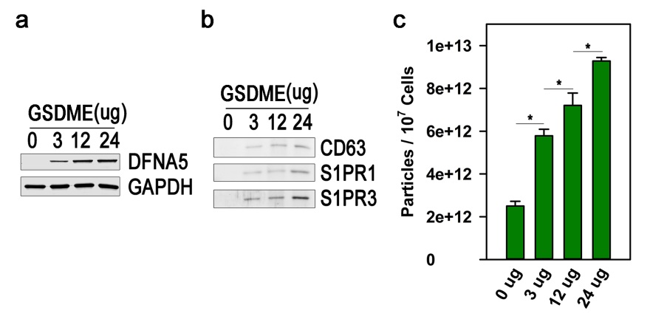
Figure S3. GSDME enhances the release of apoptotic exosomes in a dose-dependent manner. (a) HeLa cells grown to 90% confluency in a 100 mm dish were transfected with a plasmid containing GSDME cDNA in the indicated amounts. 24 hr after transfection, the cells were collected, and cytoplasmic protein was extracted. GSDME expression was observed by western blotting. (b) The cells were treated with staurosporine (1 μM) for an additional 24 hr, and apoptotic exosomes were prepared from the conditioned media. The markers of apoptotic exosomes (CD63, S1PR1, and S1PR3) were detected by western blotting from equal volumes of apoptotic exosomes. (c) Exosomal fractions were analyzed by NTA. The experiments were performed in triplicate. The data are presented as mean ± SD and *P < 0.001 in c.

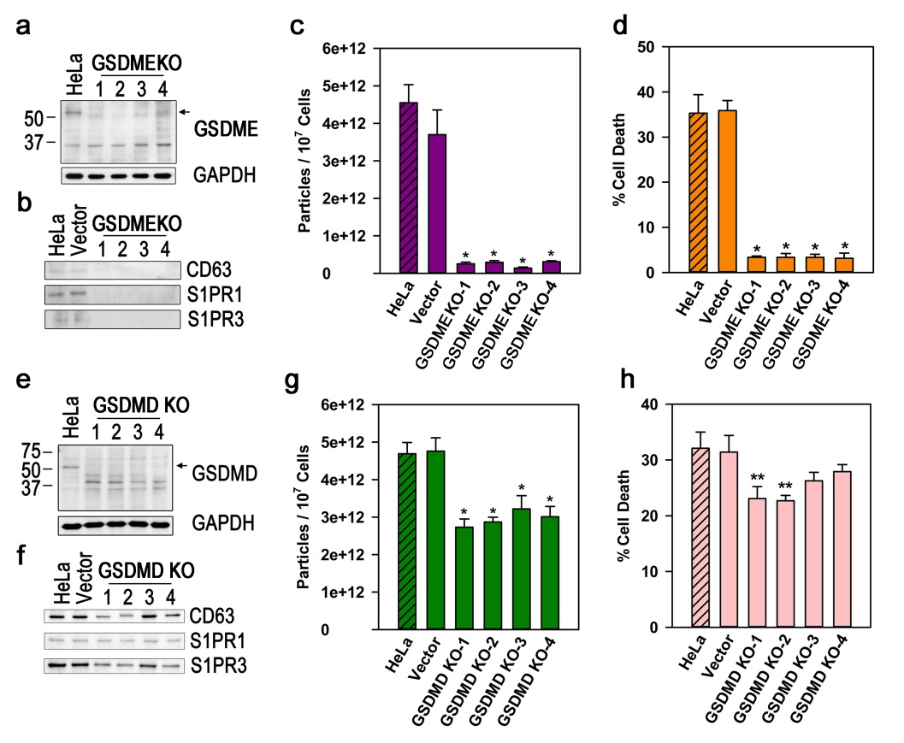

Figure S4. Knockout of either GSDME or GSDMD hinders the release of apoptotic exosomes. (a and e) Either GSDME or GSDMD was knocked out in HeLa cells by the CRISPR/Cas9 system. Arrows indicate the full-length forms of GSDME and GSDMD. (b and f) The cells were treated with staurosporine (1 μM). 24 hr after treatment, the apoptotic exosomes were purified from the conditioned media, western-blotted for CD63, S1PR1, and S1PR3. (c and g) The exosomes were analyzed by NTA. (d and h) Pyroptotic cell death was measured by the LDH assay. The experiments were performed in triplicate. The data are presented as mean ± SD and *P < 0.001, **P < 0.01 (c, d, g, and h).

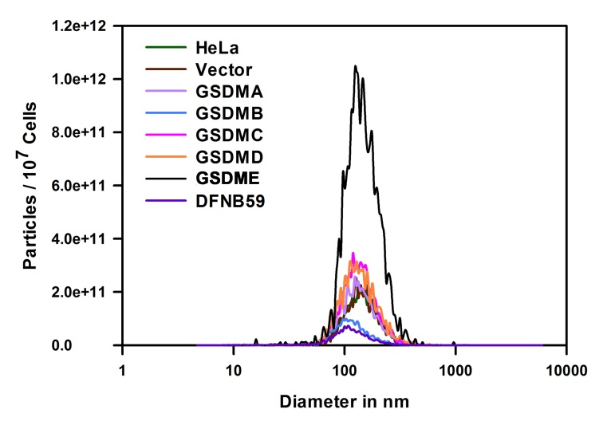
Figure S5. Overexpression of GSDMA, GSDMC, GSDMD, or GSDME increases the release of apoptotic exosomes. HeLa cells overexpressing gasdermins were treated with staurosporine (1 μM) for 24 hr. Exosomal fractions were prepared from the conditioned media and analyzed by NTA. The data are from one representative in three independent experiments.

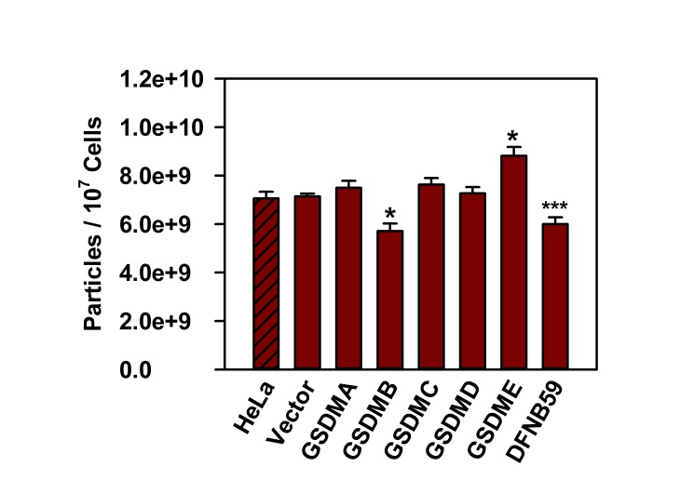

Figure S6. The release of exosomes in HeLa cells overexpressing gasdermins. HeLa cells stably expressing each gasdermin were sub-cultured in MEM with 10% FBS for 24 hrs, then washed with PBS and incubated in the media without FBS for additional 48 hrs. Number of exosomes was measured by NTAs in the conditioned media. The experiments were performed in triplicate. The data are presented as mean ± SD and *P < 0.001, ***P<0.05.

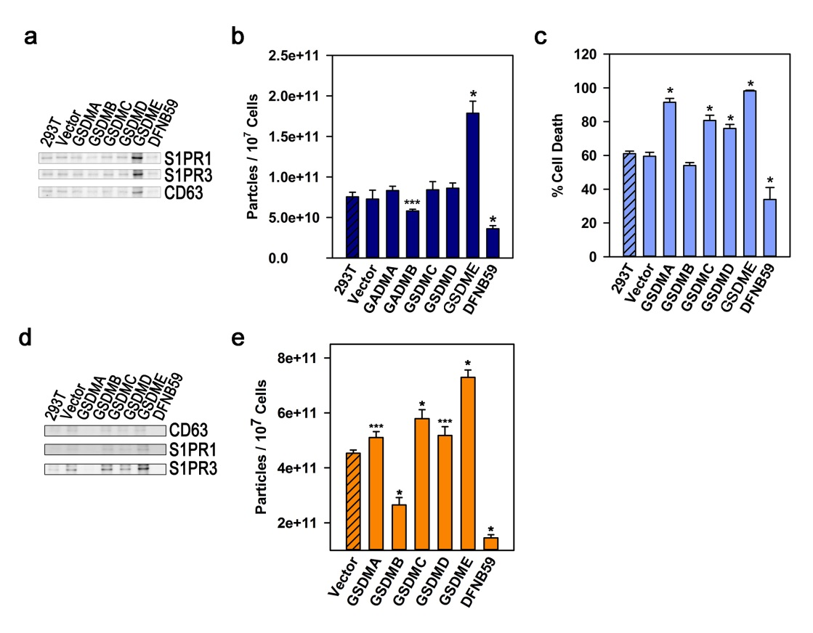

Figure S7. Gasdermins regulate the release of apoptotic exosomes in staurosporine-treated 293T cells. (a and b) Parental 293T cells and 293T cells trasduced with a control vector or a gasdermin (GSDMA, GSDMB, GSDMC, GSDMD, GSDME, or DFNB59) were incubated with staurosporine (5 μM). 48 hr after treatment, exosomal fractions were prepared from the conditioned media, and equal volumes of apoptotic exosomes were western-blotted for markers of apoptotic exosomes (S1PR1, S1PR3, or CD63) and analyzed by NTAs. (c) Pyroptotic cell death was measured by the LDH assay 24 hr after staurosporine treatment. (d and e) The cells were incubated with staurosporine (5 μM) and MG132 (10 μM). 24 hr after treatment, exosomal fractions were prepared from the conditioned media, and equal volumes of apoptotic exosomes were western-blotted for markers of apoptotic exosomes and analyzed by NTAs. The experiments were performed in triplicate. The data are presented as mean ± SD and *P < 0.001, ***P<0.05 in b, c, and e.

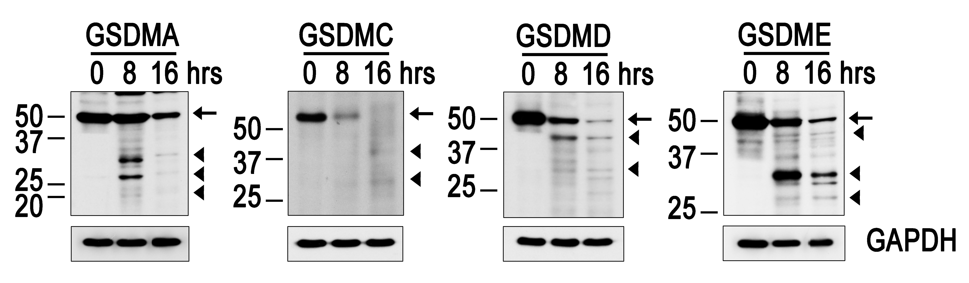

Figure S8. GSDMA, GSDMC, GSDMD, and GSDME are cleaved in 293T cells treated with staurosporine and MG132. 293T cells stably overexpressing GSDMA, GSDMC, GSDMD, or GSDME were treated with staurosporine (5 μM) and MG132 (10 μM) for the indicated time periods. The cleavage of each gasdermin was observed by western blot. The data are from one representative in the three independent experiments. Arrows denote full-length form of each gasdermin and triangles denote the cleaved fragments of each gasdermin.

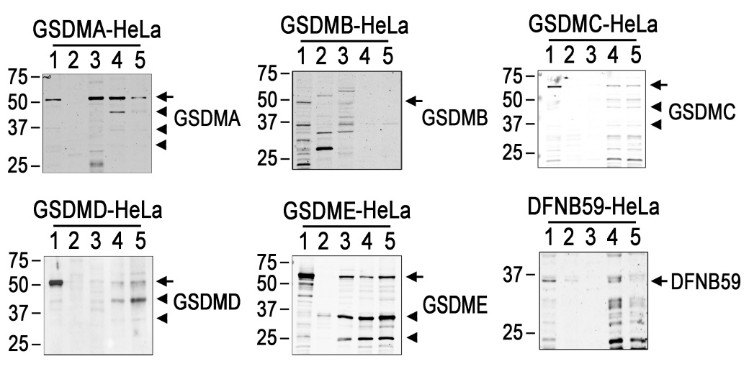

Figure S9. GSDMA, GSDMC, GSDMD, and GSDME are localized in the membrane of apoptotic exosomes. HeLa cells overexpressing gasdermins were treated with staurosporine (1 μM) for 24 hr. Equal amounts of protein extracted from non-treated control cells, staurosporine-treated cells, conditioned media, apoptotic exosomes, and membrane fractions of apoptotic exosomes were western-blotted for the indicated gasdermins. Arrows denote the full-length form of each gasdermin, and triangles denote the cleaved forms (1: non-treated control cells; 2: staurosporine-treated cells; 3: conditioned media; 4: apoptotic exosomes; 5: membrane fractions of apoptotic exosomes). Data are from one representative in three independent experiments.

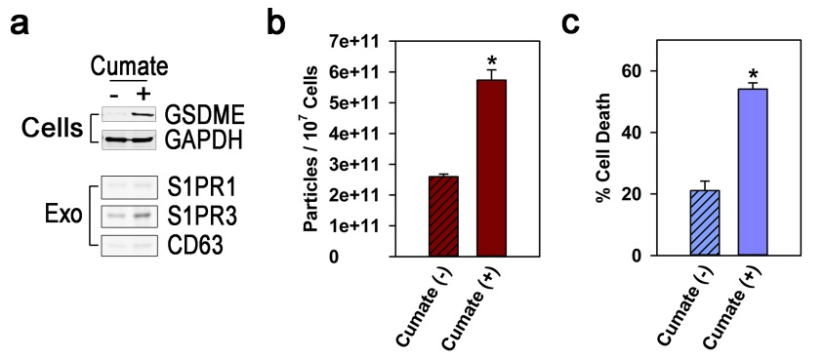

Figure S10. Full-length GSDME induced by cumate treatment increases the release of ApoExos and early pyroptotic cell death. (a, upper panel) Full-length GSDME cDNA under the control of a cumate-inducible promotor was stably expressed in HeLa cells. The cells were treated with or without cumate (20 μg/ml) for 48 hr. Induction of GSDME was confirmed by western blotting. (a, lower panel and b) Apoptotic cell death was guided by staurosporine treatment (1 μM) for 24 hr. ApoExos were prepared from the conditioned media and analyzed for ApoExo markers by western blotting and NTAs. (c) Pyroptotic cell death was measured by the LDH assay. The experiments were performed in triplicate. The data are presented as mean ± SD and *P < 0.001, in b and c.

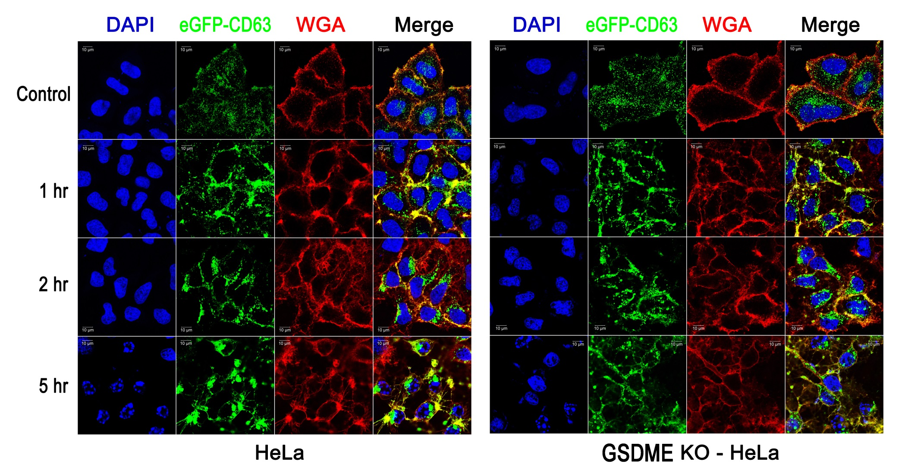

Figure S11. GSDME KO diminished the large intracellular vesicular aggregates that appear in apoptotic cells. Parental HeLa cells and GSDME knockout cells expressing eGFP-CD63 were treated with staurosporine (1 μM) for the indicated times. The cells were stained with wheat germ agglutinin-Alexa Fluor 594 (WGA), and confocal images are shown. Data are from one representative in three independent experiments.
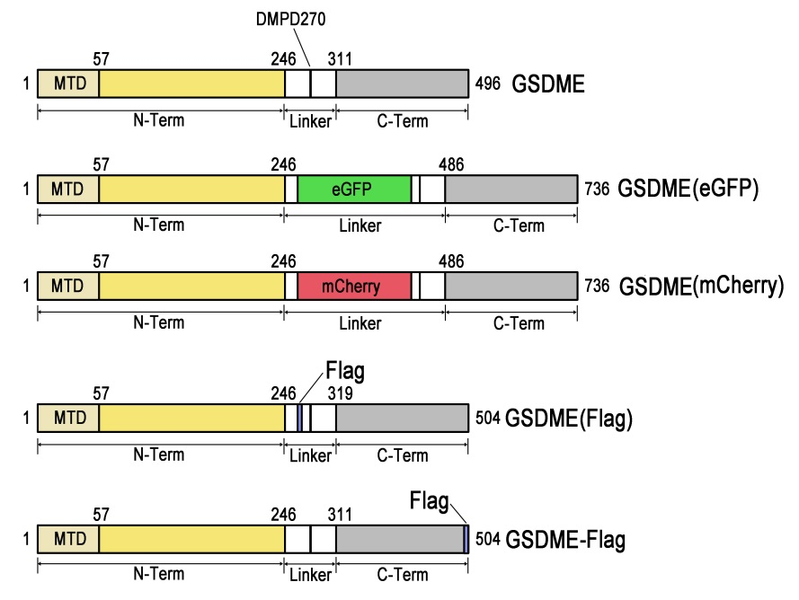

Figure S12. Schematic diagram of GSDME constructs. GSDME is composed of an N-terminal membrane translocation domain (MTD), pore-forming N-terminal segment (N-Term), C-terminal segment (C-Term), and linker region connecting the N-terminal and C-terminal segments (Linker). eGFP, mCherry, or Flag tag sequences were inserted into the linker region amino-terminally from the caspase-cleavage site (Asp270) [GSDME(eGFP), GSDME(mCherry), and GSDME(Flag)]. The Flag tag was added at the C-terminal end of GSDME (GSDME-Flag).

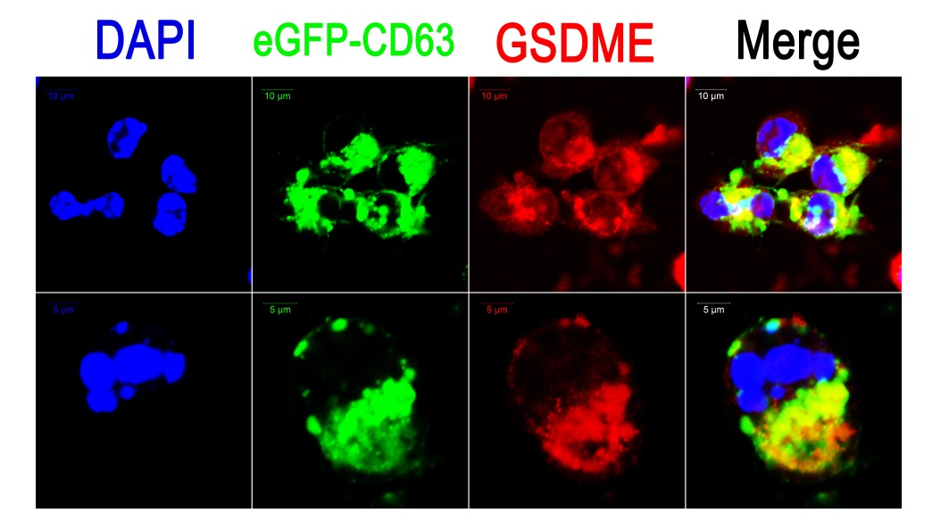
Figure S13. GSDME is co-localized with eGFP-CD63. HeLa cells expressing eGFP-CD63 were treated with staurosporine (1 μM) for 6 hrs. The cells were stained with GSDME-specific Ab and AlexaFluor594-anti-rabbit IgG secondary Ab. Data are from one representative in three independent experiments.

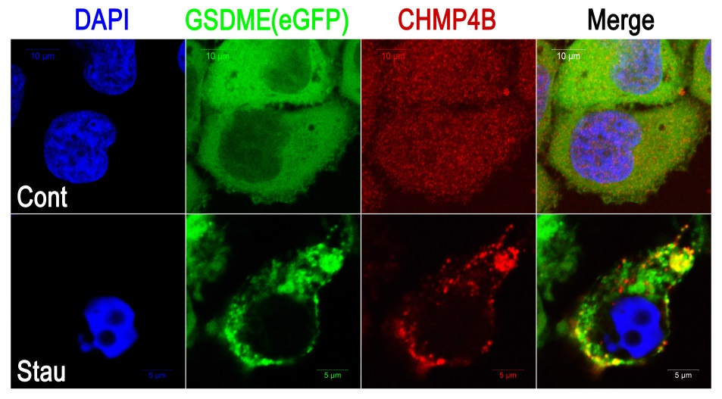
Figure S14. CHMP4B is co-localized with GSDME in apoptotic cells. HeLa cells expressing GSDME with internal eGFP were incubated with solvent or staurosporine (1 μM) for 4 hr and then stained for CHMP4B. Confocal images of the cells are shown. Data are from one representative in three independent experiments.

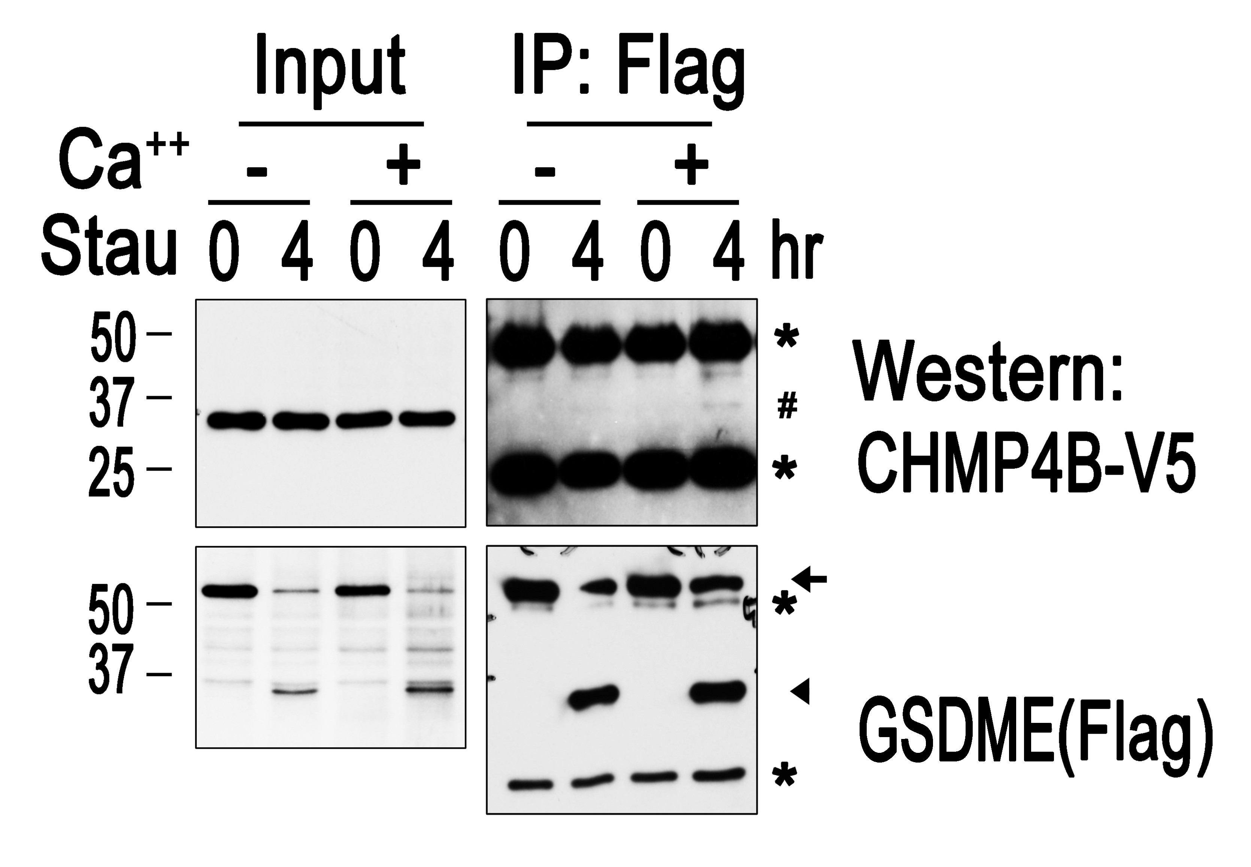

Figure S15. Interaction between GSDME and CHMP4B depends on Ca²⁺. HeLa cells expressing GSDME with an internal Flag tag [GSDME(Flag)] and CHMP4B-V5 were treated with staurosporine (1 μM) for the indicated times. Cellular lysates were prepared with and without Ca²⁺ (100 μM), of which one tenth of the volume was western-blotted for V5 and Flag (Input). The immunoprecipitates with anti-Flag Ab were western-blotted with anti-Flag and anti-V5 Abs (IP: Flag). The arrow and triangle denote full-length and cleaved N-terminal segments of GSDME, respectively. Asterisks indicate Ig heavy and light chains, and # indicates co-immunoprecipitated CHMP4B-V5. Data are from one representative in three independent experiments.

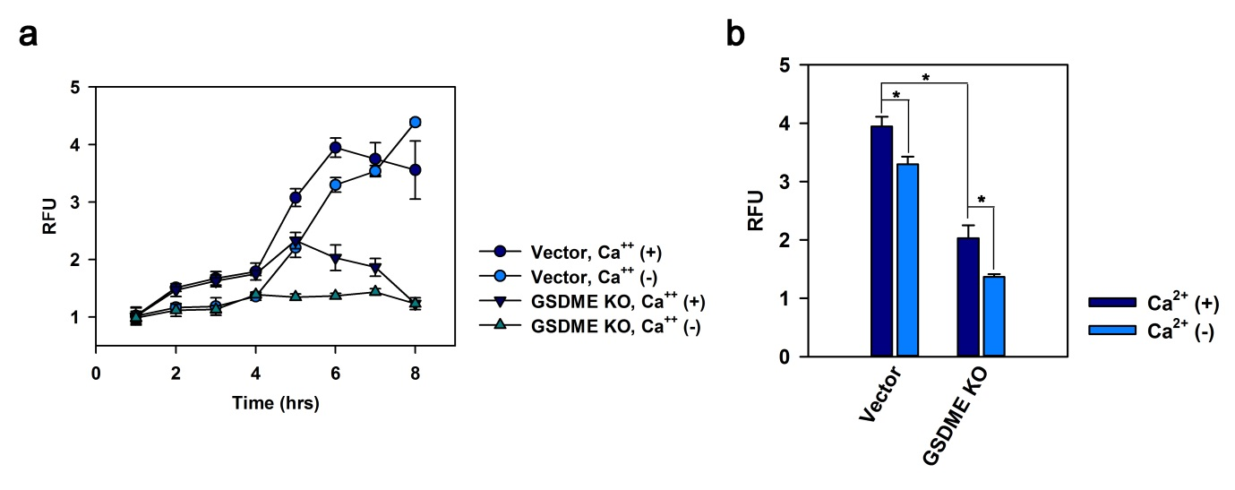

Figure S16. Intracellular free Ca²⁺ increases in a GSDME-dependent manner in the apoptotic cells and depletion of Ca²⁺ in the media partially blocks the increase of intracellular Ca²⁺. a and b Intracellular free Ca²⁺ was measured with a calcium sensor dye, eFluorTM 514, at the indicated times (a) or 6 hrs (b) in staurosporine-treated control or GSDME KO HeLa cells in either MEM or Ca²⁺-depleted MEM. The data were presented as relative fluorescence units (RFU): fluorescence intensities of the staurosporine-treated cells / fluorescence intensities of the non-treated control cells. The data pictured are from one representative experiment executed in quintuplicate in three independent experiments. Data are presented as mean ± SD and *P<0.001 in b.

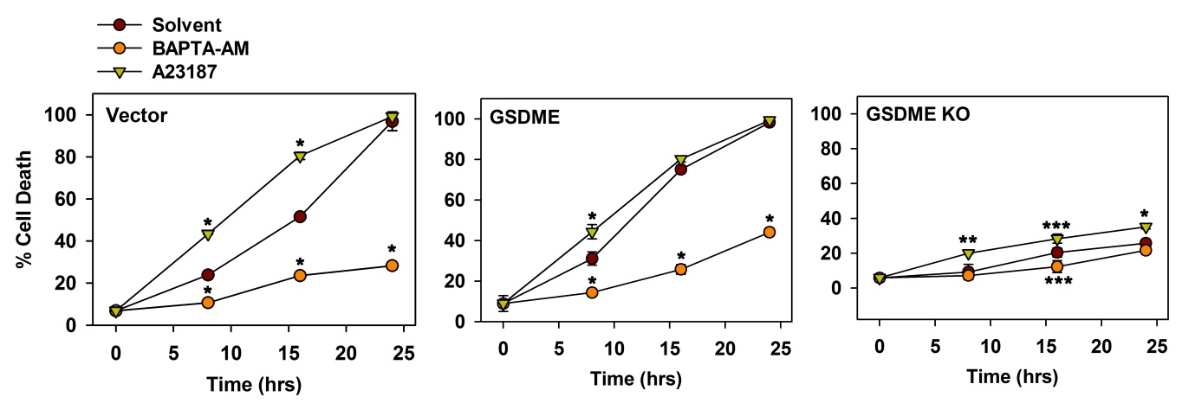
Figure S17. A calcium chelator, BAPTA-AM inhibits the cell death, in contrast, a calcium ionophore, A23187 promote the early cell death. Control cells (vector), GSDME-overexpressing cells (GSDME), and GSDME KO cells (GSDME KO) were treated with staurosporine (1 μM) for the indicated time periods. % cell death was analyzed by LDH assay. The experiments were performed in triplicate. The data are presented as mean ± SD, and *P < 0.001, **P < 0.01, ***P < 0.05.

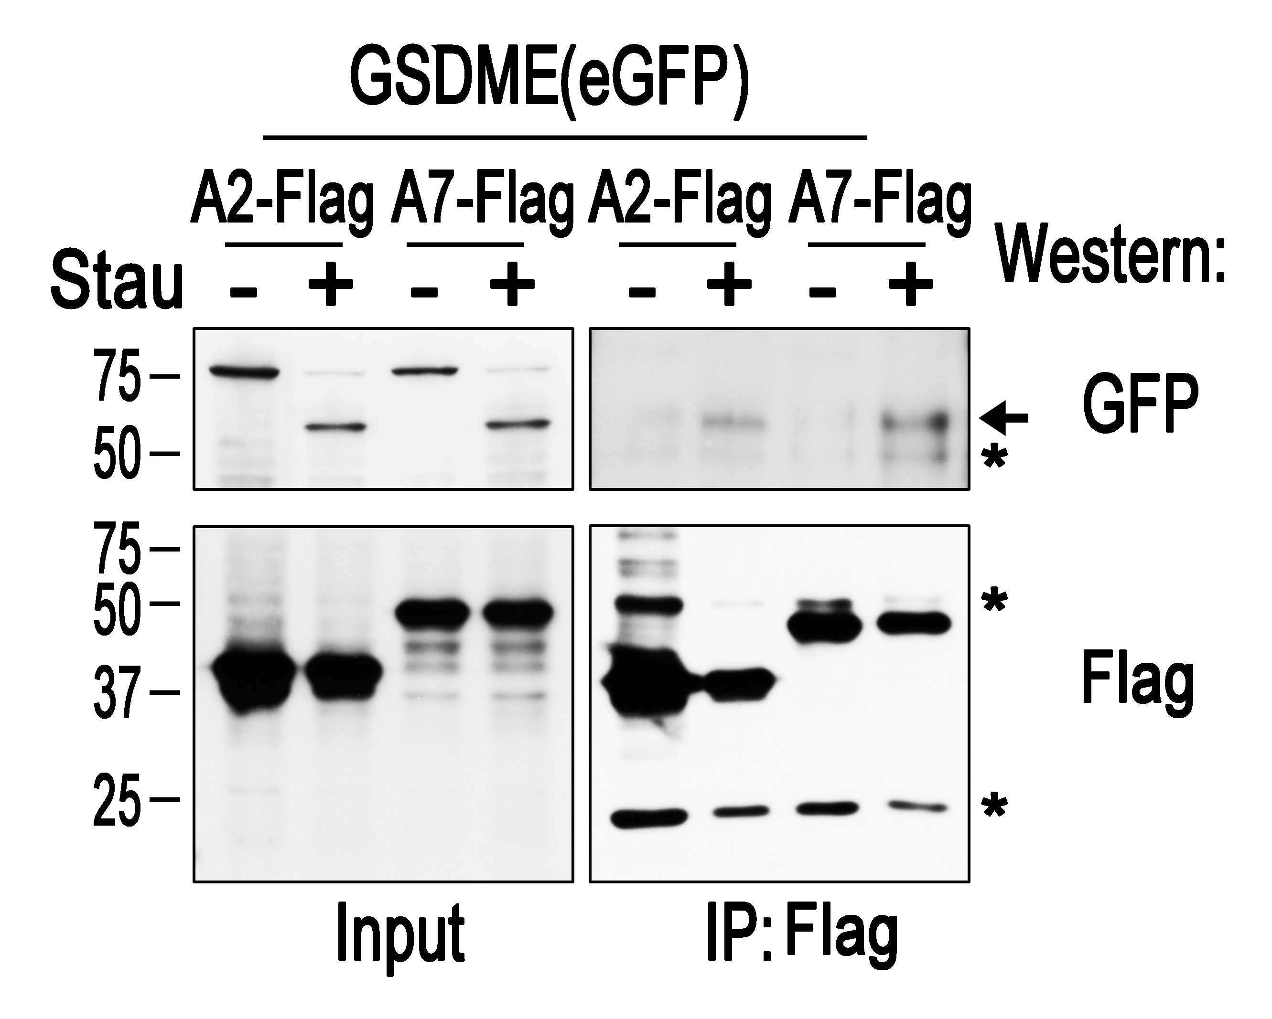
Figure S18. GSDME is co-immunoprecipitated with Annexin A2 and A7 in apoptotic HeLa cells. HeLa cells expressing ANXA2-Flag or ANXA7-Flag together with GSDME(eGFP) were treated with staurosporine (1 μM) or DMSO for 4 hr. The cell lysates were immunoprecipitated with agarose beads conjugated with anti-Flag Ab. One hundredth of the cell lysates (Input) and immunoprecipitates (IP: Flag) were western-blotted for the Flag or GFP tag. Arrows indicate GSDME(eGFP), and asterisks indicate Ig heavy and light chains. Data are from one representative in three independent experiments.

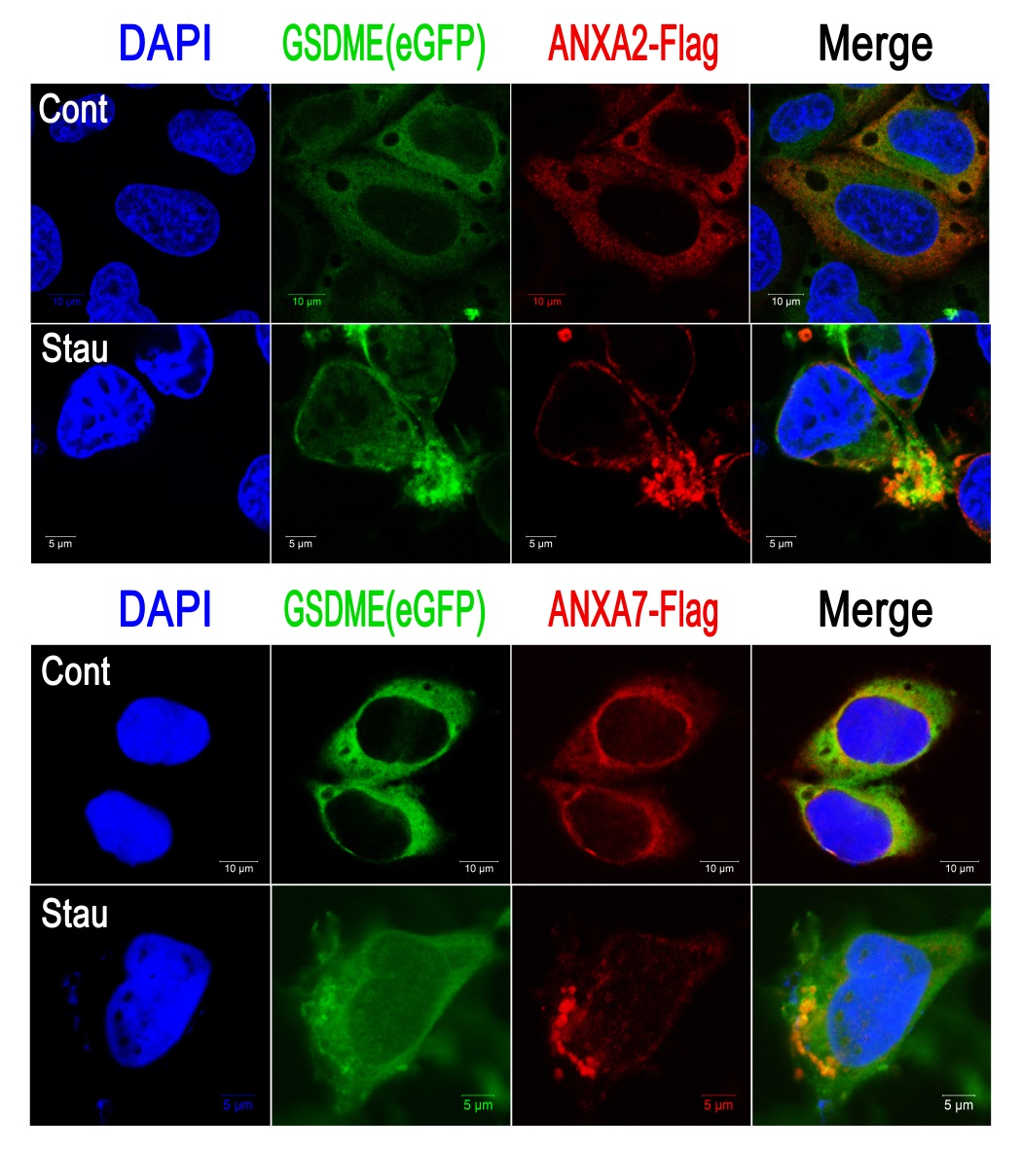
Figure S19. Annexin A2 and annexin A7 are co-localized with GSDME in apoptotic cells. HeLa cells expressing GSDME(eGFP) with ANXA2-Flag or ANXA7-Flag were treated with staurosporine (1 μM) or control solvent (DMSO) for 4 hr and stained with anti-Flag Ab and Alexa Fluor 594–conjugated anti-mouse Ig Ab. Confocal images of the cells are shown. Data are from one representative in three independent experiments.

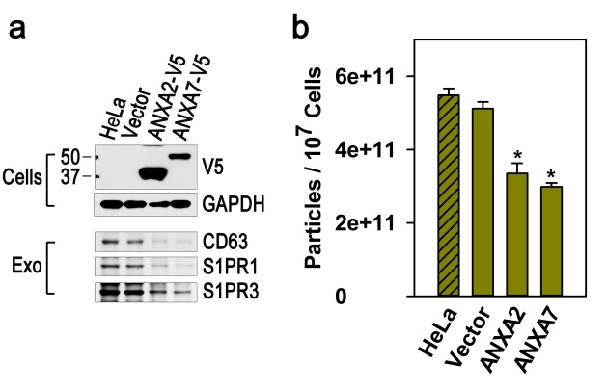
Figure S20. Overexpression of ANXA2 or ANXA7 inhibits the release of apoptotic exosomes. (a, upper panel) Control HeLa cells and cells overexpressing ANXA2 or ANXA7 tagged with V5 were western-blotted for V5-tag and GAPDH. (a, lower panel and b) The cells were treated with staurosporine (1 μM) for 24 hr. The exosomes were prepared and analyzed by western blotting or NTAs. The experiments were performed in triplicate. The data are presented as mean ± SD, and *P < 0.001 (b).

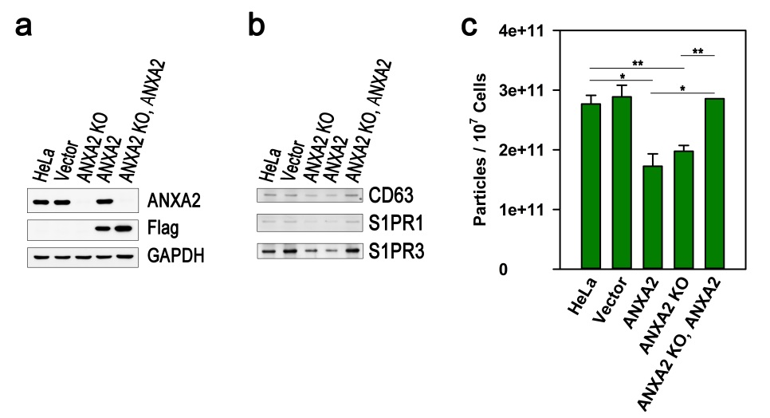

Figure S21. Constant levels of annexins are required for release of apoptotic exosomes. (a) Flag-tagged ANXA2 cDNA, having a silent mutation at the PAM (protospacer adjacent motif) sequence recognized by Cas9, was transduced into HeLa cells or ANXA2 KO cells. Expression of the ANXA2 cDNA was analyzed by western blot. (b and c) Control cells (HeLa and Vector), ANXA2 KO cells, cells expressing the ANXA2 cDNA, and the ANXA2 KO cells expressing the ANXA2 cDNA were treated with staurosporine (1 μM) for 24 hrs. The ApoExos were prepared from the conditioned media and analyzed by western blot and NTAs. The experiments were performed in triplicate. The data are presented as mean ± SD, and *P < 0.001, **P < 0.01 in c.

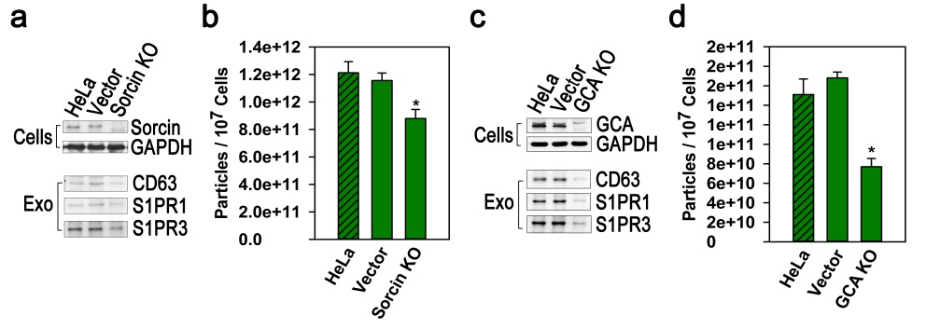

Figure S22. Depletion of sorcin reduces the release of apoptotic exosomes. (a, upper panel and c, upper penal) Control HeLa cells (HeLa and Vector) and cells depleted of the sorcin gene (Sorcin KO) or the grancalcin (GCA KO) were western-blotted for sorcin, grancalcin, or GAPDH. (a, lower panel and c, lower panel) The cells were treated with staurosporine (1 μM) for 24 hr. Apoptotic exosomes purified from the conditioned media were analyzed via western blotting. (b and d) The exosomes were analyzed by NTAs. The experiments were performed in triplicate. The data are presented as mean ± SD and *P < 0.001 (b and d).

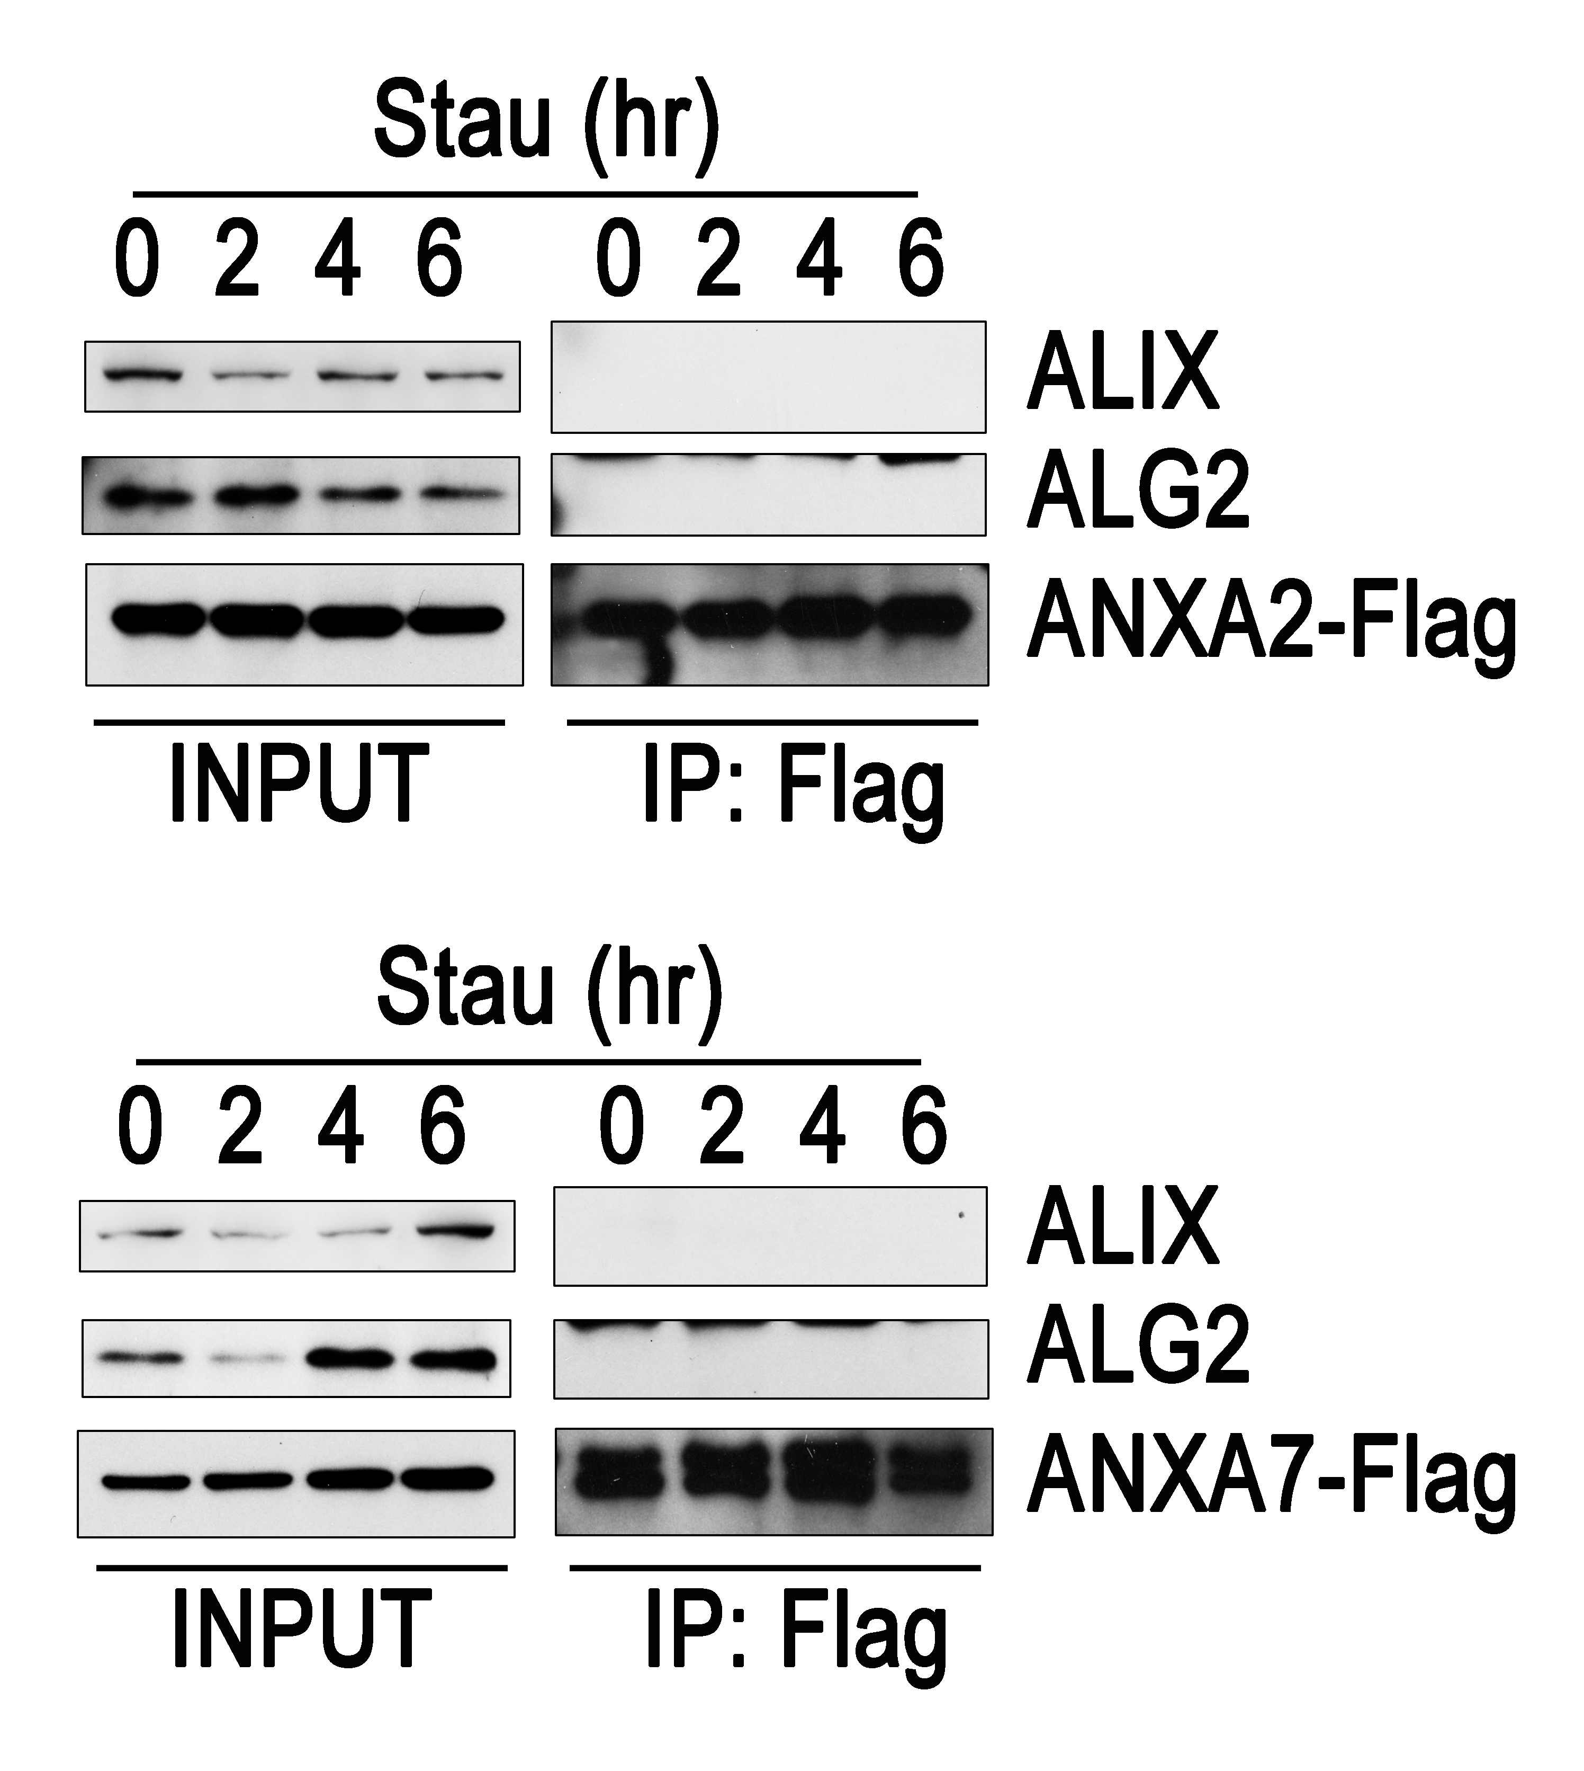

Figure S23. ALIX and ALG2 are not co-immunoprecipitated with Annexin A2 and A7 in apoptotic HeLa cells. HeLa cells expressing ANXA2-Flag or ANXA7-Flag were treated with staurosporine (1 μM) for the indicated time periods. The cell lysates were immunoprecipitated with agarose beads conjugated with anti-Flag Ab. One hundredth of the cell lysates (Input) and immunoprecipitates (IP: Flag) were western-blotted for the Flag, ALIX, or ALG2. The data are from one representative in three independent experiments.

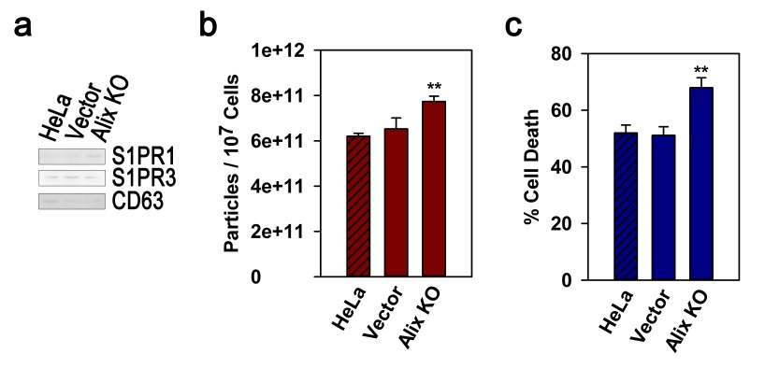

Figure S24. Alix is not associated with the biogenesis of apoptotic exosomes. (a and b) Control HeLa cells (HeLa and Vector) and Alix knockout cells (Alix KO) were treated with staurosporine (1 μM) for 24 hr. Apoptotic exosomes were prepared and analyzed by western blotting and NTAs. (c) Pyroptotic cell death was measured in cells treated with staurosporine for 12 hr. The experiments were performed in triplicate. The data are presented as mean ± SD and **P < 0.01 (b and c).

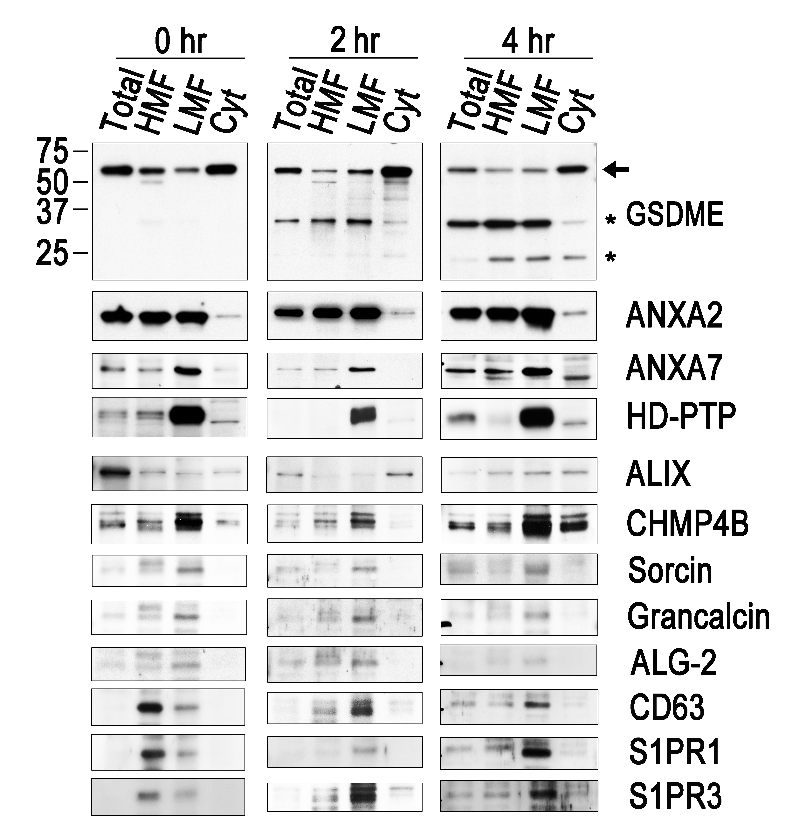

Figure S25. GSDME migrated into multivesicular body-containing LMFs is co-localized with ANXA2, ANXA7, sorcin, grancalcin, HD-PTP, and CHMP4B in apoptotic cells. GSDME-overexpressing HeLa cells were treated with staurosporine (1 μM) for the indicated times. The total cellular lysates (Total), heavy membrane fraction (HMF), light membrane fraction (LMF), and cytosolic fraction (Cyt) were then prepared. Equal amounts of protein were separated by SDS-PAGE and western-blotted for the indicated proteins. Arrows and asterisks denote the full-length and cleaved forms of GSDME, respectively. Data are from one representative in three independent experiments.

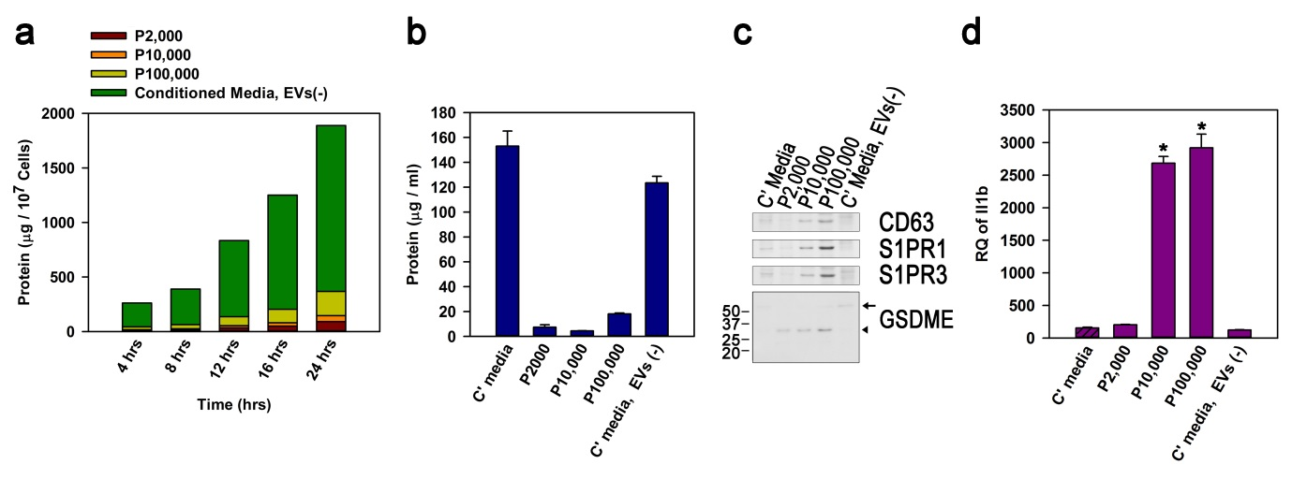
Figure S26. Apoptotic exosomes are the main inflammatory mediators released into the apoptotic conditioned media. (a) HeLa cells were treated with staurosporine (1 μM) for the indicated time periods, and EV fractions and EV-depleted conditioned media were collected from the conditioned media by a series of centrifugation (P2,000: 2,000 X g for 20 min; P10,000: 10,000 X g for 20 min; P100,000: 100,000 X g for 70 min), protein concentrations of which were measured by Bradford assay. (b) Total conditioned media (C’ media), EV fractions, and EV-depleted conditioned media [C’ media, EVs (-)], collected from the apoptotic cells treated with staurosporine for 24 hrs, were analyzed for amount of protein. (c) Equal amount of protein was inspected for expression of the ApoExos markers and GSDME by western blots. Arrow and triangle indicate the full-length and the cleaved form of GSDME, respectively. (d) bone marrow-derived macrophages were treated with equal amount of the conditioned media or each EV fraction for 16 hrs and Il1b expression was analyzed by real-time PCRs. The experiments were performed in triplicate. The data are presented as mean ± SD (b and d) and *P < 0.001 (d).

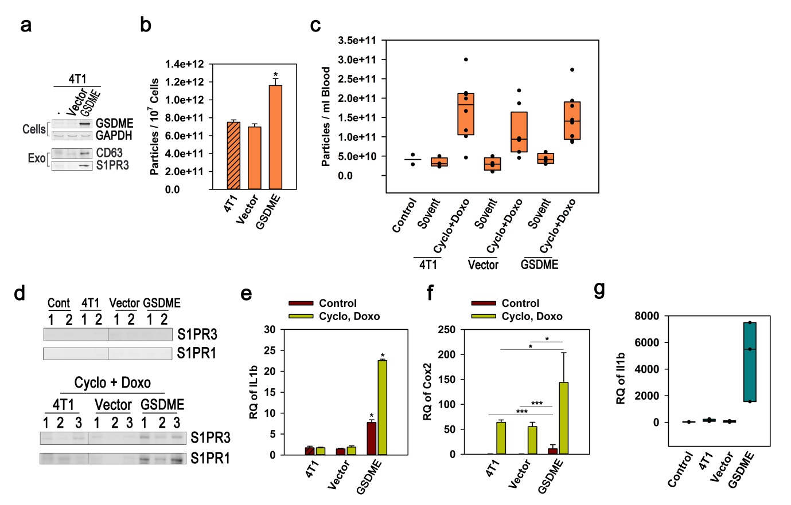

Figure S27. GSDME overexpression enhances the level of plasma apoptotic exosomes and inflammation in the 4T1 orthotropic breast cancer model. (a, upper panel) Parental 4T1 cells and cells infected with control vector or Gsdme cDNA were western-blotted to affirm Gsdme expression. (a, lower panel and b) The cells were treated with staurosporine (1 μM) for 24 hrs. The released ApoExos were measured by western blotting and NTAs. (c and d) BALB/c mice were injected in their mammary fat pads with 4T1, vector-infected 4T1, or Gsdme-infected 4T1 cells, and tumors were grown for around 3 weeks, until their mass reached 1,000 mm³. Plasma exosomes were prepared from the mice intraperitoneally treated with solvent or cyclophosphamide (50 mg/kg) and doxorubicin (3 mg/kg) and analyzed by NTAs (c) and western blotting for the markers of ApoExos (d). (e and f) mRNA expression of inflammatory mediators in liver tissue was measured by real-time PCR. (g) Equal volume of plasma exosomal fractions was treated into mouse bone marrow-derived macrophages for 16 hrs and expression of Il1b mRNA was measured by real-time PCR. The experiments were performed in triplicate in b, e, and f. Number of animals was seven and three in c-f and g, respectively. Data are from two or three representative animals in d. Data are presented as mean ± SD in b, c, and e-g. *P < 0.001 and ***P<0.05 in b, e, and f.

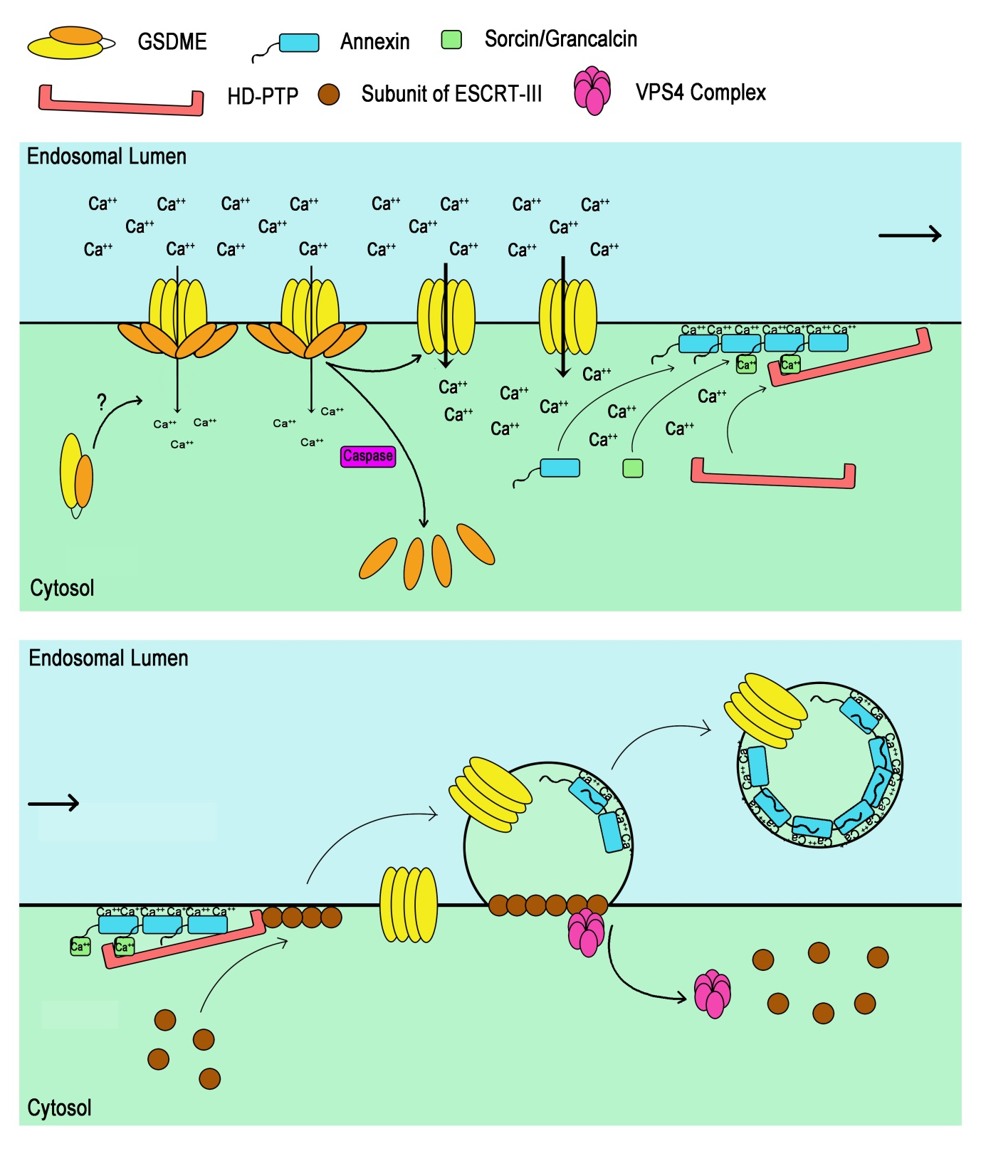

Figure S28. Schematic illustration summarizing GSDME-mediated biogenesis of apoptotic exosomes. In the apoptotic cells, GSDME migrate toward the endosomal membrane and make pores under the influence of unknown factors, where full-length GSDME are required because of an undefined role of C-terminal domain. GSDME in the membrane are cleaved by caspases, thereby producing N-terminal fragments. Ca²⁺ enters the cytosol through the pores made of N-terminal domain or full-length form of GSDME although the entrance of Ca²⁺ through the pores of the N-terminal domain oligomers of GSDME is more effective than those of full-length form. Increase of the regional Ca²⁺ concentration sequentially recruits Ca²⁺-binding proteins, annexins, sorcin/grancalcin, and HD-PTP to the endosomal membrane. Members of the ESCRT-III complex bind to the Bro1 domain of HD-PTP and begin to make outward buds in the endosomal membrane. Eventually, the budded endosomal membrane is liberated as intraluminal vesicles by membrane fission with the help of the VPS4 complex, which contributes to the fission of the endosomal membrane and disassembly of the ESCRT-III complex for recycling. The luminal side of the intraluminal vesicles is coated by annexins such as ANXA2, which possibly function as membrane scaffolds.

