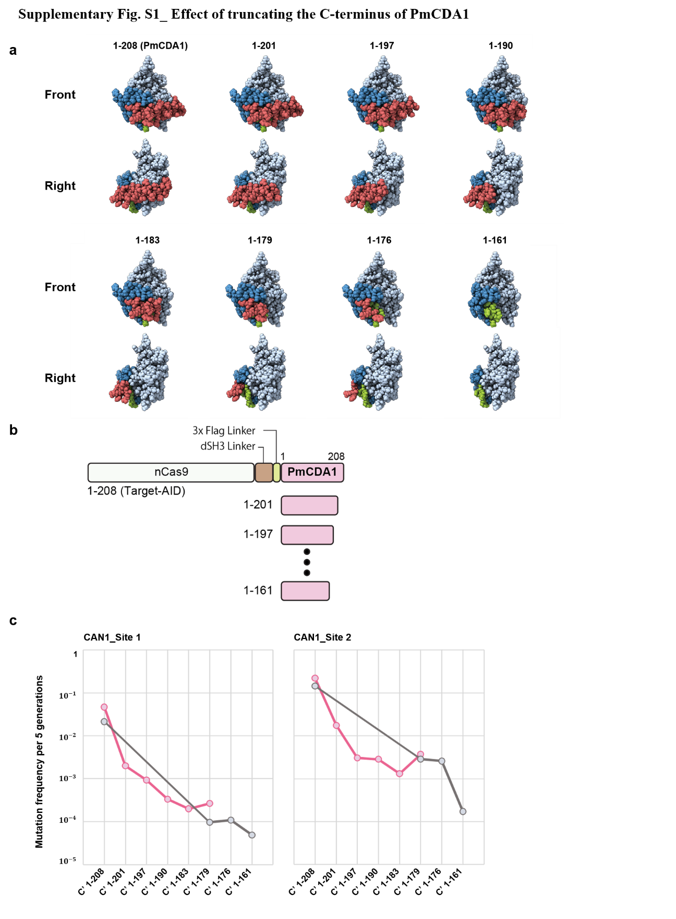
Supplementary Fig. S1_ Effect of truncating the C-terminus of PmCDA1. a, A series of space-filling structure predictions for C-terminally truncated PmCDA1. The non-catalytic dsDNA binding domain is shown in green (N-terminus) and red (C-terminus), respectively. The blue segments represent adjacent moieties to be truncated to smooth protein shape and minimize section. b, C-terminally truncated Target-AID constructs tested in c. c, Trends of on-target editing efficiencies for the truncated constructs in yeast. Occurrences of canavanine resistant mutants were measured as CAN1 gene mutants. Trend lines for different data sets (pink and grey dots) are plotted for CAN1-1 and CAN1-2 target sites.

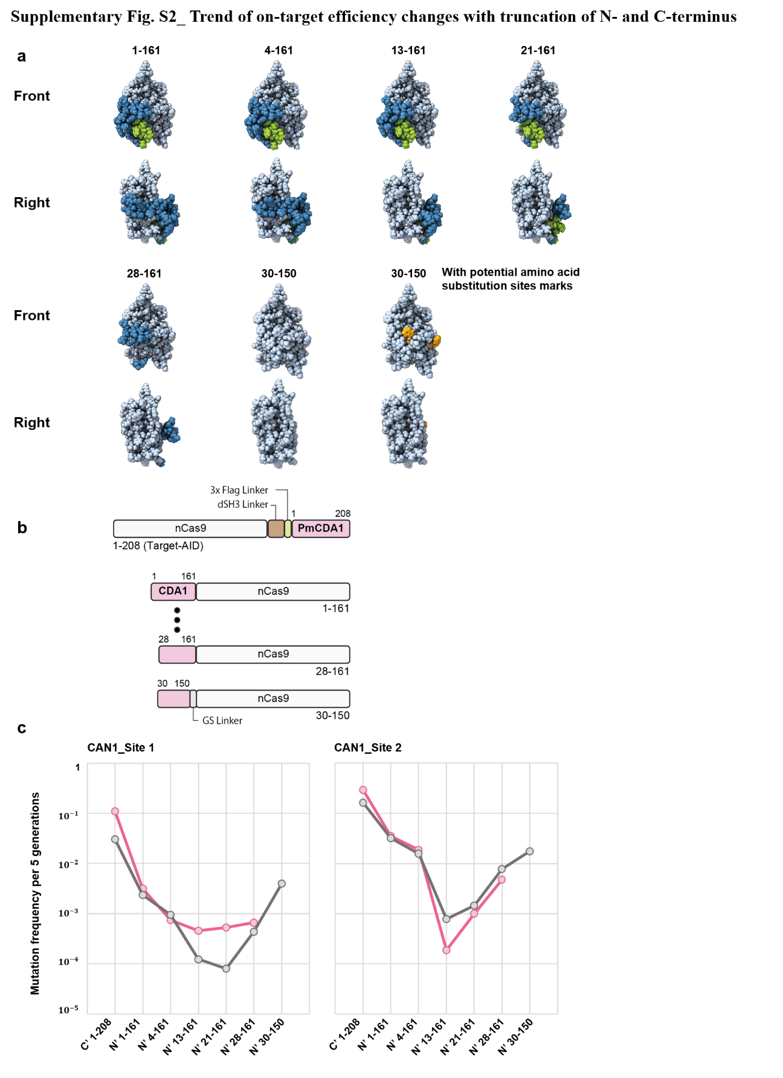
Supplementary Fig. S2_ Effect of truncating the N- and C-terminus of PmCDA1. a, A series of space-filling structure predictions for N- and C-terminally truncated PmCDA1. The non-catalytic dsDNA binding domain is shown in green (N-terminus) and the blue segments represent adjacent moieties to be truncated to smooth protein shape and minimize section. b, N- and C-terminally truncated Target-AID constructs tested in c. c, Trends of on-target editing efficiencies for the truncated constructs in yeast. Occurrences of canavanine resistant mutants were measured as CAN1 gene mutants. Trend lines for different data sets (pink and grey dots) are plotted for CAN1-1 and CAN1-2 target sites.

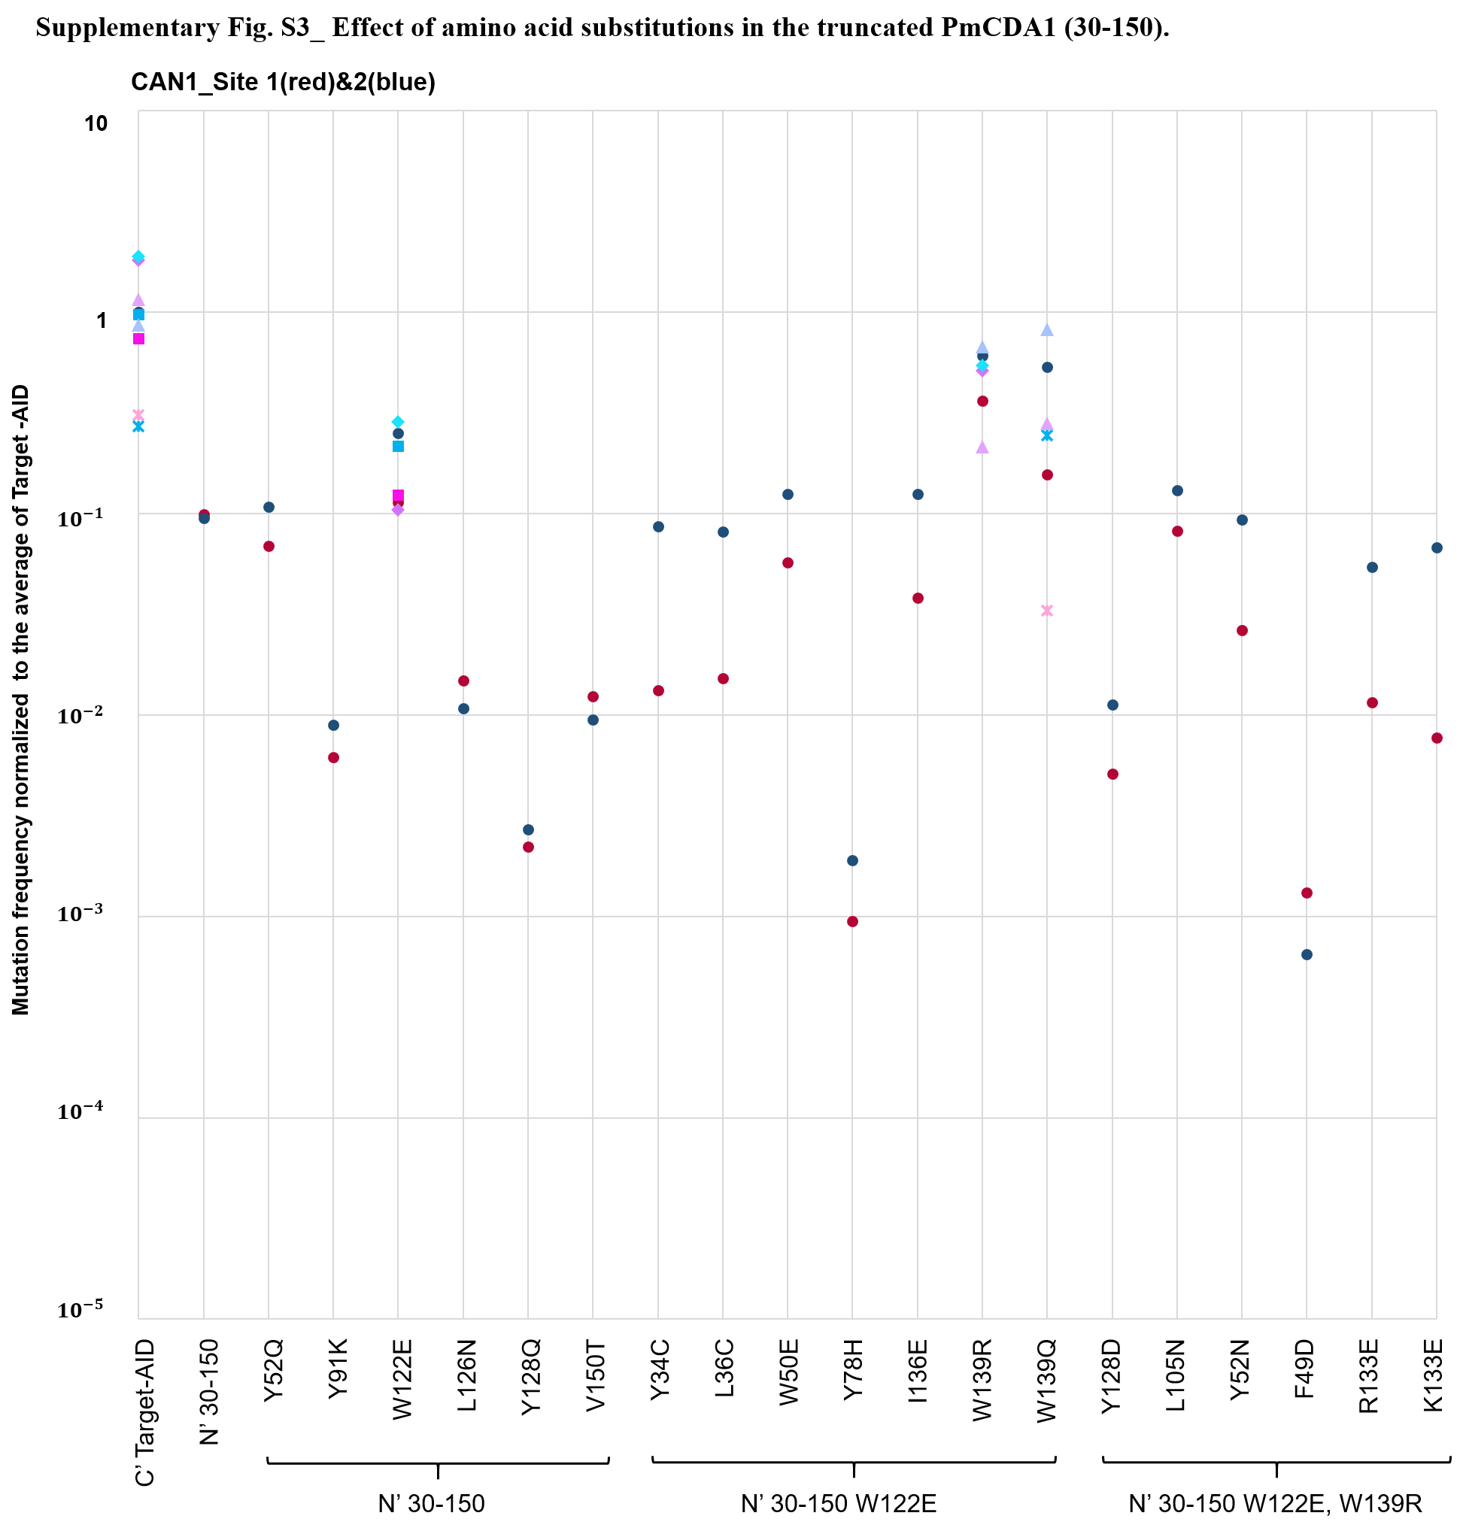
Supplementary Fig. S3_ Effect of amino acid substitutions in the truncated PmCDA1 (30-150). Hydrophobic residues exposed after truncation were subject to substitution with hydrophilic residues. On-target editing efficiency was measured by yeast canavanine assay in the forms as in Supplementary Fig. S2 and normalized to the average of Target-AID. Biological replicates were plotted for CAN1-1 (red) and CAN1-2 (blue) target sites. Different data sets are shown in different dot shapes.

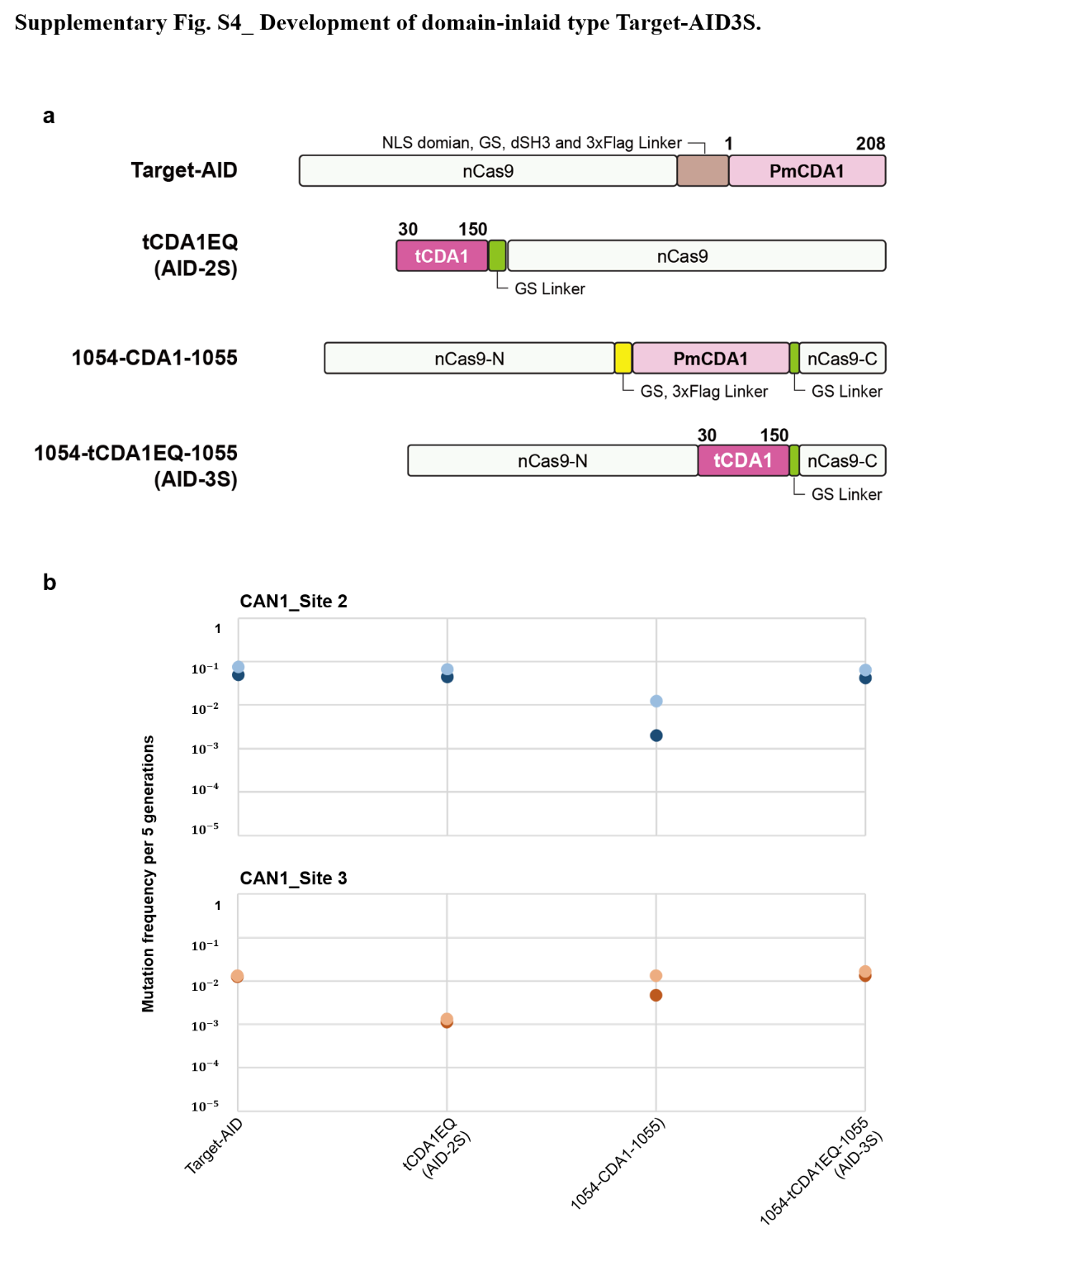
Supplementary Fig. S4_ Development of domain-inlaid type Target-AID3S. a, The domain-inlaid AID-3S (1054-tCDA1EQ-1055) was developed in position of RuvC domain of Cas9. b, On-target editing efficiencies evaluated in yeast. Biological triplicates were plotted for CAN1-2 (blue dots) and CAN1-3 (orange dots) target sites.

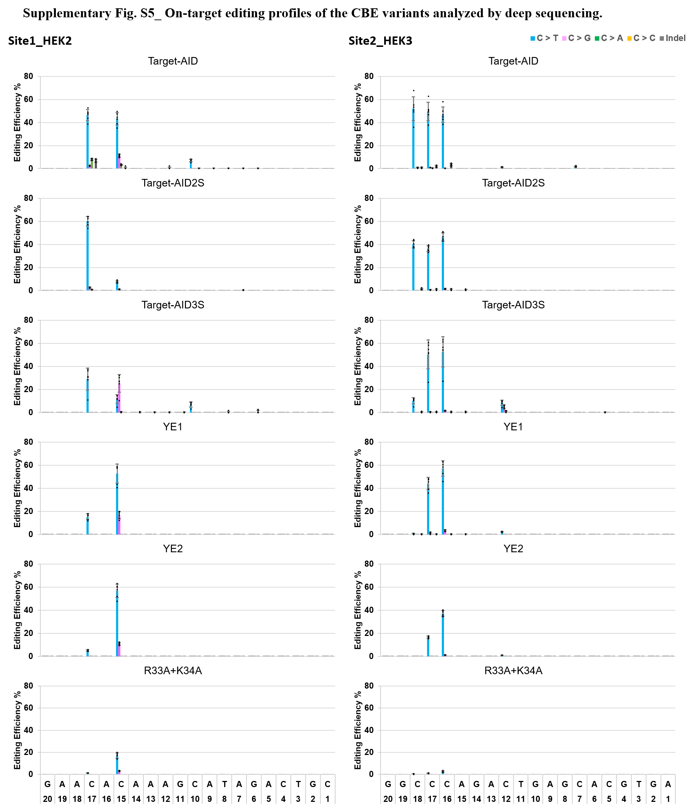
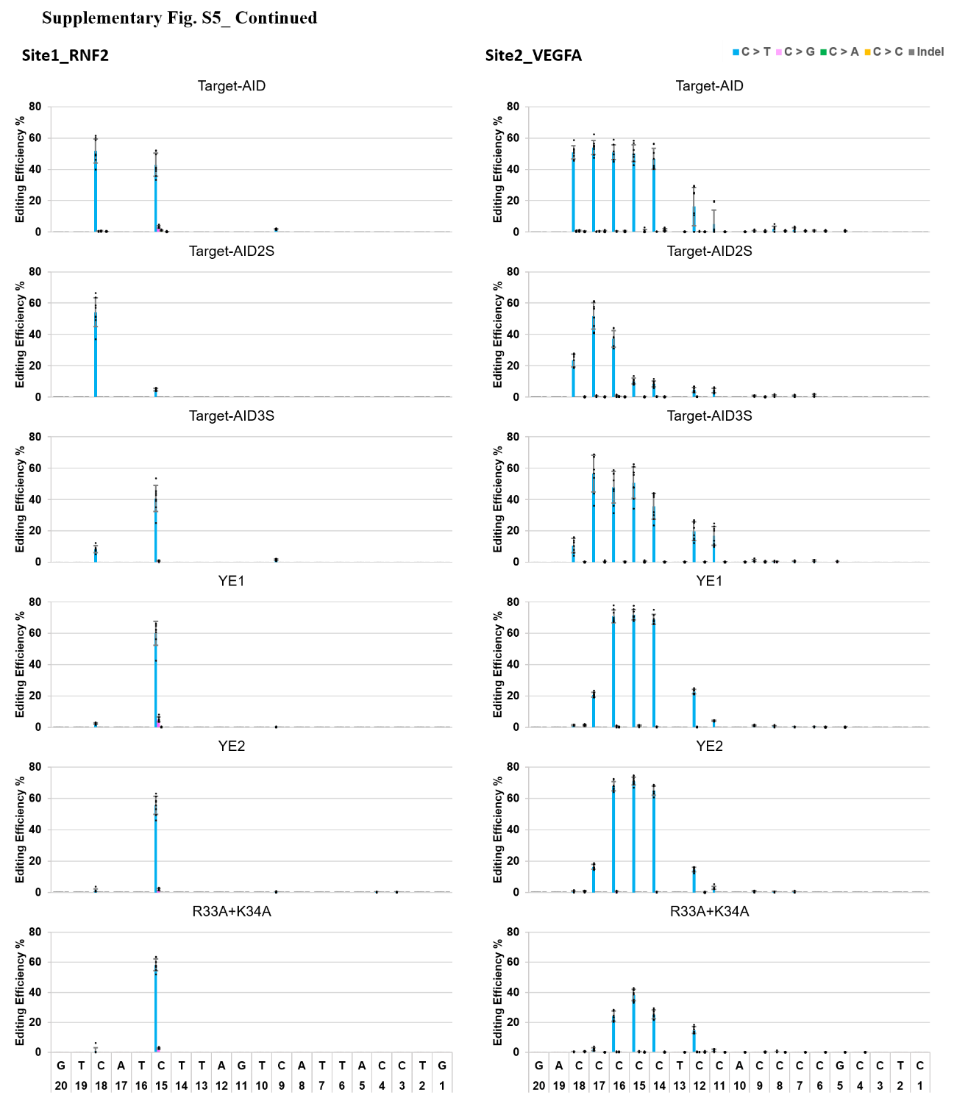
Supplementary Fig. S5_On-target editing profiles of the CBE variants in HEK293T cells. HEK2, HEK3, RNF2, and VEGFA target sites were selected and analyzed by deep sequencing. Mutation frequencies at each nucleotide position (numbered from the PAM sequence side of the target sequence toward the 5’ side) are shown. The mean scores (square bars) of each nucleotide conversion with standard deviations (error bars) are shown and each biological replicate is plotted with a dot (n=6 for HEK2 and HEK3, n=8 for RNF2 and VEGFA target sites).

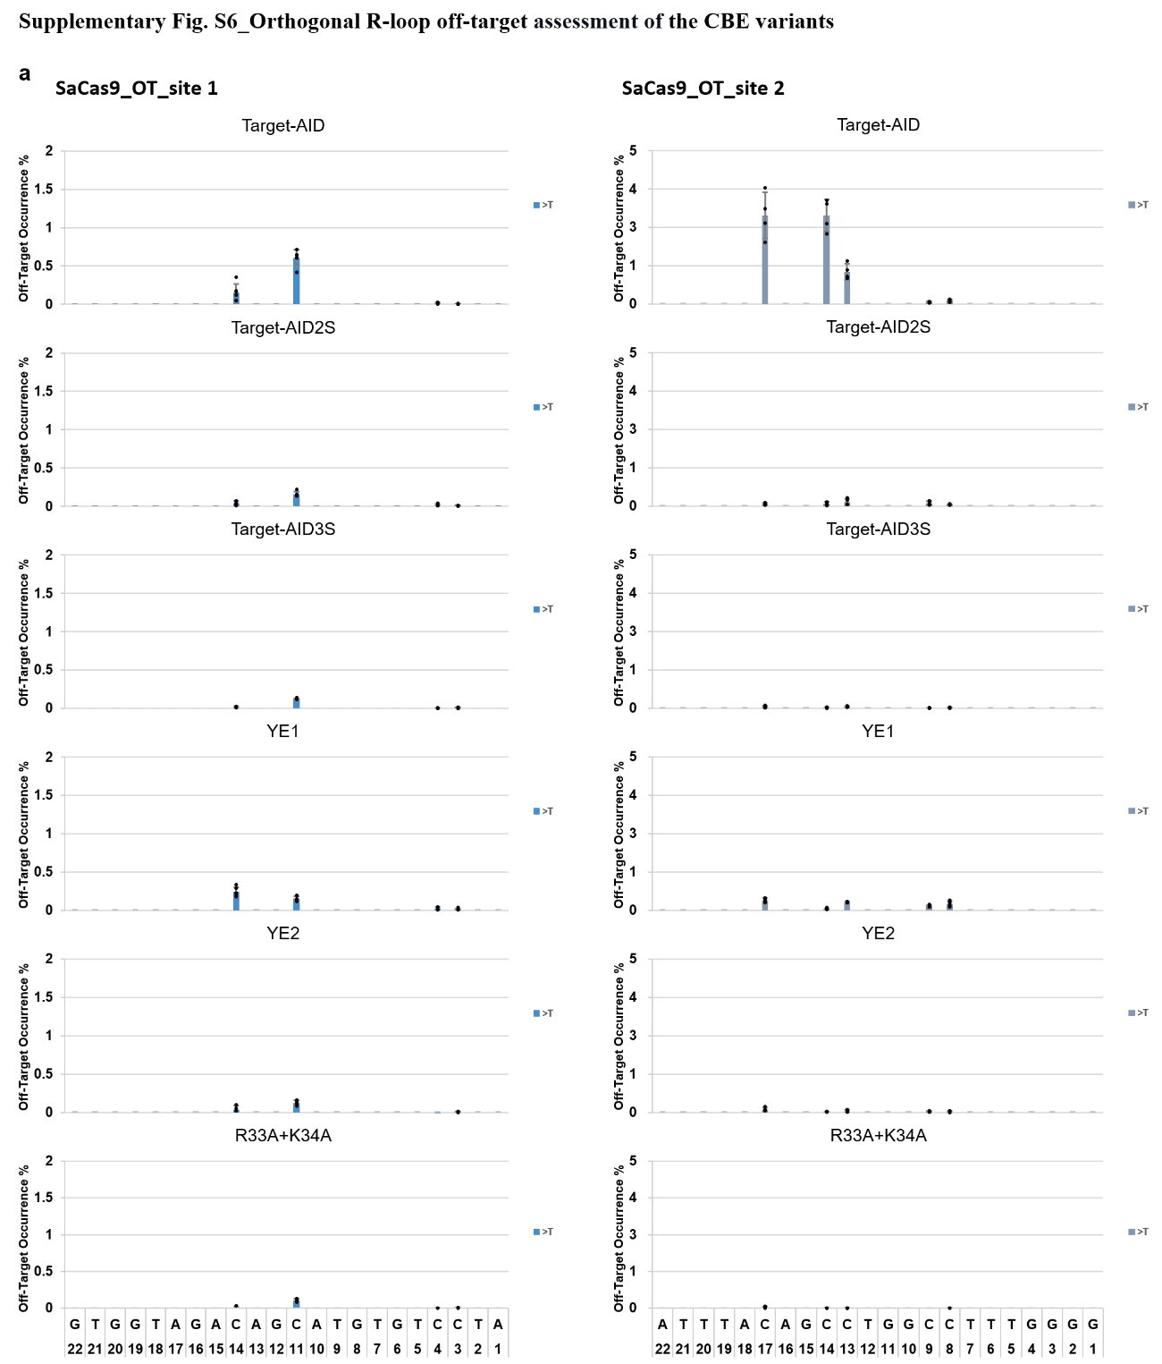

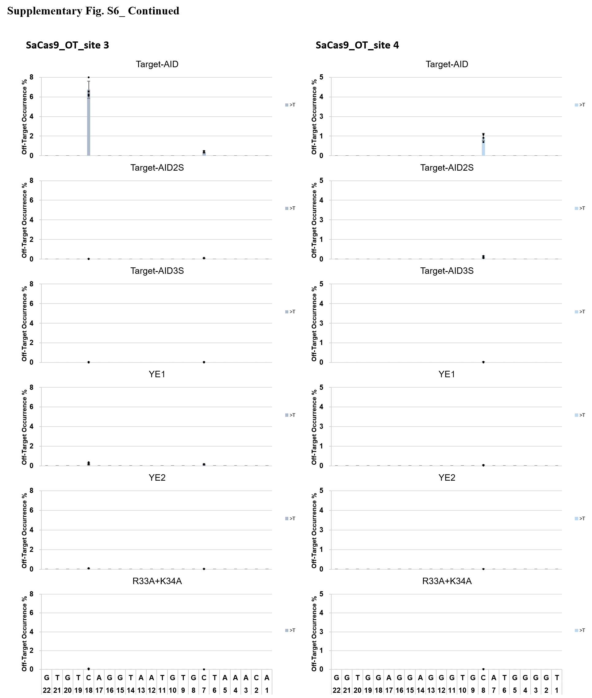

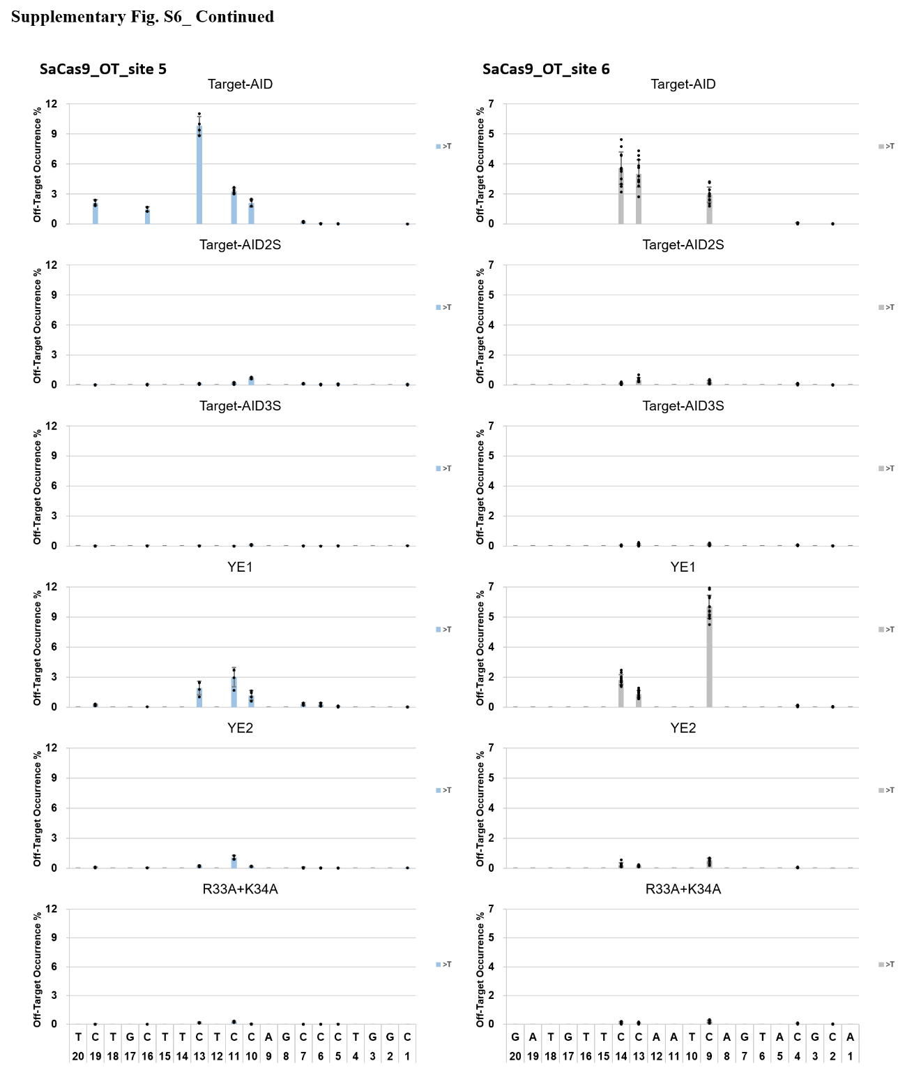

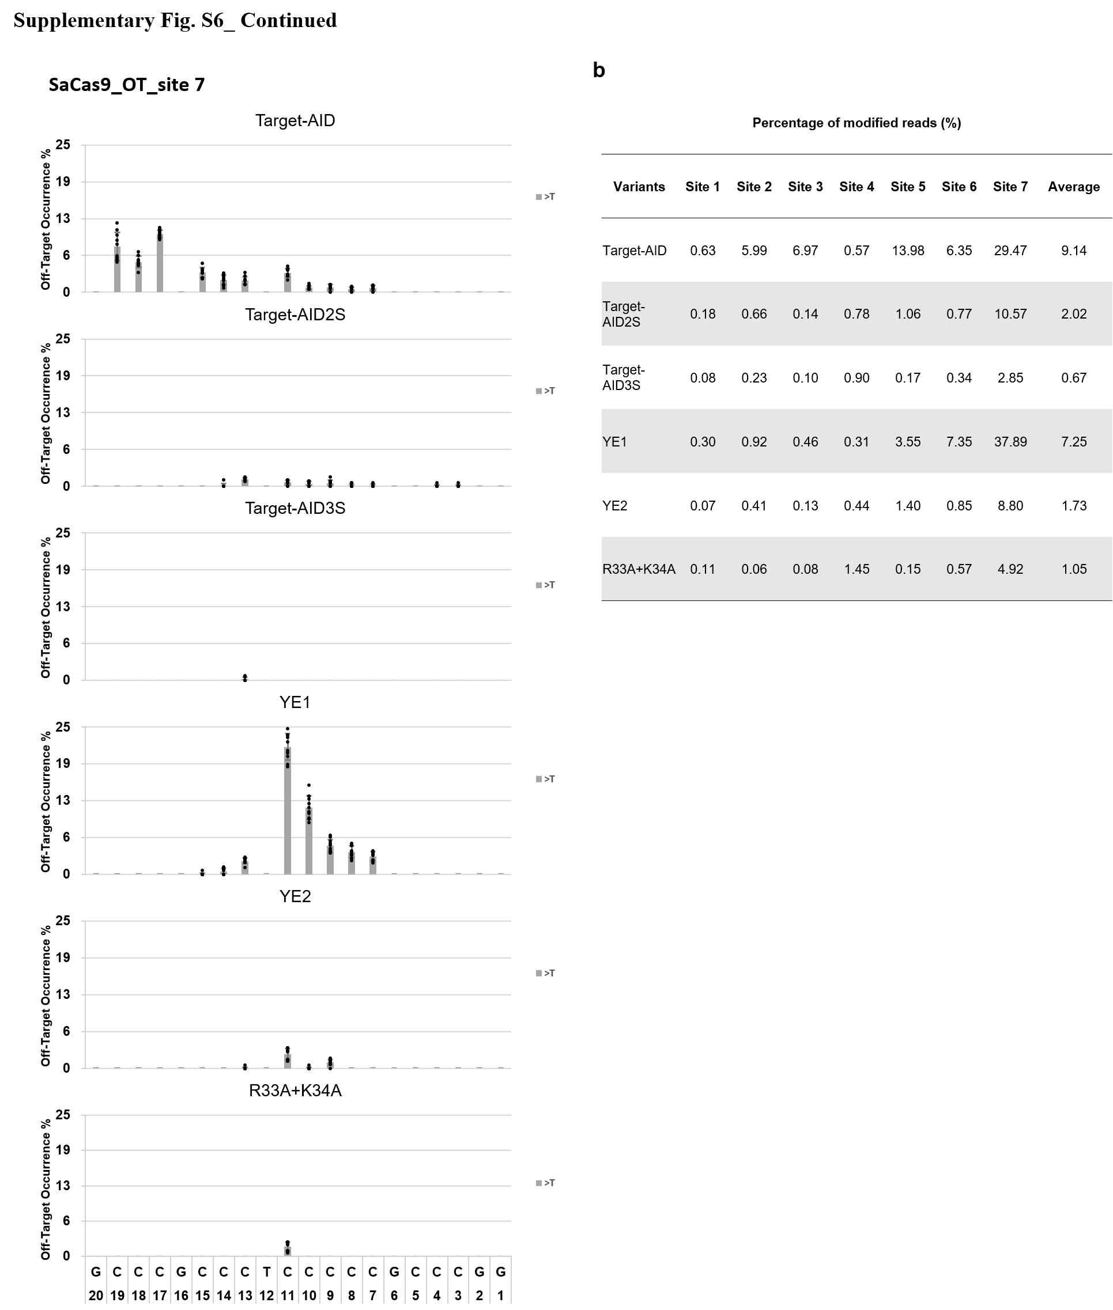
Supplementary Fig. S6_Orthogonal R-loop off-target assessment of the CBE variants. gRNA-independent off-target potential of the CBE variants assessed by the R-loop assay in HEKT293T cells. a, Seven SaCas9 target sites were selected (OT_site1~7) and the mutation frequencies at each nucleotide position are shown. The mean scores (square bars) of C to T conversion with standard deviations (error bars) are shown. Each biological replicate is plotted with a dot (n=6, n=4, n=12 and n=10 for site 1, 2~5, 6 and 7, respectively). b, Table showing the percentage of the modified reads for each target site.

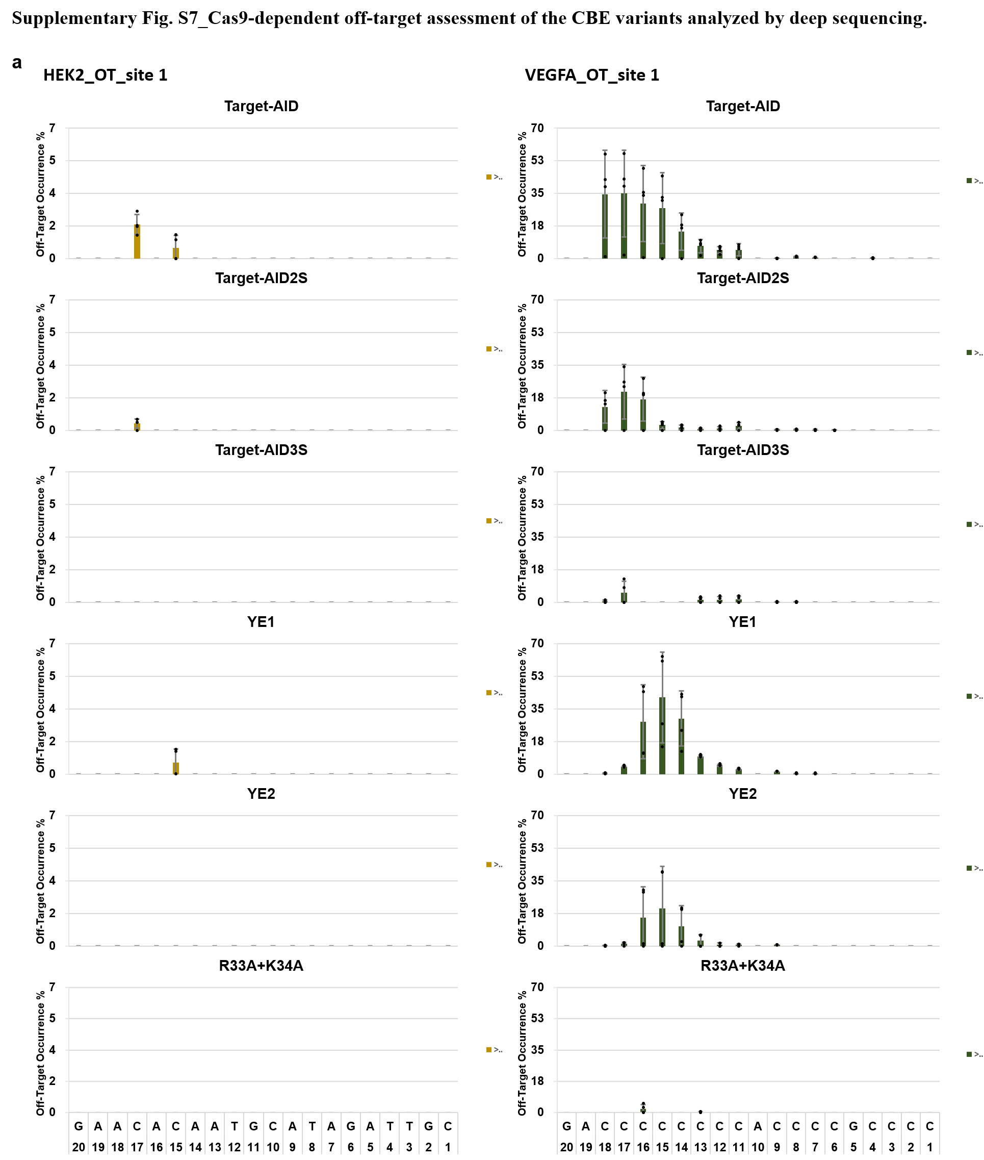

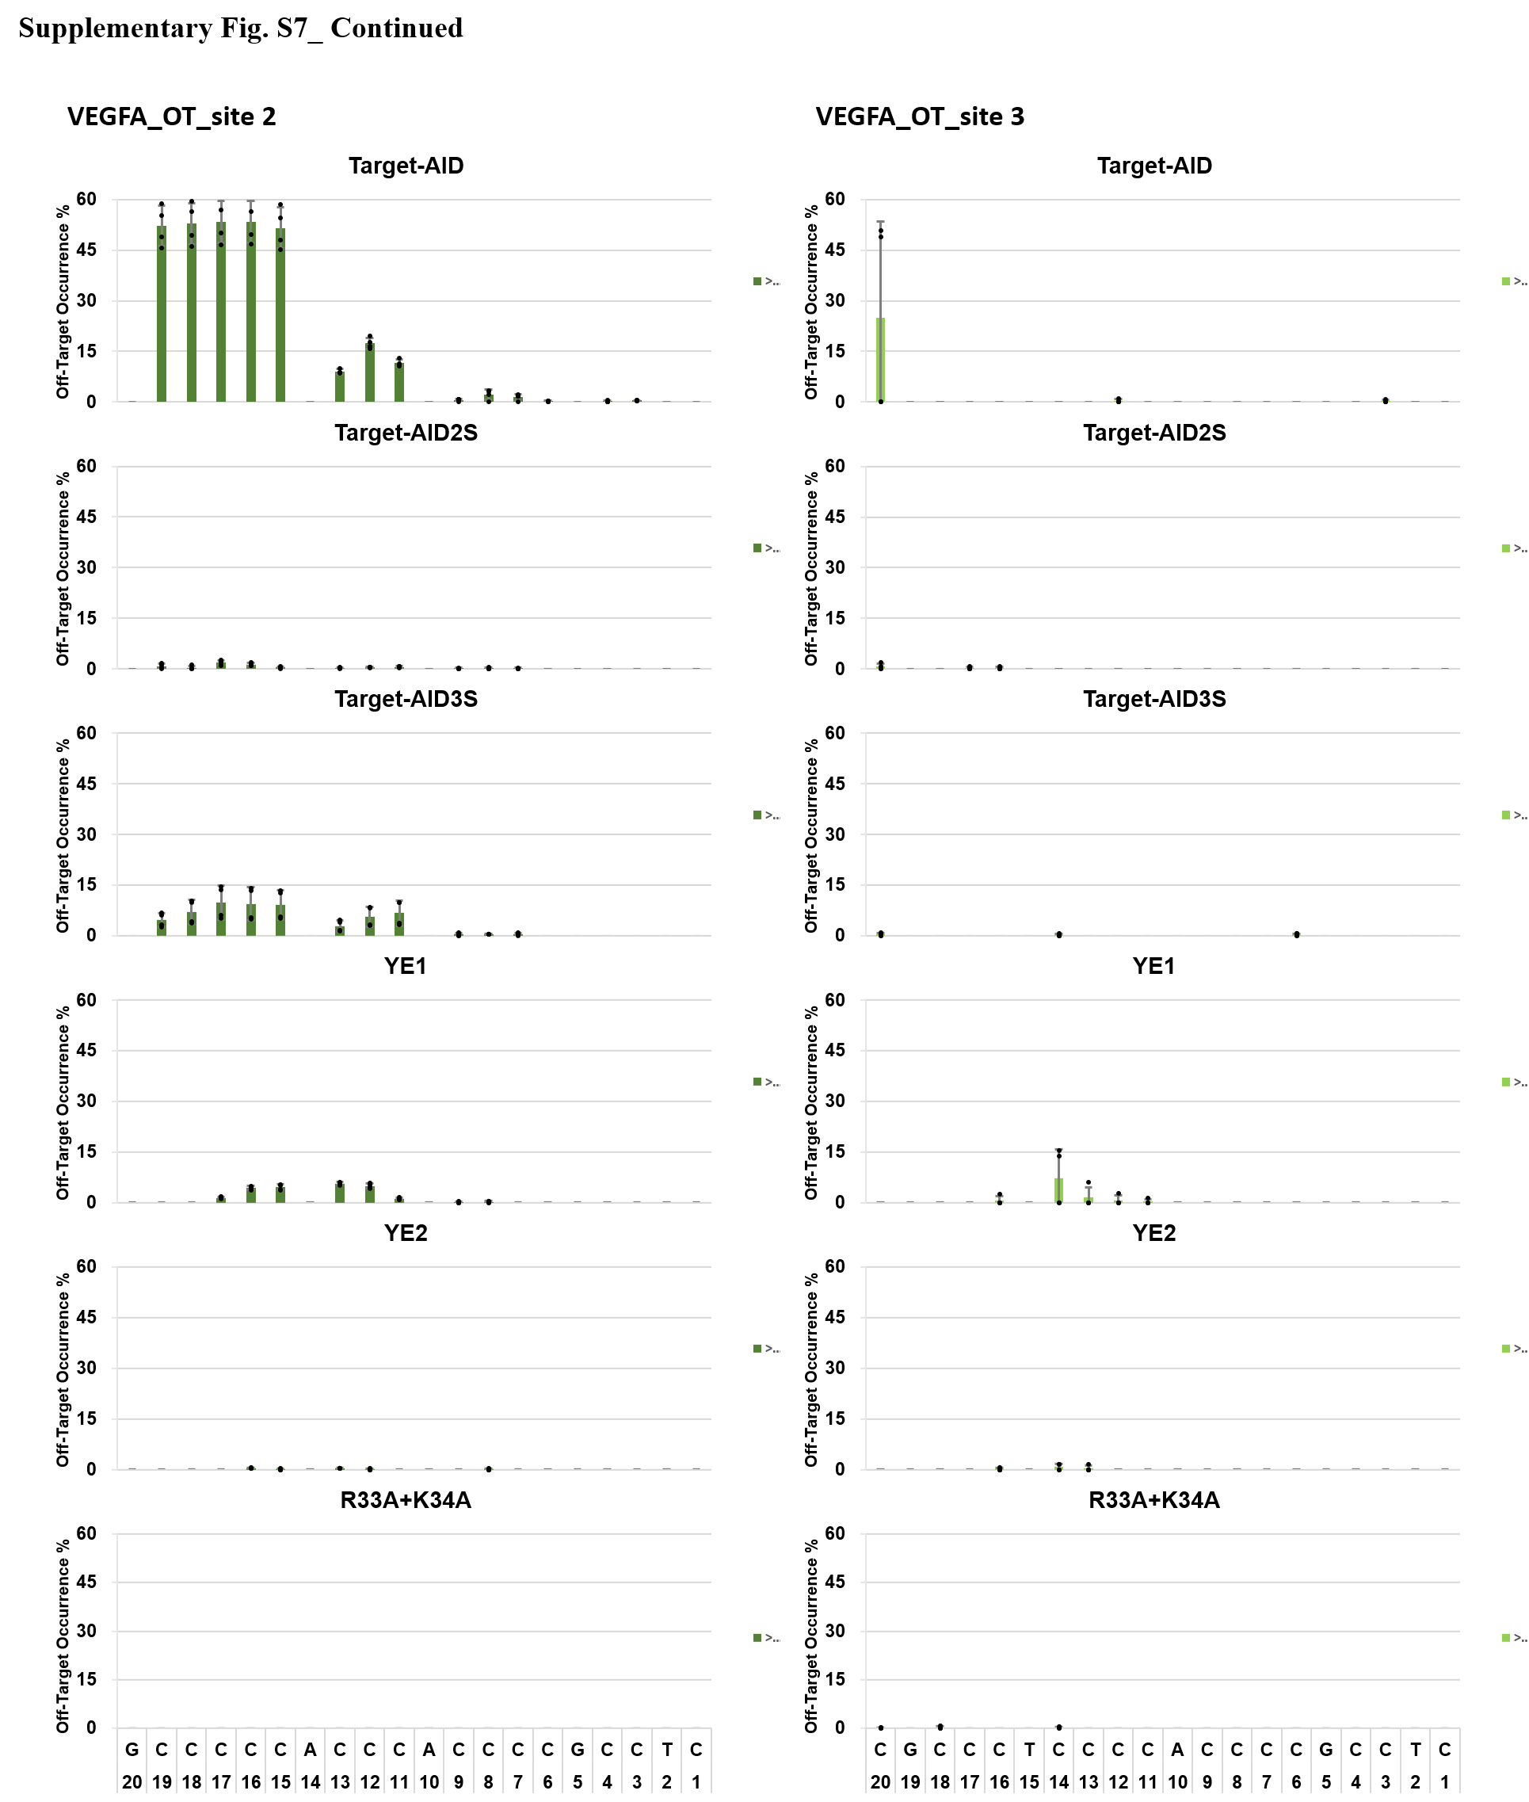

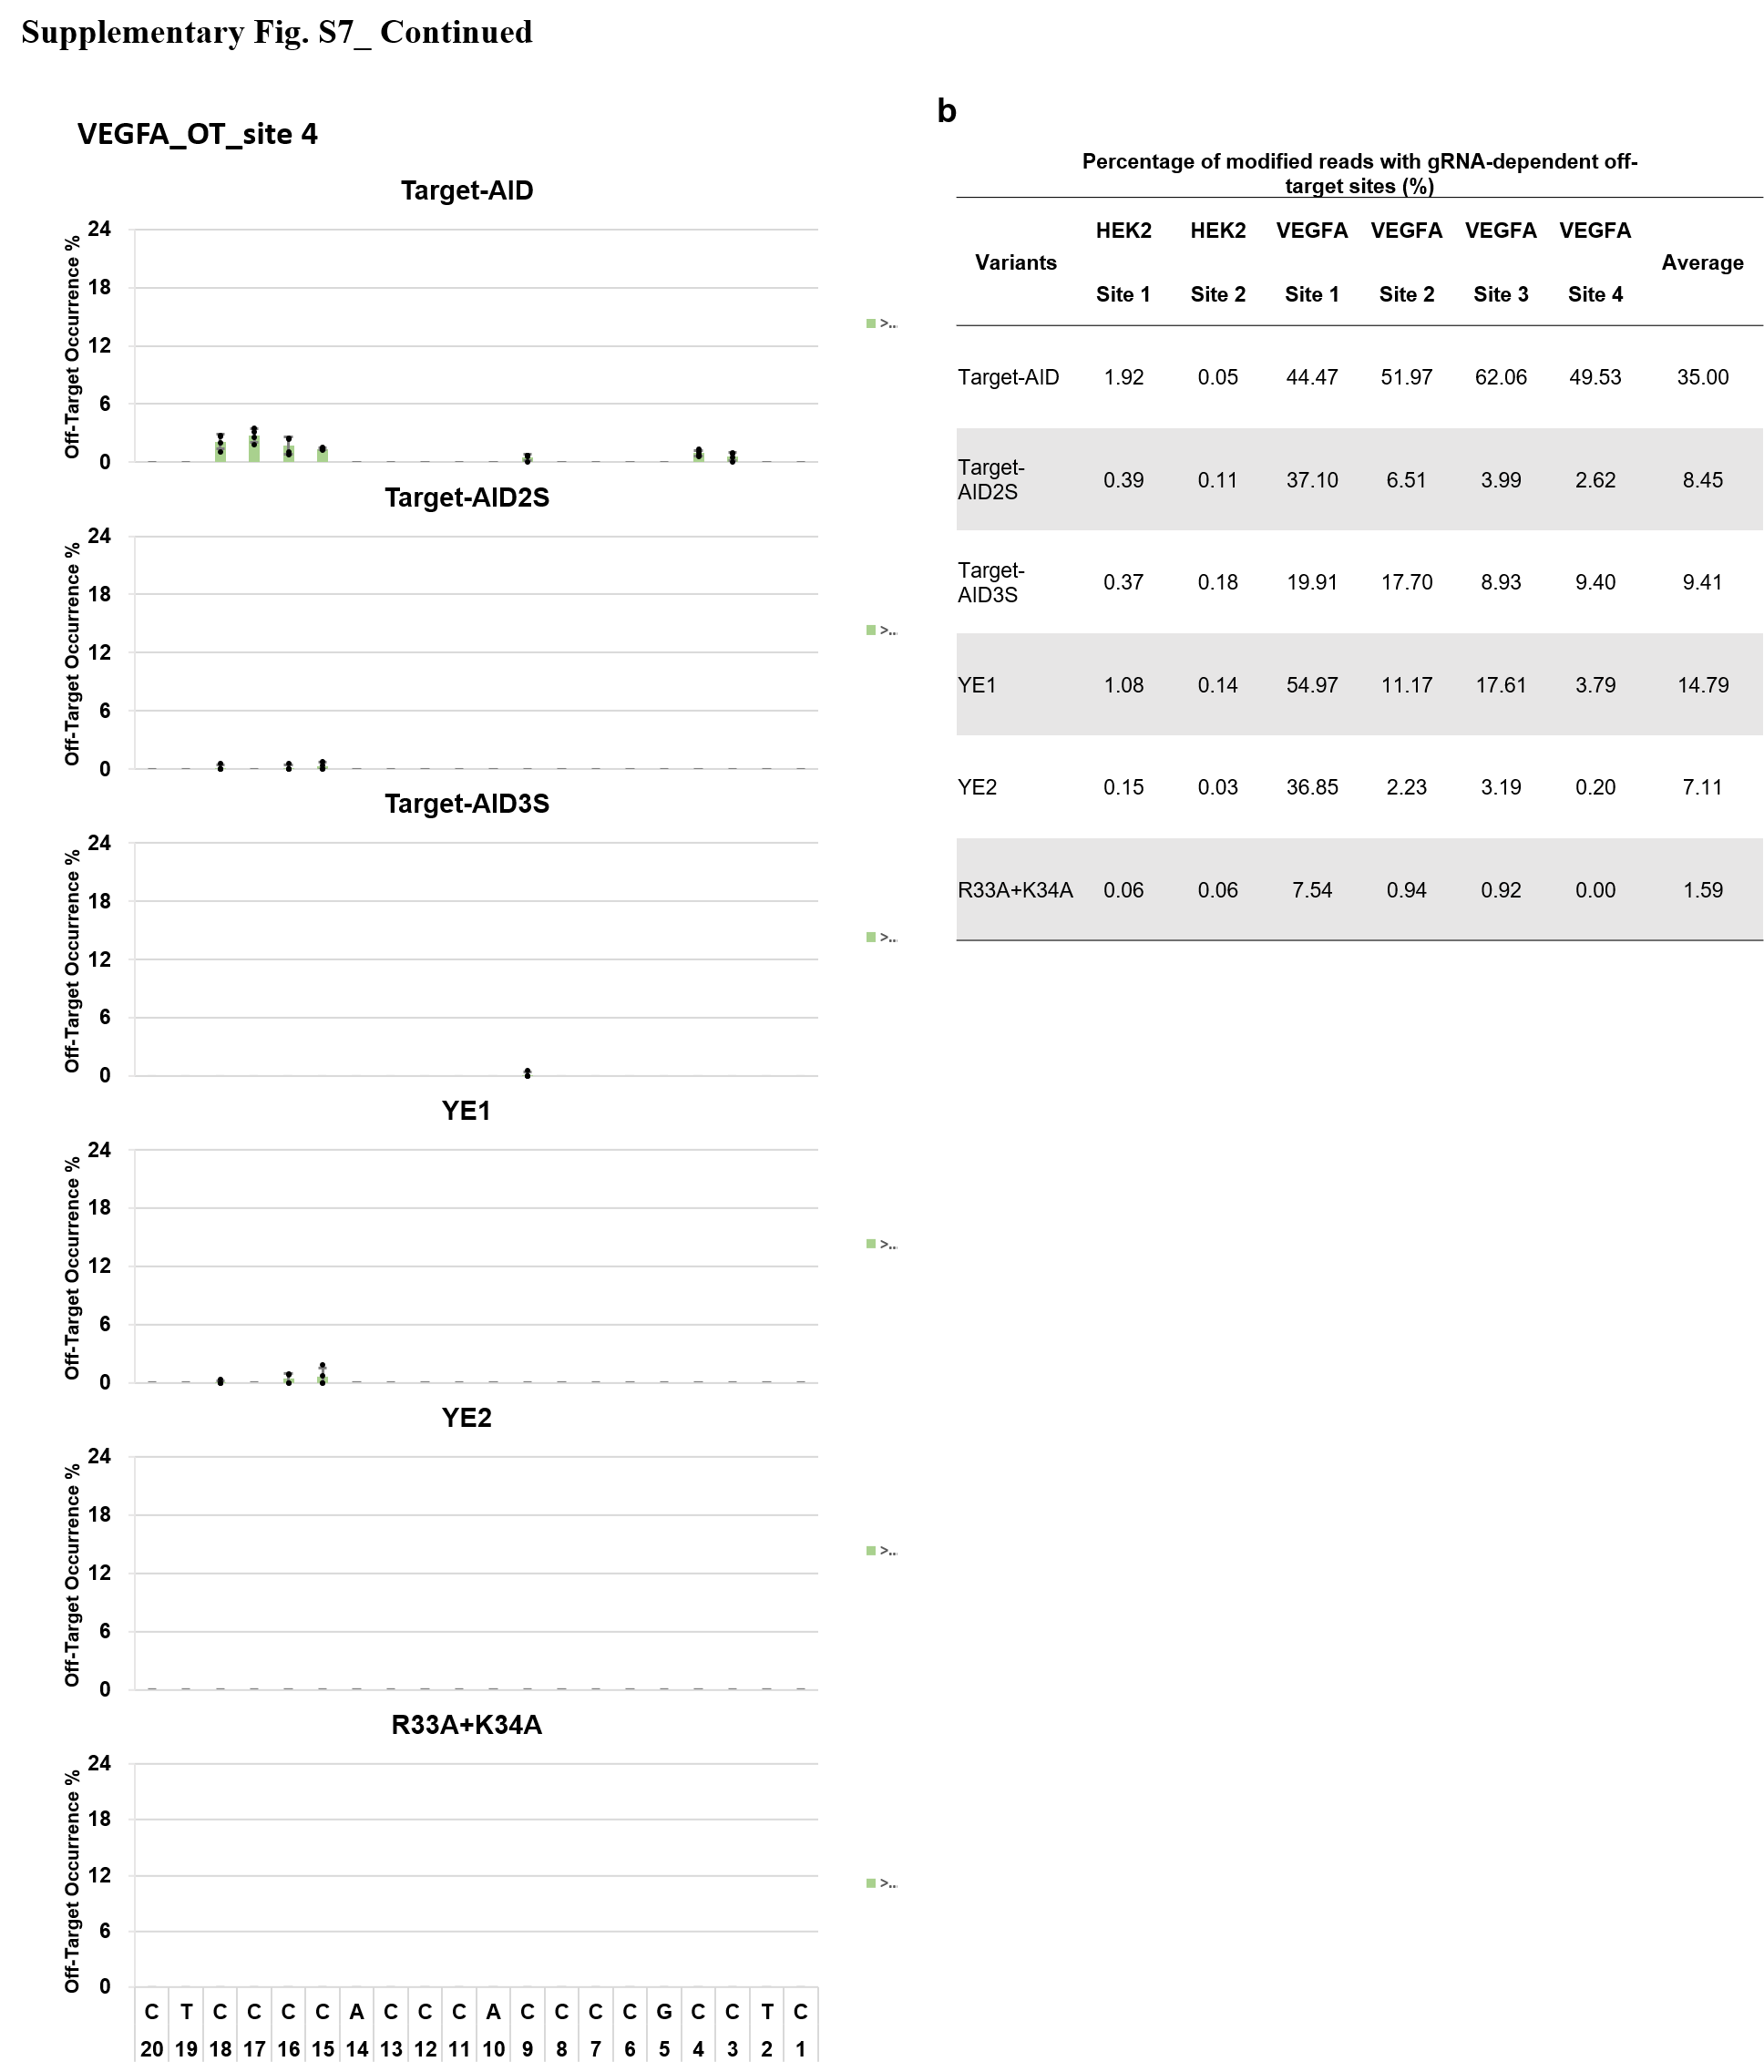
Supplementary Fig. S7_gRNA-dependent off-target of the CBE variants. gRNA-dependent off-target occurrences evaluated in HEKT293 cells. a, Two HEK2 off-target sites (1~2) and four VEGFA off-target sites (1~4) were analyzed by deep sequencing and the off-target mutation frequencies at each nucleotide position are shown (no off-target editing at HEK2_Site 2 were detected within the verified window for all CBE variants). The mean scores (square bars) of C to T conversion with standard deviations (error bars) are shown. Each biological replicate is plotted with a dot (n=4). b, Table showing the percentage of the modified reads for each target site.

