Quantum interference comparison between benzene, naphthalene, and azulene single molecular junction
Baker Naji Abdulrazzaq Alrawi, Alaa A. Al-Jobory
Department of Physics, College of Science, University of Anbar, Anbar, Iraq
Email: bak22s2002@uoanbar.edu.iq

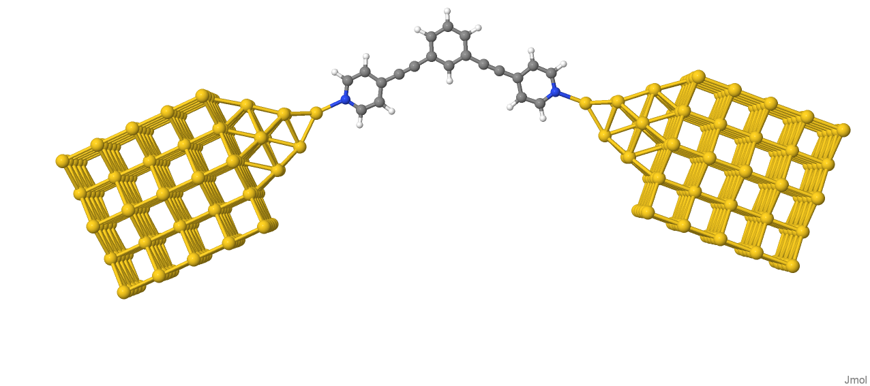
Benzene

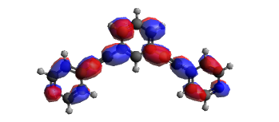
HOMO LUMO
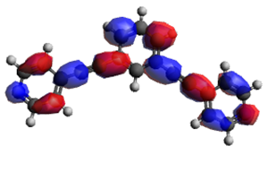
(b)

For meta connection the wave function for both HOMO and LUMO are ${ ψ}_{3}^{L}ψ_{5}^{L}<0$ and ${ ψ}_{3}^{H}ψ_{5}^{H}<0$ therefore, the T(E) are DQI.

Figure (S1): (a) A pyridine holds the benzene core to the gold electrodes. (b) The benzene molecular orbital.

S1

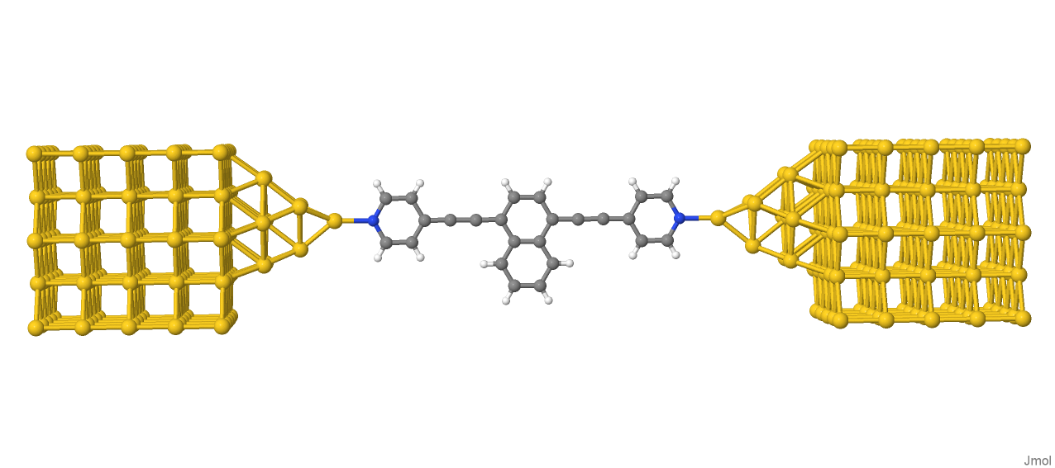
(Naphthalene)
(a)

(b)
HOMO LUMO
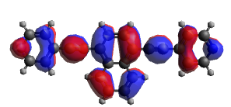
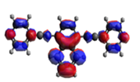

applying the product rule of HOMO and LUMO, the product ${ ψ}_{2}^{L}ψ_{5}^{L}>0$ and ${ ψ}_{2}^{H}ψ_{5}^{H}<0$ therefore we expected the transmission CQI.

Figure(S2): (a) A pyridine holds the naphthalene core to the gold electrodes. (b) The naphthalene molecular orbital.

S2
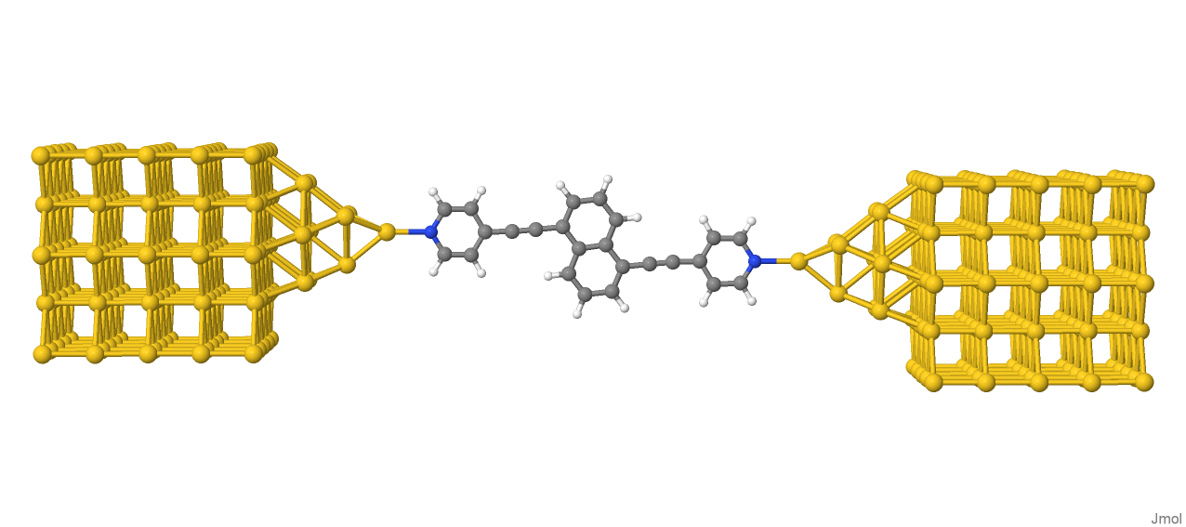

(a)

(b)
LUMO
HOMO
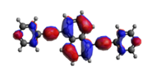
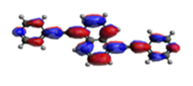

applying the product rule of HOMO and LUMO, the product ${ ψ}_{2}^{L}ψ_{7}^{L}<0$ and ${ ψ}_{2}^{H}ψ_{7}^{H}>0$ therefore we expected the transmission CQI.

Figure(S3): (a) A pyridine holds the naphthalene core to the gold electrodes. (b) The naphthalene molecular orbital.

S3
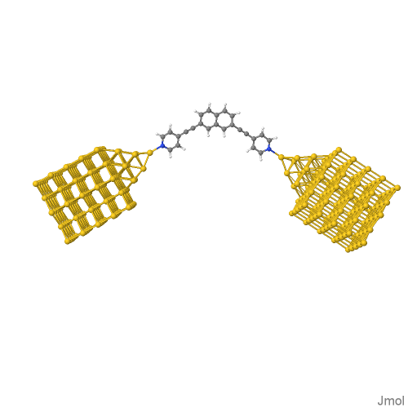
(a)

(b)

LUMO
HOMO
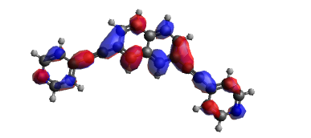
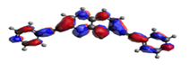

applying the product rule of HOMO and LUMO, the product ${ ψ}_{3}^{L}ψ_{9}^{L}<0$ and ${ ψ}_{3}^{H}ψ_{9}^{H}<0$ therefore we expected the transmission DQI.

Figure(S4): (a) A pyridine holds the naphthalene core to the gold electrodes. (b) The naphthalene molecular orbital.

S4

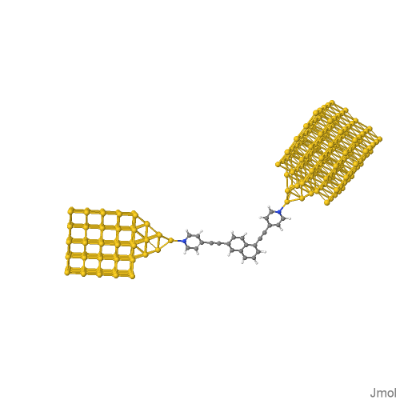

HOMO LUMO
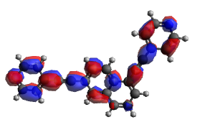
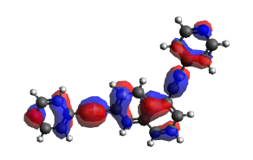

applying the product rule of HOMO and LUMO, the product ${ ψ}_{3}^{L}ψ_{7}^{L}<0$ and ${ ψ}_{3}^{H}ψ_{7}^{H}<0$ therefore we expected the transmission DQI.

Figure(S5): (a) A pyridine holds the naphthalene core to the gold electrodes. (b) The naphthalene molecular orbital.

S5

(Azulene)
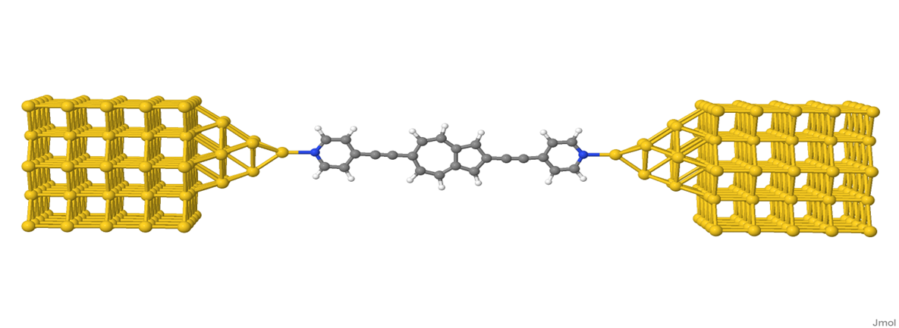

(b)
HOMO LUMO
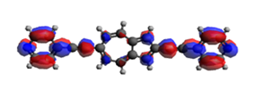
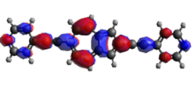

applying the product rule of HOMO and LUMO, the product ${ ψ}_{4}^{L}ψ_{9}^{L}>0$ and ${ ψ}_{4}^{H}ψ_{9}^{H}<0$ therefore we expected the transmission CQI.

Figure(S6): (a) A pyridine holds the azulene core to the gold electrodes. (b) The azulene molecular orbital.

S6

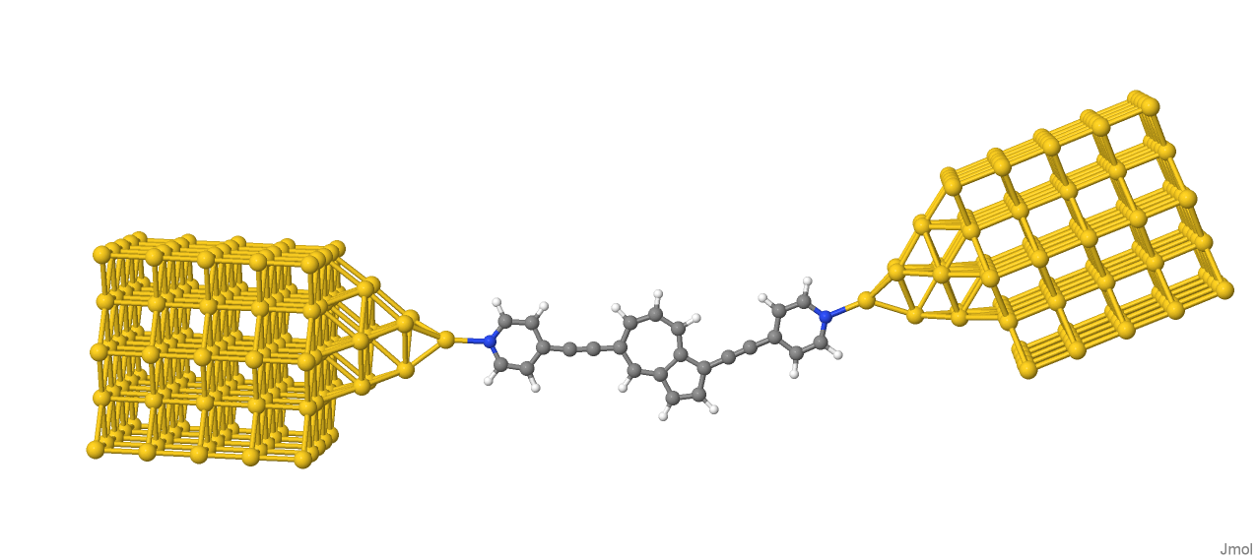

(a)

(b)

HOMO LUMO
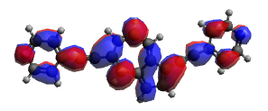
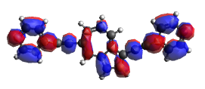

applying the product rule of HOMO and LUMO, the product ${ ψ}_{3}^{L}ψ_{8}^{L}>0$ and ${ ψ}_{3}^{H}ψ_{8}^{H}<0$ therefore we expected the transmission CQI.

Figure(S7): (a) A pyridine holds the azulene core to the gold electrodes. (b) The azulene molecular orbital.

S7

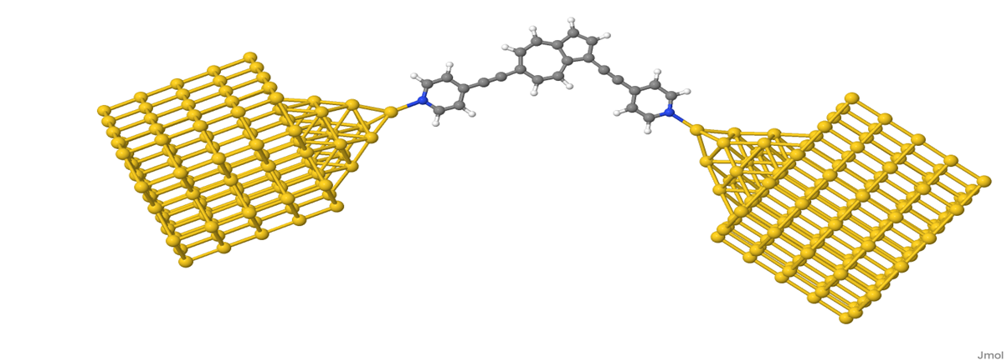

(a)

(b)
HOMO LUMO
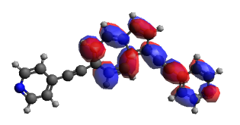
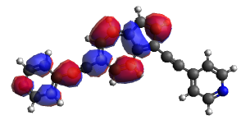

applying the product rule of HOMO and LUMO, the product ${ ψ}_{4}^{L}ψ_{10}^{L}<0$ and ${ ψ}_{4}^{H}ψ_{10}^{H}<0$ therefore we expected the transmission DQI.

Figure(S8): (a) A pyridine holds the azulene core to the gold electrodes. (b) The azulene molecular orbital.

S8

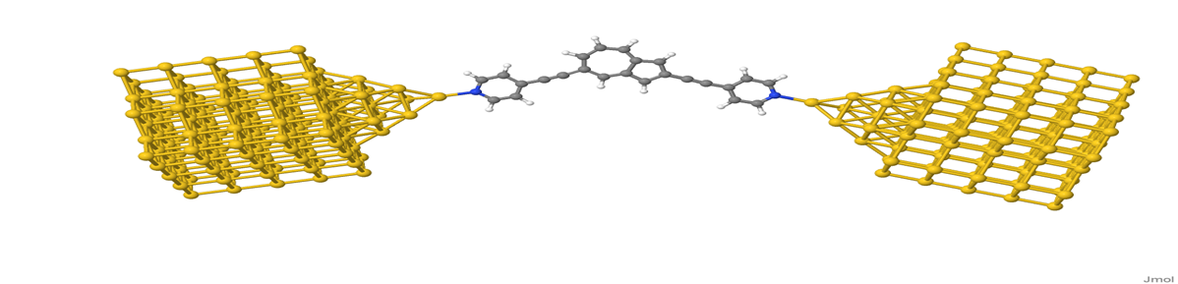
(a)

(b)

HOMO LUMO
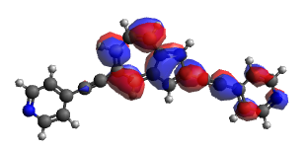
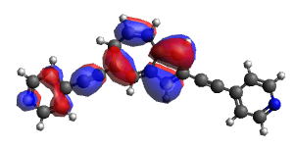

applying the product rule of HOMO and LUMO, the product ${ ψ}_{3}^{L}ψ_{9}^{L}<0$ and ${ ψ}_{3}^{H}ψ_{9}^{H}<0$ therefore we expected the transmission DQI.

Figure(S9): (a) A pyridine holds the azulene core to the gold electrodes. (b) The azulene molecular orbital.

S9

