Susceptibility to South African cassava mosaic virus is Associated with a RING Finger E3 Ubiquitin Ligase

Patience Chatukuta, Chrissie Rey*

School of Molecular and Cell Biology, University of the Witwatersrand, South Africa
*Corresponding author

ADDITIONAL FILE 1

Protoplast yields as determined by flow cytometric quantification
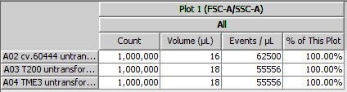
Additional Fig. 1: Enumeration of events in protoplast solutions (A02 = Manihot esculenta cv.60444; A03 = M. esculenta T200; A03 = M. esculenta TME3). Events were detected on the BD Accuri™ C6 Flow Cytometer (BD Biosciences, San Jose, CA, USA).

Mutations induced by CRISPR-mediated gene editing in MeE3L.
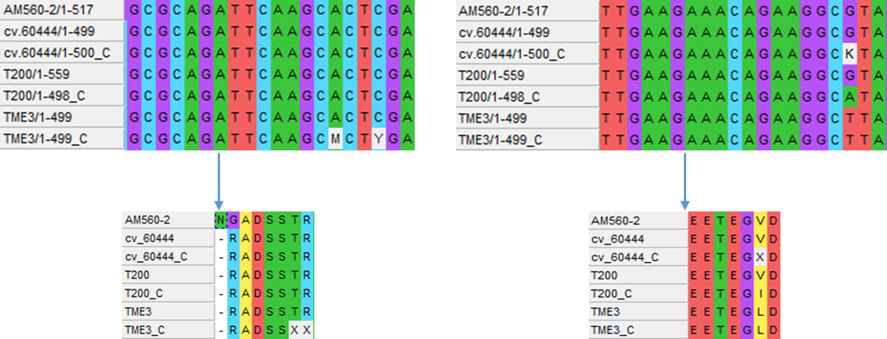
Additional Fig. 2: Nucleotide sequences and predicted amino acid sequences of CRISPR-edited MeE3L and MeE3L respectively, from cassava genotypes cv.60444, susceptible T200 and tolerant TME3, targeted by gRNA1 (GGCGCAGATTCAAGCACTCGA) and gRNA2 (GAAACAGAAGGCGTAGATTTG) against reference cassava cultivar AM560-2. C = CRISPR transformed.

