Tables
Table 1. Outcomes before and after both periods
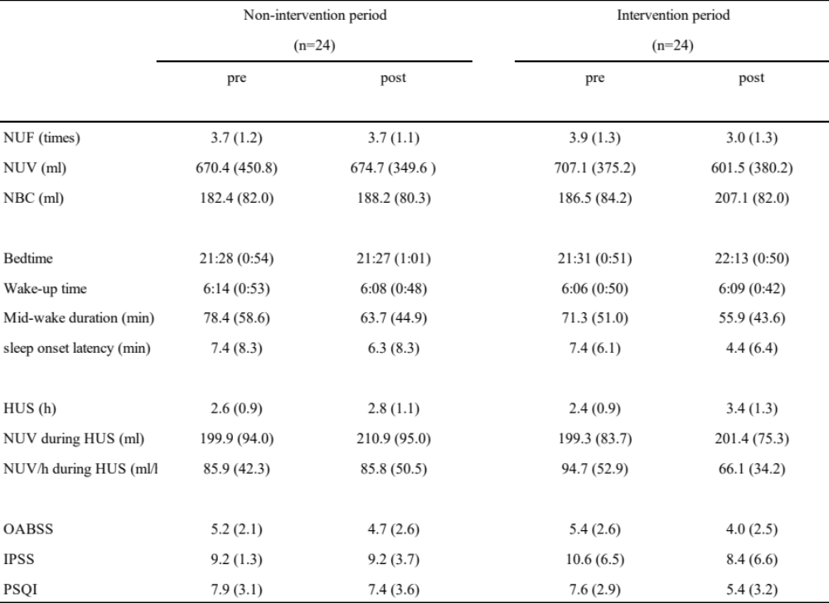Abbreviations: HUS, hours of undisturbed sleep; IPSS, International Prostate Symptom Score; NBC, nocturnal bladder capacity; NUF, nocturnal urinary frequency; NUV, nocturnal urine volume; NUV/h, nocturnal urine volume per hour; OABSS, overactive bladder symptom score; PSQI, Pittsburgh sleep quality index. Data are presented as mean (standard deviation).

Table 2. Outcomes of changes in the secondary endpoint
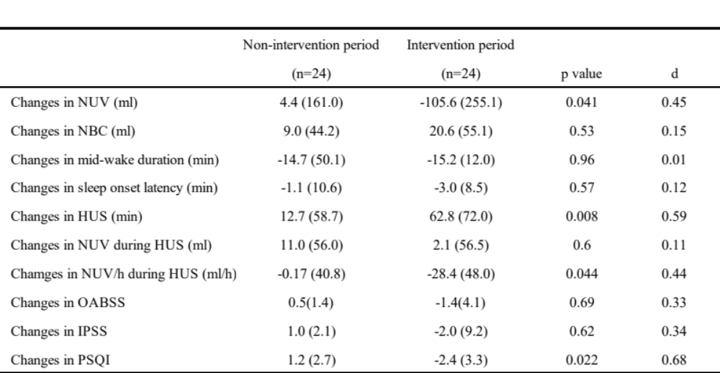Abbreviations: HUS, hours of undisturbed sleep; IPSS, international prostate symptom score; NBC, nocturnal bladder capacity; NUF, nocturnal urinary frequency; NUV, nocturnal urine volume; NUV/h, nocturnal urine volume per hour; OABSS, overactive bladder symptom score; PSQI, Pittsburgh sleep quality index.

Table 3. Patient's background
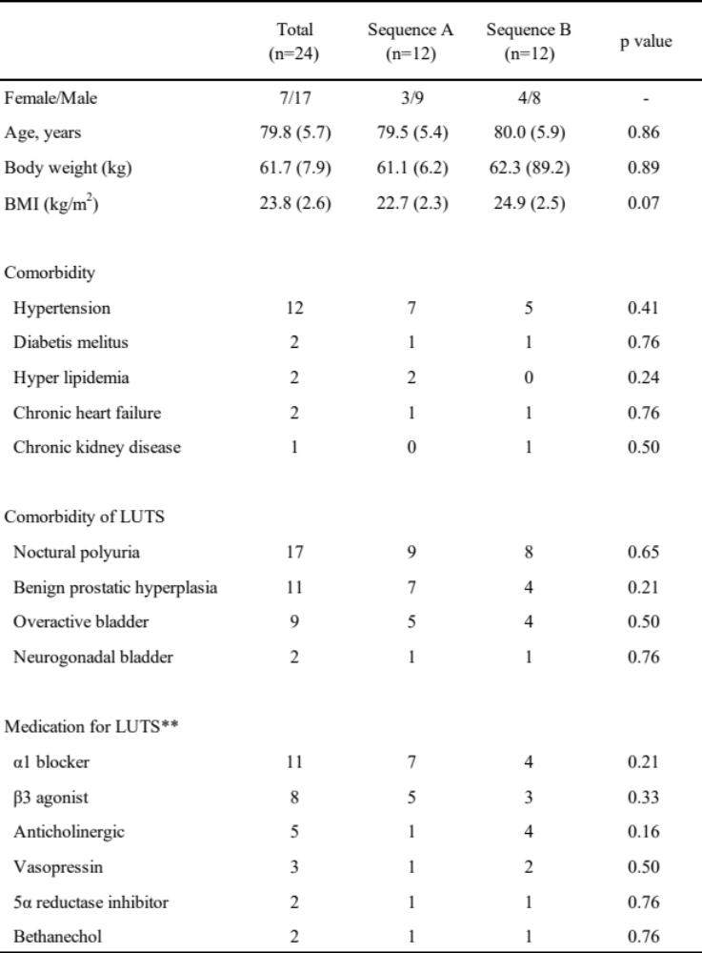
Abbreviations: BMI, body mass index, LUTS, lower urinary tract symptom.

