Supplementary Information
Gallic acid derived aza Michael adducts at diarylpropanone framework exhibit antiproliferative and synergistic antibacterial activities
Sneha Singh, Sana Khan, Alka Kurmi, Ranjana Das, Barsha Thapa, Poonam Rani, Feroz Khan, Dharmendra Saikia, Debabrata Chanda, Arvind Singh Negi*
¹CSIR-Central Institute of Medicinal & Aromatic Plants (CSIR-CIMAP), Lucknow, 226015, (U.P.), India
²Academy of Science and Innovative Research (AcSIR), Ghaziabad, U.P. 201002, India;

S1. General experimentation
Reagents and chemicals were procured from Avra Synthesis, India and used without any purification unless otherwise specified. The reference compounds podophyllotoxin, doxorubicin, paclitaxel, penicillin G, norfloxacin, rifampicin, gentamycin, and dexamethasone were procured from Merck (Sigma). Dry solvents were prepared as per standard methods. Melting points were determined in open capillaries by EZ-Melt automatic Melting Point apparatus, Stanford Research System, USA. TLCs were run on Merck silica gel 60 F₂₅₄ aluminium sheets and spots were visualised in UV cabinet (254/320nm) and further sprayed 2% ceric sulphate aqueous sulphuric acid (10%) followed by charring at 80-100ºC in a hot air oven. ¹H NMR and ¹³C NMR were recorded on Bruker 500MHz NMR spectrometer after dissolving in CDCl₃. Chemical shifts are reported in ppm as δ scale taking tetramethylsilane (TMS) as reference compound. Multiplicity has been mentioned as s, singlet; d, doublet; t, triplet; q, quartet; dd, double doublet; m, multiplet. ¹H-¹H coupling constants are given in Hz. Low Resolution Mass were obtained on Shimadzu LC-MS and High Resolution Mass were obtained on Agilent 6520 Q-TOF after dissolving in methanol.
Bacterial strains used in this study were SA-Staphylococcus aureus (MTCC96), SE-Staphylococcus epidermidis (MTCC435), MS-Mycobacterium smegmatis (UDSC mc² 155), MRSA- Methicillin-resistant Staphylococcus aureus (ATCC33591), MRSE-Methicillin-resistant Staphylococcus epidermidis (ATCC51625).

S2. Cell Culture
Human cancer cell lines were American Type Culture Collection (ATCC) obtained from NCCS, Pune and grown at 37˚C in DMEM supplemented with 10% FBS and Ab-Am (antibiotic-antimitotic) solution in a CO₂ incubator (ThermoScientific, USA) under 5%CO₂ and 95% relative humidity. Cytotoxic activity of the compounds was assessed against human cancer cell lines viz. K562 (Chronic Myeloid Leukemia), and MDA-MB-231 (Triple negative breast adenocarcinoma), by Sulphorhodamine B dye based plate assay. Doxorubicin and podophyllotoxin were used as positive controls.

S3. Antiproliferative activity by SRB assay
Sulphorhodamine B assay was performed as per reported method. Cancer cells (2×10³ cells/well) were incubated in 5% CO₂ incubated for 24 h in 96 well microplate (Grenier, Germany), Michael derivatives (6a-6h) were individually dissolved in dimethylsulphoxide (Merck, Germany), in five concentrations prepared on serial dilution. These solutions were added into the wells and left for 4h. Media was replaced with fresh one and cells were incubated for another 24 h at 37˚C in the CO₂ incubator. The concentration of dimethylsulphoxide was kept below 1.25%, which is non-toxic to cells. Afterwards, from a stock solution (5mg/mL) of 20% TCA was added in each well and incubate the plates at 4°C for 1 h. after wards 10µL Sulphorhodamine B sodium salt (SRB) was added to each well and plates were incubated for 4h at 37˚C. Rinsed with 1% acidic acid. 200µL Tribase is added to plate. The plates were read at 515 nm on SpectraMax-190 microplate reader (Molecular Devices Inc., USA) within 1h of DMSO addition. Finally, 50% inhibitory concentration (IC₅₀) was calculated for dose dependent curves. % inhibition: [1-(Absorbance of drug treated cells/ Absorbance of untreated cells) × 100].

S4. Tubulin polymerisation assay
Microtubules are cytoskeletal filaments, outer diameter of more or less 25 nm, and are composed of heterodimers of globular α-tubulin and β-tubulin molecules. Tubulin kinetics experiment was carried out using Cytoskeleton ‘assay kit’ (Inc. Denver, USA). The standard antimitotic agents, podophyllotoxin (as polymerisation inhibitor) and paclitaxel (as depolymerisation inhibitor or polymerisation stabilizer) were used as positive controls. Protein (tubulin, 3 mg/mL) was placed in polymerization buffer (80 mM PIPES, pH 6.9, 2 mM MgCl₂, 0.5 mM EGTA, 1 mM GTP and 15% glycerol) in pre-warmed at 37°C 96-well microtiter plates after treating with compound 6b in different concentrations, mixed well and rate of tubulin polymerization was determined kinetically at 340 nm at one min interval for 1h in a plate reader (Spectramax). The IC₅₀/EC₅₀ were determined from dose-dependent analysis.

S5. Anti-bacterial activity
Sample Stock solution preparation and screening was done against some bacterial strains. It was done by broth dilution method and disk diffusion assay. The standard drug used in both methods is penicillin-G as positive control.

ST1. Zone of inhibition by Michael bases in some bacterial strains.
S. No. | Sample | Zone of inhibition (mm) against  Bacterial strains
S. No. | Sample | SA | SE | MRSA | MRSE
1. | 6a | - | - | 2 | 5
2. | 6b | - | - | - | 2
3. | 6c | - | - | - | -
4. | 6d | - | - | - | -
5. | 6e | 6 | - | - | -
6. | 6f | 7 | - | - | 2
7. | 6g | - | - | 2 | 2
8. | 6h | 8 | 7 | 2 | 6
9. | Pen.-G | 20 | 44 | 13 | 19

S6. Antimicrobial Activity
Antimicrobial activity is the property of any compound (either obtained from plant material or a crude drug) to kill or inhibit the growth of microbes. The compounds having the property of inhibiting the growth are called as “Static” (e.g. bacteriostatic agents, fungi-statics etc.) and those compounds having the property of killing the microbes are called as “Cidal” compounds like bactericidal compounds. The antimicrobial assays we used in the present study are, agar disc diffusion assay and broth dilution method. All the samples were prepared by making their stock solutions of 50 mg/mL dissolved in vehicle like DMSO. An antibiotic penicillin–G used as standard drug and 1 mg/mL stock was prepared.

S7. Media and Bacterial strain culture preparation
The Mueller Hinton Agar media for anti-TB activity was used to be prepared for the assay by dissolving their respective quantities into distilled water and then autoclaving the media to sterilize for 20-30 min at 121ºC and at 15 psi pressure. Bacterial pure strain was obtained from MTCC, Chandigarh and sub-cultured for the study via sterilized liquid broth media.

S8. Disc diffusion Assay
The agar diffusion test or disc diffusion antibiotic sensitivity testing is a test performed to know the antibiotic sensitivity of microbes. In this test, agar plates were inoculated with a standardized inoculum of the particular microbe and then the filter paper discs of (5-6 mm) diameter previously treated with Michael derivatives/antibiotic were placed on the agar plate surfaces, after incubation for overnight at 37ºC. If the particular test compound of interest/antibiotic stops the bacterial /fungal growth or kills the bacteria/fungi, there will be an area present around the disks where the bacteria/fungus have not grown enough to be visible. This is called a zone of inhibition. 100 µL of inoculum (0.5 McFarland) of the bacterial culture was withdrawn with caution and spread uniformly over the surface of Mueller–Hinton agar plate to get even lawn. 10 µL of sample was impregnated on the sterile paper disc (5 mm diameter, Whatman No.3 filter paper) and placed on the bacterial lawns. The plates were then incubated for 24 h (37°C) following which the diameter of the inhibition zone was measured. The net zone of inhibition was determined by subtracting the disc diameter (i.e. 5 mm) from the total zone of inhibition shown by the test disc in terms of clear halo bacterial lawn around the disc.

S9. Broth dilution method
Minimum inhibitory concentrations (MIC) of antibiotics and test compounds were determined by the broth dilution method as described by Clinical and Laboratory Standards Institute. The antibiotic was serially diluted in Mueller-Hinton broth in 96-well plates. The Michael base derivatives (6a-6h) solution were separately added to wells in a final concentration of 50 µg/mL; then broth was inoculated with 10 μL of diluted 24 h grown culture of test organisms with a titer equivalent to 0.5 McFarland standards. Each test sample was run in duplicate. The test plates were incubated at 37˚C for 24 h. The MIC was taken as the minimum concentration of the dilutions that inhibited the growth of the test micro-organism. The growth was recorded in terms of button formation in wells; it was confirmed by adding resazurin dye. Minimum bactericidal concentration (MBC) was defined as the lowest concentration that killed 99.9% growth in the final inoculum. In 96 well plates from each well, containing Michael derivative concentrations corresponding to and higher than the MIC, after incubation at 37°C for 24 h sub-culturing 2 μL from each well on Mueller-Hinton Agar plates. The test plates were incubated at 37°C for 24 h.

S10. Evaluation of time dependent effect by time kill curve
A time-kill plot of antibacterial agents against each bacterial strain tested revealed that samples exhibited concentration and time dependent bactericidal activity. Time kill assay include only the lag, log, and possibly stationary phases of population growth of bacterial spp. For the experiment, the bacterial strains were sub-cultured grown for 24 h at 37°C on Mueller Hinton agar (MHA) plates. This procedure yielded an initial inoculum of 4.5×10⁵ cfu/mL. The final concentrations of compound were 1×MIC, 2×MIC and 4×MIC for each Bacterial isolate. For experiment freshly grown bacterial cultures was transferred to 5 mL final broth volume and incubated at 37°C with agitation (200 rpm) at pre-determined time points (0, 4, 8, 12 and 24h). About100 μL aliquots were taken in to Eppendorf tubes and diluted with 900 μL of sterile distilled water and serially diluted. An appropriate volume (100, 40 or 20 μL, depending on the dilution and the concentration of the compound) was spread onto MHA plates and incubated at 35°C for 48 h (until the colonies were seen on the plates) to determine the numbers of cfu/mL.
ST2. Antibacterial activity of compound 6h by time kill assay at its MIC, 2MIC and 4MIC up to 24h
Staphylococcus epidermidis (MTCC 435)
Time (h) | Control | 6h 1x MIC | 6h 2x MIC | 6h 4xMIC | Pen.-G 1xMIC
 | Colony forming unit (log ₁₀ cfu/ml)
0 HRS | 7 | 7 | 7 | 7 | 7
4 HRS | 7.08 | 6.96 | 6.91 | 6.13 | 6.72
8 HRS | 7.17 | 6.94 | 6.82 | 0 | 6.33
12 HRS | 7.2 | 6.9 | 6.78 | 0 | 6.15
24 HRS | 7.23 | 6.83 | 6.69 | 0 | 0

S11. Checkerboard Method
Drug interaction was analyzed in 96-well microtiter plates using checkerboard micro-dilution method. The tested dilutions were based on the MIC of the compound. Stock solutions of drugs were prepared as two-fold concentration of the final working concentration. After drug dilution, a 10 µL suspension of bacterial strains adjusted to 5X10⁵ CFU/mL was added to each well and cultured at 37⁰ C for 24 h in Mueller Hinton broth (MHB) medium. Visual readings of the MIC were measured. Each isolate was tested in triplicate on different days. To determine the MIC of drugs in combination, each drug was used at various concentrations below or at the MIC of single drug against each studied pathogens. An inoculum control (without any drug added) was taken as 100% growth. The fractional inhibitory concentration (FIC) against each organism was calculated and interpreted as per the standard procedures. The combined FIC value for the drugs was calculated. A combined FIC value of ≤0.5 was considered synergy; a value of >0.5–1 indicated an additive effect of the two drugs; a value of >1–4 was considered indifference and a combined FIC value of >4 was taken to suggest antagonism.

S12. Safety studies by acute oral toxicity
Acute oral toxicity of the compound was done in Swiss albino mice for its further development into drug product. Experiment was conducted in accordance with the organization for Economic Co-operation and development (OECD) test guideline No. 423(1987). Study and number of animals used were approved via CIMAP/2016-2019/01 dated 09/02/2017 by Institutional Animal Ethics Committee of CSIR- CIMAP, Lucknow, India. For this study, 30 mice (15 of each sex) of weighing about 20-25 gm were taken and distributed into five groups. The animals were maintained at 22 ± 5˚C with humidity control and also on an automatic dark and light cycle of 12 h. the animals were fed with the standard rat feed and provided ad libitum drinking water. Mice of group 1 were kept as control and animals of 2, 3 and 4 were kept as experimental. The animals were acclimatized for 7 days in the experimental environment prior to the actual experimentation. The test compound was first solubilized in DMSO then was suspended in sesame oil and was given at 5, 50, 300 and 1000 mg/kg body weight to animals of groups 2, 3, 4, 5 respectively. Control animals and received only vehicle.

S15. Spectra of compounds

Compound 6a: ¹ H NMR

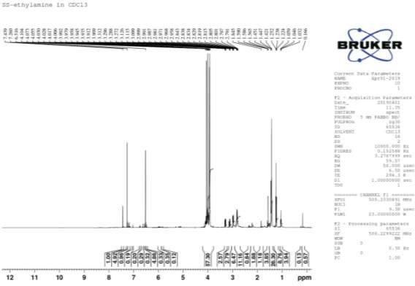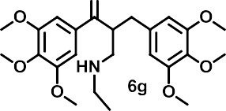
6a

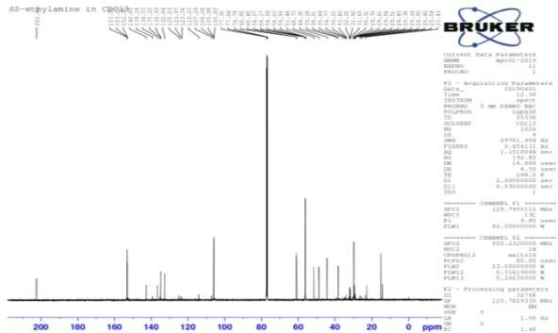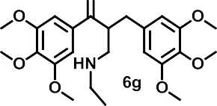Compound 6a: ¹³C NMR
6a

Compound 6a: HRMS

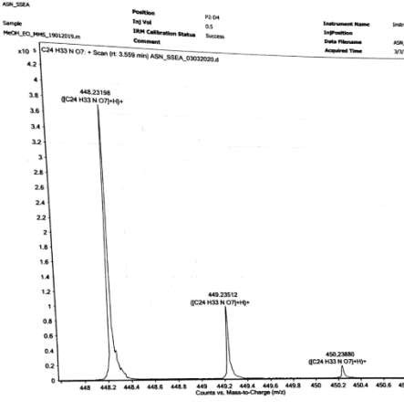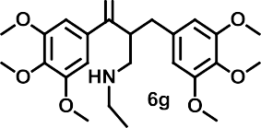
6a

Compound 6b: ¹ H NMR

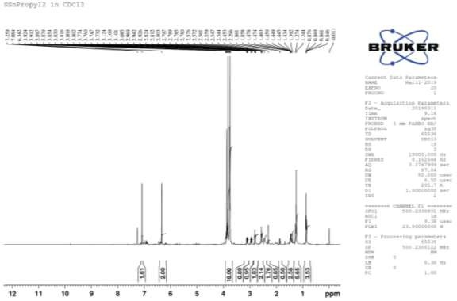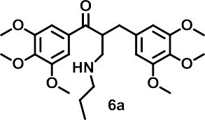

6b

Compound 6b: ¹³C NMR

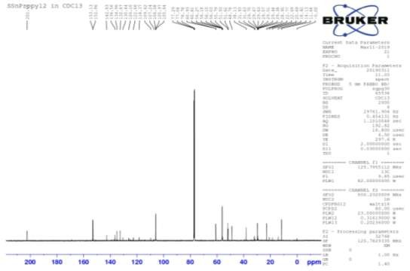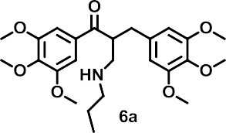
6b

Compound 6b: HRMS

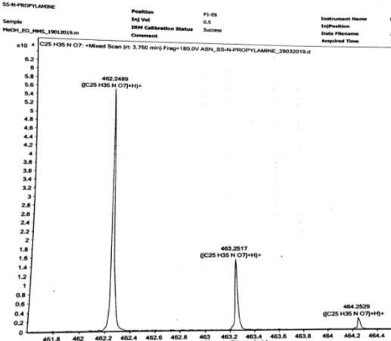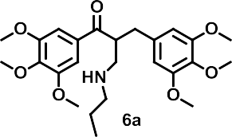
6b

Compound 6c: ¹ H NMR

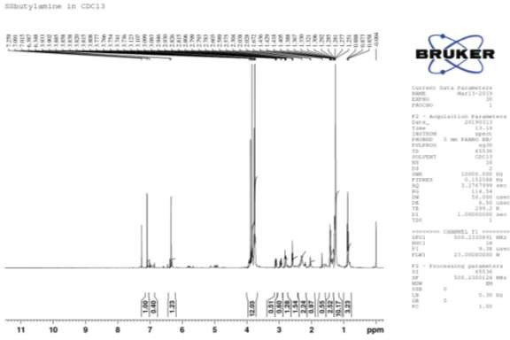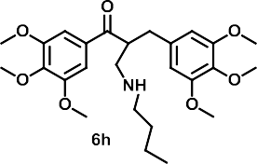
6c

Compound 6c: ¹³C NMR

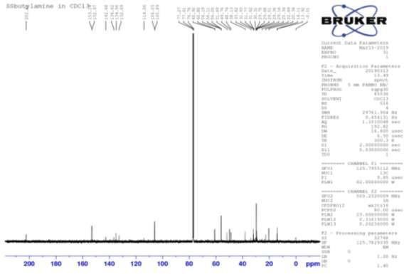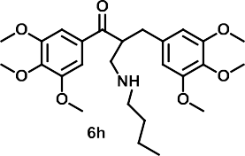
6c

Compound 6c: HRMS

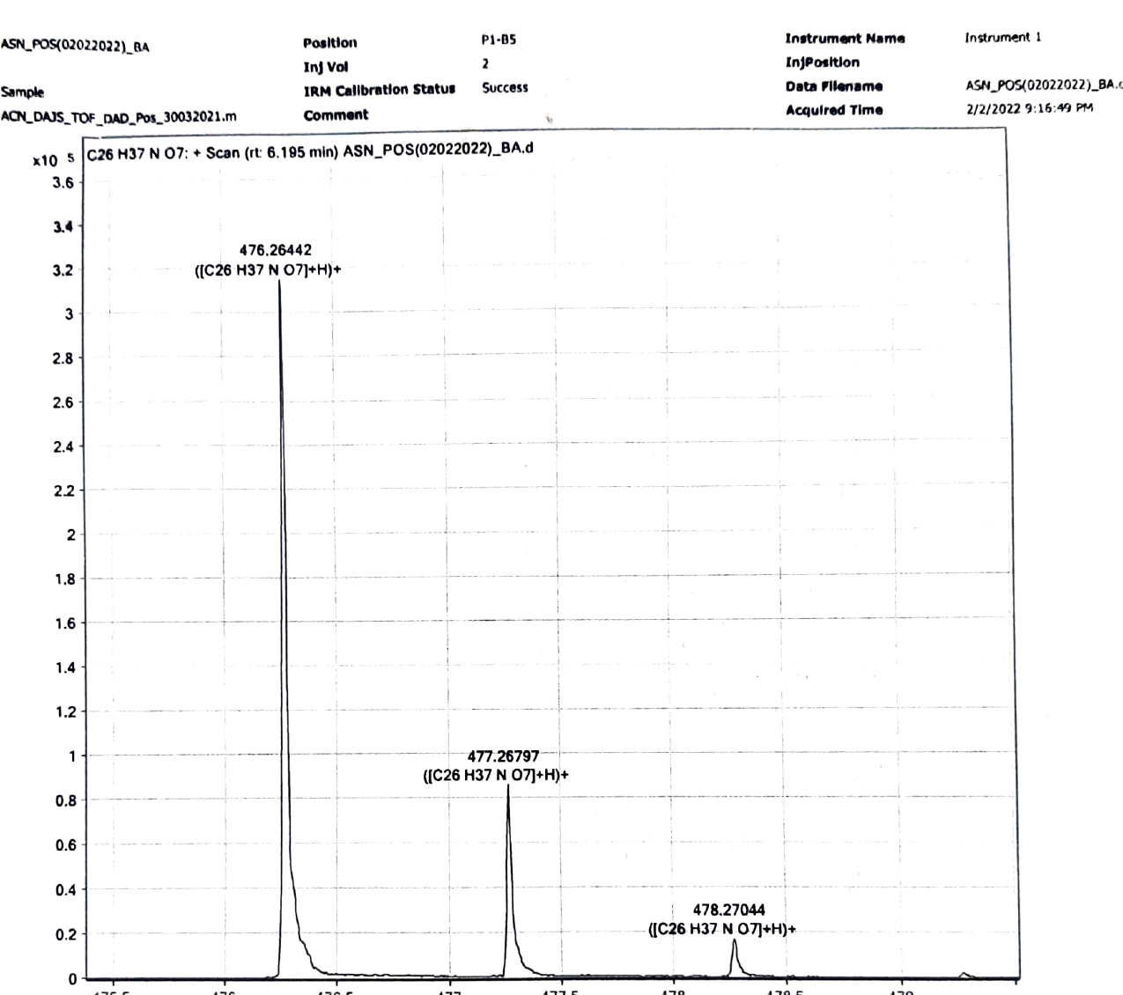
6c

Compound 6d: ¹ H NMR
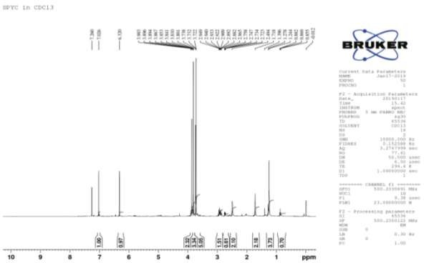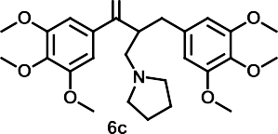
6d

Compound 6d: ¹³C NMR
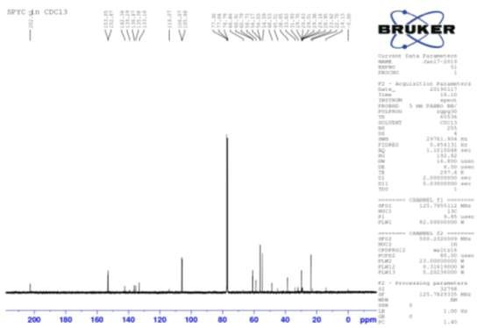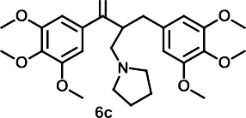
6d

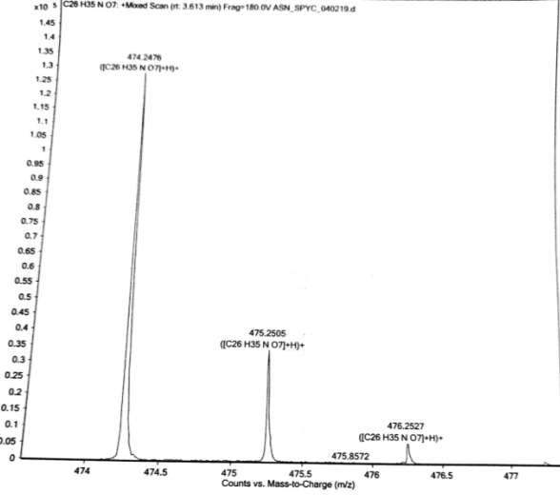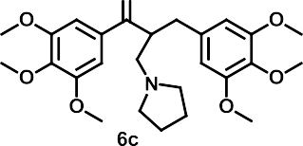Compound 6d: HRMS
6d
Compound 6e: ¹ H NMR
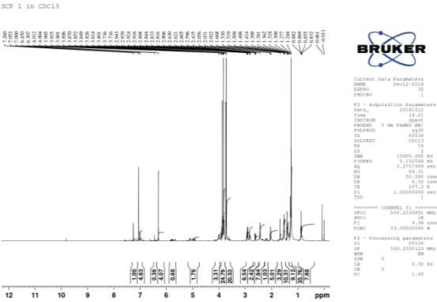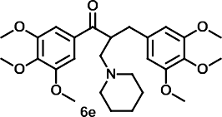

Compound 6e:¹³C NMR

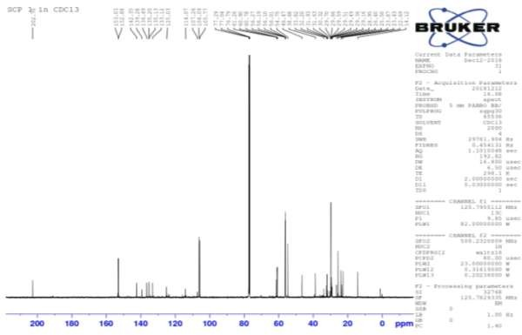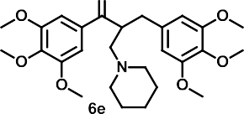
Compound 6e: HRMS

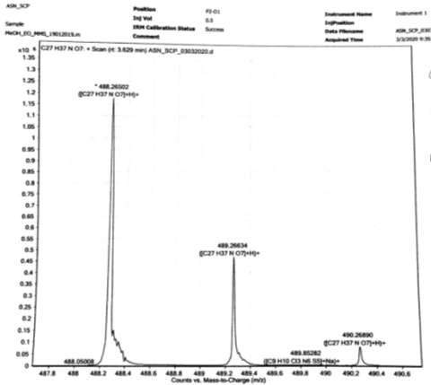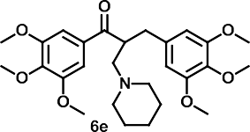

Compound 6f: ¹ H NMR
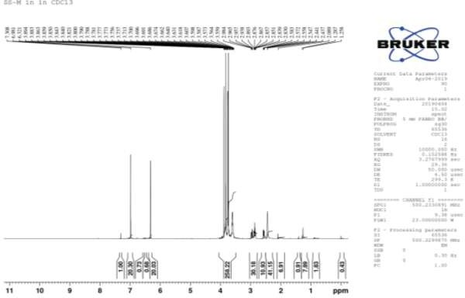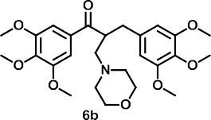
6f

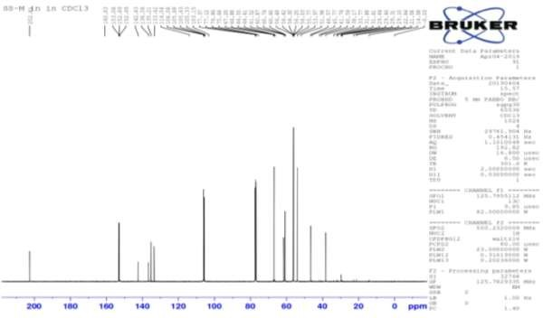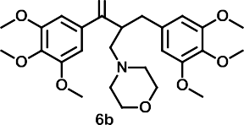Compound 6f: ¹³C NMR
6f

Compound 6f: HRMS

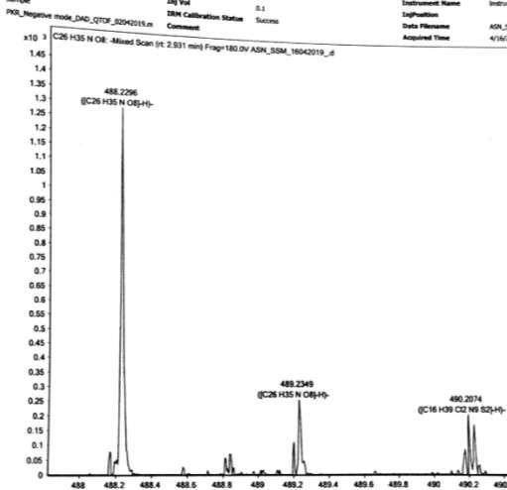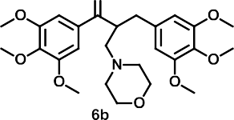
6f

Compound 6g: ¹ H NMR
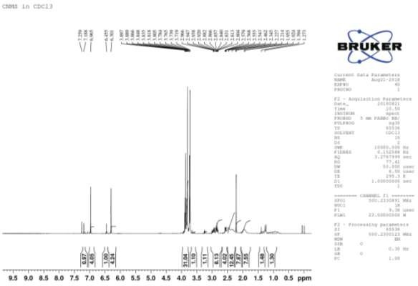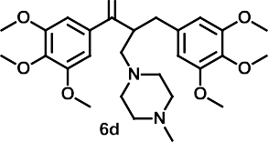
6g

Compound 6g: ¹³C NMR

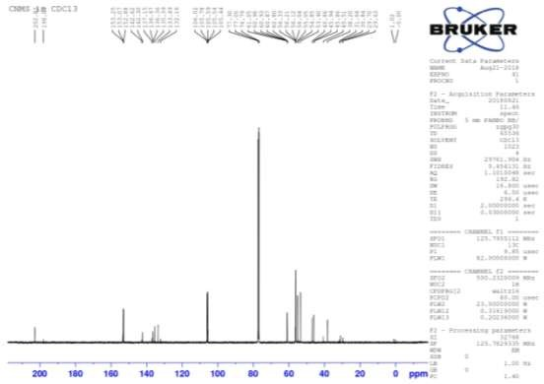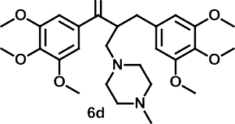
6g

Compound 6g: HRMS

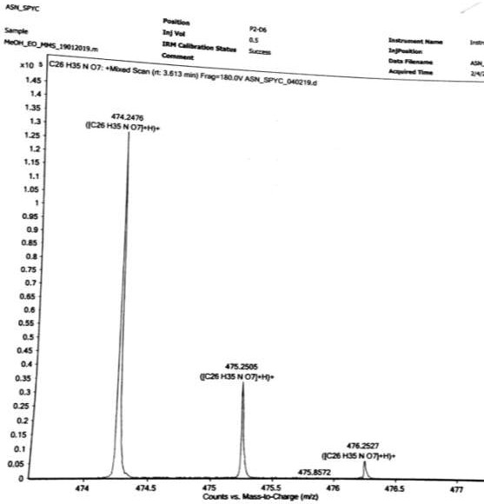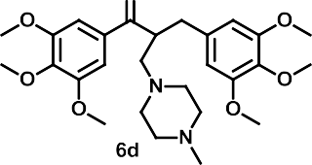
6g
Compound 6h: ¹ H NMR

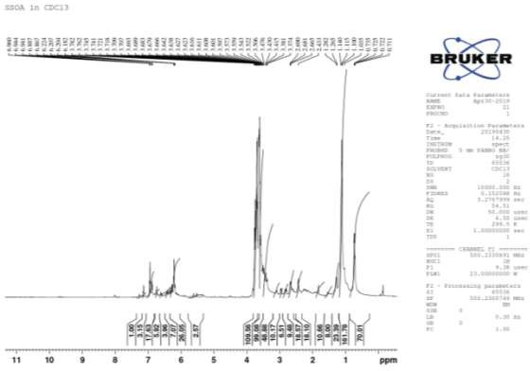
6h
6h
6h

Compound 6h: ¹³C NMR

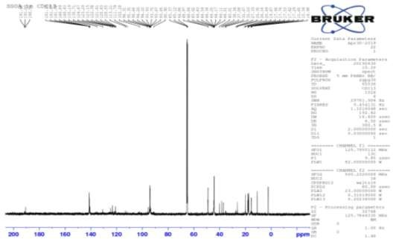
6h
6h

Compound 6h: HRMS

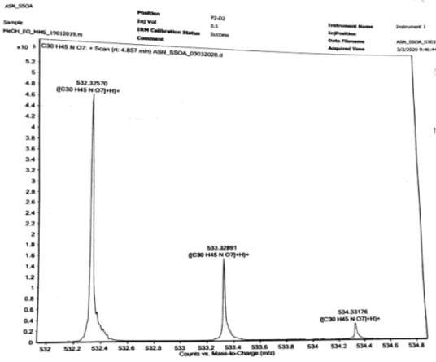

6h

…………………

