Supplementary information
Synthesis and cytotoxic evaluation of ester analogues of (-)-curine

Medicinal Chemistry Research

Suwadee Chokchaisiri¹ · Sittisak Kumjun² · Chutamas Thepmalee³ · Saowanee kumpun⁴ · Thitima Rukachaisirikul²

Suwadee Chokchaisiri
suwadee.ch@ssru.ac.th

¹ College of Allied Health Sciences, Suan Sunandha Rajabhat University, Samut Songkhram 75000, Thailand
² Department of Chemistry and Center of Excellence for Innovation in Chemistry,
Faculty of Science, Ramkhamhaeng University, Bangkok 10240, Thailand
³ Division of Biochemistry, School of Medical Sciences, University of Phayao, Phayao 56000, Thailand
⁴ Department of Chemistry, Faculty of science and Technology, Suan Sunandha Rajabhat, Bangkok 10300, Thailand

The List of Supplementary Information
Contents | Page
S1. ¹H NMR (CDCl₃, 400 MHz) spectrum of compound 2 | 3
S2. ¹³C NMR (CDCl₃, 400 MHz) spectrum of compound 2 | 4
S3. COSY spectrum of compound 2 | 4
S4. HMQC spectrum of compound 2 | 5
S5. HMBC spectrum of compound 2 | 5
S6. ¹H NMR (CDCl₃, 400 MHz) spectrum of compound 3 | 6
S7. ¹³C NMR (CDCl₃, 100 MHz) spectrum of compound 3 | 6
S8. COSY spectrum of compound 3 | 7
S9. HMQC spectrum of compound 3 | 7
S10. HMBC spectrum of compound 3 | 8
S11. ¹H NMR (CDCl₃, 400 MHz) spectrum of compound 4 | 8
S12. ¹³C NMR (CDCl₃, 100 MHz) spectrum of compound 4 | 9
S13. COSY spectrum of compound 4 | 9
S14. HMQC spectrum of compound 4 | 10
S15. HMBC spectrum of compound 4 | 10
S11. ¹H NMR (CDCl₃, 400 MHz) spectrum of compound 5 | 11
S12. ¹³C NMR (CDCl₃, 100 MHz) spectrum of compound 5 | 11
S13. COSY spectrum of compound 5 | 12
S14. HMQC spectrum of compound 5 | 12
S15. HMBC spectrum of compound 5 | 13
S16. ¹H NMR (CDCl₃, 400 MHz) spectrum of compound 6 | 13
S17. ¹³C NMR (CDCl₃, 100 MHz) spectrum of compound 6 | 14
S18. COSY spectrum of compound 6 | 14
S19. HMQC spectrum of compound 6 | 15
S20. HMBC spectrum of compound 6 | 15
S21. ¹H NMR (CDCl₃, 400 MHz) spectrum of compound 7 | 16
S22. ¹³C NMR (CDCl₃, 100 MHz) spectrum of compound 7 | 16
S23. COSY spectrum of compound 7 | 17
S24. HMQC spectrum of compound 7 | 17
S25. HMBC spectrum of compound 7 | 18
S26. ¹H NMR (CDCl₃, 400 MHz) spectrum of compound 8 | 18
S27. ¹³C NMR (CDCl₃, 100 MHz) spectrum of compound 8 | 19
S28. COSY spectrum of compound 8 | 19
S29. HMQC spectrum of compound 8 | 20
S30. HMBC spectrum of compound 8 | 20

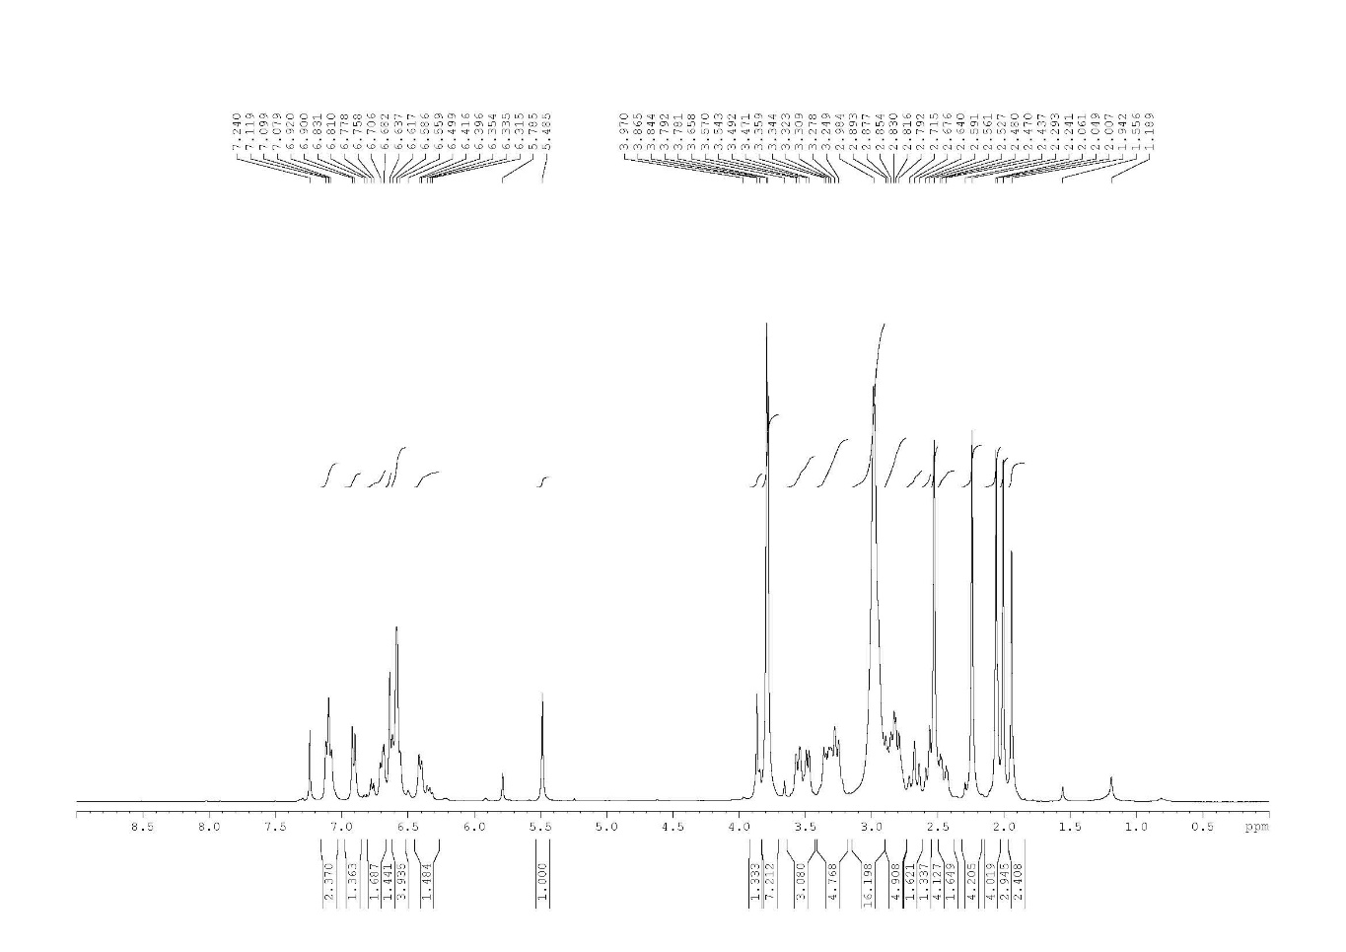
S1. ¹H NMR (CDCl₃, 400 MHz) spectrum of compound 2

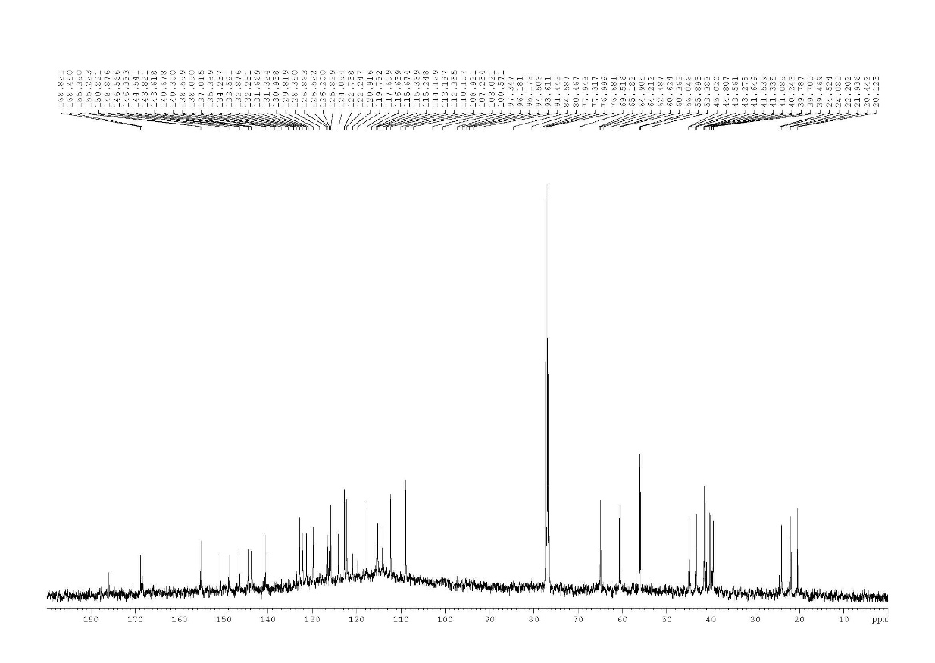
S2. ¹³C NMR (CDCl₃, 400 MHz) spectrum of compound 2

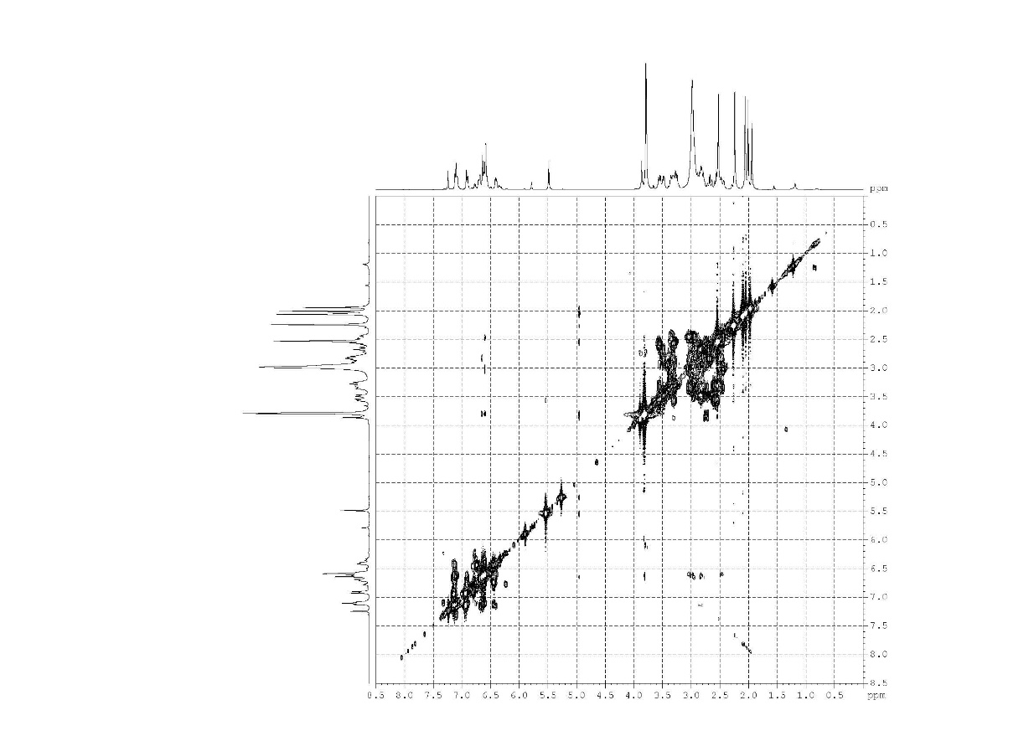

S3. COSY spectrum of compound 2

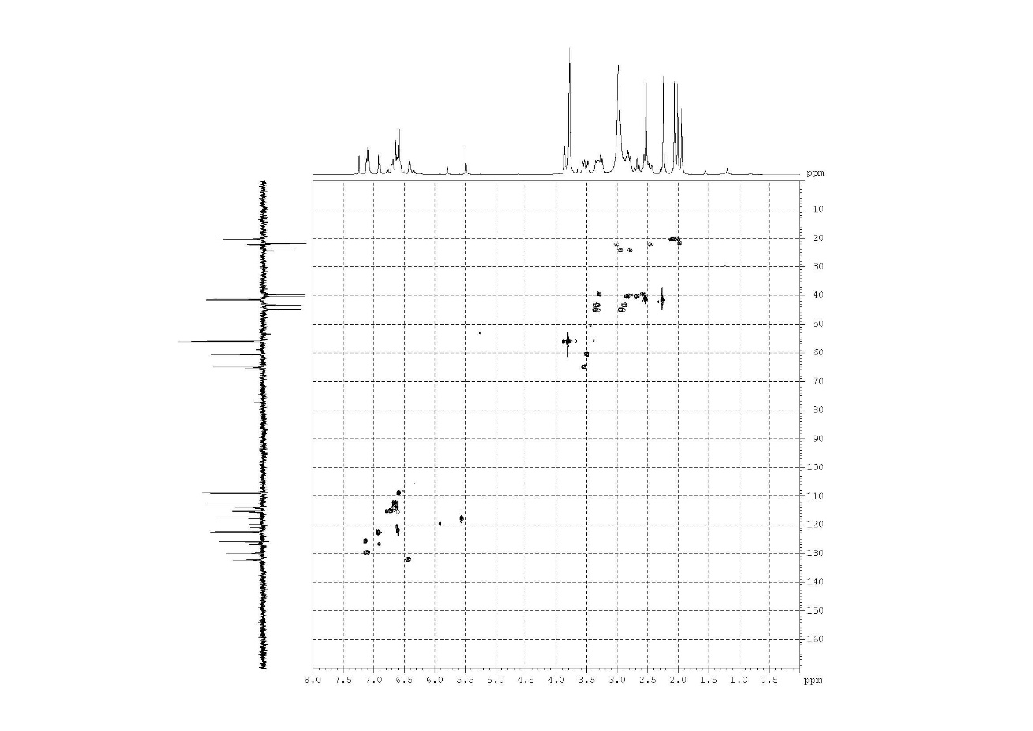
S4. HMQC spectrum of compound 2
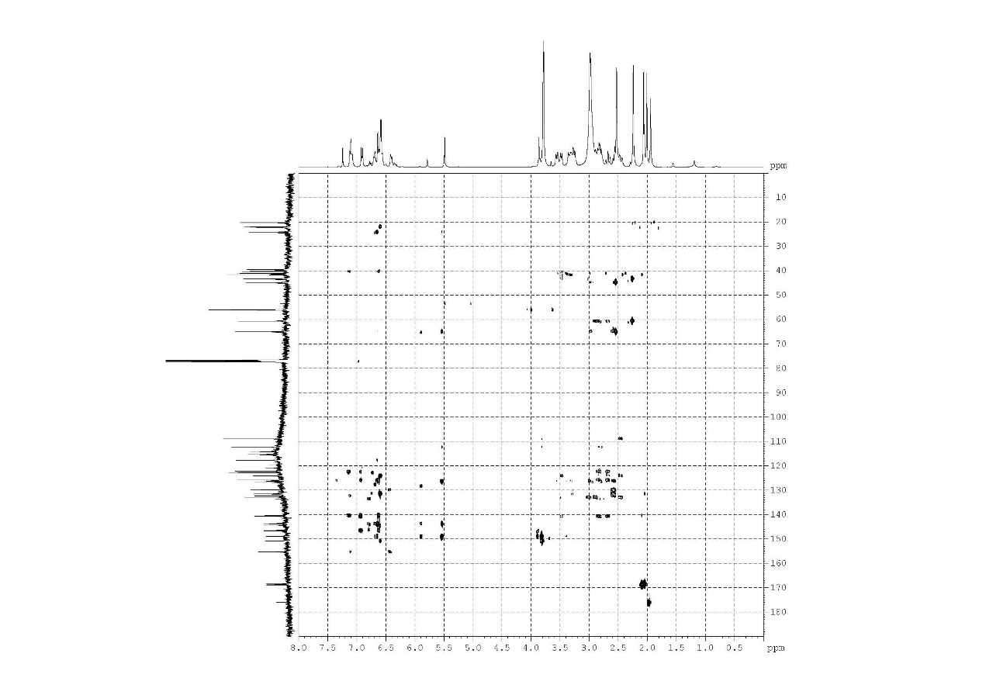
S5. HMBC spectrum of compound 2
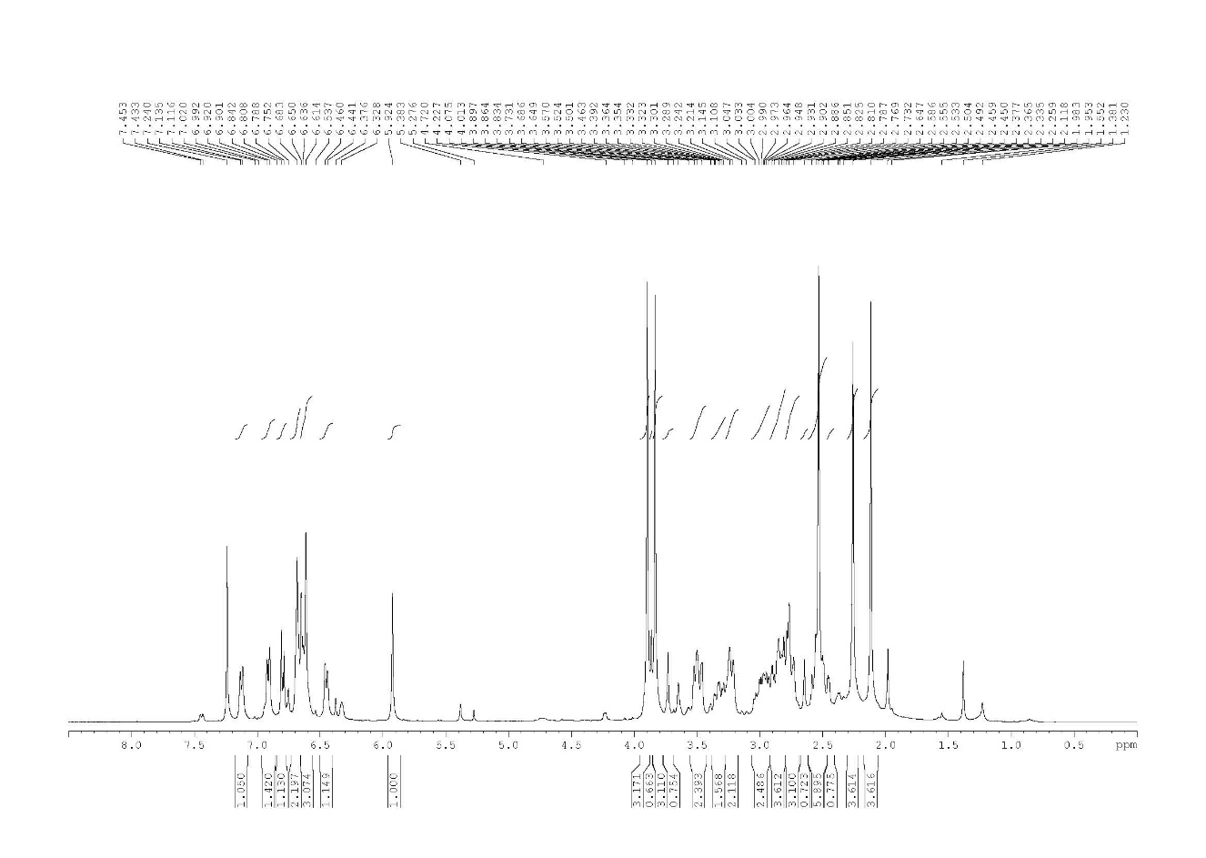
S6. ¹H NMR (CDCl₃, 400 MHz) spectrum of compound 3
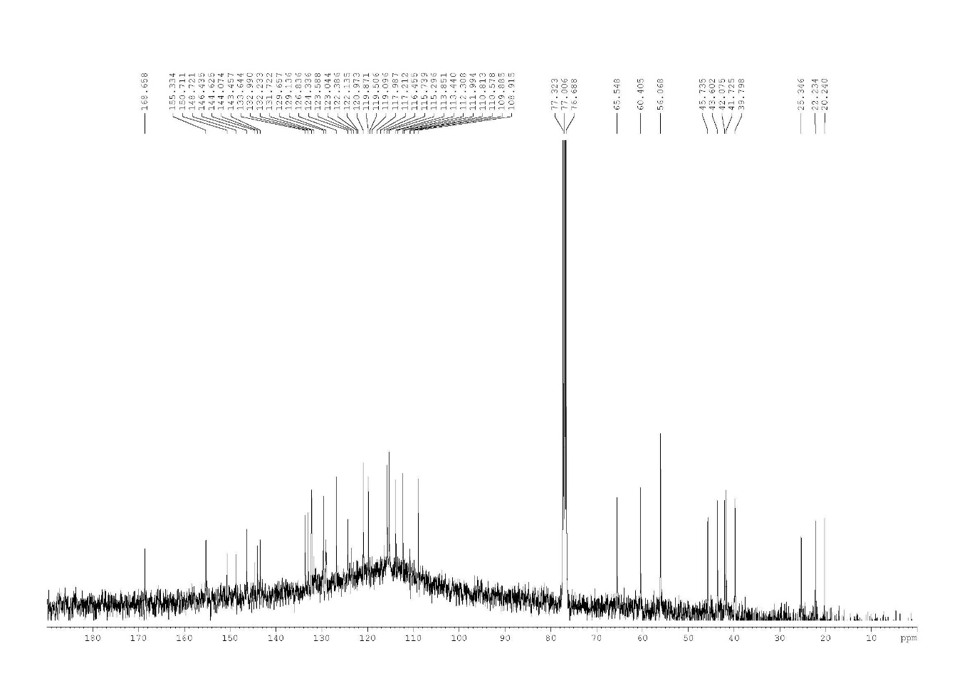
S7. ¹³C NMR (CDCl₃, 100 MHz) spectrum of compound 3
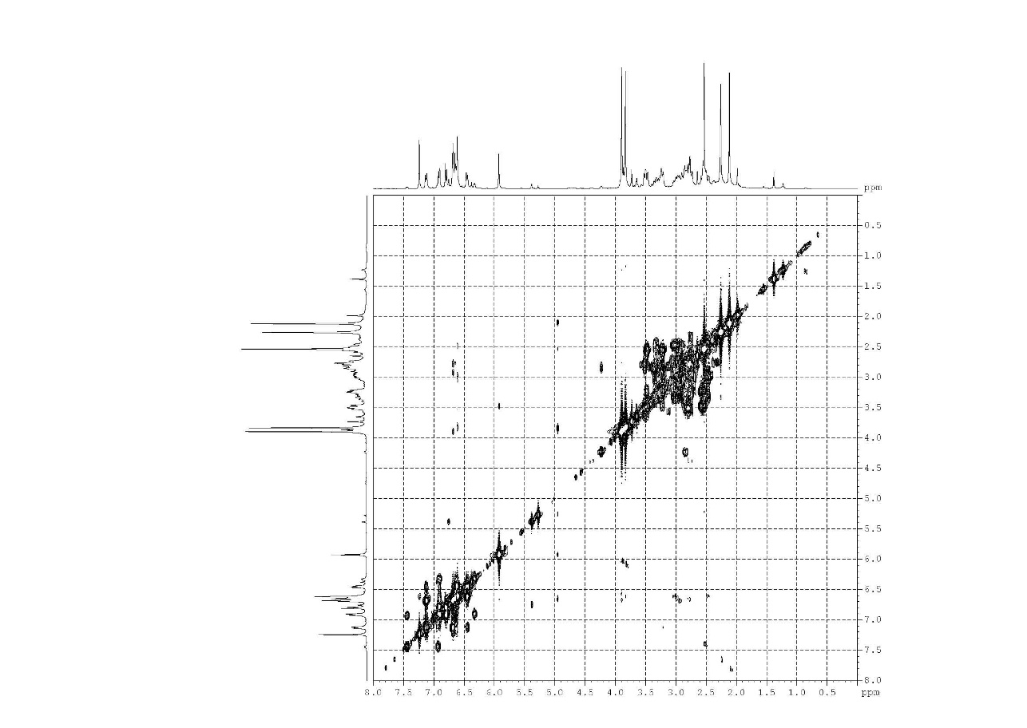
S8. COSY spectrum of compound 3

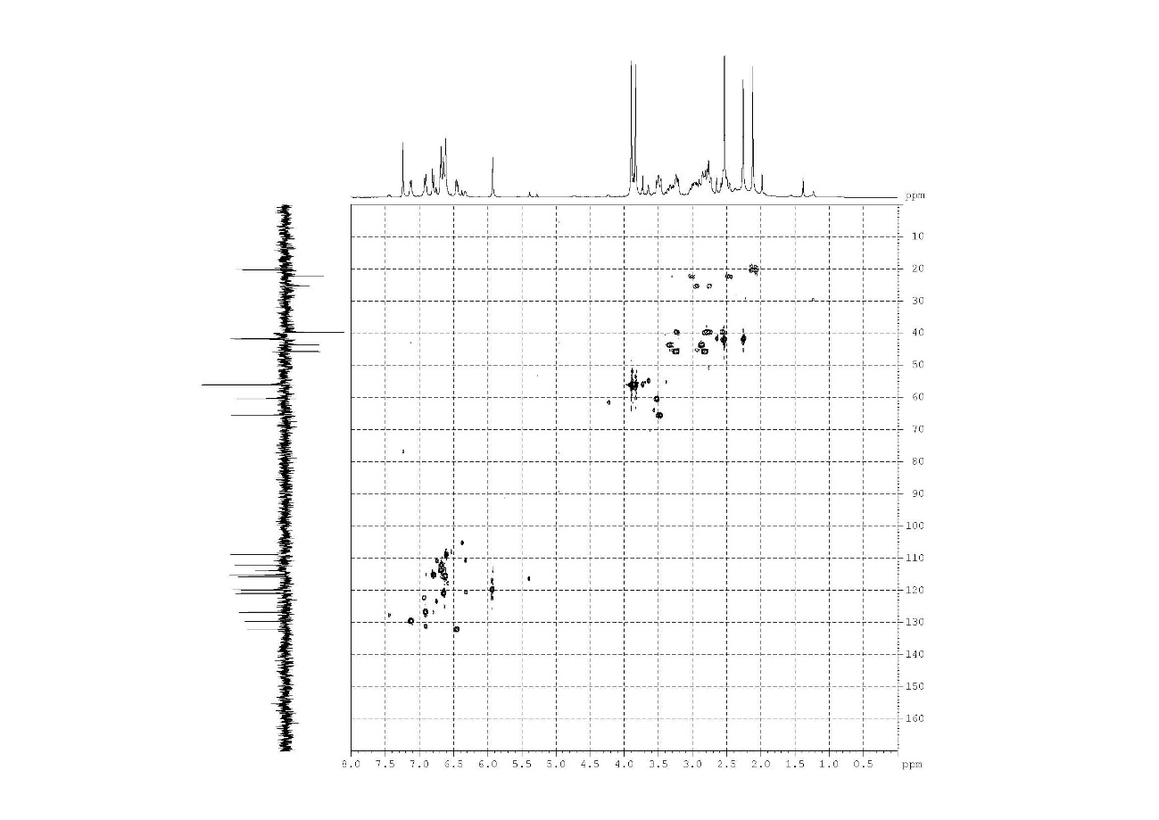
S9. HMQC spectrum of compound 3

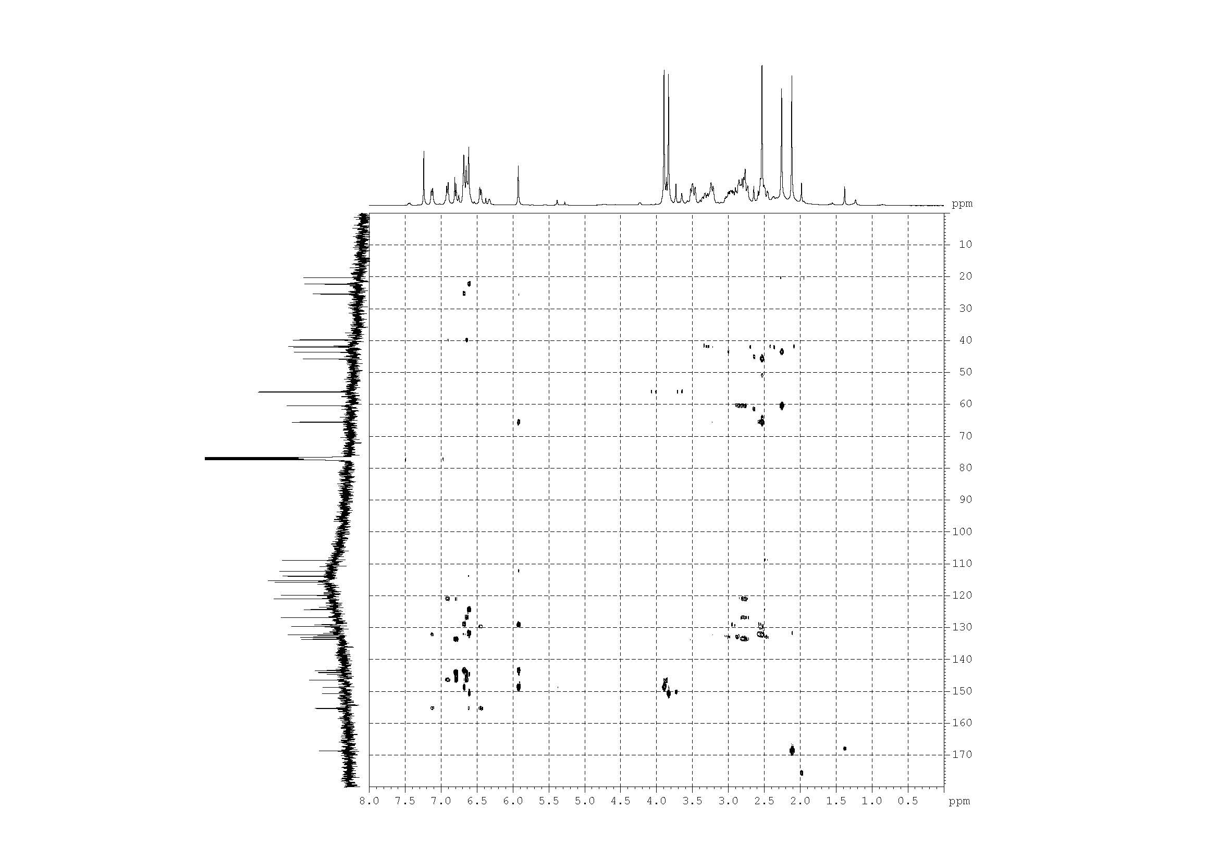
S10. HMBC spectrum of compound 3

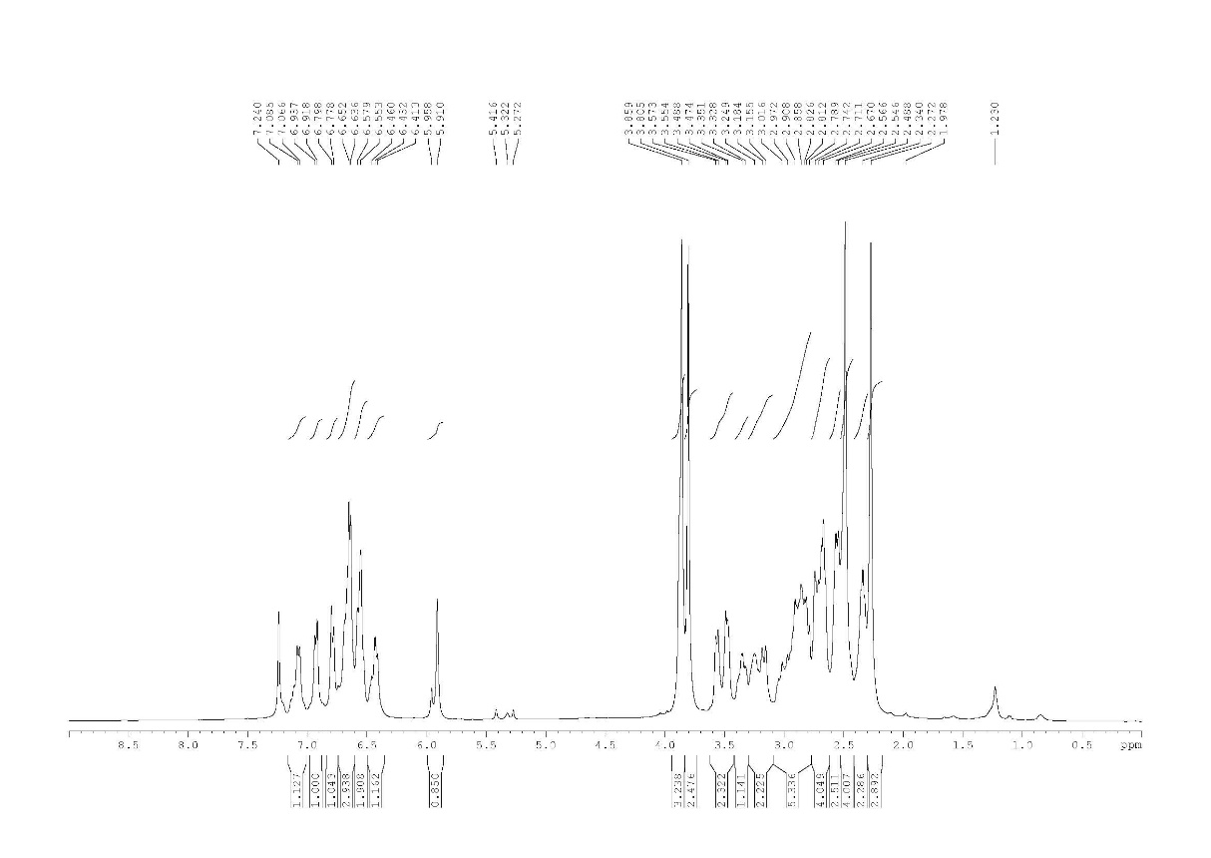
S11. ¹H NMR (CDCl₃, 400 MHz) spectrum of compound 4
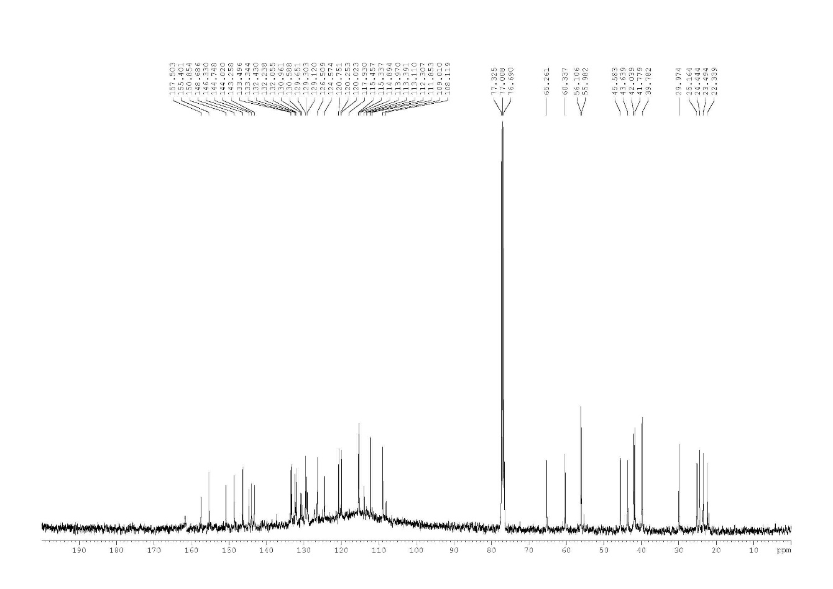
S12. ¹³C NMR (CDCl₃, 100 MHz) spectrum of compound 4
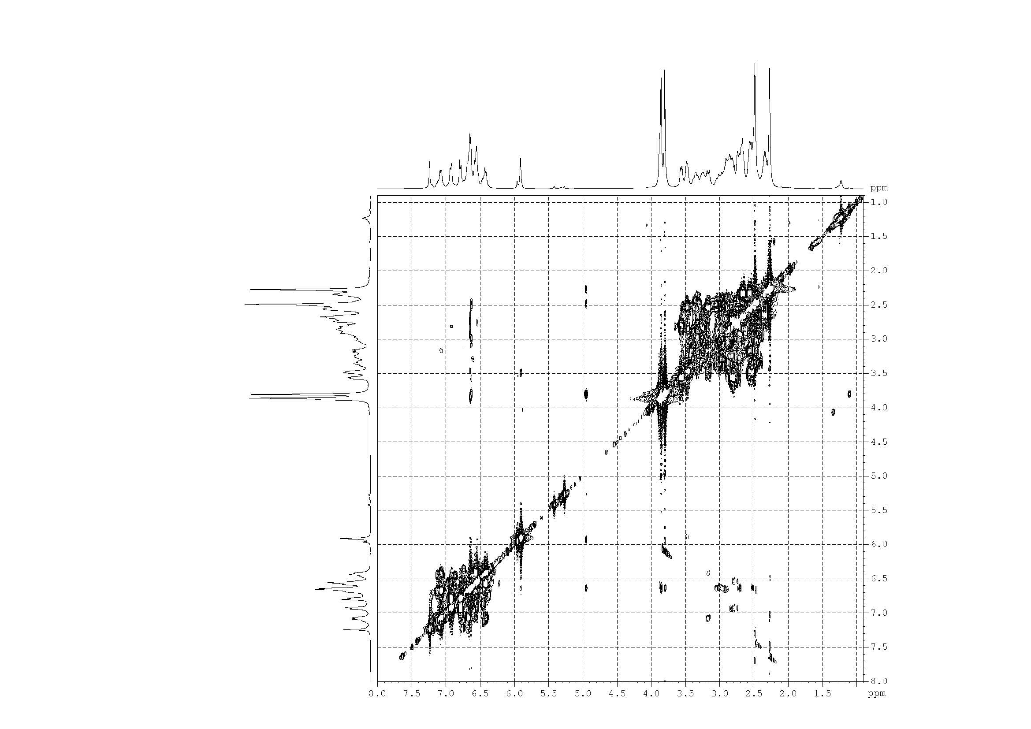
S13. COSY spectrum of compound 4
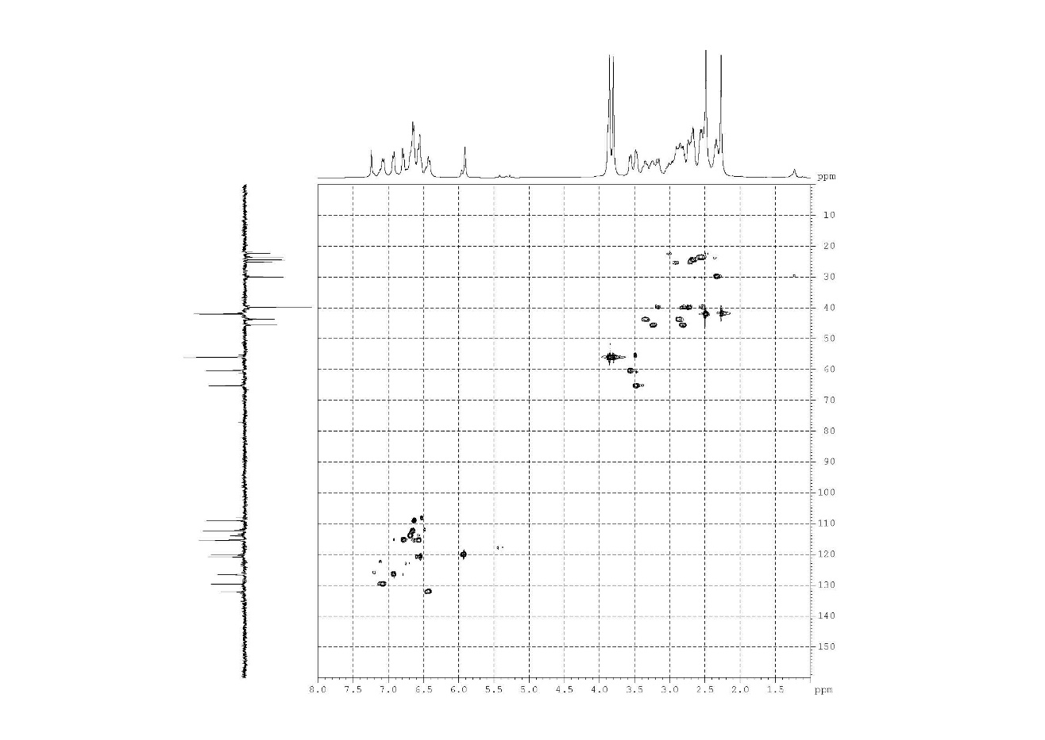
S14. HMQC spectrum of compound 4
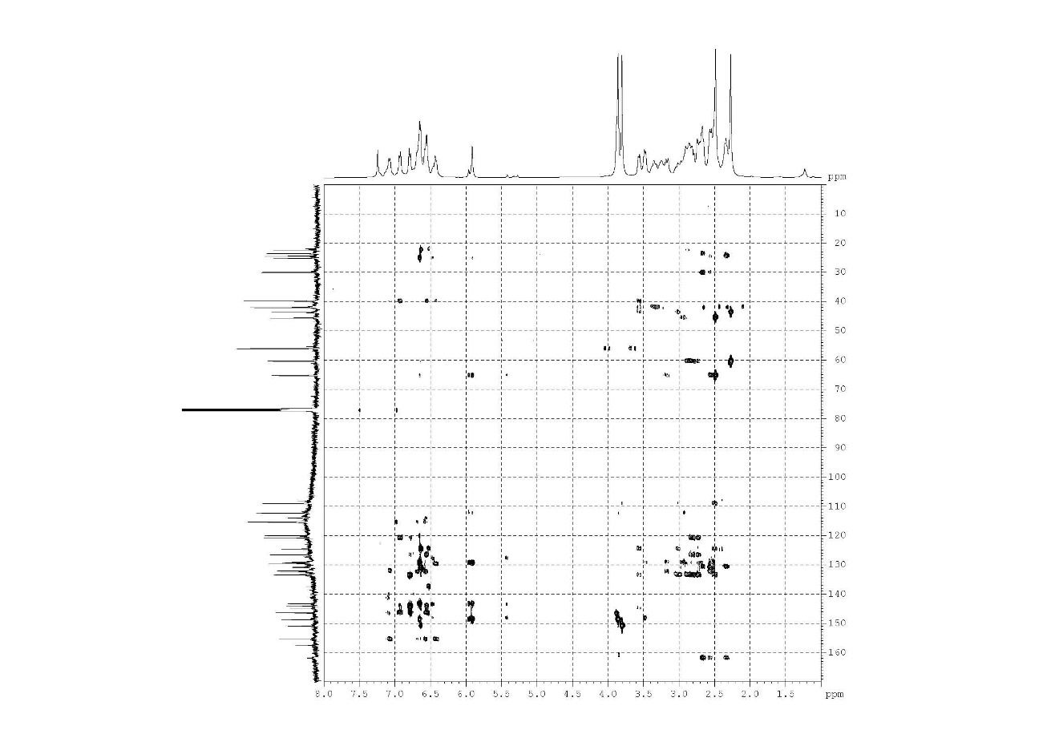
S15. HMBC spectrum of compound 4

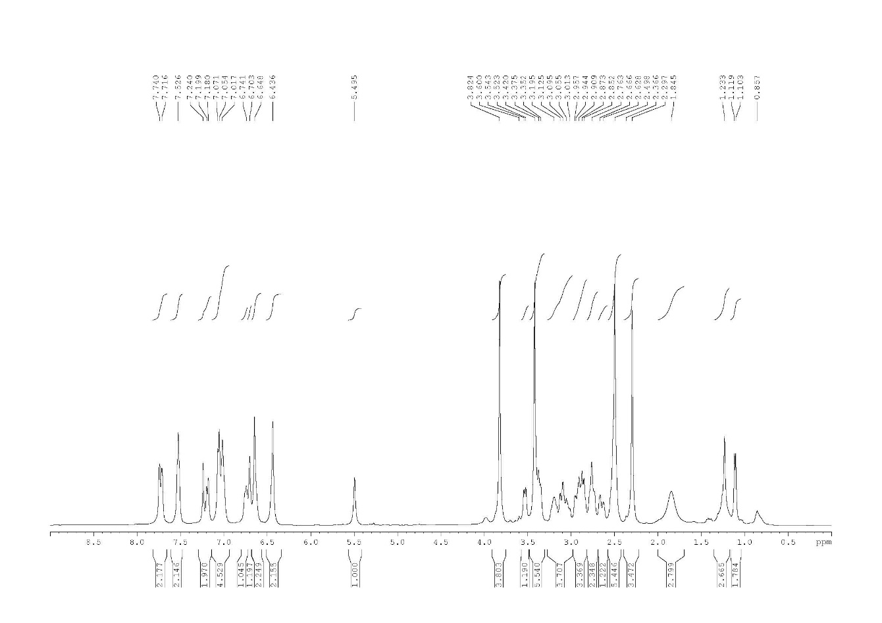
S11. ¹H NMR (CDCl₃, 400 MHz) spectrum of compound 5
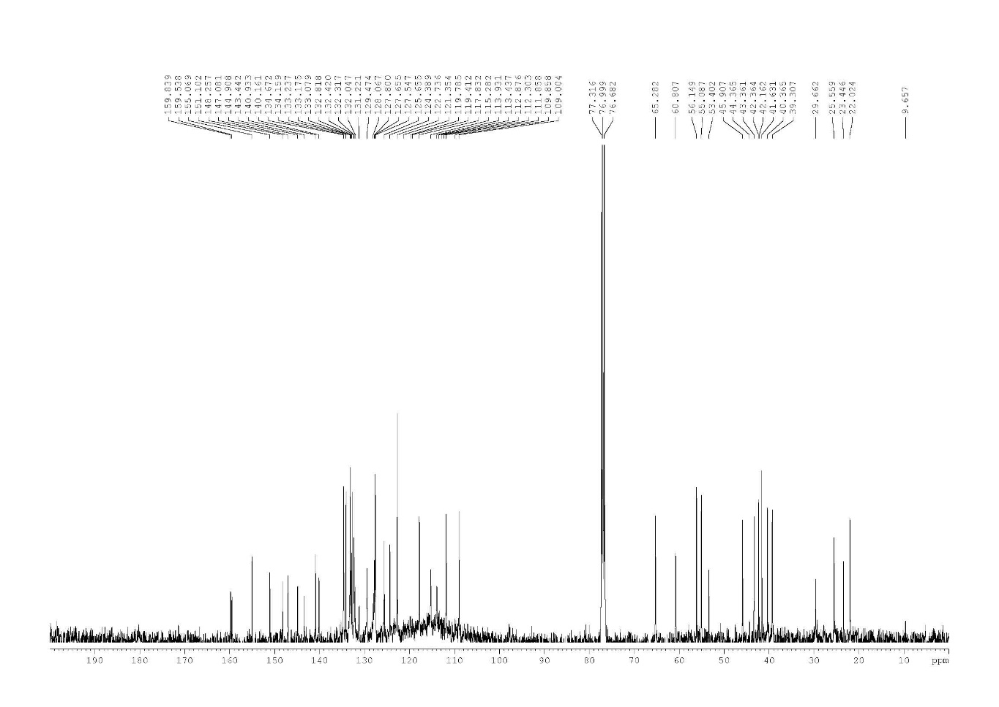
S12. ¹³C NMR (CDCl₃, 100 MHz) spectrum of compound 5
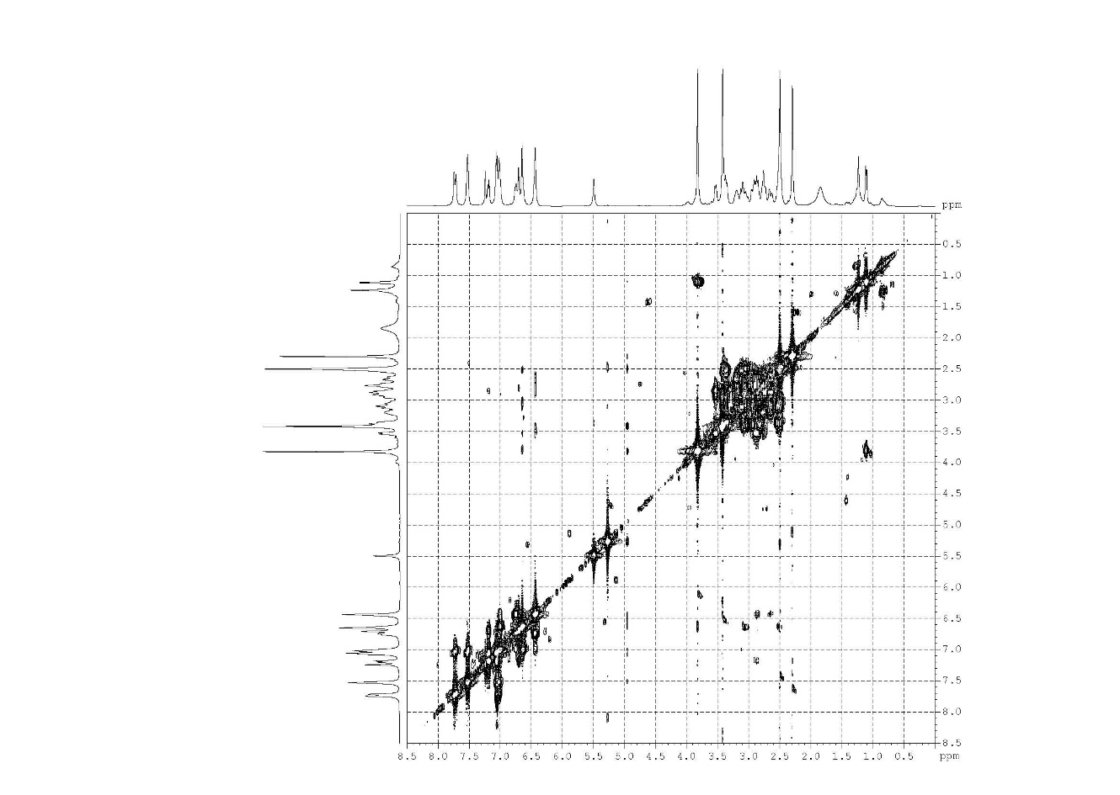
S13. COSY spectrum of compound 5
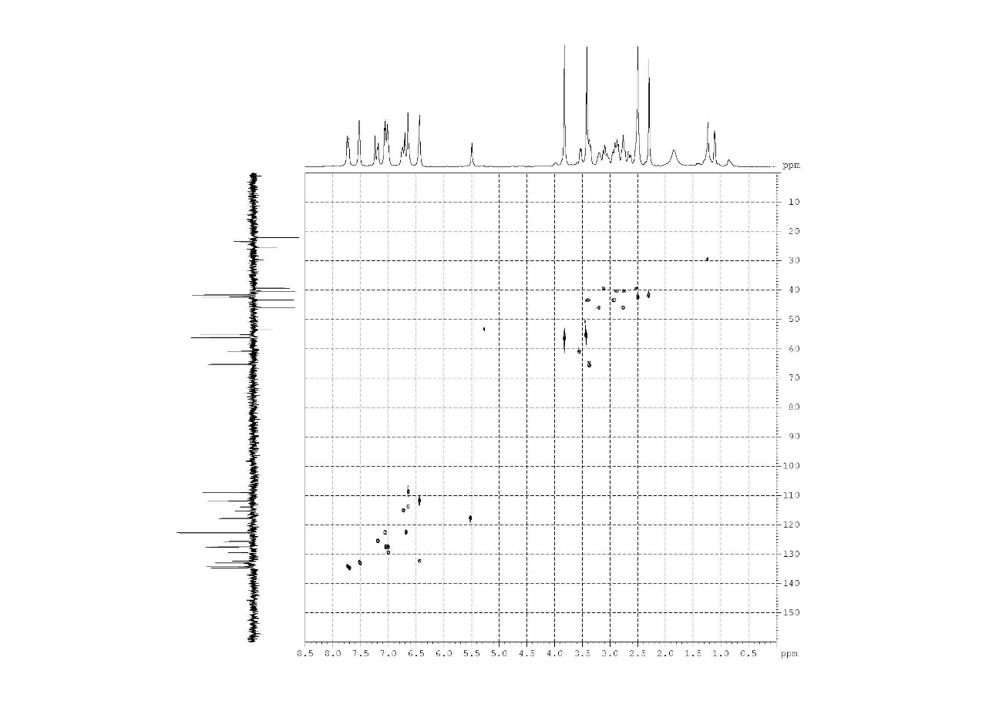
S14. HMQC spectrum of compound 5
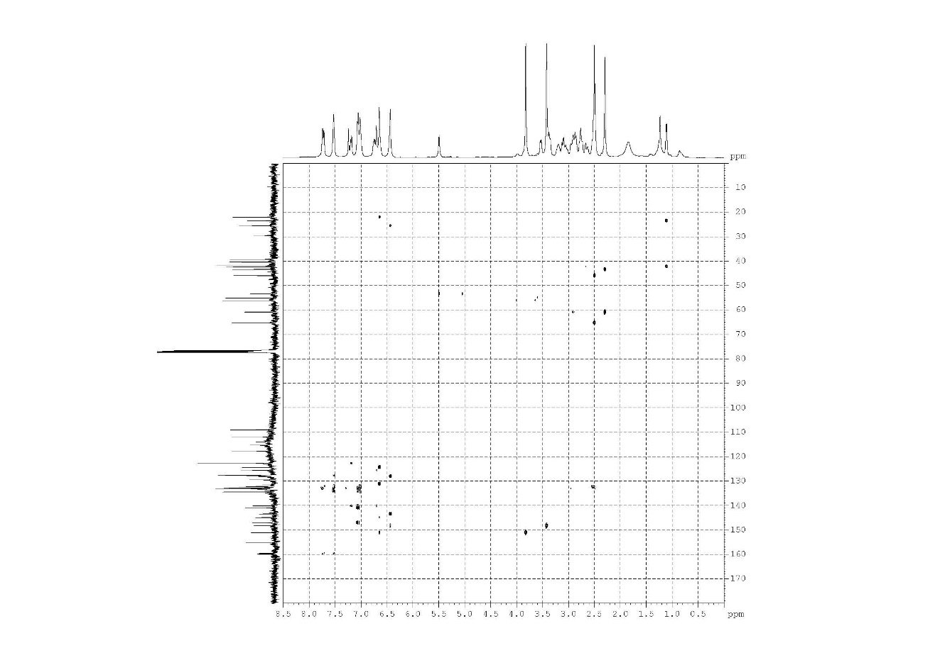
S15. HMBC spectrum of compound 5
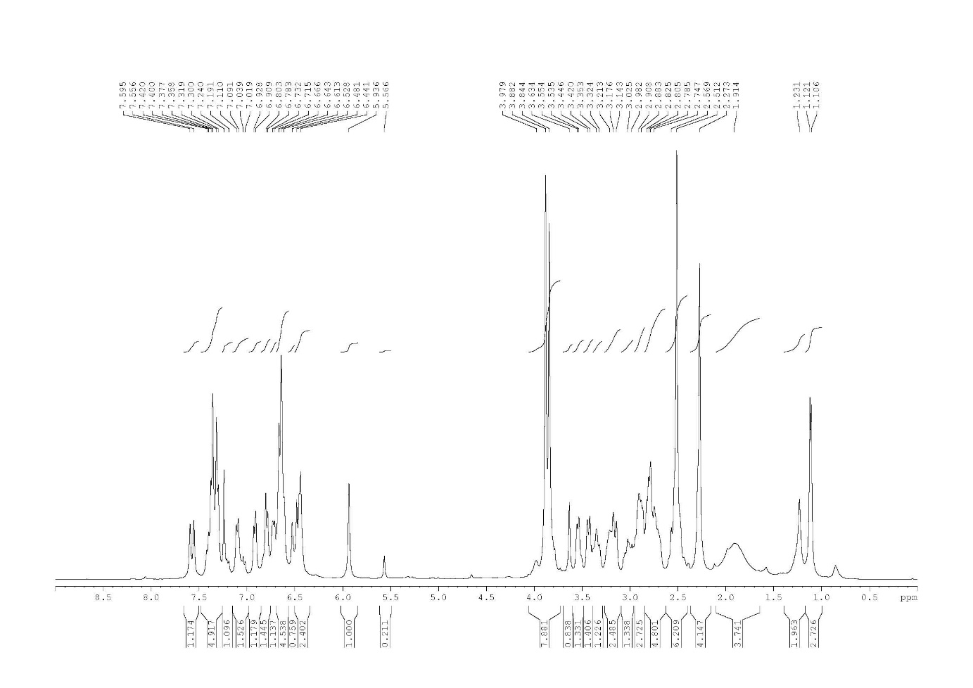
S16. ¹H NMR (CDCl₃, 400 MHz) spectrum of compound 6
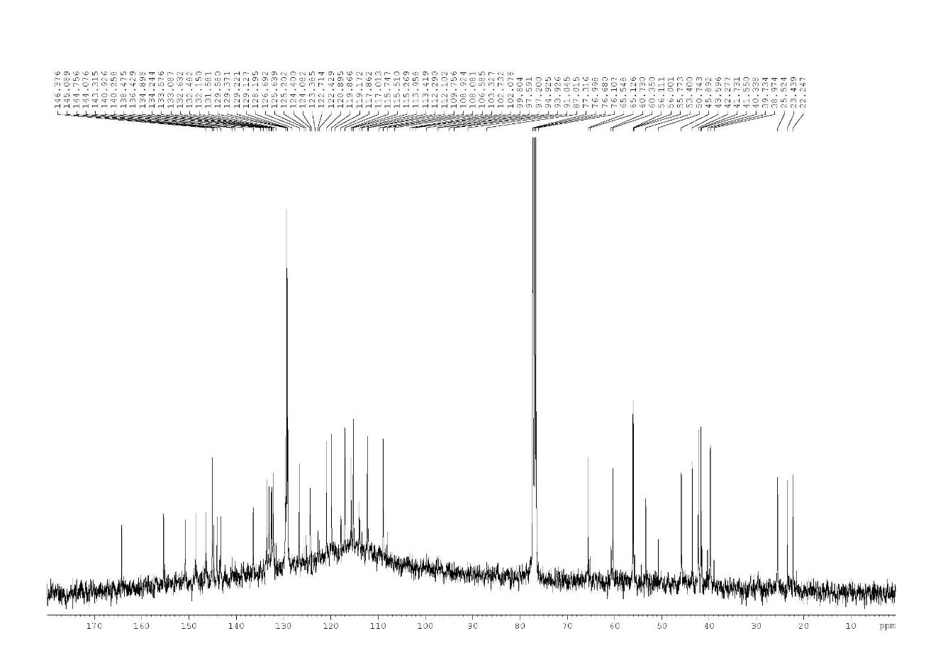
S17. ¹³C NMR (CDCl₃, 100 MHz) spectrum of compound 6
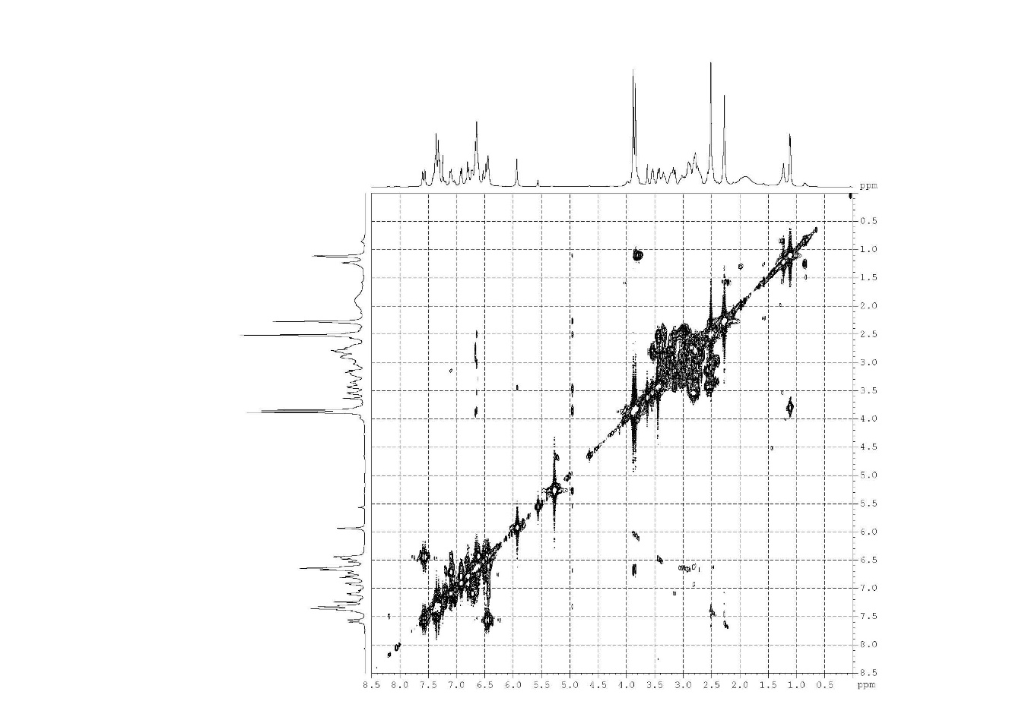
S18. COSY spectrum of compound 6
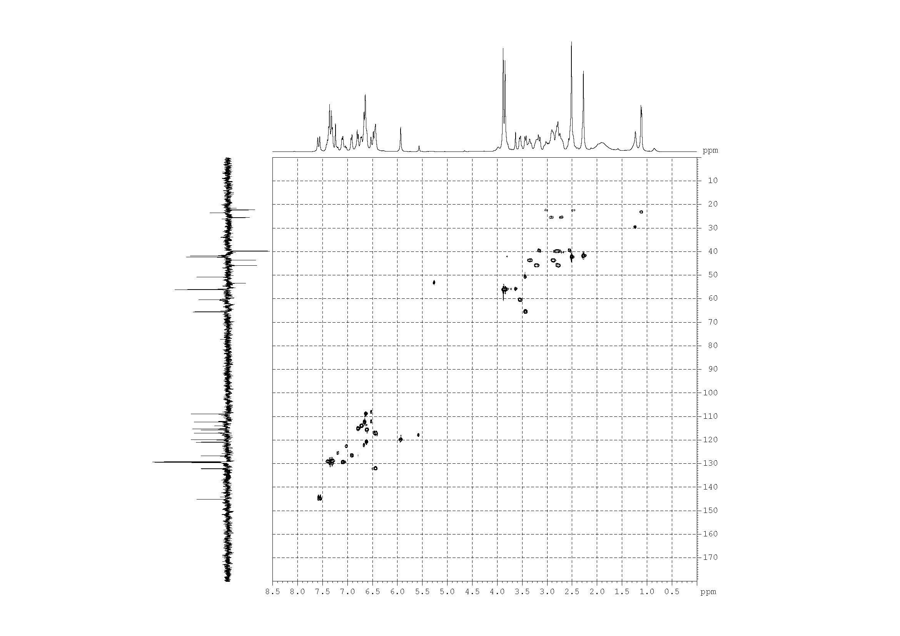
S19. HMQC spectrum of compound 6
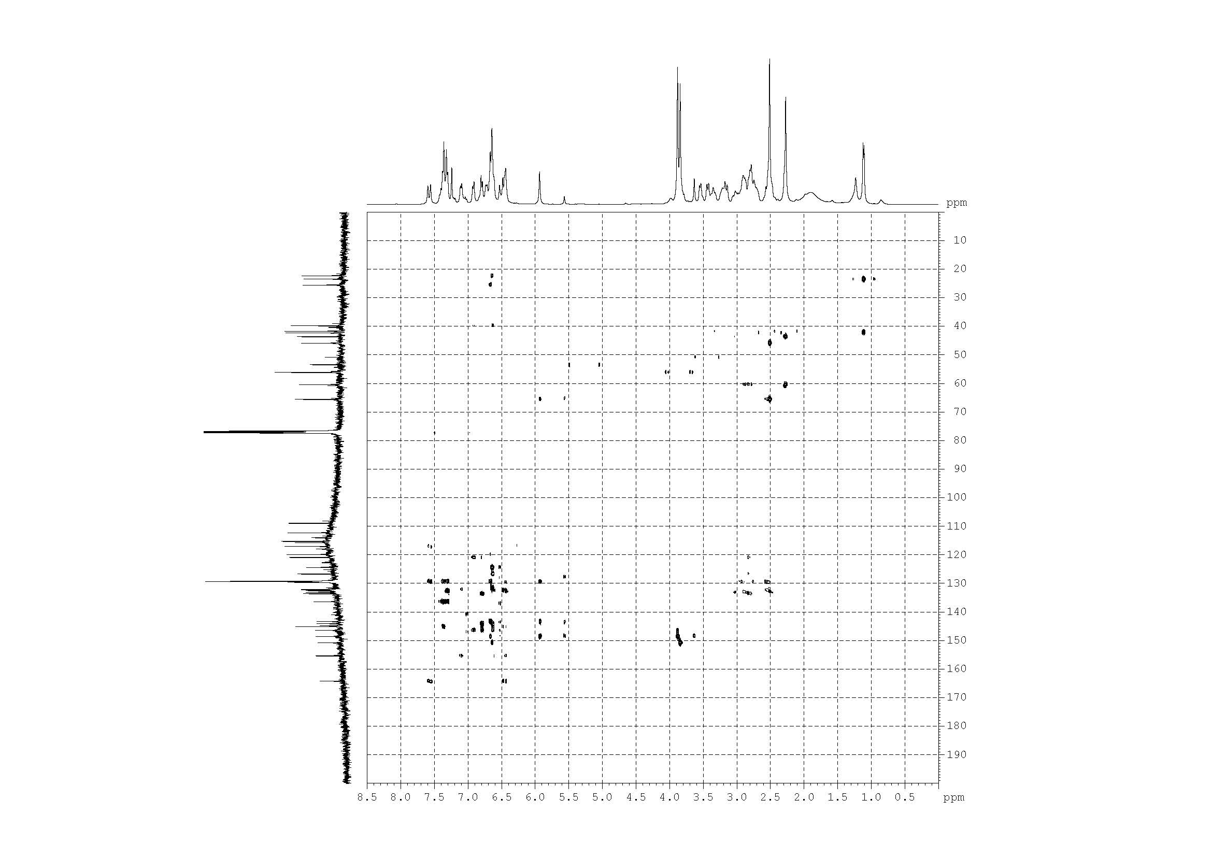
S20. HMBC spectrum of compound 6
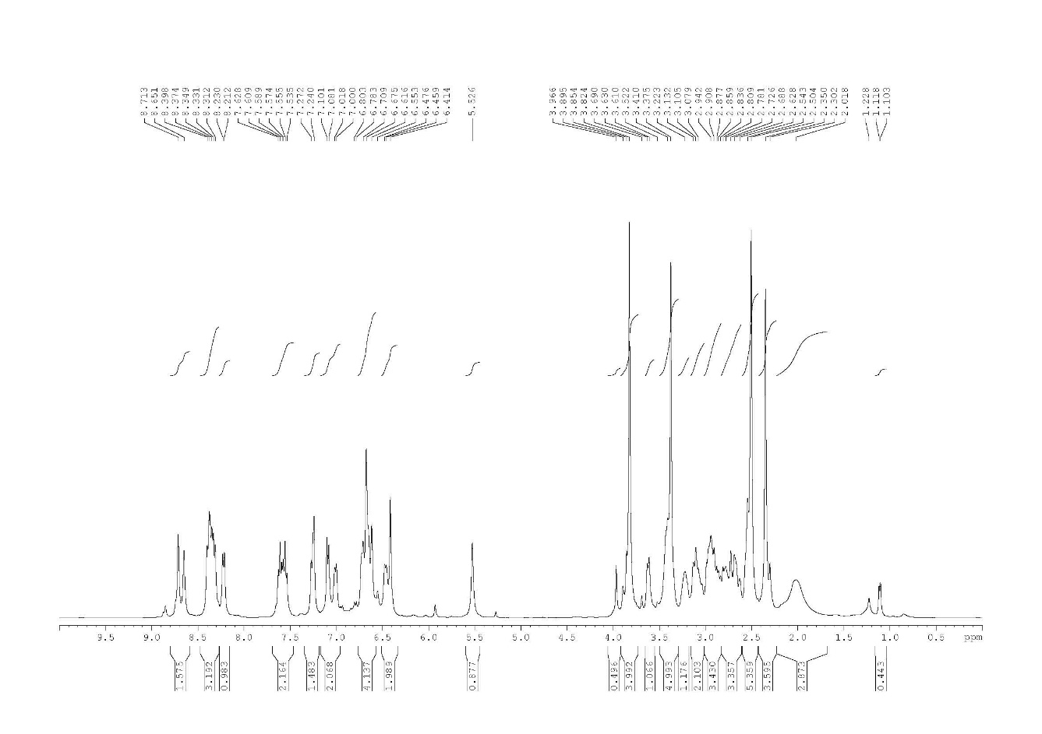
S21. ¹H NMR (CDCl₃, 400 MHz) spectrum of compound 7

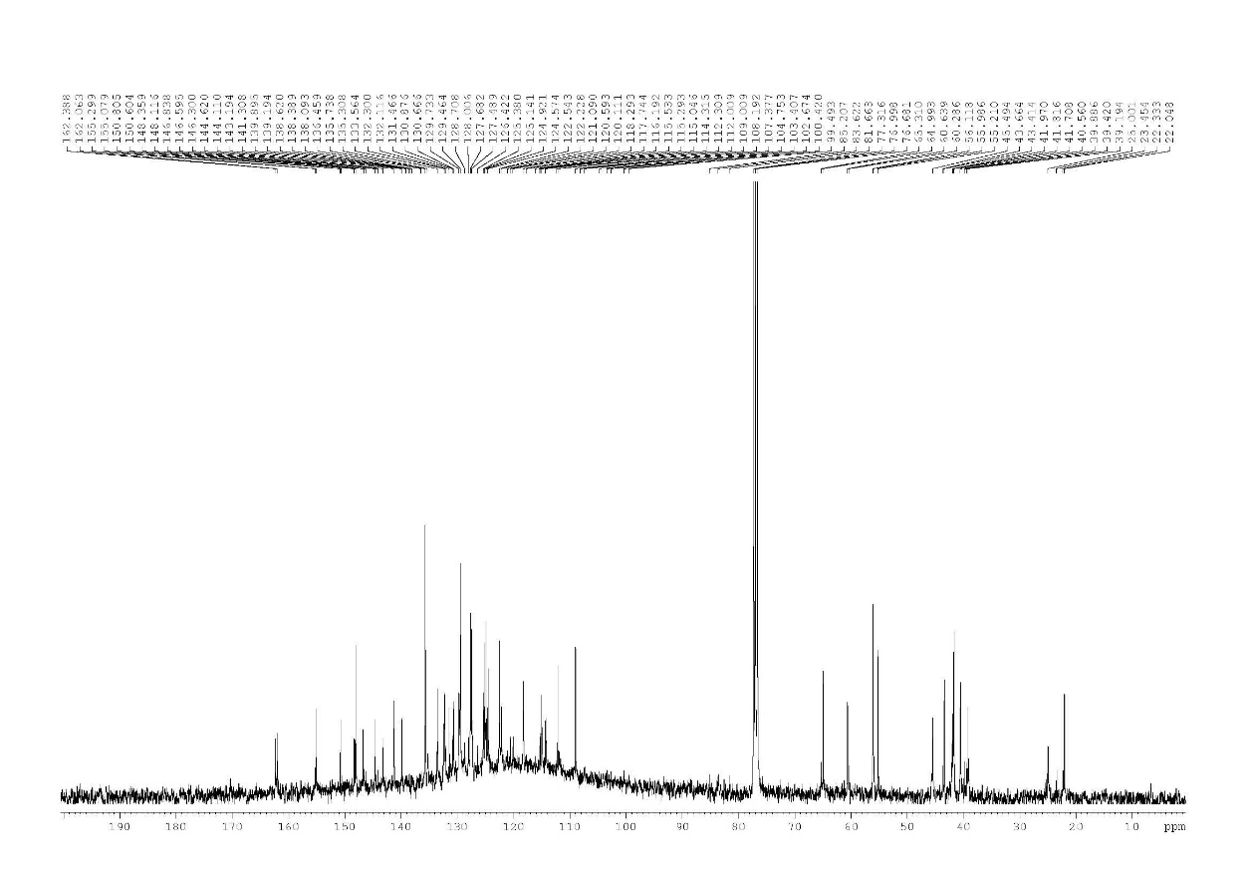
S22. ¹³C NMR (CDCl₃, 100 MHz) spectrum of compound 7
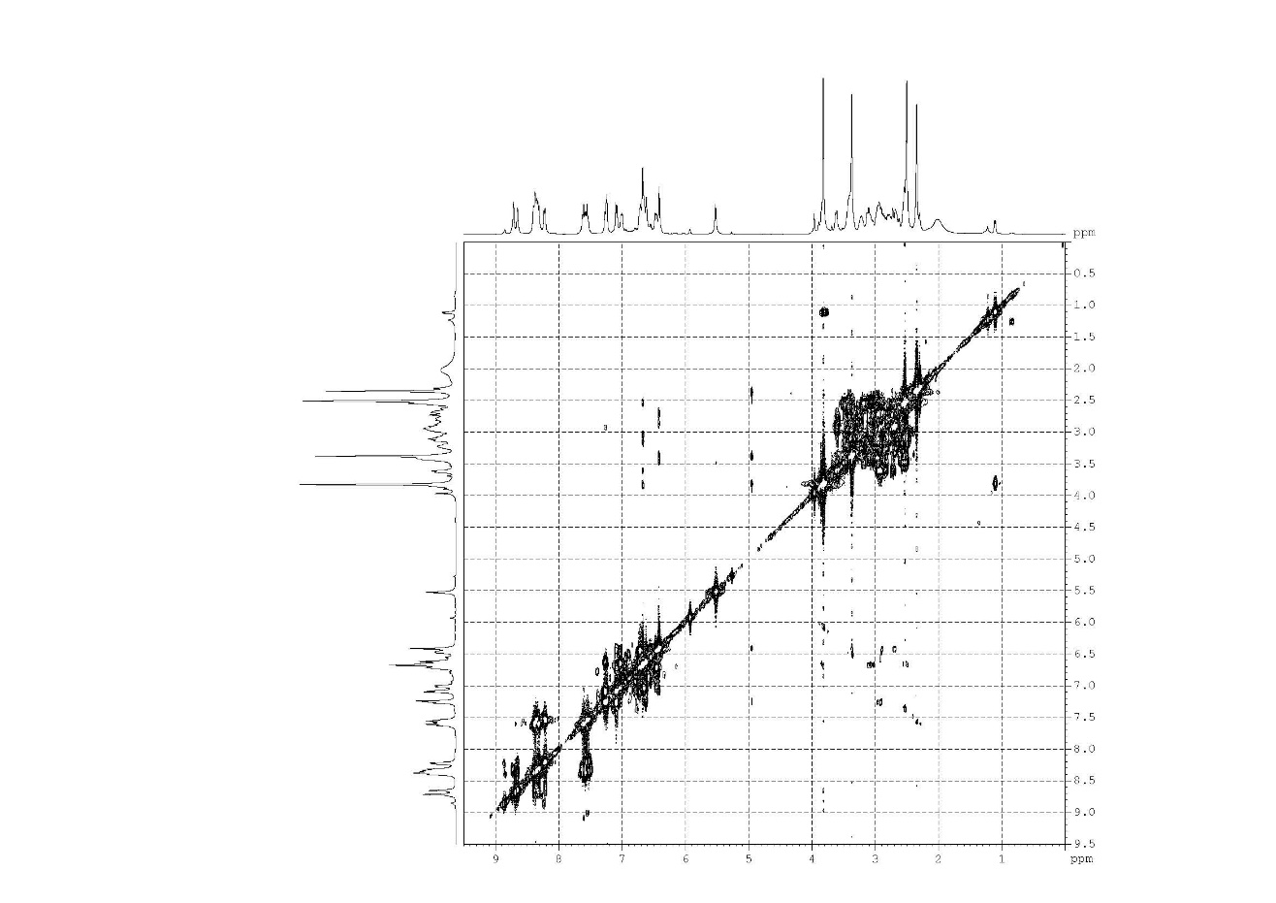
S23. COSY spectrum of compound 7

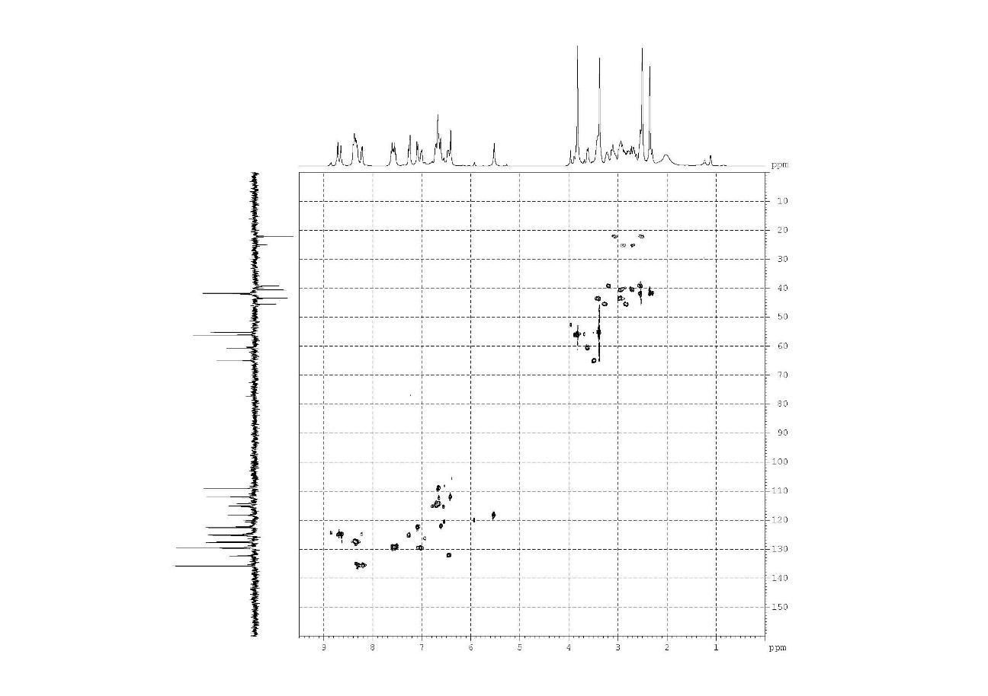
S24. HMQC spectrum of compound 7
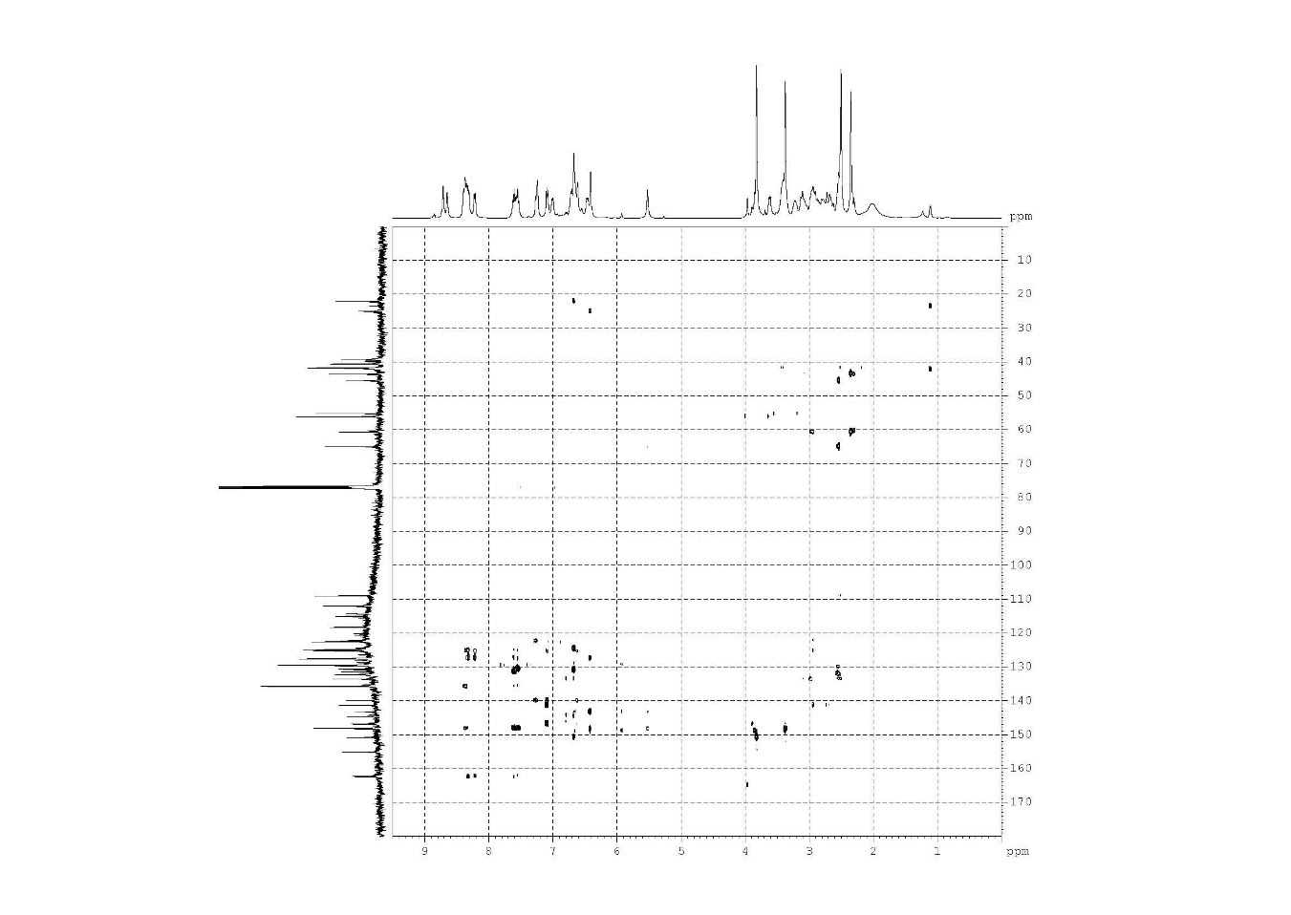
S25. HMBC spectrum of compound 7

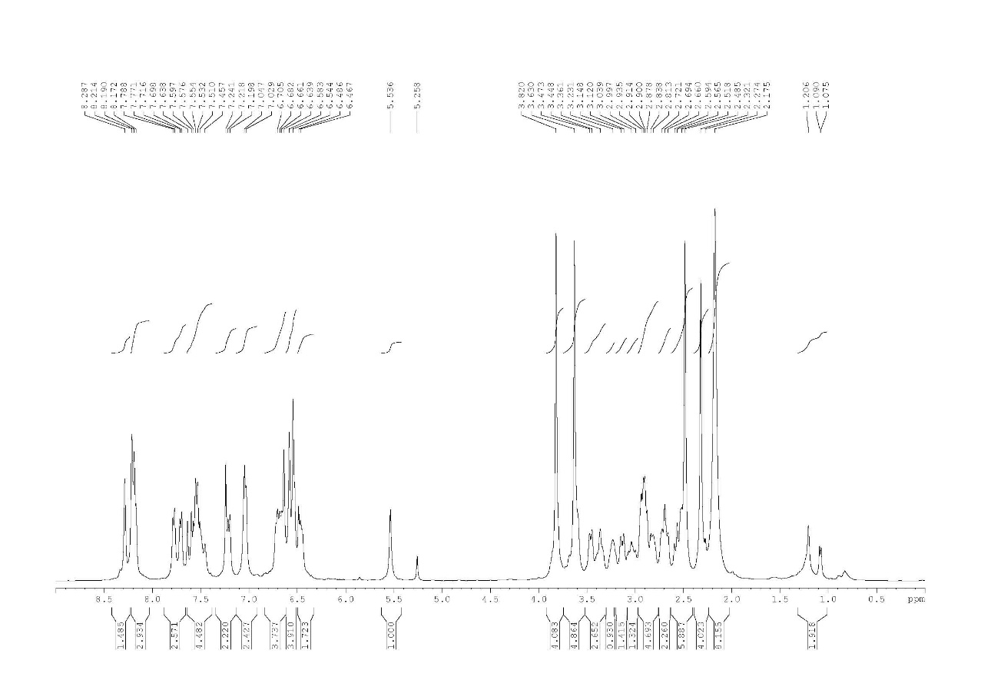
S26. ¹H NMR (CDCl₃, 400 MHz) spectrum of compound 8
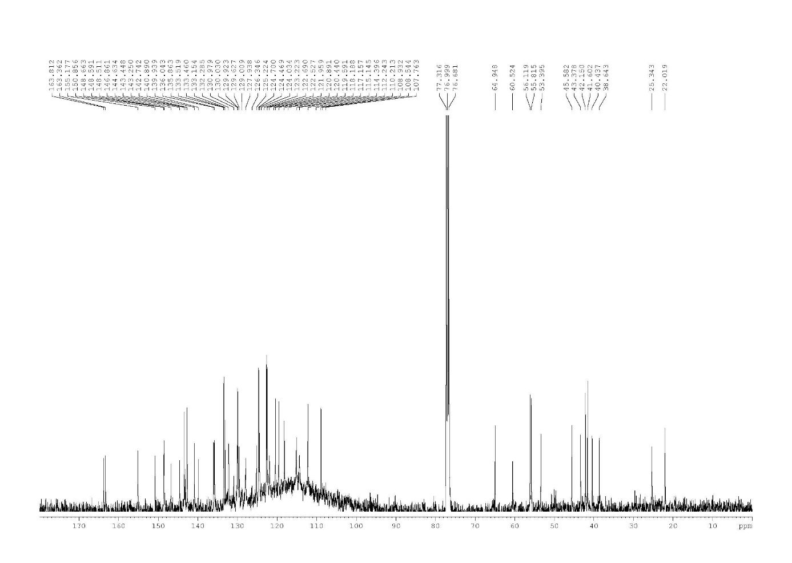
S27. ¹³C NMR (CDCl₃, 100 MHz) spectrum of compound 8
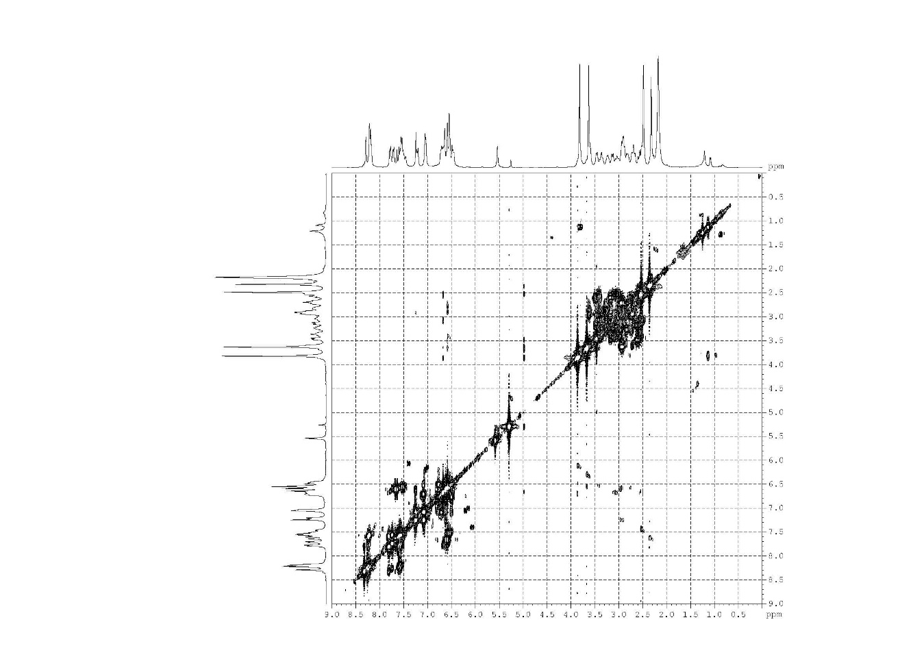
S28. COSY spectrum of compound 8
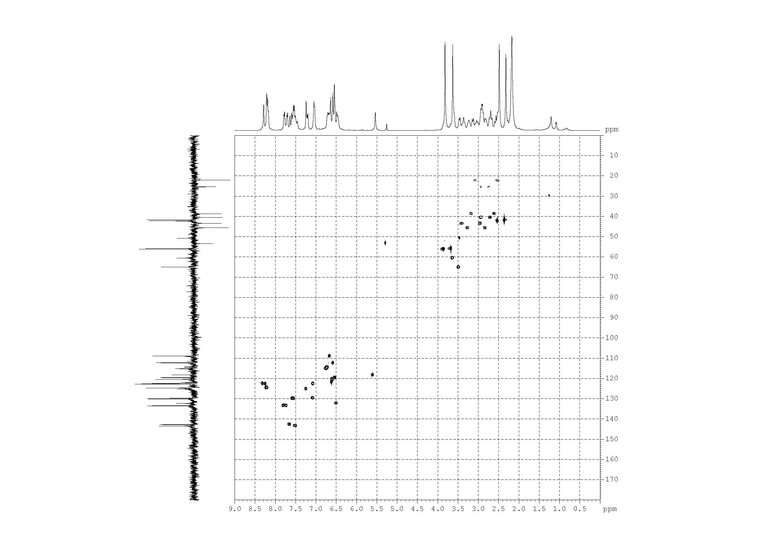
S29. HMQC spectrum of compound 8
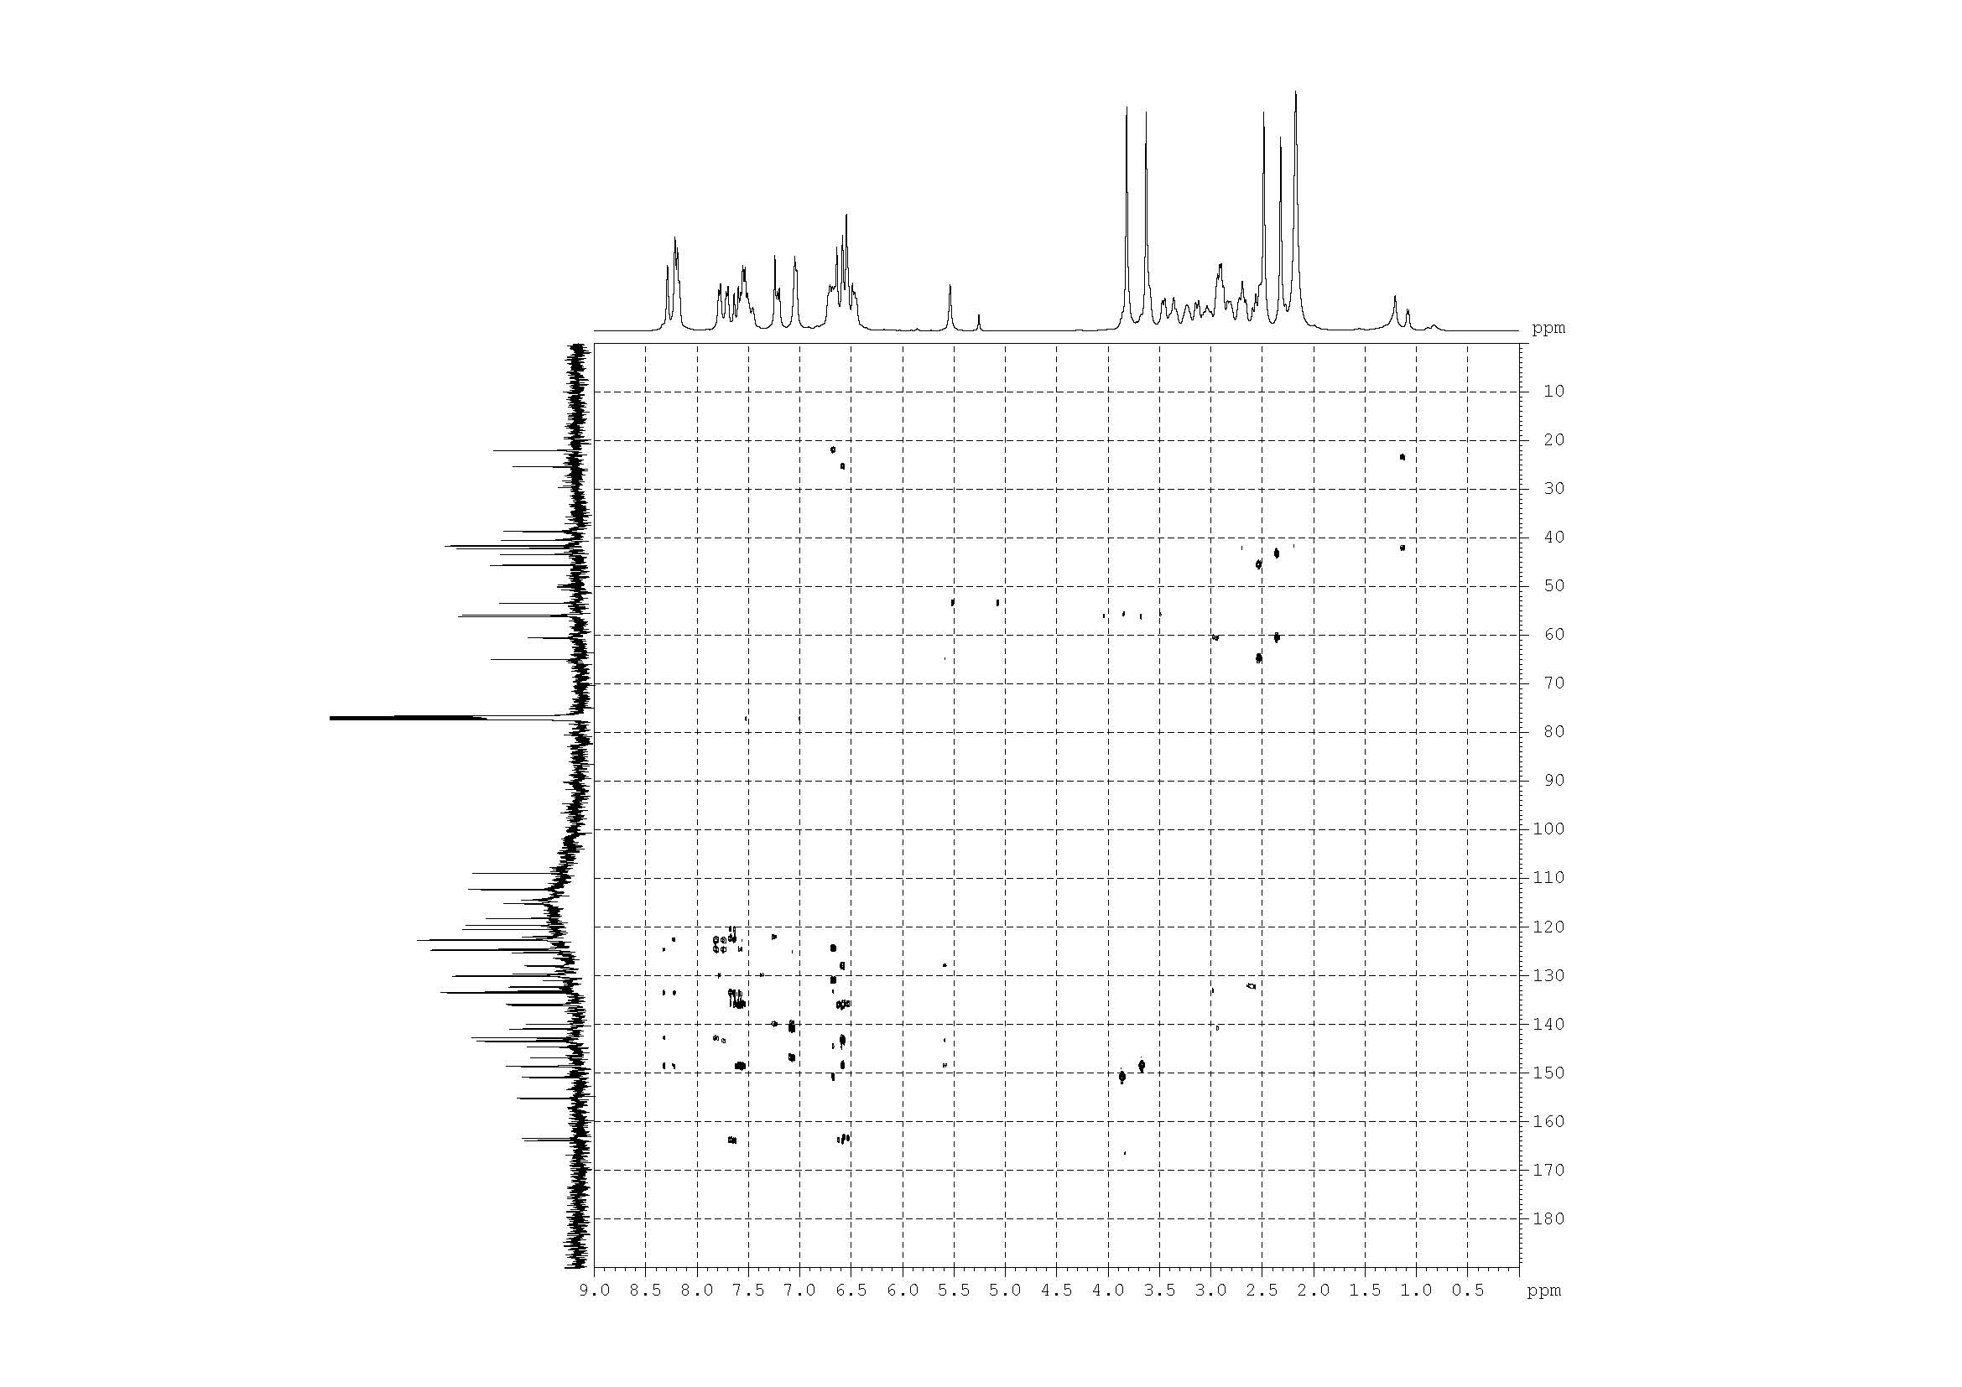
S30. HMBC spectrum of compound 8

