Supplementary material
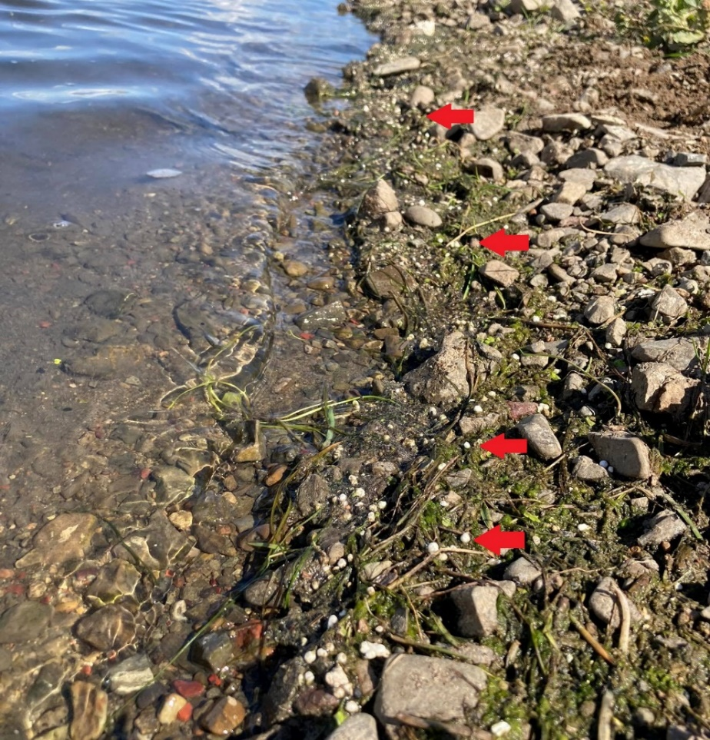
Fig. S1. Washed-up PSF on river edge (indicated by red arrows)

