Supplementary Materials

Table S1. Pro-environmental keywords and phrases

Chinese version | English version | Category*
捐钱 | Donate money | Activism
抵制破坏环境 | Boycott environmental destruction | Activism
倡导环境保护 | Advocate for environmental protection | Activism
签署环境保护请愿书 | Sign an environmental protection petition | Activism
参加志愿活动 | Participate in volunteer activities | Activism
自然保护 | Nature conservation | Activism
环境保护 | Environmental protection | Activism
环保 | Eco-friendly | Activism
买环境安全 | Buy environmentally safe product | Consumption
买有机食品 | Buy organic food | Consumption
可降解包装 | Biodegradable packaging | Consumption
买环保产品 | Buy environmentally friendly products | Consumption
避免使用气溶胶容器 | Avoid aerosol containers | Consumption
不买用动物进行实验的产品 | Do not buy products tested on animals | Consumption
不买来自濒危动物物种的产品 | Do not buy products from endangered species | Consumption
不买对环境造成危害的产品 | Do not buy products that harm the environment | Consumption
不买包装对环境造成危害的产品 | Do not buy products with harmful packaging | Consumption
不买用农药的产品 | Do not buy products with pesticides | Consumption
购买能源效率家用电器 | Buy energy-efficient appliances | Consumption
绿色消费 | Green consumption | Consumption
可持续性消费 | Sustainable consumption | Consumption
减少塑料 | Reduce plastic | Consumption
购买区域性产品 | Buy locally sourced products | Consumption
使用可再生 | Use renewable resources | Consumption
素食 | Vegetarian | Sustainable diet
低碳饮食 | Low-carbon diet | Sustainable diet
植物饮食 | Plant-based diet | Sustainable diet
少吃肉 | Eat less meat | Sustainable diet
回收纸张 | Recycle paper | Recycling
回收纸板 | Recycle cardboard | Recycling
回收塑料瓶 | Recycle plastic bottles | Recycling
回收金属 | Recycle metal | Recycling
回收玻璃瓶 | Recycle glass bottles | Recycling
回收电池 | Recycle batteries | Recycling
可循环利用 | Recyclable | Recycling
可回收包装 | Recyclable packaging | Recycling
随手关灯 | Turn off lights | Saving energy
自然晾干 | Air dry naturally | Saving energy
冬天调低暖气 | Lower heating in winter | Saving energy
用节能灯泡 | Use energy saving bulbs | Saving energy
夏天少用空调 | Use air conditioning less in summer | Saving energy
随手关水龙头 | Turn off taps | Saving energy
节约用电 | Save electricity | Saving energy
节约用水 | Save water | Saving energy
使用可降解 | Use biodegradable products | Saving energy
重复使用 | Reuse | Saving energy
不使用泡沫塑料包装 | Do not use foam plastic packaging | Saving energy
使用清洁能源 | Use clean energy | Saving energy
绿色生活 | Green living | Saving energy
低碳生活 | Low-carbon living | Saving energy
乘坐|公交车 | Take the bus | Geen transportation
公共交通|地铁 | Public transportation or subway | Green transportation
火车 | Take train | Green transportation
骑自行车 | Ride a bike | Green transportation
步行 | Walk | Green transportation
拼车 | Share car | Green transportation
减少飞机旅行 | Reduce air travel | Green transportation
垃圾分类 | Waste sorting | Waste reduction
减少浪费 | Reduce waste | Waste reduction
减少排放 | Reduce emissions | Waste reduction
Note. * The keywords and phrases were primarily based on the PEB questionnaire curated and validated by (Kalamas et al., 2014), covering 50 PEB items of 7 categories, including saving energy, consumption, activism, recycling, transportation, diets, and waste management. We translated those item keywords for characterizing PEBs into Chinese before conducting the text matching. We also added several keywords that are commonly used in Chinese culture to characterize sustainable diets, a category missing in the PEB questionnaire (Kalamas et al., 2014), for instance, “低碳生活” (low-carbon lifestyle), and “低碳饮食” (low-carbon diet).

Mediation Paths between temperature changes and emotional well-being

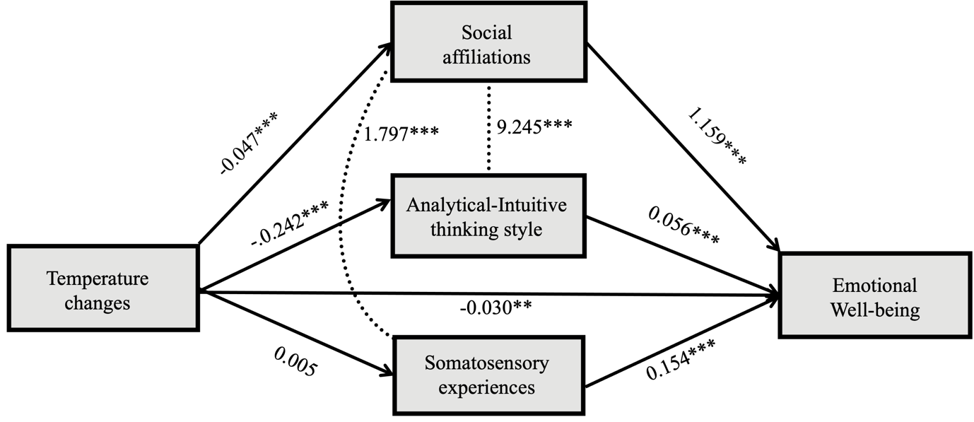
Figure S1. Mediation paths from SEMs. CFI 0.996, GFI 0.999, rmsea, 0.047

Table S2. Sampled posts with somatosensory experiences identified with SC-LIWC

Original posts | English version | Topics
"#全国多地出现囤冰箱空调热潮# 确实是，感觉随着全球变暖，现在各地区气温都普遍升高了，制冷电梯也用的越来越多。 | #National trend of stockpiling refrigerators and air conditioners emerges# Indeed, I am feeling that with global warming, temperatures in various regions are generally rising, and the use of air conditioning and refrigeration is increasing. | Making sense of their experiences.
#全球热#广东30+ 我尊滴好热好热 全球变暖大家要注意环境保护啊 | #Global heat# Guangdong's temperature is over 30 degrees, it's so hot! Everyone should pay attention to environmental protection in the face of global warming. | Pro-environment advocation
#全球变暖#真的感觉好明显 真的应该保护环境 | #GlobalWarming# It really feels obvious. We should definitely protect the environment. | Pro-environment advocation

Reference:

Kalamas, M., Cleveland, M., & Laroche, M. (2014). Pro-environmental behaviors for thee but not for me: Green giants, green Gods, and external environmental locus of control. Journal of Business Research, 67(2), 12-22. https://doi.org/10.1016/j.jbusres.2013.03.007

