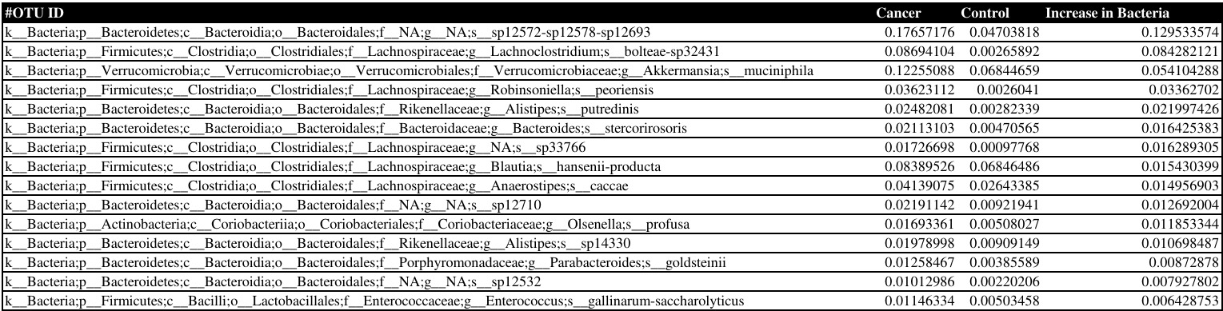Table 1. List of 15 selected positive outliers from figure 1. Column 2 represents the counts of each bacterium present in the pancreatic cancer bearing mice cohort. Column 3 represents counts of the corresponding bacterium in the control group of mice. Column 4 displays the difference between the cancer and control groups for each bacterium species, which is resultingly positive. The table is arranged in descending order.
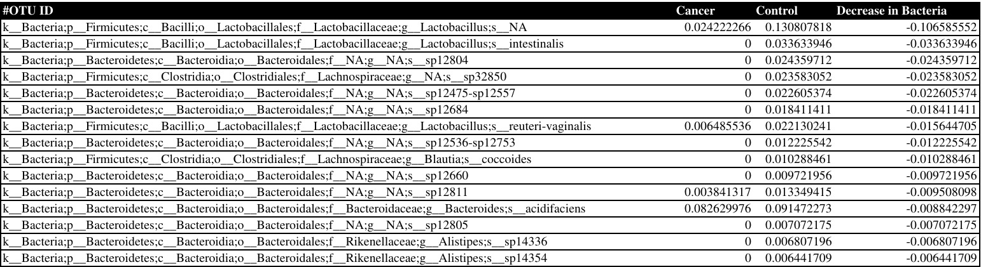Table 2. List of 15 selected negative outliers from figure 1. Column 2 represents the counts of each bacterium in the cancerous group of mice. Column 3, shows the initial presence of each bacterium in the control group of mice. Column 4 displays the difference between the cancer and control groups for each bacterium species, which is resultingly negative. The table is arranged in ascending order.

