Supplementary materials for

Toward quantitative characterization of simulated earthquake cycle complexities

Shiqi Wang
axelwang@stanford.edu
Department of Geophysics, Stanford University, Stanford, CA 94305, USA.

Table of contents
S1. Trefoil knots and quasi-periodicity
S2. Fixed points characterization for the quasi-dynamic spring slider
S3. Lyapunov exponents for the Lorenz equations
S4. Lyapunov exponents for a stable-spiral fixed point in quasi-dynamic spring slider
S5. Correlation dimension of the Lorenz attractor
S6. Attractor reconstruction for EQ-NDS

Additional references
s1. Lorenz, E.N., 1963. Deterministic nonperiodic flow. Journal of atmospheric sciences, 20(2), pp.130-141.
s2. Sprott, J.C., 2003. Chaos and time-series analysis. Oxford University Press.

S1. Trefoil knots and quasi-periodicity
A trefoil knot can be generated with the following equations:
 | $$x=[2+\cos\left(ω_{1}t\right)]\cos{(ω_{2}t)} \\ y=[2+\cos\left(ω_{1}t\right)]\sin{(ω_{2}t)} \\ z=\sin\left(ω_{1}t\right)$$ | S1.1
where $x,y,z$ are arbitrary variables, $t$ is time, and $ω_{1}$ and $ω_{2}$ are characteristic frequencies. First, let $ω_{1}=3/(2π)$ Hz and $ω_{2}=2/(2π)$ Hz. Because these two frequencies are commensurate, we obtain a trefoil knot which is a closed curve on the surface of a torus (Fig. S1-1A) and the time-series of the system is periodic (Fig. S1-1B). Then, let $ω_{1}=3/(2π)$ Hz and $ω_{2}=2.07/(2π)$ Hz, a set of values that are incommensurate. Now, the trajectory in the phase space becomes torus-filling, i.e. it traces out the shape of a torus (Fig. S1-2A). The time series now becomes quasi-periodic and does not repeat ieself (Fig. S1-2B). However, this is considered as a regular motion [26,36,56] rather than chaotic motion. Clearly, without quantitative measures, it is hard to distinguish this from chaos.
Even if it is appropriate to Fourier transform a earthquake-cycle time series (due to its spiky shape and non-uniform time sampling, see main text), the results maybe hard to interpret as they relate to how the characteristic frequencies functionally interact with each other. For example, for the case shown in Fig. S1-1, if we Fourier transform the $x$ variable, we obtain 3, instead of 2 peaks (Fig. S1-3), because Eq. S1.1 can be written as
$$x=2\cos{(ω_{2}t)}+\cos\left(ω_{1}t\right)\cos{(ω_{2}t)}$$
As a result, the middle large peak corresponds to $ω_{2}$, but the second term splits the two frequencies so the other two peaks represent $ω_{1}+ω_{2}$ and $ω_{1}-ω_{2}$.

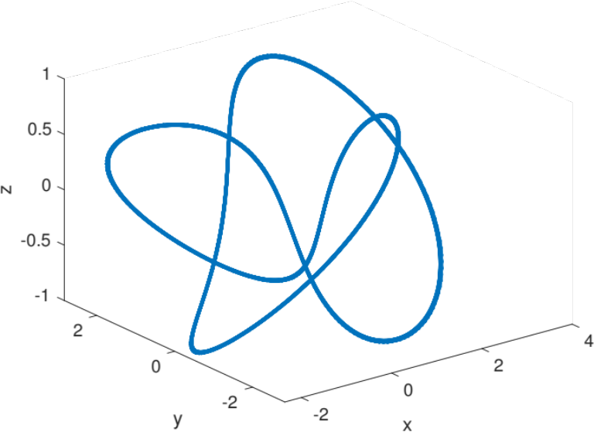
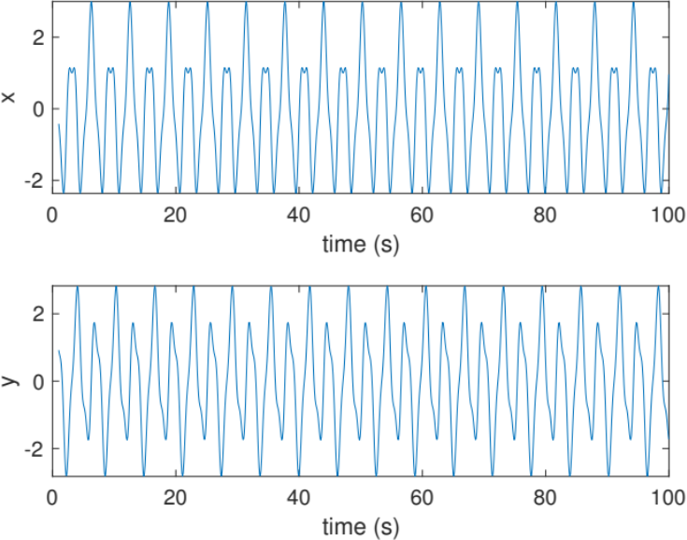
A. B.
Fig. S1-1. A. Trefoil knot in the $x-y-z$ phase space. B. $x$ and $y$ time series corresponding to the trefoil knot show periodicity. $z$ is not plotted because it is periodic from the equation.

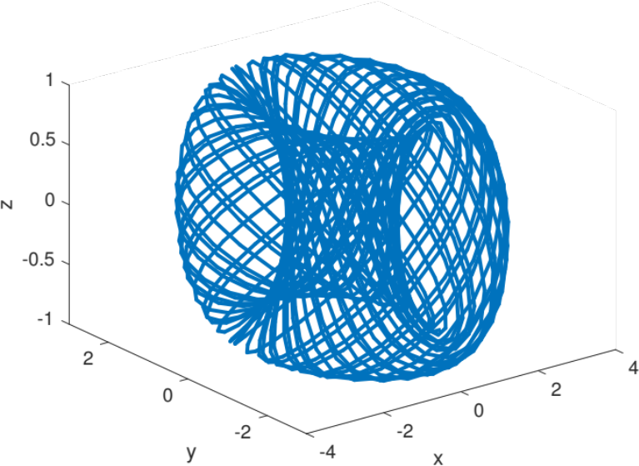
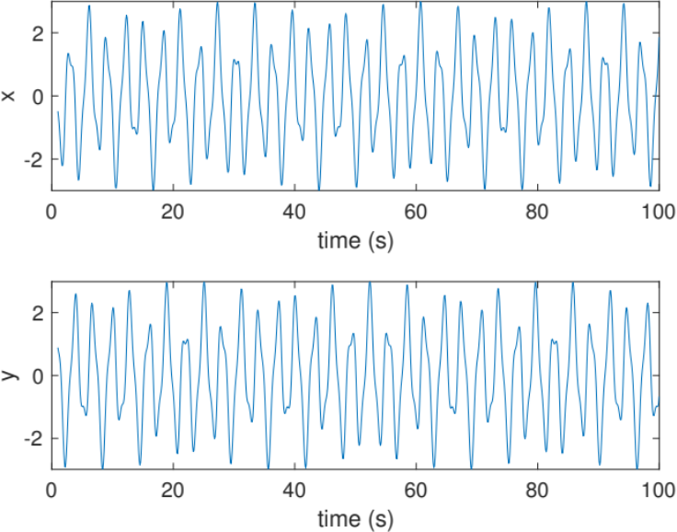
A. B.
Fig. S1-2. A. Torus-filling trajectory in the $x-y-z$ phase space. B. $x$ and $y$ time series corresponding to the torus show quasi-periodicity, where the pattern never repeats itself. $z$ is not plotted because it is periodic from the equation.
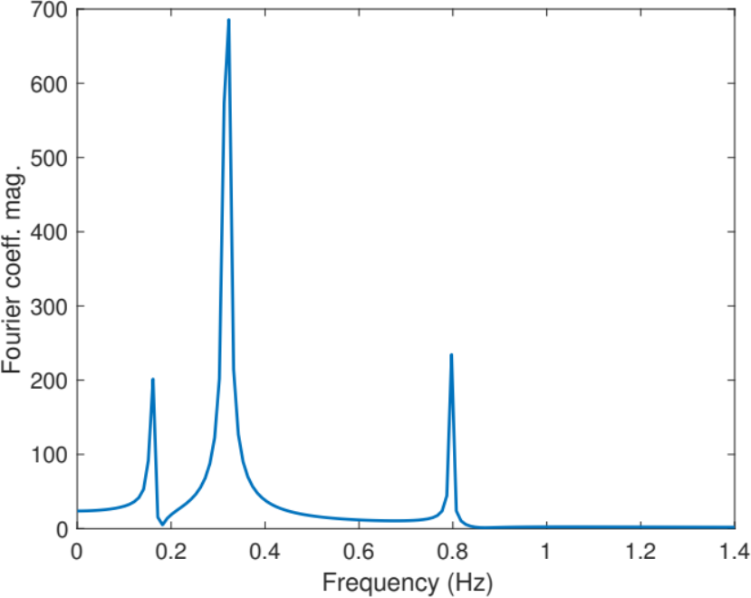
Fig. S1-3. Fourier transform of the $x$ variable in Fig. S1-1 shows 3 peaks, rather than 2. This requires knowing the functional relationship of the characteristic frequencies to interpret. Picking these frequencies precisely, to determine whether they are commensurate, is another issue.

S2. Fixed points characterization for the quasi-dynamic spring slider
The Jacobian matrix for the quasi-dynamic spring-slider is derived:
$$x_{x}^{'}=\frac{NDe^{-x}x^{'}}{{\left(1+NDe^{-x}\right)}^{2}}+\frac{-Se^{-x}-NR\left(a-b\right)}{1+N D e^{-x}} \\ x_{y}^{'}=\frac{NRf_{0}}{\left(1+NDe^{-x}\right)} \\ y_{x}^{'}=\frac{NDe^{-x}y^{'}}{{\left(1+NDe^{-x}\right)}^{2}}+\frac{-SDe^{-x}+e^{x}R\left[f_{0}\left(1-y\right)+x\left(a-b\right)\right]+e^{x}R\left(a-b\right)}{1+N D e^{-x}} \\ y_{y}^{'}=\frac{Rf_{0}e^{x}}{-{\left(1+NDe^{-x}\right)}^{2}}$$

Table S2-1 shows the eigenvalues, trace, and determinant of the Jacobian matrix and the classification of the fixed points according to Fig. 1F.

Case | Eigenvalues | Trace | Determinant | Classification
Fig. 1A | -1.12e-08+7.01e-08j  -1.12e-08-7.01e-08j | -2.24e-08 | 5.04e-15 | Stable spiral
Fig. 1B | -2.02e-14+2.01e-07j  -2.02e-14-2.01e-07j | -4.04e-14 | 4.04e-14 | Stable spiral
Fig. 1C | 4.04e-6+4.90e-06j  4.04e-6-4.90e-06j | 8.09e-6 | 4.04e-11 | Unstable spiral
Fig. 1D | -2.58e-6+4.86e-06j  -2.58e-6-4.86e-06j | -5.17e-6 | 3.03e-11 | Stable spiral
Table S2-1. Classification of fixed points shown in Fig. 1A-D. The values are kept to the second decimal place. All of the eigenvalues are complex conjugate. The imaginary number is denoted as j.

These results are consistent with visual inspections and Fig. 1F. It is noted that the fixed point in Fig. 1B is not a center but rather a stable spiral, though we are very close to the bifurcation value. It is known that the linearized stability analysis is not capable of characterizing any borderline (axes and the $p^{2}-4q=0$ line) cases shown in Fig. 1F, because the bifurcation values derived are only approximate, but not precise, which is required to illustrate any borderline case [26]. However, using a linearized analysis to study non-borderline case has been proved to be robust [26].

S3. Lyapunov exponents for the Lorenz equations
The Lorenz equations are
 | $$\dot{x}=σ(y-x) \\ \dot{y}=x\left(ρ-z\right)-y \\ \dot{z}=xy-βz$$ | S1.1
where none of the parameters and variables take any physical meaning here. For the parameters $σ=10$, $β=8/3$, and $ρ=28$, the classical Lorenz strange attractor emerges [s1] (Fig. S3-1A). In order to benchmark the algorithm used to calculate Lyapunov exponents (LEs) in this paper, I compare the results obtained for this Lorenz strange attractor with published results [s2]. The stacked equations (Eqs. M1&M3) are solved with a Runge-Kutta 45 solver from SciPy for 100s. The initial conditions are $x=0$, $y=1$ and $z=1.05$. The convergence of LEs for the Lorenz strange attractor is shown in Fig. S3-1B, and the final values are 0.695, 0.127, and -13.876. The results from published work[s2], are 0.906, 0, -14.572, obtained using a fixed time-step method and evolved for ${10}^{6}$s. Qualitatively, the LEs satisfy the expectation that one of them is positive, one of them is zero, and one of them is negative [26]. Using Eq. 12, $D_{KY}=2.050$ from my calculation and $2.062$ from the previous work. Therefore, the algorithm used in this paper, which enables the use of all explicit time-stepping methods in SciPy is deemed acceptable.

A.

B.
Fig. S3-1. A. The Lorenz strange attractor. B. Lyapunov exponents associated with the strange attractor. Note the fast convergence once the trajectories get onto the attractor.

S4. Lyapunov exponents for a stable-spiral fixed point in quasi-dynamic spring slider
The LEs are calculated for the stable spiral fixed point shown in Fig. 1A. The LEs converge to negative values again in an oscillatory manner (Fig. S4-1) similar to Fig. 3B. The LEs do not overlap each other, which means different degrees of errors are present for them as the real parts of the eigenvalues are the same for the case in Fig. 1A. I calculate the relative errors of LEs are ~22% and ~31%, which are quite large. However, given the small eigenvalues and the small LEs, and the uniqueness associated with calculating LEs for the present system with large time-step size differences, such error may be acceptable, because these LEs do not give categorical errors such as classifying the fixed point erroneously or estimating $D_{KY}$ incorrectly. In fact, because the LEs here are both negative, according to Eq. 12, $D_{KY}=0$, which correctly characterizes this fixed-point attractor.
Fig. S4-1. LEs for the stable-spiral fixed point shown in Fig. 1A. The last LEs are -8.69e-9 and -7.73e-9, which gives the relative errors mentioned in the text, respectively. The nondimensional time involves the spring constant $k$, so its labelling is different from Fig. 3B, but both simulations were run for 10 years to allow sufficient time for convergence.

S5. Correlation dimension of the Lorenz attractor
I estimate the correlation dimension of the Lorenz attractor discussed in section S3 using the same method as in the main text, and obtain $ν=2.05±0.01$, identical with the results of [35].

$$ν=2.05±0.01$$
Fig. S5-1. Estimating the correlation dimension for the Lorenz attractor discussed in section S3.

S6. Attractor reconstruction for EQ-NDS
I test choosing 4 other variables, i.e. the slip velocity time series at fault location $x=$1, 3, 5 and 7 km for the 3 simulation cases discussed in the main text (Fig. S6-1). When $N=200$, all curves form a closed loop in the embedding 3D space without knots. For the $x=$3 and 7 km cases, the resulted curves look identical. This makes sense because the time series should be identical at these two locations (Fig. 5A). For the $N=500$ and $1000$ cases, all of the curves have knots in the 3D embedding space, indicating their 2D nature. However, the variables that exhibit richer behavior show more obvious knots than the ones that appear periodic in the time-series. For example, for $N=500$, at $x=$ 1 and 5 km, the curve only has a very small knot at the lower left and upper right corners. In fact, the $x=$ 1 and 5 km curves for the $N=200$ and $N=500$ cases look comparable. Hence, it is clearly advisable to compare the two cases at 6 or 7 km. This issue is less pronounced when the EQ-NDS becomes more complicated, i.e. when $N=1000$. Even at $x=$ 1 and 5 km, the knotted nature of the curves is clearly visible.

I then try to vary the delay time/sample number (Fig. S6-2), using the case in Fig. 5H as an example. When the delay time is too small, the resulted curves are more elongated at certain directions, whereas when the delay time is too large, the knotted sections become more squeezed together harder to identify. This set of tests motivate the choice of $τ$, the delay time, in the main article.

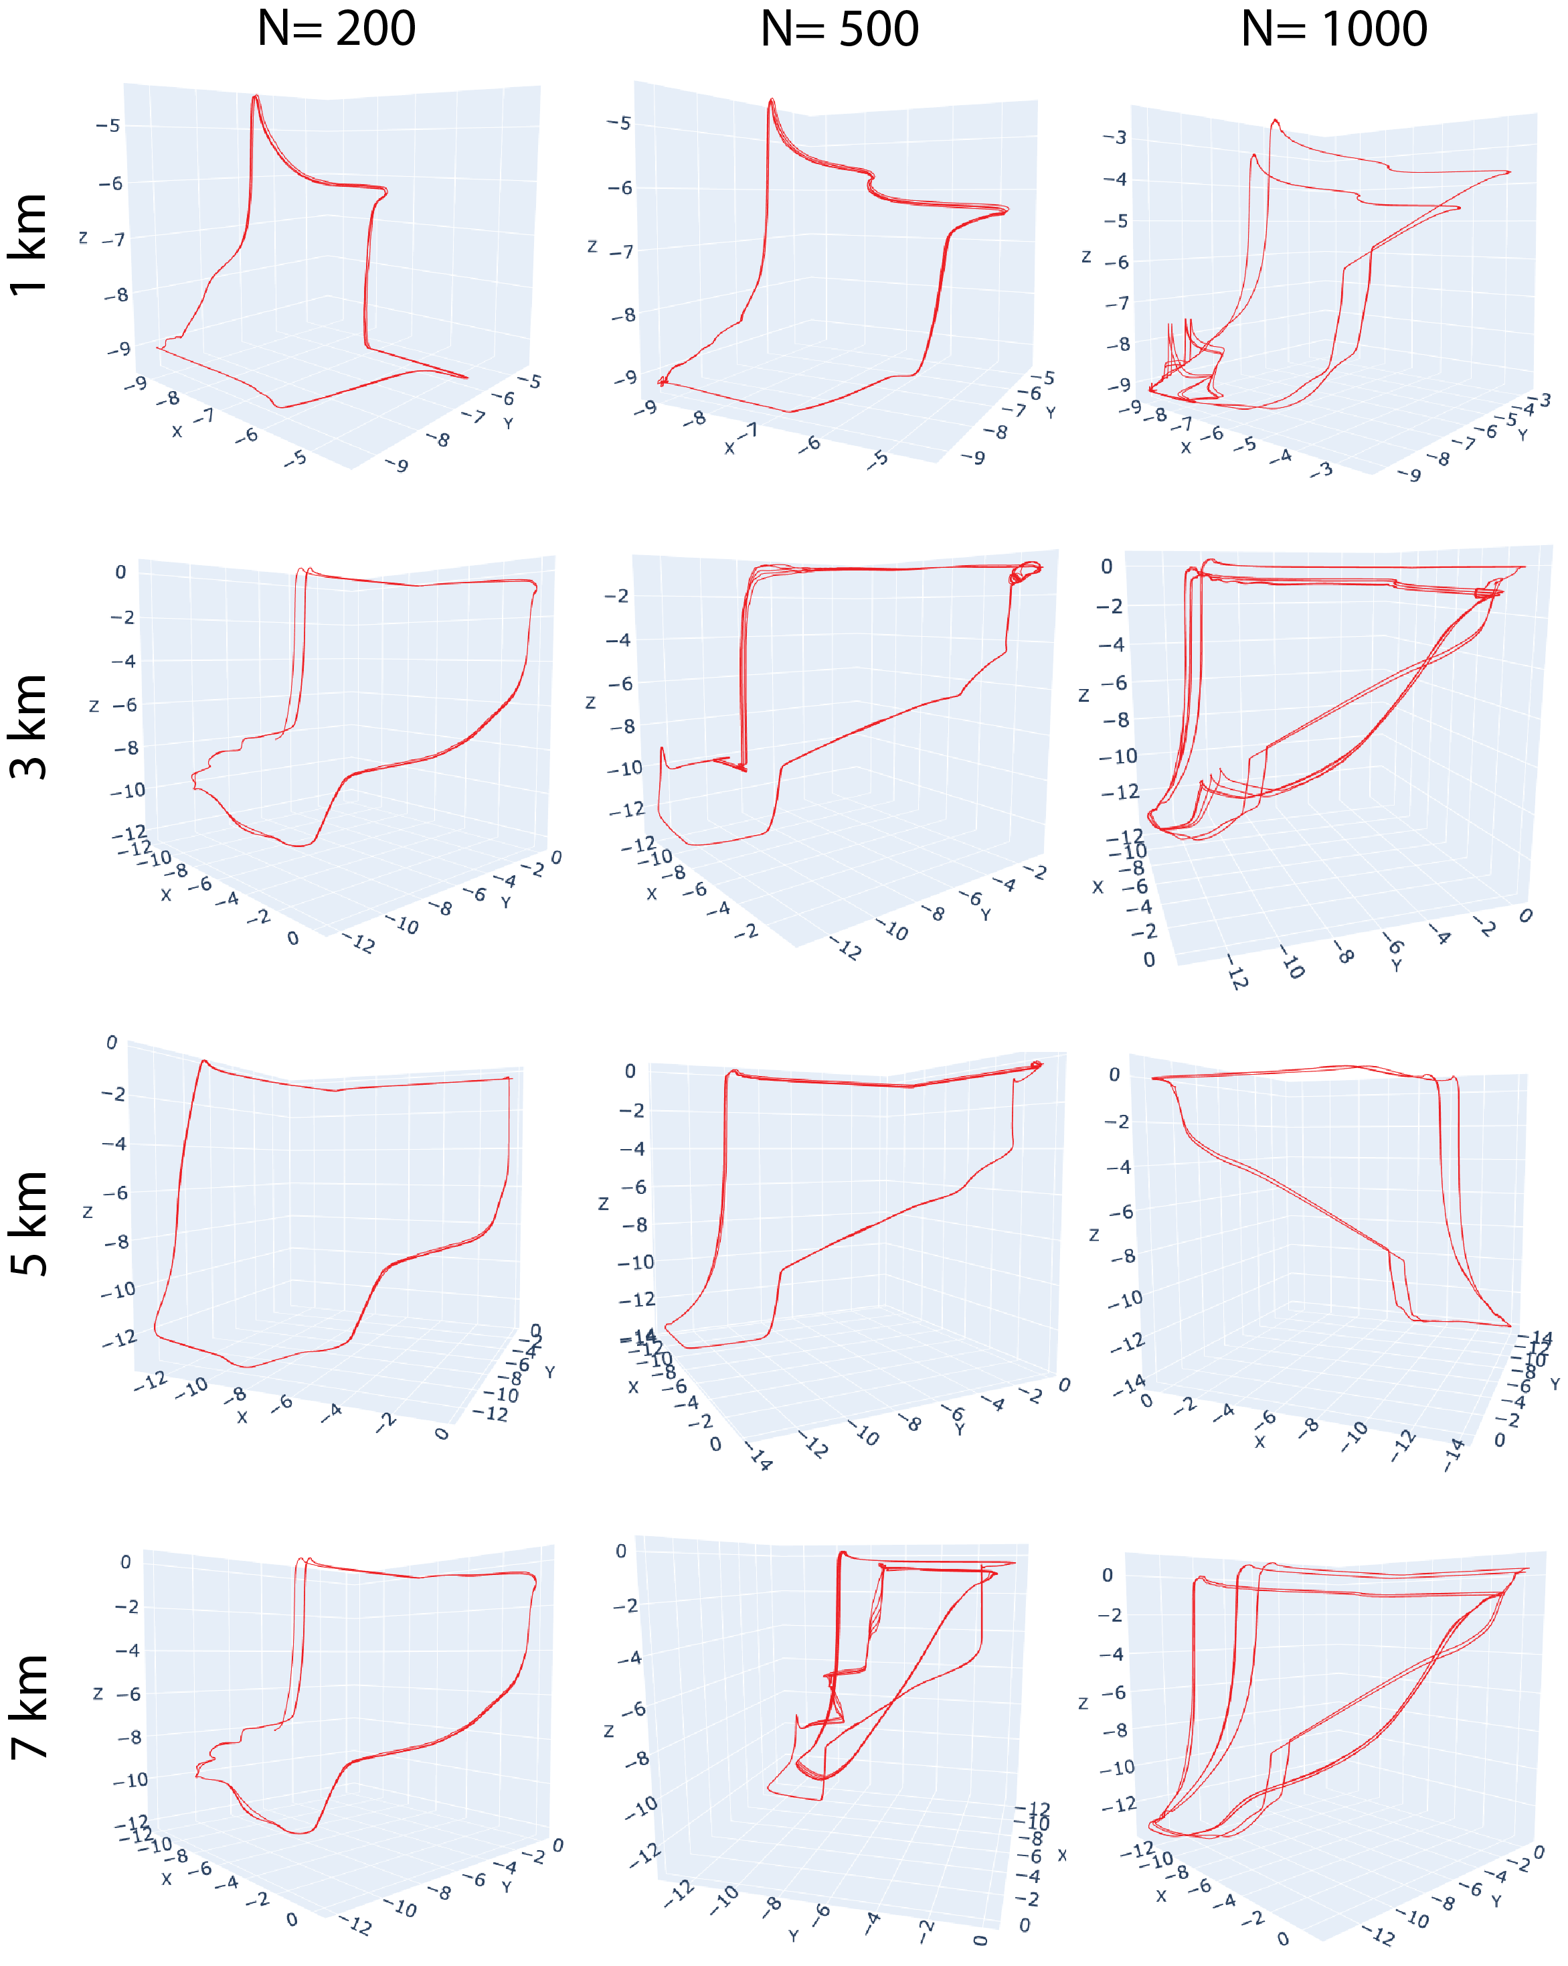
Fig. S6-1. Performing time-delay embedding with different slip-velocity variables at fault location indicated on the left margin for the 3 examples shown in Fig. 5, indicated in the top margin. The perspectives are slightly adjusted from case to case for best illustration.

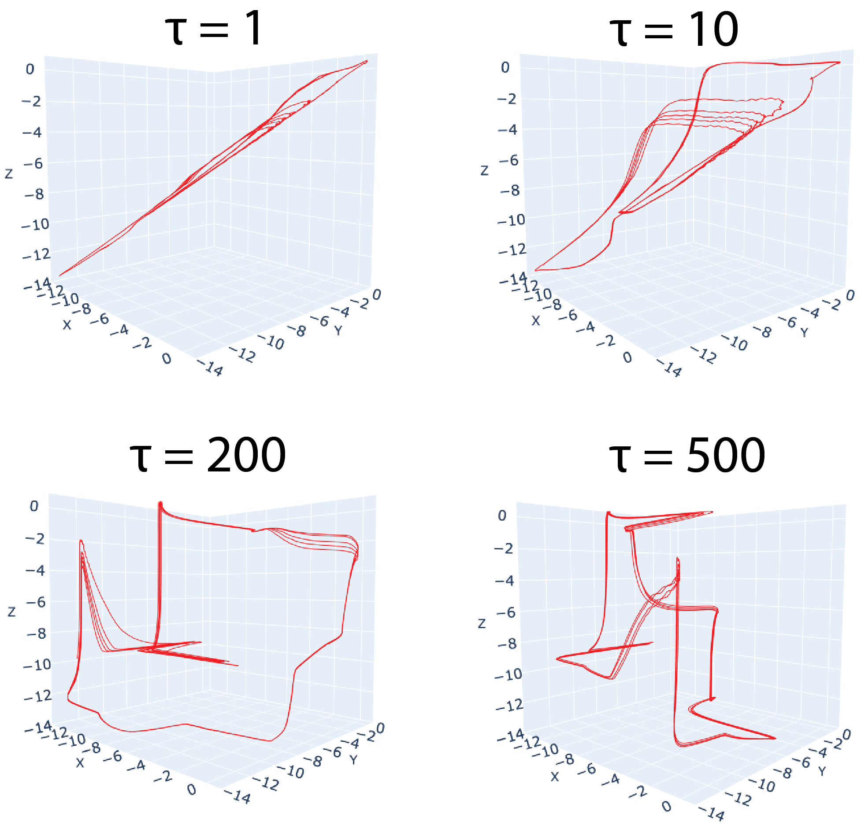
Fig. S6-2. Performing time-delay embedding with different delay time/sample for the case shown in Fig. 5H. The perspectives are slightly adjusted from case to case for best illustration.

