Supplemental Information
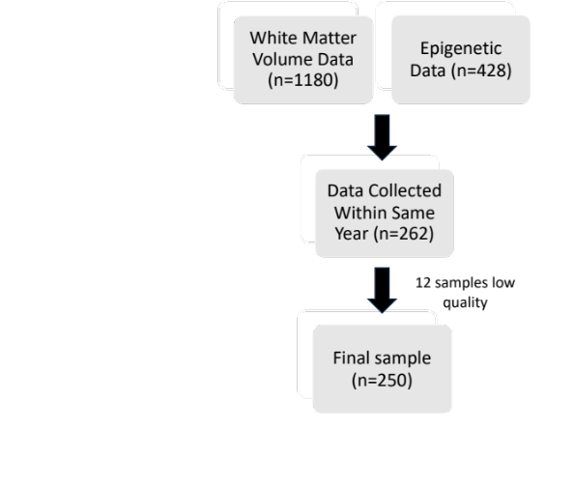
Supplementary Figure: Flowchart of sample creation

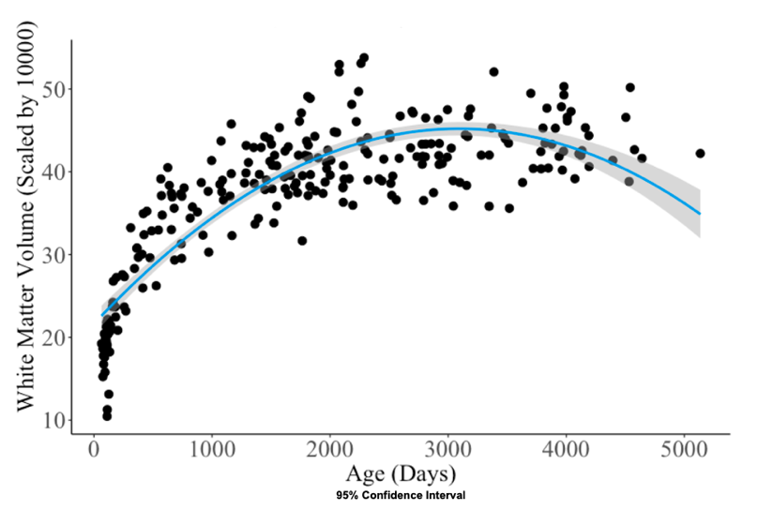
Supplementary Figure: White matter volume across age

White matter volume across age
Cross-sectional data on age and total white matter volume measured by MRI in a healthy pediatric cohort. Gray shading represents the standard error of the coefficient estimate in the regression model. A quadratic regression model was used to create a fitted curve (Age β = 1.52, Age² β = -0.024; p’s < 0.00001). There is a non-linear relationship between age and total white matter volume. White matter volume grows quickly and uniformly in healthy children in the first year of life. Total white matter volume is more variable as age increases.

