(a)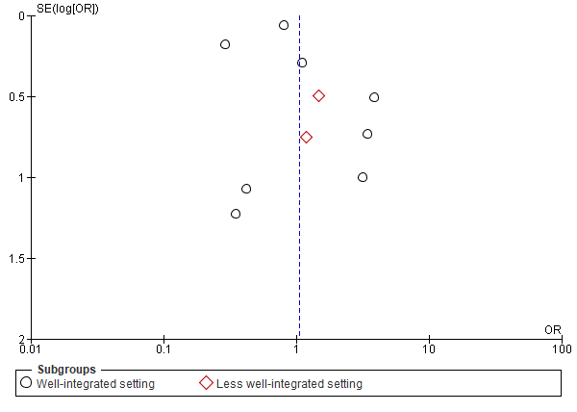  Perinatal mortality | (b)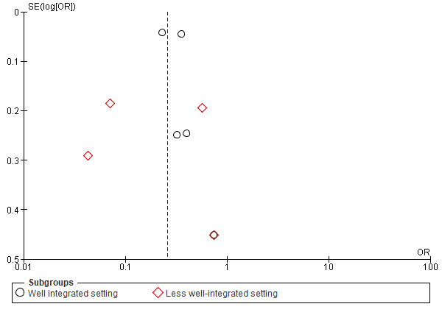  Epidural analgesia
(c)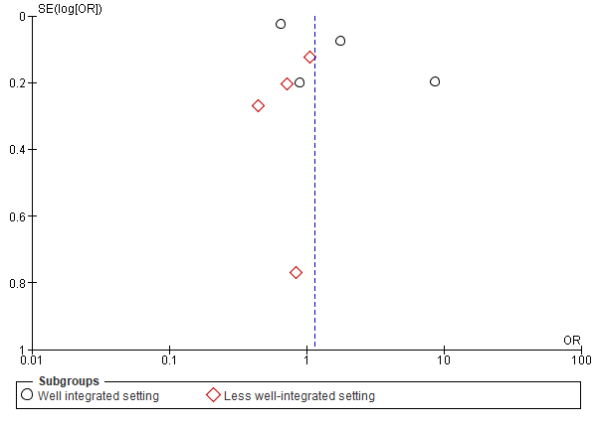  Episiotomy | (d)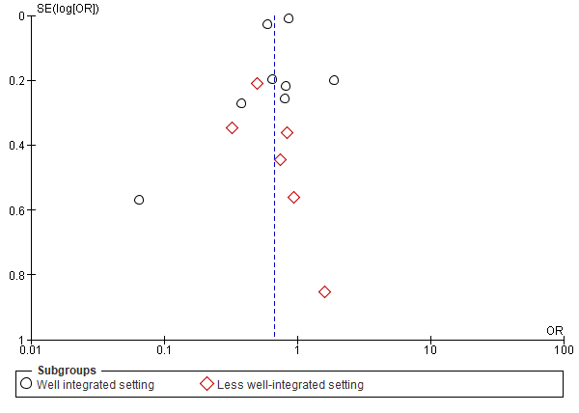  Assisted vaginal births (forceps/vacuum)
(e)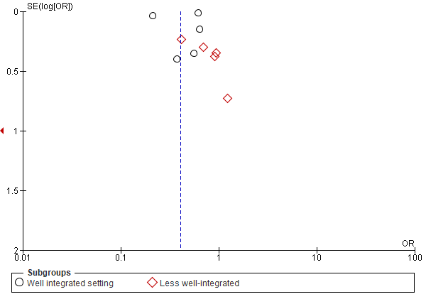  Cesarean section | (f)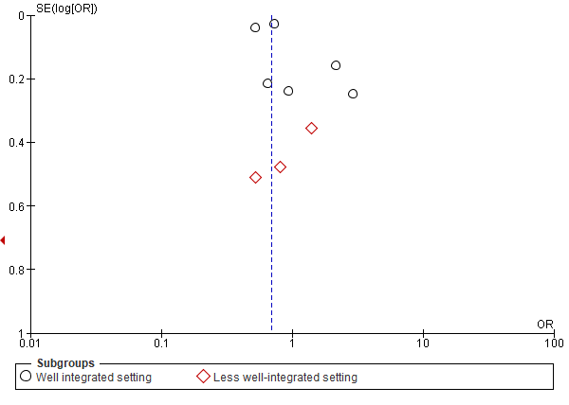  Post partum haemorrhage (PPH)
(g)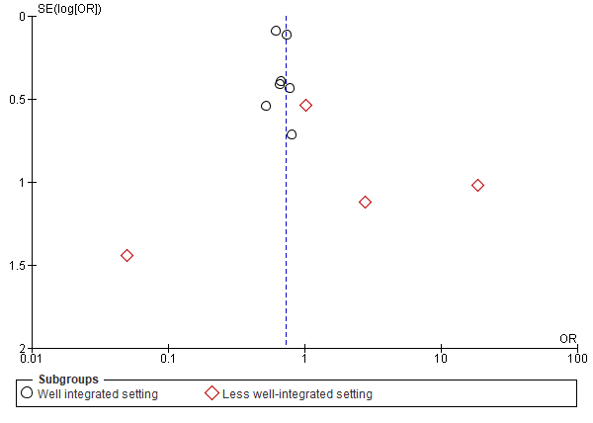  Apgar score <7 at 1/5 min(s) | (h)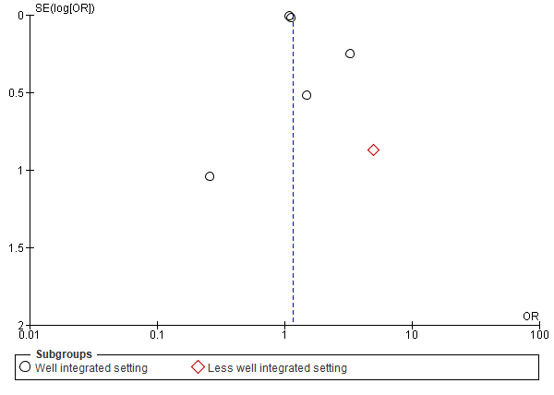  Post-term born

