Cochrane risk of bias assessment for randomised trials 2 (RoB 2)
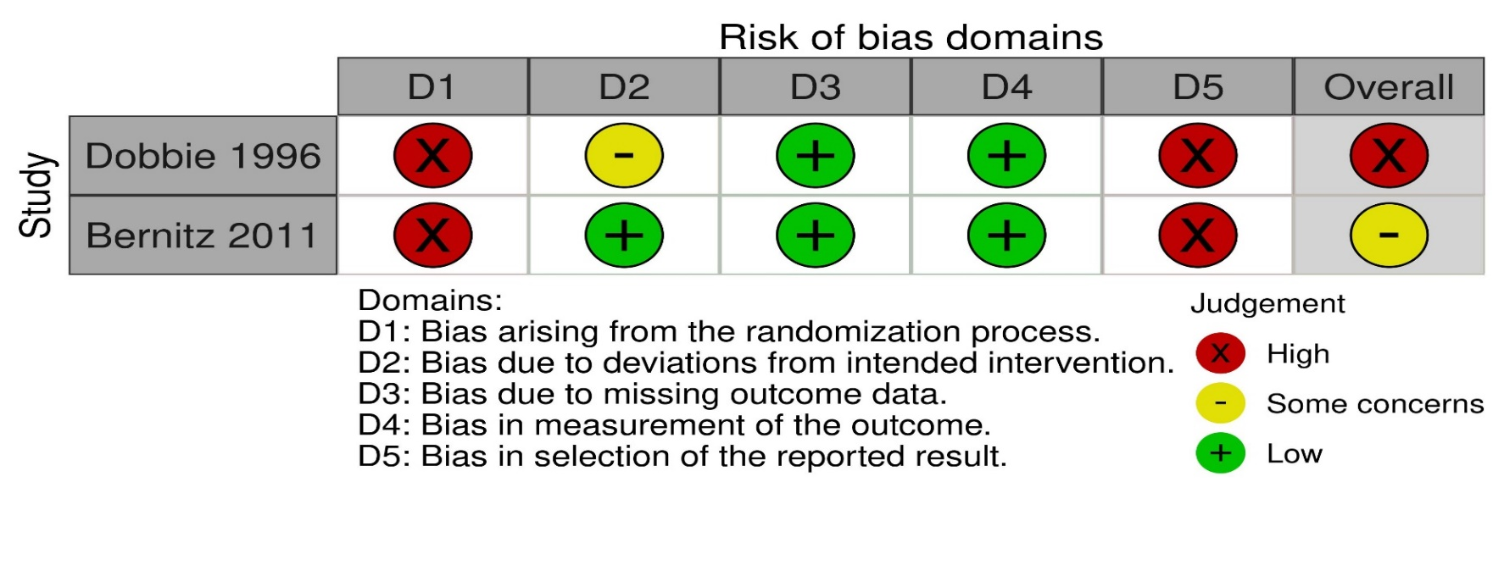
Dobbie G, Owen‐Johnstone L, Jagger C, Hopkins M, Kennedy J. Simulated home delivery in hospital: a randomised controlled trial. BJOG An Int J Obstet Gynaecol. 1993;100(4):316–23.
Bernitz S, Rolland R, Blix E, Jacobsen M, SjØborg K, Øian P. Is the operative delivery rate in low-risk women dependent on the level of birth care? A randomised controlled trial. BJOG An Int J Obstet Gynaecol. 2011;118(11):1357–64

¹Randomized control trials

