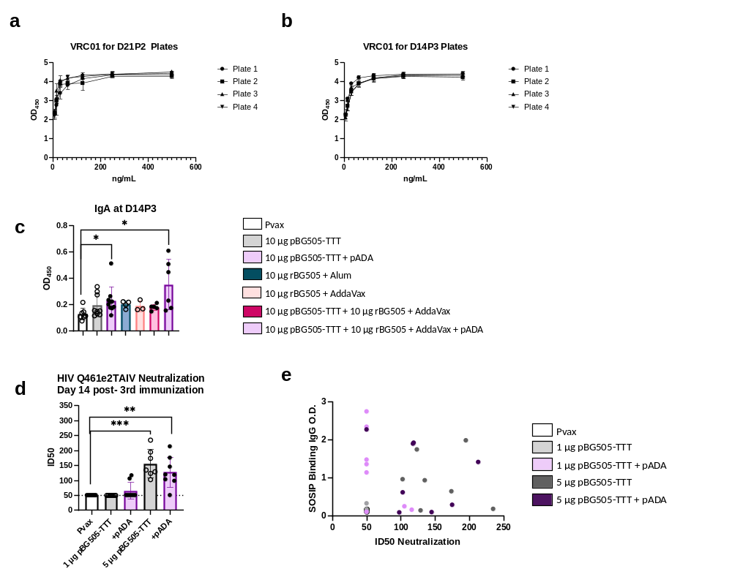
Supplemental Figure 1: Optical density curves of VRC01 human monoclonal antibody used to demonstrate consistency for ELISA assays. VRC01 curves were run on the same assay plates as data displayed in Figure 1b (a-b). SOSIP specific IgA measured via ELISA for animal experiments outlined in Figure 3a (c). Serum neutralization ID₅₀ values and Pearson correlation of SOSIP specific IgG and neutralization for animal experiments outlined in Figure 1a (d-e). Symbols represent individual animals, bars represent the mean, error bars represent the standard deviations. *p<0.05, **p<0.01, ***p<0.001, and ****p<0.0001 by Mann-Whitney-U test (d-e) or Kruskal-Wallis Anova (c).
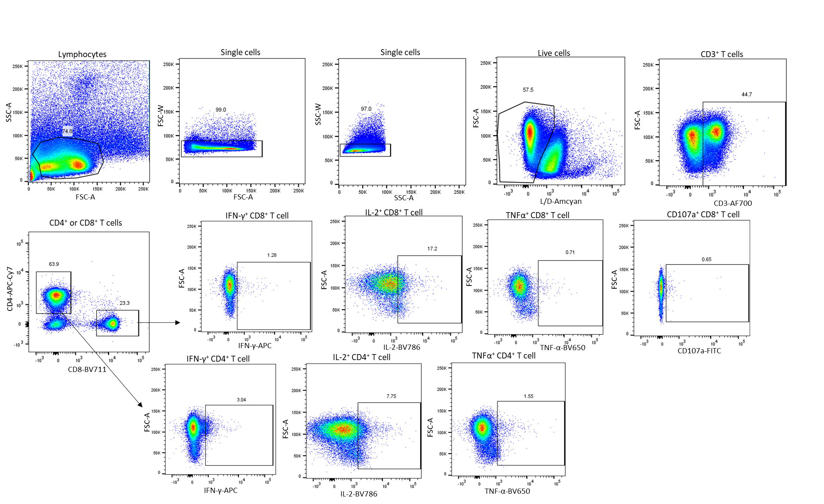

Supplemental Figure 2: Gating strategy for intracellular cytokine staining and CD107a expression. Gating is representative of peptide stimulation alone. Analyzed data (Supplemental Figure 3 and Figure 4) is represented as peptide stimulation frequencies with DMSO frequencies subtracted out to account for background activation from DMSO alone.
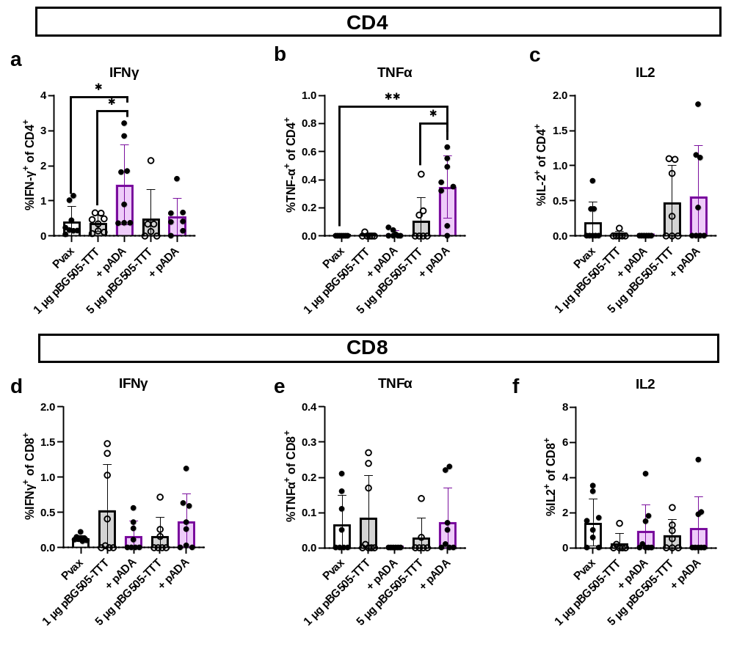
Supplemental Figure 3: Single cytokine expression for animal experiments outlined in Figure 1a. Gating strategy is displayed in Supplemental Figure 2. IFNγ, TNFα and IL2 expression in CD4⁺ T cells (a) and CD8⁺ T cells (b). Symbols represent individual animals (n=8 per group). White bars with closed circles represent mice immunized with Pvax. Gray bars with open circles represent animals immunized with bars 1 µg or 5 µg of pBG505-TTT. Purple bars with closed circles represent animals that were immunized with 1 µg or 5 µg of pBG505-TTT + pADA. Bars represent the mean and error bars represent the standard deviations. *p<0.05, **p<0.01, ***p<0.001, and ****p<0.0001 by Mann-Whitney-U test.
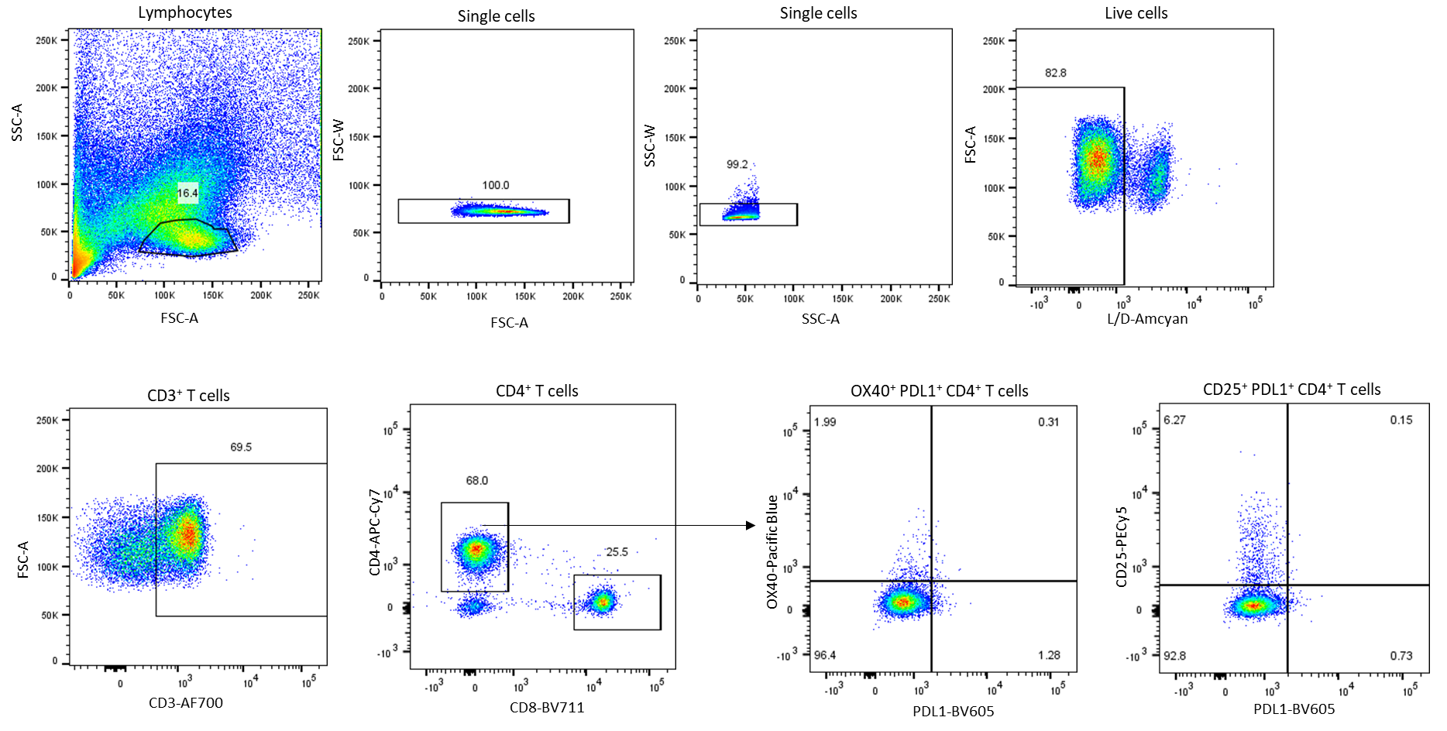
Supplemental Figure 4: Gating strategy for activation induced marker (AIM) assay
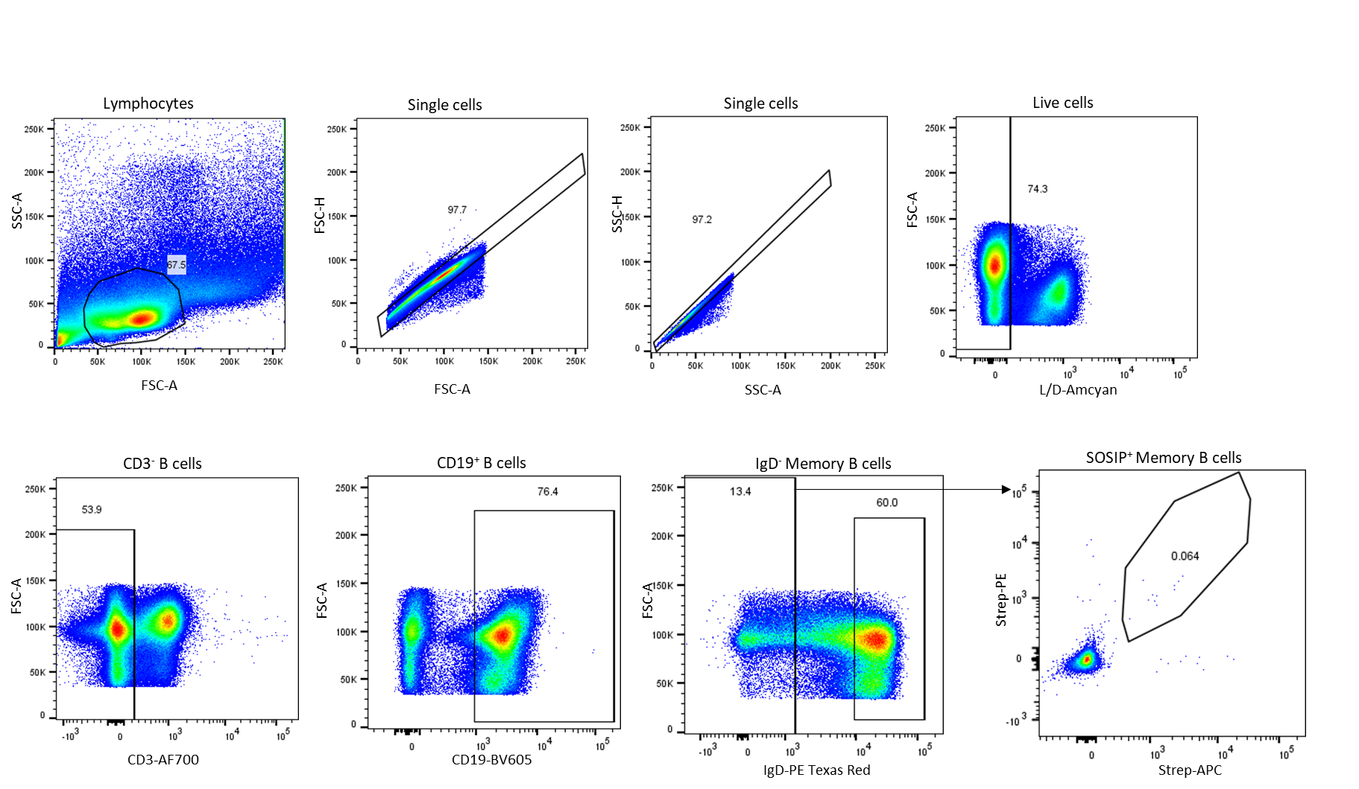
Supplemental Figure 5: Gating strategy for SOSIP specific memory B cell analysis as displayed in Figure 5c
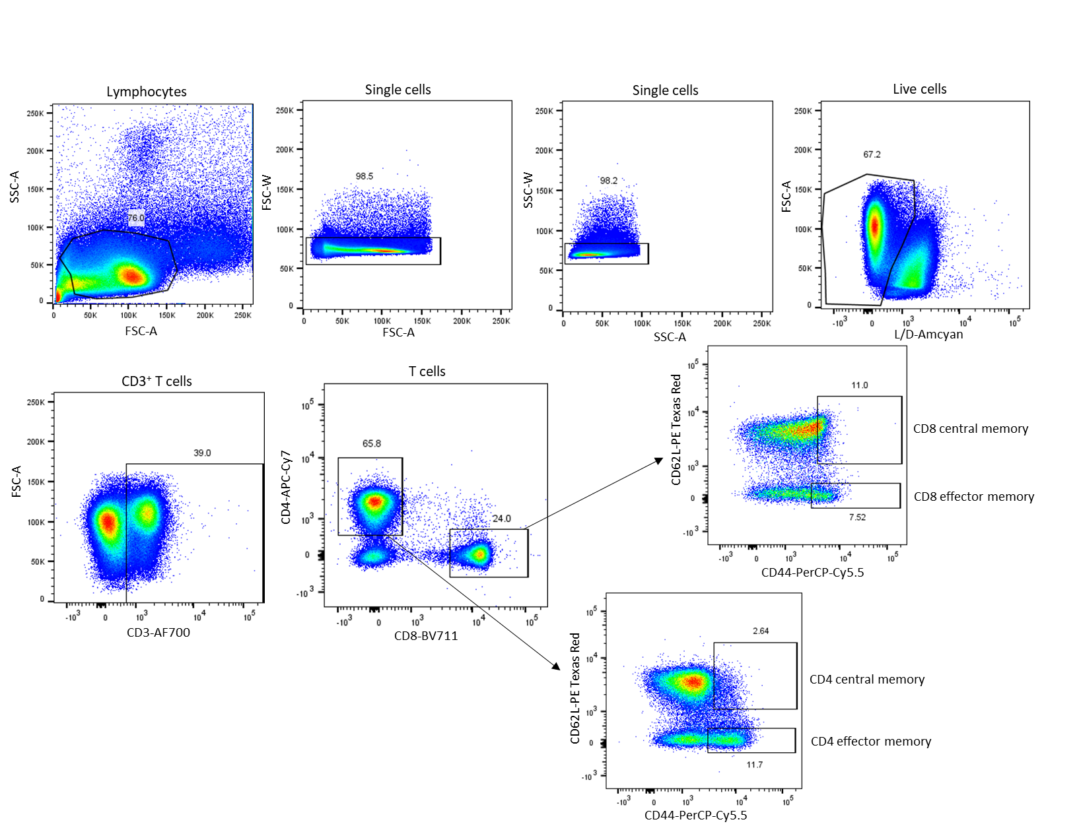
Supplemental Figure 6: Gating strategy for total T central memory (CD62L⁺, CD44⁺) and T effector memory (CD62L⁻, CD44⁺) for the animal experiment outlined in Figure 1a. See Supplemental Figure 7 for corresponding data
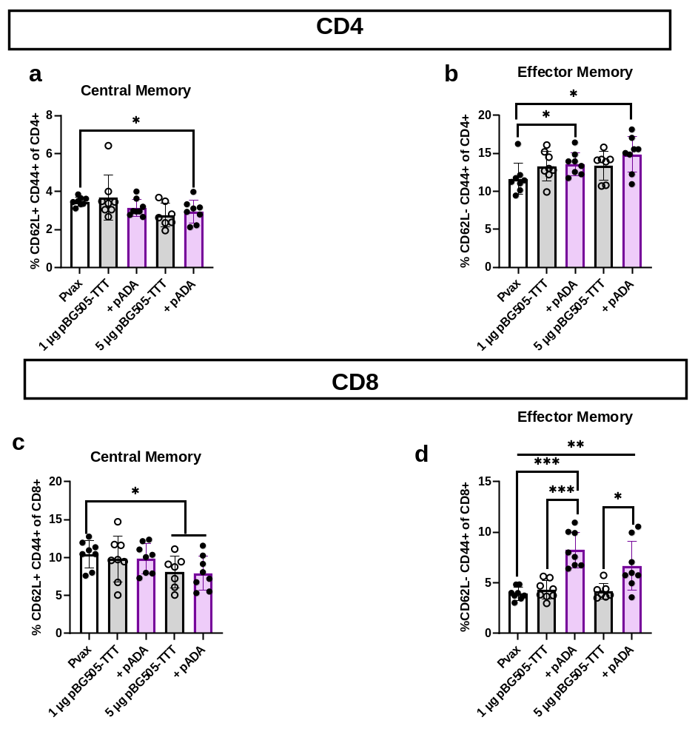
Supplemental Figure 7: Frequency of total T central memory (CD62L⁺, CD44⁺) and T effector memory (CD62L⁻, CD44⁺) for the animal experiment outlined in Figure 1a. Frequencies were determined from splenocytes that were not stimulated with BG505 peptides. CD4⁺ T central memory (a) and effector memory (b). CD8⁺ T central memory (c) and effector memory (d). Symbols represent individual animals (n=8 per group), bars represent the mean, error bars represent the standard deviations. *p<0.05, **p<0.01, ***p<0.001, and ****p<0.0001 by Mann-Whitney-U test.
Supplementary Table 1: Neutralization assays against Tier 1B Q23env17 and autologous BG505 pseudovirus using sera from DNA and protein co-immunized mice. Each row represents an individual mouse.

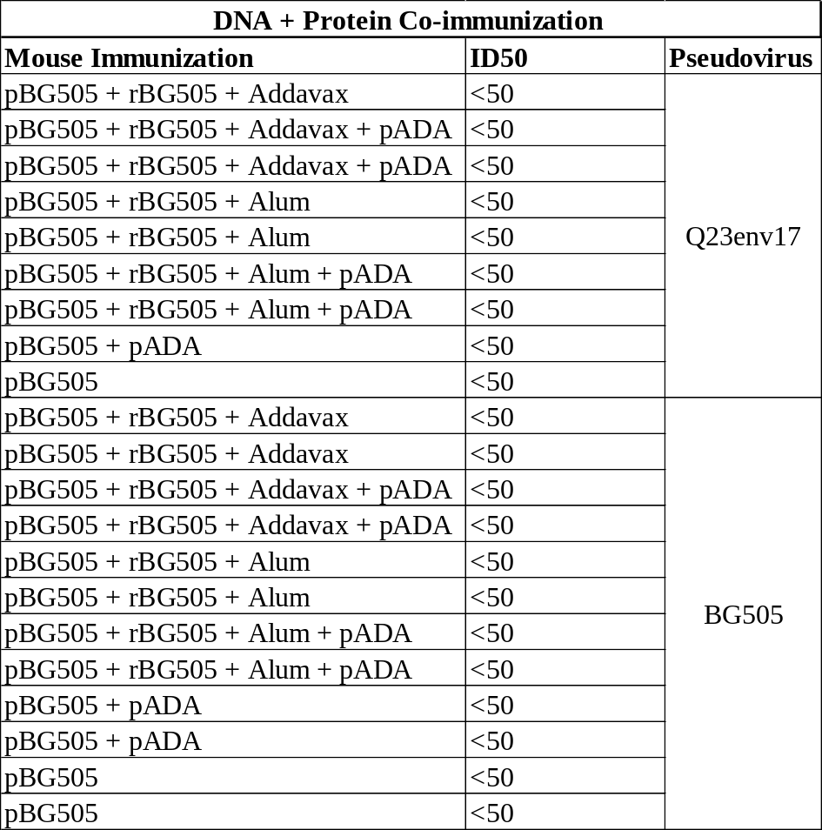
Supplementary Table 2: Neutralization assays against Tier 1B Q23env17 and autologous BG505 pseudovirus using sera from DNA immunized mice. Each row represents an individual mouse.

