Appendix

Pre-Intervention Survey

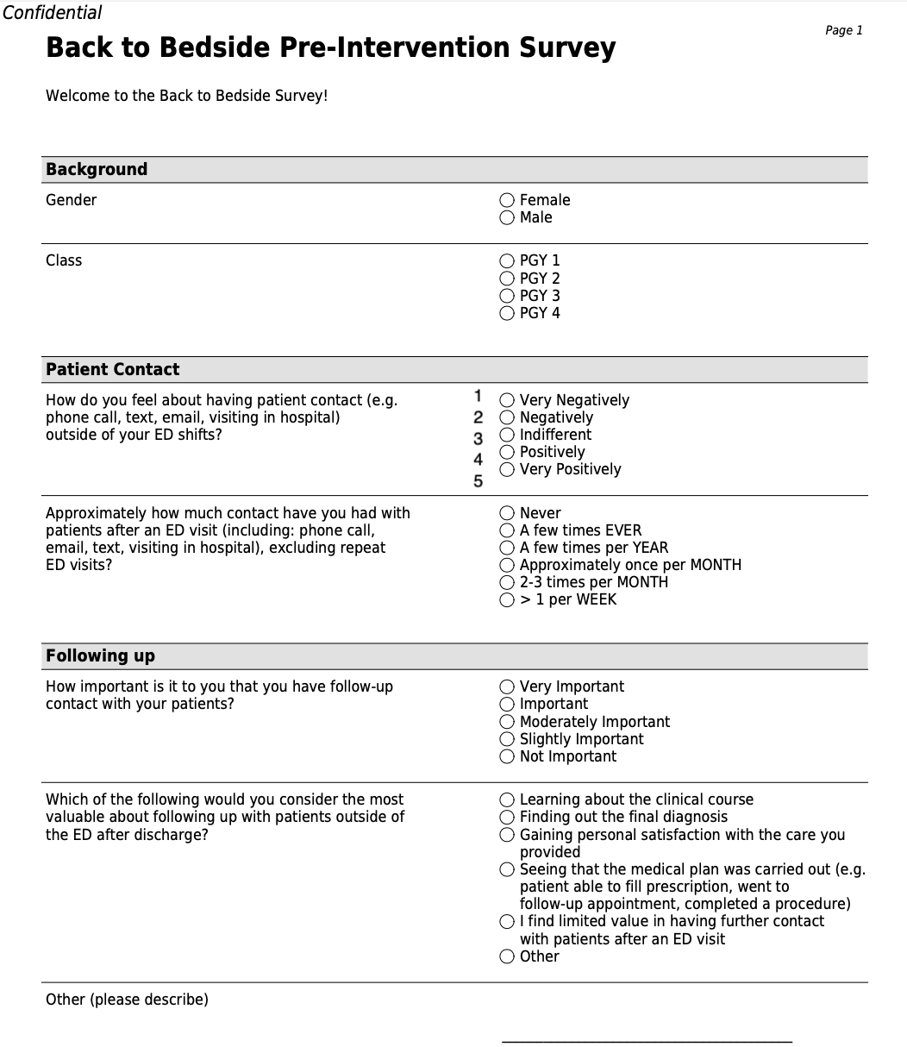

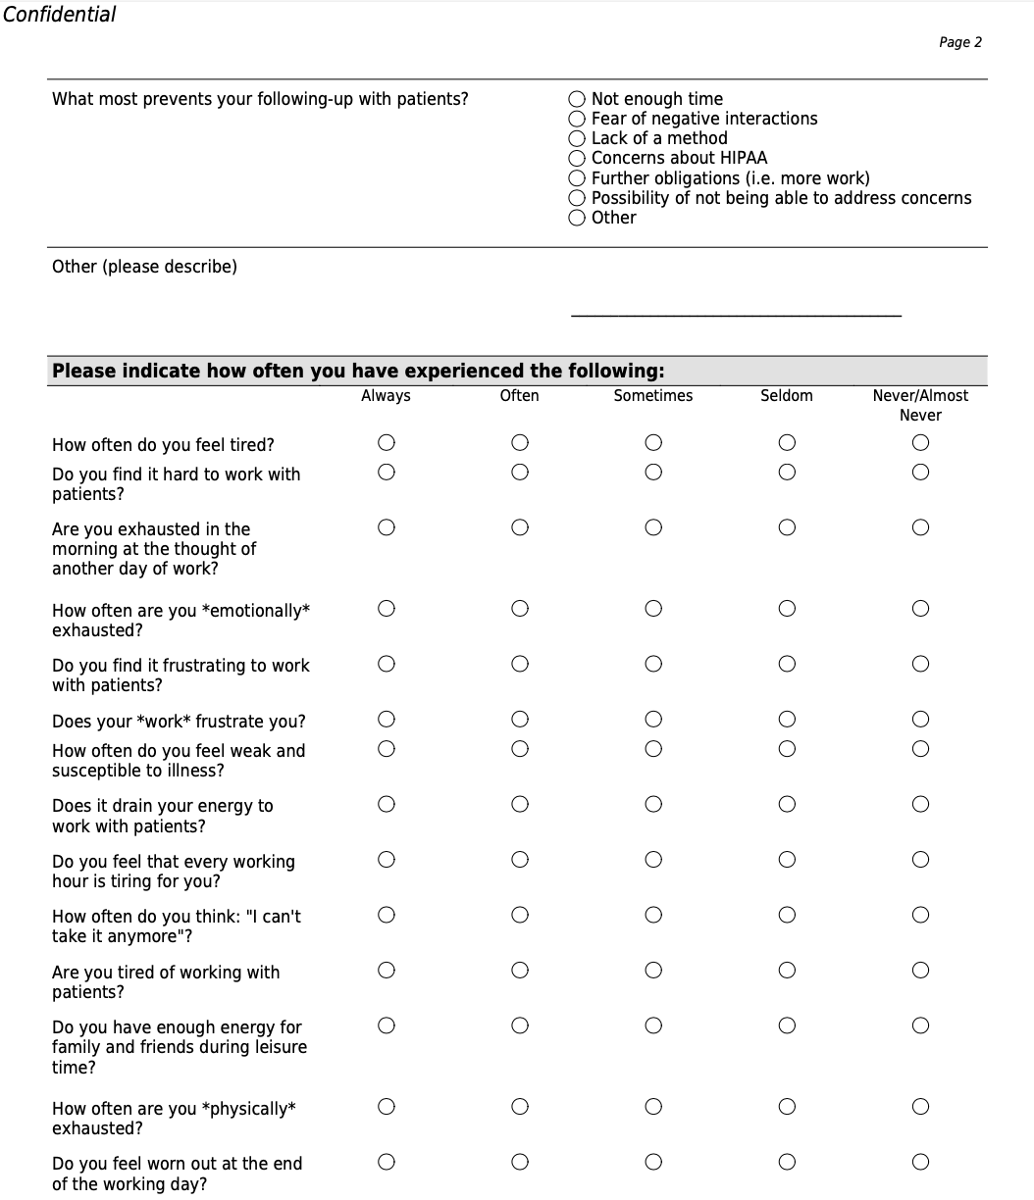

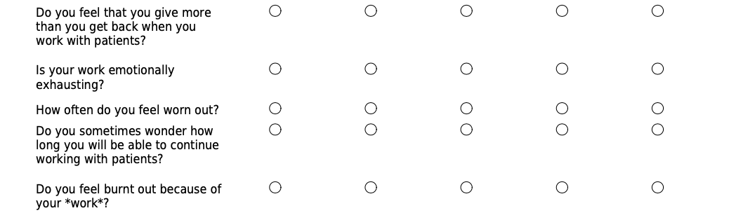

Post-Intervention Survey

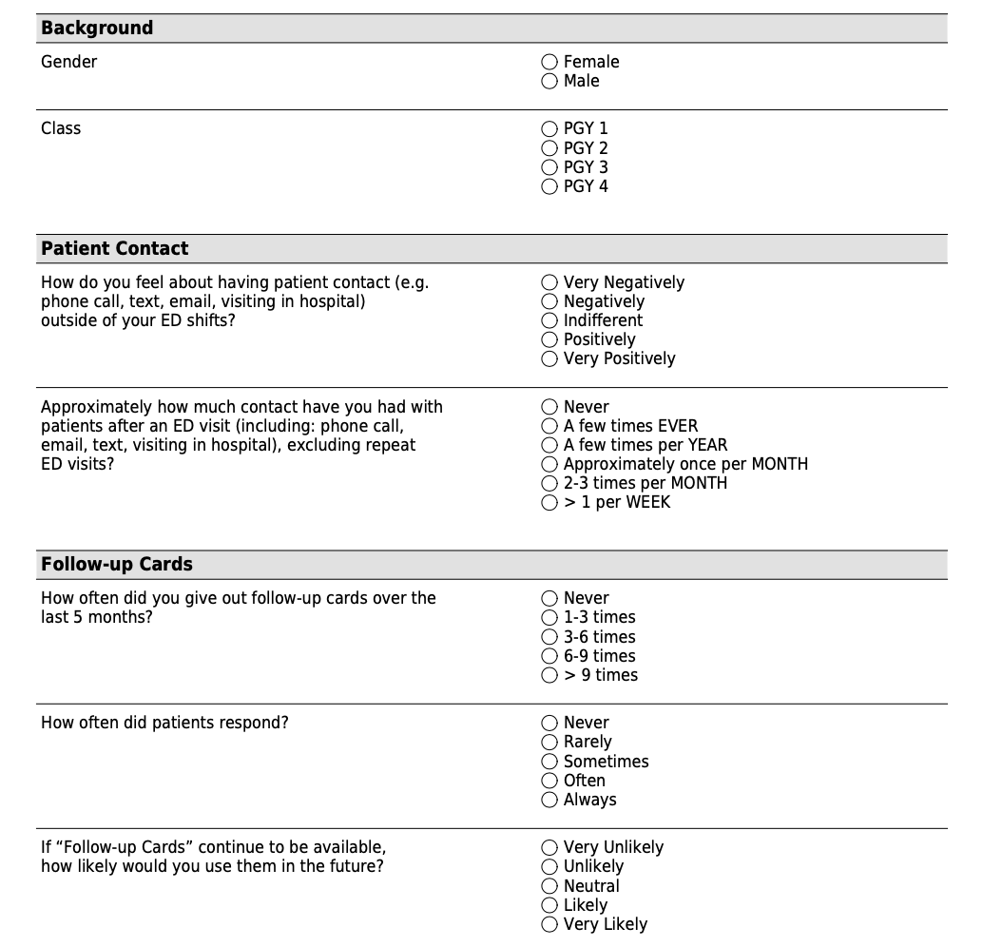

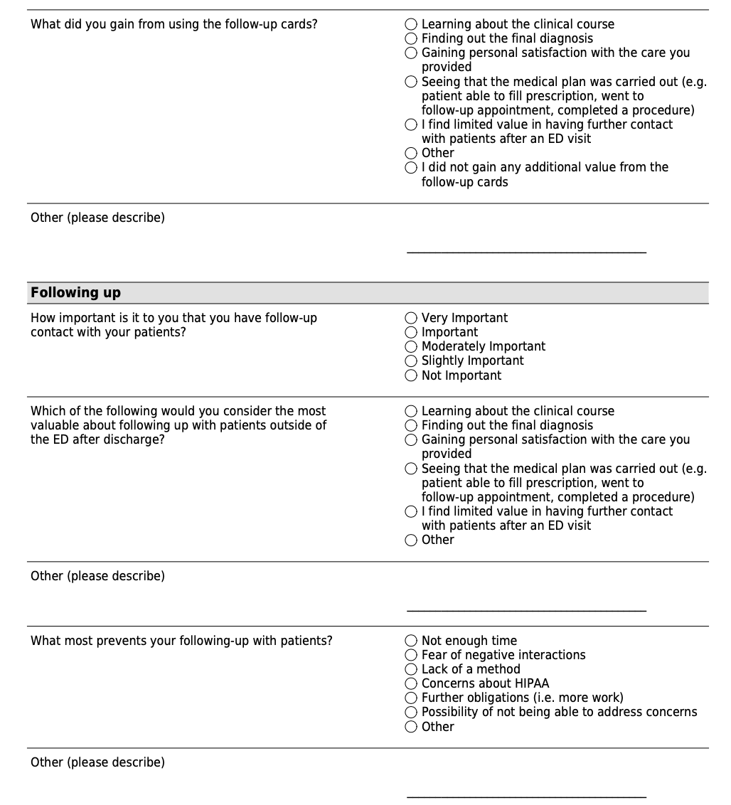

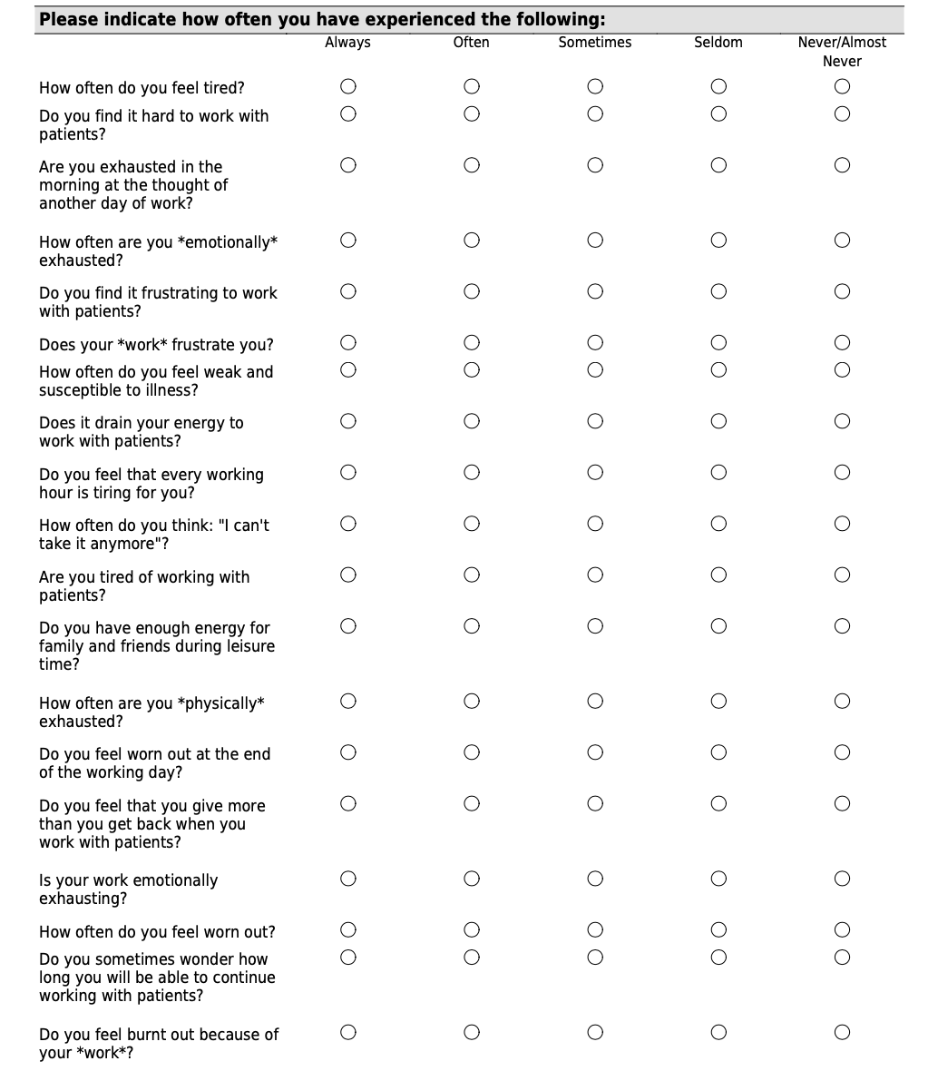

Resident Comments

“This project has made me think more about contacting patients outside of the ED visit. I sadly haven't had many intake [lower acuity] shifts as an intern (where I think the follow up cards can best be utilized) And a few times I've wanted to give the card to a patient but didn't have them in my possession. I wonder if as a next step it might be possible to build these into Epic. Where, if you'd like to give the patient the option to contact you, then the QR code would print on their discharge papers. But it doesn't appear on every patient's papers.” – PGY1

“This is a fantastic addition to our clinical work. I feel like I can have a bigger impact on patients’ lives. Maybe give us training on liability concerns and what we are allowed to say and not say to patients after they leave.” – PGY2

“I didn't end up getting around to using the cards, but I think it's a great idea and will probably do so once covid is more under control. I did provide my email address to patients when working telehealth and only had positives about the follow-up.” – PGY3

“I follow up my admitted patients, not my discharged ones. I don't know why I didn't utilize the cards more to be honest. Covid kind of interfered but return precautions kind of makes up for it in a way to me. Also there's such limited time as is and interacting with patients over the time allotted that we run over anyway just seems more exhausting. Also my feelings on exhaustion and burnout vary based on month, some good months and some bad, as can be expected. When you see a rough schedule, it makes the month harder to appreciate.” – PGY4

