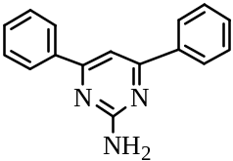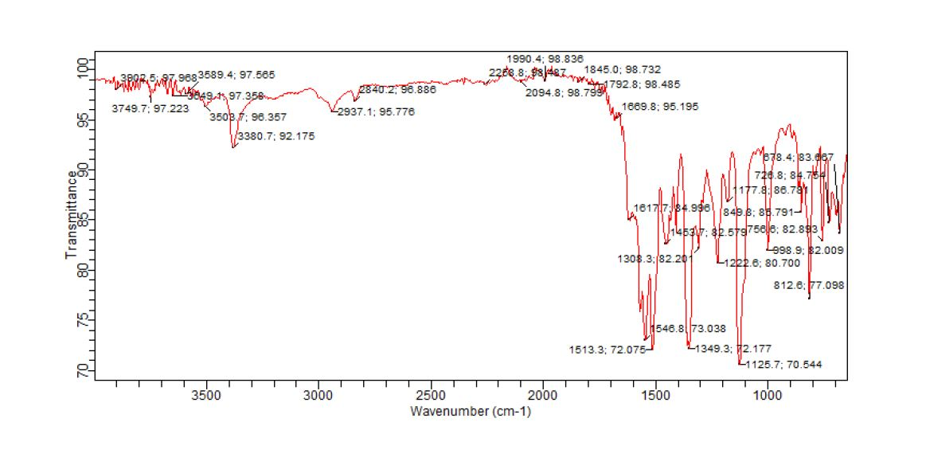
Fig. SI1.1: IR spectrum of 4,6-Diphenyl-pyrimidin-2-ylamine (PAA1)

Fig. SI1.2: GC-MS spectra of 4,6-Diphenyl-pyrimidin-2-ylamine(PAA1)

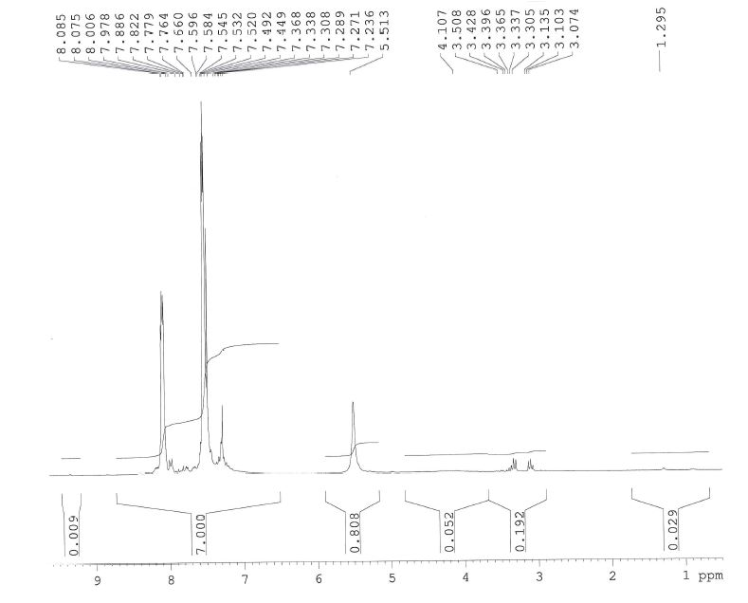
Fig. SI1.3: ¹HNMR spectrum of 4,6-Diphenyl-pyrimidin-2-ylamine (PAA1)

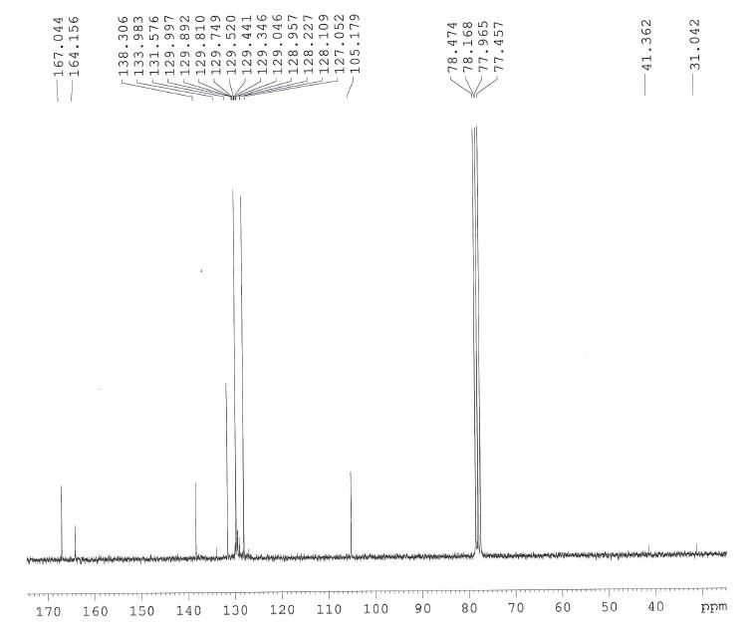
Fig. SI1.4: ¹³CNMR spectrum of 4,6-Diphenyl-pyrimidin-2-ylamine(PAA1)

