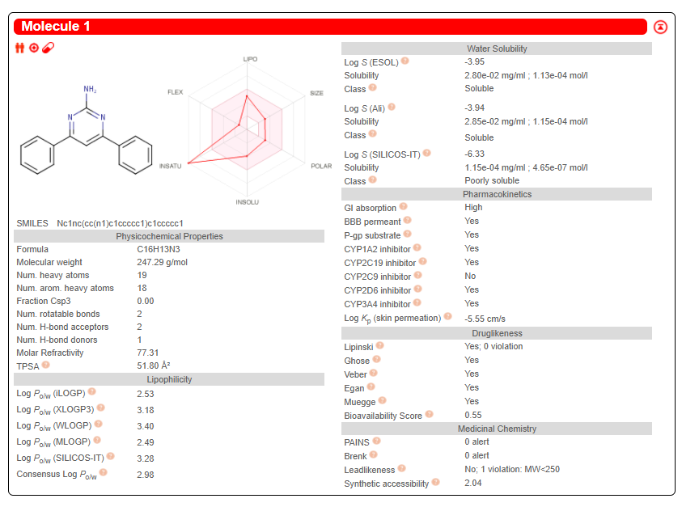
PAA1
Fig. SIC(a): One-panel -per-molecule output for the computed values of PAA1

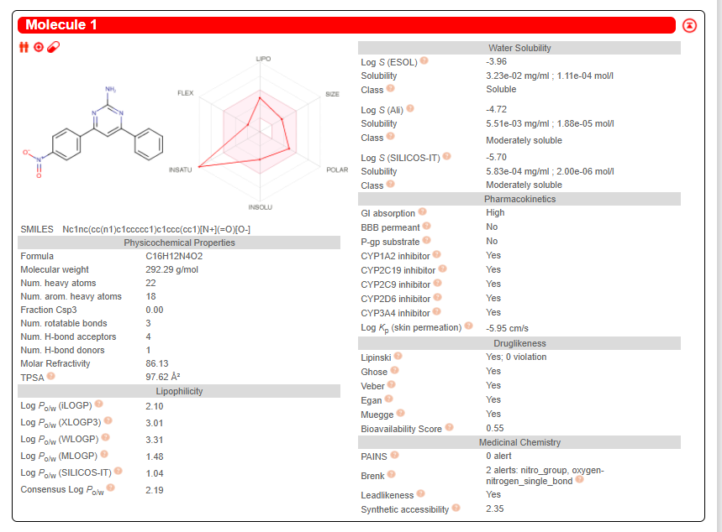
PAA2

Fig. SIC(b): One-panel-per-molecule output for the computed values of PAA2

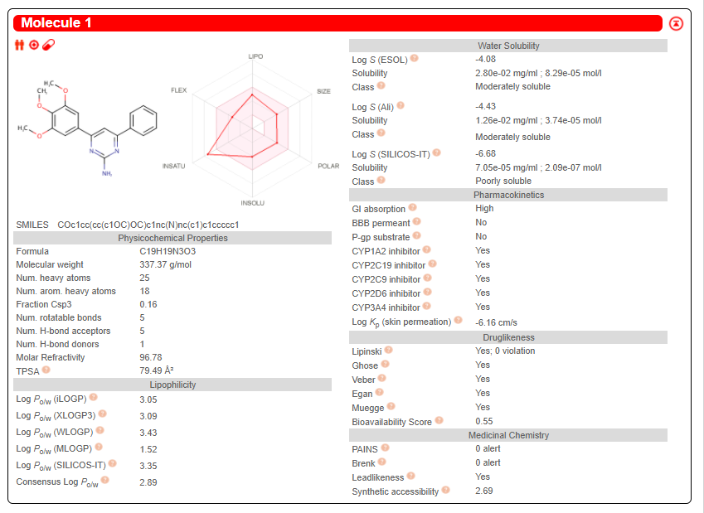
PAA3
Fig. SIC(c): One-panel-per-molecule output for the computed values of PAA3

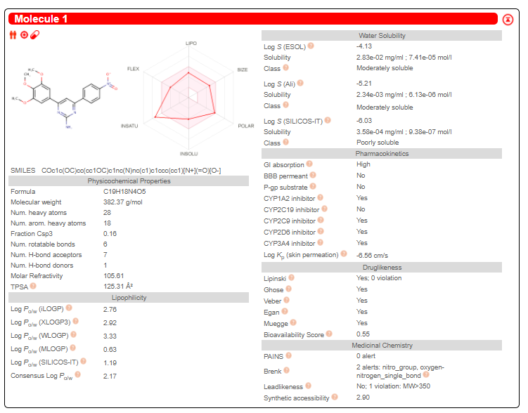
PAA4
Fig. SIC(d): One-panel-per-molecule output for the computed values of PAA4

