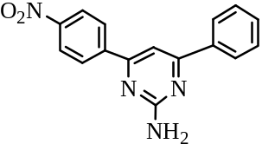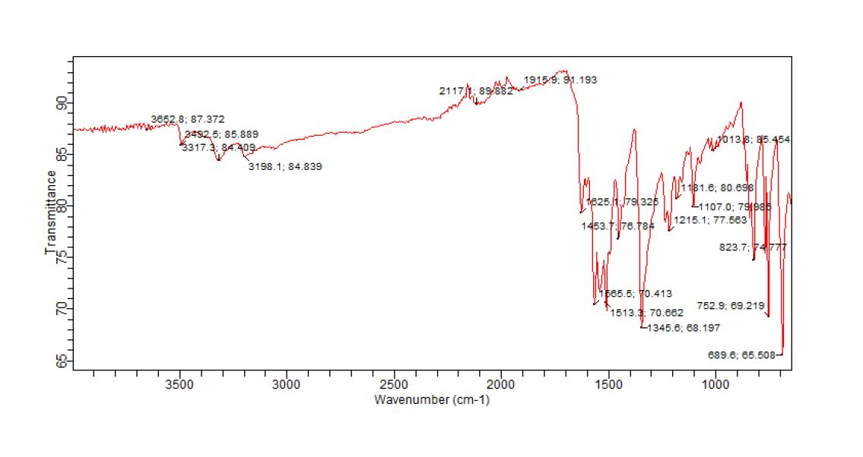
Fig. SI2.1: IR spectrum of 4-(4-Nitrophenyl)-6-phenyl-pyrimidin-2-ylamine (PAA2)

Fig. SI2.2: GC-MS spectrum of 4-(4-Nitrophenyl)-6-phenyl-pyrimidin-2-ylamine (PAA2)
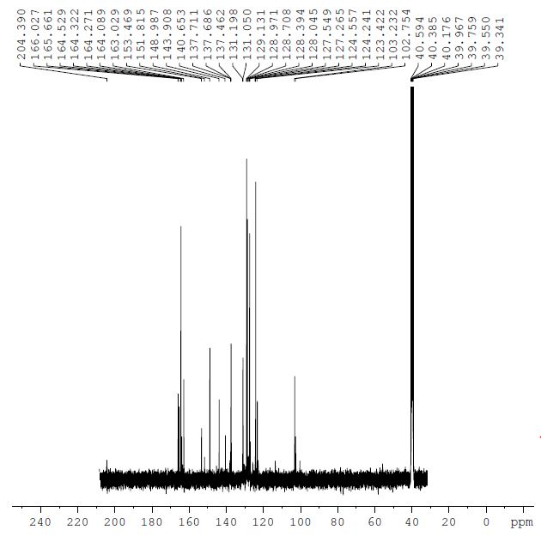
Fig. SI2.4: ¹³CNMR spectrum of 4-(4-Nitrophenyl)-6-phenyl-pyrimidin-2-ylamine (PAA2)

