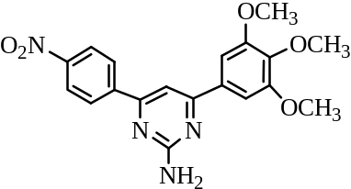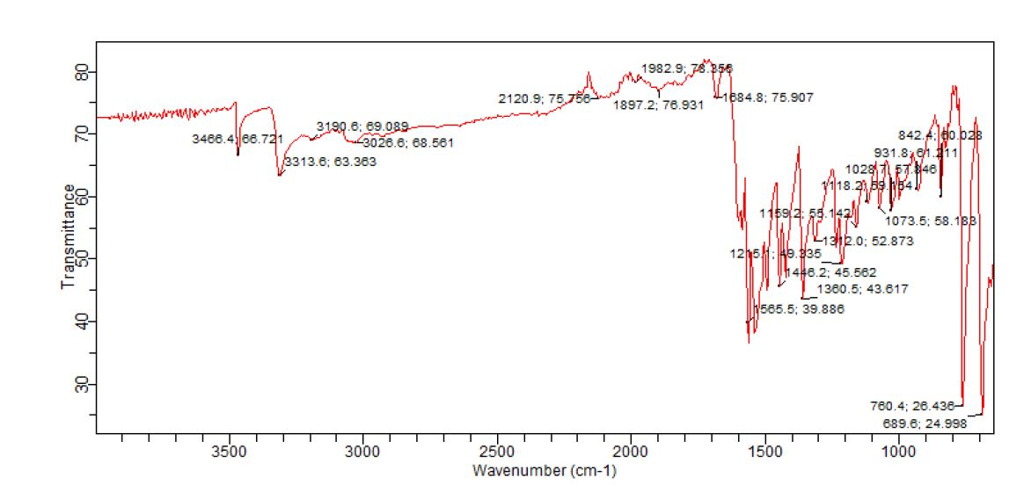
Fig. SI4.1: IR spectrum of 4-(4-Nitro-phenyl)-6-(3,4,5-trimethoxy-phenyl)-pyrimidin-2-ylamine (PAA4)

Fig. SI4.2: GC-MS spectra of 4-Phenyl-6-(3,4,5-trimethoxy-phenyl)-pyrimidin-2-ylamine (PAA4)
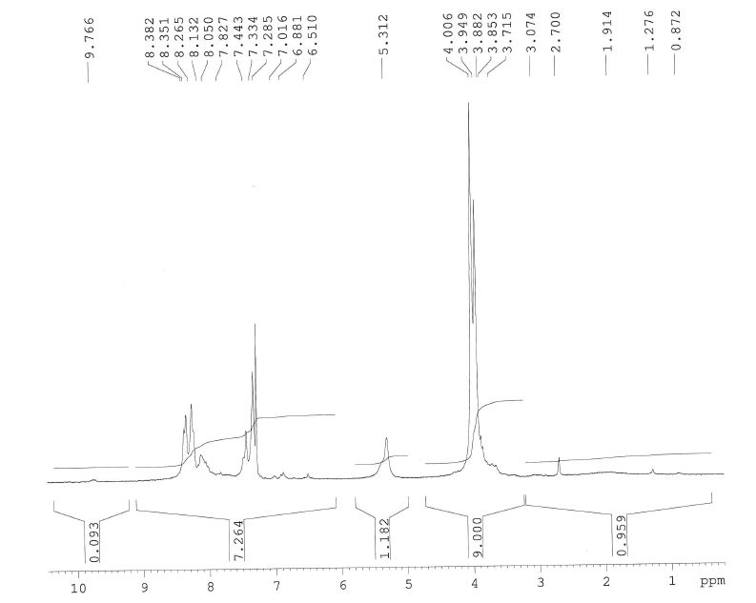
Fig. SI4.3: ¹HMR spectrum of 4-(4-Nitro-phenyl)-6-(3,4,5-trimethoxy-phenyl)-pyrimidin-2- ylamine (PAA4)

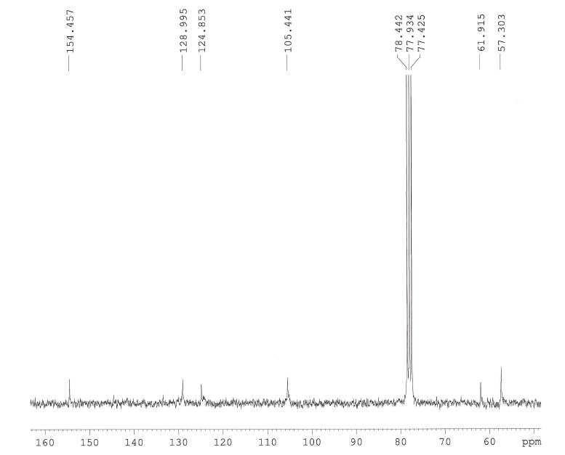
Fig. SI4.4: ¹³CNMR spectrum of 4-(4-Nitro-phenyl)-6-(3,4,5-trimethoxy-phenyl)-pyrimidin-2-ylamine (PAA4).

