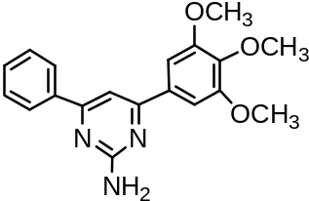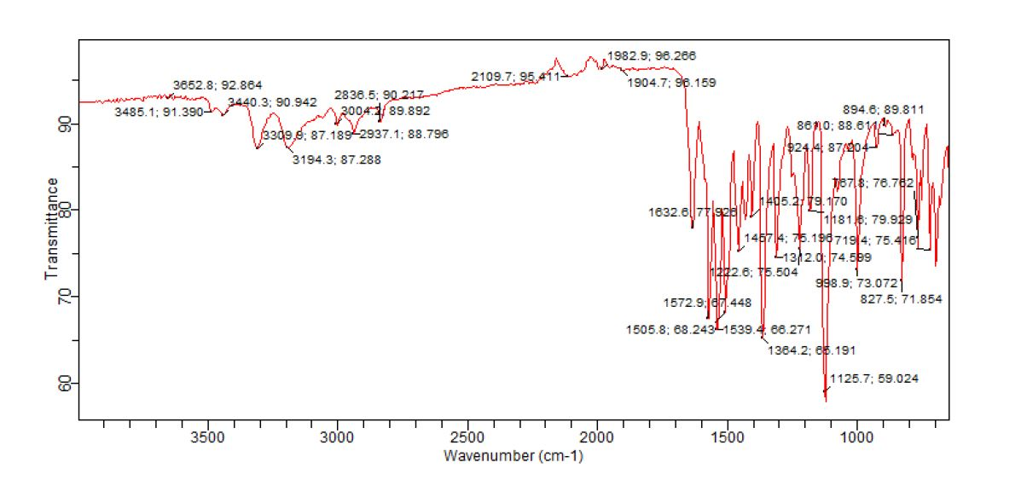
Fig SI3.1: IR spectrum of 4-Phenyl-6-(3,4,5-trimethoxy-phenyl)-pyrimidin-2-ylamine (PAA3)

Fig. SI3.2: GC-MS spectra of 4-Phenyl-6-(3,4,5-trimethoxy-phenyl)-pyrimidin-2-ylamine (PAA3)
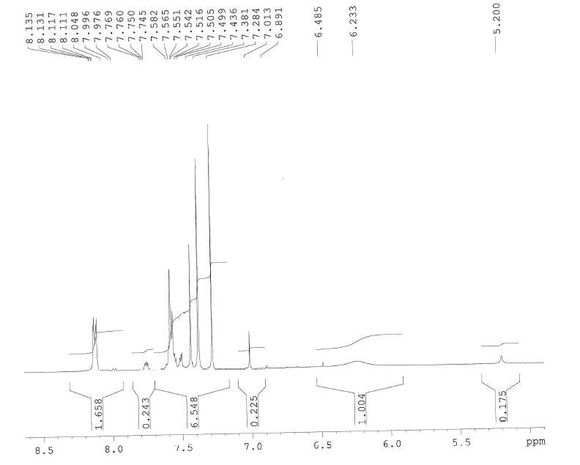
Fig. SI3.3: ¹HNMR spectrum of 4-Phenyl-6-(3,4,5-trimethoxy-phenyl)-pyrimidin-2-ylamine (PAA3)

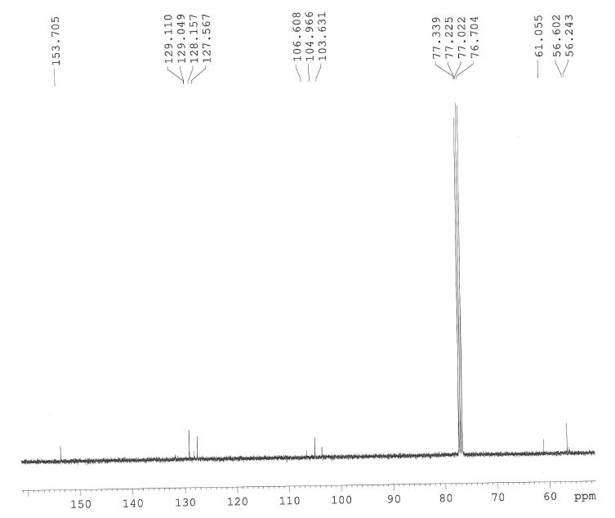
Fig. SI3.4: ¹³CNMR spectrum of 4-Phenyl-6-(3,4,5-trimethoxy-phenyl)-pyrimidin-2-ylamine (PAA3)

