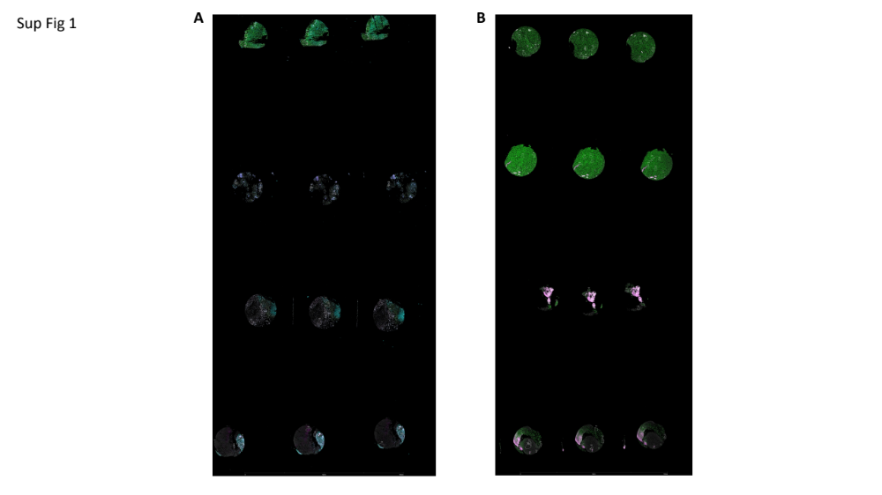

Supplemental Figure 1: Spatial staining of DIPG patient tissue: A & B) Raw staining and ROI selection images from the two GeoMx slides used in our experiment.

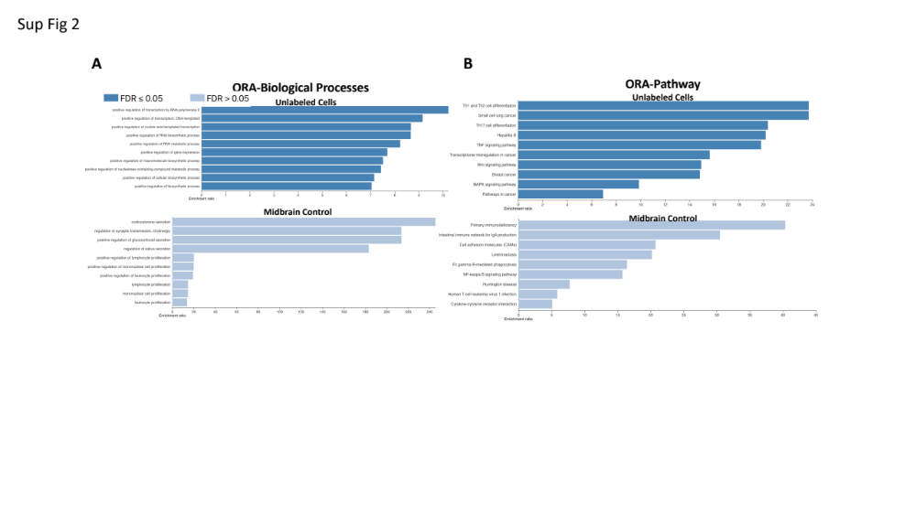

Supplemental Figure 2: Over-representation analysis demonstrates cancer signatures in unlabeled cells compared to normal midline brain. A) Over-representation analysis against biological processes conducted on our unlabeled cells vs a set of midbrain control genes. B) Over-representation analysis against biological pathways conducted on our unlabeled cells vs a set of midbrain control genes.

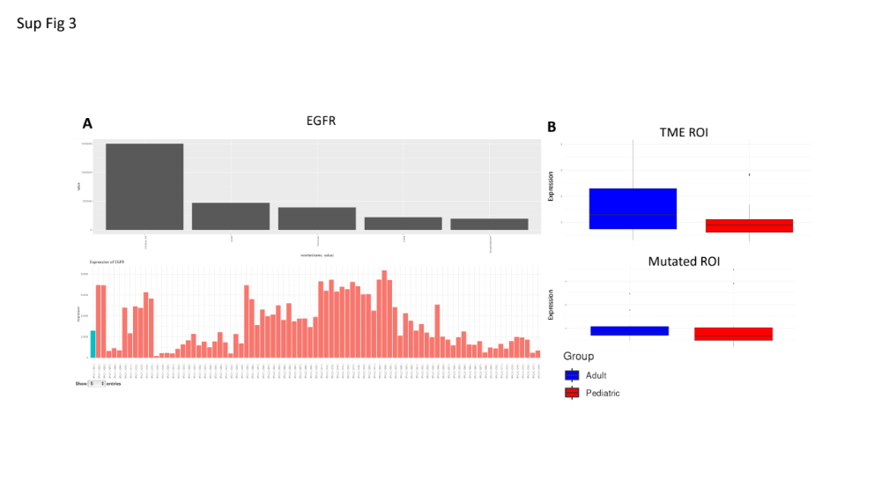

Supplemental Figure 3: EGFR expression validated at the protein level: A) Top 5 co-expression of proteins of EGFR (top) and EGFR protein expression level across all samples (bottom). B) EGFR protein expression visualized in pediatric (red) or adult samples (blue) in either TME ROIs (top) or Mutated ROIs (bottom).

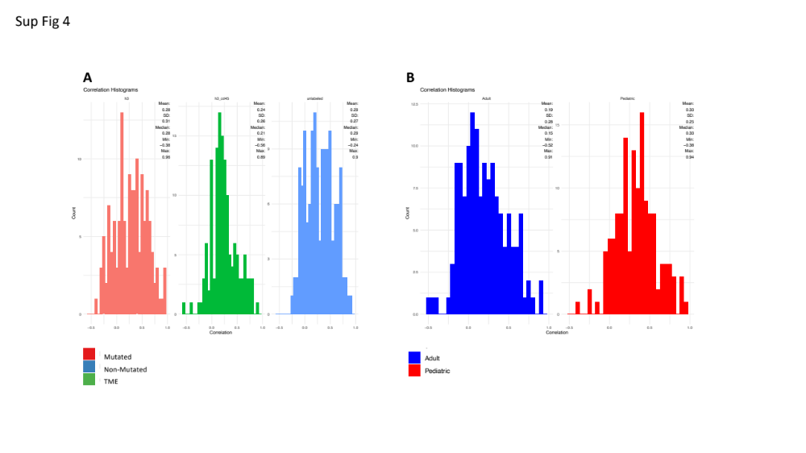

Supplemental Figure 4: RNA to protein correlation varies across age and ROI: A) RNA to protein correlation across all 3 ROIs contained in our sample populations. B) RNA to protein correlation across all adult (blue) and pediatric (red) samples.

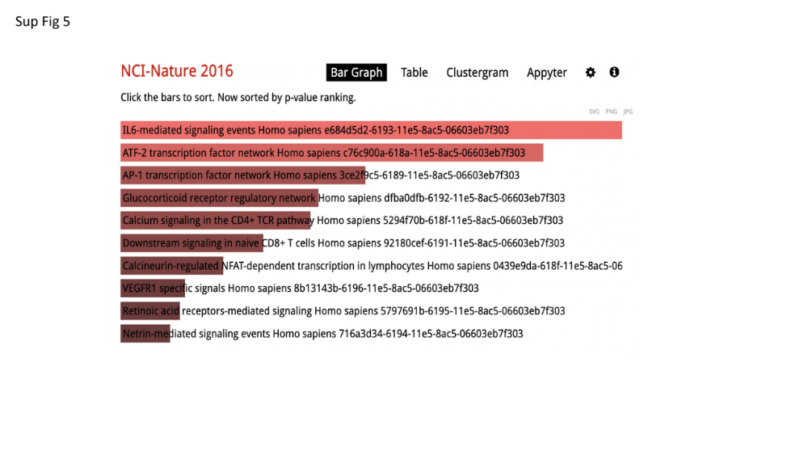

Supplemental Figure 5: Enrichment of Gene regulatory pathways involved in molecular secretion : A) RNA to protein correlation across all 3 ROIs contained in our sample populations. B) RNA to protein correlation across all adult (blue) and pediatric (red) samples.

