Prospects on the nano-plastic particles internalization and induction of cellular response in human keratinocytes

Ponnusamy Manogaran Gopinathª, Krishna Sundar Twayana^{b}, Palaniyandi Ravanan*^{b,c}, John Thomasª, Amitava Mukherjeeª & Natarajan Chandrasekaran*ª
ªCentre for Nanobiotechnology, Vellore Institute of Technology (VIT), Vellore – 632 014, Tamil Nadu, India
^{b}Apoptosis and Cell Survival Research Lab, Department of Biosciences, School of Biosciences and Technology, VIT University, Vellore – 632 014, Tamil Nadu, India
^{c}Department of Microbiology, School of Life Sciences, Central University of Tamil Nadu
Thiruvarur -610 104, Tamil Nadu, India

* Corresponding authors
Dr. Natarajan Chandrasekaran
Centre for Nanobiotechnology, Vellore Institute of Technology (VIT), Vellore, Tamil Nadu
Tel-: +91 416 2202624; fax: +91 416 2243092
E-mail address: nchandrasekaran@vit.ac.in, nchandra40@hotmail.com
Dr. P. Ravanan
Department of Microbiology, School of Life Sciences, Central University of Tamil Nadu
Thiruvarur – 610 104, Tamil Nadu.
E-mail address: ravanan@cutn.ac.in

Results
Isolation of MPs and NPs from FS samples
FS-1 and FS-2 products contained around 27.62 ± 5.83 mg of plastic particles with the size ranging from 30 nm – 372 µm per gram of product and around 41.59 ± 7.47 mg of plastic particles with the size ranging from 100 nm – 225 µm per millilitre of product, respectively. In the four-step filtration, an average of 12.51 mg MPs that are > 25 µm size, 6. 88 mg MPs within 25 – 2.5 µm range, 4. 27 mg MPs between 2.5 -0.4 µm range, 2.94 mg NPs within 400 – 200 nm size and 2.15 mg NPs of <200 nm size was found in one gram of FS-1 product. Similarly, one mL of FS-2 contained 16.81 mg, 10.27 mg, 6.05 mg, 6.37 mg, and 4.44 mg of MPs/NPs, respectively. Because of the heterogeneousness of size and shape, a nonsignificant correlation between the mass and particle number was observed. As a result, the number of particles applied to the skin could differ in each application, however, particle mass may remain constant at every use. For example, the use of 400 mg FS-1 product per wash may allow nearly 10 mg of MPs and 1.5 mg of NPs to contact skin, whereas 500 µl of FS-2 leads to exposure of around 20 mg of MPs and 2.2 mg of NPs onto the skin. We perceived from the preliminary studies that washing may remove up to 60 – 80 % of particles from the skin.

Table S1. Dynamic light scattering size distribution and zeta potential analysis of NPs suspended in the distilled water, keratin solution (0.2%), and cell culture medium.
DLS properties of Nanoplastics |  | Dispersion medium
 |  | Distilled water |  | Keratin solution (0.2%) | Culture medium (DMEM)
 |  | <1 hr | 24 hr | 24 hr | 24 hr
PENPs | Z- average (nm)  PDI  Zeta potential (mV) | 321±71  2.938  -32±3.2 | 1409±520  9.106  -9±2.6 | 305±73  0.487  -56±6.0 | 333±19  0.534  -52±7.1
PSNPs | Z- average (nm)  PDI  Zeta potential (mV) | 186±32  0.180  -38±6.1 | 179±39  0.201  -38±1.1 | 96±10  0.034  -43±5.3 | 156±18  0.143  -36±4.0
NPs-1 | Z- average (nm)  PDI  Zeta potential (mV) | 180±46  0.309  -42±1.7 | 192±25  0.311  -40±2.8 | 186±31  0.294  -46±2.0 | 354±11  0.468  -32±1.6
NPs-2 | Z- average (nm)  PDI  Zeta potential (mV) | 113±6.2  0.230  -50±1.3 | 120±7  0.242  -51±0.8 | 110±9.2  0.310  -51±1.7 | 376 ±7.7  0.501  -25±2.0

Table S2. The mean MTT values of three independent experiments of the keratinocytes exposed to different NPs particles for 24, 48, 72, 96, 120, and 144 hrs.
Sample | Time | Concentration
Sample | Time | 0µg/ml | 25µg/ml | 50µg/ml | 100µg/ml | 250µg/ml | 500µg/ml
PENPs | 24 hrs | 0.456 | 0.436 | 0.388 | 0.48 | 0.358 | 0.459
PENPs | 24 hrs | 0.423 | 0.411 | 0.427 | 0.419 | 0.38 | 0.427
PENPs | 24 hrs | 0.401 | 0.4 | 0.399 | 0.376 | 0.41 | 0.409
PENPs | 48 hrs | 0.818 | 0.815 | 0.752 | 0.781 | 0.464 | 0.497
PENPs | 48 hrs | 0.687 | 0.832 | 0.757 | 0.659 | 0.515 | 0.502
PENPs | 48 hrs | 0.747 | 0.821 | 0.694 | 0.616 | 0.42 | 0.592
PENPs | 72 hrs | 1.518 | 1.55 | 1.685 | 1.556 | 1.195 | 0.922
PENPs | 72 hrs | 1.465 | 1.608 | 1.472 | 1.45 | 1.097 | 0.712
PENPs | 72 hrs | 1.578 | 1.606 | 1.42 | 1.606 | 0.778 | 0.7125
PENPs | 96 hrs | 2.22 | 2.829 | 3.406 | 3.112 | 2.54 | 1.127
PENPs | 96 hrs | 2.674 | 2.448 | 2.649 | 2.968 | 1.752 | 1.139
PENPs | 96 hrs | 2.499 | 2.717 | 3.193 | 3.092 | 1.826 | 0.999
PENPs | 120 hrs | 3.468 | 3.323 | 3.557 | 3.301 | 2.969 | 1.091
PENPs | 120 hrs | 3.252 | 3.552 | 2.983 | 2.858 | 2.729 | 1.299
PENPs | 120 hrs | 3.693 | 3.239 | 3.056 | 3.267 | 3.012 | 1.111
PENPs | 144 hrs | 5.38 | 6.449 | 4.537 | 4.193 | 4.901 | 2.197
PENPs | 144 hrs | 5.448 | 4.835 | 4.203 | 4.337 | 4.783 | 1.877
PENPs | 144 hrs | 5.056 | 5.773 | 4.157 | 4.951 | 5.215 | 2.001
PSNPs | Concentration
PSNPs |  | 0µg/ml | 25µg/ml | 50µg/ml | 100µg/ml | 250µg/ml | 500µg/ml
PSNPs | 24 hrs | 0.456 | 0.418 | 0.403 | 0.428 | 0.435 | 0.425
PSNPs | 24 hrs | 0.423 | 0.454 | 0.436 | 0.462 | 0.394 | 0.388
PSNPs | 24 hrs | 0.401 | 0.391 | 0.375 | 0.406 | 0.418 | 0.367
PSNPs | 48 hrs | 0.818 | 0.732 | 0.828 | 0.756 | 0.701 | 0.774
PSNPs | 48 hrs | 0.687 | 0.815 | 0.884 | 0.838 | 0.921 | 0.839
PSNPs | 48 hrs | 0.747 | 0.829 | 0.782 | 0.805 | 0.855 | 0.818
PSNPs | 72 hrs | 1.518 | 1.797 | 1.689 | 1.742 | 1.667 | 1.755
PSNPs | 72 hrs | 1.465 | 1.796 | 1.874 | 1.564 | 1.524 | 1.629
PSNPs | 72 hrs | 1.578 | 1.615 | 1.658 | 1.81 | 1.84 | 1.642
PSNPs | 96 hrs | 2.22 | 2.585 | 2.714 | 3.041 | 3.037 | 2.371
PSNPs | 96 hrs | 2.674 | 3.138 | 2.976 | 2.724 | 2.569 | 2.286
PSNPs | 96 hrs | 2.499 | 3.024 | 3.286 | 3.526 | 2.487 | 2.91
PSNPs | 120 hrs | 3.468 | 4.59 | 3.466 | 3.43 | 3.522 | 3.44
PSNPs | 120 hrs | 3.252 | 3.366 | 3.78 | 3.656 | 3.054 | 3.605
PSNPs | 120 hrs | 3.693 | 3.486 | 3.428 | 3.097 | 2.92 | 3.608
PSNPs | 144 hrs | 5.38 | 6.074 | 4.742 | 6.114 | 5.64 | 6.794
PSNPs | 144 hrs | 5.448 | 5.138 | 4.572 | 4.9 | 4.878 | 5.28
PSNPs | 144 hrs | 5.056 | 4.974 | 5.82 | 4.118 | 5.416 | 6.368
NPs-1 | Concentration
NPs-1 |  | 0µg/ml | 25µg/ml | 50µg/ml | 100µg/ml | 250µg/ml | 500µg/ml
NPs-1 | 24 hrs | 0.456 | 0.401 | 0.384 | 0.394 | 0.329 | 0.270
NPs-1 | 24 hrs | 0.423 | 0.393 | 0.437 | 0.403 | 0.289 | 0.229
NPs-1 | 24 hrs | 0.401 | 0.389 | 0.406 | 0.433 | 0.301 | 0.209
NPs-1 | 48 hrs | 0.818 | 0.77 | 0.888 | 0.716 | 0.417 | 0.075
NPs-1 | 48 hrs | 0.687 | 0.838 | 0.801 | 0.742 | 0.441 | 0.076
NPs-1 | 48 hrs | 0.747 | 0.794 | 0.783 | 0.679 | 0.468 | 0.078
NPs-1 | 72 hrs | 1.518 | 1.65 | 1.555 | 1.333 | 0.766 | 0.093
NPs-1 | 72 hrs | 1.465 | 1.552 | 1.52 | 1.223 | 0.807 | 0.101
NPs-1 | 72 hrs | 1.578 | 1.502 | 1.483 | 1.416 | 0.677 | 0.076
NPs-1 | 96 hrs | 2.22 | 2.558 | 2.921 | 2.3 | 1.189 | 0.095
NPs-1 | 96 hrs | 2.674 | 2.987 | 3.146 | 2.38 | 1.141 | 0.098
NPs-1 | 96 hrs | 2.499 | 2.875 | 3.19 | 1.808 | 1.142 | 0.095
NPs-1 | 120 hrs | 3.468 | 3.168 | 3.095 | 2.668 | 1.81 | 0.086
NPs-1 | 120 hrs | 3.252 | 3.19 | 3.534 | 2.759 | 1.742 | 0.094
NPs-1 | 120 hrs | 3.693 | 3.444 | 2.912 | 2.797 | 1.66 | 0.086
NPs-1 | 144 hrs | 5.38 | 6.666 | 4.62 | 5.83 | 3.84 | 0.146
NPs-1 | 144 hrs | 5.448 | 5.626 | 5.176 | 5.316 | 4.182 | 0.156
NPs-1 | 144 hrs | 5.056 | 6.224 | 4.706 | 4.56 | 4.184 | 0.148
NPs-2 | Concentration
NPs-2 |  | 0µg/ml | 5µg/ml | 10µg/ml | 50µg/ml | 100µg/ml | 250µg/ml
NPs-2 | 24 hrs | 0.456 | 0.410 | 0.454 | 0.407 | 0.396 | 0.352
NPs-2 | 24 hrs | 0.423 | 0.455 | 0.420 | 0.421 | 0.400 | 0.340
NPs-2 | 24 hrs | 0.401 | 0.394 | 0.397 | 0.439 | 0.383 | 0.343
NPs-2 | 48 hrs | 0.818 | 0.781 | 0.95 | 0.723 | 0.629 | 0.417
NPs-2 | 48 hrs | 0.687 | 0.78 | 0.885 | 0.763 | 0.605 | 0.455
NPs-2 | 48 hrs | 0.747 | 0.8 | 0.805 | 0.694 | 0.668 | 0.43
NPs-2 | 72 hrs | 1.518 | 1.433 | 1.621 | 1.372 | 0.872 | 0.503
NPs-2 | 72 hrs | 1.465 | 1.578 | 1.905 | 1.475 | 1.12 | 0.651
NPs-2 | 72 hrs | 1.578 | 1.627 | 1.677 | 1.543 | 1.155 | 0.635
NPs-2 | 96 hrs | 2.22 | 2.775 | 3.118 | 2.358 | 1.655 | 0.454
NPs-2 | 96 hrs | 2.674 | 2.124 | 3.265 | 3.121 | 1.678 | 0.754
NPs-2 | 96 hrs | 2.499 | 2.374 | 2.479 | 2.483 | 1.865 | 0.662
NPs-2 | 120 hrs | 3.468 | 3.416 | 3.172 | 3.156 | 2.724 | 0.637
NPs-2 | 120 hrs | 3.252 | 3.464 | 3.037 | 3.137 | 2.555 | 1.07
NPs-2 | 120 hrs | 3.693 | 3.311 | 2.861 | 3.465 | 3.013 | 1.18
NPs-2 | 144 hrs | 5.38 | 6.25 | 5.276 | 4.97 | 4.104 | 0.72
NPs-2 | 144 hrs | 5.448 | 6.018 | 5.054 | 5.028 | 4.978 | 1.774
NPs-2 | 144 hrs | 5.056 | 6.744 | 5.89 | 5.784 | 4.834 | 1.548
H₂O₂ | Concentration
H₂O₂ |  | 0µM | 25µM | 50µM | 100µM | 250µM | 500µM
H₂O₂ | 24 hrs | 0.456 | 0.39 | 0.362 | 0.394 | 0.318 | 0.303
H₂O₂ | 24 hrs | 0.423 | 0.371 | 0.38 | 0.39 | 0.329 | 0.31
H₂O₂ | 24 hrs | 0.401 | 0.387 | 0.339 | 0.36 | 0.335 | 0.294
H₂O₂ | 48 hrs | 0.818 | 0.788 | 0.7 | 0.812 | 0.519 | 0.463
H₂O₂ | 48 hrs | 0.687 | 0.726 | 0.801 | 0.735 | 0.599 | 0.393
H₂O₂ | 48 hrs | 0.747 | 0.717 | 0.689 | 0.729 | 0.557 | 0.393
H₂O₂ | 72 hrs | 1.518 | 1.407 | 1.585 | 0.851 | 0.637 | 0.572
H₂O₂ | 72 hrs | 1.465 | 1.424 | 1.382 | 0.861 | 0.612 | 0.567
H₂O₂ | 72 hrs | 1.578 | 1.577 | 1.329 | 0.978 | 0.698 | 0.552
H₂O₂ | 96 hrs | 2.22 | 2.142 | 2.671 | 1.587 | 1.021 | 0.517
H₂O₂ | 96 hrs | 2.674 | 2.59 | 2.352 | 1.599 | 0.75 | 0.704
H₂O₂ | 96 hrs | 2.499 | 2.688 | 2.39 | 1.946 | 0.697 | 0.618
H₂O₂ | 120 hrs | 3.468 | 3.259 | 2.5 | 1.942 | 1.007 | 0.598
H₂O₂ | 120 hrs | 3.252 | 3.242 | 2.451 | 2.338 | 1.194 | 0.576
H₂O₂ | 120 hrs | 3.693 | 2.451 | 3.073 | 2.238 | 1.236 | 0.458
H₂O₂ | 144 hrs | 5.38 | 4.794 | 5.468 | 4.754 | 2.926 | 0.756
H₂O₂ | 144 hrs | 5.448 | 3.874 | 5.3 | 4.434 | 2.466 | 0.684
H₂O₂ | 144 hrs | 5.056 | 4.778 | 4.748 | 4.684 | 2.938 | 0.592

Figure S1. Intracellular ROS measured by DCFH2-DA staining of keratinocytes under fluorescence microscope. (a) control, (b) PENPs (100 µg mL⁻¹), (c) PSNPs (100 µg mL⁻¹), (d) NPs-1 (100 µg mL⁻¹), (e) NPs-2 (100 µg mL⁻¹) and (f) H₂O₂ (100 µM). Scale bar - 125 µm.
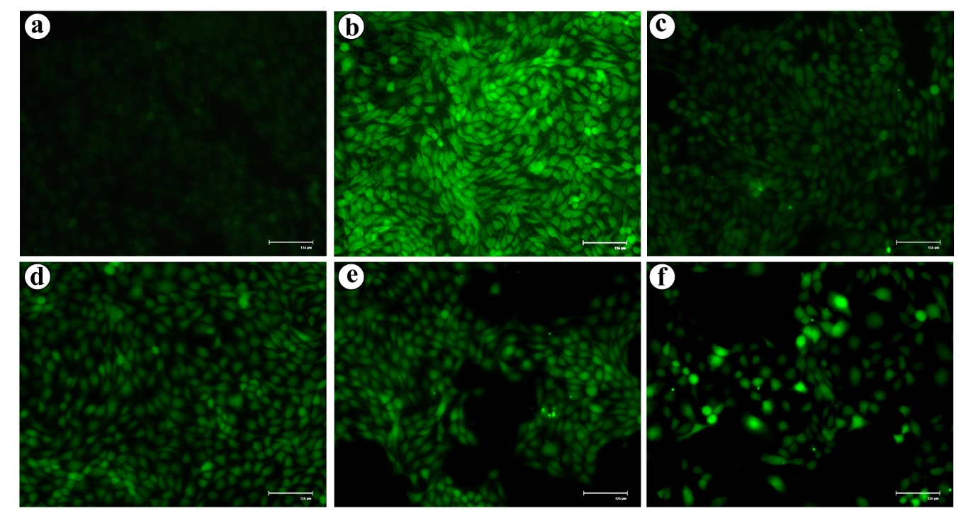

Figure S2. Time-dependent internalization and exclusion of FLPS particles. a) Phase-contrast, b) Fluorescent blue channel, c) Fluorescent green channel and d) superimposed images of HaCaT cells exposed to FLPS particles for 144 hrs. For fluorescent imaging, DAPI (λex: 357/44 nm; λem: 447/60 nm) and GFP (λex: 470/22 nm; λem: 510/42 nm) fluorescent light cubes were used. Scale bar: 20 μg.
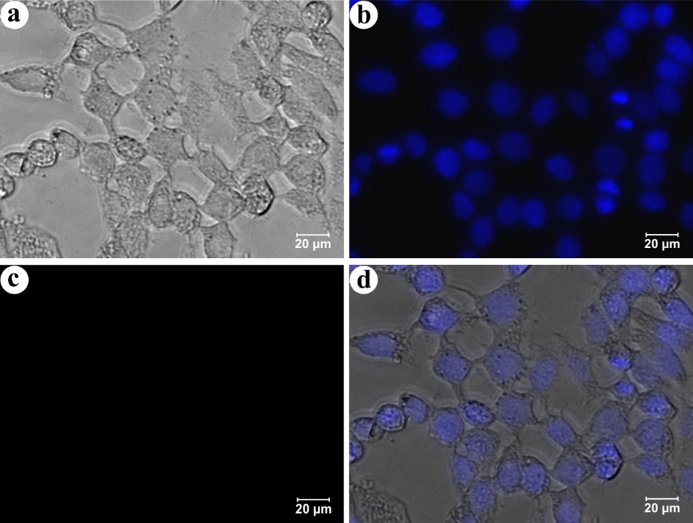

Figure S3. Protein-corona formation with protein and smaller biomolecular aggregates on NPs surface. (a) PENPs with 200 nm size protein corona, (b, c, and d) Corona mediated aggregates of 2 or 3 PSNPs, NPs-1 and NPs-2, respectively.
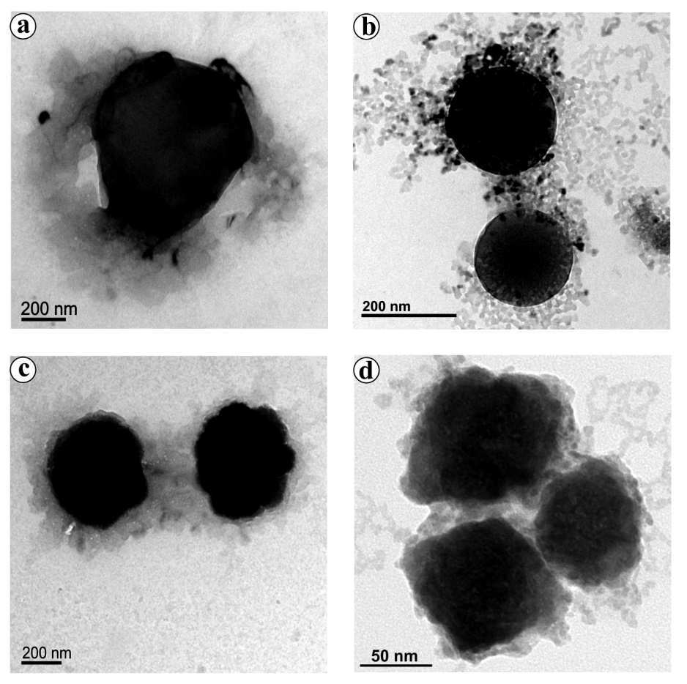

Extraction of human hair keratin
Human hair was washed with ethanol and incubated with chloroform/methanol (2: 1, v/v) mixture for 24 hrs to remove the external lipids. About 40 mg of the delipidized hair was mixed with 20 mL of a solution containing 25 mM Tris–HCl (pH 9.5), 8 M urea, and 5% 2-mercaptoethanol at 50 °C for 3 consecutive days. The mixture was filtered and centrifuged at 12000 rpm for 20 min at room temperature. The supernatant collected was dialyzed against 2 l of distilled water with 8—10 changes. The protein concentration in the final solution was determined by the Bradford protein assay using the Bio-Rad protein assay kit according to the manufacturer’s instruction. According to Nakamura et al. (2002), the final extract could be mainly composed of α-keratins and keratin-associated proteins. These α-keratins are resolved further into two subfamilies, such as Type I acidic and Type II neutral/basic keratins (Nakamura et al., 2002; Adav et al., 2018). Hence, the protein extract obtained from the human hair samples could contain both acidic and basic keratin as well as keratin-associated proteins. Therefore, the α-keratins and keratin-associated proteins might have formed keratin-corona on the NPs. Since this experiment aims to demonstrate the influence of protein corona on the rapid internalization of NPs, we have used crude keratin extract for protein-corona formation. It noteworthy to mention that to maintain the reliability in corona formation on NPs and its effect on cells, we have used coronated-NPs derived from DMEM throughout the study.

Figure. S4 HR-TEM micrograph of FLPS particles with thick keratin-corona
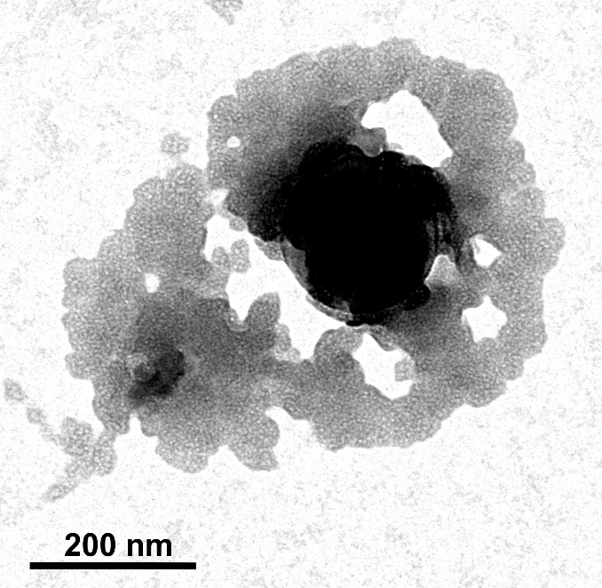
Fluorescent-PENPs preparation and keratin-corona formation
To demonstrate the influence of protein-corona in the rapid internalization of NPs, we have used fluorescently labelled polystyrene NPs (commercially procured) and the PENPs stained with the Nile red dye. For the preparation of fluorescent PENPs, we have followed a modified Nile red staining procedure to stain PENPs (Shim et al., 2016). Briefly, the dried PENPs (< 400nm) sample was dissolved in 5 mL of acetone containing Nile red dye (2µg/ mL) and mixed in a shaker incubator under a dark condition. After 5 min of mixing, the PENPs was separated by centrifugation, washed with acetone, and then dried under a vacuum dryer. Then the Nile red-stained PENPs was introduced into the human keratin solution (0.2%) and incubated for 1 hr for keratin-corona formation on PENPs. After incubation, the coronated-PENPs was separated by centrifugation (4000 rpm for 5 min) and used for the internalization studies. Here, the HaCaT cells (1x10⁵) were seeded in a culture dish and incubated to achieve confluence, and then the cells were treated with the keratin-coronated fluorescent-PENPs and -PSNPs. The fluorescent-NPs without keratin-corona was used as a control. At 30 and 60 min of exposure, the cells were harvested, washed, placed on a microscopic slide and covered with a coverslip and then observed under a fluorescence microscope.

Figure S5. Transmission electron micrographs showing the fate of the NPs post-macropinolysosomal process. (a, b) coronated PSNPs without structural damage, (c-f) partly damaged, (g-l) disintegrated and (m-o) enlarged PSNPs.
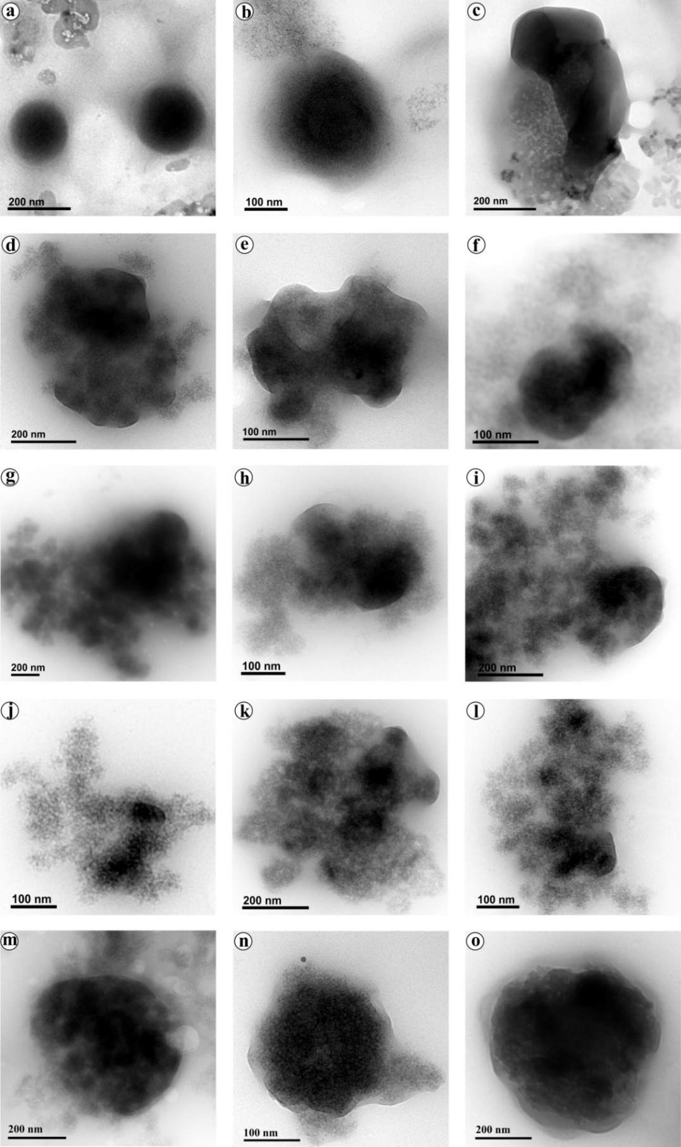
Gas chromatography analysis of styrene molecules release
The observed disintegration of PSNPs after lysosomal activity as described in this study driven us to analyse the presence of styrene molecules in the cell-free supernatant collected from the PSNPs internalized cells. Herein, the coronated PSNPs without structural damage, partly damaged, disintegrated and enlarged particles (Fig. S5) were separated from the withdrawn medium by centrifugation and the supernatant was subjected to the styrene molecules extraction according to the Colin and Chakrabarti, 1986. The extracted styrene molecules were analysed under gas chromatography along with the styrene standard (Sigma Aldrich, St. Louis, MO). It is noteworthy to mention that, the PSNPs incorporated in the culture medium was used as experimental control. However, further optimization and standardization studies are needed to validate and quantify the molecular release with other NPs as well as its effect on the cells at molecular levels.
Figure S6. Gas chromatography analysis of styrene molecules release from the macropinolysosomal activity in the PSNPs internalized cells. Ten ng of styrene molecule (Sigma Aldrich, St. Louis, MO) was used as standard.
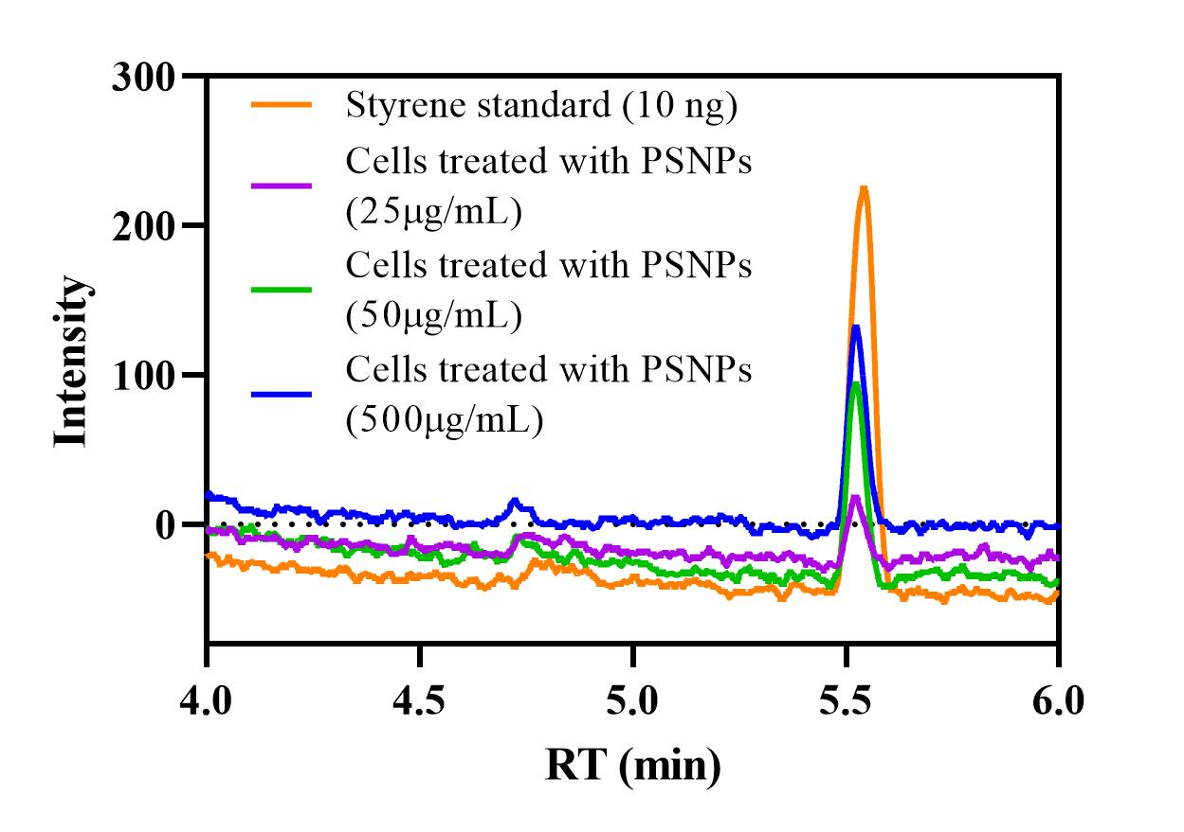
Figure S7. NPs mediated induction of cellular senescence in the HaCaT cells. (a-c) 10, 100 & 500 µg/mL of PENPs, (d-f) 10, 100 & 500 µg/mL of PSNPs, (g-i) 10, 50 & 100 µg/mL of NPs-1, ( j-l) 10, 50 & 100 µg/mL of NPs-2, (m) control and (n-o) 10 & 50 µM of H₂O₂, respectively. Scale bar - 60 µm.
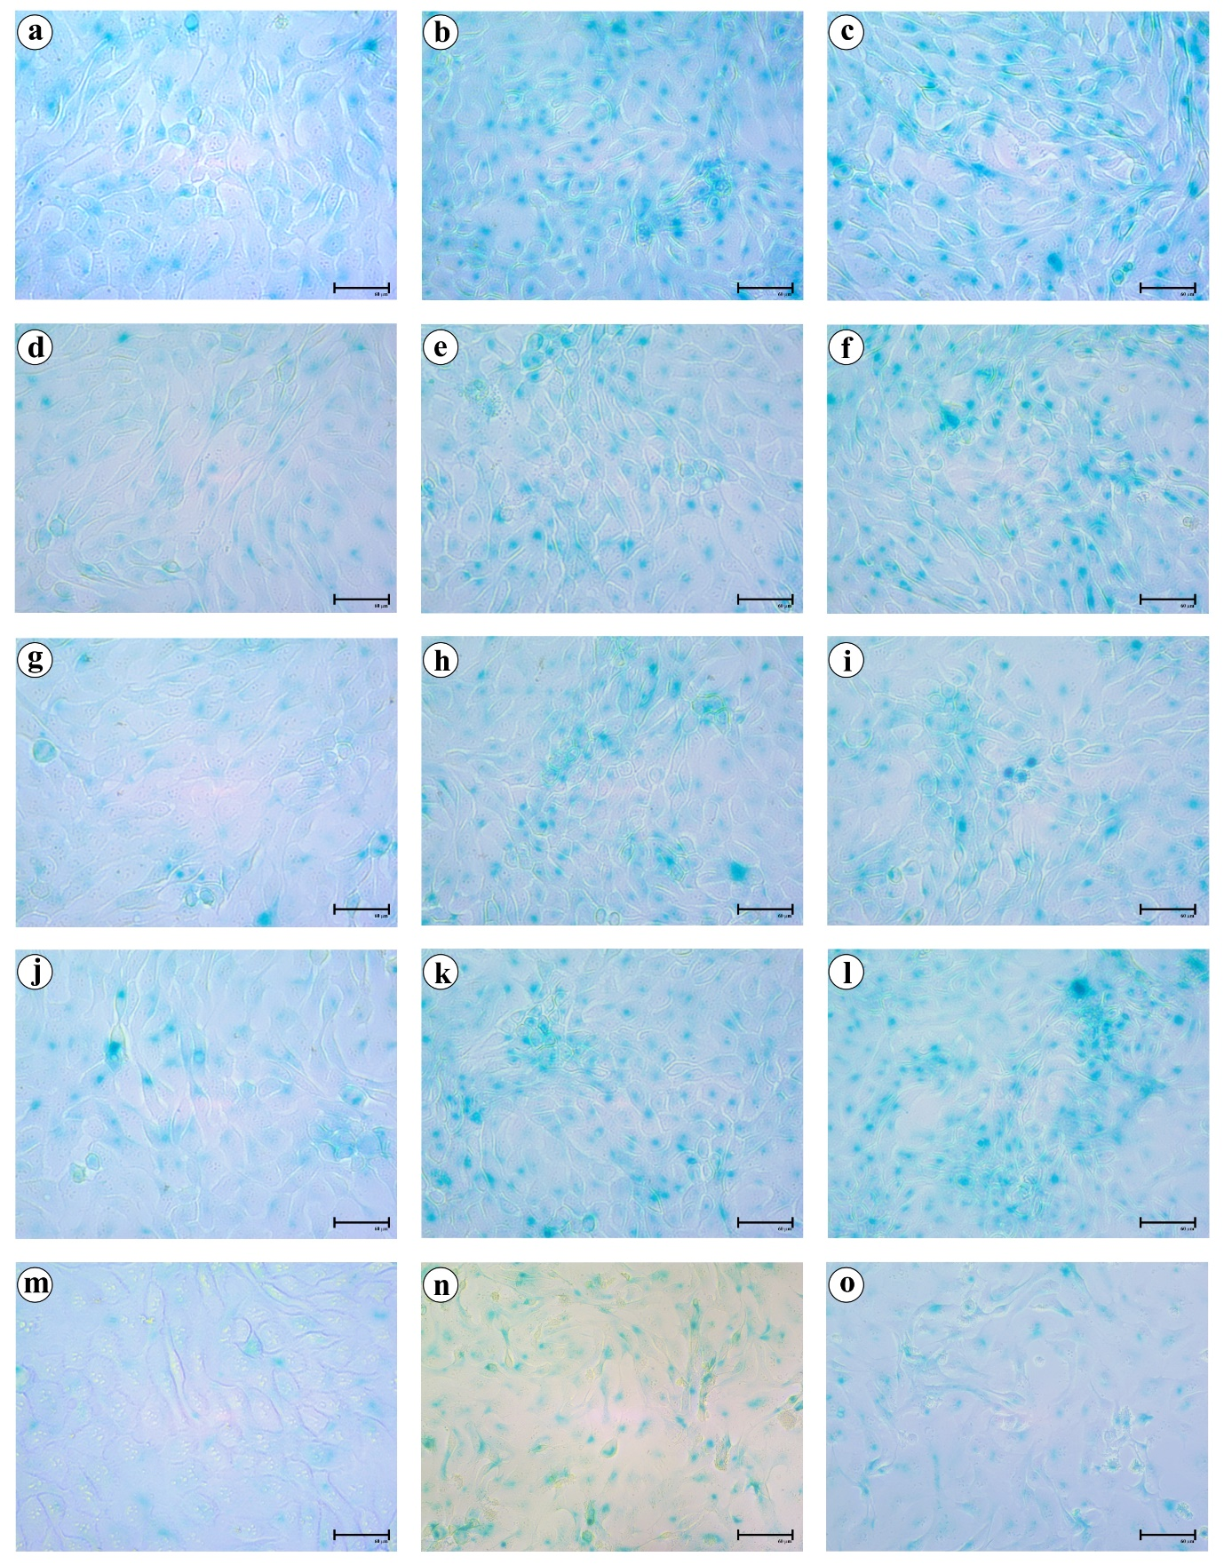
Table S3. The percentage of SA-β-gal-positive cells in PENPs, PSNPs, NPs-1, NPs-2 and H₂O₂ treated cells and untreated cells
 | Percentage of SA–β –gal–positive cells
Concentration | 10 µg/mL | 100 µg/mL | 500 µg/mL
PENPs | 56.2 ±2.9% | 75.4 ± 0.3% | 78.5 ± 2.6%
PSNPs | 50.5 ± 4.1% | 58.7 ± 2.0% | 85.2 ± 5.5%
Concentration | 10 µg/mL | 50 µg/mL | 100 µg/mL
NPs-1 | 29.2 ±1.8% | 57.1 ± 1.3% | 68.8 ± 6.5%
NPs-2 | 51.7 ± 4.3% | 73.4 ± 2.8% | 87.6 ± 0.1%
Concentration | 10 µM | 50 µM | 100 µM
H₂O₂ | 71.8 ± 3.2% | 85.4 ± 2.0% | 96.0 ± 2.4 %
Control | 13.5 ± 2.2 %

Figure S8. HR-TEM micrograph of just filtered hot water (negative control)
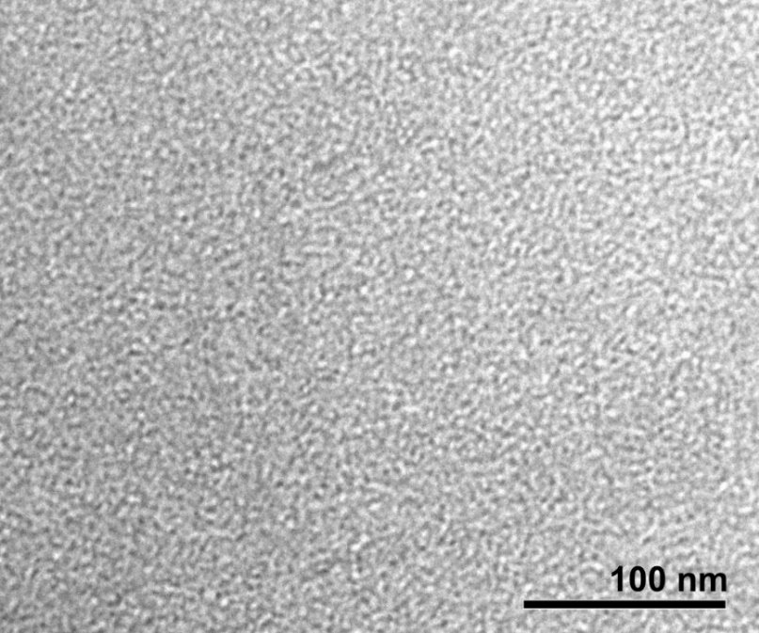
Figure S9. FE-SEM micrograph of keratin-coated glass slides (negative control) with a) smooth surface and b) rough surface.

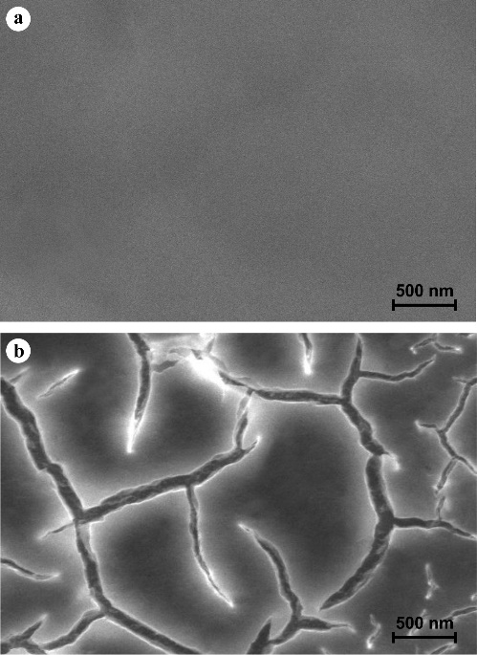
References
Adav, S. S., Subbaiaih, R. S., Kerk, S. K., Lee, A. Y., Lai, H. Y., Ng, K. W., ... & Schmidtchen, A. (2018). Studies on the proteome of human hair-Identification of histones and deamidated keratins. Scientific reports, 8(1), 1-11.
Colin P, Sirois G, Chakrabarti S. Determination of styrene in biological samples by reversed-phase liquid chromatography. Journal of Chromatography. 1986;375 2:431-7.
Nakamura, A., Arimoto, M., Takeuchi, K., & Fujii, T. (2002). A rapid extraction procedure of human hair proteins and identification of phosphorylated species. Biological and Pharmaceutical Bulletin, 25(5), 569-572.
Shim, W. J., Song, Y. K., Hong, S. H., & Jang, M. (2016). Identification and quantification of microplastics using Nile Red staining. Marine pollution bulletin, 113(1-2), 469-476.

