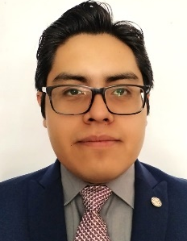
M.Sc. Daniel Hernández-Andrade. He is currently a post-master's student at the Institute of Engineering in the Geocomputing Laboratory from National Autonomous University of Mexico. His research interests include crustal deformation, GNSS technology, surveying methods, and kinematic analysis using interpolation methods.

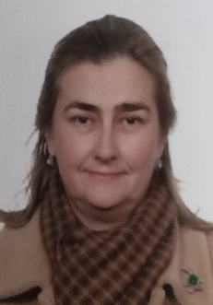
PhD. Maria Clara de Lacy Pérez de los Cobos. She is presently a Full Professor at the University CEU San Pablo (Madrid) at the department of Mathematics and Data Sciences. She became Full Professor at the Cartographic, Geodetic and Surveying Engineering in 2020 at the University of Jaen. Her research has been focused on GNSS systems and its applications.

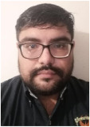
PhD. Rosendo Romero-Andrade. He received the B.E. degree in geodesy from the Autonomous University of Sinaloa (UAS), Mexico, in 2011, M.E. degree in Information Science from the Autonomous University of Sinaloa, in 2013 and Ph.D. from the Autonomous University of Sinaloa, in 2018. He is working currently at the Department of Earth and Space Science from UAS. His research interests include crustal deformation, GNSS technology, low-cost GNSS receivers and deformations.

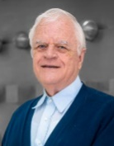
PhD. Gabriel Auvinet Guichard. PhD in Civil Engineering from the National Autonomous University of Mexico. He heads the Geocomputing laboratory at the Institute of Engineering from the same University. His research interest includes the application of probability and statistics in engineering, granular media, and the stochastic finite element method.

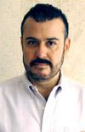
M.Eng. Edgar Méndez Sánchez. Master of Engineering (Soil Mechanics) in the Master's and Doctoral Program in Engineering of the National Autonomous University of Mexico (UNAM). His research interest is the characterization and geotechnical description of the subsoil of the Basin of Mexico, regional subsidence and cracks in the soft soils of the Valley of Mexico, Cuautitlan and Toluca.

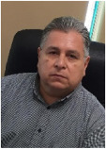

PhD. Manuel E. Trejo-Soto. Ph.D. from the Moscow State University of Geodesy and Cartography (Russian Federation), in 2007. He is working currently at the Department of Earth and Space Science from UAS. His research interests include ground-motion study, seismic geodesy, crustal deformation, GNSS technology.

