SUPPLEMENTARY MATERIAL
Intact functional brain networks in the isolated hemisphere of people after hemispherotomy

Extended Table 1. Overview over individuals with hemispherotomy included in this study. FD: framewise displacement. *preoperative resting-state fMRI was performed once and postoperative resting-state fMRI was performed twice
ID | both hemis- pheres | sex | lesional side | etiology | age at surgery (years) | age at MRI (years) | lesion volume (cm³) | mean FD (mm)
1* | yes | male | right | ganglioglioma | 26 | 26 | 302.6 | 0.26
2 | no | male | left | Rasmussen’s encephalitis | 19 | 21 | 675.4 | 0.07
3 | no | male | right | porencephaly | 16 | 19 | 440.5 | 0.22
4 | yes | female | left | Rasmussen’s encephalitis | 18 | 20 | 253.7 | 0.09
5 | no | male | left | porencephaly | 10 | 16 | 363.8 | 0.08
6 | no | male | right | porencephaly | 15 | 17 | 534.6 | 0.13
7 | no | female | right | Rasmussen’s encephalitis | 30 | 45 | 661.4 | 0.19
8 | no | female | left | hemimegalencephaly | 6 | 25 | 625.3 | 0.08
9 | no | female | left | porencephaly | 13 | 21 | 599.4 | 0.11
10 | yes | female | left | porencephaly | 18 | 20 | 177.9 | 0.14
11 | no | female | left | hemimegalencephaly | 0 | 18 | 784.2 | 0.20
12 | no | male | right | polymicrogyria | 10 | 23 | 414.1 | 0.08
13 | yes | female | left | Rasmussen’s encephalitis | 7 | 11 | 254.9 | 0.06
14 | yes | male | left | porencephaly | 33 | 43 | 358.3 | 0.26
15 | no | female | left | porencephaly | 9 | 20 | 377.2 | 0.10
16 | no | female | left | porencephaly | 11 | 22 | 344.4 | 0.14
17 | no | female | right | porencephaly | 10 | 21 | 658.9 | 0.08
18 | no | male | left | Rasmussen’s encephalitis | 12 | 18 | 552.1 | 0.08
19 | no | male | left | porencephaly | 10 | 18 | 402.6 | 0.13
20 | no | female | right | porencephaly | 25 | 36 | 652.3 | 0.07
21 | yes | female | right | hemimegalencephaly | 0 | 16 | 275.4 | 0.13
22 | yes | female | right | porencephaly | 16 | 27 | 255.6 | 0.26
23 | no | male | right | Sturge-Weber syndrome | 1 | 20 | 449.9 | 0.15
24 | no | male | right | porencephaly | 29 | 32 | 464.4 | 0.10
25 | no | female | left | porencephaly | 9 | 19 | 288.1 | 0.20
26* | yes | female | left | porencephaly | 49 | 49 | 283.7 | 0.19

Fmriprep preprocessing
Results included in this manuscript come from preprocessing performed using fMRIPrep 20.2.0 (Esteban, Markiewicz, et al. (2018); Esteban, Blair, et al. (2018); RRID:SCR_016216), which is based on Nipype 1.5.1 (Gorgolewski et al. (2011); Gorgolewski et al. (2018); RRID:SCR_002502).
Anatomical data preprocessing
A total of 1 T1-weighted (T1w) images were found within the input BIDS dataset.The T1-weighted (T1w) image was corrected for intensity non-uniformity (INU) with N4BiasFieldCorrection (Tustison et al. 2010), distributed with ANTs 2.3.3 (Avants et al. 2008, RRID:SCR_004757), and used as T1w-reference throughout the workflow. The T1w-reference was then skull-stripped with a Nipype implementation of the antsBrainExtraction.sh workflow (from ANTs), using OASIS30ANTs as target template. Brain tissue segmentation of cerebrospinal fluid (CSF), white-matter (WM) and gray-matter (GM) was performed on the brain-extracted T1w using fast (FSL 5.0.9, RRID:SCR_002823, Zhang, Brady, and Smith 2001). Volume-based spatial normalization normalisation to two standard spaces (MNI152NLin6Sym, MNI152NLin2009cAsym) was performed through non-linear registration with antsRegistration (ANTs 2.3.3), using brain-extracted versions of both T1w reference and the T1w template. The following templates were selected for spatial normalizationnormalisation: ICBM 152 non-linear 6th Generation Symmetric Average Brain Stereotaxic Registration Model [RRID:SCR_008364; TemplateFlow ID: MNI152NLin6Sym], ICBM 152 Non-linear Asymmetrical template version 2009c [Fonov et al. (2009), RRID:SCR_008796; TemplateFlow ID: MNI152NLin2009cAsym]
Functional data preprocessing
For each of the 1 BOLD runs found per subject (across all tasks and sessions), the following preprocessing was performed. First, a reference volume and its skull-stripped version were generated using a custom methodology of fMRIPrep. A deformation field to correct for susceptibility distortions was estimated based on fMRIPrep’s fieldmap-less approach. The deformation field is that resulting from co-registering the BOLD reference to the same-subject T1w-reference with its intensity inverted (Wang et al. 2017; Huntenburg 2014). Registration is performed with antsRegistration (ANTs 2.3.3), and the process regularized by constraining deformation to be nonzero only along the phase-encoding direction, and modulated with an average fieldmap template (Treiber et al. 2016). Based on the estimated susceptibility distortion, a corrected EPI (echo-planar imaging) reference was calculated for a more accurate co-registration with the anatomical reference. The BOLD reference was then co-registered to the T1w reference using flirt (FSL 5.0.9, Jenkinson and Smith 2001) with the boundary-based registration (Greve and Fischl 2009) cost-function. Co-registration was configured with nine degrees of freedom to account for distortions remaining in the BOLD reference. Head-motion parameters with respect to the BOLD reference (transformation matrices, and six corresponding rotation and translation parameters) are estimated before any spatiotemporal filtering using mcflirt (FSL 5.0.9, Jenkinson et al. 2002). The BOLD time-series (including slice-timing correction when applied) were resampled onto their original, native space by applying a single, composite transform to correct for head-motion and susceptibility distortions. These resampled BOLD time-series will be referred to as preprocessed BOLD in original space, or just preprocessed BOLD. The BOLD time-series were resampled into standard space, generating a preprocessed BOLD run in MNI152NLin6Sym space. First, a reference volume and its skull-stripped version were generated using a custom methodology of fMRIPrep. Several confounding time-series were calculated based on the preprocessed BOLD: framewise displacement (FD), DVARS and three region-wise global signals. FD was computed using two formulations following Power (absolute sum of relative motions, Power et al. (2014)) and Jenkinson (relative root mean square displacement between affines, Jenkinson et al. (2002)). FD and DVARS are calculated for each functional run, both using their implementations in Nipype (following the definitions by Power et al. 2014). The three global signals are extracted within the CSF, the WM, and the whole-brain masks. Additionally, a set of physiological regressors were extracted to allow for component-based noise correction (CompCor, Behzadi et al. 2007). Principal components are estimated after high-pass filtering the preprocessed BOLD time-series (using a discrete cosine filter with 128s cut-off) for the two CompCor variants: temporal (tCompCor) and anatomical (aCompCor). tCompCor components are then calculated from the top 2% variable voxels within the brain mask. For aCompCor, three probabilistic masks (CSF, WM and combined CSF+WM) are generated in anatomical space. The implementation differs from that of Behzadi et al. in that instead of eroding the masks by 2 pixels on BOLD space, the aCompCor masks are subtracted a mask of pixels that likely contain a volume fraction of GM. This mask is obtained by thresholding the corresponding partial volume map at 0.05, and it ensures components are not extracted from voxels containing a minimal fraction of GM. Finally, these masks are resampled into BOLD space and binarized by thresholding at 0.99 (as in the original implementation). Components are also calculated separately within the WM and CSF masks. For each CompCor decomposition, the k components with the largest singular values are retained, such that the retained components’ time series are sufficient to explain 50 percent of variance across the nuisance mask (CSF, WM, combined, or temporal). The remaining components are dropped from consideration. The head-motion estimates calculated in the correction step were also placed within the corresponding confounds file. The confound time series derived from head motion estimates and global signals were expanded with the inclusion of temporal derivatives and quadratic terms for each (Satterthwaite et al. 2013). Frames that exceeded a threshold of 0.5 mm FD or 1.5 standardised DVARS were annotated as motion outliers. All resamplings can be performed with a single interpolation step by composing all the pertinent transformations (i.e. head-motion transform matrices, susceptibility distortion correction when available, and co-registrations to anatomical and output spaces). Gridded (volumetric) resamplings were performed using antsApplyTransforms (ANTs), configured with Lanczos interpolation to minimize the smoothing effects of other kernels (Lanczos 1964). Non-gridded (surface) resamplings were performed using mri_vol2surf (FreeSurfer).
Many internal operations of fMRIPrep use Nilearn 0.6.2 (Abraham et al. 2014, RRID:SCR_001362), mostly within the functional processing workflow. For more details of the pipeline, see the section corresponding to workflows in fMRIPrep’s documentation.
Copyright Waiver
The above boilerplate text was automatically generated by fMRIPrep with the express intention that users should copy and paste this text into their manuscripts unchanged. It is released under the CC0 license.
References
Abraham, Alexandre, Fabian Pedregosa, Michael Eickenberg, Philippe Gervais, Andreas Mueller, Jean Kossaifi, Alexandre Gramfort, Bertrand Thirion, and Gael Varoquaux. 2014. “Machine Learning for Neuroimaging with Scikit-Learn.” Frontiers in Neuroinformatics 8.
Avants, B.B., C.L. Epstein, M. Grossman, and J.C. Gee. 2008. “Symmetric Diffeomorphic Image Registration with Cross-Correlation: Evaluating Automated Labeling of Elderly and Neurodegenerative Brain.” Medical Image Analysis 12 (1): 26–41. https://doi.org/10.1016/j.media.2007.06.004.
Behzadi, Yashar, Khaled Restom, Joy Liau, and Thomas T. Liu. 2007. “A Component Based Noise Correction Method (CompCor) for BOLD and Perfusion Based fMRI.” NeuroImage 37 (1): 90–101. https://doi.org/10.1016/j.neuroimage.2007.04.042.
Esteban, Oscar, Ross Blair, Christopher J. Markiewicz, Shoshana L. Berleant, Craig Moodie, Feilong Ma, Ayse Ilkay Isik, et al. 2018. “FMRIPrep.” Software. Zenodo. https://doi.org/10.5281/zenodo.852659.
Esteban, Oscar, Christopher Markiewicz, Ross W Blair, Craig Moodie, Ayse Ilkay Isik, Asier Erramuzpe Aliaga, James Kent, et al. 2018. “fMRIPrep: A Robust Preprocessing Pipeline for Functional MRI.” Nature Methods. https://doi.org/10.1038/s41592-018-0235-4.
Fonov, VS, AC Evans, RC McKinstry, CR Almli, and DL Collins. 2009. “Unbiased Nonlinear Average Age-Appropriate Brain Templates from Birth to Adulthood.” NeuroImage 47, Supplement 1: S102. https://doi.org/10.1016/S1053-8119(09)70884-5.
Gorgolewski, K., C. D. Burns, C. Madison, D. Clark, Y. O. Halchenko, M. L. Waskom, and S. Ghosh. 2011. “Nipype: A Flexible, Lightweight and Extensible Neuroimaging Data Processing Framework in Python.” Frontiers in Neuroinformatics 5: 13. https://doi.org/10.3389/fninf.2011.00013.
Gorgolewski, Krzysztof J., Oscar Esteban, Christopher J. Markiewicz, Erik Ziegler, David Gage Ellis, Michael Philipp Notter, Dorota Jarecka, et al. 2018. “Nipype.” Software. Zenodo. https://doi.org/10.5281/zenodo.596855.
Greve, Douglas N, and Bruce Fischl. 2009. “Accurate and Robust Brain Image Alignment Using Boundary-Based Registration.” NeuroImage 48 (1): 63–72. https://doi.org/10.1016/j.neuroimage.2009.06.060.
Huntenburg, Julia M. 2014. “Evaluating Nonlinear Coregistration of BOLD EPI and T1w Images.” Master’s Thesis, Berlin: Freie Universität. http://hdl.handle.net/11858/00-001M-0000-002B-1CB5-A.
Jenkinson, Mark, Peter Bannister, Michael Brady, and Stephen Smith. 2002. “Improved Optimization for the Robust and Accurate Linear Registration and Motion Correction of Brain Images.” NeuroImage 17 (2): 825–41. https://doi.org/10.1006/nimg.2002.1132.
Jenkinson, Mark, and Stephen Smith. 2001. “A Global Optimisation Method for Robust Affine Registration of Brain Images.” Medical Image Analysis 5 (2): 143–56. https://doi.org/10.1016/S1361-8415(01)00036-6.
Lanczos, C. 1964. “Evaluation of Noisy Data.” Journal of the Society for Industrial and Applied Mathematics Series B Numerical Analysis 1 (1): 76–85. https://doi.org/10.1137/0701007.
Power, Jonathan D., Anish Mitra, Timothy O. Laumann, Abraham Z. Snyder, Bradley L. Schlaggar, and Steven E. Petersen. 2014. “Methods to Detect, Characterize, and Remove Motion Artifact in Resting State fMRI.” NeuroImage 84 (Supplement C): 320–41. https://doi.org/10.1016/j.neuroimage.2013.08.048.
Satterthwaite, Theodore D., Mark A. Elliott, Raphael T. Gerraty, Kosha Ruparel, James Loughead, Monica E. Calkins, Simon B. Eickhoff, et al. 2013. “An improved framework for confound regression and filtering for control of motion artifact in the preprocessing of resting-state functional connectivity data.” NeuroImage 64 (1): 240–56. https://doi.org/10.1016/j.neuroimage.2012.08.052.
Treiber, Jeffrey Mark, Nathan S. White, Tyler Christian Steed, Hauke Bartsch, Dominic Holland, Nikdokht Farid, Carrie R. McDonald, Bob S. Carter, Anders Martin Dale, and Clark C. Chen. 2016. “Characterization and Correction of Geometric Distortions in 814 Diffusion Weighted Images.” PLOS ONE 11 (3): e0152472. https://doi.org/10.1371/journal.pone.0152472.
Tustison, N. J., B. B. Avants, P. A. Cook, Y. Zheng, A. Egan, P. A. Yushkevich, and J. C. Gee. 2010. “N4ITK: Improved N3 Bias Correction.” IEEE Transactions on Medical Imaging 29 (6): 1310–20. https://doi.org/10.1109/TMI.2010.2046908.
Wang, Sijia, Daniel J. Peterson, J. C. Gatenby, Wenbin Li, Thomas J. Grabowski, and Tara M. Madhyastha. 2017. “Evaluation of Field Map and Nonlinear Registration Methods for Correction of Susceptibility Artifacts in Diffusion MRI.” Frontiers in Neuroinformatics 11. https://doi.org/10.3389/fninf.2017.00017.
Zhang, Y., M. Brady, and S. Smith. 2001. “Segmentation of Brain MR Images Through a Hidden Markov Random Field Model and the Expectation-Maximization Algorithm.” IEEE Transactions on Medical Imaging 20 (1): 45–57. https://doi.org/10.1109/42.906424.

Head Motion
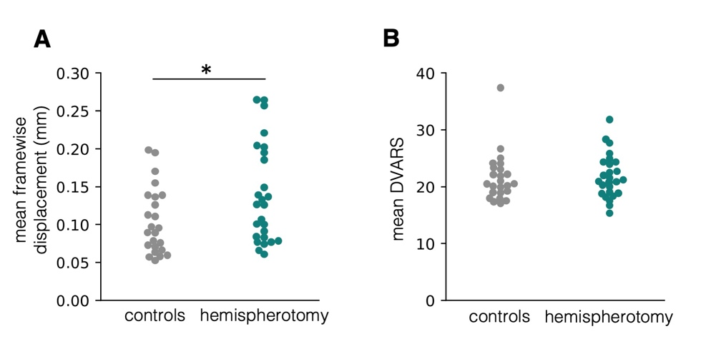
Figure S1. Head motion. (A) Mean framewise displacement in mm was significantly higher in individuals after hemispherotomy as compared to controls (t(50) = 2.15, P = 0.036). (B) The change of the BOLD signal across the entire brain at each timepoint DVARS (D: temporal derivative of timecourses, VARS: root-mean-square variance over voxels) did not differ significantly between individuals after hemispherotomy and controls (t(50) = 0.22, P = 0.83).
Gradient analysis
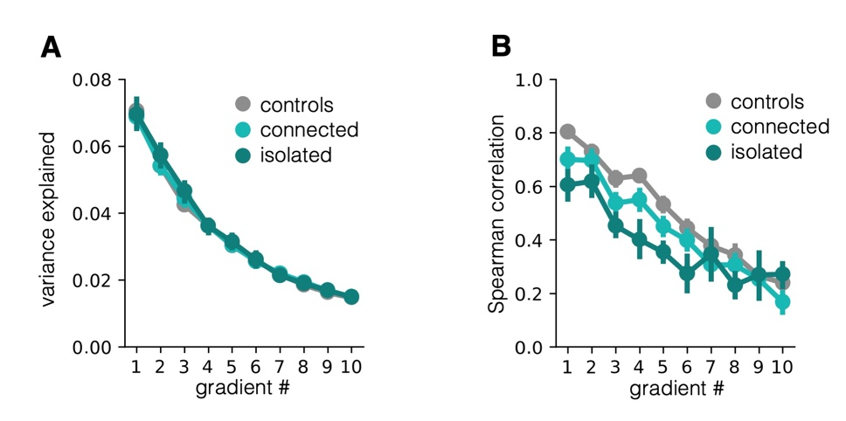
Figure S2. Gradient alignment. (A) Proportion of variance explained by the gradients sorted by magnitude of the corresponding eigenvalue for all hemispheres. (B) Spearman correlation between the aligned individual gradients and the corresponding gradient of the average connectivity matrix in controls. In (a) and (b), error bars represent 95% confidence intervals.

