APPENDIX:

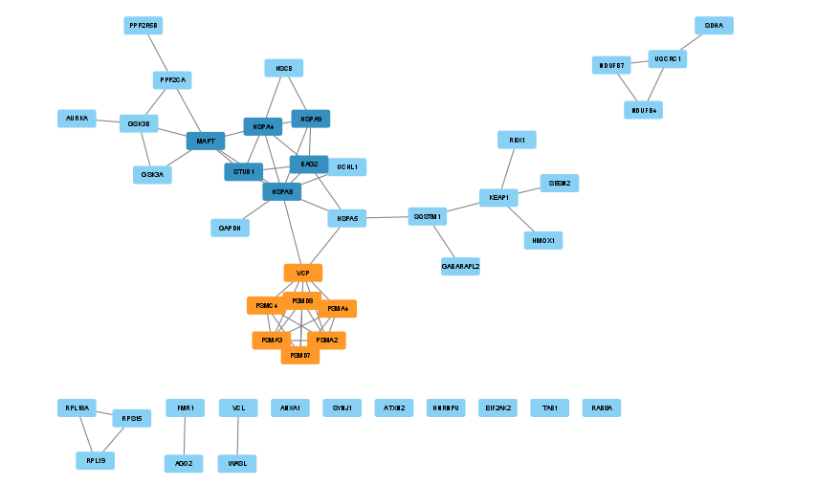
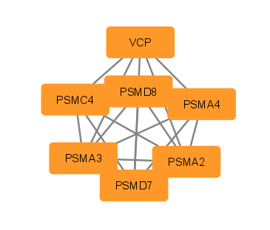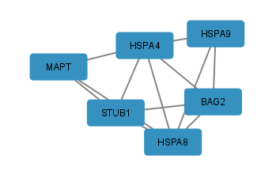
Fig. 1 Panel A: Network of common proteins involved during co-infection of PD and SARS-CoV-2 N-protein (N-PD network); The two main clusters identified in the network are depicted as: Panel B - Cluster 1 (Nodes: 7, Edges: 20, Score:6.667) and Panel C - Cluster 2 (Nodes: 6, Edges: 12, Score: 4.800)

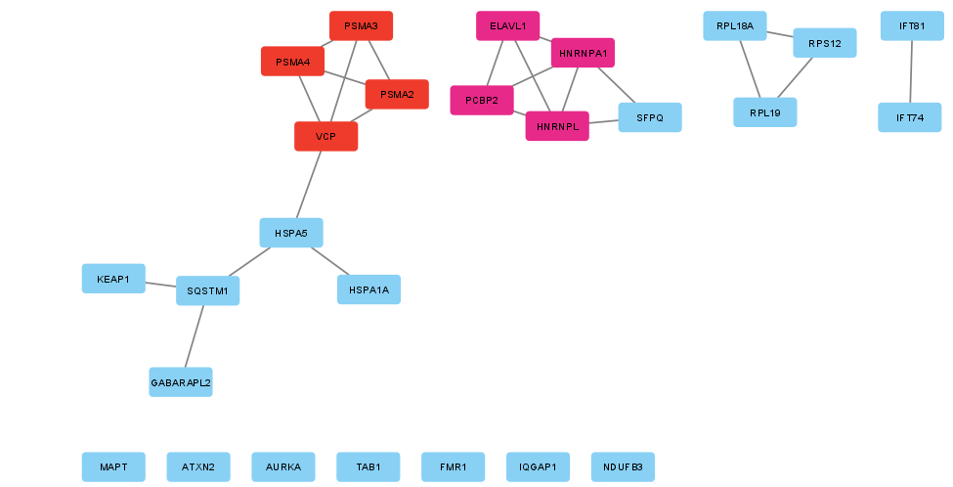
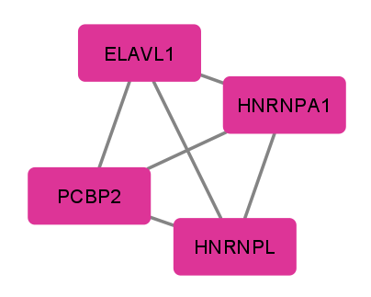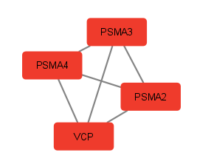
Fig. 2 Panel A -Network of common proteins involved during co-infection of dementia and SARS-CoV-2 N-protein (N-D network); The two main clusters identified in the network are depicted as: Panel B- Cluster 1 (Nodes: 4, Edges: 6, Score: 4.000) and Panel C- Cluster 2 (Nodes: 4, Edges: 6, Score: 4.000)

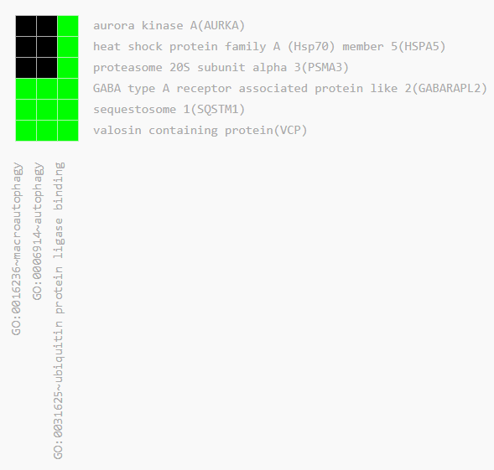
Fig. 5 Heatmap of the first functional annotation cluster obtained using DAVID
The green color represents positive association of the genes with the corresponding GO term and the black color represents a negative association between them
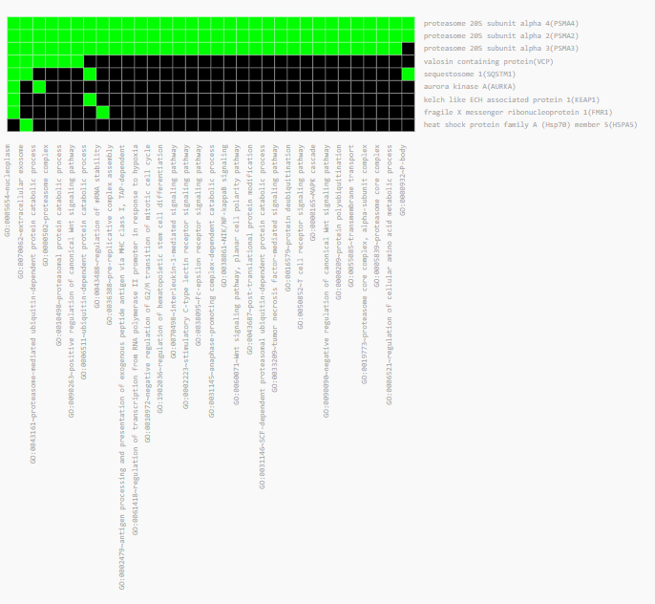
Fig. 6 Heatmap of the second functional annotation cluster obtained using DAVID
The green color represents positive association of the genes with the corresponding GO term and the black color represents a negative association between them

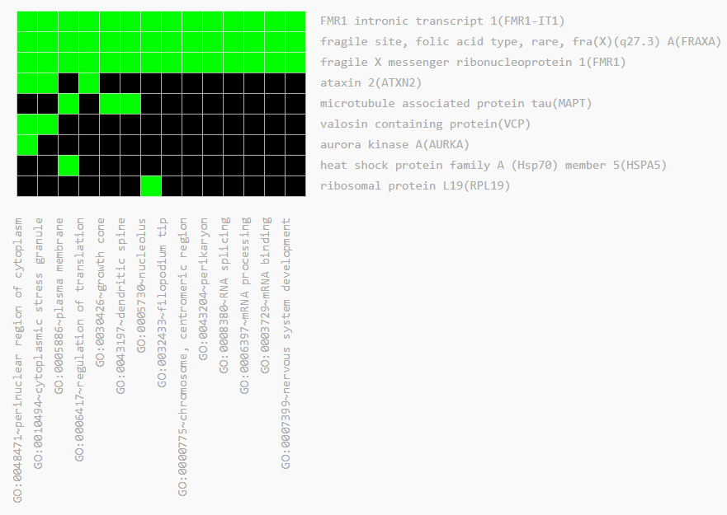
Fig. 7 Heatmap of the third functional annotation cluster obtained using DAVID
The green color represents positive association of the genes with the corresponding GO term and the black color represents a negative association between them

Table 5 Functions and biological pathways associated with the enriched proteins
Enriched Proteins | Major Functions | Pathways | Database
AURKA | Apoptotic process, cell cycle, positive regulation of protein degradation via UPS, neuron projection extension | Involved in the regulation of the TP53 pathway, regulation of PLK1 activity at G2/M transition,etc | UniProt
HSPA5 | Positive regulation of the development of neuron projection, structural organization of cerebellum, development of cerebellar Purkinje cell layer, development of substantia nigra, differentiation of neuron, positive regulation of protein ubiquitination, cellular response to unfolded protein | Pathways of neurodegeneration-multiple diseases; Amyotrophic lateral sclerosis; PD; Prion Disease | KEGG
PSMA3 | Exogenous peptide antigen processing and display via MHC class I, protein degradation via UPS | Pathways of neurodegeneration-multiple diseases; Amyotrophic lateral sclerosis; PD; Spinocerebellar ataxia; Proteasome; Prion Disease; Alzheimer Disease; Huntington Disease | KEGG
GABARAPL2 | Autophagy, negative regulation of proteasomal protein degradation, positive regulation of ATPase activity | Pathways of Mitophagy and Autophagy | KEGG
SQSTM1 | Protein degradation via UPS, protein import into nucleus, autophagy, apoptotic process | Pathways of neurodegeneration-multiple diseases; Amyotrophic lateral sclerosis | KEGG
VCP | Protein ubiquitination, viral genome replication, autophagy, stress granule disassembly, ATPase activity | Pathways of neurodegeneration-multiple diseases; Amyotrophic lateral sclerosis | KEGG
PSMA4 | Protein degradation via UPS, exogenous peptide antigen processing and display via MHC class I | Pathways of neurodegeneration-multiple diseases; Amyotrophic lateral sclerosis; PD; Spinocerebellar ataxia; Proteasome; Prion Disease; Alzheimer Disease; Huntington Disease | KEGG
PSMA2 | Protein degradation via UPS, response to virus, post-translational modification of protein | Pathways of neurodegeneration-multiple diseases; Amyotrophic lateral sclerosis; PD; Spinocerebellar ataxia; Proteasome; Prion Disease; Alzheimer Disease; Huntington Disease | KEGG
KEAP1 | Protein degradation via UPS, autophagy regulation, cellular response to oxidative stress | Pathways in PD, cancer | KEGG
FMR1 | RNA splicing, nervous system development, influence of host on the replication of the viral RNA genome, regulation of neurotransmitter secretion, viral response, neuronal action potential regulation, negative regulation of long term synaptic depression, positive regulation of intracellular transport of viral material | Glutamate receptor signaling pathway | UniProt
FMR1-IT1 | mRNA processing, regulation of translation, nervous system development, RNA splicing | - | _
FRAXA | mRNA processing, regulation of translation, nervous system development, RNA splicing | - | _
ATXN2 | Stress granule assembly, negative regulation of receptor internalization | Pathways of neurodegeneration-multiple diseases; Amyotrophic lateral sclerosis; Spinocerebellar ataxia | KEGG
MAPT | Synapse assembly, memory, regulation of autophagy, central nervous system neuron development, neuron projection development, stress granule assembly, positive regulation of axon extension, regulation of synaptic plasticity, generation of neurons, synapse organization, axon development, axonal transport, positive regulation of neuron death, positive regulation of protein localization to synapse, neurofibrillary tangle assembly, amyloid fibril formation | Pathways of neurodegeneration-multiple diseases; PD; Alzheimer Disease | KEGG
RPL19 | Cytoplasmic translation | Pathways involved in the regulation of viral mRNA translation | UniProt

